PetClinic User Manual
PetClinic is a small veterinary practice management application. You can use it to keep records of pet owners, the pets in their care, the veterinarians on staff, the specialties those vets practice, and the visits the pets make to the clinic.
This file is regenerated by the /regen-user-manual slash command. Do not edit by hand — your changes will be overwritten on the next regeneration.

Contents
- Getting around
- Welcome
- Owners
- Pets
- Visits
- Pet Types
- Veterinarians
- Specialties

Getting around
The top navigation bar is your starting point. Home takes you back to the welcome screen. Owners, Visits, Pet Types, and Specialties are direct links to those areas. The Veterinarians dropdown reveals All (the staff roster) and Add New (the new-veterinarian form).
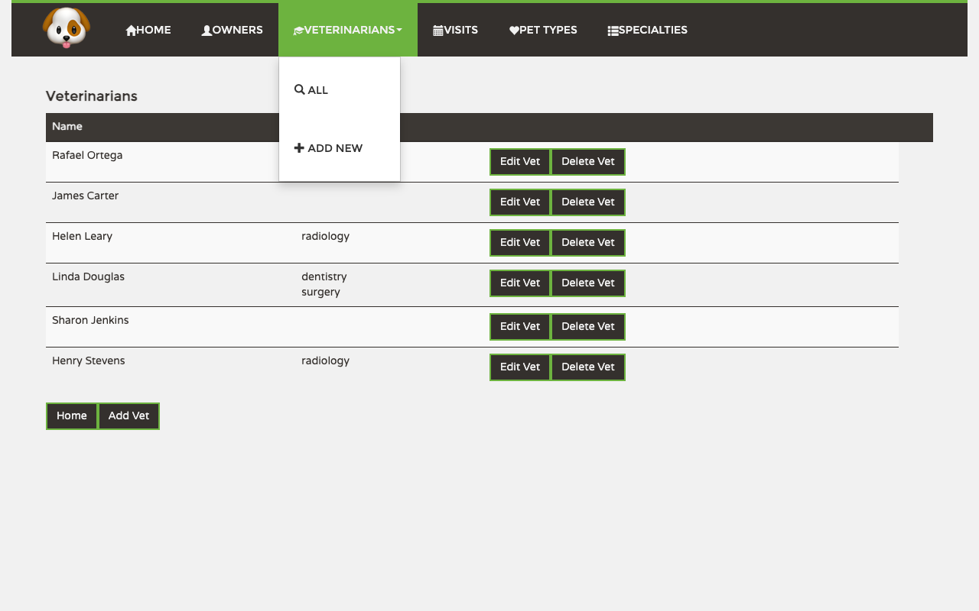
In the screenshot above, the Veterinarians menu has been opened to show its two options.

Welcome
The welcome screen is what you see when you open PetClinic or click Home. It is purely a starting point — no records or actions live here. Use the navigation bar to jump to whichever area you need.
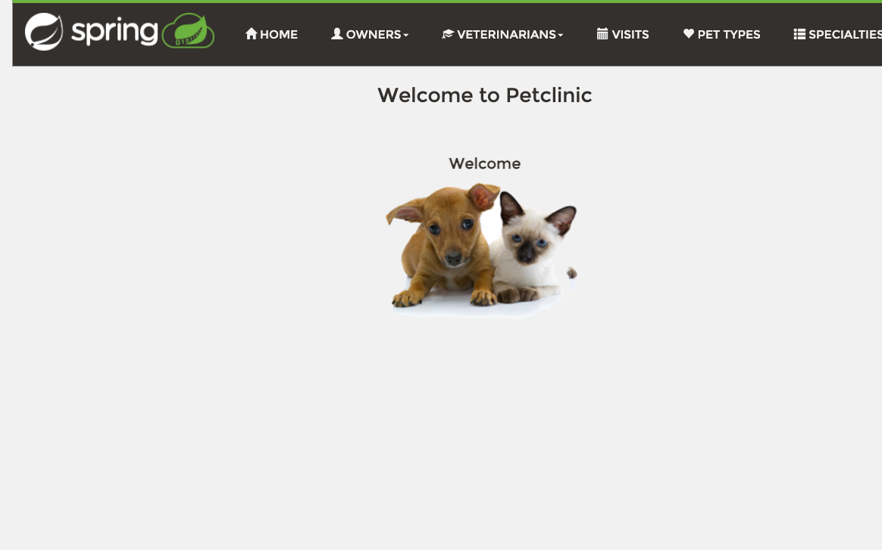

Owners
The Owners area is where you keep records for the people who bring pets to the clinic. From here you can search the existing owners, look up a specific owner’s pets and visit history, register a new owner, and edit an owner’s contact details.

Viewing the list
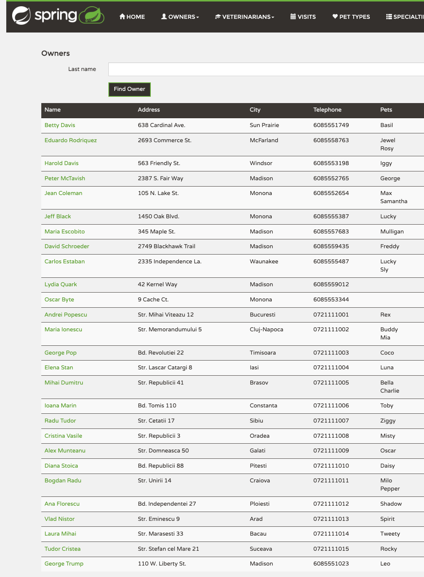
The list shows every registered owner. Each row includes the address, city, telephone, and the names of the pets associated with that owner. Above the table is a Last name search box — type a last name (or any prefix) and click Find Owner to narrow the list to matching owners. Click an owner’s name in the Name column to open their full record. The Add Owner button at the bottom of the list opens the new-owner form.

Creating a new owner
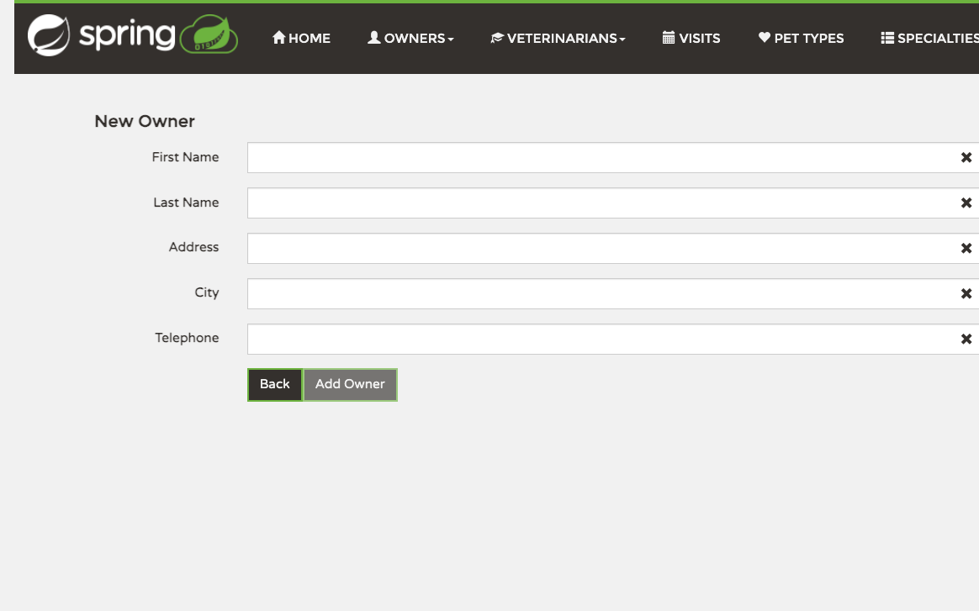
Click Add Owner on the list page to open the registration form. Fill in First Name, Last Name, Address, City, and Telephone — every field is required. The Add Owner button stays disabled until all fields have valid values. Submitting takes you back to the owners list with the new record added.

Looking at an owner’s record
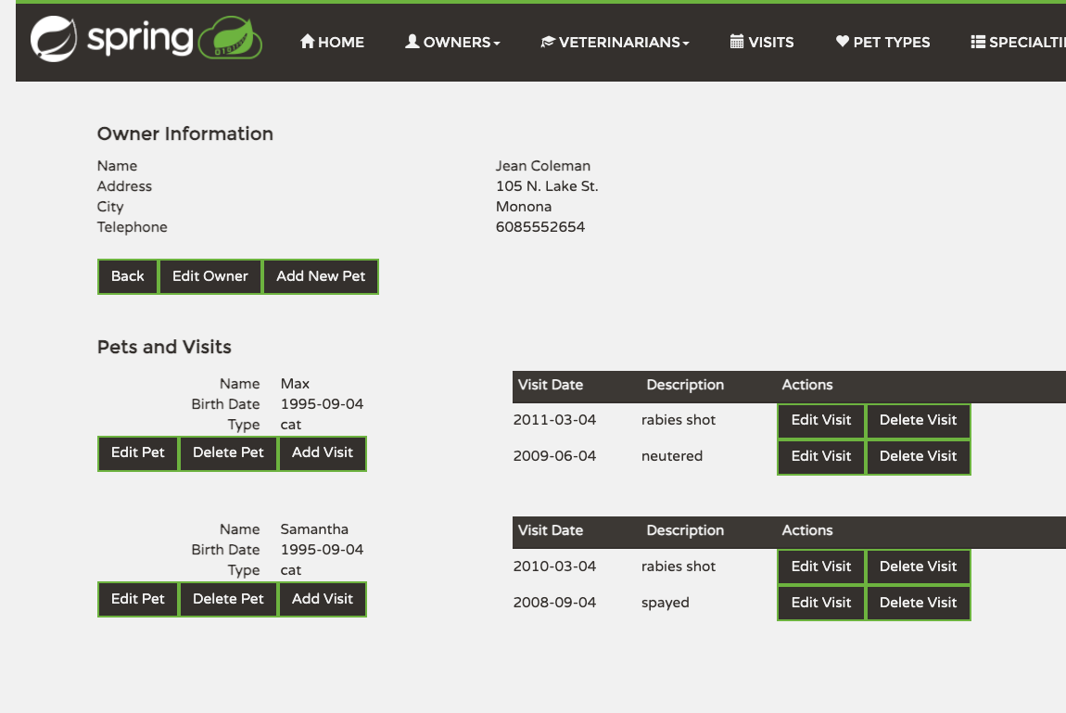
Clicking any owner name on the list opens their detail page. The top section shows the owner’s contact info with three actions: Back returns to the list, Edit Owner opens the edit form (see below), and Add New Pet registers a pet against this owner. Below that, the Pets and Visits section lists each of the owner’s pets with their birth date and type, plus per-pet Edit Pet, Delete Pet, and Add Visit buttons. Each pet’s visit history follows, with Edit Visit and Delete Visit actions on every entry.

Editing an owner
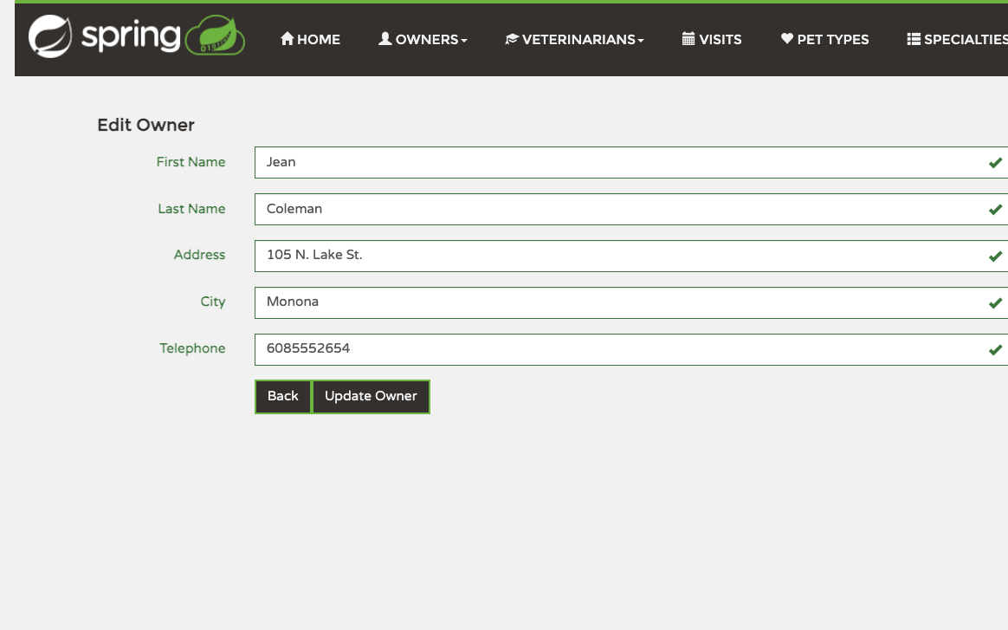
From the owner’s record click Edit Owner. The form is pre-filled with the current values; change what you need and click Update Owner to save. Back discards your changes and returns to the record.

Pets
Pets always belong to an owner — there is no standalone “all pets” listing in the staff workflow. You manage a pet through its owner’s record: add a new pet from the owner detail screen, then edit, delete, or schedule visits for it from the same place.

Adding a pet to an owner
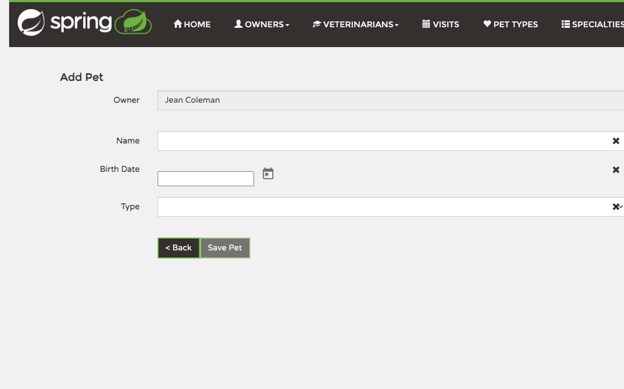
From the owner’s detail page click Add New Pet. The form locks the Owner field to whoever you came from. Enter the pet’s Name, pick a Birth Date from the calendar picker, and choose the Type (cat, dog, lizard, snake, bird, hamster, or horse). Click Save Pet to add it to the owner’s record. < Back returns to the owner without saving.

Editing a pet
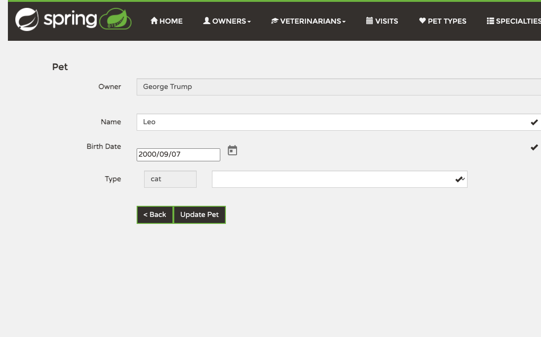
Open the owner’s detail page and click Edit Pet next to the pet you want to change. The same form opens with the current name, birth date, and type pre-filled. Adjust whatever needs changing and click Save Pet to update the record; < Back discards your changes. To delete a pet instead, click Delete Pet on the owner’s detail page — it removes the pet and all of its visit history.

Visits
The Visits area gives you a chronological view of every visit across the clinic. It is the right place to check what’s been happening recently or to find a specific visit. To register a new visit, however, you start from a specific pet — see Pets above.

Viewing all visits
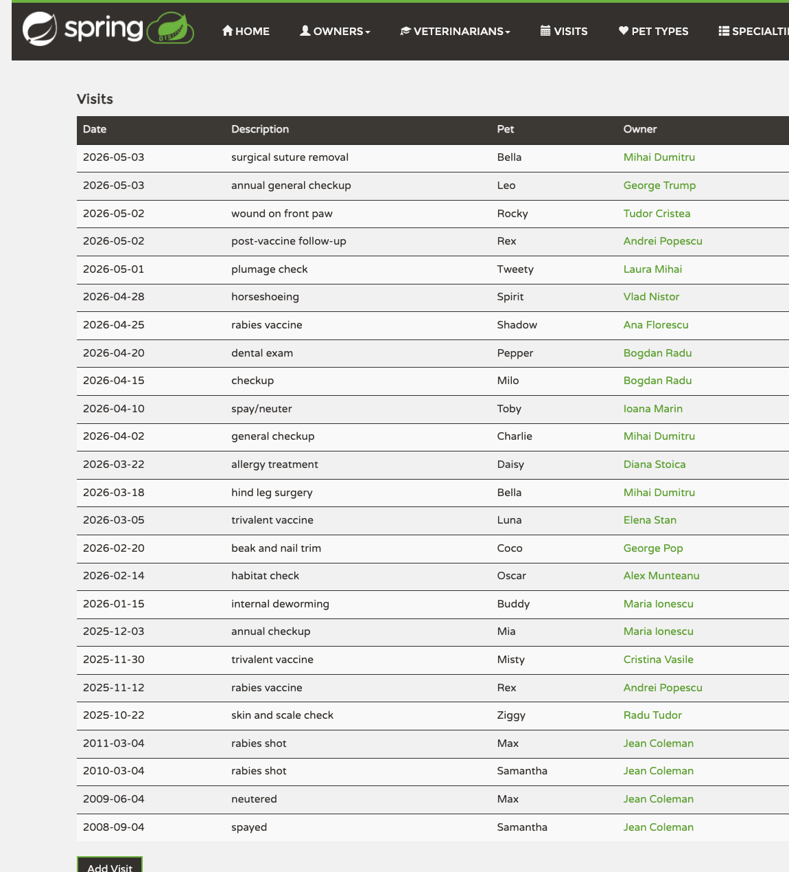
The list is sorted with the most recent visit first and grouped by year. Each row shows the visit date, the description of what was done, the pet’s name, and a link to the owner’s record. Click an owner name to jump to their detail page; from there you can see the visit in the context of that pet’s history.

Adding a visit
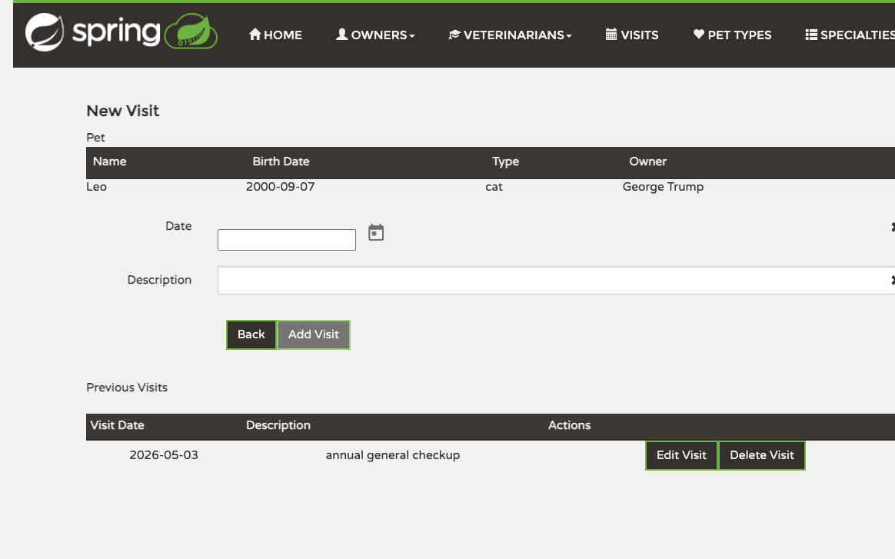
To add a visit, open the owner’s record (see Owners), find the pet that came in for the visit, and click Add Visit in that pet’s section. The New Visit form opens with the pet’s identifying details at the top and the pet’s previous visits listed below. Pick the Date from the calendar, write a Description of what was done, and click Add Visit to save. The visit appears under that pet on the owner record and in the chronological Visits list.

Pet Types
Pet Types is the list of species the clinic accepts as patients. Whenever you register a new pet, the Type dropdown is populated from this list. Edit it sparingly — adding rare types is fine, but renaming or deleting a type changes how every existing pet of that type is shown.

Viewing and editing the list
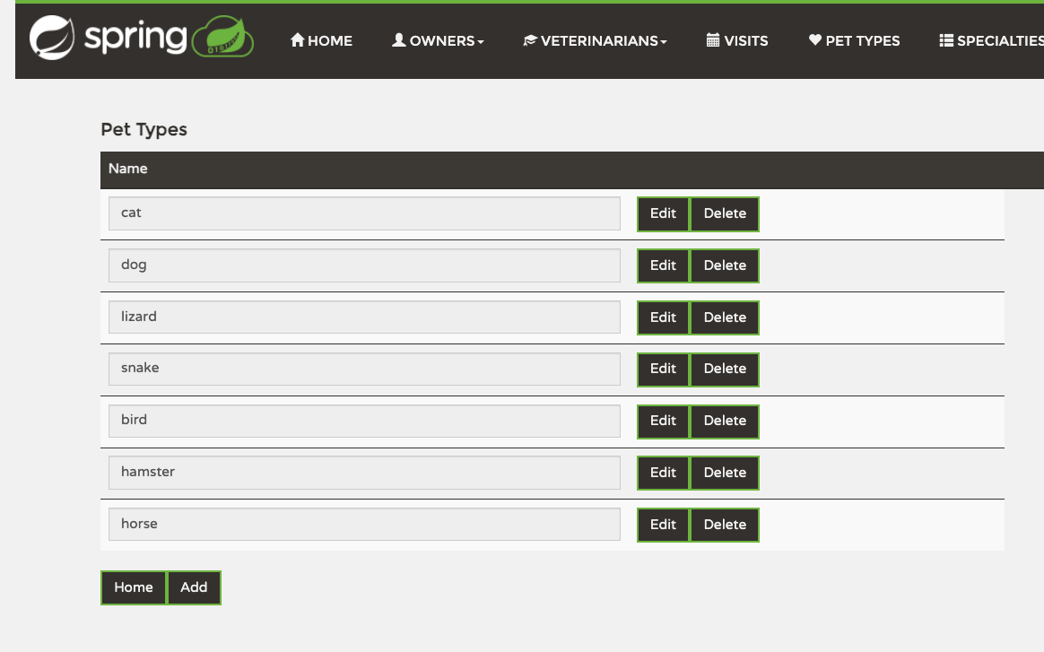
Each pet type appears as a row with Edit and Delete buttons. Click Edit to open the form for renaming a type (see below). Click Delete to remove a type the clinic no longer accepts. Home returns to the welcome screen; Add opens the new-type form below.

Adding a new pet type
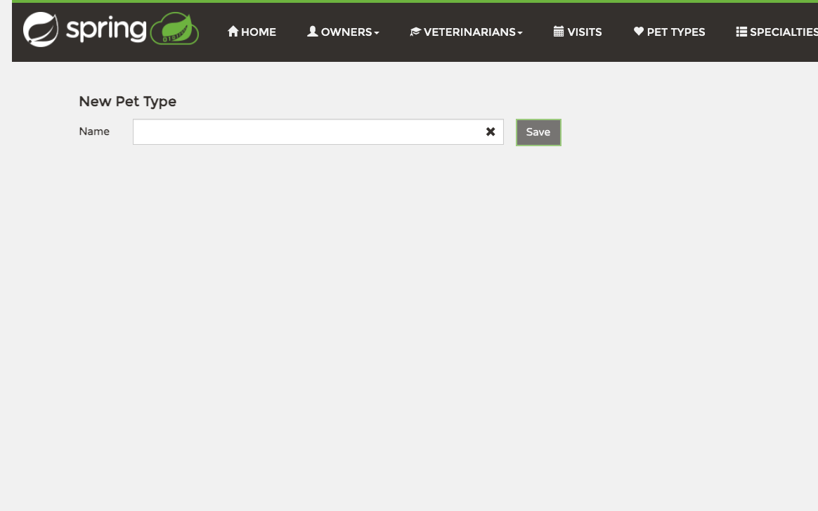
Click Add on the Pet Types list. Enter the new type’s Name in the field — for example, “rabbit” or “ferret” — and click Save. The new type immediately becomes available in the Type dropdown when registering a pet.

Editing a pet type
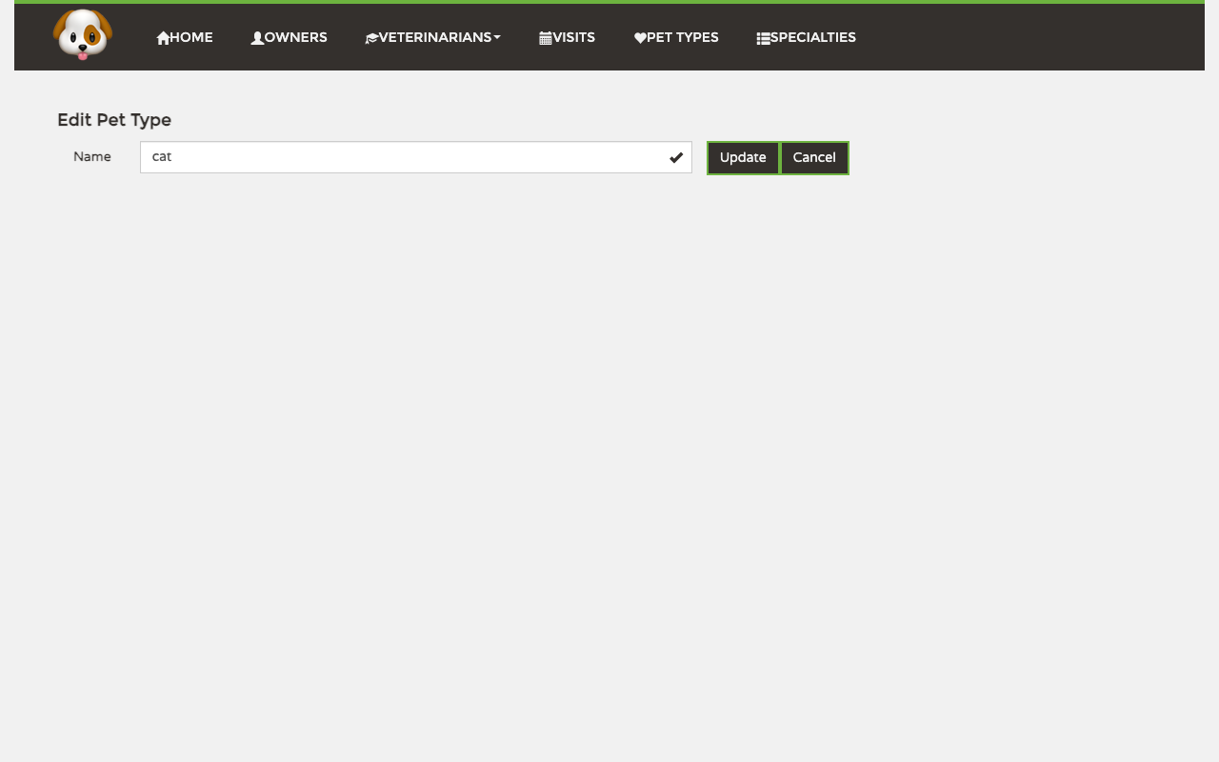
Click Edit beside the type you want to change. Update its name, then click Update. Click Cancel to leave the form without saving.

Veterinarians
The Veterinarians area is where you keep the staff roster. You can browse the current vets along with the specialties they practice, register new vets, edit their assignments, or remove vets who have left the clinic.

Viewing the list
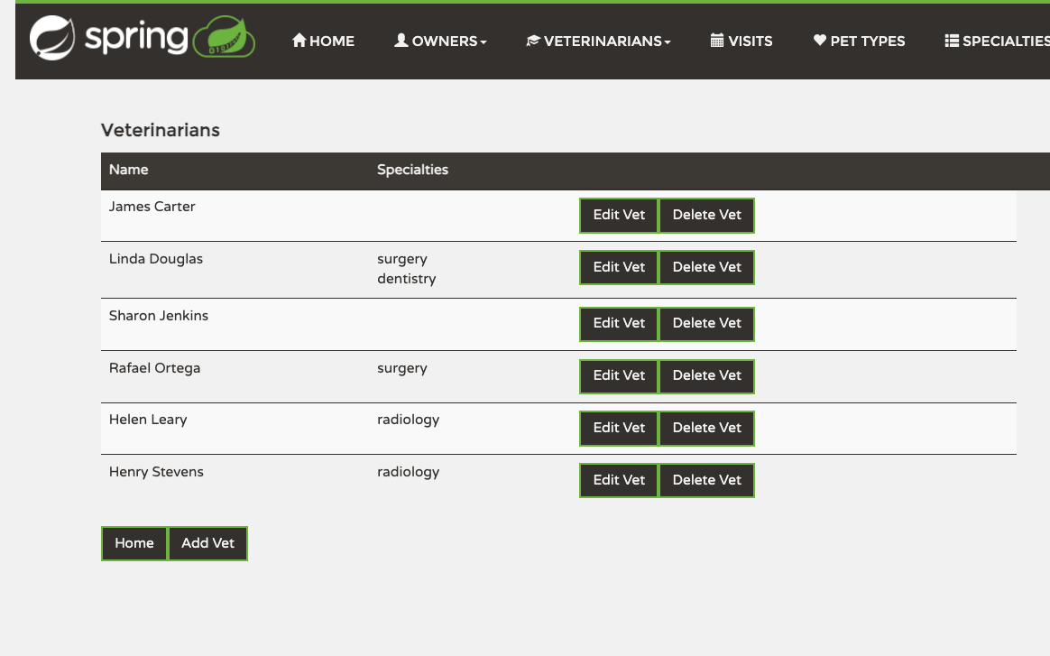
The list shows each veterinarian with their name and the specialties they are qualified in. Edit Vet opens the edit form for that vet — useful for changing their specialty assignments. Delete Vet removes them from the roster. Add Vet at the bottom opens the new-vet form; Home returns to the welcome screen.

Adding a new veterinarian
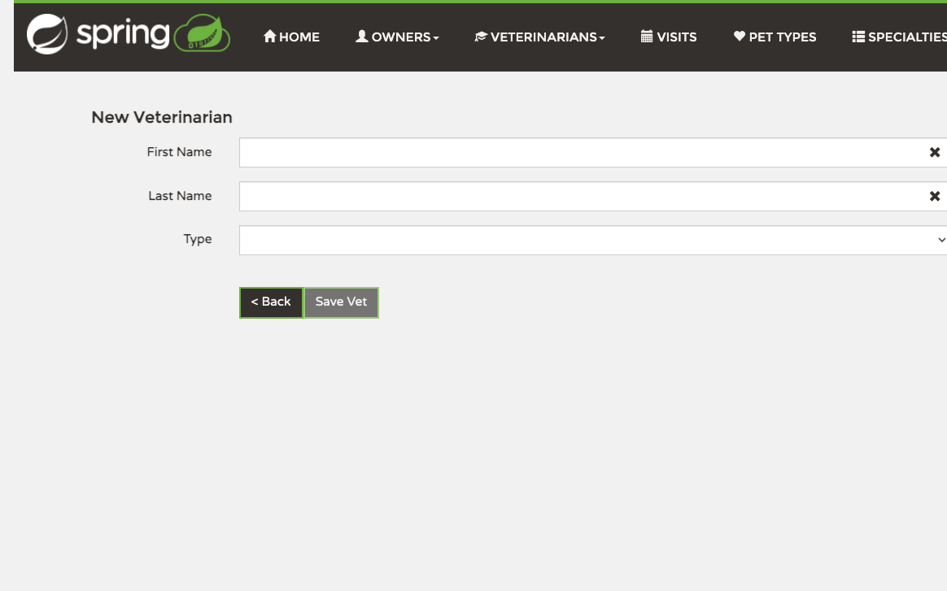
Enter the vet’s First Name and Last Name, then choose a Type (specialty) from the dropdown — radiology, surgery, or dentistry. Click Save Vet to add them to the roster. < Back discards the entry.
To assign more than one specialty to a vet, save them with their first specialty here, then open Edit Vet from the list to add additional ones.

Editing a veterinarian
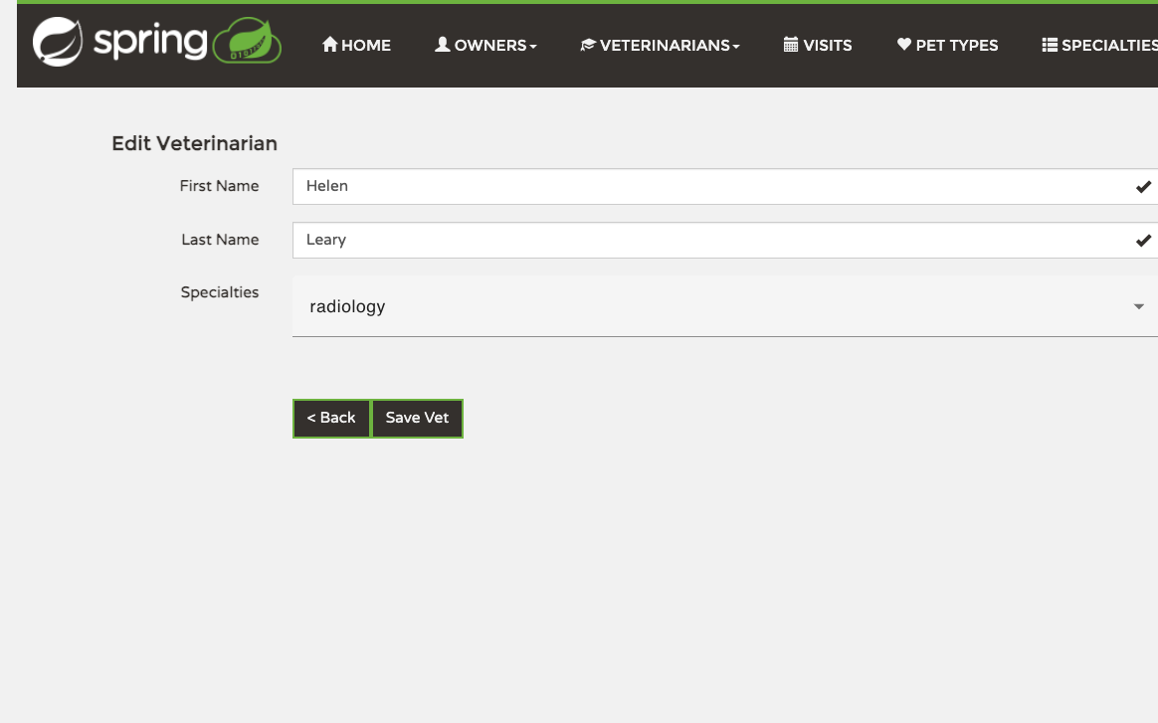
From the list click Edit Vet next to the vet you want to change. The form pre-fills First Name, Last Name, and a multi-select Specialties picker showing every specialty the vet currently holds. Click the picker to add or remove specialties — this is the screen to use whenever a vet picks up a new qualification or steps away from one. Click Save Vet to commit the changes; < Back discards them.

Specialties
Specialties is the list of veterinary disciplines a vet can be qualified in. The list is short by design — radiology, surgery, dentistry — but you can add, rename, or remove specialties to match how your clinic actually works.

Viewing and editing the list
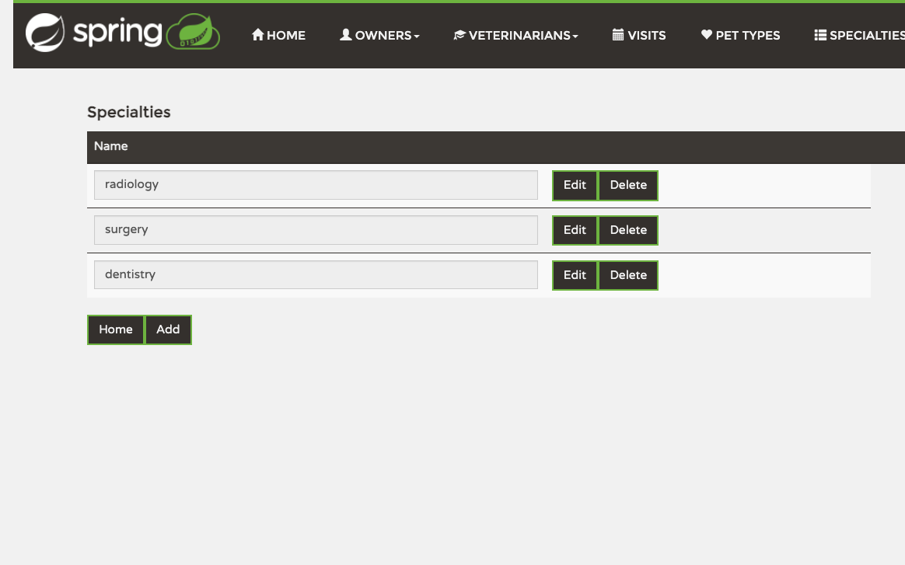
Each specialty appears as a row with its name and Edit and Delete buttons. Click Edit to open the specialty’s form (see below). Delete removes a specialty from the list. Removing a specialty unassigns it from any vet who currently practices it, so be careful before deleting.

Adding a new specialty
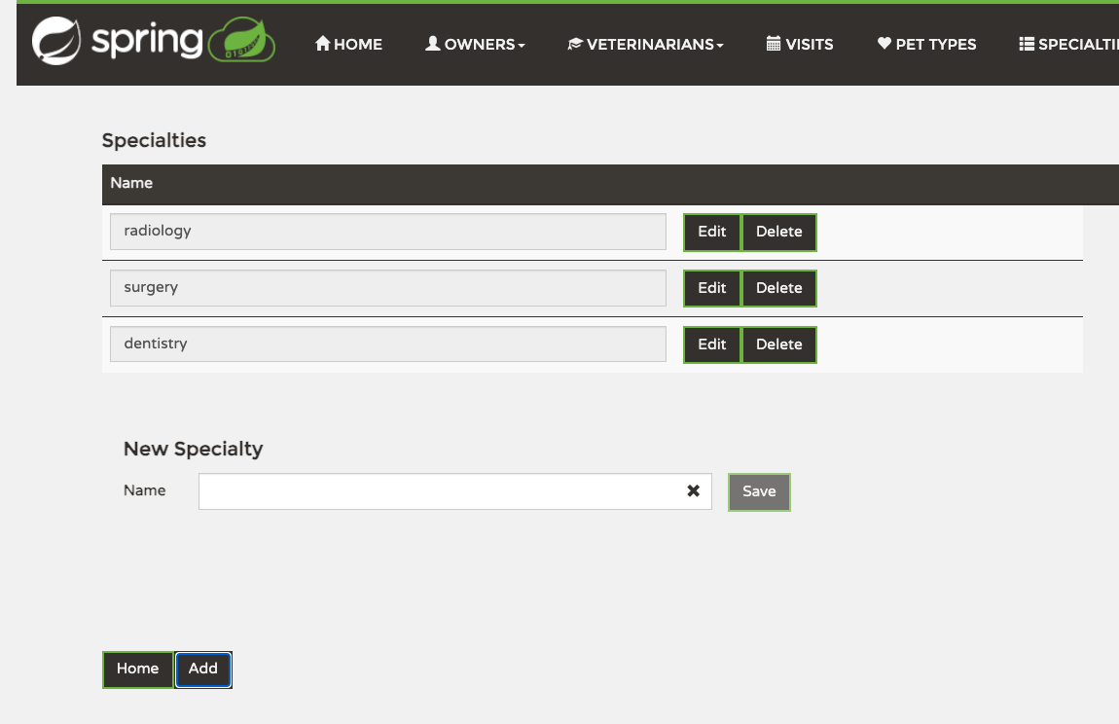
Click Add at the bottom of the Specialties list. A New Specialty form opens directly below the table. Type the name of the new discipline — for example, “cardiology” or “oncology” — and click Save. The new specialty becomes available in the Type dropdown when adding a vet, and in the multi-select picker when editing one.

Editing a specialty
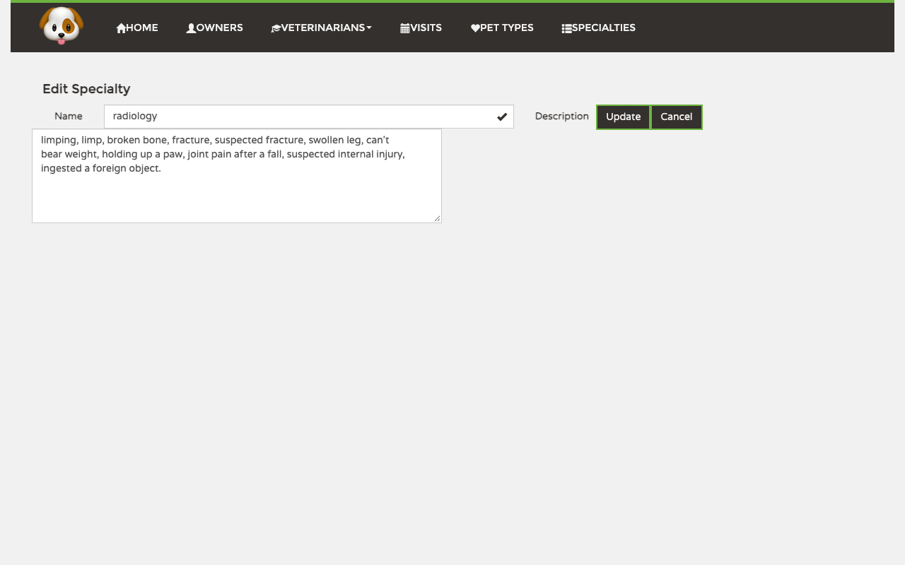
Click Edit beside a specialty. Update its name or the description of symptoms associated with it, then click Update. Click Cancel to return to the list without saving.

