PetClinic – Installation Guide
How to run the application on a developer machine

1. What you are installing
PetClinic manages the daily work of a veterinary clinic: owners, their pets, vets and visits. It has four runtime components, launched from three terminals:
Component | Port | Technology
Database | 5432, 15432 | Embedded PostgreSQL
Backend (REST API) | 8080 | Spring Boot 3.5, Java 21
Notification service | 8090 | Spring Boot 3.5; started by ./start-backend.sh
Frontend (web UI) | 4200 | Angular 16

2. Prerequisites
- Java 21 (JDK)
- Maven 3.9 or newer
- Node.js 22 with npm
- Git
- Ports 5432, 15432, 8080, 8090 and 4200 free on localhost

3. Installation steps
- Get the code
git clone https://github.com/victorrentea/petclinic.git
cd petclinic
- Install the frontend dependencies (only the first time)
cd petclinic-frontend && npm install && cd ..
- Start the database in a first terminal:
./start-database.sh
Warning: this script wipes the previous data on every start. The backend then reloads the demo dataset.
- Start the backend in a second terminal:
./start-backend.sh
Wait until the terminal prints the line below — never for a fixed number of seconds:
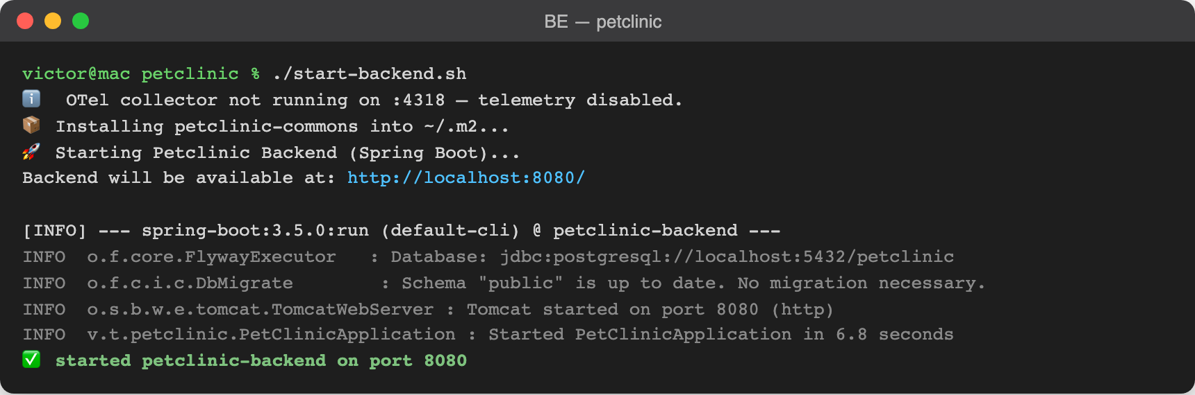
Figure 1 – The backend is ready
- Start the frontend in a third terminal:
./start-frontend.sh

4. Check that it works
- Open the application at http://localhost:4200 – the Welcome page appears.
- Browse the REST API at http://localhost:8080/swagger-ui.html.
- Open Owners › All: the demo owners are listed (e.g. Kevin McCallister).

5. Troubleshooting
- "Port … is already in use": a previous run is still alive. The script prints the PID holding the port; stop that process, then run the script again.
- Backend fails to connect to the database: make sure step 3 is still running before starting step 4.

