NETWORK INTRUSION INVESTIGATION REPORT
FormBook Information-Stealer Infection Host DESKTOP-5NLV63K

Classification | Internal Use — Training Exercise (Malware-Traffic-Analysis.net, 2026-08-09 “First to Last”)
Analyst | Ayobola
Report date | 24 August 2026
Incident type | Malware infection / Command-and-Control (C2) beaconing
Severity | High
Status | Confirmed — containment recommended
Evidence source | Full packet capture (pcap), 22,473 packets; IDS alerts
Tools used | Wireshark, VirusTotal, MITRE ATT&CK

1. Executive Summary
On 9 August 2026, intrusion-detection alerts flagged repeated FormBook command-and-control (C2) check-ins originating from inside the FIRSTTOLAST (firsttolast.tech) corporate network. Analysis of the corresponding packet capture confirmed the alerts as a true-positive malware infection.
A single internal workstation DESKTOP-5NLV63K (172.16.8.49), used by the account “rvance” was found to be infected with FormBook, an information-stealing malware family. Between 02:13 and 02:16 UTC the host repeatedly contacted at least six external C2 servers, uploading data using HTTP POST requests to short, randomised URL paths behaviour characteristic of FormBook.
No malicious payload download was observed in the captured HTTP traffic; the host was already infected and actively beaconing at the start of the capture, indicating initial delivery occurred earlier via an encrypted channel or email not present in the capture.
Recommended immediate actions: isolate the host from the network, reset the credentials for user rvance, block the six identified C2 addresses at the perimeter, and reimage the machine.

2. Affected Asset
The infected host was identified by correlating the internal address seen communicating with the alerted C2 servers, then confirming its identity from DHCP and Kerberos traffic.
Attribute | Value
IP address | 172.16.8.49
MAC address | 00:12:f0:28:d4:34 (Intel)
Host name | DESKTOP-5NLV63K
Windows user account | rvance
Domain | firsttolast.tech (FIRSTTOLAST)
Malware family | FormBook (information stealer / form grabber)

3. Timeline of Events
All times are UTC. The packet capture began at 02:07:32 UTC; relative capture times are mapped to wall-clock below.
Time (UTC) | Event
02:07:32 | Packet capture begins. Host DESKTOP-5NLV63K (172.16.8.49) obtains its IP lease via DHCP.
~02:08 | User “rvance” authenticates to the domain controller via Kerberos (AS-REQ / TGS exchanges).
~02:12 | Legitimate Windows Update / Microsoft Defender traffic observed (benign — see Section 5).
02:13 | First FormBook C2 check-in: HTTP POST /ujvq/ to 172.64.155.76.
02:13 – 02:16+ | Host beacons to six C2 servers in succession, using POST requests to randomised paths (/ujvq/, /irpw/, /lqjm/, /8nw8/).
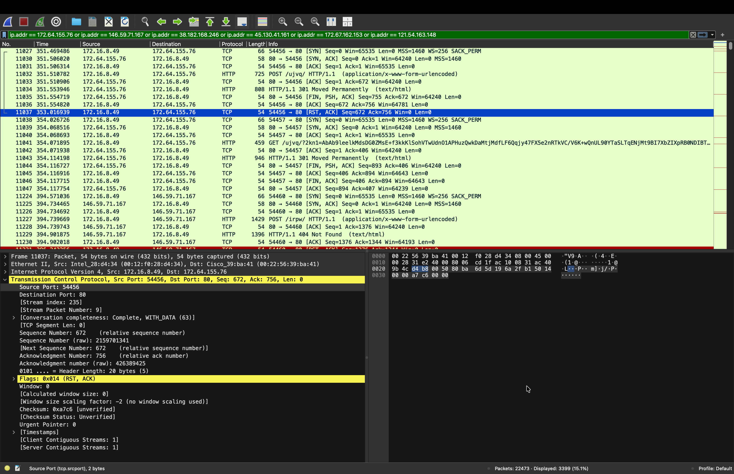
Figure 1 Host 172.16.8.49 beaconing to FormBook C2 servers. Note the repeated HTTP POST (application/x-www-form-urlencoded) requests to randomised paths.

4. Host Identification Evidence
The host name and logged-in user were recovered from Active Directory (Kerberos) authentication traffic. The computer account ends in “$”; the user account does not.
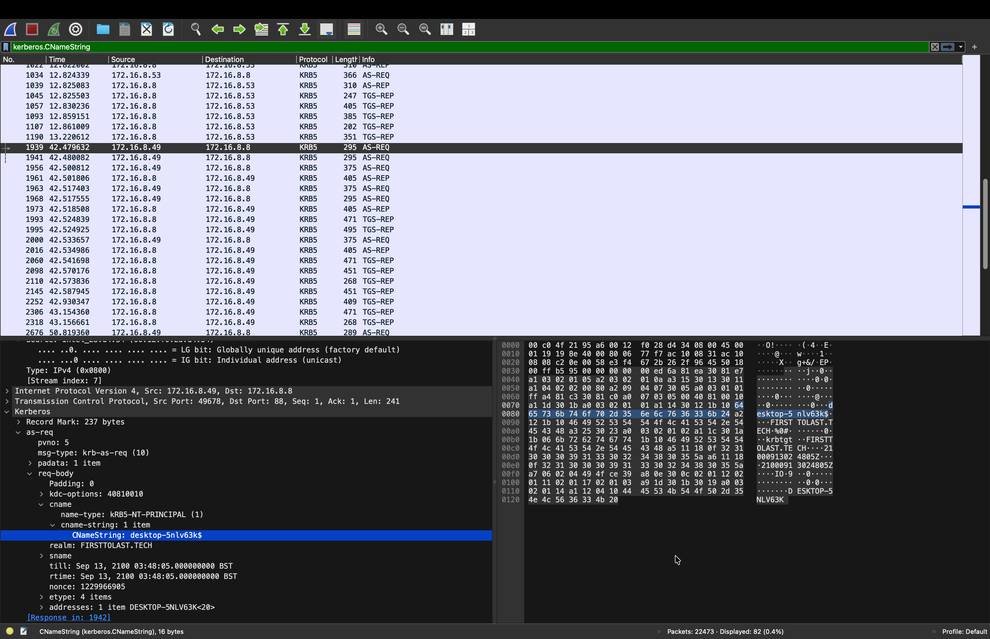
Figure 2 Kerberos AS-REQ revealing the computer account CNameString “desktop-5nlv63k$” and realm FIRSTTOLAST.TECH.
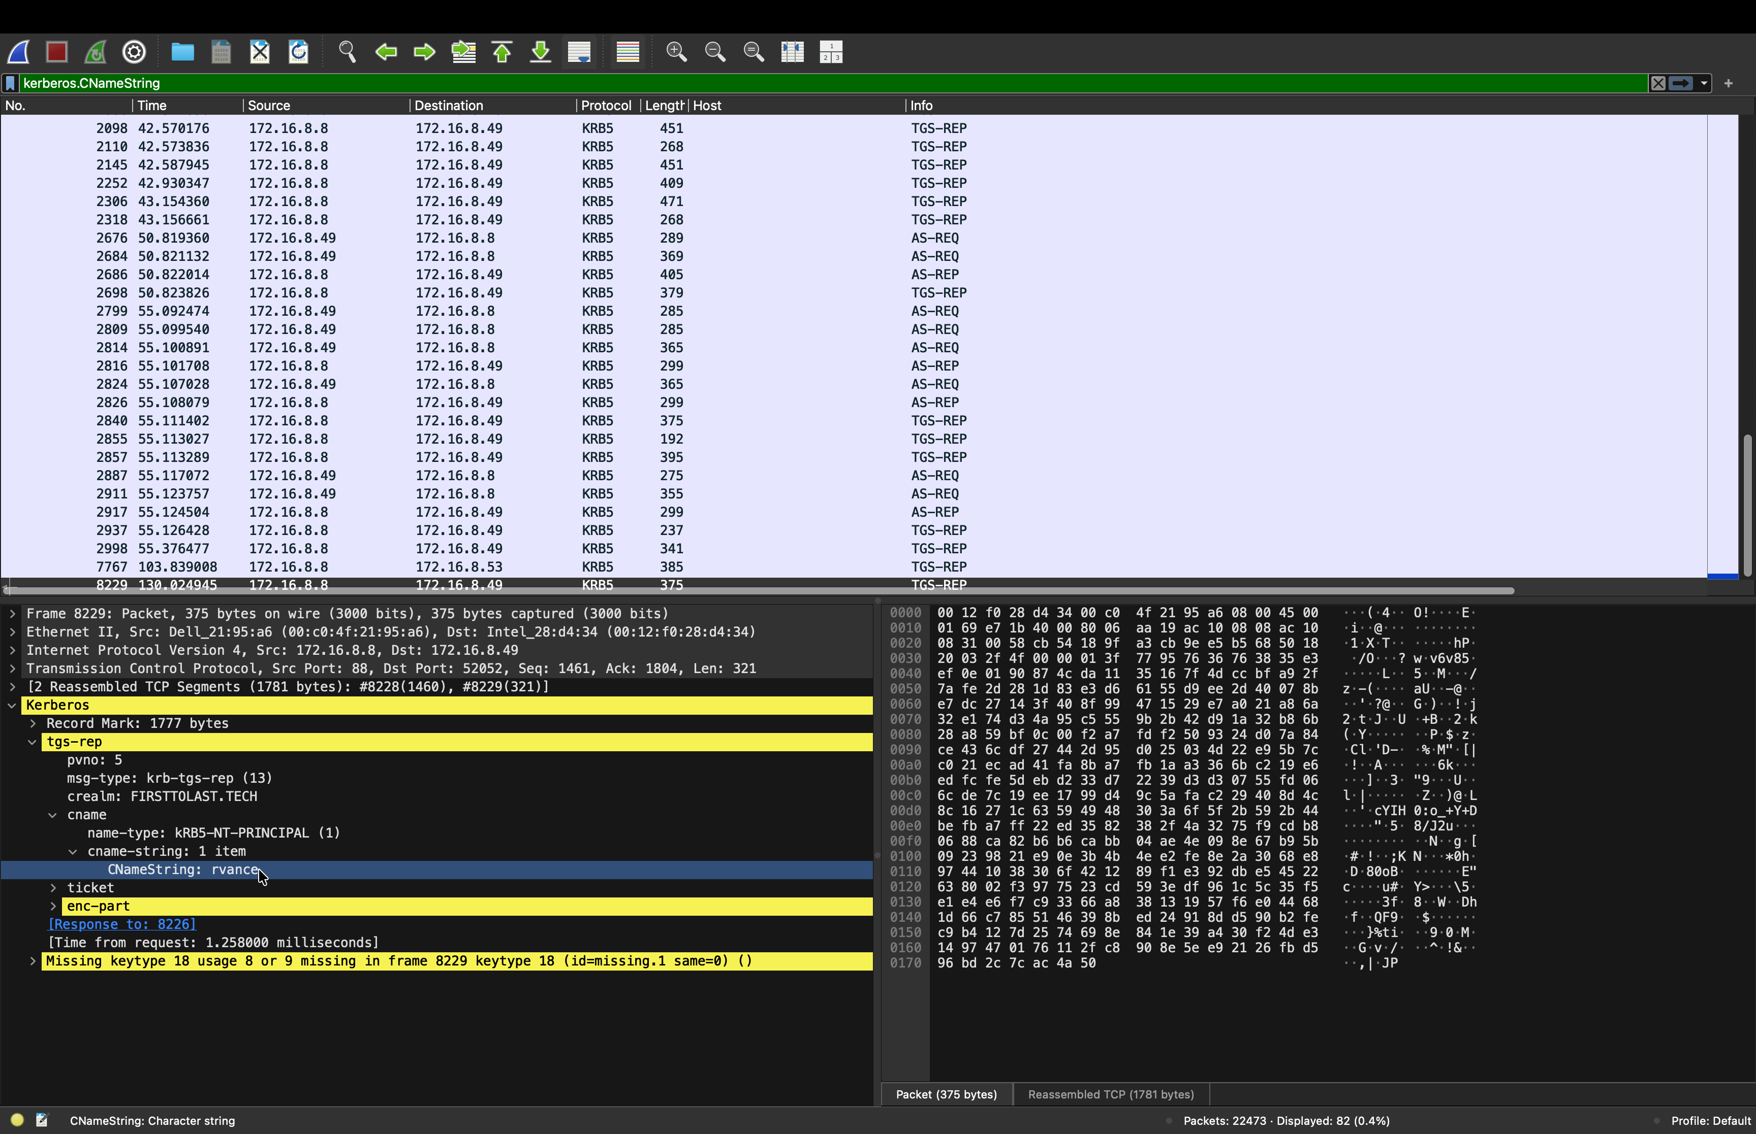
Figure 3 Kerberos exchange revealing the user account CNameString “rvance” (no trailing “$”), confirming the logged-in user.

5. Indicators of Compromise (IOCs)
The following external addresses were confirmed as FormBook C2 servers by the IDS signature and the observed beaconing behaviour.
C2 IP address | Hosting (ASN) | Observed URI path
172.64.155.76 | Cloudflare (AS13335) | POST /ujvq/
146.59.71.167 | OVH SAS (AS16276) | POST /irpw/
38.182.168.246 | — | POST /lqjm/
45.130.41.161 | — | POST /8nw8/
172.67.162.153 | Cloudflare (AS13335) | (FormBook C2)
121.54.163.148 | — | (FormBook C2)
Additional indicators:
- Malware family: FormBook (information stealer).
- C2 method: HTTP POST, Content-Type application/x-www-form-urlencoded, to short randomised URL paths.
- Domain / environment: firsttolast.tech (FIRSTTOLAST).

5.1 Reputation analysis and a key limitation
Each C2 address was checked against VirusTotal. Notably, reputation scores were low or clean — an important reminder that reputation tools lag behind live threats and are bypassed when attackers host C2 behind legitimate infrastructure (e.g. Cloudflare, OVH). The definitive evidence of malicious activity in this incident was the IDS FormBook signature and the observed beaconing behaviour, not IP reputation.
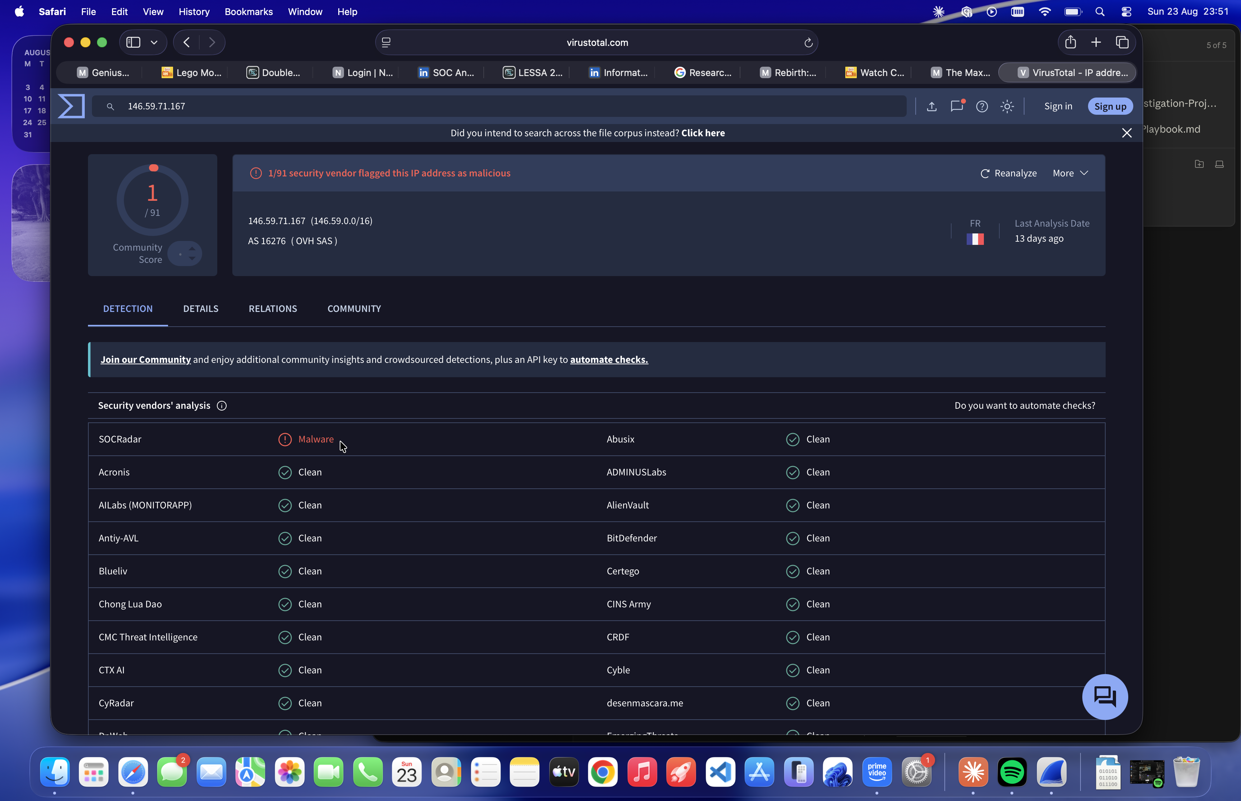
Figure 4 — 146.59.71.167 (OVH). One specialist vendor (SOCRadar) flags the address as Malware, consistent with the C2 role.
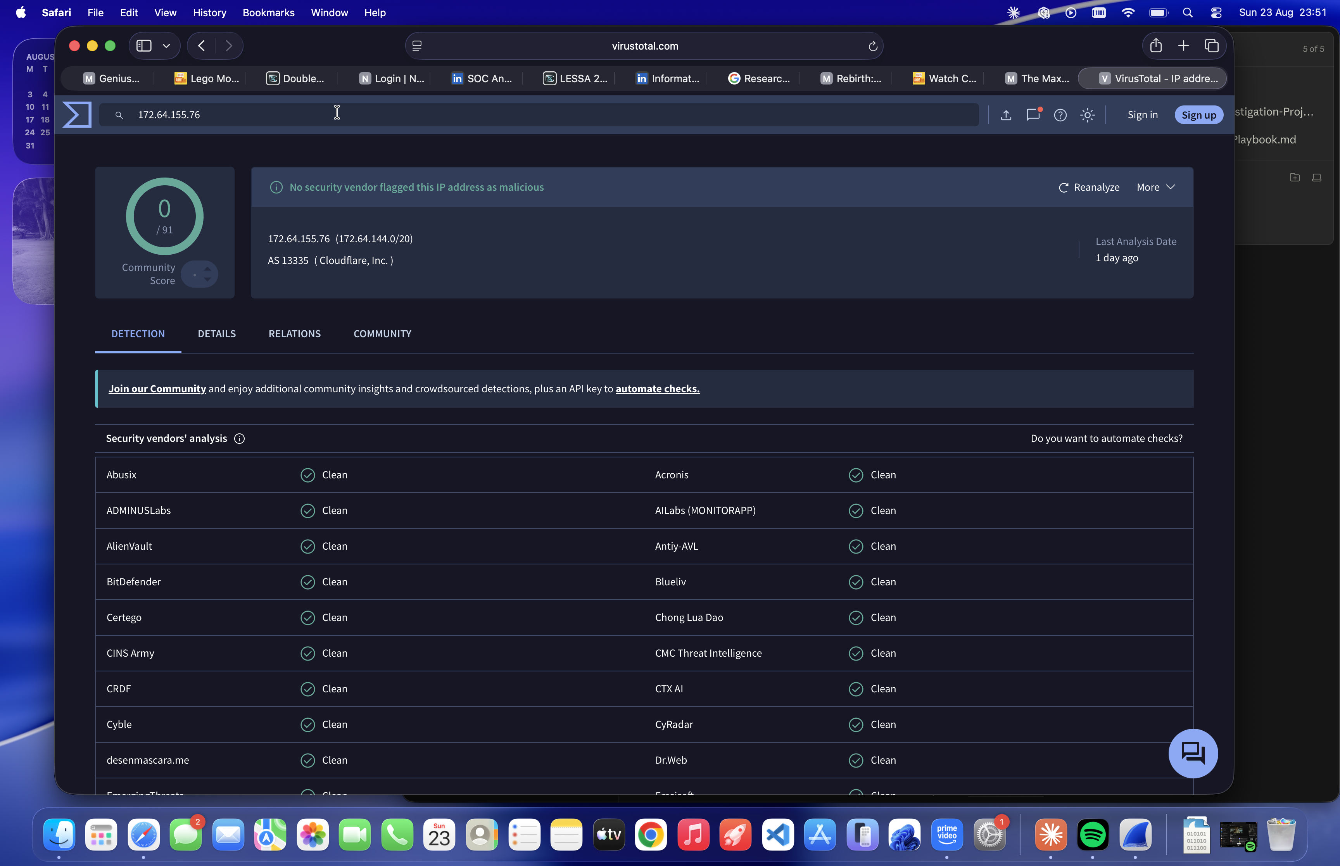
Figure 5 172.64.155.76 (Cloudflare) returns 0/91 detections. A clean score does not indicate innocence it reflects reputation lag and C2 hosted behind trusted infrastructure.

6. Traffic Reviewed and Ruled Out
During analysis, an executable download and several other external connections were examined and determined to be benign. This demonstrates the analytical step of distinguishing malicious from legitimate activity rather than flagging every download.
- am_delta_patch_...exe (from a Windows Update CDN, host 173.46.81.201): legitimate Microsoft Defender signature update. Confirmed benign — see Figure 6.
- disallowedcertstl.cab / pinrulesstl.cab (Host: ctldl.windowsupdate.com): legitimate Windows certificate-trust-list updates.
- connecttest.txt requests: standard Windows internet-connectivity checks.
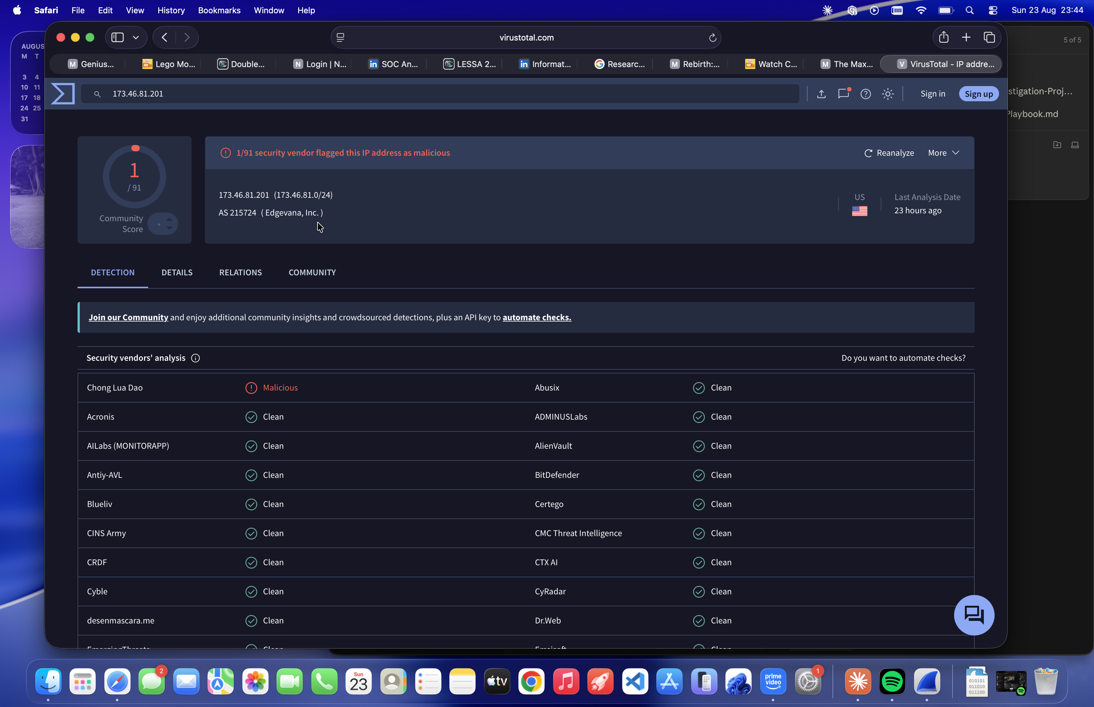
Figure 6 173.46.81.201 (Windows Update CDN, Edgevana). Effectively clean (1/91 — a single false-positive) and serving a Microsoft Defender update; ruled out as benign.

7. MITRE ATT&CK Mapping
Tactic | Technique (ID) | Evidence in this incident
Command and Control | T1071.001 Application Layer Protocol: Web Protocols | FormBook C2 check-ins over HTTP (port 80) to six servers.
Command and Control | T1104 Multi-Stage Channels | Host cycles through multiple C2 servers in sequence (“first to last”).
Exfiltration | T1041 Exfiltration Over C2 Channel | Data uploaded to C2 via HTTP POST (form-urlencoded).
Collection / Credential Access | T1056.001 (Keylogging), T1555 (Credentials from Password Stores) | Known FormBook capabilities, consistent with the observed C2 activity.
Note: the last row reflects documented FormBook capabilities consistent with the C2 traffic observed; keystroke or credential theft was not directly visible in the encrypted C2 payloads.

8. Recommendations
- Isolate host DESKTOP-5NLV63K (172.16.8.49) from the network immediately to stop ongoing C2 communication and data exfiltration.
- Reset the credentials for user rvance and any other accounts used from this host; FormBook harvests stored and typed credentials.
- Block the six identified C2 IP addresses at the firewall / web proxy.
- Reimage the machine. FormBook cannot be reliably removed in place; a clean rebuild is the safe remediation.
- Review authentication and proxy logs for the exposure window (02:13 UTC onward) to assess what data or credentials may have been exfiltrated.
- Hunt for the same IOCs across other hosts to confirm the infection is contained to a single machine.

9. Conclusion
The IDS alerts were confirmed as a genuine FormBook infection on a single internal workstation, DESKTOP-5NLV63K (172.16.8.49), used by rvance. The host was actively beaconing to six external C2 servers and should be treated as compromised. The evidence chain IDS signature, observed HTTP POST beaconing, host identification via DHCP/Kerberos, and reputation cross-checks supports a High-severity classification and the containment actions above.

Prepared as a hands-on blue-team / SOC analysis exercise using publicly available training data from Malware-Traffic-Analysis.net (2026-08-09, “First to Last”). All host names, user names, and addresses are from the training scenario.

