Abstract

Inflation has been a persistent economic challenge in many African countries, significantly impacting household welfare, economic stability, and food security. This study conducts an in-depth comparative analysis of inflation in Nigeria, Mali, Guinea-Bissau, Gambia, Liberia, Chad, and Cameroon from 2007 to 2022, utilizing data on GDP and population. By examining the interplay between these variables, the study aims to uncover the underlying drivers of inflation and assess their relative impacts across different national contexts. Data from international databases such as the World Bank, IMF, and national statistical offices were meticulously analyzed. The findings revealed some interesting insights on inflation trends. The study is focused on understanding inflation trends, it’s relationship with stock market price, and GDP for the seven selected Africa countries between 2008 and 2022. The study shows a massive impact of market stock price on inflation. Increase in price leads to increase inflation on a nation. Also, there is a positive correlation between these parameters.

Primary Objective

The primary objectives of this research are to:

1. Analyze the trends in inflation across the selected countries over the specified period.

2. Investigate the relationship between inflation, market stock price, GDP growth, and population changes.

3. Provide evidence-based recommendations for policymakers to address food inflation and enhance food security.

Understanding the dynamics of inflation is important for formulating effective economic policies that can mitigate its adverse effects. This research aims to fill the gap in comparative studies on inflation in Africa by providing a detailed analysis that considers both economic and demographic factors.

Data Collection

Data collection is a critical component of this research, ensuring that the analysis is based on reliable and comprehensive information.

Inflation Data Collection

Inflation dataset was sourced from international sources such as world bank data. The parameters in the dataset include stock market open price rate, closing price rate, high price, low price and Inflation collected in a monthly basis. Open-source platforms such as the Kaggle provided additional data to cross-verify national statistics and fill any gaps.

GDP Data Collection

GDP data were collected from the World Bank and IMF databases, providing both nominal and real GDP figures. These figures are essential for understanding the overall economic performance and its relationship with economic inflation of a nation.

Population Data:

Knowing whether increase or decrease in population can have any significant on a country's national inflation rate is paramount to this analysis, and the dataset was hereby gotten from world bank on the selected country’s percentage population growth rate.

Challenges and Solutions

1. Discrepancies in data reporting across different sources were addressed by cross-referencing and validating with multiple data points.

2. Gaps in data availability for certain years or indicators were managed through interpolation methods and the use of proxy indicators.

The reliability and validity of the data were ensured through rigorous cross-referencing and validation processes, making the analysis robust and credible.

Research Methodology

The research methodology combines quantitative and qualitative approaches to provide a comprehensive analysis of inflation trends and their determinants.

Quantitative Analysis

Statistical Techniques

Descriptive Statistics: Initial analysis involved descriptive statistics to summarize the data and provide an overview of inflation trends, GDP growth, and population changes in each country.

Key Findings

- Inflation Distribution by Countries

- Inflation Trend in Nigeria compared to other Countries

Note: This visual is an interactive one. It will be helpful in filtering the countries to compare inflation of other countries with Nigeria

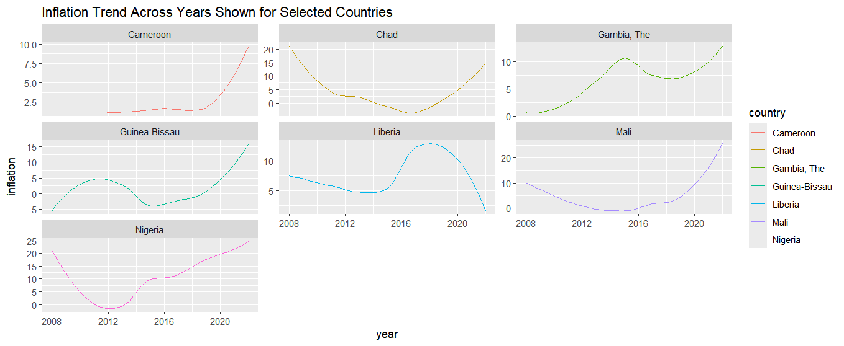

Correlation Analysis

Correlation analysis was used to explore the relationships between inflation and market stock price fluctuation.

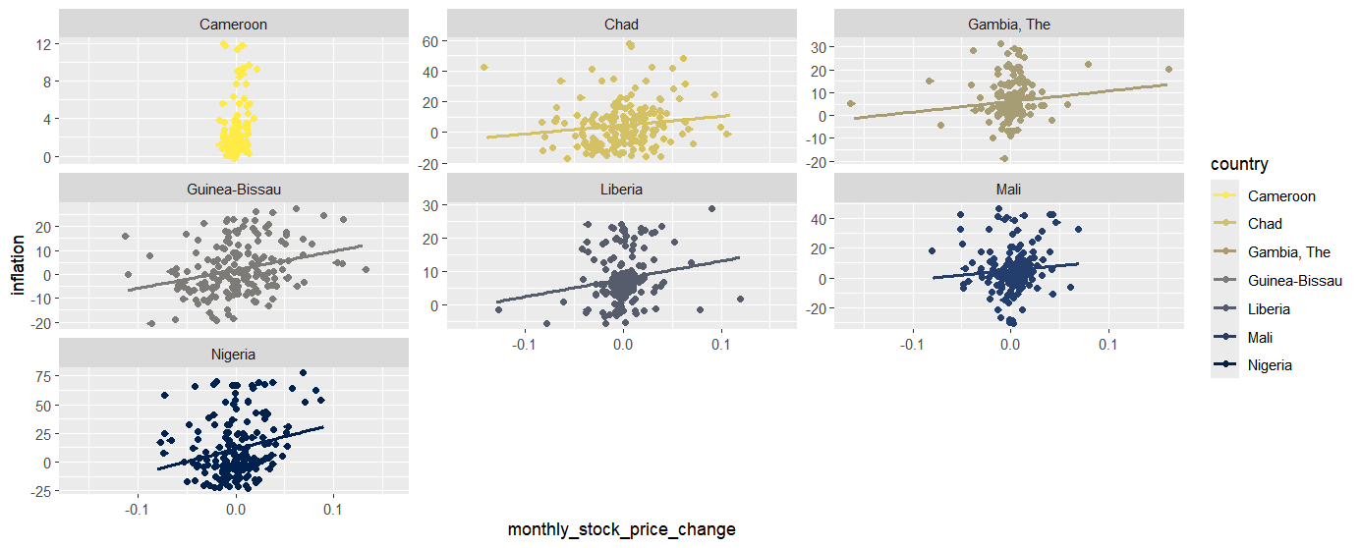

Inferential Statistics

Conducted sample t-test to test for the significant impact of market stock price change on inflation. The correlation analysis infers that the two variables (inflation and market stock price change) progress in the same direction, which means as market stock price increases on monthly basis, inflation increase. This does not mean that the there is significant impact between the two variables. To further confirm this hypothesis (There is no significant impact of market stock price on inflation), a statistical test was conducted.

Findings:

Implication

With p value (0.000000009917) less than alpha (0.05), we can reject the null hypothesis and infer that market stock price have a significant impact on inflation across different countries, within specified period.

Further Analysis

Further analysis entails analysis on other parameters as it affects inflation. These other parameters include GDP – Gross Domestic Product which is a measure of economic performance of a country.

- Understanding GDP progression trend across different countries

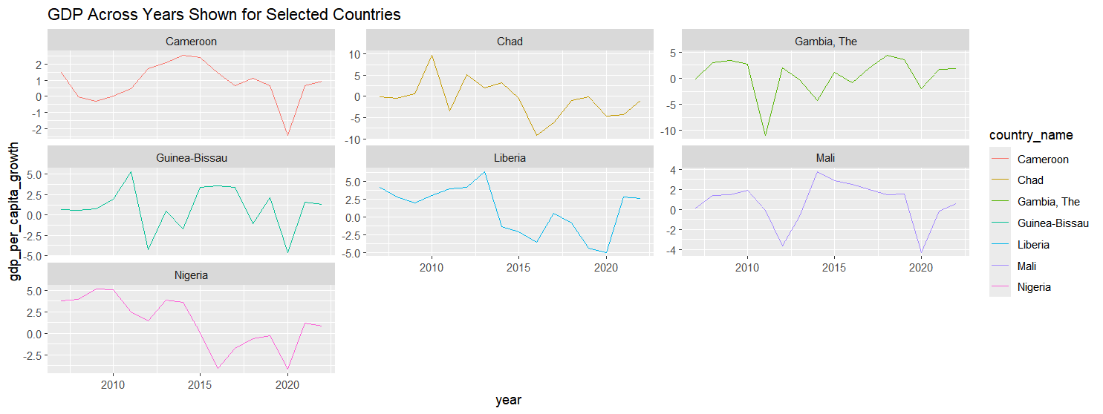

**Noticeable Trend:** There is a decrease in Nigeria GDP relative to increase in inflation across years. This raises more questions: When an economy experiences rapid GDP growth, it often leads to increased consumer and business spending thereby leading to inflation and vice versa? This can be studied utilizing correlation analysis and inferential statistics.

To further the analysis the correlation coefficient for Nigeria was calculated and it gave -0.6 correlation coefficient.

Inferential Statistics

At 95% confidence level, we reject the null hypothesis (there is no significant difference between GDP and Inflation) at p value less the 0.05 (alpha).

Conclusion: This entails that GDP might influence inflation both on positive and negative aspect.

Finally, another parameter (Population) was considered in terms of variables that can have impact on inflation.

- Understanding Population Growth Rate Across Countries

Mali and Chad have experienced the highest population growth rate across the years (annually), followed by Liberia, Cameroon, Gambia, before Nigeria.

- Understanding Growth Trend by Year

- Understanding Relationship Between Population Growth Rate and Inflation

For Nigeria, the correlation coefficient between percentage population growth rate and inflation is -0.09. This can mean that there is no impact of population growth on inflation.

Statistical Inference

With a p value of 0.362 which is greater than 0.05, we fail to reject the null hypothesis (there is no significant impact of population on inflation), and actually, there is no significant impact of population growth rate on inflation.

References

1. World Bank. (2023). World Development Indicators. Retrieved from [World Bank](https://databank.worldbank.org/source/world-development-indicators).

This source provides comprehensive data on GDP, population, and other economic indicators for various countries.

2. International Monetary Fund (IMF, 2023). World Economic Outlook Database. Retrieved from [IMF](https://www.imf.org/en/Publications/WEO)

The IMF database offers detailed economic data, including GDP and inflation rates, useful for macroeconomic analysis.

3. Food and Agriculture Organization (FAO). (2023). FAOSTAT. Retrieved from [FAO](http://www.fao.org/faostat/en/#home)

FAOSTAT provides extensive data on food prices, agricultural production, and food security indicators.

4. United Nations. (2023). World Population Prospects. Retrieved from [UN](https://population.un.org/wpp/)

This source includes population estimates and projections, vital for understanding demographic trends.

5. Akpan, S. B., Patrick, I. V., & Udoka, S. J. (2013). Food inflation and its determinants in Nigeria: Agricultural and structural factors. Journal of Economics and Sustainable Development, 4(20), 136-150.

This paper discusses the determinants of food inflation in Nigeria, focusing on agricultural and structural factors.

6. Mensah, E., & Adu, G. (2013). The effect of demographic and economic variables on food inflation in Ghana. Applied Economics and Finance, 1(1), 13-21.

This study examines the impact of demographic and economic variables on food inflation in Ghana, offering insights applicable to other African countries.

7. Ngare, E., & Nyandemo, S. (2014). Regional integration and food security in Africa: A case study of COMESA. African Journal of Economic and Sustainable Development, 3(2), 148-163.

This paper explores the role of regional integration in enhancing food security in Africa, relevant for policy recommendations.

8. World Bank. (2019). Agriculture and food security in Africa: The role of innovation and technology. Retrieved from [World Bank](https://www.worldbank.org/en/region/afr/publication/agriculture-and-food-security-in-africa)

This report highlights the importance of innovation and technology in improving agricultural productivity and food security in Africa.

9. Zhou, Y., & Staatz, J. (2016). Projected demand and supply for various foods in West Africa: Implications for investments and policy. Food Policy, 61, 198-212.

This article provides projections for food demand and supply in West Africa, offering insights into future trends and policy needs.

10. United Nations Development Programme (UNDP). (2021). The impact of COVID-19 on food security and nutrition in Africa. Retrieved from [UNDP](https://www.africa.undp.org/content/rba/en/home/library/reports/the-impact-of-covid-19-on-food-security-and-nutrition-in-africa.html)

This report examines the effects of the COVID-19 pandemic on food security and nutrition in Africa, providing context for recent food inflation trends.