Crunch Time
Victor Vong (cs160-aap)
https://www.youtube.com/watch?v=31iuNZn2iXg



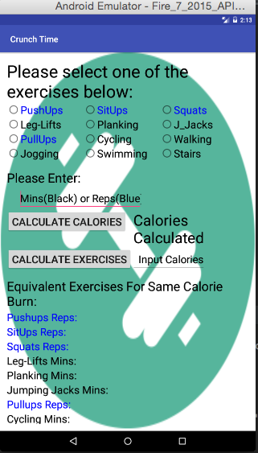

This is the opening screen. As you can see all 12 exercises are supported as radio selection buttons. There is a place for you to enter the amount of minutes or reps (labeled by color hint) for each exercise after select. Then there is a button to calculate calories burned and the proceeding result is to the right of the button. There is then a location to input calories you wish to burn and a calculate exercise button which will generate the list of equivalent calorie burning exercises at the bottom.

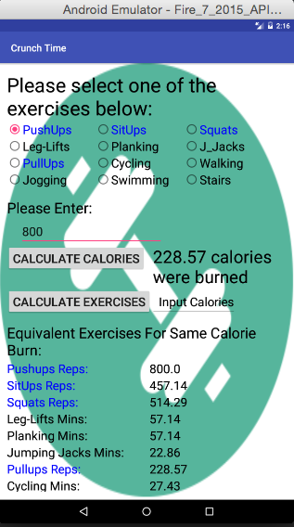

This is an example of when you select the Pushup exercise and type in 800 reps. The corresponding calorie burn is listed and at the bottom the equivalent exercise in reps or minutes is displayed for each and every exercise to achieve the same result.

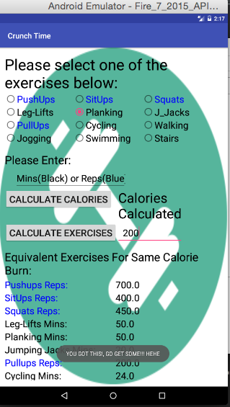

This is an a frame of using the calculate exercise button. Input was calories anyone wished to burn. When the button is clicked all 12 exercises below are listed along with their corresponding reps or minutes to achieve inputted calorie burn desire.

This is an image of a motivating message when more than 100 calories are burned or requested to be burned. (YOU GOT THIS!, GO GET SOME!!! HEHE)

