1. System Diagrams:
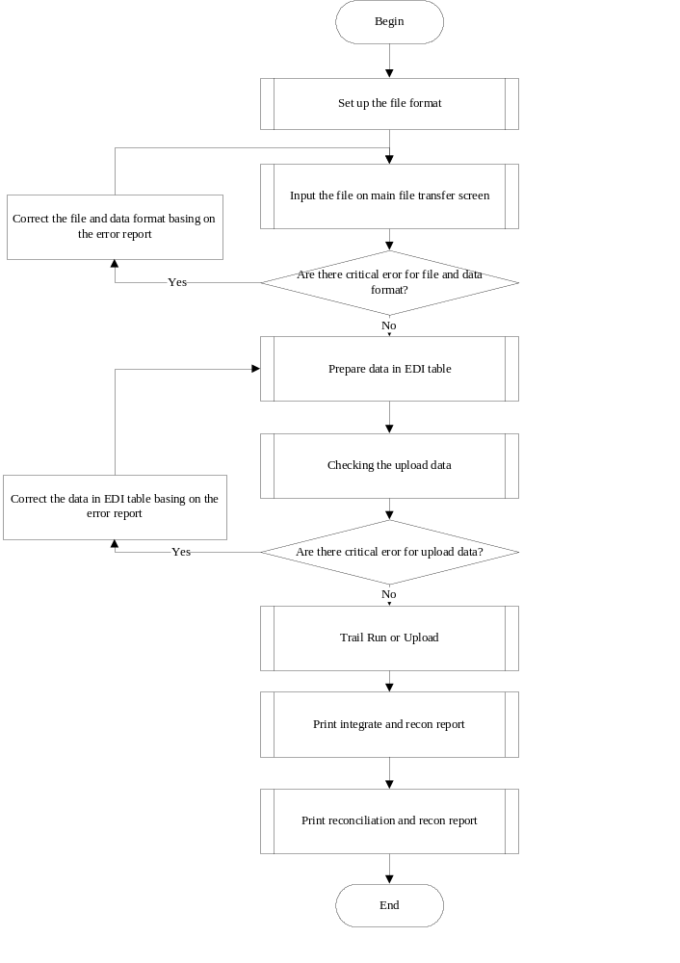
2. Member file Transfer screen (online: GHMEP021.APP)
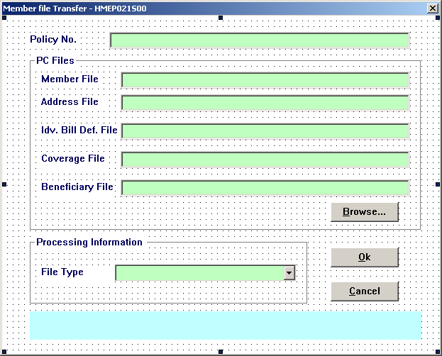
- For Idv. Bill Def. File field , only when the inputted the policy has individual product that bill type is ‘I’ or ‘V’, enable the field. Else, disable the field.
For the others, they will always be enable.
- When user upload coverage file for new and renewal type (file type = 1/2/3/4) and the policy has individual product but user hasn’t input individual definition, prompt warning message “This is a individual billing case, but you don’t have the individual billing definition file for uploading, continue? [Yes/No]”, if user select No, stop uploading.
- When click the [Ok] button, the five file fields can’t be null at same time.
- When click the [Ok] button and field is not null, below validation will be do:
  - If can’t open the file, prompt error message “Unable to open the XXXXXX File!”. And stop process and put focus on the field.
  - If the data has critical error, should prompt below error message:
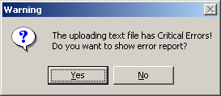
If user chooses “Yes”, program should show the control report and the control report title can show the “XXXXXX File Critical Error”.
If user chooses “No”, program should stop.
  - If the data only has warning message, program should prompt control report directly and the report should show “XXXXXX File Warning Error”. And the data can be insert EDI table.
- If all checking passes, data will be inserted in to table TMEMUPLEDIB/A/D/C/N.

3. EDI File Maintenance:
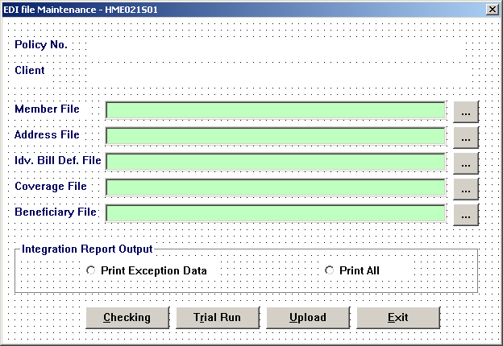
- The fields will show the upload file path and be non-edited.
- When click the detail button, user can enter the Member EDI file screen. The screen can show correct the file name, file path and correct data in TMEMUPLEDIB/A/D/C/N matching the client code, file type and operator ID.
- When edit the data in Member EDI file screen, the data can be saved into table TMEMUPLEDIB/A/D/C/N.
- When click the Checking button, system will check the data in TMEMUPLEDIB/A/D/C/N.
- All error messages will be inserted into TMEMUPLCHK. If there are critical error, set ErrorInd = ‘Y’. If there are warning error, set WarnInd = ‘Y’.
- If the ErrorInd = ‘Y’, prompt the error message:
If user chooses “Yes”, program should show the control report and the control report title can show as “XXXXXX File Critical Error”.
If user chooses “No”, program should stop.
- If the ErrorInd = ‘N’, system will enable the Trail Run and Upload button.
4. Trial Run and Upload (batch job: GHMEP022.APP)
Upload flow char:

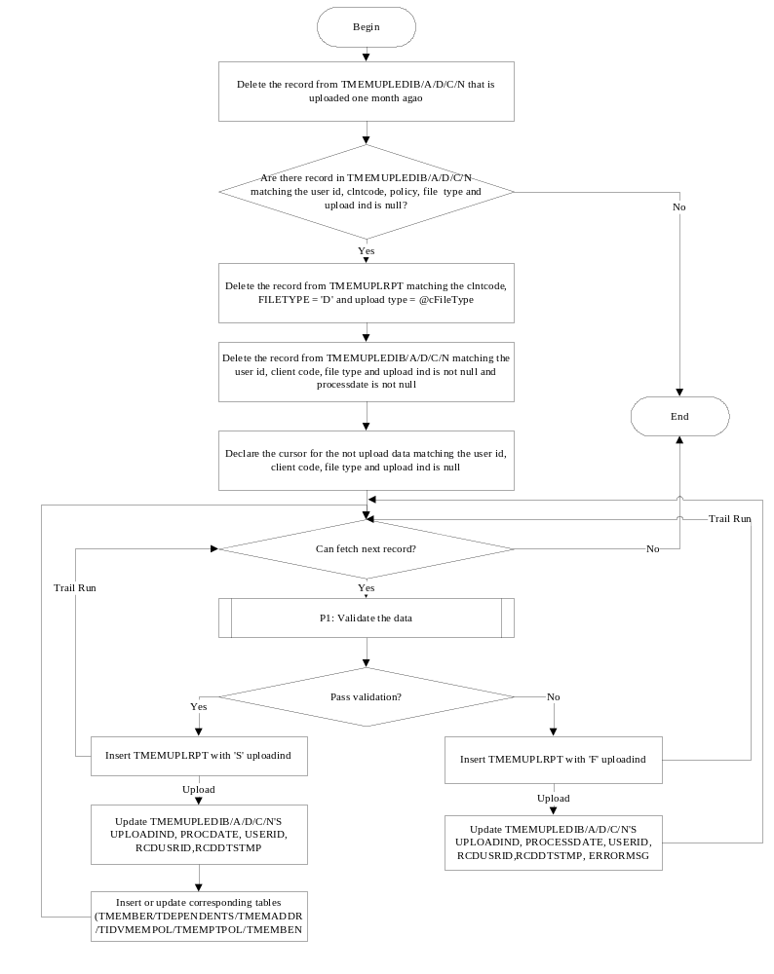5. Print integration report.
- The report can print the old value for changed record.
- When user chooses ‘Print Exception Data’ on the EDI file maintenance screen, the report only show the fail data (TMEMUPLRPT. UPLOADIND= ‘F’). When user chooses ‘Print All’, the report should show both successful and fail data.
6. Program and table relationship
Function | Key Program | Key tables
Online upload | GHMEP021.APP | TMEMUPLFMTN  TMEMUPLEDIB/A/C/D/N
Validation Checking | Basic file validation checking:  USP_GMEP052.sql  Address file validation checking:  USP_GMEP053.sql  Individual definition file validation checking:  UspGMES025ChkDefData.SQL  Coverage file validation checking:  USP_GMEP054.sql  Beneficiary validation checking:  USP_GMEP055.sql | TMEMUPLEDIB/A/C/D/N  TMEMUPLCHK
Batch job | GHMEB021Z.bat  GHMEP022.APP | TMEMUPLEDIB/A/C/D/N  TMEMUPLRPT
Upload programs | Basic file upload:  USP_MEMUPLBAS.SQL  USP_MEMUPLBASDEP.SQL  Address file upload: USP_MEMUPLADD.SQL  Individual definition file upload: UspGMES026UplDef.SQL  Coverage file upload:  USP_MEMUPLCOV.SQL  USP_MEMUPLCOVUPLOAD.SQL  Beneficiary file upload:  USP_MEMUPLBEN.SQL | TMEMUPLEDIB  TMEMBER  TDEPENDENT  TMEMUPLEDIA  TMEMADDR  TMEMUPLEDID  TIDVMEMPOL  TMEMUPLEDIC  TMEMPTPOL  TMEMUPLEDIN  TMEMBENY
Report template | Integration Report:  GHMEP02111.rpt  GHMEP02112.rpt  GHMEP02113.rpt  GHMEP02114.rpt  GHMEP02115.rpt  Un-enrolled Member Report:  GHMEP0212.rpt  Reconciliation Report:  GHMEP02131.rpt  GHMEP02132.rpt  GHMEP02133.rpt  GHMEP02134.rpt  GHMEP02135.rpt | TMEMUPLEDIB/A/C/D/N  TMEMUPLRPT

