2020

Víctor Ruiz

2/20/2020

CREATING AND INSTALL OUR PACKAGE



INDEX

CREATING A PACKAGE WITH NPM 3

# CREATING A PACKAGE WITH NPM

1. First step is to go to <https://www.npmjs.com/signup> and register

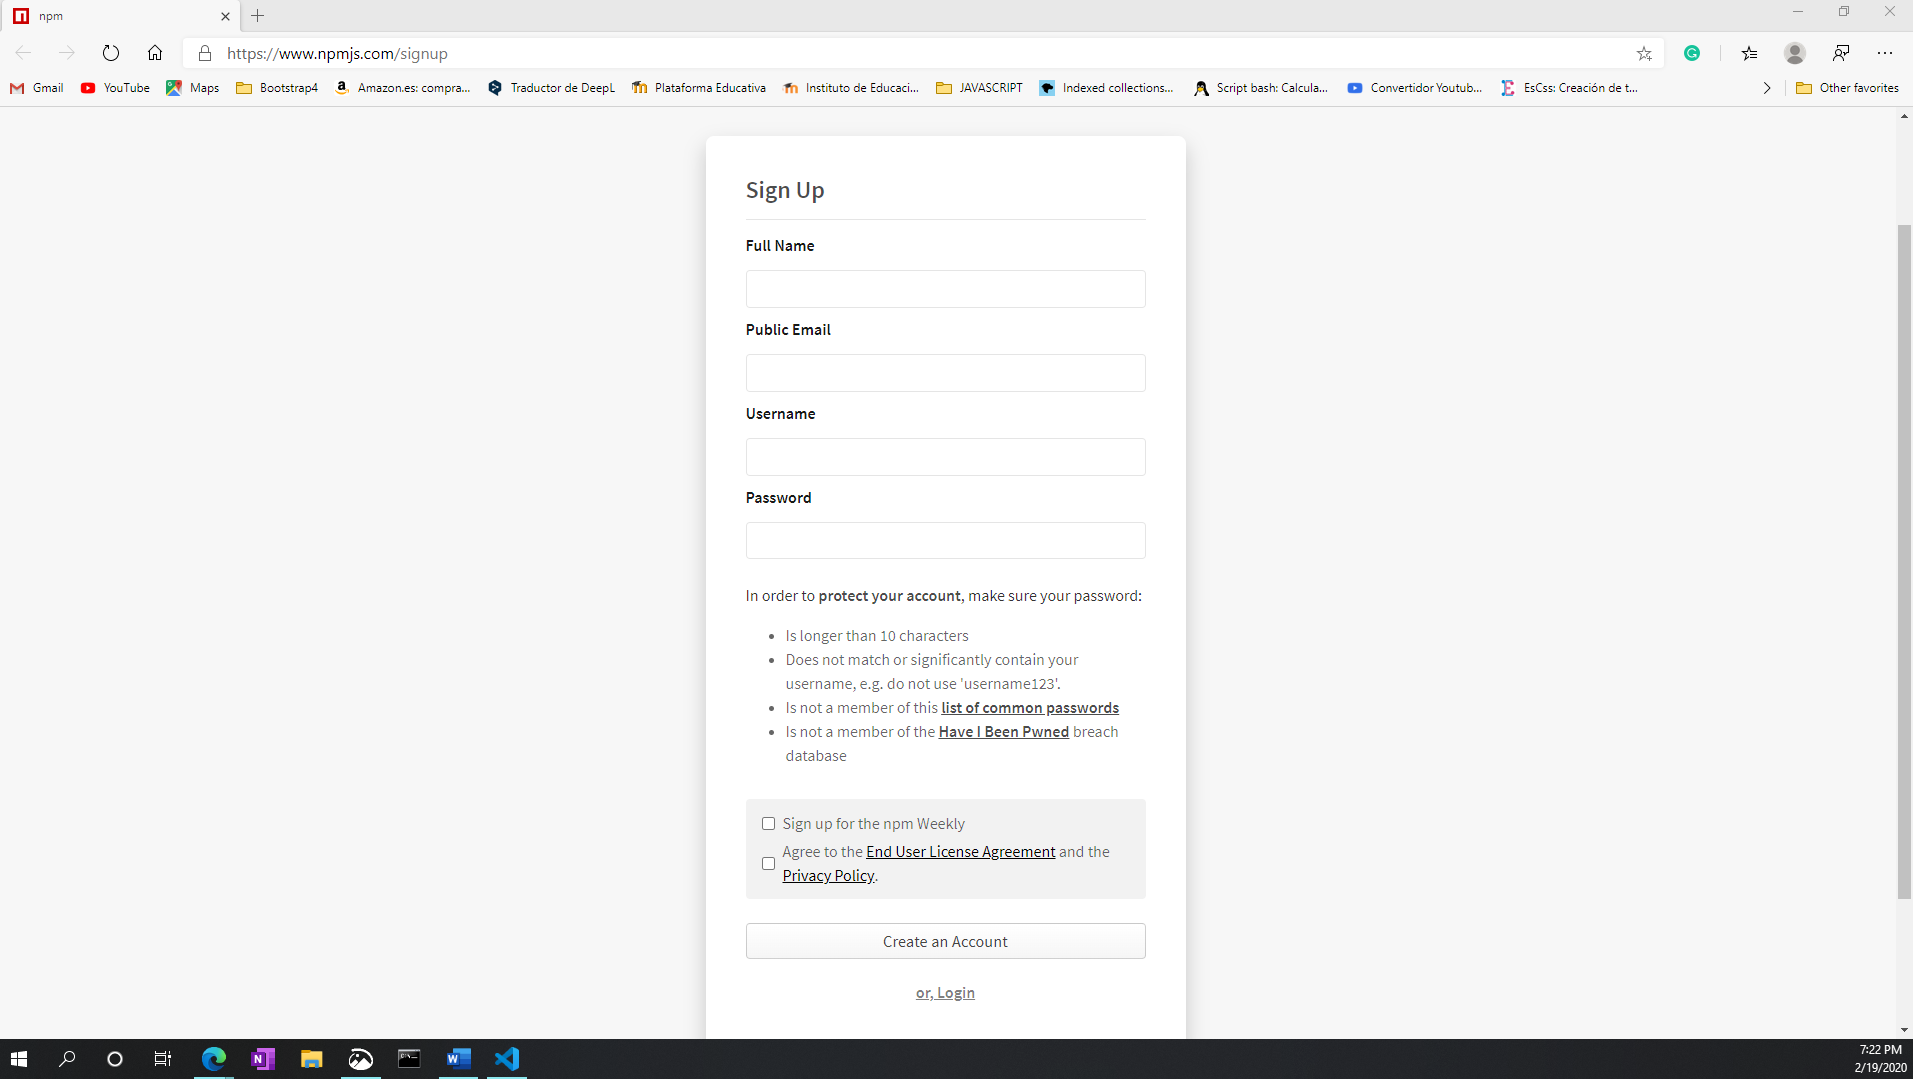

Image 1

1. Second step is to log in to cmd by opening cmd in the folder where we make the package and typing the command npm login. As we see in image 2 the result has to be logged in as victoruizr.

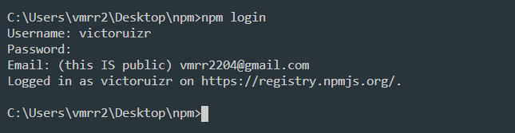

Image 2 Login in npm

1. Third step is to check if we have started correctly by using the npm whoami command. As we can see in image 3 the result that it has returned is the user name

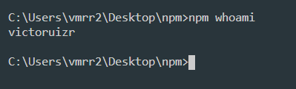

Image 3 Checking user logged

1. Fourth step is to start the package by using the npm init command. As we can see in the images 5,6,7,8 it will ask for the package name where we will put the one we want as long as we have checked that this name is not in npm, it asks for a description, the author of the package the entry point (by default). Next we see in the image 9 it will ask us if everything is ok, in this case yes.



Image 4 Inizializating a package

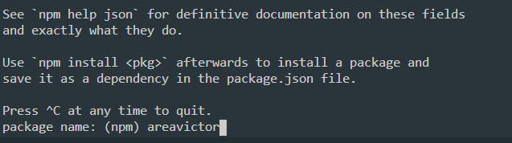

Image 5 Configurating a package

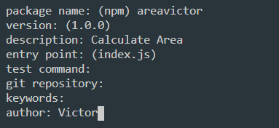

Image 6 Configurating a package

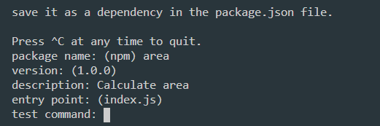

Image 7 Configurating a package

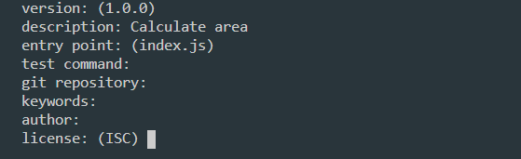

Image 8 Configurating a package

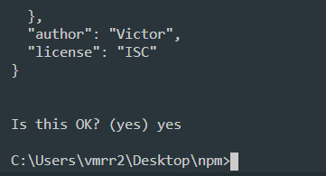

Image 9 Configurating a package

1. Fifth step is to see if the package.json generated by npm is correct.

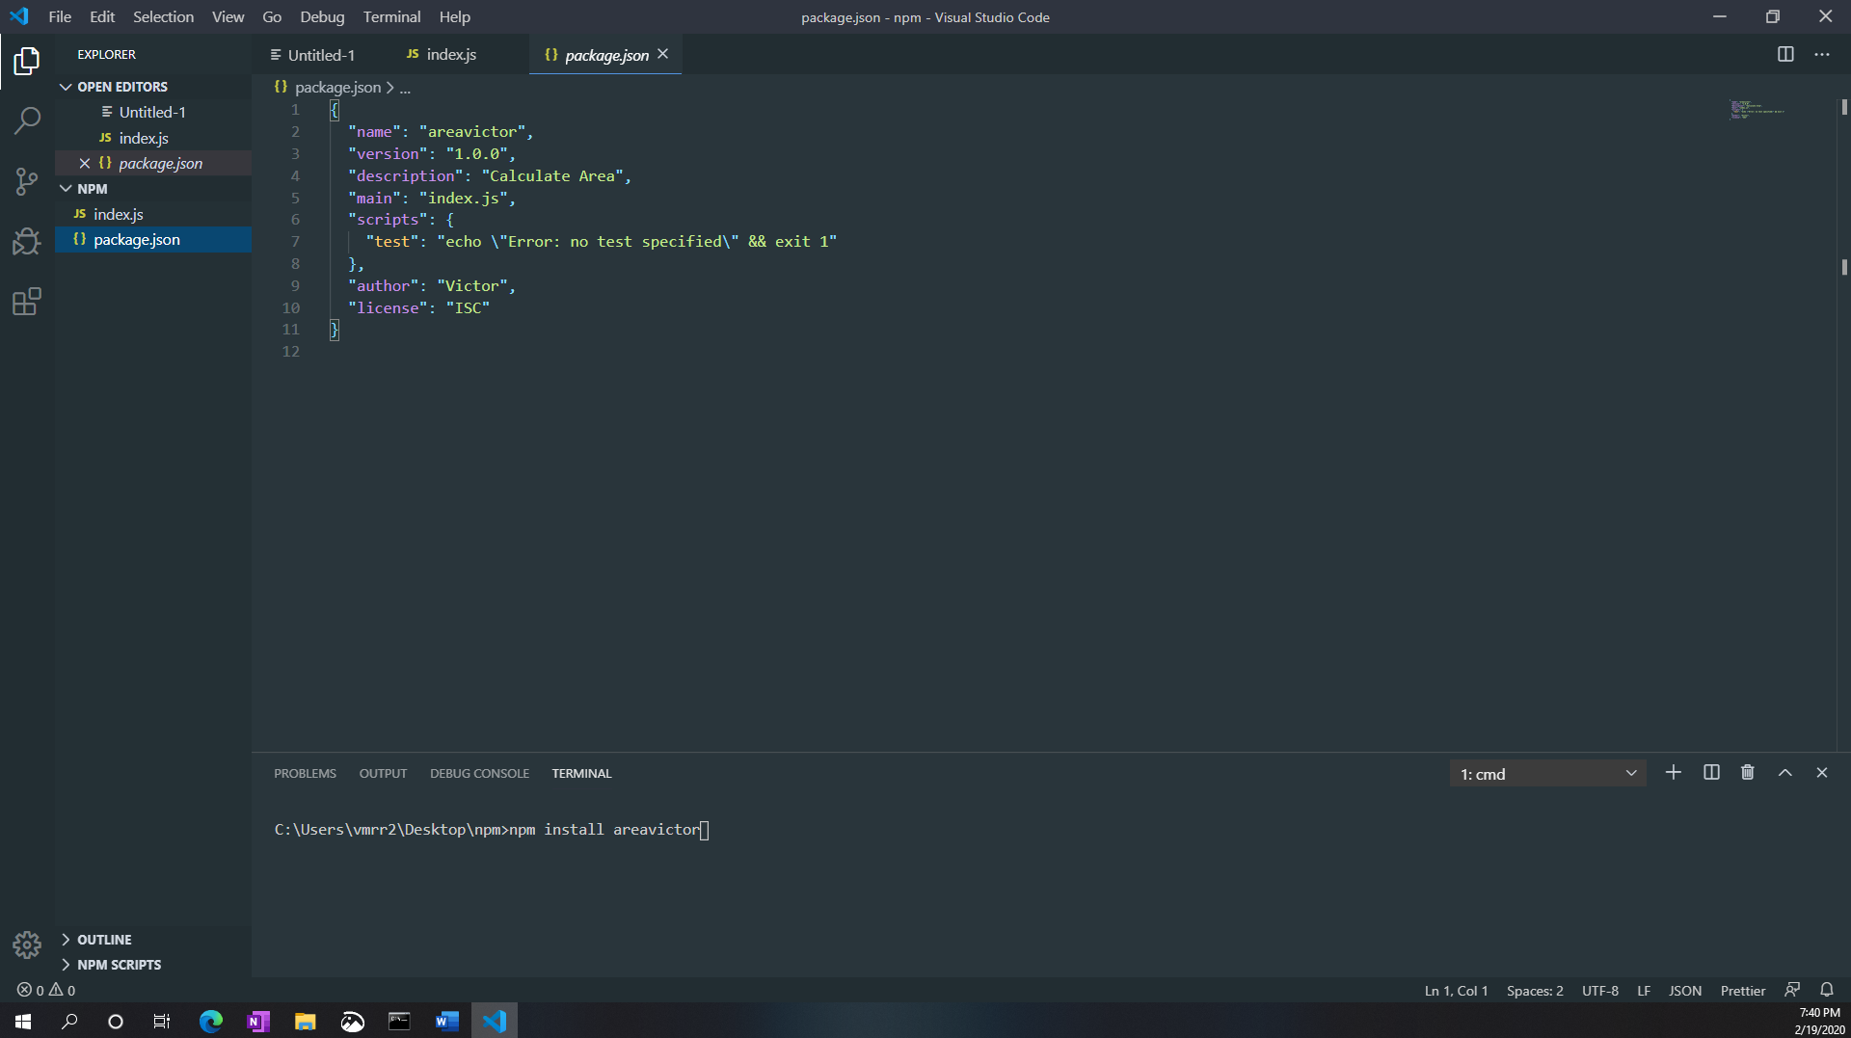

Image 10

1. Sixth step is to create a file index.js in the package folder and add the code we see in image 11

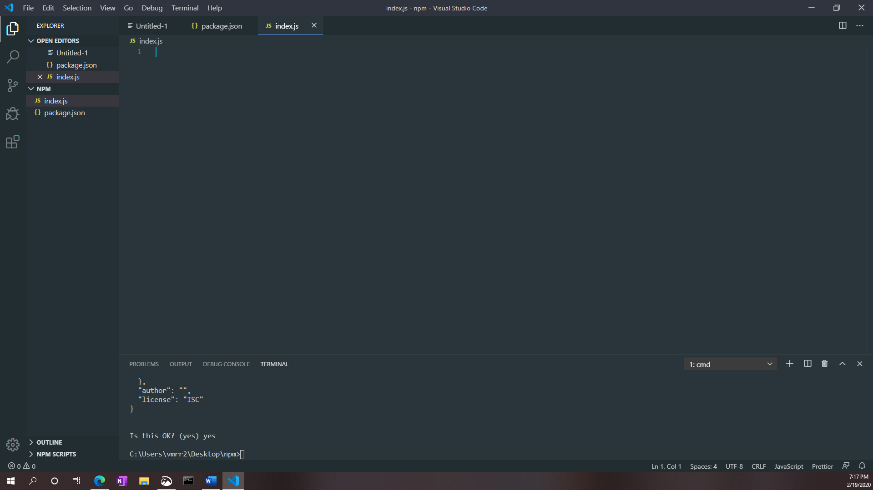

Image 11

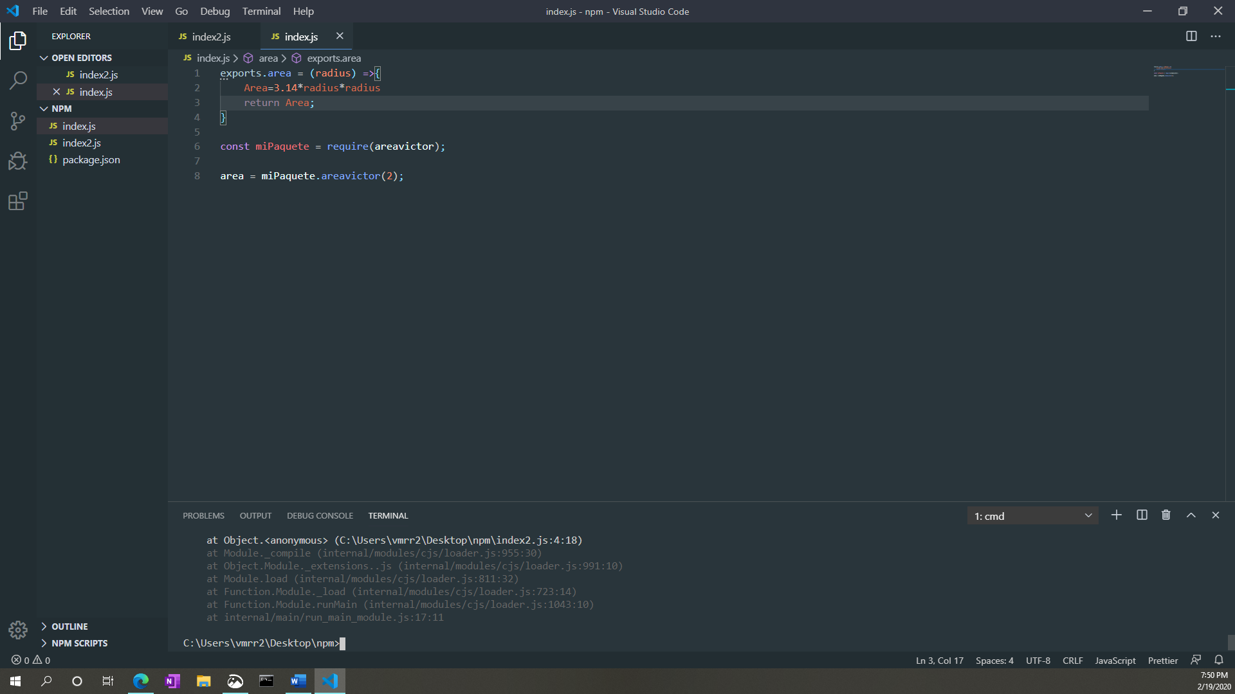

Image 12 Creating a functionality of package

1. Seventh step is to publish it. To do this we use the command npm publish. As we can see in image 15 the result has to be (+ package name), in case it gives us an error it's because of the name since it's being used in npm



Image 13

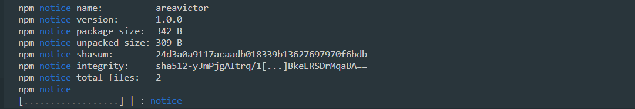

Image 14

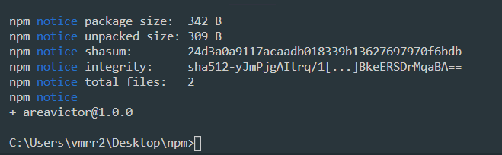

Image 15 Result of publish

1. Eighth step is to install our package by using the npm install "package name" command. The result of installing the package should be as shown in image 16

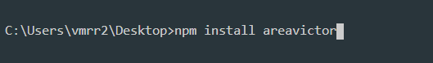

Image 16

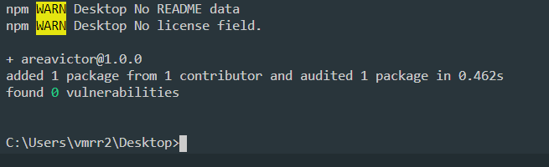

Image 17 Result of install package

1. Ninth step is to create a file index.js and add the content we see in image 17. This code does the following:

* Stores the variable areavictor in the package areavictor
* We store in the area variable the function of the package, in this case arevictor.area("number")
* Last command visualizes the result of the area you can see in the image 19

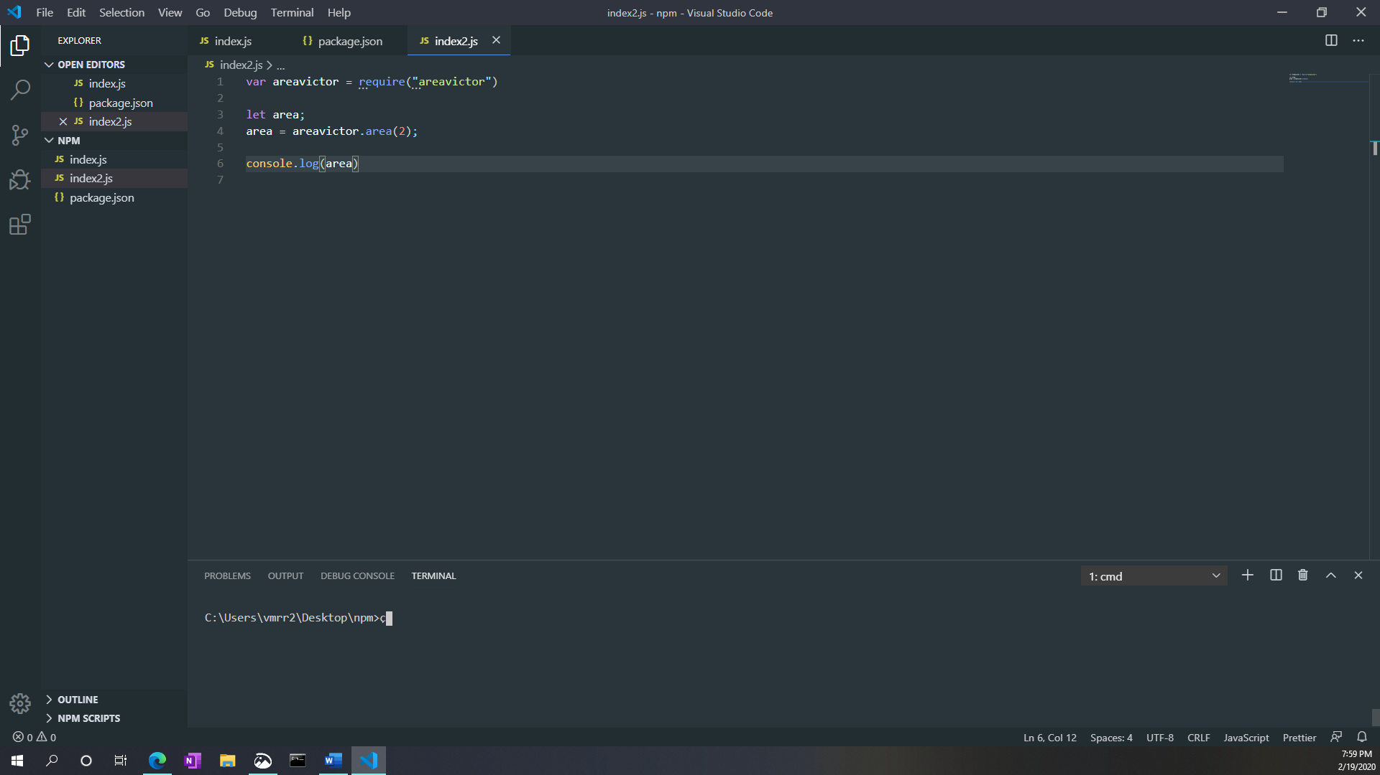

Image 18 Creating a program with my package

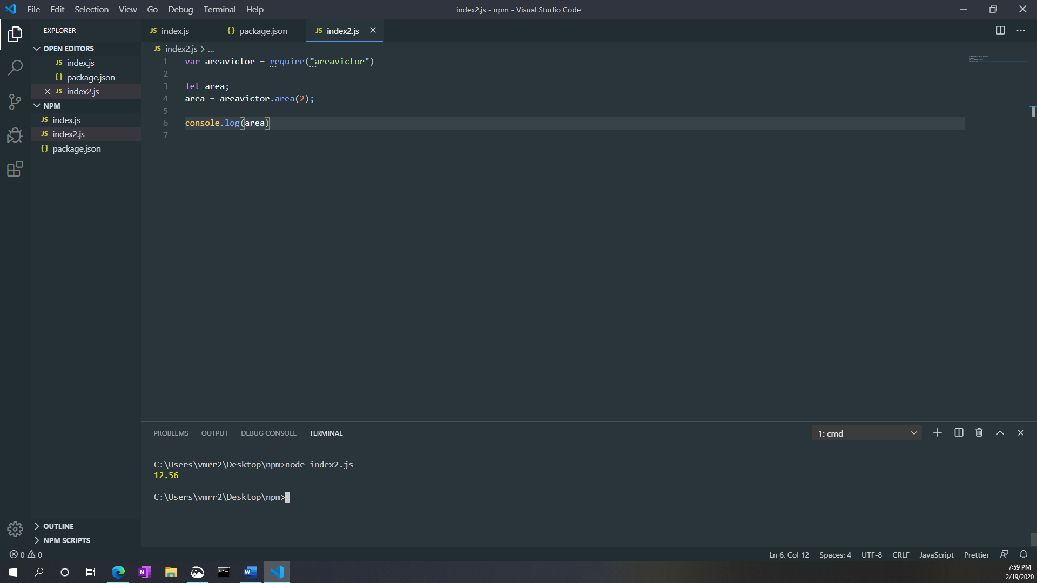

Image 19