ONLINE RETAIL SALES ANALYSIS
Project Documentation
1. Project Overview
• This project analyses sales data using Microsoft Excel and Power BI to identify sales trends and support better business decisions.
2. Tools Used
• Microsoft Excel
• Power BI
3. Dataset
• Source: UCI Machine Learning Repository – Online Retail II dataset.
• Data contains: Invoice number, stock code, product description, quantity, invoice date, unit price, customer ID, and country.
4. Steps Followed
• Cleaned and prepared the sales data.
• Removed duplicate and invalid sales records and handled missing product descriptions.
• Separated cancelled/return transactions from the main sales analysis.
• Created calculated fields such as Revenue, Year, Month, and Quarter.
• Performed basic analysis using Excel.
• Imported the cleaned dataset into Power BI.
• Created an interactive dashboard using KPIs, charts, and slicers.
5. Key Insights
• Quarter 4 recorded the highest revenue among the four quarters.
• The United Kingdom generated the highest revenue among the countries shown in the Top 10 analysis.
• In the Top 10 product analysis, Manual appeared as the highest-revenue product.
6. Screenshots
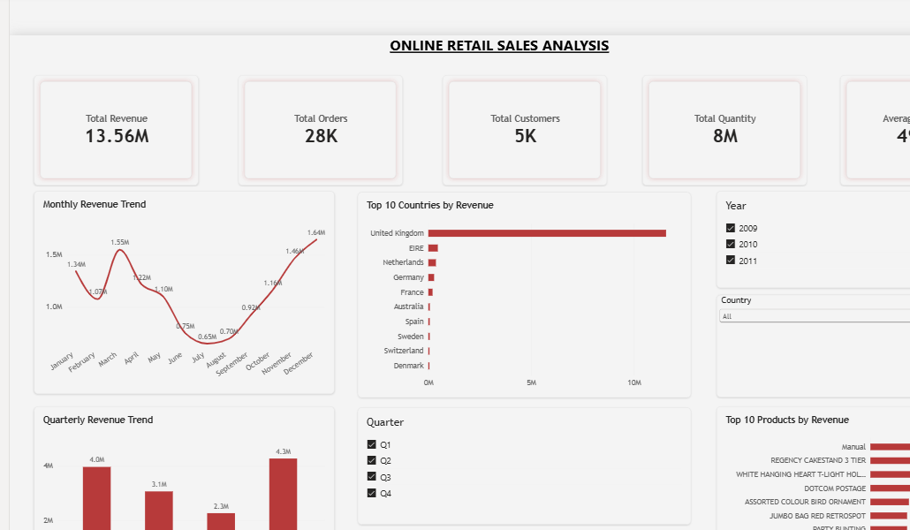
Final Power BI Dashboard
7. Files Included
• sales_data.xlsx – Cleaned data and basic analysis
• dashboard.pbix – Power BI dashboard
• README.md – Project description
8. How to Use
• Open the Excel file to review the cleaned data and analysis.
• Open the Power BI (.pbix) file in Power BI Desktop to explore the interactive dashboard and slicers.

