**Laporan Praktikum**

**Analisis Algoritma**



**Oleh:**

|  |  |
| --- | --- |
| **Victor Wijaya** | **(140810170057)** |

**PROGRAM STUDI TEKNIK INFORMATIKA**

**FAKULTAS MATEMATIKA DAN ILMU PENGETAHUAN ALAM**

**UNIVERSITAS PADJADJARAN**

**TAHUN AJARAN 2019/2020**

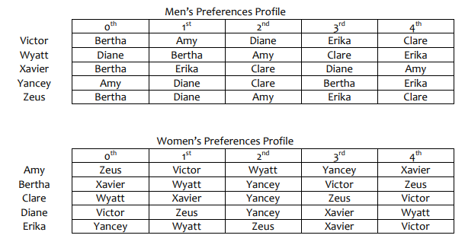

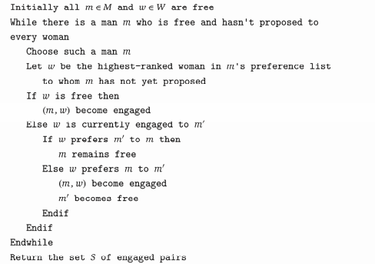

**Choose a great Relationship**

Make some iteration in loop , there is :

**1.** Victor matched with Bertha

Bertha still free

→ Then (victor , Bertha)

2. Wyatt matched with Diane

Diane still free

→ Then (Wyatt,Diane)

3. Xavier matched with Bertha

Bertha was taken with victor before but Bertha prefers Xavier than Victor

→ Then (Xavier,Bertha)

Victor Free

4. Yancey matched with Amy

Amy still free

→ Then (Yancey,Amy)

5. Zeus matched with Bertha

Bertha was taken with Xavier before but Bertha prefers Xavier than Zeus

→ Then ( Xavier,Bertha)

Zeus free

Free : Victor , Yancey , Zeus

6. Victor matched with Amy

Amy was taken with Yancey before but Amy preferes Victor than Yancey

→ Then ( Victor , Amy)

Yancey free

7. Yancey matched with Diane

Diane was taken with Wyatt before but Diane prefers Yancey than Wyatt

→ Then ( Yancey , Diane)

Wyatt free

8. Zeus matched with Diane

Diane was taken with Yancey before but Diane prefers Zeus than Yancey

→ Then ( Zeus, Diane)

Yancey free

Free : Yancey , Wyatt

9. Wyatt matched with Bertha

Bertha was taken with Xavier and Bertha is still prefers Xavier

→ Then Wyatt free

10. Yancey matched with Clare

Clare free

→ Then (Yancey , Clare )

Free : Wyatt

11. Wyatt matched with Amy

Amy was taken with Victor before and Amy is still prefer Victor

→ Then Wyatt free

Free : Wyatt

12. Wyatt matched with Clare

Clare was taken with Yancey but Clare prefers Wyatt than Yancey

→ Then (Wyatt , Clare )

Yancey free

Free : Yancey

13. Yancey matched with Bertha

Bertha was taken with Xavier before and Bertha is still prefer Xavier

→ Then Yancey free

Free: Yancey

14. Yancey matched with Erika

Erika free

→ Then (Yancey, Erika)

Free : Nothing , everybody got their relationship

**And then for the conclusion about the relationship are :**

(Victor, Amy)

(Wyatt, Clare)

(Xavier, Bertha)

(Yancey, Erika)

(Zeus, Diane)

#include <iostream>

#include<cstdlib>

#include <cmath>

using namespace std;

int mp[5][5]={1,0,3,4,2,

3,1,0,2,4,

1,4,2,3,0,

0,3,2,1,4,

1,3,0,4,2};

int wp[5][5]={4,0,1,3,2,

2,1,3,0,4,

1,2,3,4,0,

0,4,3,2,1,

3,1,4,2,0};

bool ok(int q[], int col)

{ int i;

for(i=0; i<col;i++)

{

if(q[col]==q[i])

return false;

}

for(i=0; i<col; i++)

{

if( ( mp[col][q[i]]<mp[col][q[col]] )&& ( wp[q[i]][col]<wp[q[i]][i]) )

return false;

if( ( wp[q[col]][i]<wp[q[col]][col] )&& ( mp[i][q[col]]<mp[i][q[i]]) )

return false;

}

return true;

}

void backtrack(int &col){

col--;

if(col==-1) exit(1);

}

void print(int q[])

{

int i,j;

cout<<"Man"<<" "<<"Woman"<<endl;

for( i=0;i<5;i++){

cout<<" "<<i<<" "<<q[i]<<endl;

}

}

int main(){

int q[5];

q[0]=0;

int c=1;

bool from_backtrack=false;

while(1){

while(c<5){

if(!from_backtrack)

q[c]=-1;

from_backtrack=false;

while(q[c]<5){

q[c]++;

while(q[c]==5)

{ backtrack(c);

q[c]++;

}

if(ok(q, c))

break;

}

c++;

}

print(q);

system("pause");

backtrack(c);

from_backtrack=true;

}

}



**Where :**

|  |  |  |  |
| --- | --- | --- | --- |
| MAN | | WOMAN | |
| 0 | Victor | 0 | Amy |
| 1 | Wyatt | 1 | Bertha |
| 2 | Xavier | 2 | Clare |
| 3 | Yancey | 3 | Diane |
| 4 | Zeus | 4 | Erika |

Based on the program, the relationship are:

Victor – Erika

Wyatt – Bertha

Xavier – Amy

Yancey – Diane

Zeus – Clare

Analisi Algoritma

1. Tidak, karena ada perbedaan cara mengerjakan. Saat mengerjakan manual menggunakan perfect maching, sementara di c++ menggunakan stable matching
   1. Tidak, karena berdasarkan hasil hitung manual proses iterasi telah selesai sebelum n2 iterasi.
   2. Iya, karena jika ada satu pria yang belum bertunangan pasti ada satu wanita yang belum bertunangan. Hal ini disebabkan oleh pada algoritma G-S setiap pria akan tepat bertunangan dengan satu wanita.
   3. Iya, karena setiap orang akan mendapat satu pasangan
   4. Stabil, karena pada awalnya semua belum punya pasangan sehingga tidak akan terjadi perselingkuhan