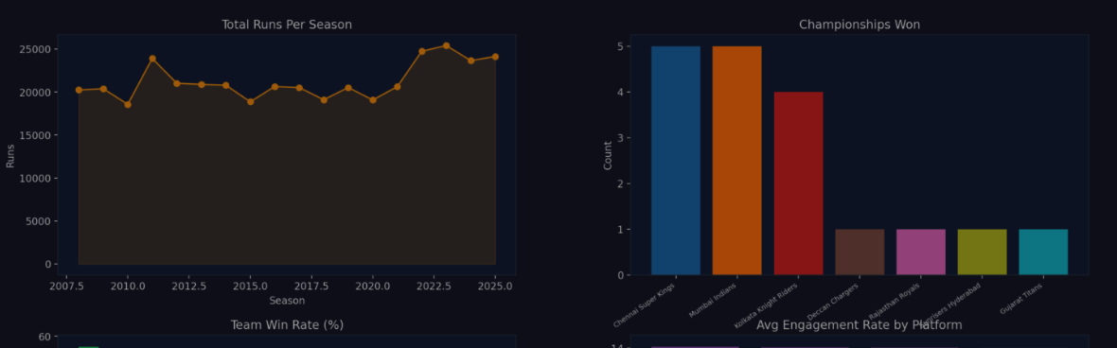
Analyze Food Delivery Demand Across Regions to Inform Market Expansion & Logistics
Data Science Capstone Project | Topic 7 | FoodTech
Phase 3: Business Objectives, Questions & Hypotheses
 | Expanded Business Objective
1 | Regional Demand & Market Expansion Potential — Identify which cities/regions (Urban, Semi-Urban, Metropolitan) generate the highest order volume, revenue, and growth momentum, to prioritize where FoodTech should expand next.
2 | Customer Behavior, Segmentation & Loyalty — Understand how customer type (New/Returning/Loyal), demographics, and cuisine preference drive spend and retention, to strengthen loyalty programs and targeted marketing.
3 | Delivery Partner & Logistics Efficiency — Evaluate delivery partner performance (speed, ratings, delays) across vehicle types and regions to optimize logistics routing and partner allocation.
4 | Restaurant Performance & Operational Capacity — Assess restaurant-level preparation time, ratings, and order capacity utilization to identify high-performing and under-capacity restaurants by cuisine and city.
5 | Order Economics, Discounts & Profitability Risk — Quantify how discounting, payment mode, festival demand spikes, and order cancellations/delays affect net revenue and profitability, to guide pricing and risk mitigation.
This document expands the FoodTech capstone's business objectives into five focused objectives, translates them into 20 data-driven business questions, and converts each question into a testable statistical hypothesis (H0 / H1), completing the Phase 3 deliverable: refined problem statement, assumptions, and hypothesis/reporting plan.

Business Questions

Objective 1 — Regional Demand & Market Expansion
Q1. Which regions (Urban / Semi-Urban / Metropolitan) generate the highest total order volume and Net_Revenue?
Q2. How does average Final_Amount per order differ across regions?
Q3. Which regions show the strongest repeat-order growth potential (based on Total_Orders per customer)?
Q4. Does order volume spike differently by region during Festival_Flag periods?

Objective 2 — Customer Behavior & Loyalty
Q5. How does Average_Spend differ across Customer_Type (New / Returning / Loyal)?
Q6. Which Preferred_Cuisine is most associated with Loyal customers vs New customers?
Q7. Does Total_Orders correlate with Average_Spend at the customer level?
Q8. How does Order_Rating differ across customer segments (New/Returning/Loyal)?
Q9. Which Payment_Mode is preferred by each Customer_Type?
Q10. Does Age_Group influence Preferred_Cuisine choice?

Objective 3 — Delivery Partner & Logistics Efficiency
Q11. How does Avg_Delivery_Speed_KMPH differ across Vehicle_Type?
Q12. Is there a relationship between Delivery_Efficiency_Score and Avg_Customer_Rating?
Q13. Do Delayed_Deliveries differ significantly by Region?
Q14. Does Delivery_Time_Minutes (Orders table) impact Order_Rating?

Objective 4 — Restaurant Performance & Capacity
Q15. Does Avg_Preparation_Time_Minutes correlate with Avg_Rating at the restaurant level?
Q16. Which Cuisine_Type has the highest average restaurant rating?
Q17. Do restaurants flagged Low_Capacity_Flag = "Yes" show lower Avg_Rating than others?
Q18. How does Order_Capacity_Per_Day vary by City?

Objective 5 — Order Economics, Discounts & Risk
Q19. Does Discount_Applied significantly affect Final_Amount / Net_Revenue per order?
Q# | Relationship Tested | Statistical Test | NullHypothesis (H0) | Alternative Hypothesis (H1)
Q1/Q2 | Region vs Order Value/Revenue | One-way ANOVA (two-tailed) | H0: Mean Final_Amount is equal across all regions. | H1: Mean Final_Amount differs across at least one region.
Q4 | Festival_Flag vs Order Volume | Independent t-test (one-tailed, right) | H0: Mean daily order volume is equal on festival vs non-festival days. | H1: Mean daily order volume is greater on festival days.
Q5 | Customer_Type vs Average_Spend | One-way ANOVA (one-tailed) | H0: Mean Average_Spend is equal across New, Returning and Loyal customers. | H1: Mean Average_Spend differs, expected Loyal > Returning > New.
Q6 | Preferred_Cuisine vs Customer_Type | Chi-square test (two-tailed) | H0: Preferred_Cuisine is independent of Customer_Type. | H1: Preferred_Cuisine is associated with Customer_Type.
Q7 | Total_Orders vs Average_Spend | Pearson correlation (one-tailed, right) | H0: No significant correlation exists (rho = 0). | H1: A significant positive correlation exists (rho > 0).
Q8 | Customer_Type vs Order_Rating | One-way ANOVA (two-tailed) | H0: Mean Order_Rating is equal across customer segments. | H1: Mean Order_Rating differs across customer segments.
Q9 | Payment_Mode vs Customer_Type | Chi-square test (two-tailed) | H0: Payment_Mode choice is independent of Customer_Type. | H1: Payment_Mode choice is associated with Customer_Type.
Q10 | Age_Group vs Preferred_Cuisine | Chi-square test (two-tailed) | H0: Preferred_Cuisine is independent of Age_Group. | H1: Preferred_Cuisine is associated with Age_Group.
Q11 | Vehicle_Type vs Delivery Speed | One-way ANOVA (two-tailed) | H0: Mean Avg_Delivery_Speed_KMPH is equal across vehicle types. | H1: Mean Avg_Delivery_Speed_KMPH differs by vehicle type.
Q12 | Delivery_Efficiency_Score vs Avg_Customer_Rating | Pearson correlation (one-tailed, right) | H0: No significant correlation exists (rho = 0). | H1: A significant positive correlation exists (rho > 0).
Q13 | Region vs Delayed_Deliveries | Chi-square test (two-tailed) | H0: Delay rate is independent of Region. | H1: Delay rate is associated with Region.
Q14 | Delivery_Time_Minutes vs Order_Rating | Pearson correlation (one-tailed, left) | H0: No significant correlation exists (rho = 0). | H1: A significant negative correlation exists (rho < 0).
Q15 | Avg_Preparation_Time_Minutes vs Avg_Rating | Pearson correlation (one-tailed, left) | H0: No significant correlation exists (rho = 0). | H1: A significant negative correlation exists (rho < 0).
Q16 | Cuisine_Type vs Avg_Rating | One-way ANOVA (two-tailed) | H0: Mean Avg_Rating is equal across all cuisine types. | H1: Mean Avg_Rating differs across at least one cuisine type.
Q17 | Low_Capacity_Flag vs Avg_Rating | Independent t-test (one-tailed, left) | H0: Mean Avg_Rating is equal for Low_Capacity_Flag = Yes vs No. | H1: Mean Avg_Rating is lower for Low_Capacity_Flag = Yes restaurants.
Q18 | Order_Capacity_Per_Day vs Actual Orders | Pearson correlation (one-tailed, right) | H0: No significant correlation exists (rho = 0). | H1: A significant positive correlation exists (rho > 0).
Q19 | Discount_Applied vs Net_Revenue | Pearson correlation (one-tailed, left) | H0: No significant relationship exists between discount and net revenue. | H1: Higher discount is associated with lower net revenue per order.
Q20 | Order_Status vs Region | Chi-square test (two-tailed) | H0: Order_Status is independent of Region. | H1: Order_Status is associated with Region.
Q20. Is Order_Status (Cancelled/Returned vs Delivered) associated with Region or Delivery_Time_Minutes

Hypothesis Table Reference:
Each question is converted into a null and alternative hypothesis with the matched statistical test and expected direction (tail), so results from the EDA notebook can be reported directly against this plan.

