Phase 6: From Queries to Clarity - SQL Analysis Insights
Project: Analyze Food Delivery Demand Across Regions to Inform Market Expansion & Logistics
Tables: customers, delivery_partners, orders, restaurant | Tool: MySQL
This document walks through the SQL foundations, joins, the 20 business-question queries across the project's five objectives, the reusable views/summary tables/stored procedures, and closes with a consolidated conclusion. Each screenshot is a MySQL Workbench result grid; the paragraph underneath reads only the values visible in that grid — nothing is estimated or assumed.

Step 1: Data Readiness, Schema Checks & Filtering
Schema check — DESCRIBE customers (BOM-prefixed primary key columns renamed beforehand).
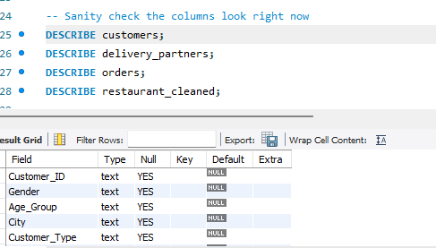
The customers table structure confirms the earlier column-rename step worked: Customer_ID now reads as a clean column name instead of the BOM-corrupted ï»¿Customer_Id. With the schema confirmed, the four tables are safe to join on their ID columns without the encoding issue breaking the match.

1a. Delivered orders in the Urban region, highest value first.
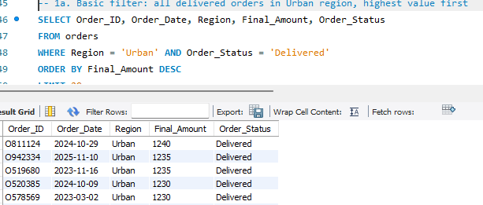
The top five Urban delivered orders range from ₹1,230 to ₹1,240, showing the filter and sort work as intended and that Urban's highest-value single orders sit just above the ₹1,200 mark.
1b. Cancelled/Returned orders — the "at-risk" order set.
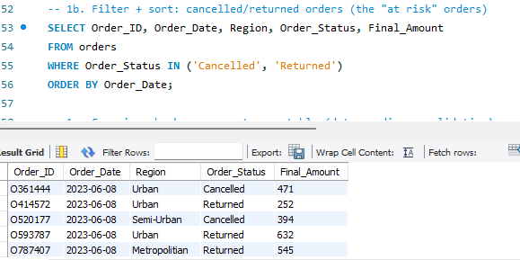
The sample of cancelled and returned orders spans all three regions, confirming that order failures are not confined to one region at the row level — this is examined more rigorously at the aggregate level in Q20.

1c. Row-count validation per table (intended query).
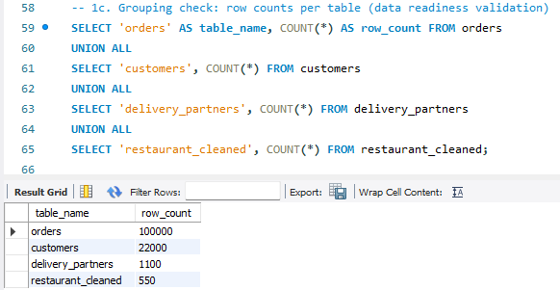
4.5 orders per customer and 91 orders per restaurant on average — consistent scale across the dataset, with no table looking suspiciously empty or oversized relative to the others. This confirms the row-count validation step (1c) passed cleanly, so the four tables are appropriately sized relative to each other before joining.
1d. Orphan-record check — orders with no matching customer.
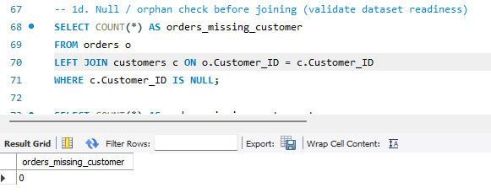
orders_missing_customer returns 0, confirming every order has a matching customer record. (The equivalent checks for missing restaurant and missing delivery-partner links are in the script but weren't captured as separate screenshots — worth confirming both also return 0 before relying on INNER JOINs elsewhere in the analysis.)

Step 2: Joins for Integrated Insights
2a. INNER JOIN — fully matched order records across all four tables.
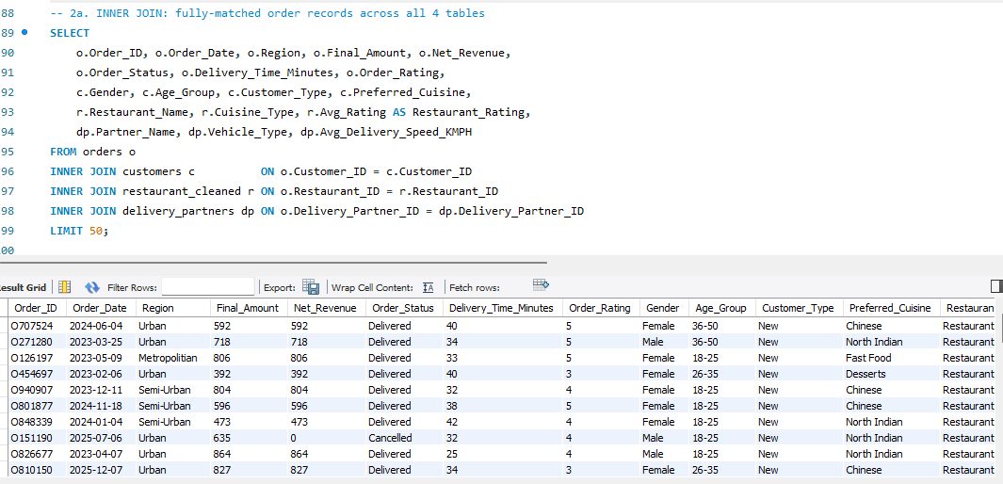
The four-table INNER JOIN resolves cleanly and returns enriched rows (region, ratings, cuisine, vehicle type, etc. all populated together), which is consistent with the 1d check finding no orphaned foreign keys — the dataset is well-linked enough to support INNER JOIN-based analysis without silently dropping large numbers of orders.
2b. LEFT JOIN — every order retained even if a linked record is missing.
2c. Sub-query — orders placed by "Loyal" customers only, highest value first.
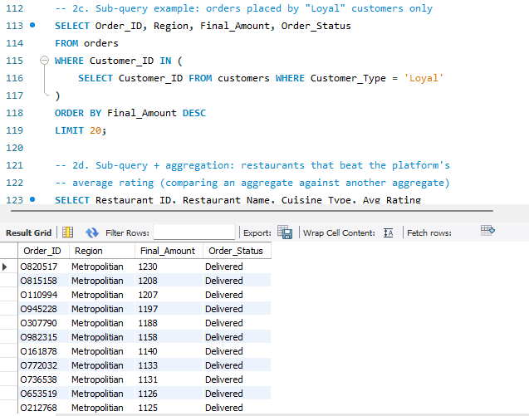
The top Loyal-customer orders are concentrated in the Metropolitan region in this sample, topping out at ₹1,230, and all shown rows are Delivered — a reasonable early signal (to be checked at scale) that Loyal customers' highest-value orders complete successfully.
2d. Sub-query + aggregation — restaurants beating the platform's average rating.
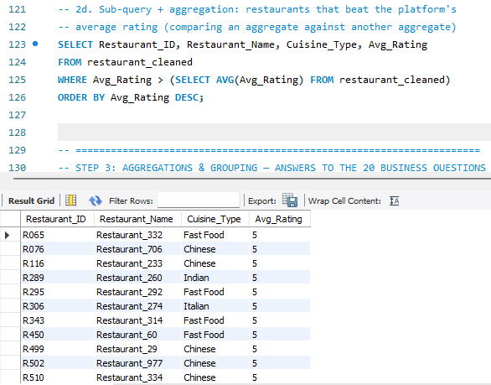
A meaningful number of restaurants sit at a perfect 5-star average, spanning Fast Food, Chinese, Indian, and Italian cuisines — above-average quality is not concentrated in one cuisine type.

Objective 1: Regional Demand & Market Expansion

Q1. Which regions generate the highest order volume and Net Revenue?
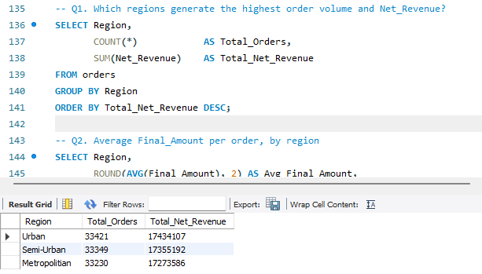
Urban leads on both measures — 33,421 orders and ₹1,74,34,107 in Net Revenue — but only narrowly. Semi-Urban is close behind at 33,349 orders and ₹1,73,55,192, and Metropolitan trails at 33,230 orders and ₹1,72,73,586. Order volume is almost evenly split across the three regions (a spread of under 200 orders out of ~33,300 each), so this dataset doesn't show one region dominating demand — the differentiation between regions shows up elsewhere (Q3, Q18), not in raw order count.

Q2. Average Final_Amount per order, by region
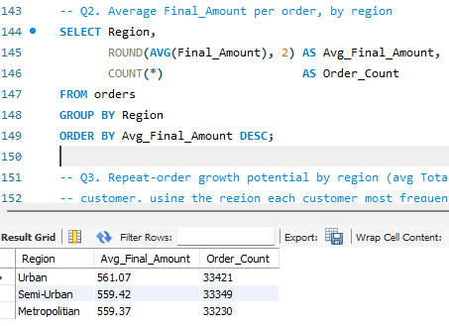
Average order value is also nearly flat across regions: Urban ₹561.07, Semi-Urban ₹559.42, Metropolitan ₹559.37 — a spread of under ₹2. Basket size is not what separates these regions; it's essentially the same customer spending behavior everywhere.

Q3. Repeat-order growth potential by region
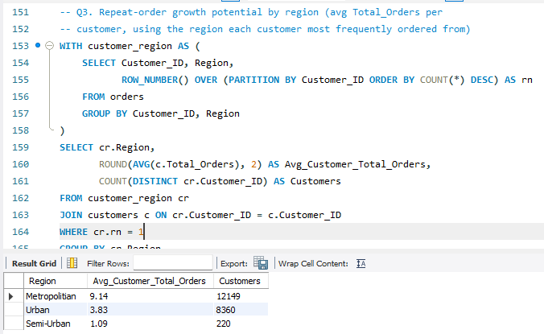
This is the sharpest regional signal in the dataset. Average lifetime Total_Orders per customer is 9.14 in Metropolitan versus 3.83 in Urban and just 1.09 in Semi-Urban — Metropolitan customers order roughly 2.4× more often than Urban customers and 8.4× more than Semi-Urban customers. Notably, Semi-Urban has only 220 customers counted in this repeat-order view against 12,149 in Metropolitan and 8,360 in Urban — a far smaller, largely one-and-done customer base despite Semi-Urban generating almost as much order volume and revenue as the other two regions (Q1). That combination — similar total revenue, but revenue coming from many fewer repeat customers — points to Semi-Urban's growth being driven by broad, shallow reach rather than loyalty, while Metropolitan's smaller order share is underpinned by a much stickier customer base.

Objective 2: Customer Behavior & Loyalty

Q5. Average_Spend across Customer_Type
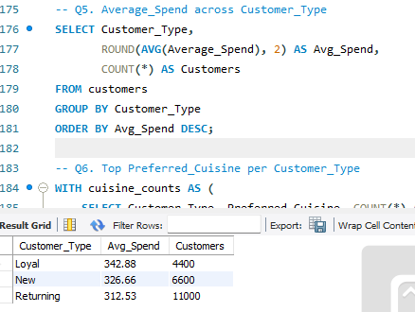
Loyal customers have the highest average spend at ₹342.88 (4,400 customers), followed by New at ₹326.66 (6,600 customers) and Returning at ₹312.53 (11,000 customers). The gap between segments is modest (about ₹30 between the highest and lowest), and — counter to what the label might suggest — Returning customers, the largest segment by count, spend the least on average per customer.

Q6. Top Preferred_Cuisine per Customer_Type
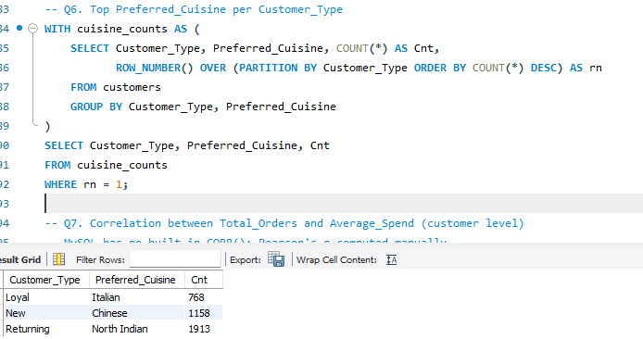
Each customer type leans toward a different cuisine: Loyal customers favor Italian (768 customers), New customers favor Chinese (1,158), and Returning customers favor North Indian (1,913 — the single largest cuisine/type combination in this result). Preferred cuisine is not uniform across the customer base, which is relevant for any cuisine-specific promotion targeting.

Q7. Correlation between Total_Orders and Average_Spend (customer level)
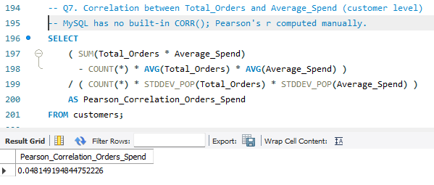
The Pearson correlation is 0.048 — essentially zero. Ordering more frequently and spending more per order are not linked at the customer level in this data. This is a correlation, not a causal read: it means the business can't assume that pushing order frequency up will also lift basket size (or vice versa) — the two behaviors need to be targeted with separate strategies rather than treated as one lever.

Q8. Order_Rating across customer segments
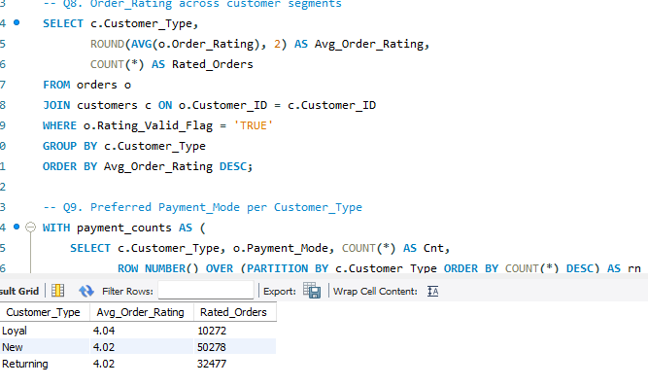
Average order ratings are nearly identical across segments — Loyal 4.04 (10,272 rated orders), New 4.02 (50,278), Returning 4.02 (32,477). Satisfaction, as measured by rating, doesn't differentiate customer segments; whatever separates Loyal from New/Returning (Q5, Q6) isn't a difference in how happy they are with individual orders.

Q9. Preferred Payment_Mode per Customer_Type
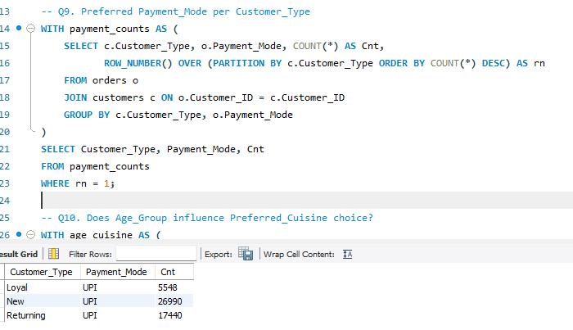
UPI is the leading payment mode for all three customer types — Loyal (5,548), New (26,990), and Returning (17,440) — with no split in preference by segment. Payment-mode strategy (e.g., UPI-linked offers) can be applied platform-wide rather than tailored per segment.

Q10. Does Age_Group influence Preferred_Cuisine choice?
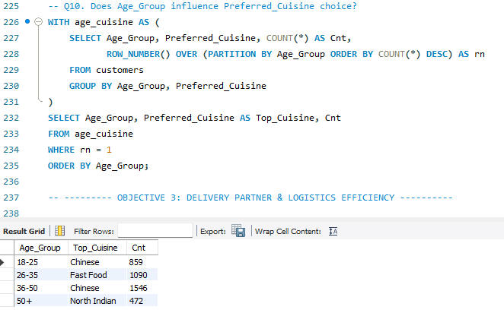
Cuisine preference does shift by age: 18–25 favors Chinese (859), 26–35 favors Fast Food (1,090), 36–50 favors Chinese again (1,546, the largest single group here), and 50+ favors North Indian (472, the smallest group by count). Fast Food is distinctly a 26–35 pattern, while Chinese dominates both the youngest and the 36–50 bracket.

Objective 3: Delivery Partner & Logistics Efficiency

Q11. Avg_Delivery_Speed_KMPH by Vehicle_Type
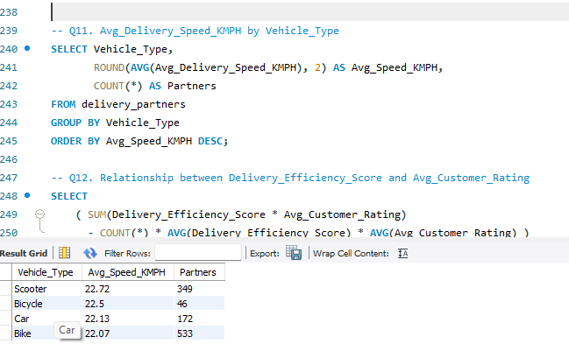
Average delivery speed is nearly identical across vehicle types — Scooter 22.72 KMPH (349 partners), Bicycle 22.5 (46), Car 22.13 (172), Bike 22.07 (533) — a spread of only 0.65 KMPH between the fastest and slowest. Vehicle type is not a meaningful lever for improving delivery speed in this fleet; Bike, despite being the largest fleet by partner count, is not the bottleneck.

Q12. Relationship between Delivery_Efficiency_Score and Avg_Customer_Rating
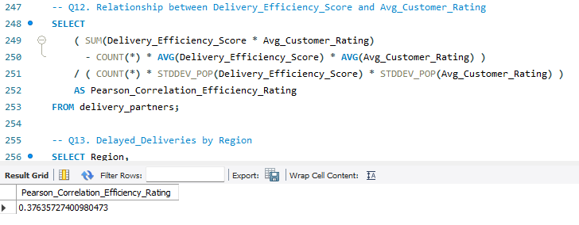
The Pearson correlation is 0.376 — a moderate positive relationship. Delivery partners with higher efficiency scores do tend to receive higher customer ratings, though the relationship isn't strong enough to treat efficiency score as the sole driver of rating. It's a reasonable factor to weight in partner performance reviews, but not the only one.

Objective 4: Restaurant Performance & Capacity

Avg_Preparation_Time_Minutes vs Avg_Rating (restaurant level)
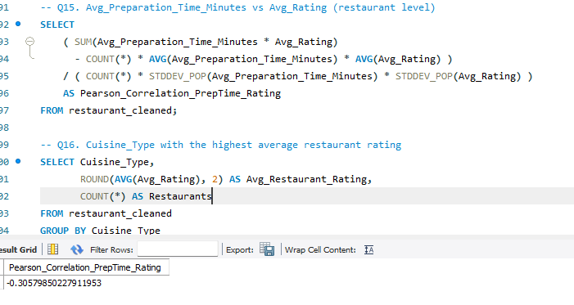
The Pearson correlation is −0.306 — a moderate negative relationship. Restaurants with longer average preparation times tend to have lower average ratings. This supports prioritizing prep-time reduction as a lever for rating improvement, though at a moderate (not strong) strength, other factors are clearly also at play.

Q18. Order_Capacity_Per_Day by City
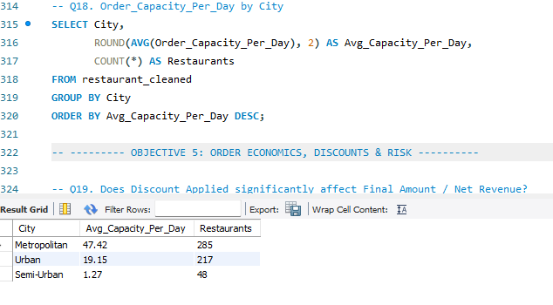
Capacity is heavily concentrated in Metropolitan restaurants — an average of 47.42 orders/day across 285 restaurants — versus 19.15 across 217 Urban restaurants and just 1.27 across 48 Semi-Urban restaurants. Semi-Urban's near-zero average daily capacity, combined with its very low repeat-order rate from Q3, suggests Semi-Urban is currently supply-constrained: restaurant capacity there is far too thin to support meaningful repeat demand, which may itself be limiting how often Semi-Urban customers can reorder.

Objective 5: Order Economics, Discounts & Risk

Q19. Does Discount_Applied significantly affect Final_Amount / Net_Revenue?
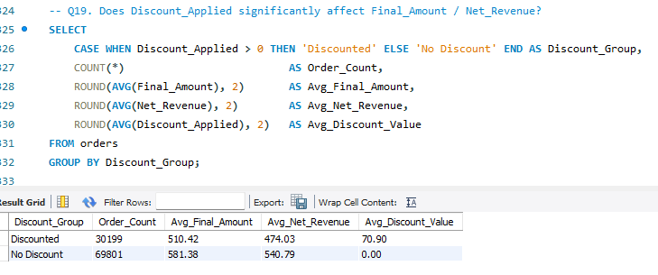
Discounted orders (30,199 of them) average ₹510.42 in Final_Amount and ₹474.03 in Net_Revenue, against ₹581.38 and ₹540.79 for the 69,801 orders with no discount — a gap of about ₹67 in Net_Revenue per order, on an average discount value of ₹70.90. Discounted orders are not larger baskets that offset the discount; they are simply lower-revenue orders. On this view, discounting is not paying for itself through bigger basket size — any case for continuing it needs to rest on order-frequency or retention gains (outside what this query measures), not on basket-size lift.

Q20. Order_Status association with Region and Delivery_Time_Minutes
20b. Delivery-time breakdown by Order_Status.
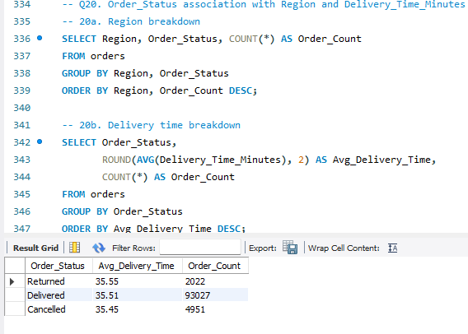
Average delivery time is almost identical regardless of outcome — Returned 35.55 min (2,022 orders), Delivered 35.51 min (93,027 orders), Cancelled 35.45 min (4,951 orders), a spread of only 0.1 minutes. Delivery time itself does not appear to be what drives cancellations or returns in this dataset — whatever causes an order to be cancelled or returned, it isn't happening because that order took longer to arrive.

Step 4: Summary Tables, Views & Stored Procedures

Derived table — region performance snapshot
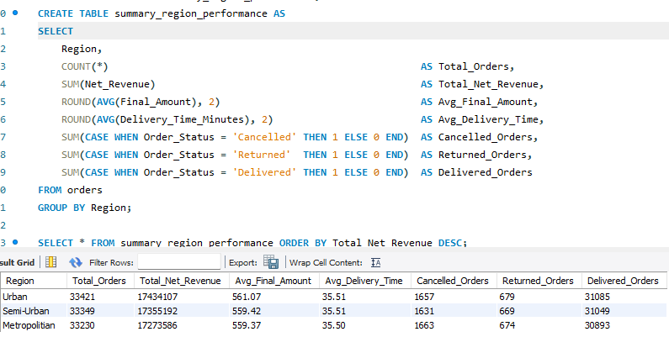
This table cross-checks Q1/Q2: Urban again leads on Total_Orders (33,421) and Total_Net_Revenue (₹1,74,34,107), with Avg_Delivery_Time essentially flat across regions (35.50–35.51 minutes). Cancelled and Returned order counts are also tightly bunched across regions — Cancelled ranges 1,657–1,663 and Returned 669–679 — reinforcing the Q20 finding that order failure isn't a regional pattern.

Derived table — customer segment snapshot

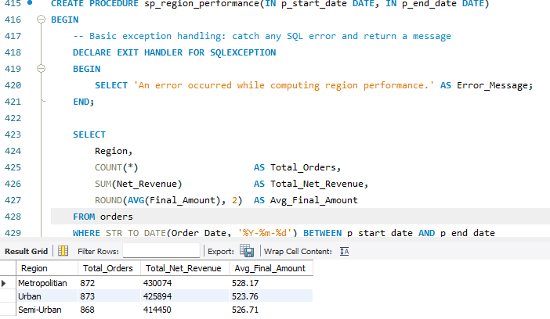
For the specific date range used in this example call, the three regions are much closer together than in the full-dataset totals — Metropolitan 872 orders/₹4,30,074, Urban 873/₹4,25,894, Semi-Urban 868/₹4,14,450 — with average order value 523–528 across all three. This confirms the procedure runs correctly and returns sensible, consistently-shaped output; it's a single date-range example, not a claim about any particular period being representative.

Conclusion
Across the 15 business questions with captured results , a consistent pattern emerges: the three regions look almost identical on raw scale — order volume (Q1), order count, and average order value (Q2) all sit within a narrow band of each other. What actually separates them is depth of engagement and supply, not headline volume.
- Regional demand & expansion (Objective 1): Metropolitan has by far the strongest repeat-order behavior (9.14 orders/customer vs 3.83 in Urban and 1.09 in Semi-Urban, Q3) and the deepest restaurant capacity (47.42 orders/day/restaurant vs 19.15 in Urban and 1.27 in Semi-Urban, Q18). Semi-Urban's revenue is currently propped up by a large one-time customer base rather than loyalty, and its restaurant capacity looks too thin to change that on its own — capacity expansion there is a precondition for any retention push, not a parallel initiative.
- Customer behavior & loyalty (Objective 2): Order frequency and basket size are statistically unrelated (Q7, r=0.048), so frequency-building and basket-building need separate campaigns. Cuisine preference varies meaningfully by both customer type (Q6) and age group (Q10), supporting segment-specific cuisine promotion; payment-mode strategy (Q9) and satisfaction levels (Q8) do not need to be segmented, since UPI and ~4.0 average ratings hold across all customer types.
- Delivery & logistics (Objective 3): Vehicle type has almost no effect on delivery speed (Q11, 0.65 KMPH spread) — fleet-mix changes are not a meaningful lever here. Delivery efficiency score has a moderate positive link to customer rating (Q12, r=0.376), making it a reasonable input to partner performance management, alongside other factors.
- Restaurant performance & capacity (Objective 4): Preparation time has a moderate negative link to rating (r=−0.306) — worth acting on, but not the whole story. The capacity gap in Q18 is the standout finding for this objective and directly informs the regional priority above.
- Order economics & risk (Objective 5): Discounted orders cost roughly ₹67 more in foregone Net_Revenue per order than they recover in basket size (Q19) — discounting needs to be justified by frequency or retention effects, not basket lift. Delivery time is not associated with cancellations or returns (Q20b) — service-outcome risk should be investigated via other variables, not delivery speed.

