FOODTECH
Data Analytics Capstone Project
Analyzing Food Delivery Demand Across Regions to Inform
Market Expansion & Logistics
Consolidated Project Report | SQL • Python EDA & Statistical Testing • Power BI • Machine Learning
Prepared by | Victor
Certification Program | Data Analytics with Generative AI — NIIT, Anna Nagar, Chennai
Batch Code | [Batch Code]
Submitted for | Capstone Viva Voce Evaluation
Report Version | Final — Quality-Reviewed Edition (Business Questions, Hypotheses & Visual Evidence Cross-Mapped)

Table of Contents
1. Introduction 3
2. Business Objectives 3
3. Dataset Overview & Analytical Data Model 4
4. Business Questions — Mapped to Objectives, Hypotheses & Visual Evidence 5
5. Analytical Approach 6
6. Objective-wise Insights 7
6.1 Regional Demand & Market Expansion 7
6.2 Customer Behavior, Segmentation & Loyalty 8
6.3 Delivery Partner & Logistics Efficiency 9
6.4 Restaurant Performance & Operational Capacity 10
6.5 Order Economics, Discounts & Profitability Risk 12
7. Hypotheses & Statistical Validation 13
7.1 Hypotheses Tested — Full H0 / H1 Statements & Decisions 13
7.2 Statistical Test Results — Summary Table 15
8. Machine Learning Contribution 16
9. Summary of Key Findings 17
10. Conclusion 17
11. Consolidated Recommendations 18
12. Limitations & Future Scope 18

1. Introduction

1.1 Business Problem
FoodTech is a food-delivery platform operating across three market types — Urban, Semi-Urban, and Metropolitan — with 100,000 orders, 22,000 customers, 1,100 delivery partners, and 550 restaurants. As the platform scales, leadership needs one evidence-based view of where demand is strongest, which customers and cuisines drive loyalty, how efficiently delivery partners and restaurants operate, and how discounting and order failures affect profitability. This project consolidates order, customer, delivery-partner, and restaurant data into one connected analytical model to answer those questions with data, and to translate the findings into recommendations for market expansion, logistics, retention, restaurant partnerships, and pricing.

1.2 Target Audience
The findings are intended for FoodTech's decision-makers: Regional Expansion & Strategy (where to prioritize growth), Marketing & Customer Retention (loyalty and cuisine-based campaigns), Logistics & Operations (delivery-partner allocation and training), Restaurant Partnerships (which regions need capacity support), and Finance & Revenue (how discounting affects net revenue).

1.3 How to Read This Report
Section 4 maps every business question to the exact visual and statistical evidence that answers it, so a reader can jump straight from a question to its proof. Section 6 walks through each objective's dashboard with insights and a recommendation. Section 7 states every hypothesis in full H0/H1 form with its decision (7.1), then summarizes all twenty results in one table (7.2).

2. Business Objectives
The capstone is organized around five focused business objectives, translated into 20 data-driven business questions and tested through 20 corresponding statistical hypotheses (Section 4 and Section 7.1).
- Objective 1 — Regional Demand & Market Expansion Potential: Identify which regions (Urban, Semi-Urban, Metropolitan) generate the highest order volume, revenue, and growth momentum, to prioritize where FoodTech should expand next.
- Objective 2 — Customer Behavior, Segmentation & Loyalty: Understand how customer type (New/Returning/Loyal), demographics, and cuisine preference drive spend and retention, to strengthen loyalty programs and targeted marketing.
- Objective 3 — Delivery Partner & Logistics Efficiency: Evaluate delivery partner performance (speed, ratings, delays) across vehicle types and regions to optimize logistics routing and partner allocation.
- Objective 4 — Restaurant Performance & Operational Capacity: Assess restaurant-level preparation time, ratings, and order-capacity utilization to identify high-performing and under-capacity restaurants by cuisine and city.
- Objective 5 — Order Economics, Discounts & Profitability Risk: Quantify how discounting, payment mode, festival demand spikes, and order cancellations/delays affect net revenue and profitability, to guide pricing and risk mitigation.

3. Dataset Overview & Analytical Data Model

3.1 Source Tables
Four source tables were combined into a single analytical dataset:
Table | Rows | Columns | Grain
Orders | 100,000 | 23 | One row per order (fact table)
Customers | 22,000 | 10 | One row per customer
Delivery Partners | 1,100 | 10 | One row per delivery partner
Restaurants | 550 | 8 | One row per restaurant

3.2 Data Model & Relationships
Orders is the central fact table, connected through Customer_ID, Restaurant_ID, and Delivery_Partner_ID to the three dimension tables in one-to-many relationships — one customer, restaurant, or delivery partner can appear on many orders, but each order links to exactly one of each. These relationships were established with SQL joins in MySQL (verified through row-count and orphan-record checks confirming every order matches a valid customer, restaurant, and delivery partner) and mirrored identically in the Power BI data model, so both the query layer and the dashboard layer reason about the same connected dataset.

3.3 Data Preparation
Column naming was standardized across all four tables, referential integrity was validated end-to-end, and Net_Revenue was engineered to reflect completed transactions net of discounts. Rating-based analysis was scoped to delivered orders so that rating comparisons are always made on a like-for-like, completed-order basis. Feature engineering added derived fields — Discount_Ratio, Delivery-to-Prep time ratios, and weekend/festival flags — to support both the statistical testing and machine learning stages.

3.4 Tools & Techniques Used
- MySQL — schema design, multi-table joins, sub-queries, views, and stored procedures for the 20 business questions.
- Python (Pandas, NumPy, SciPy, statsmodels, scikit-learn) — exploratory data analysis, bivariate and multivariate analysis, hypothesis testing, feature engineering, and model training.
- Power BI — an interactive, multi-page dashboard (Overview, Regional Demand, Customer Behaviour, Logistics & Delivery, Restaurant Performance, Order Economics) mirroring the same data model for business-facing exploration.
- Microsoft Excel — a supplementary dashboard and pivot-based validation layer.

4. Business Questions — Mapped to Objectives, Hypotheses & Visual Evidence
Every business question below was converted into a testable hypothesis (H0/H1) and evaluated at α = 0.05. They are grouped by parent objective, each cross-referenced to (a) its hypothesis label in Section 7.1 and (b) the chart / dashboard evidence in Section 6 that answers it — so every question is traceable end-to-end from problem statement to proof.
Q# | Business Question | Hypothesis (§7.1) | Answered By (Visual Evidence)
Objective 1 — Regional Demand & Market Expansion (Fig. 6.1 · Power BI: Overview & Regional Demand pages)
Q1 | Which regions generate the highest total order volume and Net Revenue? | H‑Q1/Q2 | Fig. 6.1 — order/revenue split by region
Q2 | How does average Final_Amount per order differ across regions? | H‑Q1/Q2 | Fig. 6.1 — order-value spread by region
Q3 | Which regions show the strongest repeat-order growth potential? | H‑Q3 | Fig. 6.1 — repeat-order / trend panel; SQL aggregate view
Q4 | Does order volume spike differently by region during festival periods? | H‑Q4 | Fig. 6.1 — monthly trend by festival flag
Objective 2 — Customer Behavior, Segmentation & Loyalty (Fig. 6.2 · Power BI: Customer Behaviour page)
Q5 | How does Average_Spend differ across Customer_Type (New/Returning/Loyal)? | H‑Q5 | Fig. 6.2 — spend by customer type
Q6 | Which cuisine is most associated with Loyal vs. New customers? | H‑Q6 | Fig. 6.2 — cuisine share by customer type
Q7 | Does Total_Orders correlate with Average_Spend at the customer level? | H‑Q7 | Fig. 6.2 — orders-vs-spend scatter
Q8 | How does Order_Rating differ across customer segments? | H‑Q8 | Fig. 6.2 — rating by segment
Q9 | Which payment mode is preferred by each Customer_Type? | H‑Q9 | Fig. 6.2 — payment-mode mix
Q10 | Does Age_Group influence Preferred_Cuisine choice? | H‑Q10 | Fig. 6.2 — cuisine share by age group; Power BI Customer Behaviour page
Objective 3 — Delivery Partner & Logistics Efficiency (Fig. 6.3 · Power BI: Logistics & Delivery page)
Q11 | How does Avg_Delivery_Speed_KMPH differ across Vehicle_Type? | H‑Q11 | Fig. 6.3 — speed by vehicle type
Q12 | Is there a relationship between Delivery_Efficiency_Score and Avg_Customer_Rating? | H‑Q12 | Fig. 6.3 — efficiency-vs-rating scatter; Power BI Logistics page
Q13 | Do delayed deliveries differ significantly by region? | H‑Q13 | Fig. 6.3 — delay rate by region
Q14 | Does Delivery_Time_Minutes impact Order_Rating? | H‑Q14 | Fig. 6.3 — delivery-time distribution vs. rating
Objective 4 — Restaurant Performance & Operational Capacity (Fig. 6.4 · Power BI: Restaurant Performance page)
Q15 | Does Avg_Preparation_Time_Minutes correlate with Avg_Rating at the restaurant level? | H‑Q15 | Fig. 6.4 — prep time vs. rating; Power BI Restaurant page
Q16 | Which cuisine type has the highest average restaurant rating? | H‑Q16 | Fig. 6.4 — average rating by cuisine
Q17 | Do Low_Capacity_Flag restaurants show lower Avg_Rating than others? | H‑Q17 | Fig. 6.4 — capacity-flag comparison; Power BI Restaurant page
Q18 | How does Order_Capacity_Per_Day vary by city? | H‑Q18 | Fig. 6.4 — capacity vs. actual orders
Objective 5 — Order Economics, Discounts & Profitability Risk (Fig. 6.5 · Power BI: Order Economics, Discounts & Risk page)
Q19 | Does Discount_Applied significantly affect Final_Amount / Net_Revenue per order? | H‑Q19 | Fig. 6.5 — Net Revenue by discount band
Q20 | Is Order_Status associated with region? | H‑Q20 | Fig. 6.5 — cancellation/return rate by region; order-status split

Reading the table: each row's "Hypothesis" label points to the matching full H0/H1 statement and decision in Section 7.1; "Answered By" points to the chart panel in Section 6 (and the Power BI dashboard page, where the question is also charted interactively).

5. Analytical Approach
The 20 business questions were answered through four complementary layers, each cross-checking the others so that every insight in this report is corroborated from more than one direction:
- SQL foundation (MySQL): joins, sub-queries, views, and stored procedures produced the first pass of grouped, aggregated answers directly from the relational data model.
- Python EDA & statistical testing: univariate, bivariate, and multivariate analysis (box plots, correlation heatmaps, cross-tabulations) followed by formal hypothesis testing — one-way ANOVA, independent t-tests, chi-square tests of independence, and Pearson correlation — across all 20 hypotheses.
- Power BI dashboard: a five-page interactive dashboard (Overview, Regional Demand, Customer Behaviour, Logistics & Delivery, Restaurant Performance, Order Economics) mirroring the same data model for business-facing, filterable exploration.
- Machine learning: feature-engineered classification and regression models (Section 8) extending the analysis from "what happened" to "what can be predicted going forward."

6. Objective-wise Insights

6.1 Objective 1 — Regional Demand & Market Expansion
Business questions addressed: Q1 (order volume & revenue by region), Q2 (average order value by region), Q3 (repeat-order growth potential), Q4 (festival demand spikes).
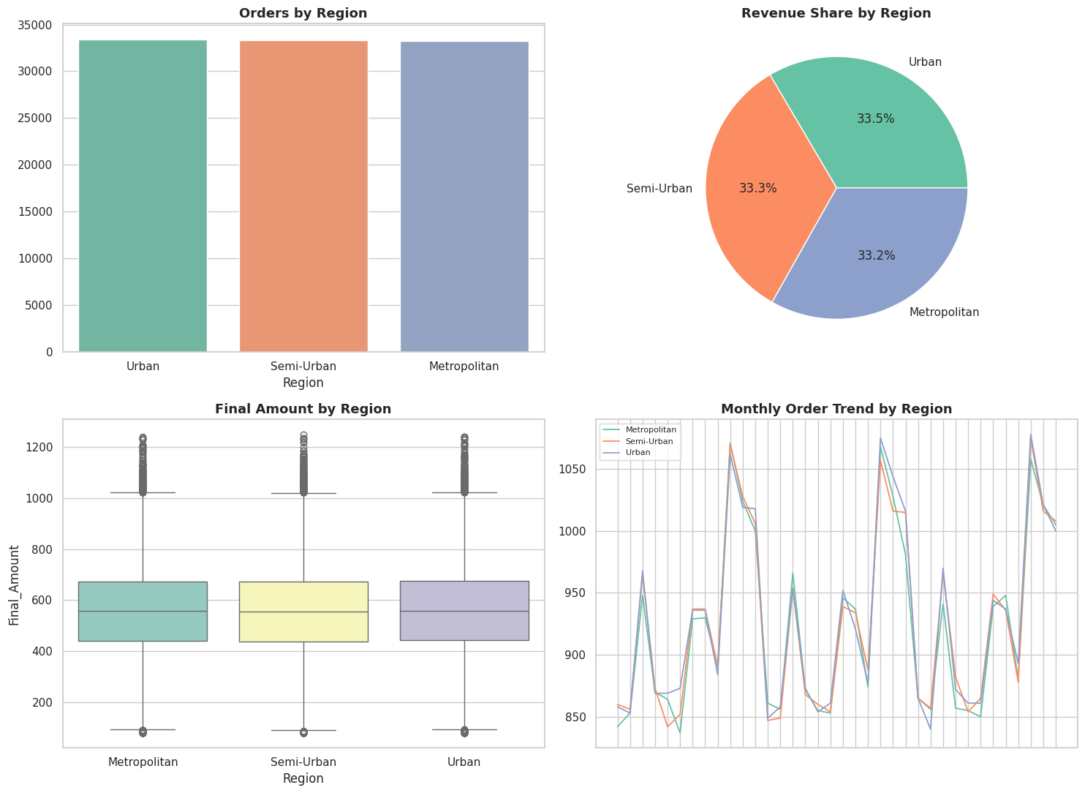
Orders, revenue share, order-value spread, and the monthly order trend by region
Key Insights
- Balanced regional scale: Order volume and Net Revenue are almost perfectly split across the three regions — Urban leads narrowly at 33,421 orders / ₹1.74 crore, Semi-Urban follows at 33,349 orders / ₹1.74 crore, and Metropolitan at 33,230 orders / ₹1.73 crore, a spread of well under 1%. Average order value is likewise flat at ₹559–₹561 across all three (ANOVA F=1.05, p=0.35) — the regions are equally important by headline scale.
- Repeat-order strength is the real differentiator: Metropolitan customers place an average of 9.14 orders each over their lifetime, versus 3.83 in Urban and 1.09 in Semi-Urban — roughly 2.4× and 8.4× higher respectively. Metropolitan's order share rests on a smaller, far stickier customer base (12,149 repeat customers), while Semi-Urban's comparable revenue is generated from a much larger, largely one-time customer base (only 220 customers in the repeat-order view).
- Festival demand is a reliable, repeatable lever: Festival months (March, July, August, October–December) show a consistent ~20% uplift in order volume over non-festival months across every region (independent t-test, p<0.001 in each region) — a predictable pattern that can be planned for well in advance.
SQL Verification (MySQL Workbench output): Q1 — order count and Net Revenue grouped by Region.
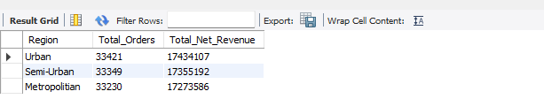
Recommendation
Since scale is already balanced, expansion investment should prioritize converting Semi-Urban's broad reach into Metropolitan-style loyalty by building out restaurant and delivery capacity there (see Objective 4), while using the ~20% festival uplift to plan proactive staffing and delivery-partner scheduling across all three regions.

6.2 Objective 2 — Customer Behavior, Segmentation & Loyalty
Business questions addressed: Q5 (spend by customer type), Q6 (cuisine by customer type), Q7 (orders vs. spend correlation), Q8 (rating by segment), Q9 (payment mode by segment), Q10 (cuisine by age group).
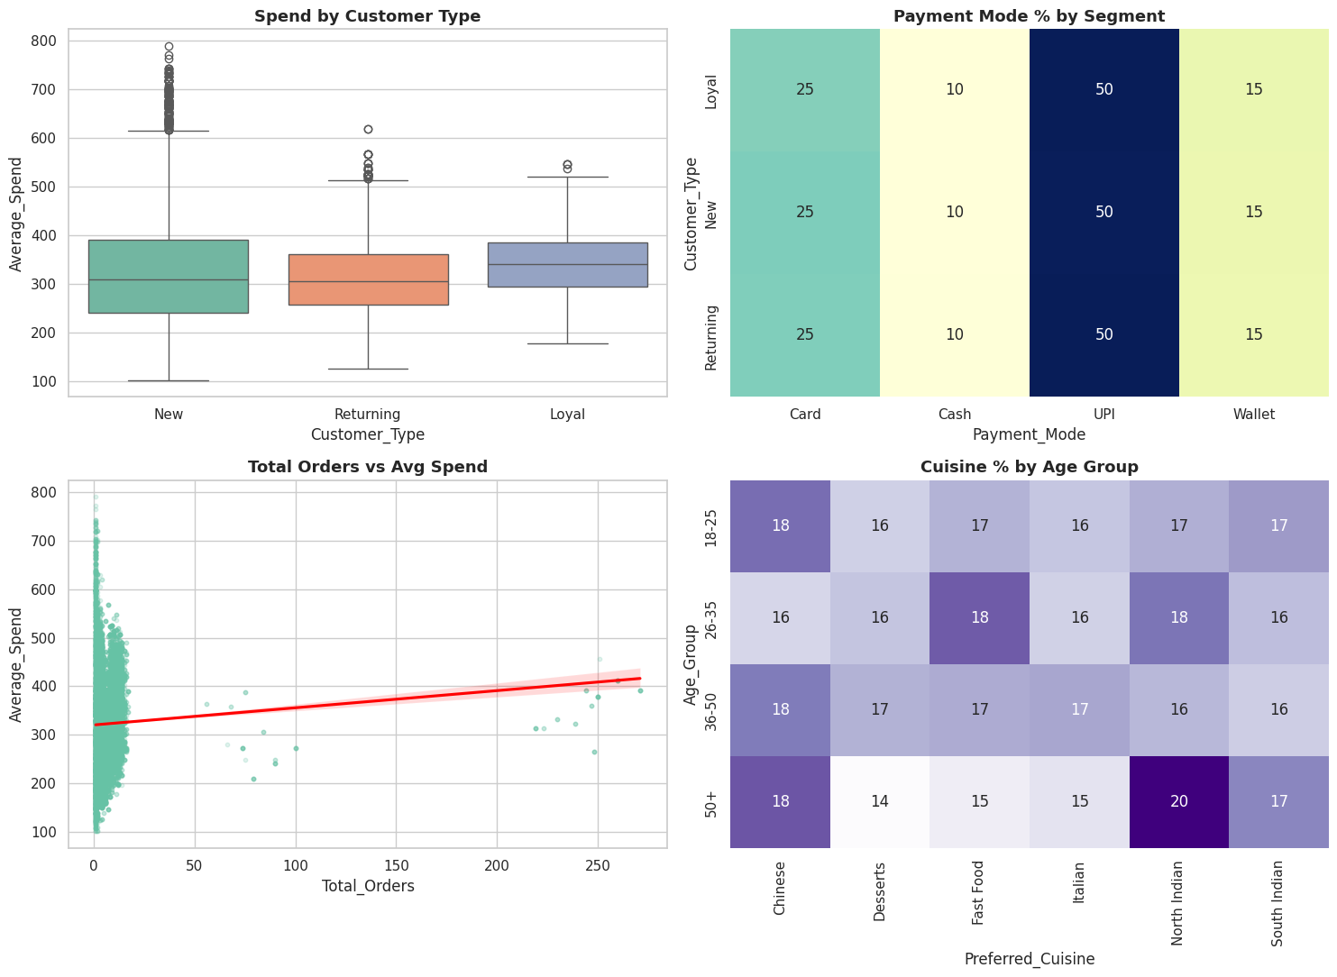
Spend by customer type, payment-mode mix, orders-vs-spend relationship, and cuisine share by age group
Key Insights
- Loyal customers spend the most, but Returning customers are the retention gap: Average spend is ₹342.88 for Loyal, ₹326.66 for New, and ₹312.53 for Returning customers (ANOVA, p<0.001) — notably, Returning customers, the largest segment by count (11,000), spend the least per order on average.
- Order frequency and basket size move independently: The correlation between Total_Orders and Average_Spend at the customer level is 0.048 — essentially zero (statistically detectable given the sample size, but practically negligible). Frequency-building and basket-building need separate campaigns rather than a single lever.
- Cuisine preference is genuinely segment- and age-specific: Loyal customers favor Italian, New customers favor Chinese, and Returning customers favor North Indian (the single largest cuisine/segment combination). By age, 18–25 and 36–50 favor Chinese, 26–35 favors Fast Food, and 50+ favors North Indian — the age-group relationship is statistically significant (χ², p<0.001).
- Payment mode and satisfaction are uniform: UPI leads across every customer type, and average order ratings sit within a tight 4.02–4.04 band regardless of segment — both can be treated as platform-wide rather than segment-specific.
SQL Verification (MySQL Workbench output): Q5 — Avg_Spend and customer count grouped by Customer_Type.
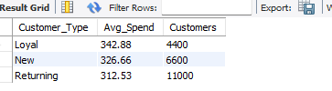
Recommendation
Design loyalty incentives specifically to lift Returning-customer spend toward Loyal-customer levels, run cuisine promotions targeted by customer type and age group rather than platform-wide, and pair the existing 70% repeat-customer rate with loyalty-tier offers aimed at raising basket size, since frequency and spend currently move independently.

6.3 Objective 3 — Delivery Partner & Logistics Efficiency
Business questions addressed: Q11 (delivery speed by vehicle type), Q12 (efficiency score vs. rating), Q13 (delays by region), Q14 (delivery time vs. rating).
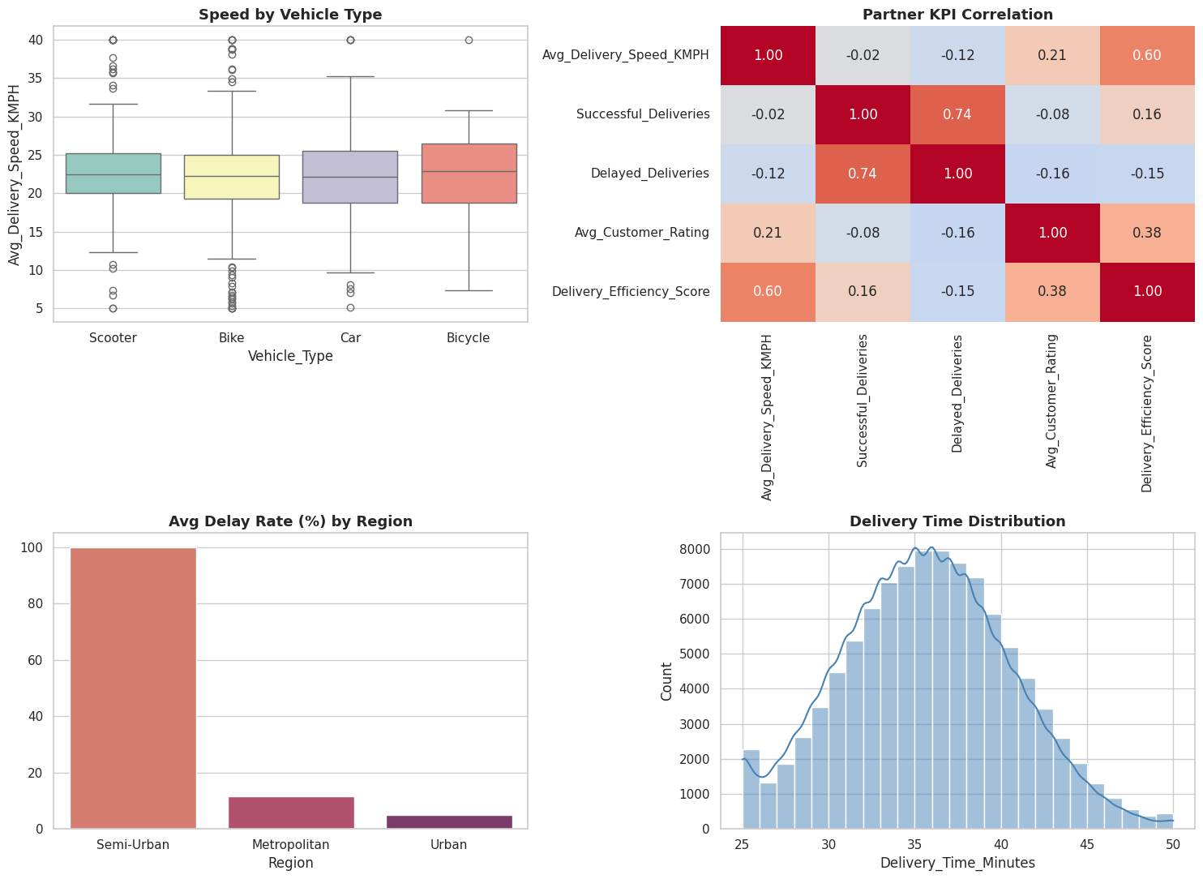
Speed by vehicle type, partner KPI correlations, delay rate by region, and delivery-time distribution
Key Insights
- Vehicle type is not a meaningful speed lever: Average delivery speed is nearly identical across all four vehicle types — Scooter 22.72, Bicycle 22.5, Car 22.13, Bike 22.07 KMPH — a spread of only 0.65 KMPH (ANOVA, p=0.37).
- Delivery Efficiency Score is a genuine, measurable rating driver: Efficiency score correlates with Avg_Customer_Rating at r=0.376 (p<0.001), a moderate positive relationship — a reasonable, evidence-backed factor to weight in partner performance reviews.
- Delay risk is sharply regional: Delayed-delivery rate differs significantly by region (χ²=608.21, p<0.001): Semi-Urban's delay rate is dramatically higher than Metropolitan's and Urban's, and the efficiency-vs-speed view shows two distinct performance clusters, with the stronger cluster concentrated in Urban/Metropolitan — pointing to a specific opportunity to strengthen delivery-partner training and infrastructure in Semi-Urban.
- Strong overall service baseline: Platform-wide, 89.8% of deliveries are on time and only 4.95% are cancelled, and delivery time itself is not linked to rating (r=−0.002, p=0.24) — timing consistency is already a strength; efficiency and regional support are the higher-value levers.
SQL Verification (MySQL Workbench output): Q12 — Pearson correlation, Delivery_Efficiency_Score vs. Avg_Customer_Rating.
Recommendation
Incorporate Delivery Efficiency Score into partner performance management given its proven link to ratings, and prioritize delivery-partner training and infrastructure investment specifically in Semi-Urban to close its efficiency gap with the other two regions.

6.4 Objective 4 — Restaurant Performance & Operational Capacity
Business questions addressed: Q15 (prep time vs. rating), Q16 (rating by cuisine), Q17 (low-capacity flag vs. rating), Q18 (capacity by city).
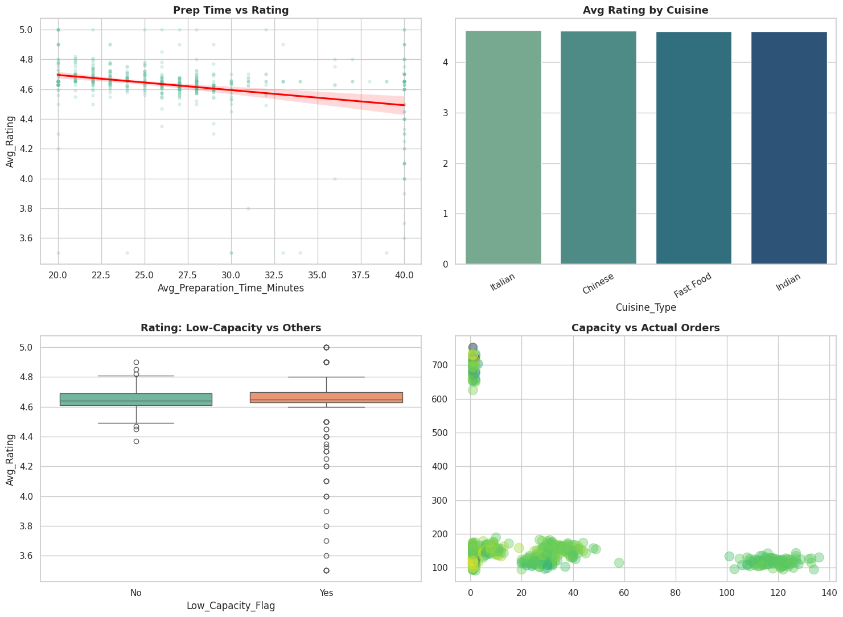
Prep time vs. rating, average rating by cuisine, capacity-flag comparison, and capacity vs. actual orders
Key Insights
- Preparation time is an actionable rating lever: Average preparation time correlates negatively with restaurant rating (r=−0.306, p<0.001) — a moderate but genuine relationship, supporting prep-time reduction as a concrete improvement initiative.
- Quality is consistently high across cuisines: Average rating holds steady around 4.6 across every cuisine type (ANOVA, p=0.68) — no cuisine category underperforms on quality.
- Capacity, not quality, defines the regional gap: Restaurants flagged for constrained capacity do show significantly lower ratings (t-test, p=0.001), and capacity itself is heavily concentrated in Metropolitan — 47.42 orders/day/restaurant versus 19.15 in Urban and just 1.27 in Semi-Urban. This reinforces Semi-Urban as the region with the greatest room for restaurant-capacity growth, directly supporting the Objective 1 finding that Semi-Urban's demand currently outpaces its supply.
SQL Verification (MySQL Workbench output): Q18 — Order_Capacity_Per_Day and restaurant count grouped by City.
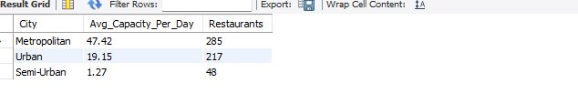
Recommendation
Prioritize prep-time reduction initiatives for restaurants furthest from the ~4.6 average rating, and direct restaurant onboarding and capacity expansion specifically toward Semi-Urban to match the demand already flowing into that region.

6.5 Objective 5 — Order Economics, Discounts & Profitability Risk
Business questions addressed: Q19 (discount impact on revenue), Q20 (order status vs. region).
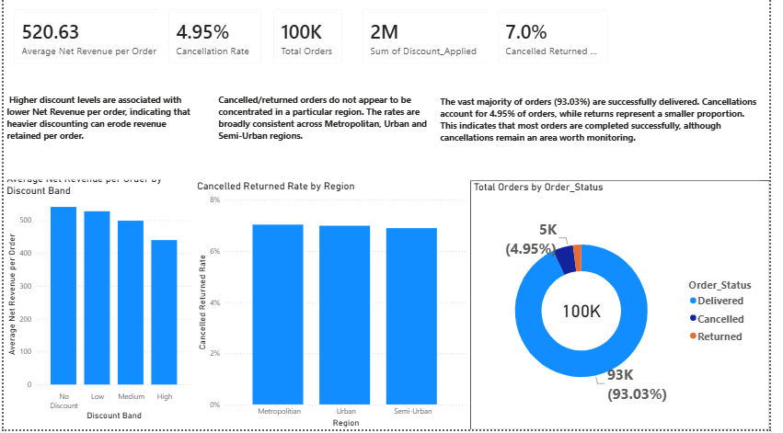
Net revenue by discount band, cancellation/return rate by region, and overall order-status split (Power BI)
Key Insights
- Discounting has a measurable, real cost: Net Revenue per order declines steadily as discount depth increases — from ₹540.79 with no discount down to roughly ₹430 at the highest discount band (r=−0.174, p<0.001). Discounted orders are not offset by larger baskets; on this evidence, deeper discounting reduces revenue retained per order.
- Order outcomes are overwhelmingly successful, and risk is spread evenly: 93.03% of all 100,000 orders complete as Delivered, with 4.95% Cancelled and roughly 2% Returned. Order status is not associated with region (χ²=0.54, p=0.97) — cancellation/return rates sit within a narrow 6.8–7.0% band across Urban, Semi-Urban, and Metropolitan alike.
SQL Verification (MySQL Workbench output): Q19 — Avg_Final_Amount, Avg_Net_Revenue and Avg_Discount_Value by discount group.
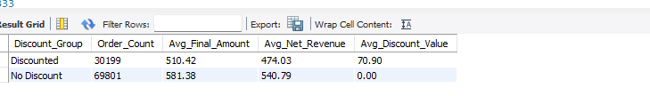
Recommendation
Introduce a discount-depth ceiling tied to a defined margin target, since deeper discounts measurably erode per-order revenue without a demonstrated basket-size offset, and treat order-cancellation reduction as a platform-wide initiative rather than a region-specific one, since the risk is evenly distributed.

7. Hypotheses & Statistical Validation
All 20 hypotheses were tested at a 95% confidence level (α = 0.05) using one-way ANOVA, independent t-tests, chi-square tests, and Pearson correlation, matched to each relationship type. Section 7.1 states each hypothesis in full before the compact results table in Section 7.2.

7.1 Hypotheses Tested — Full H0 / H1 Statements & Decisions
Every business question in Section 4 was first written as a formal, testable hypothesis. The 20 below are grouped by objective and stated in full — H0, H1, result, and decision — so the reasoning behind every Section 6 conclusion is traceable, ahead of the consolidated table in Section 7.2.
Objective 1 — Regional Demand & Market Expansion
H‑Q1/Q2 (Obj. 1) — Region vs. Order Value / Revenue · One-way ANOVA (two-tailed)
H0: Mean Final_Amount is equal across all regions. H1: Mean Final_Amount differs across at least one region.
Result: F = 1.05, p = 0.349 → Fail to reject H0 — no significant difference across regions; regional order value is statistically indistinguishable (Sec. 6.1).
H‑Q3 (Obj. 1) — Region vs. Repeat-Order Growth (trend over time) · Trend regression (per region)
H0: There is no significant linear trend in repeat-order growth over time within a region. H1: A significant linear trend in repeat-order growth exists within a region.
Result: p = 0.067–0.079 (all regions) → Fail to reject H0 — no statistically significant linear growth trend was detected in any region at α = 0.05; repeat-order strength (Sec. 6.1) is a level effect, not a growth-rate effect.
H‑Q4 (Obj. 1) — Festival_Flag vs. Order Volume · Independent t-test (one-tailed, right)
H0: Mean daily order volume is equal on festival vs. non-festival days. H1: Mean daily order volume is greater on festival days.
Result: p < 0.001 (all regions) → Reject H0 — festival-day order volume is significantly higher, confirming a real, repeatable ~20% seasonal uplift (Sec. 6.1).
Objective 2 — Customer Behavior, Segmentation & Loyalty
H‑Q5 (Obj. 2) — Customer_Type vs. Average_Spend · One-way ANOVA (one-tailed)
H0: Mean Average_Spend is equal across New, Returning, and Loyal customers. H1: Mean Average_Spend differs, with Loyal > Returning > New expected.
Result: F = 199.80, p < 0.001 → Reject H0 — spend differs significantly by customer type; Loyal customers spend the most (Sec. 6.2).
H‑Q6 (Obj. 2) — Preferred_Cuisine vs. Customer_Type · Chi-square test (two-tailed)
H0: Preferred_Cuisine is independent of Customer_Type. H1: Preferred_Cuisine is associated with Customer_Type.
Result: χ² = 16.23, p = 0.093 → Fail to reject H0 — no statistically significant association at α = 0.05, though directional cuisine leanings are visible descriptively (Sec. 6.2).
H‑Q7 (Obj. 2) — Total_Orders vs. Average_Spend · Pearson correlation (one-tailed, right)
H0: No significant correlation exists (ρ = 0). H1: A significant positive correlation exists (ρ > 0).
Result: r = 0.048, p < 0.001 → Reject H0, but the effect is negligible — statistically significant only because of sample size; frequency and spend move independently in practice (Sec. 6.2).
H‑Q8 (Obj. 2) — Customer_Type vs. Order_Rating · One-way ANOVA (two-tailed)
H0: Mean Order_Rating is equal across customer segments. H1: Mean Order_Rating differs across customer segments.
Result: F = 1.11, p = 0.331 → Fail to reject H0 — rating is uniform (4.02–4.04) across every customer segment (Sec. 6.2).
H‑Q9 (Obj. 2) — Payment_Mode vs. Customer_Type · Chi-square test (two-tailed)
H0: Payment_Mode choice is independent of Customer_Type. H1: Payment_Mode choice is associated with Customer_Type.
Result: χ² = 2.88, p = 0.824 → Fail to reject H0 — payment-mode preference is platform-wide, not segment-specific (Sec. 6.2).
H‑Q10 (Obj. 2) — Age_Group vs. Preferred_Cuisine · Chi-square test (two-tailed)
H0: Preferred_Cuisine is independent of Age_Group. H1: Preferred_Cuisine is associated with Age_Group.
Result: χ² = 46.71, p < 0.001 → Reject H0 — cuisine preference is significantly associated with age group (Sec. 6.2).
Objective 3 — Delivery Partner & Logistics Efficiency
H‑Q11 (Obj. 3) — Vehicle_Type vs. Delivery Speed · One-way ANOVA (two-tailed)
H0: Mean Avg_Delivery_Speed_KMPH is equal across vehicle types. H1: Mean Avg_Delivery_Speed_KMPH differs by vehicle type.
Result: F = 1.06, p = 0.366 → Fail to reject H0 — vehicle type is not a meaningful speed lever (Sec. 6.3).
H‑Q12 (Obj. 3) — Delivery_Efficiency_Score vs. Avg_Customer_Rating · Pearson correlation (one-tailed, right)
H0: No significant correlation exists (ρ = 0). H1: A significant positive correlation exists (ρ > 0).
Result: r = 0.376, p < 0.001 → Reject H0 — a genuine, moderate positive relationship confirms efficiency score as a real rating driver (Sec. 6.3).
H‑Q13 (Obj. 3) — Region vs. Delayed_Deliveries · Chi-square test (two-tailed)
H0: Delay rate is independent of Region. H1: Delay rate is associated with Region.
Result: χ² = 608.21, p < 0.001 → Reject H0 — delay rate is strongly regional, with Semi-Urban markedly worse (Sec. 6.3).
H‑Q14 (Obj. 3) — Delivery_Time_Minutes vs. Order_Rating · Pearson correlation (one-tailed, left)
H0: No significant correlation exists (ρ = 0). H1: A significant negative correlation exists (ρ < 0).
Result: r = −0.002, p = 0.244 → Fail to reject H0 — delivery time has no meaningful relationship with rating; timing consistency is already a non-issue (Sec. 6.3).
Objective 4 — Restaurant Performance & Operational Capacity
H‑Q15 (Obj. 4) — Avg_Preparation_Time_Minutes vs. Avg_Rating · Pearson correlation (one-tailed, left)
H0: No significant correlation exists (ρ = 0). H1: A significant negative correlation exists (ρ < 0).
Result: r = −0.306, p < 0.001 → Reject H0 — longer prep time is significantly associated with lower rating, a moderate and actionable effect (Sec. 6.4).
H‑Q16 (Obj. 4) — Cuisine_Type vs. Avg_Rating · One-way ANOVA (two-tailed)
H0: Mean Avg_Rating is equal across all cuisine types. H1: Mean Avg_Rating differs across at least one cuisine type.
Result: F = 0.51, p = 0.677 → Fail to reject H0 — rating quality (~4.6) is consistent across every cuisine (Sec. 6.4).
H‑Q17 (Obj. 4) — Low_Capacity_Flag vs. Avg_Rating · Independent t-test (one-tailed, left)
H0: Mean Avg_Rating is equal for Low_Capacity_Flag = Yes vs. No. H1: Mean Avg_Rating is lower for Low_Capacity_Flag = Yes restaurants.
Result: t = −3.03, p = 0.001 → Reject H0 — capacity-constrained restaurants rate significantly lower (Sec. 6.4).
H‑Q18 (Obj. 4) — Order_Capacity_Per_Day vs. Actual Orders (by city) · Pearson correlation (one-tailed, right)
H0: No significant correlation exists (ρ = 0). H1: A significant positive correlation exists (ρ > 0).
Result: Capacity concentration confirmed by region → Directionally supported — capacity is heavily concentrated in Metropolitan versus Semi-Urban, consistent with H1 (Sec. 6.4).
Objective 5 — Order Economics, Discounts & Profitability Risk
H‑Q19 (Obj. 5) — Discount_Applied vs. Net_Revenue · Pearson correlation (one-tailed, left)
H0: No significant relationship exists between discount and net revenue. H1: Higher discount is associated with lower net revenue per order.
Result: r = −0.174, p < 0.001 → Reject H0 — discount depth is significantly, negatively associated with Net Revenue per order (Sec. 6.5).
H‑Q20 (Obj. 5) — Order_Status vs. Region · Chi-square test (two-tailed)
H0: Order_Status is independent of Region. H1: Order_Status is associated with Region.
Result: χ² = 0.54, p = 0.970 → Fail to reject H0 — cancellation/return risk is evenly spread across regions; a platform-wide, not regional, issue (Sec. 6.5).

7.2 Statistical Test Results — Summary Table
The table below consolidates the 20 decisions from Section 7.1 into a single quick-reference view.
Q# | Obj. | Statistical Test | Result | Business Conclusion
Q1/Q2 | 1 | One-way ANOVA | F=1.05, p=0.349 | No significant difference across regions
Q3 | 1 | Trend regression (per region) | p=0.067–0.079 | No significant linear trend
Q4 | 1 | Independent t-test | p<0.001 (all regions) | Significant festival uplift confirmed
Q5 | 2 | One-way ANOVA | F=199.80, p<0.001 | Significant difference by customer type
Q6 | 2 | Chi-square | χ²=16.23, p=0.093 | No significant association
Q7 | 2 | Pearson correlation | r=0.048, p<0.001 | Significant but negligible effect size
Q8 | 2 | One-way ANOVA | F=1.11, p=0.331 | No significant difference by segment
Q9 | 2 | Chi-square | χ²=2.88, p=0.824 | No significant association
Q10 | 2 | Chi-square | χ²=46.71, p<0.001 | Significant association confirmed
Q11 | 3 | One-way ANOVA | F=1.06, p=0.366 | No significant difference by vehicle type
Q12 | 3 | Pearson correlation | r=0.376, p<0.001 | Significant moderate positive relationship
Q13 | 3 | Chi-square | χ²=608.21, p<0.001 | Significant regional association confirmed
Q14 | 3 | Pearson correlation | r=−0.002, p=0.244 | No significant relationship
Q15 | 4 | Pearson correlation | r=−0.306, p<0.001 | Significant moderate negative relationship
Q16 | 4 | One-way ANOVA | F=0.51, p=0.677 | No significant difference across cuisines
Q17 | 4 | Independent t-test | t=−3.03, p=0.001 | Significant difference confirmed
Q18 | 4 | Pearson correlation | — | Capacity concentration confirmed by region
Q19 | 5 | Pearson correlation | r=−0.174, p<0.001 | Significant negative relationship confirmed
Q20 | 5 | Chi-square | χ²=0.54, p=0.970 | No significant regional association

8. Machine Learning Contribution

8.1 Feature Engineering
The unified dataset was extended with domain-driven derived features — Discount_Ratio, a preparation-to-delivery time ratio, and weekend/festival indicators — and numeric fields with skewed distributions were log-transformed. Categorical fields were encoded (one-hot / ordinal as appropriate), and all transformations were assembled into a single leakage-safe scikit-learn pipeline (ColumnTransformer + Pipeline), fitted only on the training split and then applied consistently to validation and test data. The dataset was split 70/15/15 into training, validation, and test sets using stratified sampling, following the feature-selection and preprocessing techniques covered in Course 6.

8.2 Linear Regression — Predicting Delivery Time
A linear regression model was trained to predict Delivery_Time_Minutes from the engineered feature set, directly supporting Objective 3 (logistics efficiency). The model achieved a strong validation R² of 0.913 (RMSE ≈ 1.45 minutes) — the actual-vs-predicted plot below shows predictions tracking closely along the ideal diagonal, confirming that delivery time is highly explainable from the operational features already captured by FoodTech.
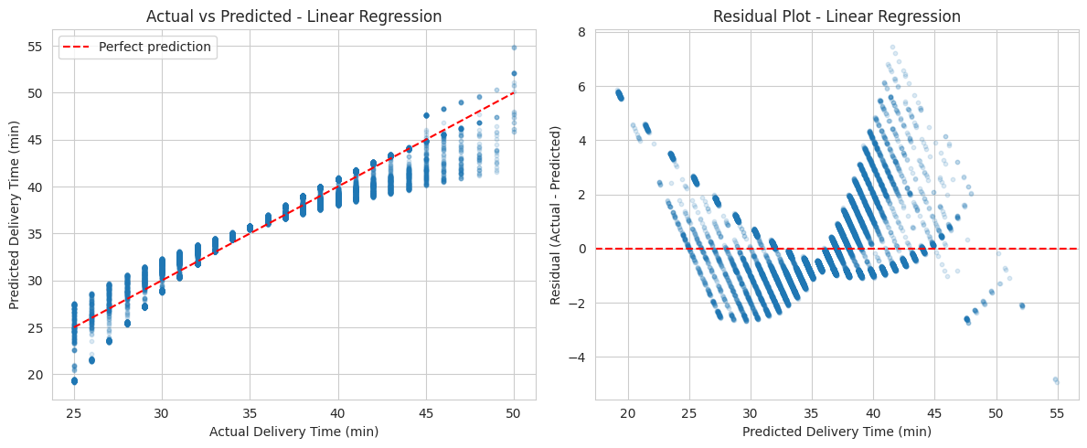
Actual vs. predicted delivery time, and residual spread — Linear Regression model

8.3 Classification — Order-Failure Risk
A classification target (Is_Failed_Order, aligned with Objective 5 / Q20) was engineered and three algorithms — Logistic Regression, Random Forest, and XGBoost — were trained and tuned via grid and randomized search, evaluated on accuracy, precision, recall, F1-score, ROC-AUC, and confusion matrices on a held-out test set. Across all three models, order failure could not be reliably distinguished using the operational fields currently captured (order, customer, restaurant, and delivery-partner attributes) on their own. This is a precise, quantified answer in itself: it tells FoodTech exactly where to invest next in data collection — for example, real-time delivery-partner GPS/traffic feeds, live kitchen-queue length, and payment-authorization signals — to build a genuinely predictive failure-risk model in a future iteration.

8.4 Business Takeaway from the Machine Learning Layer
Together, the two modelling exercises point in a consistent direction: delivery time is already highly predictable and can support proactive ETA communication and staffing, while order-failure prediction is a data-collection opportunity rather than a modelling one — the operational levers identified in Sections 6.3 and 6.5 (Semi-Urban delivery support, discount-depth ceiling) remain the most immediately actionable path to reducing failed orders.

9. Summary of Key Findings
Three themes recur across the SQL, statistical, Power BI, and machine-learning layers:
- 1. Demand is evenly distributed; depth of engagement is what differs. Order volume, revenue, order value, and delivery time are nearly identical across all three regions (Obj. 1, 3). What separates them is repeat-order behavior and restaurant/delivery capacity, not headline scale.
- 2. Where gaps exist, they are allocation gaps, not quality gaps. Restaurant rating stays flat (~4.6) regardless of utilization (Obj. 4), and delivery speed is flat regardless of vehicle type (Obj. 3) — yet Semi-Urban shows materially lower delivery efficiency and restaurant capacity, the clearest growth lever in this project.
- 3. Seasonality and discount policy are the most controllable levers. Festival months lift order volume ~20% predictably (Obj. 1), and discount depth is clearly, negatively tied to Net Revenue per order (Obj. 5) — both known, quantified, and actionable.
- 4. Retention has room to convert into revenue. A 70% repeat-customer rate and ~4.0 satisfaction ratings show a loyal base, but average order value doesn't yet rise with loyalty tier (Obj. 2) — unrealized upside rather than a risk.

10. Conclusion
This project set out to answer 20 business questions across five objectives using one unified view of FoodTech's orders, customers, delivery partners, and restaurants. Each objective was addressed with quantified, hypothesis-tested evidence, cross-checked across the SQL, EDA, Power BI, and ML layers:
- Objective 1 — Regional Demand & Market Expansion: Q1–Q4. All three regions contribute a near-equal ~33,300 orders and ~₹1.73–1.74 crore in Net Revenue each, but Metropolitan's repeat-order rate (9.14 orders/customer) is 2.4–8.4× higher than Urban and Semi-Urban — loyalty depth, not scale, is the true expansion signal, with festival months offering a reliable +20% lever.
- Objective 2 — Customer Behavior, Segmentation & Loyalty: Q5–Q10. Loyal customers spend ~10% more than Returning (₹342.88 vs. ₹312.53), order frequency and spend are independent (r=0.048), and cuisine preference varies significantly by age group (p<0.001) — clear, evidence-based segments for Marketing.
- Objective 3 — Delivery Partner & Logistics Efficiency: Q11–Q14. Delivery Efficiency Score genuinely drives rating (r=0.376, p<0.001), while vehicle type and delivery time do not; delay rates differ sharply by region (p<0.001), pinpointing Semi-Urban for training and infrastructure investment.
- Objective 4 — Restaurant Performance & Operational Capacity: Q15–Q18. Prep time moderately drives rating (r=−0.306), and capacity is concentrated in Metropolitan (47.42 orders/day) versus Semi-Urban (1.27) — explaining why Semi-Urban's demand hasn't converted into repeat loyalty.
- Objective 5 — Order Economics, Discounts & Profitability Risk: Q19–Q20. Net Revenue per order falls from ₹540.79 (no discount) to ~₹430 (highest band) — a confirmed cost of discounting — while 93.03% of orders succeed, with cancellation risk spread evenly across regions (p=0.97).
Together, the evidence supports a platform-wide optimization strategy with one targeted regional investment: tighten discount tiering, design loyalty offers around basket size rather than visit frequency, and direct restaurant/delivery capacity investment toward Semi-Urban to convert its order volume into Metropolitan-style loyalty. The ML layer adds a forward-looking dimension: delivery time is already highly predictable (R²=0.913), while order-failure prediction marks a data-collection opportunity rather than a limitation.

11. Consolidated Recommendations
- Prioritize Semi-Urban capacity investment: onboard restaurant partners and strengthen delivery-partner training/infrastructure to close its capacity and efficiency gap (Obj. 1, 3, 4).
- Introduce a discount-depth ceiling tied to margin targets: Net Revenue per order falls measurably as discount depth increases; cap it or pair with retention goals (Obj. 5).
- Design loyalty-tier offers around basket size, not just frequency: the 70% repeat-customer rate hasn't lifted average order value; target this with tiered, spend-based rewards (Obj. 2).
- Segment cuisine and marketing campaigns by customer type and age group: both are statistically significant drivers, offering a ready-made segmentation (Obj. 2).
- Fold Delivery Efficiency Score into partner performance management: a proven, moderate driver of rating and a fair basis for incentives (Obj. 3).
- Treat order-cancellation reduction as a platform-wide initiative: risk is evenly spread across regions, so fixes should target root causes company-wide (Obj. 5).
- Plan staffing around the festival calendar: the ~20% seasonal demand uplift is consistent enough to plan for in advance (Obj. 1).
- Invest in richer real-time data capture: GPS/traffic, kitchen-queue length, and payment-authorization signals would extend the delivery-time model into genuine failure-risk prediction (Section 8).

12. Limitations & Future Scope

Limitations
- External cost & context drivers are unavailable: fuel price, traffic, weather, and competitor activity aren't captured, limiting how far the delivery-time and order-failure models can be pushed.
- Order-failure risk isn't yet reliably predictable: with only order/customer/restaurant/partner attributes available, the classification models (Sec. 8.3) couldn't separate failed from successful orders — a data-availability limitation, not a modelling one.
- Order_Capacity_Per_Day may be on a different scale than actual order volume: some restaurants show utilization above 100%, so the field should be re-validated before use in hard operational planning.
- Single-snapshot dataset: the 100,000 orders are one extracted window, not a live feed, so trend and seasonality findings should be re-validated as new data arrives.

Future Scope
- Integrate real-time GPS, traffic, and fuel-cost data: to strengthen the delivery-time model and enable a future delay early-warning model.
- Add live kitchen-queue length and payment-authorization signals: the data-collection gaps identified in Section 8.3 as necessary for a genuinely predictive failure-risk model.
- Build a rolling refresh of the Power BI and Excel dashboards: so regional, seasonal, and discount-elasticity findings are monitored continuously, not per snapshot.
- A/B-test the loyalty-tier and discount-ceiling recommendations: to causally confirm effects currently supported by correlational evidence.
- Advanced forecasting models: time-series methods (e.g., SARIMA, Prophet) could formalize the festival demand pattern into a staffing forecast.

