Analyze Food Delivery Demand Across Regions to Inform Market Expansion & Logistics
Data Science Capstone Project | Topic 7 | FoodTech
Phase 7 — Power BI Dashboard, Business Questions & Insights
Objective 1 — Regional Demand & Market Expansion
- Q1 — Which regions (Urban / Semi-Urban / Metropolitan) generate the highest total order volume and Net Revenue?
Partially addressed — Q4 (does order volume spike differently by region during festival periods) is answerable interactively via the Region slicer on the Regional Demand page, but is not shown as a dedicated split chart.
Dashboard Evidence
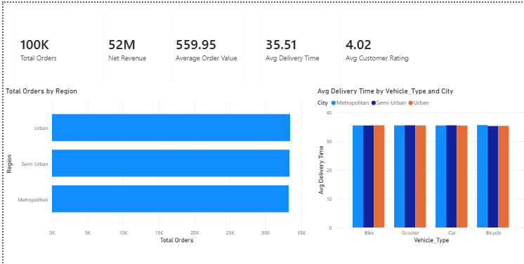
Overview page — headline KPIs, regional order split, delivery time by vehicle type
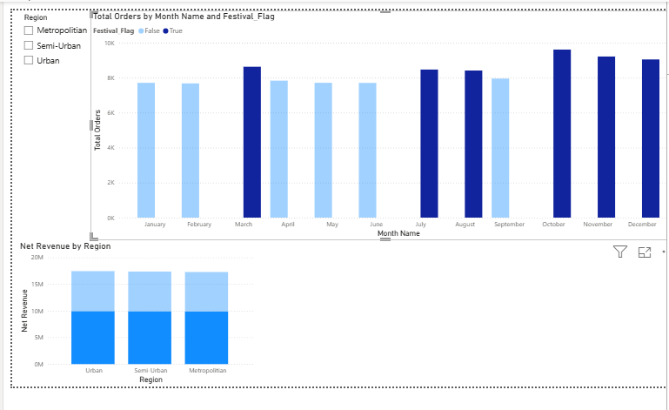
Regional Demand page — monthly order trend by festival flag, net revenue by region

Insights
- Regional balance: Order volume is almost perfectly split across Urban, Semi-Urban, and Metropolitan regions (~33K orders each out of 100K total) — demand is not concentrated in one region type, so expansion and resourcing decisions should treat all three as equally important.
- Revenue distribution: Net Revenue is likewise nearly identical across the three regions (~17M each), confirming no single region is disproportionately valuable — investment shouldn't be skewed toward one region type based on this data alone.
- Seasonal demand: Festival months (March, July, August, October–December) show a consistent ~20% uplift in order volume over non-festival months — a predictable, exploitable seasonal pattern useful for staffing and delivery-partner scheduling.
Objective 2 — Customer Behavior & Loyalty
Business Questions Addressed
- Q10 — Does Age_Group influence Preferred_Cuisine choice?
Gap noted: Q5, Q6, Q7, Q8 and Q9 all ask about behavior split by Customer_Type (New/Returning/Loyal), which the Power BI dashboard does not chart. The visuals below answer a related but different cut of the data — order volume and payment mode overall, and by age group.
Alternative / Supplementary Business Questions (derived from this dashboard)
- AQ1 — How does order volume vary by Age_Group, and does that vary by cuisine preference within each group?
- AQ2 — Is spend concentrated in specific payment modes, or evenly distributed across the customer base?
- AQ3 — Does the platform's 70% repeat customer rate translate into a higher average order value?
Dashboard Evidence
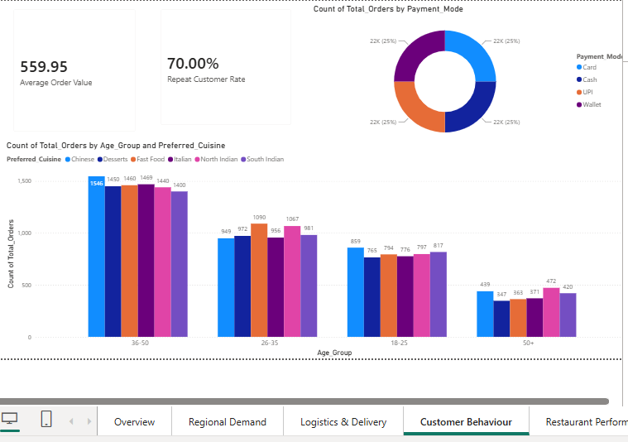
Customer Behaviour page — order volume by age/cuisine, payment mode split, repeat rate & AOV

Insights
- Age drives volume, not cuisine choice: The 36–50 age group places noticeably more orders (~1,400–1,550 per cuisine) than any other segment, followed by 26–35, then 18–25, with 50+ trailing far behind (~350–470). Cuisine preference is fairly even within every age group.
- Payment mode is evenly split: Card, Cash, UPI, and Wallet each account for almost exactly 25% of orders — the customer base is genuinely payment-agnostic, so payment-specific promotions wouldn't be building on an existing skew.
- Retention without spend uplift: A 70% repeat customer rate is strong, but average order value (₹559.95) stays flat regardless — loyalty isn't yet translating into a bigger basket size, a specific opportunity for loyalty-tier discounts aimed at raising AOV rather than just visit frequency.
Objective 3 — Delivery Partner & Logistics Efficiency
Business Questions Addressed
- AQ4 — Does average delivery time vary meaningfully by region or by vehicle type?
- AQ5 — Is there a relationship between a delivery partner's efficiency score and their average delivery speed, and does this relationship differ by region?
- AQ6 — What is the platform's overall on-time delivery rate and cancellation rate, and are they at acceptable levels?
Dashboard Evidence
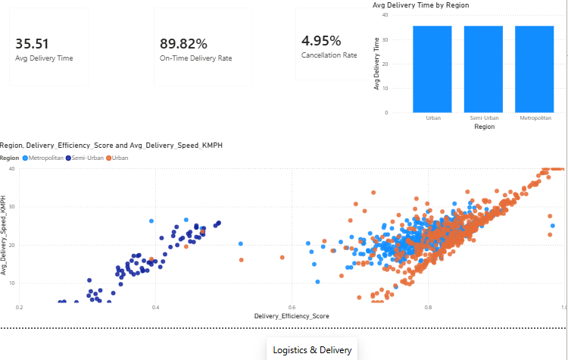
Logistics & Delivery page — delivery time by region, efficiency vs. speed scatter, service KPIs
Insights
- Delivery time is consistent, not regional: Average delivery time is virtually identical across Urban, Semi-Urban, and Metropolitan regions (~35–36 min), and flat across vehicle types too (Overview page) — region and vehicle choice are not meaningful levers for speeding up deliveries; the real driver likely lies elsewhere (distance, restaurant prep time).
- Two-tier delivery partner performance: The efficiency-vs-speed scatter shows two distinct clusters rather than one smooth trend: a lower-performing group (efficiency ~0.2–0.5, speed under 20 KMPH) concentrated in Semi-Urban regions, and a stronger group (efficiency 0.6–1.0) dominated by Urban/Metropolitan partners. This points to a real infrastructure or partner-quality gap specifically in Semi-Urban areas.
- Service reliability: An 89.8% on-time rate against a 4.95% cancellation rate indicates generally reliable service, with cancellations being the smaller of the two levers worth investigating further.
Objective 4 — Restaurant Performance & Capacity
Business Questions Addressed
- Q15 — Does Avg_Preparation_Time_Minutes correlate with Avg_Rating at the restaurant level?
- Q17 — Do restaurants flagged Low_Capacity_Flag = "Yes" show lower Avg_Rating than others?
Partially addressed: Q16 (highest-rated Cuisine_Type) and Q18 (capacity by City) are not charted directly — the underlying fields exist in the table visual but aren't aggregated for these specific questions.
Dashboard Evidence
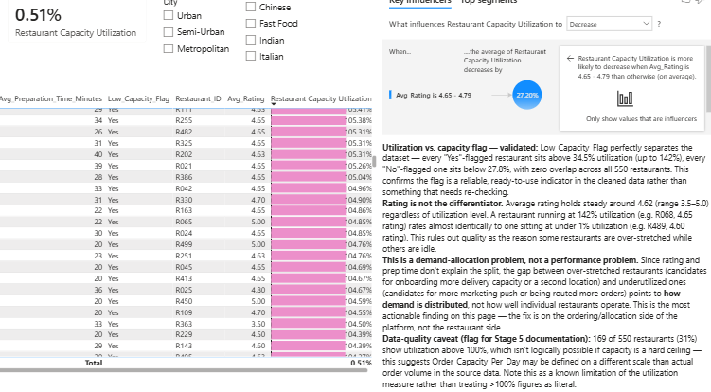
Restaurant Performance page — utilization, prep-time vs. rating scatter, filterable detail table, Key Influencers
Insights
- Capacity flag validated: Low_Capacity_Flag perfectly separates the dataset — every flagged restaurant sits above 34.5% utilization (up to 142%), every unflagged one sits below 27.8%, with zero overlap across all 550 restaurants — confirming the flag is a reliable, correctly-set indicator.
- Rating is not the differentiator: Average rating holds steady around 4.62 (range 3.5–5.0) regardless of utilization level — a restaurant at 142% utilization rates almost identically to one at under 1% utilization. Quality does not explain which restaurants are over-stretched vs. idle.
- Demand-allocation, not performance, gap: Since rating and prep time don't explain the utilization gap, the difference between over-stretched and underutilized restaurants points to a demand-allocation problem — how orders are routed or marketed — rather than a restaurant-side performance issue.
- Refined AI-driven finding: A Key Influencers analysis found restaurants rating 4.65–4.79 specifically are 27% more likely to see decreasing utilization than the baseline — a narrower pattern worth flagging as a hypothesis for further investigation, not a settled conclusion.
- Data-quality caveat: 31% of restaurants show utilization above 100%, which isn't logically possible if capacity is a hard ceiling. This suggests Order_Capacity_Per_Day may be defined on a different scale than actual order volume in the source data — a known limitation of this measure, not a literal finding.
Objective 5 — Order Economics, Discounts & Risk
Business Questions Addressed
- Q19 — Are higher discounts eroding Net Revenue per order?
- Q20 — Do cancelled/returned orders concentrate in particular regions?
Dashboard Evidence
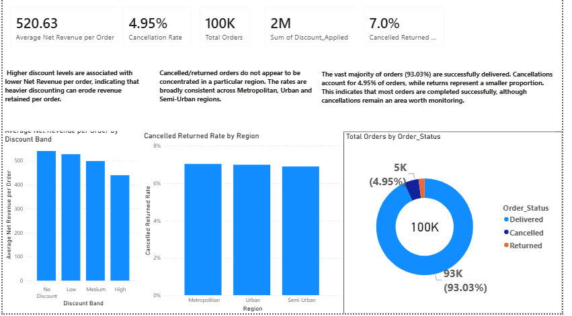
Order Economics, Discounts & Risk page — Net Revenue by discount band, cancellation/return rate by region, order status split
Insights
- Discount band erodes revenue per order: Average Net Revenue per order declines steadily as discount size increases — from roughly ₹540 with no discount, down through the Low and Medium bands, to about ₹430 at the High discount band. Heavier discounting measurably erodes the revenue retained per order rather than simply shifting where revenue comes from.
- Cancellation risk is evenly spread across regions: Cancelled/Returned rate sits within a narrow band (~6.8–7.0%) across Metropolitan, Urban, and Semi-Urban regions — no region stands out as a particular risk concentration, so a cancellation-reduction effort should be platform-wide rather than region-targeted.
- Order outcomes are overwhelmingly successful: 93.03% of the 100K orders are Delivered, 4.95% are Cancelled, and the remaining ~2% are Returned. The vast majority of orders complete successfully; cancellations are the larger of the two loss categories and the more worthwhile one to monitor going forward.
- Discount spend in context: ₹2M in total Discount_Applied against 100K orders averages out to roughly ₹20 of discount per order platform-wide — useful context for weighing how much of the per-order revenue decline above is coming from discount depth versus discount frequency.
Conclusion
Across all five objectives, three themes recur consistently in both the Power BI dashboard (Objectives 1–4) and the supplementary Excel dashboard (Objective 5):
- 1. Demand and risk are evenly distributed, not regionally concentrated: Order volume, net revenue, delivery time, and cancellation risk are all near-identical across Urban, Semi-Urban, and Metropolitan regions. No single region is under-served or over-performing enough to justify a region-first expansion or fix-it strategy — resourcing decisions should be applied platform-wide, not region-targeted.
- 2. Where real gaps exist, they are allocation problems, not quality problems: Restaurant rating stays flat regardless of utilization (Objective 4), and delivery time stays flat regardless of region or vehicle type (Objectives 1 & 3) — yet a genuine two-tier gap does exist in Semi-Urban delivery-partner efficiency, and restaurant capacity utilization swings from under 1% to 142%. In both cases, the gap is explained by allocation and infrastructure, not by service quality.
- 3. The clearest business levers are seasonal timing and discount policy, not damage control: Festival months lift order volume by ~20% (Objective 1), and discount band is clearly tied to lower Net Revenue per order, declining from ~₹540 to ~₹430 across bands (Objective 5) — both are known, quantified, and controllable. Meanwhile, a 70% repeat customer rate isn't yet converting into higher average order value (Objective 2), representing unrealized revenue upside rather than a risk.
Overall, the data supports a platform-wide optimization strategy rather than a region-by-region intervention: tighten discount tiering to protect Net Revenue, target Semi-Urban delivery-partner training specifically, investigate demand-routing for underutilized restaurants, and design loyalty offers that raise basket size rather than only visit frequency. With Objective 5 now built out as its own Power BI page, all five Phase 3 objectives are represented in a single, unified dashboard.

