Victor Yamaykin

IST659 Lab02

4/16/21

Lab 02 – Conceptual Modeling

Case Study 1 – College Classes Modeling:

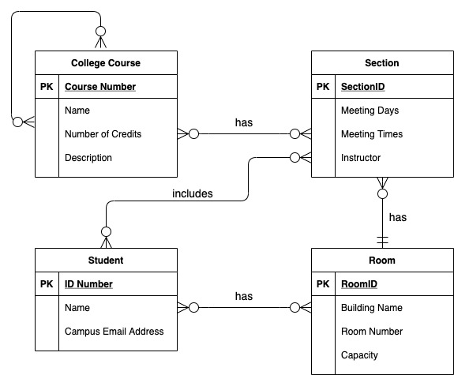

Case Study 2 – Project Management:

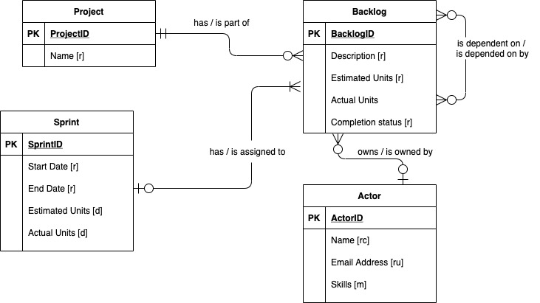

Case Study 3: Book Publishing Database:

|  |  |
| --- | --- |
| **Entity** | **Attribute** |
| Publisher | Publisher Name [ru]  Publisher Address ID [r]  Publisher Phone Number [r] |
| Book | Publisher Name [r]  ISBN [ru]  Book Title [r]  Book Price [r]  Number of Pages [r] |
| Author | Author ID [ru]  ForeName[rc]  Surname [rc]  Author Address ID [r] |
| AuthorBook | Author ID [r]  ISBN [ru]  Royalty Rate [r]  Check ID [ru] |
| Check | Check ID [ru]  Check Amount [r]  Check Issued Date [r]  Author ID [r] |
| Address | Address ID [ru]  Address Line 1 [rc]  Address Line 2 [rc]  Address City [rc]  Address State / Province / Region [rc]  Address Country [rc]  Address Zip / Postal Code [r] |
| **Relationships** | |
| A **Publisher** has 1 and only 1 unique name. A **Publisher** is at 1 and only 1 **Address**.  A **Book** has 1 and only 1 **Publisher**. A **Publisher** publishes 1 or many optional **Book**.  Each **Book** belongs to 1 or many mandatory **Author**. An **Author** writes 1 or many optional **Book**.  Each **Author** has 1 or more Royalty Rate. Each **Royalty Rate** is for 1 and only 1 **Author**.  A **Royalty Rate** is for 1 and only 1 **Author**. Each **Author** has 1 and only 1 check for each **Book**.  Each **Check** belongs to 1 and only 1 **Author**. Each **Author** has 1 or more optional **Check**. | |

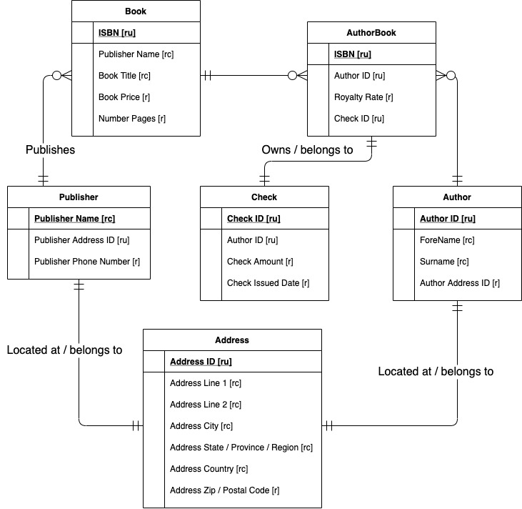

Part 2: VidCast Conceptual Model

|  |  |
| --- | --- |
| **Entity** | **Attribute** |
| User | User ID [ru]  User Name [ru]  Email Address [ru]  Description [o]  User URL [o]  User Tags [m]  Following [m]  Followed By [m] |
| Tag | Tag ID [ru]  Tag Name [r]  User ID [ru]  Vidcast ID [ru] |
| VidCast | VidCast ID [ru]  Title [r]  User ID [ru]  Start DateTime [o]  Projected Duration [o]  VidCast Tags [m] |
| Recording | VidCast ID [ru]  VidCast URL [ru]  Start DateTime [r]  End DateTime [r]  Actual Duration [d]  Status [r] |
| **Relationships** | |
| Each **User** has 1 and only 1 name and email address. A **User’s** profile is identified by 1 or more **Tag.**  A **User** has 0 or more followers who are also a **User**. A **User** follows 0 or more **User**.  A **User** records 1 or more optional **VidCast**. Each **VidCast** is recorded by 1 and only 1 **User.**  A **VidCast** contains 1 or more **Tag.** A **Tag** describes 1 or more **User** or **VidCast**.  Each **VidCast** has 1 and only 1 **Recording**. | |

