Victor Yamaykin

IST 659 Lab 03 – Logical Models

Case Study 1: College Course Database

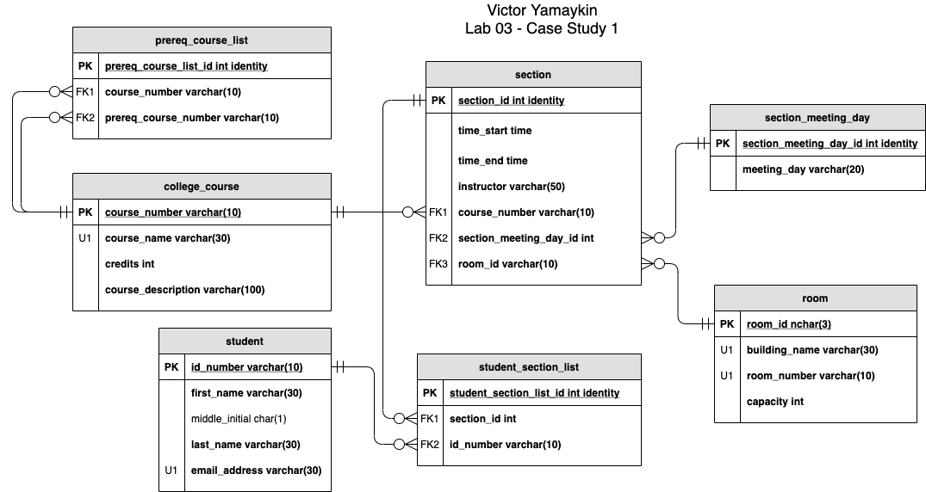

Case Study 2: Agile Project Management

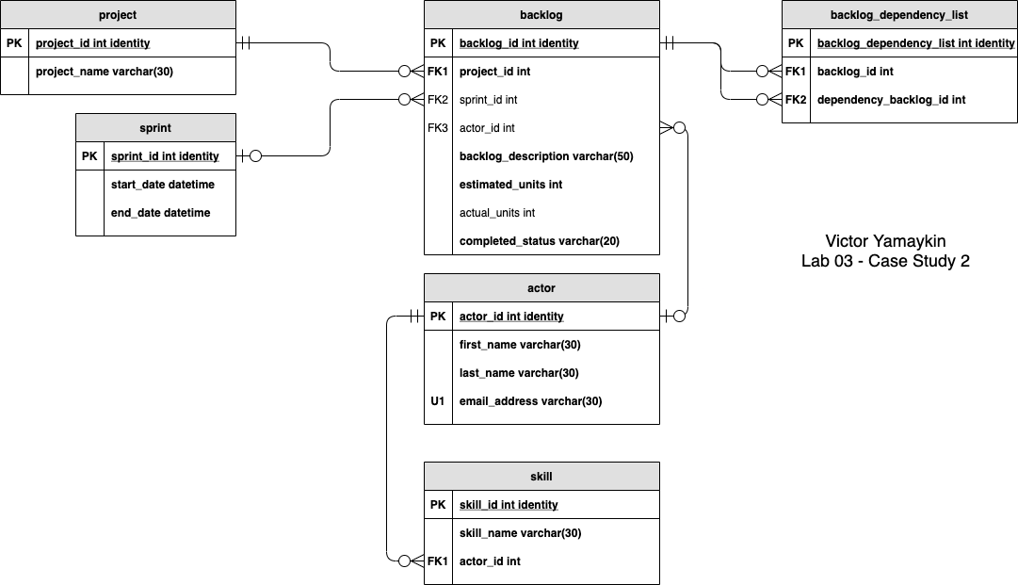

Case Study 03: Book Publisher Database

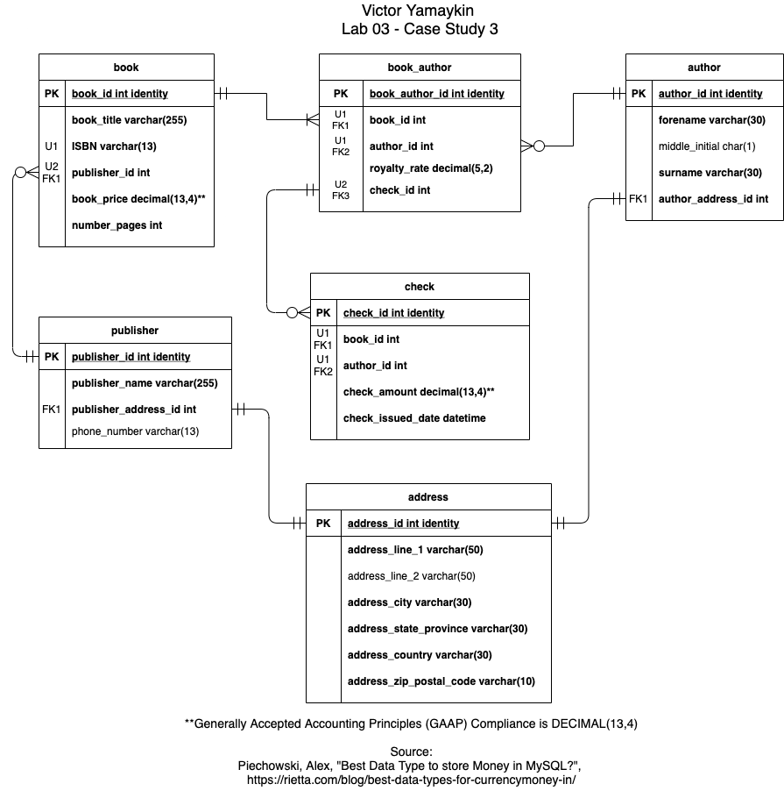

Case Study 04: VidCast Logical Model

