Victor Yamaykin

IST659 M407

05/05/2021

User Table

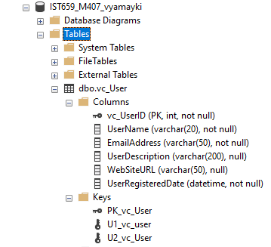

User Login Table

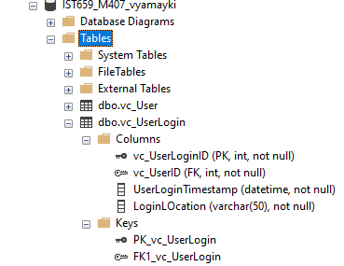

User Records

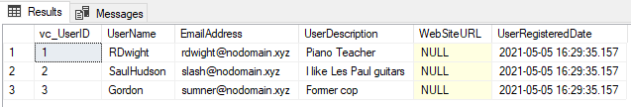

User Tables

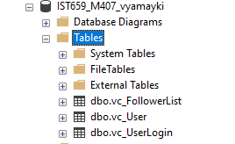

VidCast Tables

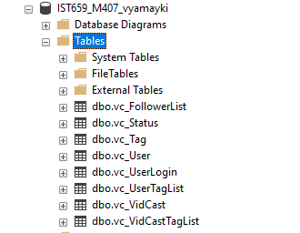

SQL Query File

/*

Author : Victor Yamaykin

Title : Lab 05

Course : IST659 M407

Term : April, 2021

*/

-- Drop tables

DROP TABLE IF EXISTS vc_UserTagList

DROP TABLE IF EXISTS vc_VidCastTagList

DROP TABLE IF EXISTS vc_VidCast

DROP TABLE IF EXISTS vc_Status

DROP TABLE IF EXISTS vc_Tag

DROP TABLE IF EXISTS vc_FollowerList

DROP TABLE IF EXISTS vc_UserLogin

DROP TABLE IF EXISTS vc_User

-- Creating the User table

CREATE TABLE vc_User (

-- Columns for the User table

vc_UserID int identity

, UserName varchar(20) not null

, EmailAddress varchar(50) not null

, UserDescription varchar(200)

, WebSiteURL varchar(50)

, UserRegisteredDate datetime not null default GetDate()

,

-- Constraints on the User table

CONSTRAINT PK_vc_User PRIMARY KEY (vc_UserID)

, CONSTRAINT U1_vc_User UNIQUE(Username)

, CONSTRAINT U2_vc_User UNIQUE(EmailAddress)

)

-- End Creating the User table

-- Creating the UserLogin table

CREATE TABLE vc_UserLogin (

-- Columns for the UserLogin table

vc_UserLoginID int identity

, vc_UserID int not null

, UserLoginTimestamp datetime not null default GetDate()

, LoginLOcation varchar(50) not null

,

-- Constraints on the User Login table

CONSTRAINT PK_vc_UserLogin PRIMARY KEY (vc_UserLoginID)

, CONSTRAINT FK1_vc_UserLogin FOREIGN KEY (vc_UserID) REFERENCES vc_User(vc_UserID)

)

-- End Creating the User Login table

-- Adding Data to the User table

INSERT INTO vc_User(UserName, EmailAddress, UserDescription)

VALUES

('RDwight', 'rdwight@nodomain.xyz', 'Piano Teacher')

, ('SaulHudson', 'slash@nodomain.xyz', 'I like Les Paul guitars')

, ('Gordon', 'sumner@nodomain.xyz', 'Former cop')

SELECT * FROM vc_User

-- Creating the FollowerList table

CREATE TABLE vc_FollowerList (

-- Columns for the FollowerList table

vc_FollowerListID int identity

, FollowerID int not null

, FollowedID int not null

, FollowerSince datetime not null default GetDate()

, LoginLOcation varchar(50) not null

,

-- Constraints on the User Login table

CONSTRAINT PK_vc_FollowerList PRIMARY KEY (vc_FollowerListID)

, CONSTRAINT U1_vc_FollowerList UNIQUE (FollowerID, FollowedID)

, CONSTRAINT FK1_vc_FollowerList FOREIGN KEY (FollowerID) REFERENCES vc_User(vc_UserID)

, CONSTRAINT FK2_vc_FollowerList FOREIGN KEY (FollowedID) REFERENCES vc_User(vc_UserID)

)

-- End Creating the User Login table

-- Creating the Tag table

CREATE TABLE vc_Tag (

-- Columns for the Tag table

vc_TagID int identity

, TagText varchar(20) not null

, TagDescription varchar(100)

,

-- Constraints on the Tag table

CONSTRAINT PK_vc_Tag PRIMARY KEY (vc_TagID)

, CONSTRAINT U1_vc_Tag UNIQUE (TagText)

)

-- End Creating the Tag table

-- Creating the Status table

CREATE TABLE vc_Status (

-- Columns for the Status table

vc_StatusID int identity

, StatusText varchar(20)

,

-- Constraints on the Status table

CONSTRAINT PK_vc_Status PRIMARY KEY (vc_StatusID)

, CONSTRAINT U1_vc_Status UNIQUE (StatusText)

)

-- End Creating the Status table

-- Creating the VidCast table

CREATE TABLE vc_VidCast (

-- Columns for the VidCast table

vc_VidCastID int identity

, VidCastTitle varchar(50) NOT NULL

, StartDateTime datetime

, EndDateTime datetime

, ScheduledDurationMinutes int

, RecordingURL varchar(50)

, vc_UserID int NOT NULL

, vc_StatusID int NOT NULL

,

-- Constraints on the VidCast table

CONSTRAINT PK_vc_VidCast PRIMARY KEY (vc_VidCastID)

, CONSTRAINT FK1_vc_VidCast FOREIGN KEY (vc_UserID) REFERENCES vc_User(vc_UserID)

, CONSTRAINT FK2_vc_VidCast FOREIGN KEY (vc_StatusID) REFERENCES vc_Status(vc_StatusID)

)

-- End Creating the VidCast table

-- Creating the VidCastTagList table

CREATE TABLE vc_VidCastTagList (

-- Columns for the VidCastTagList table

vc_VidCastTagListID int identity

, vc_TagID int

, vc_VidCastID int

-- Constraints for the VidCastTagList table

CONSTRAINT PK_vc_VidcastTagList PRIMARY KEY (vc_VidCastTagListID)

, CONSTRAINT U1_vc_VidcastTagList UNIQUE (vc_TagID, vc_VidCastID)

, CONSTRAINT FK1_vc_VidcastTagList FOREIGN KEY (vc_TagID) REFERENCES vc_Tag(vc_TagID)

, CONSTRAINT FK2_vc_VidcastTagList FOREIGN KEY (vc_VidCastID) REFERENCES vc_VidCast(vc_VidCastID)

)

-- End Creating the VidCastTagList table

-- Creating the UserTagList table

CREATE TABLE vc_UserTagList (

-- Columns for the UserTagList table

vc_UserTagListID int identity

, vc_TagID int

, vc_UserID int

-- Constraints for the UserTagList table

CONSTRAINT PK_vc_UserTagList PRIMARY KEY (vc_UserTagListID)

, CONSTRAINT U1_vc_UserTagList UNIQUE (vc_TagID, vc_UserID)

, CONSTRAINT FK1_vc_UserTagList FOREIGN KEY (vc_TagID) REFERENCES vc_Tag(vc_TagID)

, CONSTRAINT FK2_vc_UserTagList FOREIGN KEY (vc_UserID) REFERENCES vc_User(vc_UserID)

)

-- End Creating the UserTagList table