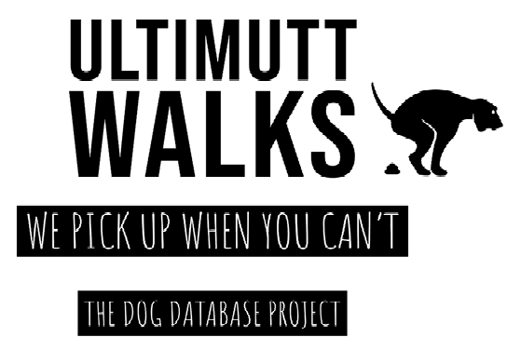

Contents

Summary 2

Stakeholders 2

Business Rules 3

Glossary 3

Data Questions 4

Conceptual Model 5

Logical Model 6

**Raw Data Sample**: (Note from Chad: This is optional!) 6

# Summary

Ultimutt Walks is a dog walking business located in Fort Lauderdale, FL and has been operating since April of 2019. Currently Ultimutt Walks has no formal system in place to keep track of any data for the business. Their data is currently being kept on several planners, in staff phones, or not stored anywhere at all. We propose to implement a database for Ultimutt Walks so that they may track customers, scheduling, profits, and to identify any trends that may be useful to increase business. In Phase 1 we will be defining the business in terms of entities and relationships by determining business rules, providing a data glossary, identifying the questions we would like to answer as a result of this project, and demonstrating both a conceptual and logical model of the future database. After review and upon approval from the stakeholders involved, we will then be able to move to the next phase of implementing this database.

## Stakeholders

The stakeholders included in this project are the owner, the employees, customers, their current investors, and their potential business partner Wag, who has discussed buyouts with Ultimutt Walks. We have proposed that the implementation of a database will increase the profitability of the Company and therefore will affect all stakeholders positively. Customers will be able to access their past and scheduled walks and make updates about their pets if needed. Employees will be able to view their walk schedule and log any information about each walk completed. Investors, owners, and potential business partners will be able to track profitability, number of walks each week, and have an overview of day-to-day business.

## Business Rules

* A customer owns one or more pets.
* A customer places an order.
* A staff member completes an order.
* An order contains order details.
* An order status updates the order.
* A dog walk makes up an order detail.
* A pet is included in an order detail.
* A staff payment is paid to a staff.
* An order creates an invoice.
* An invoice payment completes the invoice.
* An invoice status updates the invoice.

## Glossary

A **customer** is a person who schedules a service through Ultimutt Walks.

A **pet** is an animal owned by a person.

An **order** is placed by a customer and contains the time the order is placed, which staff member will complete it, the customer who placed the order, and the staff member assigned to the order.

An **order detail** includes the requested date for the service to take place, the amount charged for the order, the status of the order, and may contain details about the dog walk.

A **dog walk** is a service where a pet or pets is taken outside for a certain number of miles or minutes.

The **order status** can either be OPEN or CLOSED.

A **CLOSED order status** means that a staff member has completed the order.

An **OPEN order status** means that an order is scheduled and assigned to a staff member.

A **staff member** is a person employed by Ultimutt Walks.

A **staff payment** is earnings paid to one of the staff after the customer pays for the service.

An **invoice** is sent to the customer to be paid after their order is completed.

An **invoice status** is either PAID or UNPAID.

A **PAID invoice status** is when Ultimutt Walks has received payment for a completed order.

An **UNPAID invoice status** is when Ultimutt Walks has not received any payment.

## Data Questions

* How many walks are requested for the same day versus being prescheduled?
* What are the most serviced zip codes?
* What are the profits of the company at any given moment?
* What is the average length of a dog walk? How many miles are walked a month?
* What is the average age for a pet and what is the most common breed?

## Conceptual Model

## Logical Model

## **Raw Data Sample**: (Note from Chad: This is optional!)

As aforementioned, Ultimutt Walks previously was using notebooks, phones, and from memory to store data. Below is Customer and Pet information from one of the company’s notebooks