Victor Yamaykin

IST 659 – Project Part 1

Table of Contents

Summary: 1

Stakeholders: 1

Business Rules: 1

Questions to Answer: 1

Glossary: 2

Conceptual Model: 3

Logical Model: 3

# Summary:

The purpose of the database is help sections with maintaining data quality for the National Council of Jewish Women (NCJW), a non-profit committed to community organizing and advocacy for social and economic justice. The entire organization is made up of several sections throughout the United States. Currently, the sections’ members add their contact information to an Excel spreadsheet and send it to National once a year. The recent migration from one Member ID system to another has shown there are several areas of improvement to prevent duplicates and maintain data integrity. For example, there are members with first names that go over the limit of 20 characters, inconsistency in date formatting, etc. To address these issues, this project will include the following deliverables: summary report, conceptual and logical models, a database in MySQL, and user interface form to collect member data.

# Stakeholders:

The principal stakeholders are the NCJW section membership board members who will instruct current and new members how to use the form and keep track of engagement via four possible contact methods: phone, text, email, or direct mail. The leadership and events manager at the national level will then receive an annual report of the sections’ members.

# Business Rules:

A Member has one and only one VANID. A member purchases one or more Memberships.

Each Member can purchase a Membership from one or more Sections.

Each Section is made up of many Members.

Every membership is assigned to one and only one member

A Member receives one or more Engagement initiatives.

Engagement tracks the involvement of each Member.

Section connects with one or more Members via a Contact Method.

# Questions to Answer:

How do sections collect data on new members and submit updated information to National?

How does National support sections with tracking engagement of current and new members?

Are there particular membership levels that are less popular?

Which part of the country has the most engagement with events? Volunteering? Other ideas?

Are there fewer members of a certain age because of dues?

How to prevent duplicates?

# Glossary:

Member: A single person, family, or organization that belongs to NCJW

Section: A group (active or inactive) belonging to the NCJW network

Origin Source Code: the event or transfer of contact information where the member contact was first entered, e.g. NCJWebinars, 201907RaisersEdge_Conversion, RepoRights, etc.

Membership Level: Set by the section. Most common are Annual, Life, and Three-Year. There are also gifted memberships, so Annual Comp, Life Comp, and Three-Year Comp. Sections are allowed to add their own levels including Advocate, Seasoned Senior, etc.

VAN ID: “Voter Advocacy Network” Identifier

Activist Code: The state and the section name, i.e. (IL: Chicago North Shore)

National: The main office of NCJW

Engagement: connecting with new members to learn more about their interests and potential leadership. It begins with sending the welcome packet, a follow-up meeting, and invitations to events. Communication is via four possible contact methods: phone, text, email, or direct mail

Welcome Packet: an email or direct mail with an introduction and survey of interests and

Email Interests: Desire to receive one or more of the following communications: Reproductive Justice, Religious Freedom, Monthly Emails, Israel, Gender Based Violence, Federal Courts, eJournal, Civil Rights, Demand Gun Violence Prevention, etc.

Suppressions: do not call, email, text, or mail. Also whether deceased or not.

# Conceptual Model:

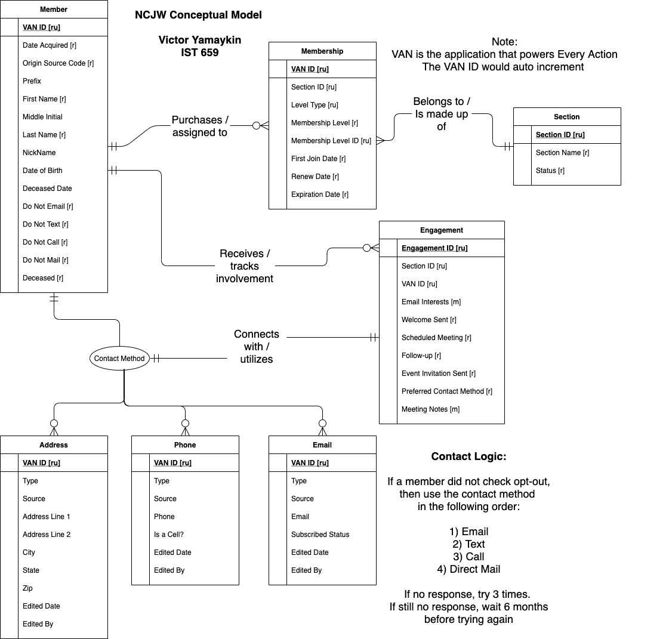

# Logical Model: