**Database Design**

**National Council of Jewish Women Membership Schema**

**Victor Yamaykin**

*IST 659 Data Admin Concepts & DB MGMT*

**Version 1.0**

5/3/2021

Table of Contents

Introduction 3

Purpose 3

Overview 3

Glossary 4

Conceptual Model 6

Description: 6

Diagram: 6

Logical Model 6

Description: 6

Diagram: 7

SQL 7

User Interface 8

Reflection 8

# Introduction

## Purpose

The purpose of the database is to help with maintaining data quality for the National Council of Jewish Women (NCJW), a non-profit committed to community organizing and advocacy for social and economic justice. The entire organization is made up of several sections throughout the United States. Currently, the sections’ members add their contact information to an Excel spreadsheet and send it to National once a year. The recent migration from one Member ID system to another has shown there are several areas of improvement to prevent duplicates and maintain data integrity. For example, there are members with first names that go over the limit of 20 characters, inconsistency in date formatting, etc. To address these issues, this project will include the following deliverables: summary report, conceptual and logical models, a database in MySQL, and user interface form to collect member data.

## Overview

Stakeholders:

The principal stakeholders are the NCJW section membership board members who will instruct current and new members how to use the form and keep track of engagement via four possible contact methods: phone, text, email, or direct mail. The leadership and events manager at the national level will then receive an annual report of the sections’ members.

Data Requirements include:

* A Member has one and only one VANID. A member purchases one or more Memberships.
* Each Member can purchase a Membership from one or more Sections.
* Each Section is made up of many Members.
* Every membership is assigned to one and only one member
* A Member receives one or more Engagement initiatives.
* Engagement tracks the involvement of each Member.
* Section connects with one or more Members via a Contact Method.

Questions to Answer:

* How do sections collect data on new members and submit updated information to National?
* How does National support sections with tracking engagement of current and new members?
* Are there particular membership levels that are less popular?
* Which part of the country has the most engagement with events? Volunteering? Other ideas?
* How do we easily create a list of members to email or contact via other methods?

# Glossary

Activist Code: The state and the section name, i.e. (IL: Chicago North Shore)

Email Interests: Desire to receive one or more of the following communications: Reproductive Justice, Religious Freedom, Monthly Emails, Israel, Gender Based Violence, Federal Courts, eJournal, Civil Rights, Demand Gun Violence Prevention, etc.

Engagement: connecting with new members to learn more about their interests and potential leadership. It begins with sending the welcome packet, a follow-up meeting, and invitations to events. Communication is via four possible contact methods: phone, text, email, or direct mail

Member: A single person, family, or organization that belongs to NCJW

Membership Level: Set by the section. Most common are Annual, Life, and Three-Year. There are also gifted memberships, so Annual Comp, Life Comp, and Three-Year Comp. Sections are allowed to add their own levels including Advocate, Seasoned Senior, etc.

Membership Type: can be an individual, family, or an organization

National: The main office of NCJW

Origin Source Code: the event or transfer of contact information where the member contact was first entered, e.g. NCJWebinars, 201907RaisersEdge_Conversion, RepoRights, etc.

Section: A group (active or inactive) belonging to the NCJW network

Suppressions: do not call, email, text, or mail. Also whether deceased or not.

VAN ID: “Voter Advocacy Network” Identifier

Welcome Packet: an email or direct mail with an introduction and survey of interests

# Conceptual Model

## Description:

Below is an entity-relationship model that represents the data that NCJW section membership chairs are expected to collect, maintain, and utilize for engagement.

## Diagram:

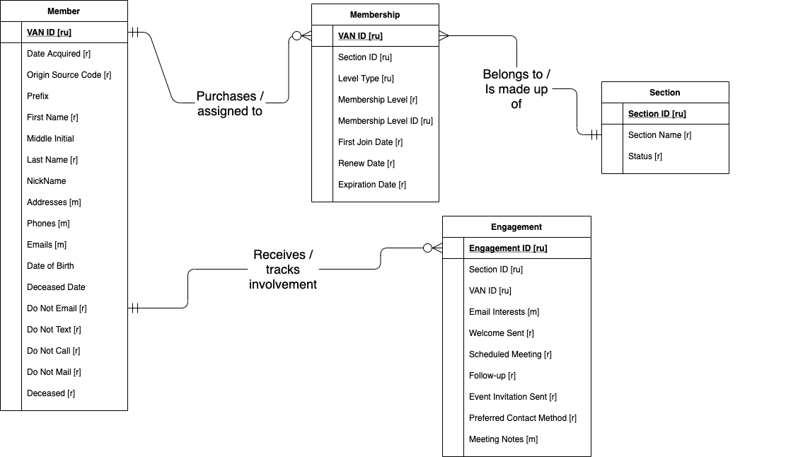

# Logical Model

## Description:

Below is the logical model for how to structure the tables in a relational database, which will allow NCJW sections to answer questions and build contact lists to support community organizing efforts.

## Diagram:

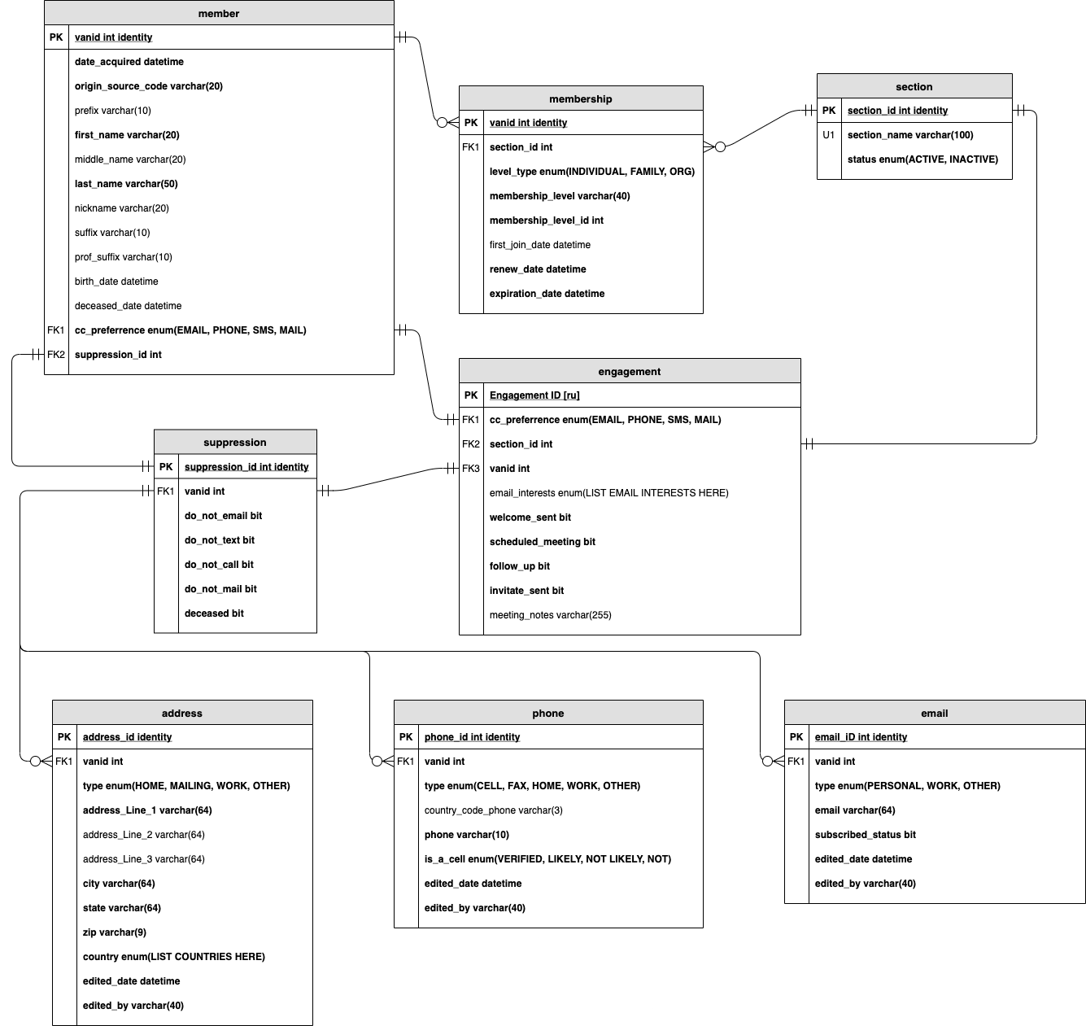

# SQL

# User Interface

# Reflection