|  |  |  |  |
| --- | --- | --- | --- |
|  | | | |
| **On the Majesty and Mystery of Our God** | | | |
| **HOLY TRINITY SUNDAY** | | | |
| June 15, 2025 | | | |
|  | | | |
|  | *“Winning souls for Christ. Coaching Christians for life.”*  4651 Kernan Blvd S, Jacksonville, FL 32224 • (904) 642-8900 | | |
| **A Place to Call Home: Victory Lutheran** | | | |
| In the name of our Savior, Jesus Christ, welcome home. We especially welcome to our house of worship our guests who have joined us today. We pray you will be strengthened by the good news about God’s grace, love, and forgiveness to us through Jesus. We say with the Psalmist, whether here on campus or viewing online, “I rejoiced with those who said to me, ‘Let us go to the house of the Lord’” (Psalm 122:1). May the Lord continue to help us grow in His grace and knowledge as we hear, speak, and sing His holy Word.  **Please sign the Connection Card** inside the worship folder and return it in the basket on the worship table. Members, please update your contact info if there is a change.  **Restrooms** are located in the hallway to the left as you exit the sanctuary. Changing tables are available in both restrooms.  **A Quiet Room** for children who need a moment to get settled with a parent or guardian is located on the right before entering the sanctuary. | | | |
| Visit our website: **www.victorylutheran.org** or find us on Facebook, Instagram, and YouTube! | |  | |
| **Worship Series Focus: UNDIVIDED ATTENTION**  We live in a world where a thousand things are competing for our attention. There is the real danger that we focus on the frivolous and ignore the indispensable. As a result, we often talk about the importance of being “free from distraction.” But the stakes are higher than that. We need to be freed from distraction. We need the spiritual power to give our undivided attention to that which truly makes a difference, not only here and now, but also in eternity. A life focused on all the right things is only possible because of a Savior who is always focused on us. On the Day of Pentecost, Jesus sent the Holy Spirit to give his followers power and focus. Still today, through his Word, Jesus grants those gifts to his disciples.  We have come to the second half of the Church Year. In the first half, we focused on the life of Christ. In this second half, we turn our attention to all the teachings of Christ. May we give them our undivided attention. | | | |
| **Today’s Worship: We Can See Things Clearly**  At the top of the list of things worthy of our undivided attention: God. That does not mean if we focus long and hard, we will understand all there is to know about God. That is impossible! For example, Scripture teaches that there is one God in three persons: Father, Son, and Holy Spirit. Our reason objects, “How can three be one?” So, God’s very existence is a mystery, far beyond our ability to comprehend, no matter how long we ponder it. Yet, while we cannot understand everything about our God, he is still worthy of our undivided attention. For there is plenty about God’s majesty that we can understand. We can understand that God provides for us as a loving Father. We can understand how much God loves us, for that was proven in the sacrifice of God the Son. We can understand that every time we gather in the name of our Triune God, the Holy Spirit grants us the greatest of blessings. These truths are worthy of our undivided attention! | | |

*The Service: Setting Three*

# Our Path for Worship



Serving in Worship

***Pastor*** *Rev. Jonathan Kolander*

***Accompanist*** *Name*

Acknowledgments

Unless otherwise indicated, Scripture quotations are from The Holy Bible, New International Version®, NIV®. Copyright © 1973, 1978, 1984, 2011 by Biblica, Inc.TM Used by permission of Zondervan. All rights reserved worldwide.

Liturgical and musical settings of Scripture based on text from The Holy Bible, New International Version®, NIV®. Copyright © 1973, 1978, 1984, 2011 by Biblica, Inc.TM Used by permission of Zondervan. All rights reserved worldwide.

Software distributed in partnership with Northwestern Publishing House.

Created by Christian Worship: Service Builder © 2025 Concordia Publishing House.

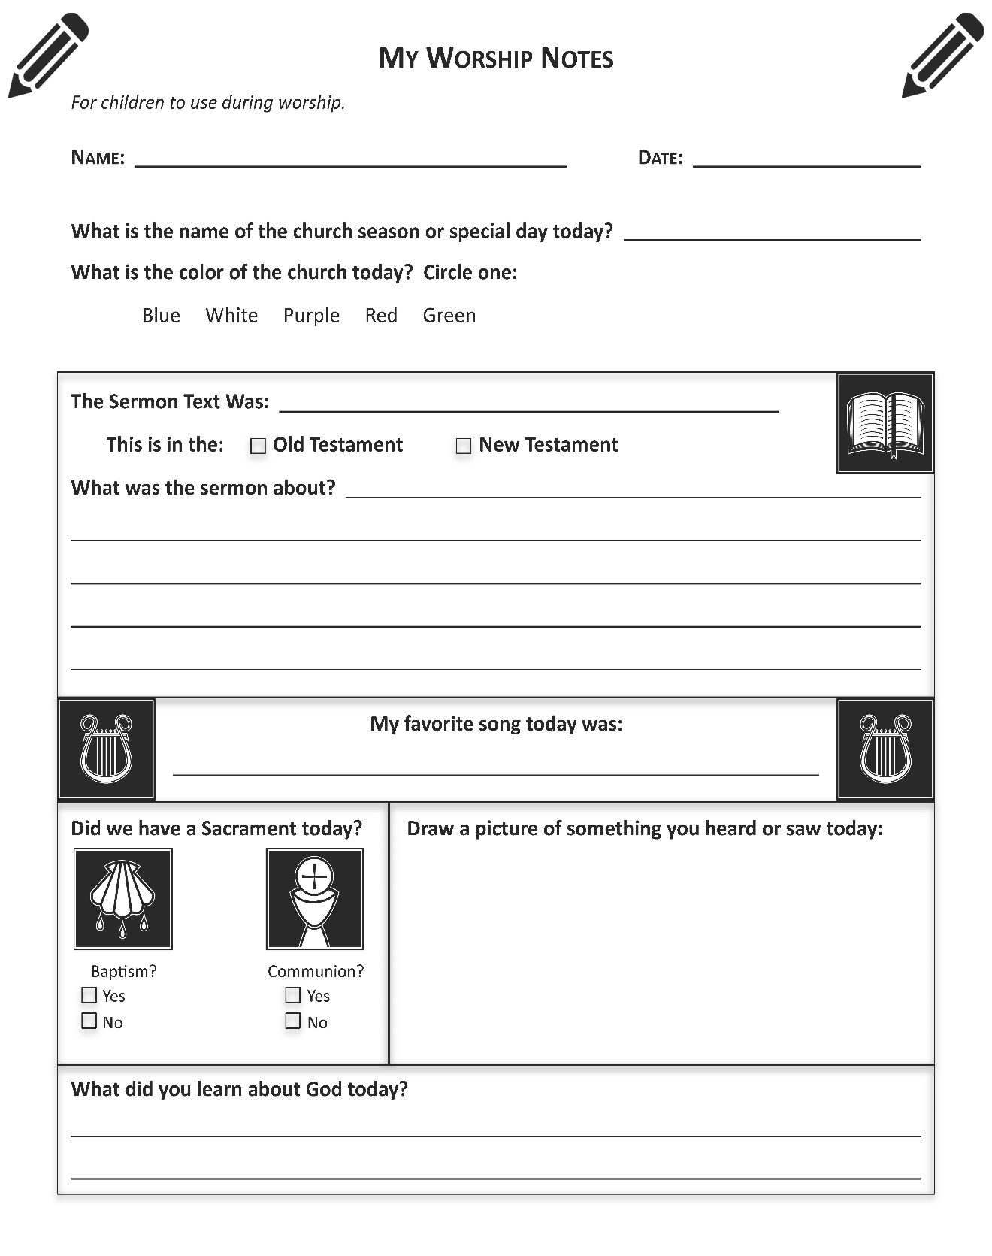

|  |  |  |  |
| --- | --- | --- | --- |
| Upcoming Service Themes | | | |
|  |  | May 4 | We Can See Things Clearly |
|  | May 11 | We Know Jesus Is Trustworthy and True |
|  | May 18 | We Live Lives of Lavish Love |

**For reflection based on today’s Scripture readings…**

1st:

2nd:

3rd:

|  |  |  |
| --- | --- | --- |
|  | | |
|  | | |
| Sunday Service Times | | |
| 8:00am  9:15am  10:30am | Worship  Bible Class and Sunday School  Worship with Livestream | |
|  | | |
| **Contact Information** | | |
| Brad Smith, Office Manager — (904) 642-8900  office@victorylutheran.org | | |
| Jonathan Kolander, Pastor — (414) 510-0971  pastork@victorylutheran.org | | |
| Katie Seelman Preschool Director — (904) 955-1926  director@victorylutheran.org | | |
| Jarrett Mielke, Staff Minister — (941) 735-6962  jmielke@victorylutheran.org | | |
| Victory is a member congregation of the Wisconsin Evangelical Lutheran Synod (WELS), headquartered in Waukesha, Wisconsin. | |  |