# Assignment 1, Cloud Application Development Exercise 1: Setting Up Google Cloud SDK

1. **Objective**: Install and configure the Google Cloud SDK on your local machine.

# Steps:

* + Visit the Google Cloud SDK installation page.
  + Follow the instructions to download and install the SDK for your operating system.
  + After installation, run gcloud init to initialize the SDK and authenticate with your Google account.
  + Configure the default project and region.
  + Verify the installation by running gcloud version and gcloud info.

# Questions:

* + What command did you use to authenticate with your Google account?

# gcloud auth login

* + How did you set the default project?

* + What information does the gcloud info command provide

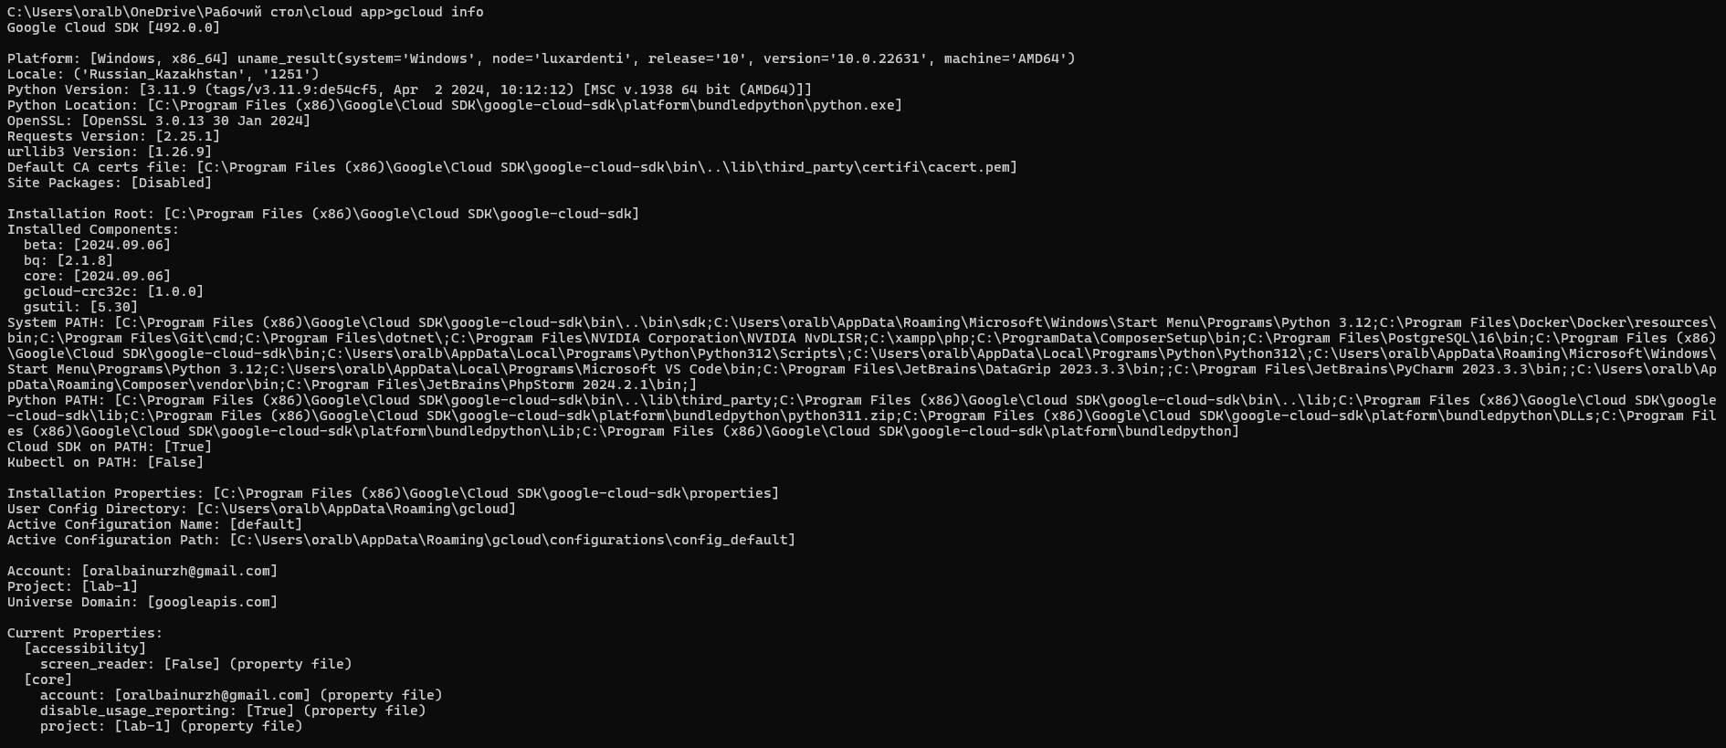

# Exercise 2: Exploring Cloud Shell

1. **Objective**: Familiarize yourself with the Google Cloud Shell environment.

# Steps:

* + Open the Google Cloud Console and activate Cloud Shell.
  + Explore the environment by listing files and checking the available tools.
  + Run the command gcloud config list to see your current configuration.
  + Create a directory named gcp-intro and navigate into it.
  + Use the built-in code editor to create a simple README.md file describing your GCP project.

# Questions:

* + What is the default home directory in Cloud Shell?

# /home/oralbainurzh – default home directory is home/username

* + What tools are pre-installed in Cloud Shell?

**PostgreSQL client, Terraform, Ansible, Maven, Gradle, gcloud CLI, bq, kubectl, docker, git, vim, emacs, nano, Python, pip, Node.js, npm, Go, Java, Ruby, PHP, MySQL client, OpenJDK, Cloud SQL Proxy, Helm, jq**

* + How can you open the built-in code editor in Cloud Shell?

# We should click on the pencil icon (Open Editor) located in the top- right corner of the Cloud Shell window

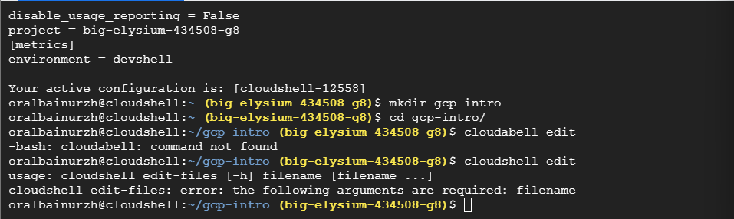**Exercise 3: Managing Projects with Google Cloud SDK**

1. **Objective**: Use Google Cloud SDK to manage projects.

# Steps:

* + List all the projects associated with your Google account using gcloud projects list.
  + Create a new project with the command gcloud projects create PROJECT_ID --name="My First GCP Project".
  + Set this new project as your default project.
  + Explore project metadata using gcloud projects describe PROJECT_ID.
  + Delete the project using gcloud projects delete PROJECT_ID after completing the exercise.

# Questions:

* + How do you list all projects associated with your account?

# gcloud projects list

* + What command is used to set a default project?

# gcloud config set project [project-id]

* + How do you describe project metadata?

# gcloud projects describe [project-id] Exercise 4: Using Cloud Shell for Basic Operations

1. **Objective**: Perform basic file and directory operations in Cloud Shell.

# Steps:

* + In Cloud Shell, create a directory structure that mimics a small project (e.g., myproject/src, myproject/tests, myproject/docs).  
    
  + Create a few files in these directories and use commands like touch, nano, cat, and rm to manipulate them.

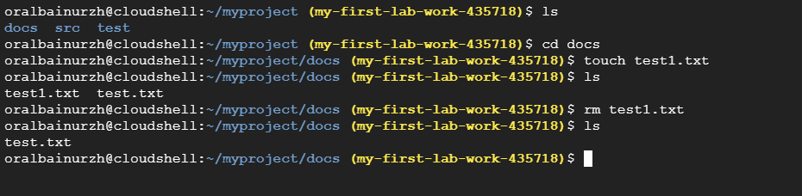  
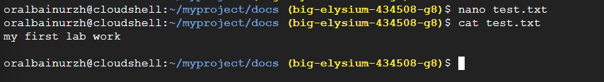

* + Write how to use gsutil to create a new Cloud Storage bucket and upload a file from your Cloud Shell environment.  
    
  + Verify the file upload by listing the contents of the bucket.

# Questions:

* + What command did you use to create the directory structure?

# mkdir src && mkdir tests && mkdir docs

* + How did you upload a file to a Cloud Storage bucket?

# gsutil cp main.txt gs://my-bucket-lab-1

* + How can you list the contents of a Cloud Storage bucket?

# gsutil ls gs://my-bucket-lab-1

**Exercise 5: Automating Tasks with Shell Scripts in Cloud Shell**

1. **Objective**: Write and execute a basic shell script in Cloud Shell.

# Steps:

* + In Cloud Shell, create a new shell script named setup.sh in your gcp-intro directory.  
    Изображение выглядит как текст, снимок экрана, программное обеспечение, Значок на компьютере

    Автоматически созданное описание
  + The script should automate the creation of a new directory, a simple text file, and set up a basic Google Cloud configuration (e.g., set a default project).
  + Make the script executable using chmod +x setup.sh.
  + Run the script and verify that it performs the expected tasks.

# Questions:

* + What command did you use to make the script executable?

# chmod +x setup.sh

* + How did you ensure the script was executed correctly?

# Checked if the new directory was created correctly and checked the contents of this new directory

* + What steps did your script automate?
    1. step was creating a new directory with the command:

# mkdir -p new_directory

* + 1. step was creating a new txt file with the content inside: **echo "This is a sample file created by setup.sh" > new_directory/sample.txt**
    2. step was setting a default project:

# gcloud config set project laboratory-work-1-435706

* + 1. step the information that the script ended:

**echo "Setup complete!"**