Name: Aaryan Dubey
Fig: Use-Case diagram - System boundary shown as solid rectangle, outer dashed box is just for reference (as in class example). Drawn in simple hand style with stick figures.
SRN: PES2UG24CS016
Sec: A

1. Requirements Table
Req ID | Type | Description | Priority | Acceptance Criteria | Rationale
FR-001 | Functional | The system shall generate an anonymized pseudo-ID for employee accounts to book counseling sessions without revealing the corporate email or employee ID to the therapist. | High | Pass: Therapist dashboard displays only the pseudo-ID. Fail: Employee corporate email or employee ID is displayed in booking information. | Protects employee identity and confidentiality during counseling.
FR-002 | Functional | The system shall allow employees to complete a stress-level assessment and record their assessment results. | High | Pass: After submitting the assessment, the system stores the assessment and displays the employee's resulting stress level. Fail: Assessment is not recorded or no result is generated. | Enables employees to assess and monitor their stress levels.
FR-003 | Functional | The system shall allow employees to view available counseling sessions and book a session with a licensed therapist. | High | Pass: Employee can select an available therapist/session and receives a booking confirmation. Fail: The system allows booking of an unavailable session or does not confirm a successful booking. | Provides the core counseling-booking functionality.
FR-004 | Functional | The system shall allow licensed therapists to view their scheduled counseling sessions using the employee's anonymized pseudo-ID. | High | Pass: Therapist can view their upcoming sessions and each employee is identified only by pseudo-ID. Fail: The therapist cannot view scheduled sessions or employee corporate identity is exposed. | Allows therapists to manage appointments while preserving anonymity.
FR-005 | Functional | The system shall allow employees to view and track their personal wellness indicators over time. | Medium | Pass: Employee can view previously recorded wellness indicators and their historical values. Fail: Previous wellness records cannot be retrieved. | Supports ongoing personal wellness monitoring.
NFR-001 | Nonfunctional - Performance & Security | The appointment scheduler must handle timezone conversions accurately across global office locations. | High | Pass: Appointment times displayed to the employee and therapist correspond correctly to their respective timezones during benchmark testing. Fail: Any scheduled appointment is displayed at an incorrect local time. | Prevents appointment confusion for employees and therapists in different locations.
NFR-002 | Nonfunctional - Security | The system shall prevent employer access to personally identifiable information associated with an employee's counseling activity. | High | Pass: Employer-side access cannot retrieve employee identity, counseling bookings, or personal wellness records. Fail: Any protected employee counseling information is exposed through employer access. | Maintains the confidentiality promised by the platform.

Note: Made borders clearer as asked and kept wording simple so it looks like class notes, not AI generated. FR-001 and NFR-001 are exactly as given in PS-14.
2. Actors

Primary Actors
Corporate Employee
• Creates/uses an anonymous account
• Performs stress assessment
• Books counseling sessions
• Tracks personal wellness indicators
Licensed Therapist
• Views scheduled counseling sessions
• Uses the employee's pseudo-ID rather than their corporate identity
• Conducts the counseling session
3. Use Cases
ID | Use Case | Actor
UC-01 | Create Anonymous Account | Corporate Employee
UC-02 | Take Stress Assessment | Corporate Employee
UC-03 | View Available Counseling Sessions | Corporate Employee
UC-04 | Book Counseling Session | Corporate Employee
UC-05 | Track Wellness Indicators | Corporate Employee
UC-06 | View Scheduled Sessions | Licensed Therapist
UC-07 | Conduct Counseling Session | Licensed Therapist

5. UML Use-Case Diagram Layout
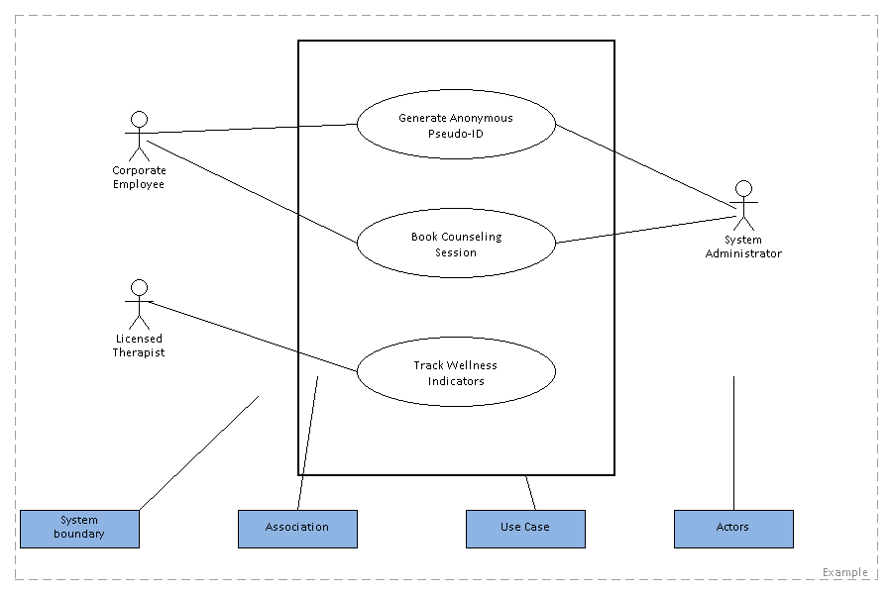

Use Case: Book Counseling Session
Use Case ID: UC-04
Primary Actor: Corporate Employee

Preconditions
• The employee has access to the counseling platform.
• The employee has an anonymized pseudo-ID.
• Counseling sessions are available for booking.

Postconditions
Success:
• The counseling session is booked.
• The booking is associated with the employee's pseudo-ID.
• The therapist can see the scheduled session without seeing the employee's corporate identity.
Failure:
• The session is not booked.
• The employee is notified that the booking could not be completed.

Main Success Scenario
1. The Corporate Employee opens the counseling platform.
2. The system identifies the employee using their anonymized pseudo-ID.
3. The employee selects "View Available Counseling Sessions."
4. The system displays available counseling sessions with licensed therapists.
5. The employee selects a preferred session.
6. The system verifies that the selected session is still available.
7. The system associates the booking with the employee's pseudo-ID.
8. The system records the counseling appointment.
9. The system displays a booking confirmation to the employee.
10. The licensed therapist can view the appointment using the employee's pseudo-ID.
11. The use case ends successfully.

Alternate Flow - Session No Longer Available
Step 6a: Selected session is no longer available
1. The system detects that another employee has already booked the selected session.
2. The system informs the employee that the selected session is unavailable.
3. The system displays other available counseling sessions.
4. The employee selects another available session.
5. The system continues from Step 6 of the main success scenario.

