Software Engineering Lab
Lab 1: Requirements Engineering & UML Use-Case Modelling

Student Name: Aaryan Dubey  SRN: PES2UG24CS016  Dept: CSE, PES University | Problem Statement 14  Healthcare & Telemedicine  Corporate Mental Wellness  & Counseling Platform

About the System
This platform is for company employees who want to check their stress levels and book therapy sessions confidentially. The main point is anonymity. Instead of using real email or employee ID, the system gives a pseudo ID like EMP-XXXX for every booking. So even the therapist or HR cannot link the session back to a real person. We built this lab around that idea and tried to keep requirements simple and testable.

1. Requirements Table
Note: FR-001 and NFR-001 are as given in the problem statement. All requirements are written as The system shall... and we have 5 FRs plus 2 NFRs as asked.
Req ID | Type | Description | Priority | Acceptance Criteria | Rationale | Peer Comments
FR-001 | Functional | The system shall generate an anonymized pseudo-ID (like EMP-XXXX) for each employee so they can book counseling sessions without showing corporate email or employee ID to the therapist. | High | Pass: Only pseudo-ID is visible on therapist side, no PII in booking data.  Fail: Any email, name or ID appears in dashboard or API. | Keeps identity private so people feel safe to seek help without work fear. | Reviewed, looks ok. Keep same ID for follow up sessions.
FR-002 | Functional | The system shall provide a self-assessment module using GAD-7 and PHQ-9 questionnaires to check stress, anxiety and depression levels. | High | Pass: Score (0 to 21) is calculated within 1 sec and shows risk level.  Fail: Score not calculated or data saved with real identity. | Helps catch early burnout using standard clinical tools. | Good. Maybe auto suggest booking if score is high.
FR-003 | Functional | The system shall allow employees to search, filter and book confidential tele-counseling sessions with licensed therapists by specialization, language and available slots. | High | Pass: Slot is reserved without double booking, confirmation in under 2 sec, no email exposed.  Fail: Double booking or email exposed. | This is the core booking feature of the system. | Link timezone handling (NFR-001) while showing slots.
FR-004 | Functional | The system shall give a personal wellness dashboard where employees can log daily mood, sleep hours and see stress trends over time. | Medium | Pass: Graphs for 7, 30, 90 days are shown and visible only to the employee.  Fail: Data not shown or visible to HR. | Lets employees track their own progress privately. | HR should only see aggregate stats for more than 50 people.
FR-005 | Functional | The system shall let therapists write and save anonymized session notes linked only to the pseudo-ID. | High | Pass: Notes saved with pseudo-ID, encrypted, only treating therapist can view.  Fail: Notes linked to real ID. | Needed for continuity of care while keeping privacy. | Important for compliance.
NFR-001 | Non-Functional (Performance) | The appointment scheduler shall handle timezone conversions correctly for global offices and respond quickly even at peak load. | High | Pass: With 1000 concurrent bookings, timezone is correct and P95 is under 1 sec.  Fail: Wrong time or response over 2 sec. | Avoids missed sessions due to timezone confusion. | Add daylight saving test also.
NFR-002 | Non-Functional (Security) | The system shall encrypt all stored data (assessments, notes, logs) with AES-256 and use TLS 1.3 in transit, with no plain PII stored. | High | Pass: No plain PII in DB, TLS 1.3 on all APIs.  Fail: Plain text found or non TLS allowed. | Needed for HIPAA/GDPR and to block employer access. | Must for security.
In total we have 5 FRs and 2 NFRs as required. Priorities are High except FR-004 which is Medium because dashboard is useful but not critical for booking.

2. UML Use-Case Diagram
System Boundary: Corporate Mental Wellness & Counseling Platform
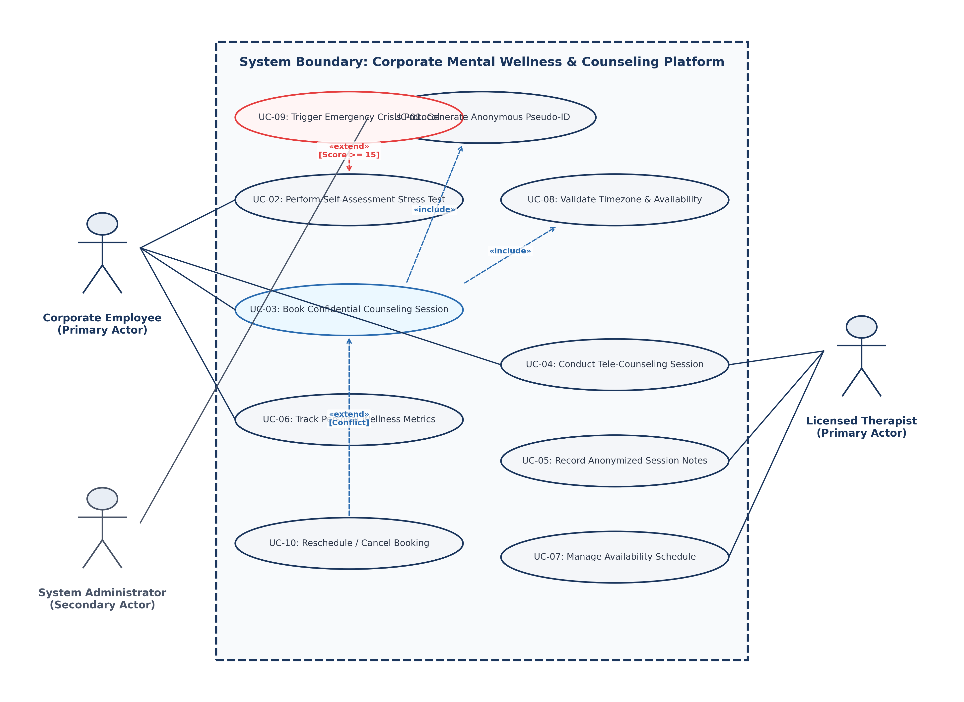
What the diagram shows:
- Actors: Corporate Employee as primary user, Licensed Therapist as primary provider, and System Administrator as secondary support. We kept three actors because the handout asked for at least three.
- Use cases: UC-01 Generate Anonymous Pseudo-ID, UC-02 Perform Self-Assessment Stress Test, UC-03 Book Confidential Counseling Session, UC-04 Conduct Tele-Counseling Session, UC-05 Record Anonymized Session Notes, UC-06 Track Personal Wellness Metrics, UC-07 Manage Therapist Availability, UC-08 Validate Timezone and Slot Availability, UC-09 Trigger Emergency Crisis Protocol, UC-10 Reschedule or Cancel Booking. So total ten use cases which covers more than the minimum five.
- Relationships: UC-03 includes UC-01 and UC-08. This means every booking has to generate or verify pseudo-ID and also check timezone. UC-09 extends UC-02 when stress score is 15 or more, and UC-10 extends UC-03 when there is a schedule conflict. So we have two includes and two extends, which satisfies both the handout and PS-14 requirement.
Source files included: use_case_diagram.puml (PlantUML) and use_case_diagram.dot (Graphviz) | Exports: PDF, PNG, SVG

3. Use-Case Flow Specification
Use Case: UC-03 Book Confidential Counseling Session
Primary Actor: Corporate Employee
Secondary Actor: Licensed Therapist
Supporting System: Timezone Engine, Anonymization Service
Description
This flow explains how an employee books a confidential session. The employee searches for a therapist, checks available slots in their own local timezone, and confirms the booking. The whole process uses only the pseudo-ID like EMP-XXXX, so real identity is never shown to the therapist or stored in plain text.
Pre-condition: 1) Employee is logged in via SSO 2) Pseudo-ID service is working 3) Therapists have set their availability
Post-condition: 1) Slot is booked and saved 2) Meeting link and invite sent with pseudo-ID only 3) No PII is exposed anywhere
Trigger
Employee clicks Schedule Confidential Session on the dashboard, or is redirected there after getting a high score in the self-assessment (UC-02).
Main Success Scenario
Step by step flow for UC-03 (happy path)
Step | What User Does | What System Does
1 | Employee clicks Book Counseling Session | System starts booking flow and includes UC-01 (Generate Pseudo-ID)
2 | Employee agrees to anonymous mode | System gives or verifies pseudo-ID like EMP-7F89X
3 | Employee filters therapists by specialization, language etc. | System shows matching therapist profiles
4 | Employee selects a therapist | System fetches slots and includes UC-08 (Validate Timezone and Slot Availability)
5 | Employee picks a date and time slot | System locks the slot for 5 minutes and shows booking summary with pseudo-ID
6 | Employee confirms booking | System checks lock validity and saves booking in DB
7 | - | System creates encrypted video meeting link linked to pseudo-ID
8 | - | System sends calendar invites to employee portal and therapist dashboard
9 | - | System updates therapist availability
10 | Employee sees confirmation page | System shows meeting link and option to add to calendar. End of use case.
Alternate Flow
What happens when things do not go as per happy path
Alternate Flow 5a: Slot already taken (conflict)
- 5a1. While employee is selecting, someone else books the same slot.
- 5a2. System finds conflict during UC-08 check and releases the temporary lock.
- 5a3. Shows message: Sorry, this slot was just booked. Please choose another time.
- 5a4. Employee picks a different slot, workflow continues from Step 5.
Alternate Flow 8a: User cancels (extends UC-10)
- 8a1. At confirmation step, employee clicks Cancel.
- 8a2. System calls extend UC-10 (Reschedule or Cancel Booking).
- 8a3. Releases the 5 minute lock and makes slot available again.
- 8a4. Shows Booking cancelled. Nothing was saved. Flow ends.
Exception Flow 2a: High stress alert (extends UC-09)
- 2a1. If employee came from UC-02 with GAD-7 score of 15 or more (severe).
- 2a2. System triggers extend UC-09 (Emergency Crisis Protocol).
- 2a3. Shows 24/7 crisis helpline banner along with booking options.

End of Lab 1 Submission
This document was prepared for SE Lab 1 submission. Diagram and tables are also available as separate PDF, PNG, XLSX files in the same folder for verification.

