Name: Aaryan Dubey SRN: PES2UG24CS016 Sec: A
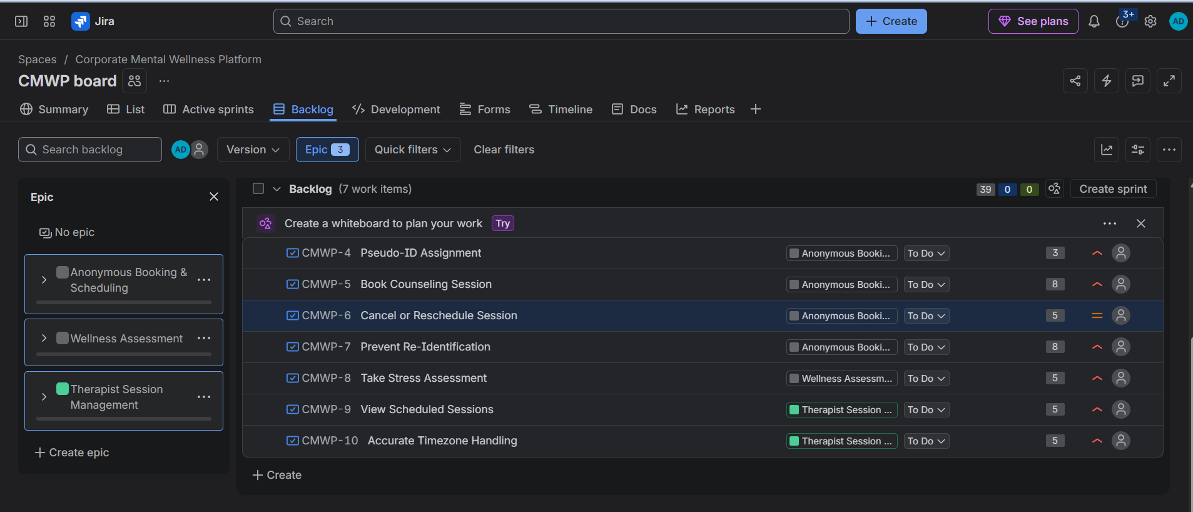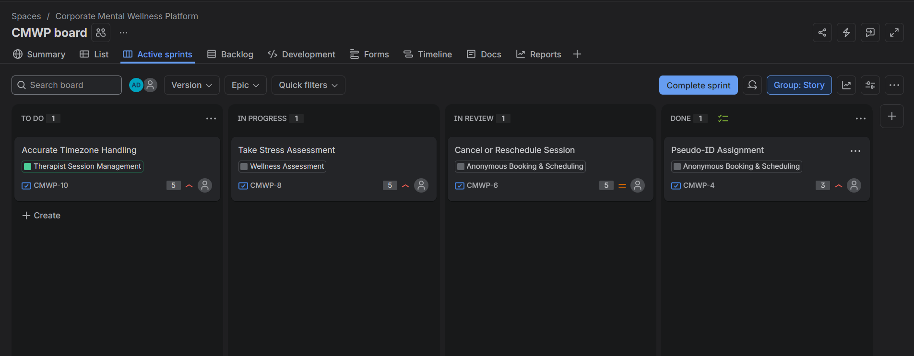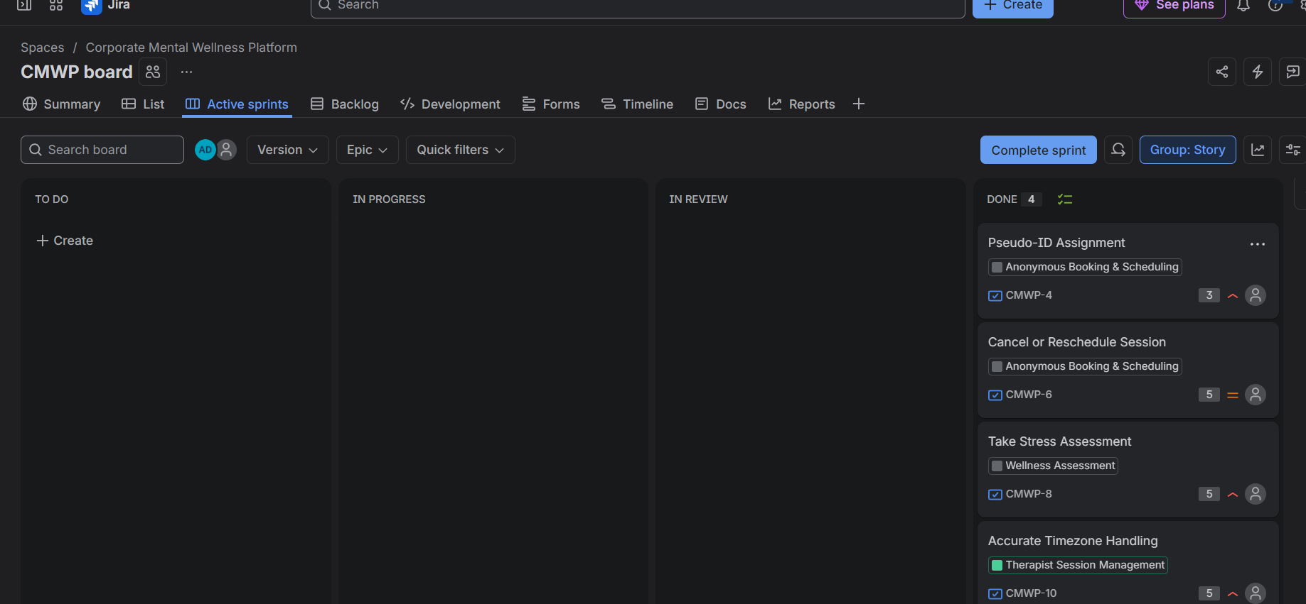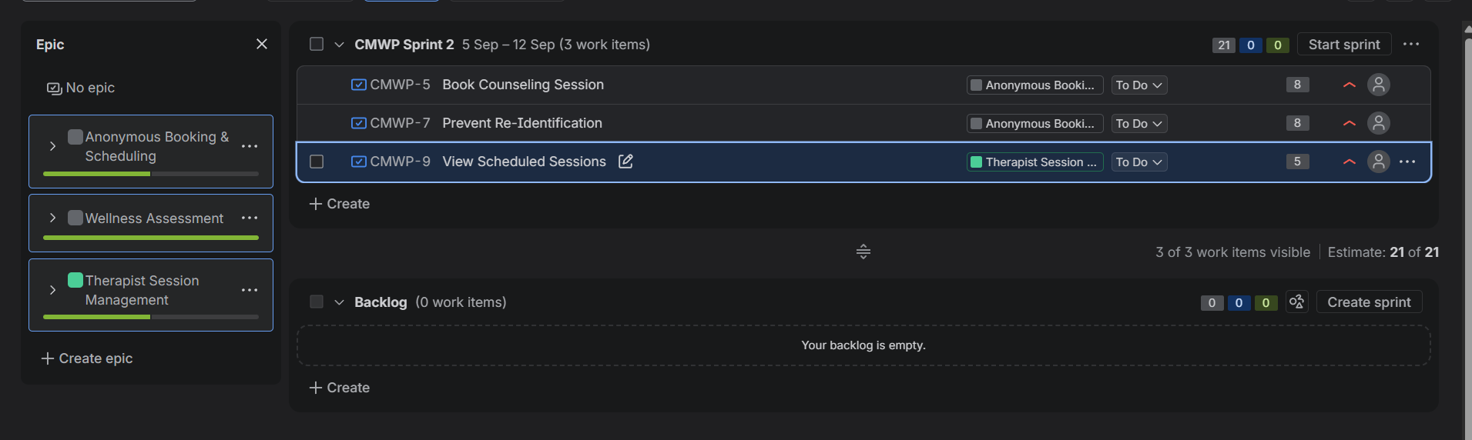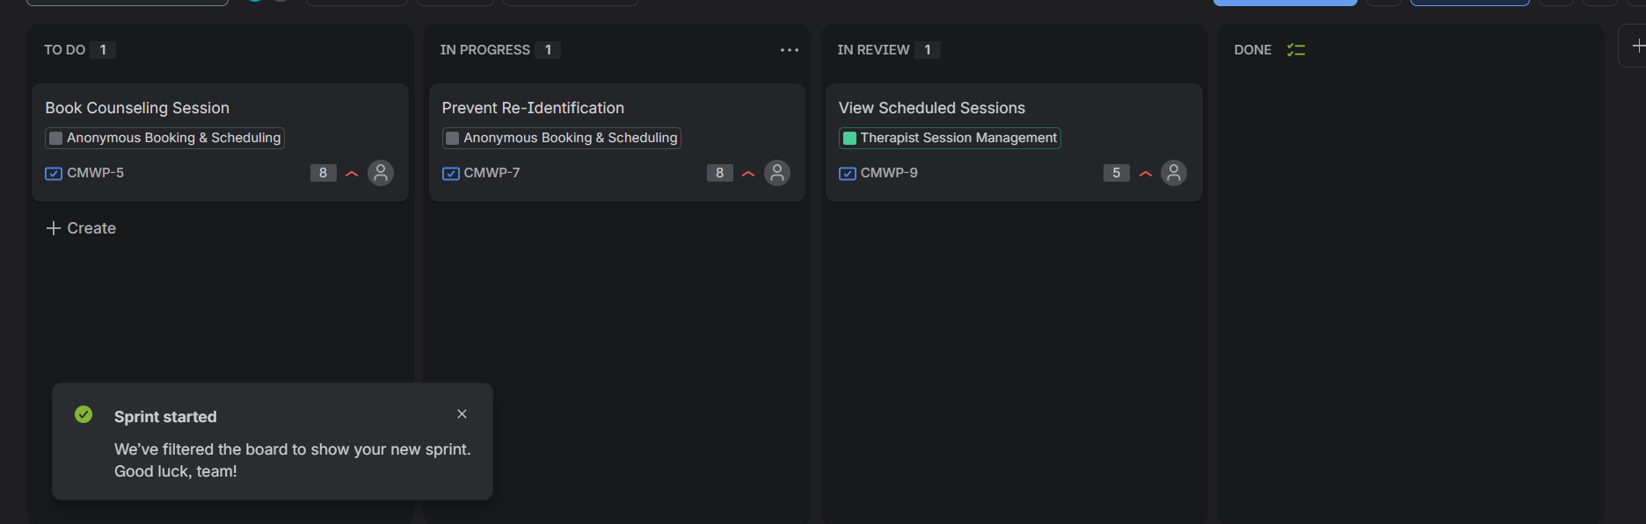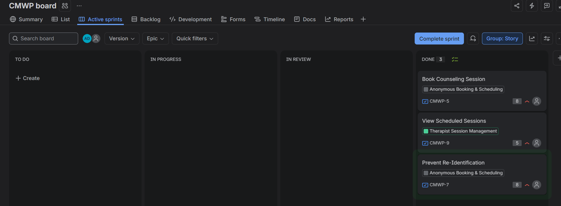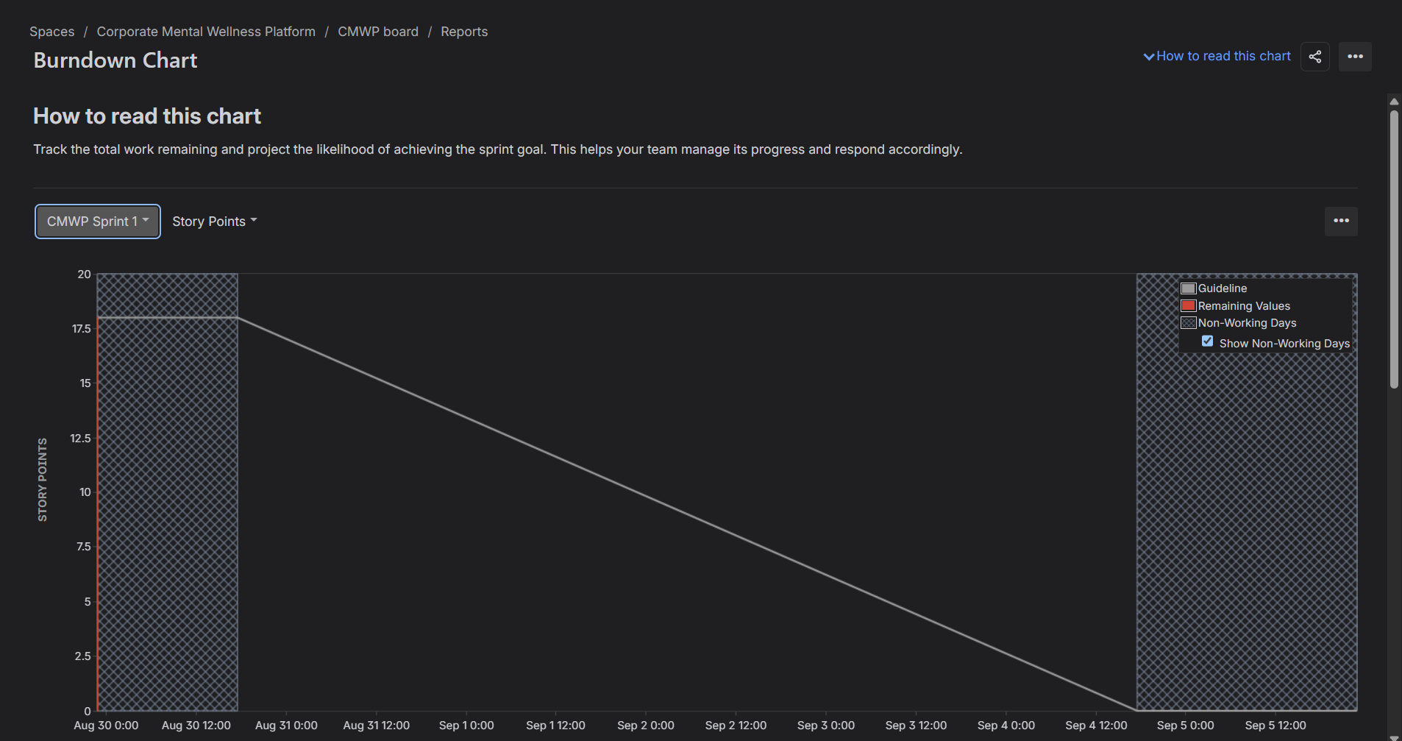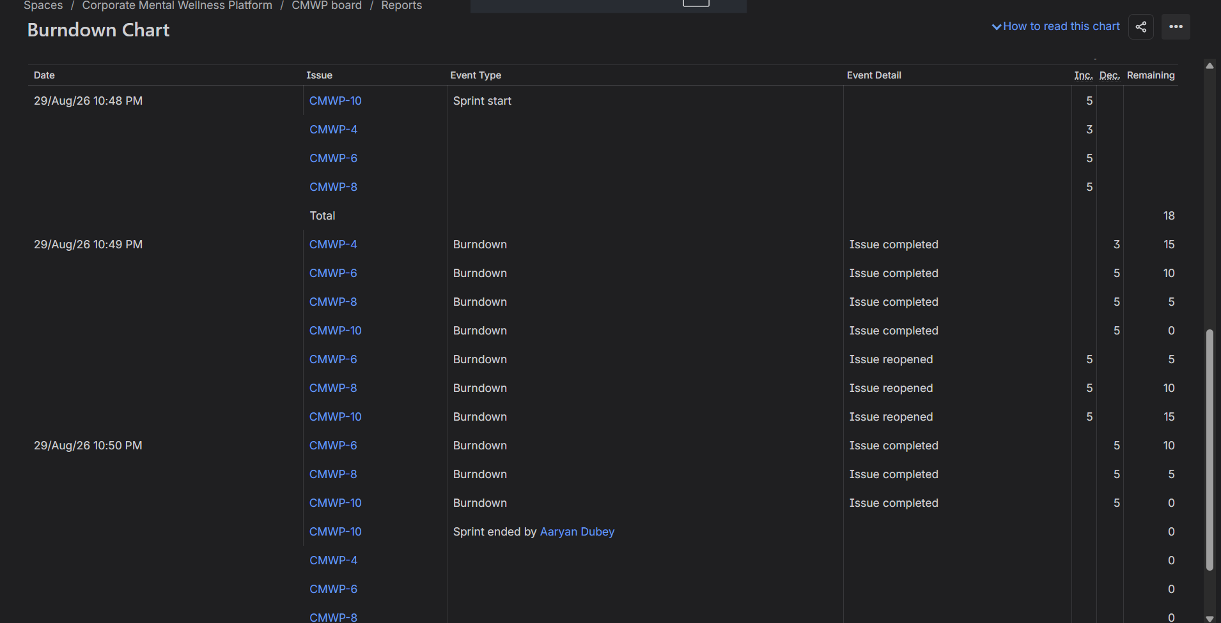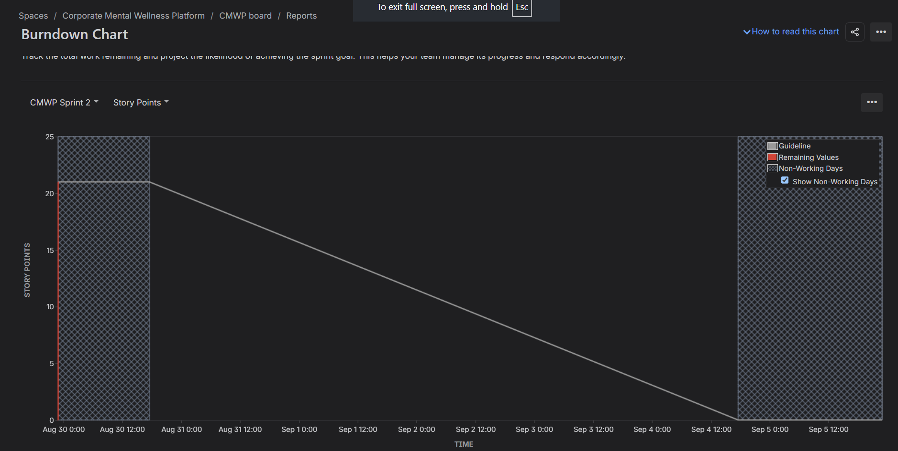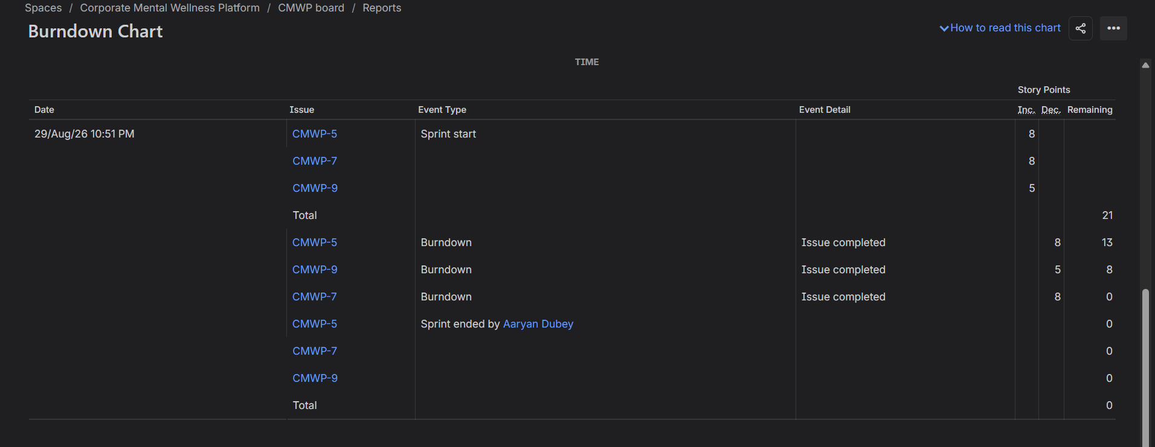

1. Did your estimations reflect the effort?

Not really, since this was a simulated sprint and not an actual one. I gave Book Counseling Session and Prevent Re-Identification 8 points, since they had the highest complexity, with several steps that may involve additional queries or require extra care (check if a particular slot is available, making sure that any query transformation that can potentially de-anonymize an employee is prohibited). These stories would take significantly longer to develop than a 3-point Pseudo-ID story in a real-life project. Since everything was marked “Done” during the session, none of the estimations reflected the actual time spent on a task. However, they still make sense, since the relative size of the stories holds true — their complexity in points vs. each other was adequate.

2. Was your backlog well-prioritized?

I think it was, since I prioritized the stories according to my Lab 1 requirements table. Anonymity features (Pseudo-ID, Prevent Re-Identification) were set to “High” due to their importance for maintaining user privacy and the integrity of the data. The main feature of the platform, counseling session booking, had the same priority level due to its essentiality. Cancel/Reschedule had a “Medium” priority since it was a supportive feature. Having one “Medium” item on my list allowed me to easily identify what scope changes I could make if needed during the sprint planning. The prioritization made perfect sense to me.

3. How did your simulated sprint aligned to your plan?

Sprint 1: Pseudo-ID Assignment, Cancel or Reschedule Prevent Re-Identification. Take Stress Assessment. Sprint 2: Book Counseling Session, Prevent Re-Identification (carry over) View Scheduled Sessions. All seven stories were completed during two sprints. Since it was only a simulation and not an actual development, I simply moved cards from To Do to In Progress and then to In Review and finally to Done. The process resembled a real one, except for the duration — in a real project, these operations would take days, not minutes. Everything was performed in accordance with the Scrum process.

4. What did you learn from the burndown chart about your teams capacity?

Both burndown charts depict a single drop to zero, which means that the whole sprint scope has been completed right at the end. This may or may not be the case, depending on the project and the team’s dynamics. In my opinion, the chart does not convey much information apart from that. I think that the event log demonstrates the sprint progress more transparently, since it shows when individual items were completed and updated. The simulation even allowed me to see some errors — during the process, I had several items closed and then re-opened before completing them. In a real project, the burndown line would not have a sudden drop to zero — the completion rate would depend on how much work the team could commit to during the planning meeting and then actually do during the sprint. If there are daily standings and any obstacles during the development that slow the team down, the line will depict this with every day update. A steep decline is a sign of either a severely inaccurate estimation (the team committed to way more work than they could realistically deliver) or issues that arose during the final days of the sprint.

