Software Architecture and Design Specification
Project: Task Manager Application
Version: 1.0
Authors: Balaji Gowda S R, Aaryan Dubey, Aadi Kore, Akash Pawar
Course Coordinator: Miss Pavitra
Date: 14-09-2026
Status: For Review

Team Details
S. No. | USN | Team Member | Project
9 | PES2UG25CS804 | Balaji Gowda S R | Task Manager Application
10 | PES2UG24CS016 | AARYAN DUBEY | Task Manager Application
11 | PES2UG24CS006 | AADI KORE | Task Manager Application
12 | PES2UG24CS041 | AKASH PAWAR | Task Manager Application

Revision History
Version | Date | Author | Change Summary
1.0 | 14-09-2026 | Project Team | Initial Software Architecture and Design Specification prepared from the approved SRS.

Approvals
Role | Name | Signature / Email | Date
Course Coordinator | Miss Pavitra

Table of Contents
1. Introduction
2. Document Overview
3. Architecture
4. Design
5. Appendices
This specification follows the supplied SAD template and uses the Task Manager Application requirements, terminology, acceptance criteria, security requirements and RTM from the team's SRS.

1. Introduction

1.1 Purpose
This document specifies the software architecture and design of the Task Manager Application. It translates the approved requirements into architectural layers, components, interfaces, data structures, interaction flows, security controls, error handling and traceability references.

1.2 Scope
The design covers user authentication, task creation and editing, priority and due-date management, status and category management, search and filtering, overdue monitoring, notifications, task summaries, controlled administration, persistent records and secure access.

1.3 Audience
The intended audience is the project team, QA/testers, course coordinator/evaluators, system administrators and end users.

1.4 Definitions
- SRS: Software Requirements Specification
- UI: User Interface
- API: Application Programming Interface
- CRUD: Create, Read, Update, Delete
- FR: Functional Requirement
- NFR: Non-Functional Requirement
- RTM: Requirements Traceability Matrix
- OTP: One-Time Password
- RBAC: Role-Based Access Control

2. Document Overview

2.1 How to Use This Document
The document presents the proposed architecture, component responsibilities, UML models, interface design, security architecture, error handling, monitoring, UX considerations, risks, requirement traceability and future design considerations.

2.2 Related Documents
- Software Requirements Specification (SRS) for Task Manager Application, Version 1.0, dated 09-09-2026.
- Requirements Traceability Matrix (RTM) included in the supplied SRS.

2.3 Design Principles
- Separation of concerns between presentation, application, domain and data responsibilities.
- Authenticated and authorized access to protected task information.
- Persistent storage of valid task records.
- Clear validation and understandable error feedback.
- Modular design so individual services/components can be tested and maintained independently.

3. Architecture

3.1 Goals & Constraints
Goals: provide a maintainable, secure and usable task-management system; support reliable persistence of task records; provide responsive common user actions; and keep access to user and task information controlled.
- Only authenticated users may access protected task data.
- Task records must remain associated with the correct user or authorized assignee.
- User input must be validated before storage or processing.
- Administrative functions must be restricted to authorized administrator/manager users.
- The design must support the measurable SRS targets: common user actions within 3 seconds for at least 90% of transactions under normal test load and at least 99% availability excluding planned maintenance.

3.2 Stakeholders & Concerns
Stakeholder | Primary Concerns
User | Simple navigation, quick task updates, correct task visibility, reminders and understandable feedback.
Administrator / Manager | Controlled access, user/task oversight and maintainability.
Project Evaluator | Requirement compliance, test evidence, architecture/design documentation and traceability.
Project Team / QA | Modularity, validation, testability, security and reliable data handling.

3.3 Architecture / Component Diagram
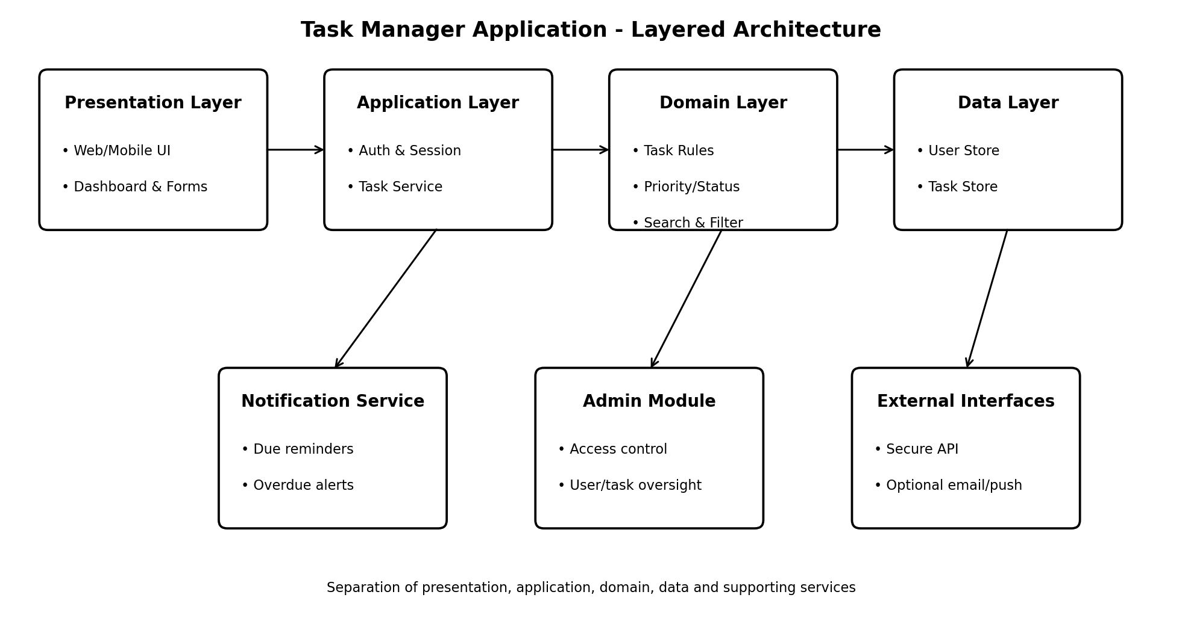
Figure 1. Layered architecture for the Task Manager Application. The design separates the user interface, application services, task/domain rules and persistent data, with supporting notification, administration and external-interface components.

3.4 Component Descriptions
Component | Responsibilities
Presentation / UI | Displays dashboard, task forms, task details, search/filter controls, notifications and account functions. Performs client-side feedback and presents important task states clearly.
Authentication & Session | Authenticates users, creates/terminates sessions and prevents unauthenticated access to protected task data.
Task Service | Handles task creation, viewing, editing and deletion, while enforcing authorization and validation.
Task/Domain Rules | Applies priority, due-date, status and category rules and determines overdue conditions.
Search & Filter | Searches accessible tasks and applies status, priority, category and due-date filters; supports deterministic sorting.
Notification Service | Generates configured reminders or notifications for upcoming and overdue tasks when enabled.
Summary Service | Aggregates accessible task records and produces counts by relevant status.
Administration / Access Control | Restricts administrative operations to authorized administrator/manager roles.
Data Store | Persistently stores users, sessions, tasks, categories, statuses and notification-related records.

3.5 Chosen Architecture Pattern and Rationale
A layered architecture is selected for the Task Manager Application. Presentation responsibilities are separated from application services, domain rules and persistence. This structure supports maintainability, testability and controlled access. The design avoids unnecessary coupling between the UI and data storage and allows supporting services such as notifications and administration to remain modular.

3.6 Technology Stack & Data Stores
The supplied SRS intentionally keeps technology-specific details technology-neutral. Therefore, this design does not prescribe a specific programming language, framework, database product or hosting platform. The logical data store must persist user, session, task, category, status and notification-related records.

3.7 Risks & Mitigations
Risk | Mitigation
Unauthorized access to protected task data | Require authentication and enforce authorization before task retrieval or modification.
Unauthorized administrative access | Apply role-based access control to administrative functions.
Invalid or malicious input | Validate and sanitize user-provided values before processing or storing them.
Data loss after successful save | Use persistent storage and verify recovery after application restart.
Temporary communication failure | Return understandable errors and avoid losing already saved task data.
Slow common operations | Use efficient application/data access and verify the 90th-percentile response-time target through testing.

3.8 Traceability to Requirements
Requirement | Architectural Component
TMA-F-001 / TMA-F-002 / TMA-SR-001 | Authentication & Session
TMA-F-010 / TMA-F-011 / TMA-F-012 | Task Service + Data Store
TMA-F-020 / TMA-F-021 / TMA-F-022 / TMA-F-023 | Task/Domain Rules
TMA-F-030 / TMA-F-031 / TMA-F-032 | Search & Filter
TMA-F-033 | Task/Domain Rules + Monitoring logic
TMA-F-040 | Notification Service
TMA-F-041 | Summary Service
TMA-F-042 / TMA-SR-002 | Administration / Access Control
TMA-NF-001 / TMA-NF-002 / TMA-NF-004 | Application Services + Data Store
TMA-NF-003 / TMA-SR-003 / TMA-SR-004 / TMA-SR-005 | Security / Access Control Layer

3.9 Security Architecture
The security architecture is based directly on the SRS security objectives and requirements. Protected task and account information is accessible only after authentication and authorization. Administrative functions use role-based authorization. Passwords are handled securely and are never stored in plaintext. Network communication carrying credentials or task data uses secure transport. User input is validated and sanitized.

3.10 Security Threat View
Threat / Concern | Design Control
Spoofing / account impersonation | Authentication and session management.
Tampering with task data | Authorization checks, validation and controlled task updates.
Information disclosure | Protected task access and secure transport for credentials/task data.
Denial of service / excessive requests | Application-level request controls and monitoring of failures.
Elevation of privilege | Role-based authorization for administrative functions.
Sensitive information in logs | Do not place credentials or sensitive task information in application logs.

3.11 UML Class Diagram
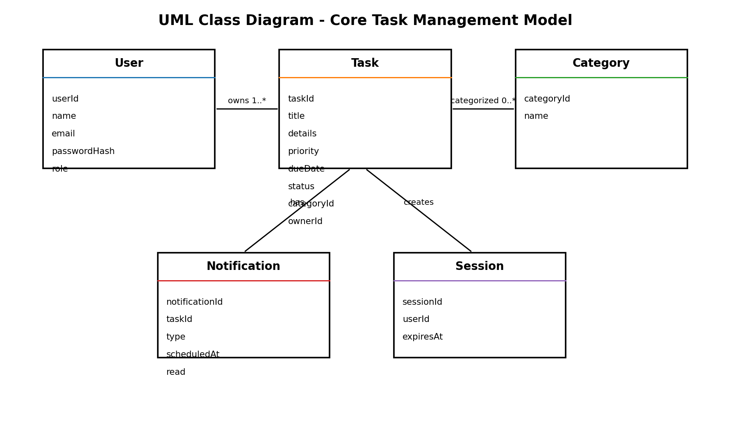
Figure 2. Core domain model. User owns accessible tasks; tasks may be categorized and can generate notifications. Sessions represent authenticated access.

4. Design

4.1 Design Overview
The design uses modular layers and components so that user interactions, business rules, data access, notifications and administration can be developed and tested with clear responsibilities. The principal flows are task creation/update and task search/filtering.

4.2 UML Sequence Diagrams
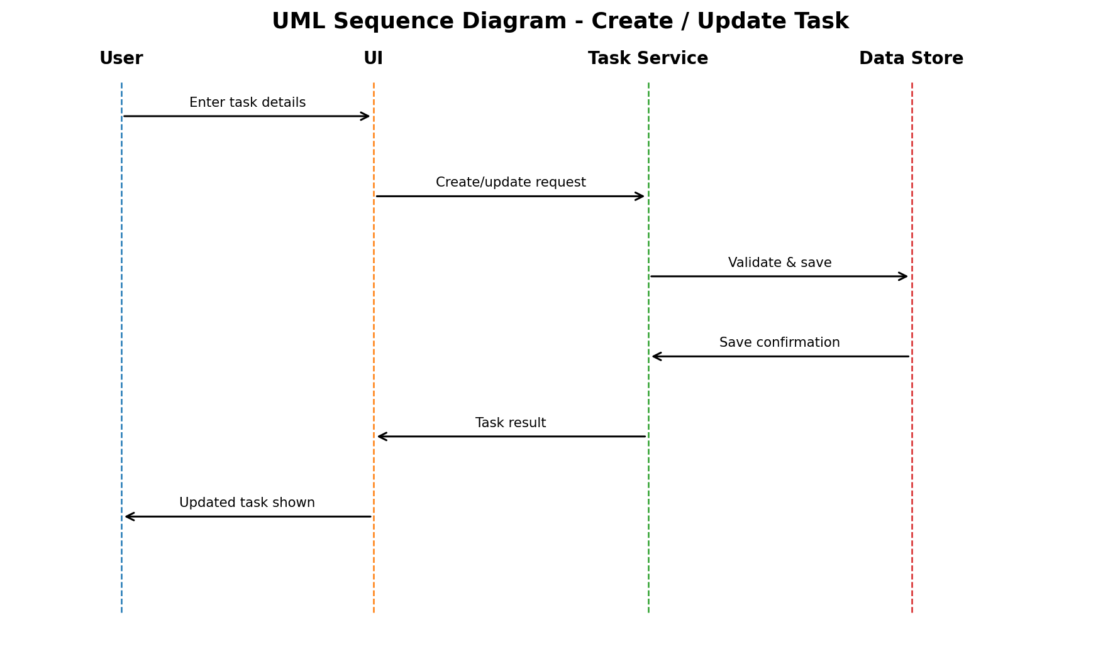
Figure 3. Sequence flow for creating or updating a task. The service validates the request, persists the valid record and returns the resulting task to the UI.
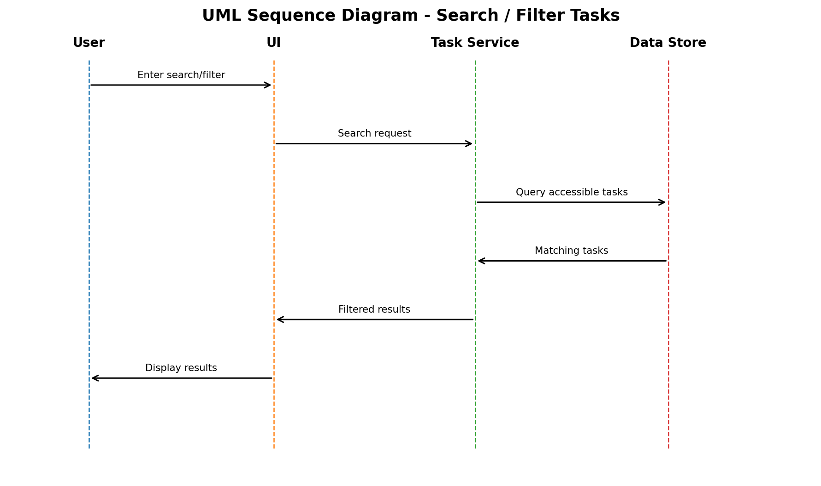
Figure 4. Sequence flow for searching and filtering tasks. The service queries only accessible task records and returns matching results to the UI.

4.3 API Design
The SRS requires an optional API layer for communication between the client interface and application services. The following logical interfaces define two core component interactions without assuming a particular implementation technology.
Interface | Operation | Request | Response / Errors
Authentication Service | POST /login | {email, password} | Authenticated session / invalid-credential error.
Task Service | POST /tasks | {title, details, priority, dueDate, categoryId} | Created task / validation or authorization error.
Task Service | PUT /tasks/{taskId} | Updated task fields | Updated task / authorization, validation or not-found error.
Search & Filter | GET /tasks?query=&status=&priority=&category= | Search/filter parameters | Accessible matching tasks / validation error.

API security rule: requests for protected task operations must be associated with an authenticated session, and authorization must be checked against the requested task and user role.

4.4 Error Handling, Logging & Monitoring
- Use standardized, user-understandable error messages for failed operations.
- Reject invalid input before processing or persistence.
- Do not expose passwords, credentials or other sensitive information in application logs.
- Preserve already saved task data when temporary communication failures occur.
- Monitor response time, availability, transaction/request failure rate and application recovery after restart.
- Use test cases defined in the SRS to verify performance, reliability, security, data integrity and usability.

4.5 UX Design
The primary interface should provide a clear dashboard with navigation for tasks, task creation, task details, filters, search, notifications and account functions. Forms should contain labels, validation messages and confirmation feedback. Overdue, completed and high-priority tasks should be distinguishable using clear text and UI indicators. Controls should support keyboard/touch accessibility and consistent navigation.

4.6 Open Issues & Next Steps
- Select the implementation technology and deployment environment during implementation, since the supplied SRS does not prescribe them.
- Define the exact notification mechanism and delivery schedule.
- Finalize database schema and indexing strategy.
- Implement and verify the high-priority functional requirements and security requirements.
- Execute the acceptance-test suites and update the RTM status from Not Started (N) as implementation progresses.

5. Appendices

5.1 Glossary
Term | Meaning
SRS | Software Requirements Specification
UI | User Interface
API | Application Programming Interface
CRUD | Create, Read, Update, Delete
RBAC | Role-Based Access Control
RTM | Requirements Traceability Matrix
NFR | Non-Functional Requirement
OTP | One-Time Password

5.2 References
- Team Software Requirements Specification (SRS), Task Manager Application, Version 1.0, 09-09-2026.
- SRS requirements, acceptance-test references and RTM supplied by the project team.

5.3 Tools / Modeling
The diagrams in this document are UML-style architectural/design representations prepared for the Task Manager Application. The design is intentionally technology-neutral where the SRS does not provide implementation-specific details.

