Project Backlog

# Epic

As an investor, I want to open an online library, so I can allow readers to borrow books.

## User Stories

**As a library admin, I want to login into the online library, so I can manage the books supply.**

### Definition of done

1. The admin is able to add books.
2. The admin is able to change a book (e.g. title due to a typo, number of available books).
3. The admin is able to remove book(s).
4. The admin is able to add, edit and remove user(s).
5. The admin is able to manage the due books.

### Test cases

|  |  |  |  |
| --- | --- | --- | --- |
| Steps | Expected results | Actual results | Status |
| The admin opens the library web page. | The page is properly loaded and provides the login panel. |  | OK |
| The admin tries to log into the library, with a wrong password. | The admin login attempt is rejected, with “The password you entered was not valid.” |  | OK |
| The admin provides the correct credentials. | The admin is logged in and he/she is redirected to the administration page.  The welcome message displays the current date/time and it’s updating real time. | The admin is logged, but the welcome message doesn’t display the date and the time is not taking into account the daylight saving. | KO |

Incident report: LIB-1

Steps to reproduce:

1. The admin logs into the library.
2. It checks the accuracy of the info, so it can handle the due books.

Expected results: The welcome page is providing the current date/time in the local format.

Actual results: The date is not displayed, and the provided time is not considering the daylight saving. Also, the provided value is not changing in real time.

See the attached screen shot and logs.

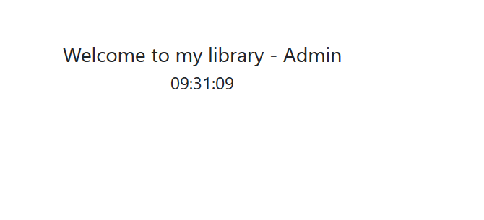

|  |  |  |  |
| --- | --- | --- | --- |
| Steps | Expected results | Actual results | Status |
| The admin is going to Books management and chooses to add a new one. | The add book form is provided. |  | OK |
| The admin starts to fill in the required info. | The provided fields are allowing only valid values. | It is allowed to enter negative values for the edition and copies.  It is not allowed to add ISBN codes, but only plain numbers.  A drop-down should be provided to able to choose the year value. | KO |

Incident report: LIB-2

1. The admin logs into the library.
2. It chooses to add a new book, as a new item arrived.
3. ­It tries to enter a valid ISBN for the book.

Expected results: The ISBN value is allowed.

Actual results: Only plain numbers are allowed.