|  |  |
| --- | --- |
| Project Code: |  |
| Project Title: | ZROAD |

|  |  |
| --- | --- |
| Project Overview: | An AR android application to provide map navigation service |

|  |  |  |  |
| --- | --- | --- | --- |
| Created by: | Lau Wing Ying, Vicx | **Student Number:** | 51849843 |
| Program Code: | CS4511 | | |
| Version: | Version 1.0 | | |
| Date: | 23/09/2013 | | |
|  | | | |
| Supervisor: | Dr WONG, Shek Duncan | | |

**Contents**

1. Background 3

1.1. Assumptions 4

2. Project objectives 4

3. Project Scope 5

4. System design 5

4.1. Functionalities 5

4.2. Project Struncture 6

4.2.1. Architecture and Design 6

4.2.2. User types 7

4.3. Data flow 7

4.3.1. Server side 7

4.3.2. Client side 8

5. Project Schedule 9

6. Conclusion 9

7. Appendix 9

# Background

In this IT century, most people get at least one mobile phone, information flow media is changed from physical material to digital tool. It brings a lot of benefit. Time cost is reduced and more information can be displayed with one click.

Traditionally, people navigate themselves with a paper map but now, as the popularity of mobile device, people will use applications like Google map, transportation application to find the position of their vacation.

Since the world-wide geographical information has been collected online, map service through the internet is now widely used. However, people who cannot find the place they want even with the map are still not the minority.

There are still problems to cause less effective of maps guideline.

* **Accuracy in mapping instruction to the reality**

With input of destination and current location, existing navigation system generates a representation of suggested path displayed on 2D map. The visual aids are not sufficient for users to apply the path into the reality. How the path mapped to the reality is depended on the users. This costs inconsistent performance to the navigation.

* **Inconveniency**  
  When users get the path on 2D map, they need to integrate the path on the screen to the surrounding in the reality. It is inconvenient to work on the integration and finding directions.
* **Recognition**There may not be significant recognition for the surrounded building when users observe the road environment. Users require time to locate their position by investigating the surrounding environment.
* **Details of road/building information**

Road information and street information may be required by users. As most geographical information is gathered by the internet, there are rich details of street and building.

For this purpose, what we should do is, connect the geographic information with augmented reality in Zroad – To enhance the ability of map navigation.

## Assumptions

The application is developed for public users.

Assume all Users smart phone has the following architecture:

* Android 2.2 or above
* Supporting OpenGL ES 2.0
* Internet connection (Network/WiFi)
* GPS Access
* Camera function and Camera Access
* Phone Storage

Assume all Users agree their smart phone to grasp their geographical location.

Assume all Users use this application in outdoor situation.

Assume all Users’ smart phone GPS location is accurate.

# Project objectives



Using an enhanced map on hand is the best choice for people who get loss easily. The more details can people get the information, the easier people to arrive the destination. The ability of the application response the actual location and the surrounding environment can help the user to get the direction efficiently.

Zroad is a mobile application that provides augmented reality based guideline to user to get to the destination efficiently. Zroad, with the pronunciation 'See road', directs user to their destination with the camera and GPS in their mobile device. Even non-map readers now lose in the complicated road like 'Z' shape, they can still easily get their way with instructions from Zroad. After inputting the destination, all they need to do is to simply raise their mobile device with the camera, focus to the surroundings where they currently are. Zroad will give them directions with some arrows. Users will not need to worry about the map and just follow the given arrows.

To increase the efficiency of map navigation, AR-based map navigation brings more benefit to user.

* Help locating surrounded buildings with the map
* Help the non-map reader to arrive to the destination with Zroad
* Recognize the surrounding building
* Navigate the direction of movement

# Project Scope

* Scoped within MongKok
* Data based on Google Walking directions which are in beta and its suggested route may be missing sidewalks or pedestrian paths.
* Target User is familiar with the culture in Hong Kong.

# System design

## Functionalities

* + 1. Recognize the surrounding building

Users must open the camera in the mobile.

Raise the phone to the street view and the building name, street name and road number will be shown on the screen.

* + 1. Locate the current position on map with direction

Users can get the current position when they open the application and allow the access of GPS information.

* + 1. Get the correct way to the destination place

Check the route from the current location to the destination.

Raise the phone and there will be a clear arrow that pointing to the right direction from point to point.

## Project Struncture

### Architecture and Design

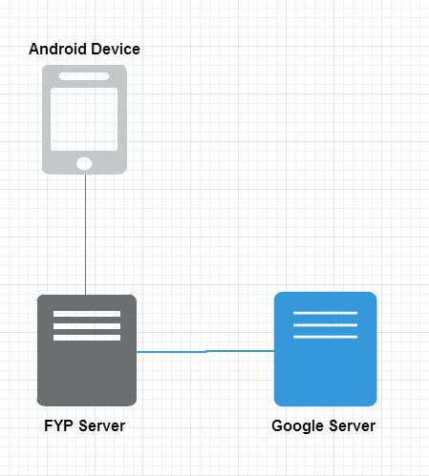There is Server, android system smart phone, Google Map Server,

Wikitude SDK is used to develop the application. The library in Wikitude SDK unifies all Augmented Reality technologies which help in overlaying text, images, graphics or 3D objects in the camera capture.

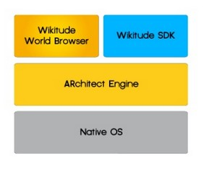

### User types

#### Use case diagram

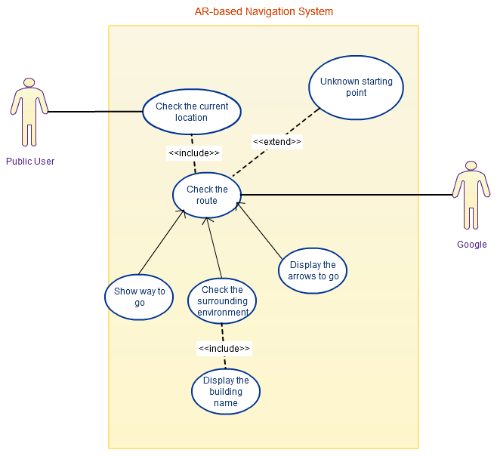

Figure 9.2.3.1-1 Use Case Diagram of AR-based Navigation System

## Data flow

### Server side

[Get the GPS information]

Get the GPS information

Get the direction

Open the camera

[get the camera view]

Recognize the camera view

[get the street name, road number, building name. ]

Present the street information, building information

Request the destination place name

[get the place name]

Process the way to go

[return the direction to go]

Show the direction to go

### Client side

[send the current gps location]

Open the camera

[send the camera view]

[get the street name, road number, building name. ]

Present the street information, building information

[send the destination place]

[get the direction to go]

Show the direction to go

# Project Schedule

Visualize the direction with visual aids showing in the augmented-reality screen

Name the surrounded buildings in the augmented-reality screen with Wikitude SDK

|  |  |  |
| --- | --- | --- |
| Period | Task(s) |  |
| Sep | * Initialize the Project Plan * Study on WikiTude | |
| Mid-Sep | * Finalize the Project Plan * SetUp Server | |
| Oct | * Research on UI Design, Google Map, GPS * Study on the existing navigation system | |
| Mid-Oct | * Finalize the Program Structure * Initialize the development of Zroad | |
| Nov | * Finalize the First Interim Report | |
| Late-Nov | * UI Design * Unit Test the existing method | |
| Dec | * Integration Test | |
| Jan | * System Test | |
| Feb | * Test Zroad in the reality * Finalize the Second Interim Report | |
| Mar | * Enhance Zroad * Finalize Zroad | |
| April | * Finalize the Final Report | |

# Conclusion

# Appendix

<http://earthmeasurement.com/GPS_accuracy.html>