

City University of Hong Kong
Department of Computer Science

BSCCS Final Year Project Report 2012-2013

12CS092
NetSync - Personal File Synchronization System
(Volume 1 of 1)

Student Name | : | Tsang Yi Sha
Student No. | : | 51818370  For Official Use Only
Programme Code | : | BSCCS
Supervisor | : | WONG, Shek Duncan
1st Reader  2nd Reader | :  : | KEUNG, Wai Jacky  Lee Chan Hee

Student Final Year Project Declaration
I have read the project guidelines and I understand the meaning of academic dishonesty, in particular plagiarism and collusion. I hereby declare that the work I submitted for my final year project, entitled:

NetSync - Personal File Synchronization System

does not involve academic dishonesty. I give permission for my final year project work to be electronically scanned and if found to involve academic dishonesty, I am aware of the consequences as stated in the Project Guidelines.

Student Name: | TSANG YI SHA |  | Signature:
Student ID: | 51818370 |  | Date: | APRIL 15 2013

Interim Report
Table of Contents
Interim Report 2
Acknowledgement 7
Abstract 8
1. Introduction 9
1.1 Background 9
1.2 Problems & Opportunities 10
1.2.1 Cloud technology and products 10
1.2.2 Dropbox 12
1.2.3 Use of encryption tools 13
1.4 Organisation 15
2 Literature Review 16
2.1 Cloud Storage 16
2.1.1 SPI Framework 17
2.1.2 Features 20
2.1.3 Section Summary 21
2.2 Existing cloud services 21
2.3 Dropbox – the target platform for NetSync 23
2.3.1 Background 23
2.3.2 Description 23
2.3.3 Remarkable features 25
2.3.4 Latest development 26
2.3.5 Security Concerns 26
2.3.6 Section Summary 28
2.4 Third-party encryption tools 29
2.4.1 SecretSync 30
2.4.2 Truecrypt 31
2.4.3 Section Summary 33
2.5 Diffie-Hellman Key exchange 34
2.5.1 Discrete Logarithm Problem 34
2.5.2 Diffie-Hellman Problem 34
2.5.3 Limitations 36
2.6 Secure Socket Layer 37
2.6.1 Handshake Protocol 38
2.6.2 Record Protocol 41
2.6.3 Limitations 42
3 Methodologies 43
3.1 Authentication 43
Transmission through encrypted channels 43
3.2 Key Exchange 45
3.2.1 Mechanism 45
3.3 Data Encryption 48
3.3.1 Security Issues with Data-at-rest 48
3.3.2 XTS-AES 49
3.3.3 Mechanism 50
3.3.4 Ciphertext Stealing 52
3.3.5 Evaluation 54
3.4 Data Synchronisation 55
3.4.1 Overview 55
3.4.2 rsync algorithm 56
4 System Design 58
4.1 Functionalities 58
4.1.1 File synchronisation 58
4.1.2 Passing through Firewall 58
4.1.3 Client side encryption 58
4.1.4 Sharing under encryption 59
4.1.5 Local folder encryption 59
4.1.6 Section Summary 59
4.2 System Components 60
4.2.1 Structure of components 60
4.2.2 Interaction of Components 61
4.2.3 Details of components 62
4.3 Work flow 70
4.3.1 Server side 70
4.3.2 Client side 71
4.3.3 Version Control 72
5 Implementation 74
5.1 Environment 74
5.2 Synchronisation 75
5.2.1 Rsync using C# native code 75
5.2.2 Rsync using cwRsync 81
5.2.3 Monitoring file change 83
5.3 Key Exchange 84
5.3.1 Generating public and private keys 84
5.3.2 Key exchange process 85
5.4 XTS-AES 87
5.4.1 Preparation 87
5.4.2 Encryption 88
5.4.3 Decryption 89
6. Results & Evaluation 90
6.1 Efficiency 90
6.2 User Interface 91
6.3 File Sharing 91
6.4 Security 91
6.5 Chapter Summmary 91
7. Further Development 93
7.1 Installation 93
7.2 Authentication 93
7.3 User interface 93
7.3 Encryption on the fly 94
7.4 Web page & mobile version 94
8 Conclusion 95
9 Project Management 96
9.1 Environment 96
9.2 Management Methodology 97
9.3 Project Timetable 98
9.4 Detailed schedule 99
9.5 Milestones 102
10 References 103
11 Appendix 110

Acknowledgement
This final year project would not have been possible without the support of many people. The author wishes to express her gratitude to her supervisor, Prof. Duncan Wong who was amply helpful and offered treasured guidance, support and assistance. Not forgetting to her friends who always been there. The author would also like to convey thanks to the Department of Computer Science for providing the laboratory facilities. Finally, The author wishes to express her love and gratitude to her beloved families and fiancé; for their understanding & endless love, through the duration of her studies.

Abstract
Cloud storage services like Dropbox have gained popularity over the years. While such services provide greater convenience for users to have access to their files on-the-go on any devices with an internet connection, security has become more increasingly a concern for some users, especially for those who possess such need to store sensitive data on the cloud. The issue of data privacy and integrity has created a market for third party encryption tools.
The existing encryption tools in the market, while providing protection for the confidentiality of data, are often not well considered and have caused much inconvenience to users. The use of SecretSync and Truecrypt as an encryption tool for Dropbox, for instance, suffers from a major drawback as it makes the sharing of encrypted files impossible with another user. In fact, other similar solutions are very likely to suffer from this downfall.
NetSync aims at providing a better solution for encrypted file synchronisation. Unlike some other solutions on the market, NetSync provides a one-stop solution for the encryption, decryption and synchronisation of cloud data. It is virtually combining the security provided by some popular services like SecretSync and TrueCrypt; and the convenience of cloud storage offered by Dropbox.
The solution presented in this report adopts Diffie-Hellman key exchange approach to share a common cryptographic key. The project utilises XTS-AES as the encryption method. Rsync algorithm is used for the file synchronisation. The incorporation of these methodologies makes NetSync a highly competitive solution on the market.

1. Introduction

1.1 Background
Until recently, emails and removable storage devices have been two common channels with which data can be carried across different devices. While emails allow users to transfer files without using external storage devices, there are generally limitations on the size of the attached files. Popular free email providers nowadays, such as Gmail, Hotmail and Yahoo Mail, have generally a size limit of 25 mega bytes (MB) for the files a user can attach to a particular email [1]. It is basically impossible to send large files directly through these services.
To avoid the file size limitations associated with free email services, some people have resorted to using thumb drives ⁽¹⁾ to transfer larger files between different computers. A thumb drive normally provides a relatively larger storage space. Compared to emails, file size limit is no longer a concern with thumb drives.
However, there are still some other issues. Firstly, while the portability of thumb drives brings along a lot of convenience in transporting larger files, the same portability also creates some security issues. There is a risk of losing a thumb drive due to its small size. In fact, there have been several cases in which medical practitioners from the Hospital Authority in Hong Kong had lost thumb drives storing the personal data of patients [2][3]. As we can see from these cases, sensitive data may be exposed when external storage devices are not used with care and diligence.
Second, as a user copy files from a thumb drive to different devices for further editing, these edited copies may cause confusions and conflicts if he / she forgets updating the original document. In other words, there is a lack of version controlling ⁽²⁾ when a user is using these portable drives to work in different computers.

- Thumb drives, or USB flash drives, are kind of removable storage devices which are small in size and easy to carry. Most of the thumb drives have a weight lighter than 30 grams (g) [4] with a storage capacity of up to 256 gigabytes (GB) [5].
- Version control is a mean to manage the change of file(s). It has another name called revision control. Each version (change) may consist of very minor changes, but it is important to keep version control, so that a file can be restored when necessary [6].

1.2 Problems & Opportunities
While the performance of Email and thumb drives is unsatisfactory, there exist some new technologies and products in the market to address the need of secure data storage. This section introduces various cloud technology and products developed throughout the years. In particular, it discusses the opportunities and problems brought from Dropbox and various encryption techniques.

1.2.1 Cloud technology and products
The idea of cloud technology was first introduced in the 1960s, and implemented after 2008 [7]. Cloud computing has been changing how people use the Internet and how they interact with their personal files and documents. Cloud computing is essential for many of the services which we often use these days: from movie and music rental and sales services like Amazon, to services provided by the Internet Giant like Gmail, Google Docs, and Chrome OS. All these services either are built upon or utilize cloud technology to provide some functionality which has been embraced by users worldwide without much thought. Figure 1 shows the evolution of computing technologies.
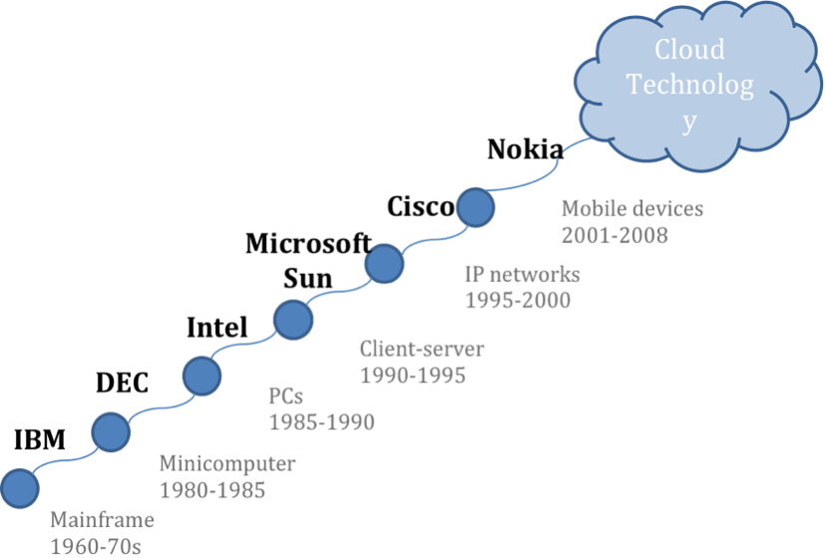
Figure 1: Evolution of computing technologies

The emergence of services utilizing cloud technology over the years has made cloud technology become prevalent nowadays. According to TwinStrata, 83 per cent of interviewees are using / planning to use cloud storage for various purposes [8].
There are about 375 million users who are using cloud storage services in October 2012. It is already a double of the figure last year. Figure 2 shows the worldwide forecast for personal cloud subscriptions. The HIS iSuppli Research shows the estimation of cloud usage, which indicates a steady increase of users [9]. Also, it is estimated that there will be about 33 per cent of users’ data stored in the cloud in 2016 [10].
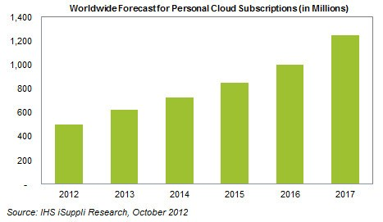
Figure 2: Personal Cloud Subscription [9]
The influx of cloud lovers is not without its reason. With this technology, users can enjoy a low cost of data storage with high flexibility. There is no longer a need to carry data around using an external physical storage device [11]. There are a number of popular cloud storage services in the market, like Dropbox, Google Drive and Microsoft Skydrive [12]. With the existence of these tools, it is not necessary for people to send attachments through emails manually or to be afraid of losing their thumb drives. These tools also bring convenience to users by providing file synchronisation and sharing services.

1.2.2 Dropbox
In this project we focus on Dropbox as a platform to implement our proposed application considering its popularity among users from different sectors. Dropbox provides 2 GB of free space for a new user. Users can enjoy the file synchronisation service by simply saving a file to Dropbox. The service allows people to retrieve their files anywhere easily. With Dropbox, the problem of version control is solved, since users will only work on a single file when editing.
In 2011, Dropbox reported that there were 50 million users, which was a threefold increase compared with the figure in 2010. It was expected to gain $240 millions of revenue by the end that year [13]. This rapid increase of user and revenue has reflected the popularity of Dropbox, and also the potential commercial value of this kind of service.

Problems
However, every coin has two sides. There are quite a number of potential pitfalls. Dropbox is a cloud service [14], which is backed by many servers for ensuring the availability and stability. The same set of users’ files may be backed up with multiple copies, and stored in different data centres [15]. In addition, Dropbox also stores the past versions of files for users [16]. The storing of multiple copies of users’ files increases the risk of unauthorized access.

Data Security
To ensure a higher security level, Dropbox has provided the service of Secure Socket Layer ⁽¹⁾, Advanced Encryption Standard ⁽²⁾, AES encryption for data transfer and storage respectively [17]. Nevertheless, the encryption is done on the server side, which means that the encryption key is not owned by the user. It implies that the user’s file can be decrypted by the server solely. It may pose a potential security risk even though Dropbox has a strict policy of data access.
- SSL builds a secure communication among the connecting machines. It helps to identify machines, encrypt data and check the data integrity [18].
- AES is a symmetric key algorithm, which uses the same key for both encryption and decryption. File is separated into blocks under this algorithm [19].

1.2.3 Use of encryption tools
The discussion above shows that as convenient as Dropbox may be, it may not be the best choice for some users on some applications. For example, security risks may be highly concerned by users who wish to synchronise confidential files between different machines. In situation like this when security and confidentiality is a major concern, encryption may be a solution to address the issue.

In order to improve the security of Dropbox, there are some encryption tools in the market which users may make use of. The examples are SecretSync and Truecrypt [20][21]. By using these tools, the file is encrypted before being sent to the Dropbox server. In this way, the content of the file will not be exposed even if it is intercepted or stolen.

Problems
Despite the enhancement of security level, there are drawbacks of using these third party encryption tools. SecretSync requires double storage size which is not preferable to users [22]. Truecrypt, on the other hand, requires the mounting and dismounting of a virtual volume for syncing which may not be convenient for users [23]. In addition, files encrypted by these tools cannot be shared with other users since decryption is only possible with the user’s key. A more in-depth evaluation of these third party encryption tools can be found in Section 2.4.

As it can be seen from the above discussion, while the use of an additional third-party encryption tool for Dropbox can make the use of the famous cloud storage service more secure, it affects the overall user experience. As such, there is a need of a more convenient and secured file synchronisation system which can take the advantages of Dropbox and encryption tools without any trade-offs.
1.3 Objectives
The aim of this project is to take the advantages of the existing technologies while solving the problems presented in the previous section. This project targets at providing a convenient and secure file synchronisation system, namely, NetSync.

To provide the services of file synchronisation and sharing, NetSync makes use of a centralised storage. Users’ files are stored in the cloud, and thus can be accessed anywhere.

Also, NetSync implements encryption on the client side in order to protect data confidentiality and user’s privacy. Before sending a file to the server, the file will firstly be encrypted using a secret key, which is only known by the user. Without which, no one can decrypt the file.

Under the key exchange mechanism of NetSync, the feature of sharing can be kept. There is no difficulty of sharing due to decryption. NetSync provides another way of key exchange for sharing purposes. By exchanging a common key, an encrypted file can be shared by users.

To achieve a higher security level, NetSync provides an encryption service for the files stored in the NetSync folder. With encryption, a hacker is not able to read any data even when a file is stolen. More importantly, this encryption will not affect the usage of the file. A user can open the file as normal, because the file will be decrypted once the user opens it. This encryption/decryption-on-the-fly feature keeps the both convenience and security.

Due to the scale of this project, the functionalities of sharing by URL, setting user privilege of shared files and mobile platform supporting are not in the scope of this project. They will be considered as a part of further development. For now, the main concern of this project is enhancing the security level without diminishing convenience.

1.4 Organisation
The rest of this report is organised as follows. Chapter 2 reviews cloud technology and evaluate Dropbox based on its features and security concerns. Two encryption tools, SecretSync and Truecrypt are also reviewed and discussed. The chapter ends with a critique of Diffie-Hellman key exchange and Secure Socket Layer.
Chapter 3 of this report includes the methodologies adopted in this project, including the authentication, key exchange approach, encryption mode and method of synchronisation.
Chapter 4 introduces the system functionalities. Detailed descriptions of different components are given in this chapter. The workflows of how the system functions are then provided.

In chapter 5, the implementation of NetSync is introduced. This includes a description of the system environment, the implementation of file synchronisation, including the processes of file monitoring, notifications, as well as the adoption of cwRsync for synchronisation. In addition, the implementation of key exchange mechanism, the generation of prime and keys are also discussed. The use of XTS-AES encryption, the preparation and process of en/decryption are also described in this chapter.

Chapter 6 reports and evaluates the results obtained by the implementation of the system design. This includes the efficiency of NetSync in carrying out encryption, as well as the security and sharing of encrypted files.

In Chapter 7, we will look at the possible further development of the implementation presented in this project. In particular, the possibility of incorporating a installation package, authentication mechanism, user interface, encryption on the fly, and mobile application development are discussed.

The Project Management section reports the environment and management methodology used. Project timetable, detailed schedule and milestones are included to demonstrate the planning of whole project.

2 Literature Review

2.1 Cloud Storage
Cloud computing is the use of pre-existing technologies (hardware and software) to form an environment for virtual centralisation of resources over a network. There are 3 main services provided by cloud computing. They can be described using the SPI Framework [24]. SPI is an acronym for the most common cloud computing service models, namely, software as a service (SaaS), platform as a service (PaaS), and Infrastructure as a service (IaaS).
Software as a Service (SaaS) is a software distribution model in which applications are hosted by a service provider and distributed to customers / users over a network. Platform as a Service (PaaS) is a model for delivering operating systems and / or other related services over a network without the need for users to download or install the application. Infrastructure as a Service (IaaS) involves outsourcing the equipment (servers, storage, network equipments) used to support the operations of cloud computing services [25].
Figure 3 below shows an overview of SPI Framework and examples of the services provided under each model.
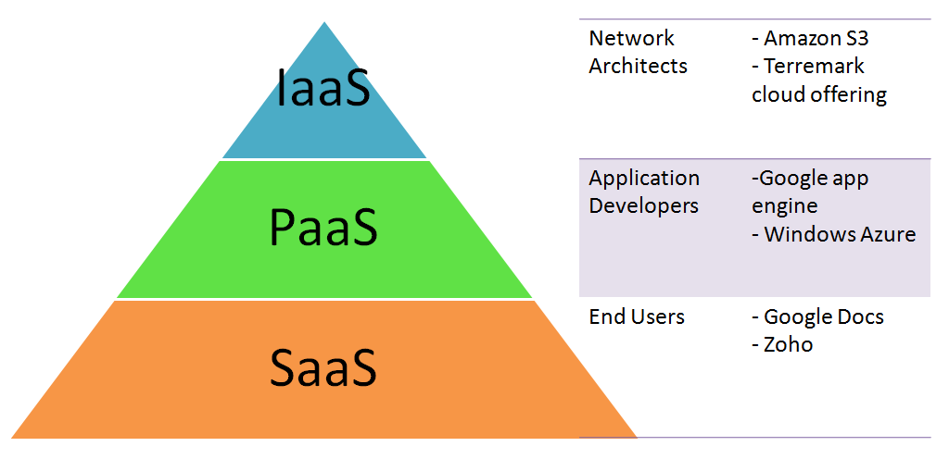
Figure 3 An overview of the SPI Framework

2.1.1 SPI Framework

Software-as-a-Service (SaaS)
In a non-cloud setting, users have to own a list of hardware, software, and complete a series of preparation before running an application. The deployment of a new application would usually involves the setting up of or the checking of the network environment, the hardware devices, software licenses, as well as the compatibility of operating system.
Under the SaaS model, users can run applications on the cloud infrastructure without worrying about the operating environment. The deployment concerns are all taken care of by SaaS providers. As such, the cost of using cloud-based software is normally lower due to the reduced cost of licensing and setting up / maintenance of hardware devices.
This service is usually used by the end users. Google Docs and Zoho are two famous applications under the SaaS model.
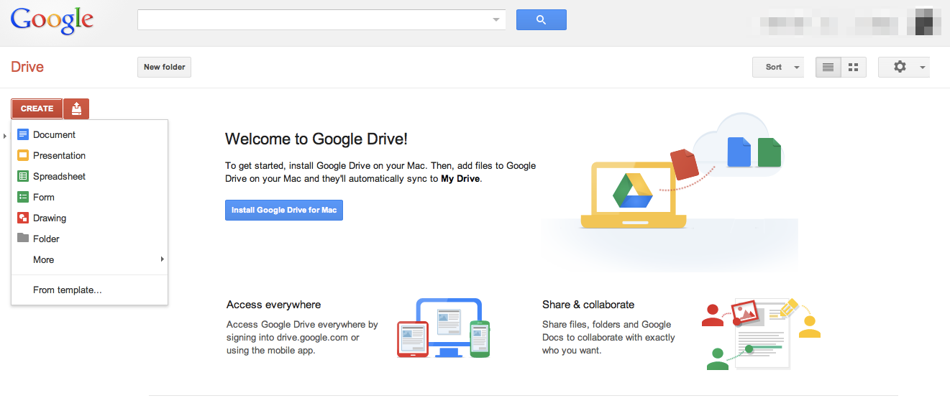
Figure 4 Google Drive (AKA Google Docs)
With Google Docs, users can access the service with their own computing devices. The user’s knowledge of the cloud infrastructure is unnecessary before he or she can use the service.

Platform-as-a-Service (PaaS)
Users of PaaS are mainly application developers. They can write applications and deploy them on the cloud with no requirement of system administration skills. Development environment is provided. The components of backend system, such as web servers and database are managed by PaaS providers.
This service allows a low cost of starting up a company to deploy applications. As no setup is needed, users can simply develop, deploy and test their applications on the given environment. Examples of PaaS are AppScale and Microsoft Windows Azure.

Figure 5 A screen capture of AppScale
AppScale is an example of open source cloud platforms under the PaaS paradigm. With AppScale, users can deploy their applications onto a number of popular cloud services as a number of famous APIs are implemented by the service, including those of Google App Engine, Amazon EC2 and Eucalyptus private clouds.

Infrastructure-as-a-Service (IaaS)
IaaS is at the highest level of the SPI framework, in which the users are usually network architects. Users can enjoy shared resources including computing resources and storage without concerning the actual location of servers, security, backup, etc. The details of infrastructure are abstract. Under the IaaS model, a pay-per-use charging scheme is often adopted, which enhances the flexibility of this service. Users can add new capacity to handle peak loading. Therefore, more comprehensive outsourcing can be supported. Amazon S3 and Dropbox offering are two famous providers of IaaS.
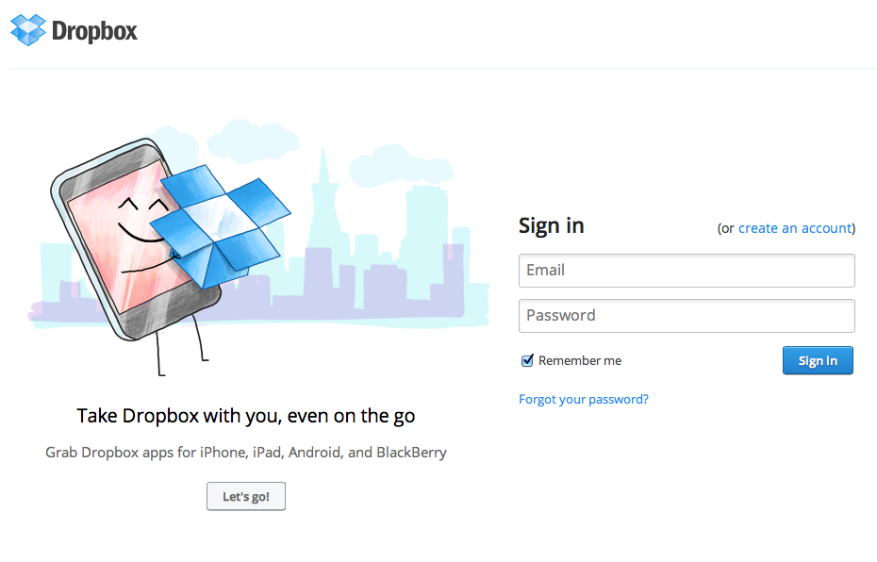
Figure 6 The login page of Dropbox
Dropbox is a very famous cloud storage solution. Users only need to install a client application with which a Dropbox folder is automatically created. With such folder, synchronisation with the cloud is automatic. Users do not need to be concerned about the actual locations of the servers storing the user’s documents and files. Dropbox provides a basic free service with a 2GB storage space, and it provides programs for users to increase the storage by fulfilling certain tasks; at the same time, a paid membership scheme is also available for heavy users.

2.1.2 Features
Since the inception of cloud computing, it has played an important part in ensuring that companies and businesses using services associated with it run smoothly at a minimal cost. Cloud computing has provided various types of services which are secure, reliable, and available at all time. In this section, some of the features of cloud computing are presented [26].

Resource sharing
Instead of using dedicated resource, resources are shared at certain levels including application, host and network.

Scalability
A key characteristic of cloud computing is its quick scalability. The estimation of resource using is difficult. Over-estimation causes wastage of idle resources while under-estimation causes delay of project or increasing cost when getting immediate resources. With cloud computing, resource planning becomes less important, since resources can be increased or released when needed.

Elasticity
Upgrades and modifications to the services are carried out promptly and effortlessly allowing the cloud computing service to be robust. A business owner can easily request for additional processing power, storage space, network bandwidth, and licenses /subscriptions.

Dynamic-provisioning of resources (Pay per use)
Another advantage of cloud computing is the flexibility of the billing model. With dynamic provisioning of resources, users are required to pay for the actual amount used only. The provider allocates more resources as they are needed and removes them when they are not. The low cost of entry encourages small initial investment, while the dynamic nature of resources allocation leaves small businesses with plenty of flexibility shall there be a dire need of additional resources.

Self-provisioning of resources
With user self-provisioning, the user purchases resources from the cloud provider and settles the payment online. The provider's resources are made available within a short period of time.

2.1.3 Section Summary
The scalability and elasticity of cloud computing, together with its variability in the provision of resources, have made possible some of the most salient cloud based services we see today. In the next section, some exisiting cloud services will be surveyed and discussed.

2.2 Existing cloud services
Dropbox, Google drive and SkyDrive are the three most popular cloud storage tools available in the market [27]. Dropbox was officially launched in 2008. Google Drive was officially launched on 24 April 2012, which is a relatively new service [28]. SkyDrive is a product of Microsoft, which is a part of Windows Live services. A comparison is made for comparing the features of Dropbox, Google Drive and SkyDrive, as shown in Table 1.
Table 1 Comparison of the 3 cloud storage services
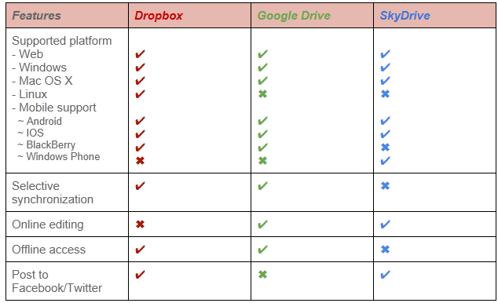
Table 1 Comparisons of the 3 cloud storage services (Cont'd)
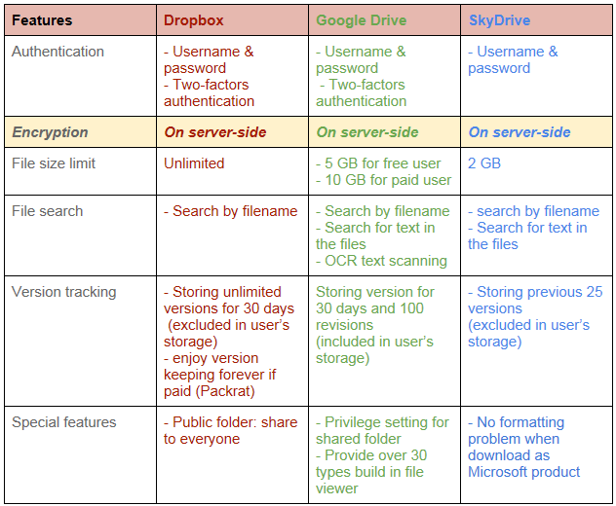
As it can be seen in Table 1, the three tools provide similar services in different levels. The common features like file search and version tracking are highly regarded by users of these services. They will be added into the further development scope of NetSync.
One of the main key features that distinguish NetSync from other existing services is the security of data. The highlighted part in the table shows the encryption method adopted by the existing services. As shown, all of them are using server-side encryption. One of the problems associated with the sole adoption of server side encryption is that under this approach, the server itself solely owns the key. This may cause some concern for users who wish to own a secret key.

2.3 Dropbox – the target platform for NetSync
Dropbox is one of the more established cloud storage services available in the market. Given its cross-platform availability and popularity among users (see Table 1). It is chosen as the target platform for the development of NetSync.

2.3.1 Background
The founder of Dropbox, Drew Houston was inspired after having forgotten to bring his thumb drive frequently [29]. He stated that the problems of existing services at the time include the limitation on file size, network related issues, unsophisticated implementation and coding imperfections. Therefore, Dropbox was created in an attempt to address these issues and limitations.

2.3.2 Description
Dropbox acts like a transferring point that receives users’ file and stores them on Amazon's Simple Storage Service (Amazon S3) [30]. Amazon S3 provides a cloud service which allows users to access their files anywhere, as long as they have access to the Internet [31].
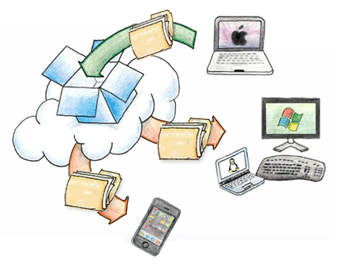
Figure 7 Supported platforms for Dropbox services (Mac, Windows, Mobile, etc.)

Prior to October 4, 2012, two types of folder are available in Dropbox, public folder and private folder. As the folder names suggest, contents in the public folder will be able to be accessed by anyone, as long as they have the link. On the contrary, files in private folder will only be accessible to the owner. To provide a better sharing service, contents in the private folder can also be shared as long as the user invites the target person.
After October 4, 2012, the public folder is no longer available to all the newly created account. All the extra functionality provided by the Public folder is now accessible anywhere in a user’s Dropbox. A “share link” can be created via user’s computers, phones, and tablets within any Dropbox folder. [32]
There is a reason that Dropbox has been widely used by the public. Dropbox is not only suitable for personal use, but also team use. Organisations can use it for team project [33]. Up to now, there are already more than 50 million users using Dropbox.

2.3.3 Remarkable features

File synchronisation and ways of access
Dropbox is a user-friendly file synchronizing service. Users can access files not only by browsing their website, but also from a synchronised Dropbox folder which is created by installing the client application on the computer. Any files in the folder are synchronised to the cloud and also to all the registered devices of the owner.

File sharing
Sharing is another feature of Dropbox. Dropbox provides several ways of sharing files [34]. Users can either create a shared folder for another Dropbox user, or share a hyperlink which maps to the file(s) to a non-Dropbox user. Users can also create a public gallery for sharing image files.

File restoration
Security is another renowned feature of Dropbox. In order to prevent the loss of data, every file a user put into Dropbox will be backed up. Besides, it will keep snapshots of incremental updates of each file for 30 days. As such, even if a file is deleted or changed accidentally, the user can still retrieve the old version from this restoration system.

Advanced security measures
Secure Socket Layer (SSL) protocol and Advanced Encryption Standard (AES)-256 bit encryption are used for data transmission and data encryption.

2.3.4 Latest development

Linking to Facebook
User can link his/her Dropbox account to his/her Facebook account. It is convenient that user can select items in Dropbox and share to others through Facebook directly [35].

Two-step verification (Two-step authentication)
A new type of authentication has been added, which acts as an extra layer of security. A security code will be received by a user’s mobile phone. When logging in, user has to enter the username and password, plus the security code [35].

New setting of shared folder
For a shared folder, user can choose an option which permits the members to invite other people to share the folder [35]. This adds into the convenience of the already comprehensive sharing options.

2.3.5 Security Concerns

Risk of file backup and version keeping
Dropbox is a cloud service which is backed up by many servers for ensuring the undisrupted availability. The same set of users’ files may be backed up as one or more copies, and stored in different servers.

As shown in the diagram below, we can see that files are backed up in different servers. For example, we can see that there are three copies of document “Z” stored in three different servers.
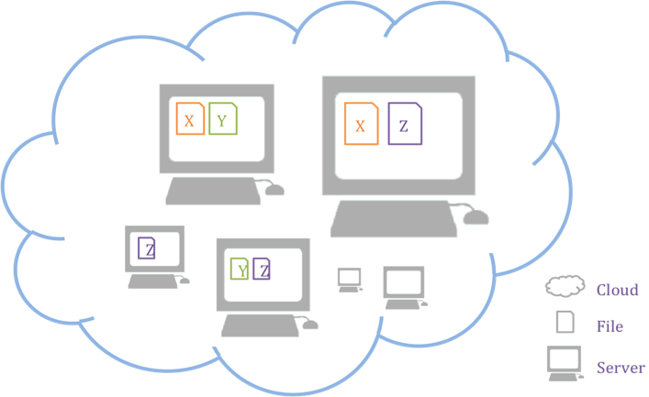
Figure 5 A demonstration of how files are backed up in Dropbox
In addition, Dropbox will automatically store the past versions of files for users. The existence of multiple copies of the files increases the risk of unauthorised access. Using the above example, there are three servers storing file “Z”, including the original file, its backups as well as its past versions. If an attacker hacks into one of the servers, the data may be exploited. As the number of server increases, so does chance of data leakage.

Risk of unauthenticated access
Dropbox has claimed that there is only a small amount of employees can access users’ data, and there is strict policy and access control applied to the staffs. Only the files’ metadata will be accessed in case of a legitimate need. However, the chance of data leaking is not eliminated. It is undeniable that there exist an opportunity of unauthorized accesses to user’s data.

In July 2012, a security breach was substantiated in which thousands of users had their credentials stolen after hackers targeted Dropbox. It was reported that usernames and passwords recently stolen from other services were used to sign in to some Dropbox accounts. In this incident, an employee’s Dropbox account containing a project document with user email addresses was also jeopardized [36]. This incident is a perfect example of how unauthenticated access to user’s account is difficult to avoid.

Risk of server side encryption
The encryption measure used by Dropbox is a server side encryption which its encryption key is defined by the server, instead of the user. Since the encryption key is owned by the server completely, the decryption of files is done by the server solely without the user’s consent. Server side encryption is problematic in the sense that the user who actually owns the files does not have the key necessarily for the decryption of their own file. A better alternative, as provided in the proposed solution, is to let the user take part in the encryption / decryption process.

Risk of hidden vulnerabilities
Some security researchers stated that Dropbox had been subjected to 3 different kinds of possible security threats [37]. First, there was a risk that users’ data would be accessed without any authorization by spoofing hashes. It happened since Dropbox used hashed values to identify the data’s owner. In addition, by using a user’s host ID, a hacker could pretend that he was the claimed user and get all files from that user’s account. The third threat was substantiated when a hacker used a specifically composed URL for getting files through SSL. Although these vulnerabilities have been closed now, it is worried that hidden problems may still exist.

Risk of system bugs
Except the hidden vulnerabilities, human errors may occur. On June 19, 2011, during system maintenance, a code updated had introduced a bug which turned off the authentication system [38]. The bug was discovered after four hours. During that period, a hacker could access one’s account by the login email address without knowing the correct password and get all the data of that account.

2.3.6 Section Summary
From the growing number of member and revenue of Dropbox, it is undeniable that Dropbox is a well-received tool with considerable popularity. It makes users’ life easier by providing convenient data storage services. However, the risk for using Dropbox should also be taken into consideration. The disadvantages and potential security risks mentioned in the previous sections show that Dropbox may not be an ideal choice for some users on some applications. For example, security risks may be highly concerned by users who wish to synchronise confidential files between different machines.

2.4 Third-party encryption tools
To achieve better security, third-party encryption tools may be considered by Dropbox users. There are several encryption tools in the market. Among which, SecretSync and Truecrypt are one of the top fives which therefore are selected to be analysed in this review [39].

Unlike the server side encryption adopted by the three cloud storage giants, the security provided in these third-party encryption tools takes the approach of client side encryption. By using these third-party encryption methods, each file updated will first be encrypted before sending to Dropbox server. This fills the gap associated with the server side encryption, where the content owner is not allowed to own the key to decrypt his/ her own files. With this approach, sensitive information can be shared confidently online. The content of the file will not be exposed even if it is stolen, as the hacker would not have access to the encryption key. With these encryption tools, user can take full advantage of Dropbox without giving up their privacy or content rights.

2.4.1 SecretSync
SecretSync was created by a setup called Completely Private Files and has been a renounced third-party encryption tool for Dropbox. The service was later replaced by Viivo, which was developed with the objective to make sharing, exchanging and securing users’ data on the cloud safe and simple [40]. In this project, the discussion still mainly evolves around SecretSync due to its popularity.

Mechanism
After installation, an additional folder called “SecretSync” will be installed. It is a separate folder from the one of Dropbox. For any sensitive or confidential data, user can put them into SecretSync folder and the data will be detected by SecretSync. Before synchronising to Dropbox, data will firstly be encrypted with 256-bit AES encryption. The key for encryption is a secret key which is solely owned by the user. As such, data cannot be decrypted without the secret key.

Files put into SecretSync will be synchronised to Dropbox after encryption

Drawbacks
This application may sharply reduce the computer space. If a user wants to protect all files in Dropbox, he will put the files into SecretSync folder. Then, in his computer, there are Dropbox folder and SecretSync folder, which contain the same data. It implies that the space needed is doubled, which may be a burden if the data size is huge.

2.4.2 Truecrypt
TrueCrypt is another popular open-source disk encryption program with multiple platform support. Currently, Truecrypt supports Microsoft Windows 7/Vista/XP, Mac OSX, and Linux.
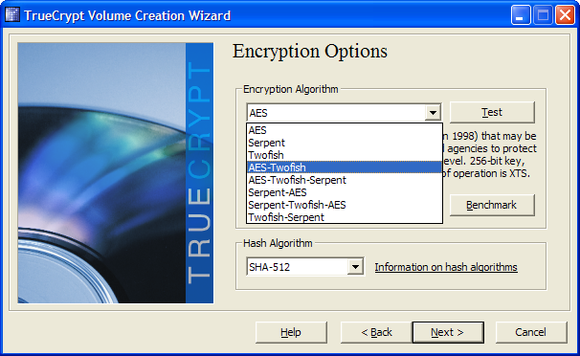
Figure 8 A TrueCrypt Interface (http://www.truecrypt.org/)

Mechanism
With Truecrypt, a user will create an encrypted virtual volume which contains user’s files. The virtual volume is stored as a single file within Dropbox. Synchronisation with the Dropbox server is achieved as a user dismounts a volume from his local computer after making modification in the volume. Further synchronisation between different devices is then possible.
In order to create a TrueCrypt volume, a user will choose an encryption algorithm and a hash algorithm. Volume size will also be specified. This volume will be mounted to a virtual drive with a password defined by the user. Every time the user mounts the volume, a password is required for authentication. After mounting, user can use this volume as a normal local drive, while data inside is encrypted. All data, including the file content, file name and metadata will never be exploited. TrueCrypt will only put decrypted data in RAM temporarily. Even if a computer is shut down by accident, no decrypted data will remain in the virtual volume.
In addition, TrueCrypt has provided a feature of on-the-fly encryption/decryption. For instance, when a user tries to open a video in the volume, the decryption process is done continuously on the local machine as the video player access the video. Such approach avoids the lengthy decryption time associated with accessing large files like videos. Throughout the process, no user intervention is necessary because it is processed by the software in the background.

Drawbacks
Although TrueCrypt has provided a tutorial for beginners, there are nearly twenty steps involved. The set up process is time consuming and complicated for some novice users.
Besides, users may have a false perception that a file updated in a TrueCrypt volume will be synchronised immediately on the cloud. However, what actually happens is that a user has to dismount the volume before synchronisation can take place.

2.4.3 Section Summary
While encryption tools protect the confidentiality of data, their application is often not well considered and causes much inconvenience to users. First, most solutions require users to install an additional client software to have the files encrypted / synchronised. This means that users would have to deal with 2 different applications for the same set of files which they own.
Second, there are some major drawbacks with these encryption tools. Truecrypt requires the mounting and dismounting of a volume which may cause some confusion for some users. SecretSync on the other hand, requires double storage size which is not efficient especially when the synchronised folder is of a considerable size.
Finally, these tools affect the functionality of Dropbox. The client side encryption means that a file is being encrypted before being sent to the server. When a user needs to share this file to another user, that user will get an encrypted version of the file. Without the appropriate software the decryption key, the sharing of files is simply impractical.
Considering the advantages and disadvantages of Dropbox and encryption tools, NetSync aims at providing a better solution for encrypted file synchronisation. NetSync provides a one-stop solution for the encryption, decryption and synchronisation of cloud data. It is virtually a combination of the security provided by SecretSync and TrueCrypt; and the convenience of cloud storage offered by Dropbox. The detail explanation of the solution will be discussed in the Methodology and System Design chapters of this report.

2.5 Diffie-Hellman Key exchange
The Diffie-Hellman technique is the first practical key exchange algorithm in the world. It is a method of digital encryption that utilises numbers raised to specific powers to generate cryptographic keys, making it mathematically overwhelming for hackers to decode the keys. The Diffie-Hellman technique is based on the Discrete Logarithm Problem which is a hard mathematic problem [41]. Such problem is discussed in 2.5.1.

2.5.1 Discrete Logarithm Problem
Let p be a prime number, given the value of a, g and p, computing y=gª mod p is easy. However, the calculation will be a lot more difficult if we are given the value of y, g, and p to compute a. For example, for p=97, g=5, y=35, in order to compute a such that gª mod p=35, all possibilities from 1 to 96 have to be tried for obtaining the value of a. This example implies that the Discrete Logarithm Problem is difficult as long as p is large enough.

2.5.2 Diffie-Hellman Problem
Let’s assume that there are two people in the system, Alice and Bob. Alice and Bob will choose a large random number as their private key, and they will keep this key as a secret. Through the communication, they will agree on a common value of base. Their public key will then be created by calculating the base to the power of the private key.
To compute the value of the exchange key, Alice and Bob can use their private key to exponentiate the other’s public key. Both of them will get an identical value, which is not easy to be computed by others.
The following example illustrates the flow of key exchange.
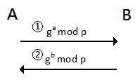
A=Alice, B=Bob
- A sends her public key gª mod p to B.
- B replies with his public key g^{b} mod p.
To compute the shared key K,
A computes (g^{b})ª=g^{ba} =g ^{ab} mod p, while B computes (gª) ^{b}=g ^{ab}=g ^{ab} mod p.
As a result, K= g ^{ab} mod p

The Diffie-Hellman technique is popular since there is no shortcut to compute the secret exponents. This technique is based on the Discrete Logarithm Problem, which is commonly agreed to have no shortcut of calculating. As long as the Discrete Logarithm Problem is not solved, the Diffie-Hellman key exchange is secure. Even the process of key exchange is intercepted by an eavesdropper, the secret key cannot be easily computed.

2.5.3 Limitations
As we can see from the above, the Diffie-Hellman technique is well known for its security. Such security relies on the complexity nature of the Discrete Logarithm Problem. While eavesdroppers may be able to intercept the key exchange, the computation of the shared key is deemed to be extremely difficult. However, this key exchange scheme is no longer secure when there is an active attacker in the network. The following example illustrates the flow of key exchange if there is man-in-the-middle attack.
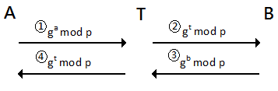
A=Alice, B=Bob, T=Trudy
- A wants to send her public key gª mod p to B, but it is intercepted by T.
- T impersonates A, and sends her public key g^{t} mod p to B.
- B receives the key of fake “A”, then replies with his public key g^{b} mod p.
- T once again intercepts the key, she gets B’s key and replaces it with her own key, g^{t} mod p.
To compute the shared key K, A computes g^{at} mod p, and B computes g^{bt} mod p, while T holds these two values at the same time. In this way, T can communicate with A and B using g^{at} mod p and g^{bt} mod p respectively, without A’s or B’s knowledge.

2.6 Secure Socket Layer
Secure Socket Layer (SSL), originally created by Netscape, is a commonly deployed security standard used for establishing an encrypted connection between a server and a browsing client. The technology is currently used by millions of websites to ensure the integrity and privacy of the online transactions established between their web server and their customers. With a secured connection, customers do not need to worry about the possibility of their sensitive data, such as credit card accounts or addresses, to be intercepted by a hacker in the data transfer process.
SSL is a certificate-based protocol that adopts a third party certificate Authority, or CA, to identify the authenticity of either or both the client and the web server. In order to establish an SSL connection, a web server needs to be equipped with an SSL Certificate. Generally, a SSL secured connection is marked by https:// instead of http:// in the URL of the website. Currently, the protocol is supported by all modern browsers such as Safari, Chrome, Firefox, Opera, as well as Internet Explorer.
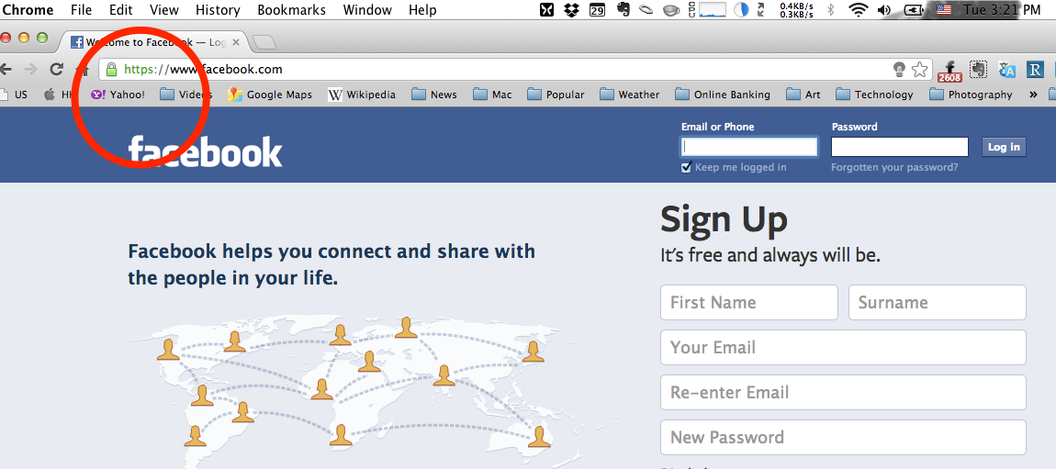
Figure 9
An example of how SSL is adopted by Facebook and indicated in the address bar of Google Chrome

Technically, SSL is a protocol that is located between the application layer and the transport layer [42]. SSL uses the public-and-private key encryption system from RSA to ensure confidentiality. It establishes a secure channel for data transmission between the web browser and the web server. The channel is transparent. The data received and read on one side will be exactly the same as the data sent and written on the other side. With this feature, most of the protocol can be run over SSL.
Two phases including Handshake and Record Protocol are defined for SSL. The details will be discussed as follows.

2.6.1 Handshake Protocol
A handshaking protocol is the method with which two computers on a network establish a connection [43]. The handshaking process has to be completed before any data transmission can begin. This protocol is responsible for the setup of the shared environment required for secure data transmission. Authentication of server and establishment of cryptographic keys for en/decryption are done in this phase.
There are three main purposes of handshake.
- A set of algorithms for data encryption will be agreed on both the client and the server side.
- Cryptographic keys will be established based on the agreed algorithms.
- The client will be authenticated (optional).
Figure 10 shows an overview of the SSL handshake sequence.
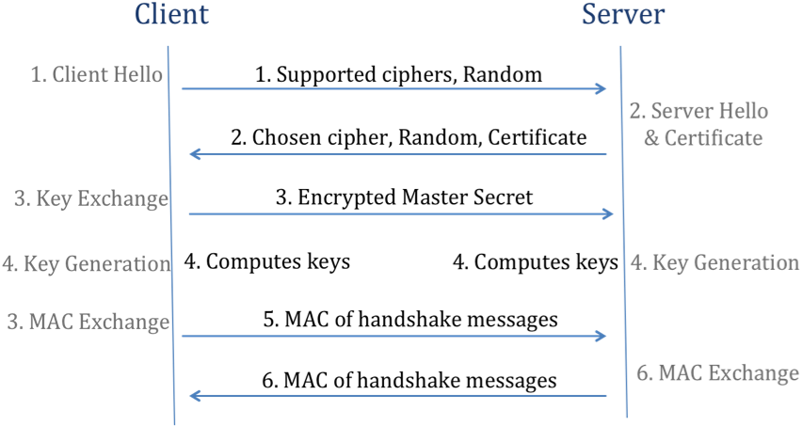
Figure 10 SSL Handshake Procedures

As we can see from figure 10, the entire sequence of the SSL handshake can be divided into 6 different steps:
- Client Hello
Client Hello package with random numbers and a list of supported ciphers are sent from client to server.
- Server Hello & Certificate
Server Hello package including a cipher chosen by the server and a random number is sent back to the client. Server Certificate will also be provided for authentication purpose, client can validates the certificate against CA certificates.
- Key Exchange
Client generates a pre-master key, and encrypts this key with the extracted public key of server. Then, the encrypted key is being sent to server.
- Key Generation
Both client and server compute the encryption key by using the value of random number exchanged. MAC is also being calculated.
- MAC Exchange
Client sends the calculated MAC of all the messages of handshake to the server. The MAC serves to prevent the handshake from tampering.
- MAC Exchange
Server sends the calculated MAC of all the messages of handshake to the client.

2.6.2 Record Protocol
This protocol is responsible for the data transfer [44]. On the sending end, data is being broken up into fragments, and the fragments will be transmitted under protection. Record is being verified on the receiving end.
The data fragmentation is shown in Figure 11.
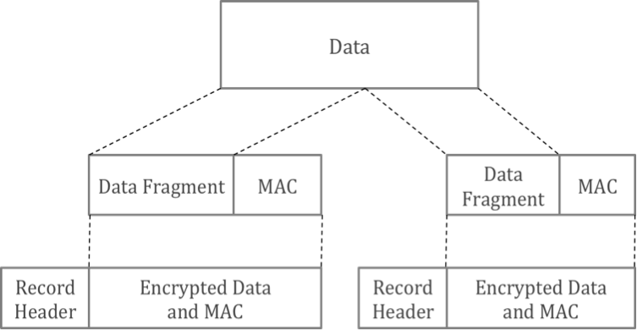
Figure 11 SSL data fragmentation and protection
As shown in Figure 11, data is split into a series of fragments. For each fragment, a MAC is computed to ensure data integrity. This MAC will be appended to the fragment and verified by the receiving end. Encryption is then implemented to form an encrypted payload. Finally, a record header is added to this payload.

2.6.3 Limitations
Despite the high adaptation rate of SSL, the protocol suffers from a number of limitations. The use of SSL requires the deployment of server certificate for validation purposes. While SSL provides a channel-level security with which data is kept secret during the transmission, the performance of data transmission is affected [45]. A SSL connection can be 100 times slower than a TCP connection. The performance is relied on the chosen protocol, the quality of server hardware, and the environment of network.
The main source of performance drawbacks comes from the connection setup. This performance cost directly incurs operational costs. Internet servers are usually heavily loaded even when insecure protocols are used for handshaking. The adaptation of computationally intensive security protocols such as SSL usually means that more servers must be obtained to maintain a reasonable quality of service. With this in mind, some performance degradation is unavoidable. While it is often possible to minimise SSL’s performance impact with careful systems design and configuration, such level of optimisation is time consuming is deemed inefficient in this project considering its scale and application.

3 Methodologies

3.1 Authentication
Authentication is the process of identifying the validity and genuineness of an individual or an item. There are different kinds of authentication methods developed over the years in an attempt to address different security needs. These include login passwords, and security token. Over the years, login names and passwords have served their purpose as the most commonly adopted authentication measure for many online services.
Until recently, such method has even been used by all major financial institutions to allow them provide online banking services to their clients. Security tokens, on the other hand, is a more recent development of authentication technology. Such tokens involve either the provision of a physical device to users to ease the authentication complexity or a software token sent electronically via mobile network services when using various online services. One example of such deployment is the security token of HSBC, which has been implemented to provide an extra layer of security to its clients. Other banking institutions, such as Standard Chartered Bank, use one time security token sent to a user’s registered mobile number for authentication purposes.
Although security tokens provide an extra layer of security, the deployment of such technology require additional hardware equipment to be issued to users. The disadvantages of this measure include the risk of losing such token, as well as the increased maintenance costs. In this project, login credentials are used as the authentication tool considering the ease of deployment, and costs. This method is called password-based authentication.
Password-based authentication (PA) is a protocol in which a password is used as the basis of authentication. PA is a well-known technique used in distributed web services. With PA, complex information is removed and users do not need to remember long and cumbersome passwords before they can use such. While this authentication technique is so commonly used, it suffers from practical attacks such as impersonation and password guessing.

Transmission through encrypted channels
To reduce the he risk of password interception, cryptographic protection can be adopted. One of the most commonly used techniques is SSL. Such feature is built into most Internet browsers nowadays.

3.2 Key Exchange
The Diffie-Hellman Key Exchange is ineffective under man-in-the-middle-attack. Such problem originates from the lack of authentication. The sending side cannot ensure who is on the other side. To avoid this issue, authentication is adopted in the modified Diffie-Hellman Key Exchange technique in NetSync.

3.2.1 Mechanism
A hash value will be produced by the sending machine. This hash value is calculated with a public key of the sender and a verification code. The public key will then be sent along with this hash value. When the receiver gets the two items, he will calculate the hash value with the received public key and his verification code.

The key for authentication is the verification code. The identity of the sender can be verified if the calculated hash value matches the received one, logically, if there is a mismatch between the two hash values, there is a possibility of a threat of man-in-the-middle-attack.
When a user synchronises his files among different devices, the verification code serves to differentiate the identity of the sender, as the calculation of the hash value is largely impossible without the verification code.
However, the case becomes more complicated when files need to be shared between different users. Under the current key exchange approach, a user will not be able to calculate the hash value if he doesn’t have the verification code of the other user. To share files between users, the verification code must also be shared. To achieve this goal, the system will generate a one-time verification code to the sender, and require the sender to enter the email of the receiver so that the code can be sent in an email message.
In the following, an example will be given for the key exchange process.

Background information
Suppose there are two machines, Alice and Bob.
- Alice is the machines of user Alice.
- Bob is the machine of user Bob.

Alice₁
Private key | a₁
Public key | A₁=g^{a1} mod p
password | PWD

Bob
Private key | b₁
Public key | B₁=g^{b1} mod p
password | ABC

Key exchange of different users
Alice and Bob own different passwords. Therefore, they need to get a common secret data.

- Getting common secret data
- A verification code is generated, say “TempPWD”.
- This verification code will be sent to Bob using email address provided by Alice

- Key exchange
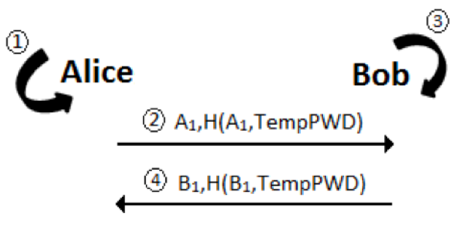
- Alice computes a hash value, H(A₁, PWD) with the her public key A₁ and verification code PWD.
- Alice sends the hash value and public key to Bob.
- Alice computes a hash value with the received public key A₁ and the shared verification code, TempPWD. She then verifies if the received hash value is equal to the one she calculated.
* In this step, Bob identified Alice
- Bob will do the step 1-3 to identify himself.
* Finally, they identified each others.

3.3 Data Encryption

Encryption is the process of encoding a piece of data in such a way that hackers or other unauthorised users cannot access it. A message can be encrypted using an encryption algorithm with an encryption key. That key specifies how the message is to be encoded. Only an authorised party is able to decode the encoded file using a secret decryption key.

3.3.1 Security Issues with Data-at-rest
One of the key challenges for cloud service providers is the protection of data at rest. Examples of data at rest include archived data, files stored on hard disk drives and thumb drives, and in our discussion, data stored on the cloud. The term refers to data in storage devices but excludes any data which repeatedly traverses the network or that which is temporarily stored in RAM. The protection of such data is important because hackers and unauthorised users may access and/ or modify the data. Disk encryption is an example of data-at-rest protection when the storage media is a sector-addressable device (e.g., a hard disk). There are different disk encryption methods in the market, and they all aim to remain the confidentiality of data on the disk without sacrificing speed and storage space.
To make sure data can be accessed promptly, a disk needs to be divided into several 512-byte sectors. Such division allows data in each sector be encrypted and decrypted independently. To ensure the confidentiality of data, different sectors should be processed differently. Otherwise, confidentiality may be jeopardised when a hacker copy a sector of the disk to an unused sector, requesting its decryption.

3.3.2 XTS-AES
Advanced Encryption Standard (AES) is a symmetric-key algorithm implemented by the U.S. government and is widely applied for data encryption purposes[46]. XTS-AES is a method based on Phil Rogaway’s XEX (Xor-Encrypt-xor) tweakable block cipher[47] and has added the concept of ciphertext stealing. With XEX, encryption can only be performed on complete blocks. The addition of ciphertext stealing helps to extend the input data strings. With such measure, data strings with sizes not divisible by a block size, i.e. data strings of non-128- bit multiples, can also be handled[46]. XTS-AES was approved as an encryption method for block-oriented storage device, such as hard disk, in Institute of Electrical and Electronics Engineers (IEEE) [47][48].
XTS-AES is a length preserving encryption method which produces a ciphertext of an equivalent length from its plaintext counterpart[49]. This mode implements AES twice for each block and uses two different keys. These keys are generally produced by splitting the cipher key in halves. As a result of this splitting process, key sizes of AES 128-bit and AES 256-bit encryption have to be 256 bits and 512 bits respectively [46].

3.3.3 Mechanism
Considering the security issues relating to data encryption, and the nature of XTS-AES, below is a description of some encryption assumptions base on which the requirements of the encryption mechanism is set. The prototypical encryption procedure is also provided thereafter.
Encryption Assumptions
- The cipher text is known by an attacker.
- The encryption method is also known.
- The only secret is the key.

Encryption Requirements [48]
- Encryption is length preserving.
- Access and encryption of data are independent for each data block.
- Among the metadata, only the location of data blocks will be used.
- At different data blocks, the identical plaintext is encrypted to different cipher texts.

Procedures of XTS-AES encryption[49]
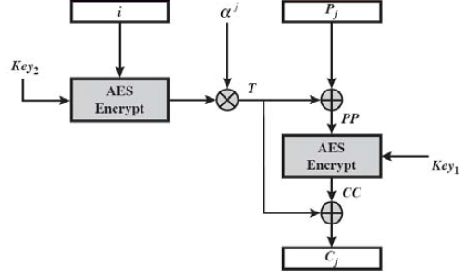
Diagram of XTS-AES encryption

The XTS-AES encryption procedure for a single 128-bit block is modelled with this equation:
C ← XTS-AES-blockEnc(Key, P, i, j)
- T ← AES-enc(Key2 2 , i) ⊗ αj
2. PP ← P ⊕ T
3. CC ← AES-enc(Key1 , PP)
4. C ← CC ⊕ T

Key | Key₁ || Key_{2,} where key=256 or 512 bits encryption key
P_{j} | The j_{th} block of 128-bit plaintext
C_{j} | The j_{th} block of 128-bit ciphertext
j | The sequence number of the 128‐bit block inside the data unit
i | 128‐bit tweak, a tweak is assigned for each data block
α_{j} | A primitive element of GF(2128) that corresponding to polynomial x
⊕ | Bit-wise exclusive-OR operation
⊗ | Modular multiplication of two polynomials
← | Assignment of a value to a variable
| | Concatenation

3.3.4 Ciphertext Stealing
For many existing cipher modes, one of the essential requirements for the encryption is with the block size. This means that the input has to be a sequence of complete blocks which consists of data of sizes corresponds to the multiples of the sizes of the blocks. To deal with inputs which do not comply with this requirement, ciphertext stealing can be used.
Ciphertext stealing, or CTS in short, uses a block cipher mode of operation to allow the process of such data without expanding the ciphertext. The technique changes the last two blocks of the plaintext so that their transmission is reordered.
The process is represented in Figure 12. When the last block (plaintext) is incomplete, the second last ciphertext block will be extracted to fill that plaintext block. With this process, the encryption of the last plaintext block is now possible. With the encryption of the last plaintext block finished, an exchange is then taken place with second last ciphertext block. Such exchange then convert the ciphertext block to the length of the final plaintext equivalent by removing the “borrowed” bits. As a result, the length of the ciphertext and that of the original message will be identical.

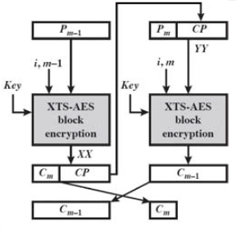
Figure 12 Ciphertext Stealing in action
Assume the length of last block (P_{m}) is 28 bits,
Length of CP=128-28=100 bits (block size-P_{m} size)
For block P_{m-1}, CP is taken as an input for block P_{m} while C_{m} is the ciphertext of block P_{m}.
For block P_{m}, the encrypted output, C_{m-1} will be the ciphertext of block P_{m-1}.

3.3.5 Evaluation
XTS-AES is superior to other encryption methods as the encryption can be applicable to individual data-units (or sectors) separately and in an arbitrary order. For example, some encryption modes that chain multiple data units requires the reading of several data units to decrypt a single unit[49]. Under XTS-AES, there is no such chaining of multiple data units throughout the decryption process. This feature addresses the need to support random partial access to the encrypted data.

The superiority of XTS-AES is also demonstrated by its ability to address copy-and-paste attacks, in which the attacker uses a different segment to replace a target ciphertext segment. By using the XTS method, an independent tweak key is used to ensure that the encryption/decryption processes would not involve the use of the primary encryption key adopted by some algorithms [47].

With XTS-AES, authentication control is already equipped into its technology, which provides superior security to other approved confidentiality-only methods. XTS-AES is especially useful in addressing unauthorised modification of encrypted information. As a result, data integrity can be ensured.

XTS-AES is widely supported by the industry and research publications [48], [50]. The confidentiality it provides for the protected data have it chosen by several popular encryption tools such as TrueCrypt, BestCrypt, dm-crypt [46] as their encryption method.

3.4 Data Synchronisation
Data synchronisation refers to the concept of maintaining the coherence and data integrity of multiple versions (copies) of a dataset. There are two types of data synchronisation: one-way file synchronisation and two-way file synchronisation. In one-way file synchronisation, a copy of a set of updated files is transferred from a 'source' location to a 'target' location(s). Throughout the synchronisation process, no files are copied back to the source location from the target location. The situation is very much different in two-way file synchronisation, in which updated files are copied in both directions. Due to this major difference, two-way file synchronisation has the advantage of being able to keep the files in the two locations identical. In our discussion here, when we talk about synchronisation, the term refers to one-way synchronisation only.
File synchronisation is used in all existing cloud storage solutions we have looked at so far. The automatic synchronisation process saves a lot of time both for the users and the system from copying identical files to and from the cloud. Because the process is automatic, human errors can be avoided while deciding which files to sync in between the cloud account and the user’s devices. Such synchronisation feature is especially useful for users who need to work with multiple computing devices, be it tablet PCs, laptop computers and desktop workstations.
Rsync is an efficient and convenient file copying tool, which provides file synchronizing and backing up services in Unix systems [51]. The copying can be done via to/from a remote rsync daemon. The program comes with a very rich set of options which allows very versatile specification of the set of files to be copied. [52]

3.4.1 Overview
Delta encoding is used when necessary in order to minimise data transfer. “rsync algorithm” is used in rsync for minimising the size of data transfer and improve the speed of synchronisation. As only the differential (diff) of two files is sent, the algorithm reduces link latency when compared with the sending of an entire file in between computers.

3.4.2 rsync algorithm
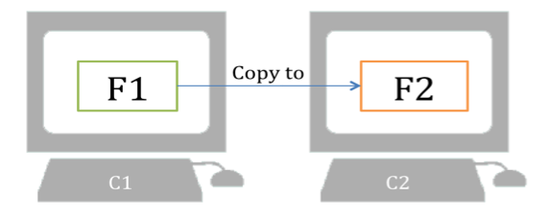
Assume there are two computers (C1 and C2). C1 contains a file (F1) while C2 contains another file (F2). The contents of F1 and F2 are similar. To copy F1 to F2, the algorithm works as the following steps [53][54]:
- F2 is divided into blocks with a fixed size while the final block may have a smaller size.
- C2 calculates the checksum for each block and send the results to C1.
- C1 calculates the checksum for the first block of F1, and then compares it with the received checksums to see if there is a match.
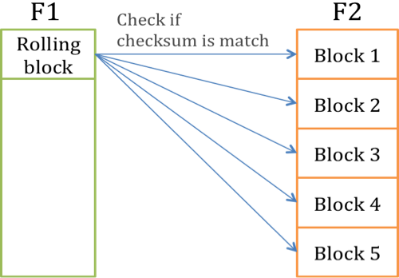

- If no match is found, C1 moves one byte down and calculates the checksum of this block. In this way, C1 searches through F1 one byte by one byte to form all possible blocks of F1.
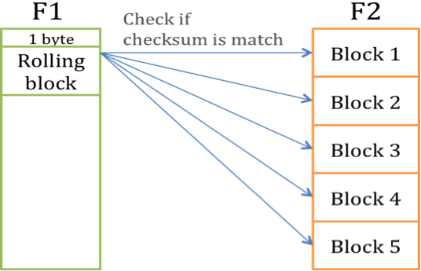
- If a match is found, it implies that this block is identical in F1 and F2. In this case, instead of moving one byte down, C1 moves to the end of the block.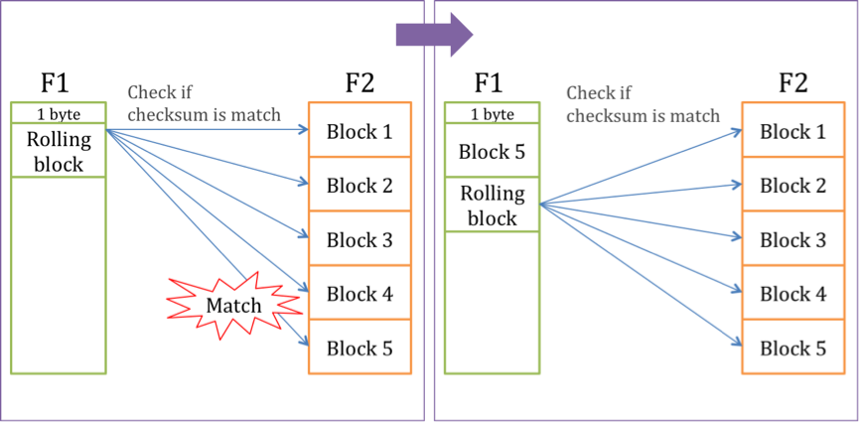
- A set of instructions is sent to C2. If there is no match, the instruction is the changed data. For the rest, the instruction is a reference of that block. According to the instructions, C2 is able to construct F2 into the new version.
Based on the above steps, C2 can get the difference from C1 and update F2.

4 System Design
In this chapter, an introduction of the major system functionalities is presented. System components, including their relationship, structure, and functions are also explained and discussed in this chapter. At the end of this chapter, a workflow of the system is also provided.

4.1 Functionalities

4.1.1 File synchronisation
NetSync adopts cloud technology to provide file synchronisation services to its users. The cloud acts as a centralised storage for users’ files. Users do not have to deal with the technical details regarding file synchronisation process as they carry out their associated workflows. The program provides a hassle free synchronised cloud storage solution for its users.
The use of NetSync is extremely easy. After installation, files are automatically saved across all registered computing devices (laptops, desktop PCs, mobile computing devices) once a file is saved to NetSync, no manual input / command is necessary.

4.1.2 Passing through Firewall
NetSync addresses the ineffectiveness of some file synchronisation tools in the market when they are dealing with firewalls. In NetSync, files are transferred though Port 80 under the HTTP protocol. As such, files synchronisation should be undisrupted even when a user is working behind a firewall.

4.1.3 Client side encryption
Data confidentiality is provided by NetSync is via data encryption. Client side encryption is implemented before a file is synchronised to NetSync’s server. With such measure, only encrypted files are stored on the server, which largely strengthens confidentiality. The adaptation of an encryption key helps ensure the integrity of the files stored in the cloud. As the key is only known by the user himself, unauthorised access and manipulation of files is impossible as long as the user has taken appropriate measures to keep the key safe.

4.1.4 Sharing under encryption
Unlike SecretSync and Truecrypt, where sharing is impossible with the implementation of the private key feature, files sharing is made possible in NetSync with the introduction of the key exchange mechanism. The sharing inability associated with the decryption mechanism in SecretSync and Truecrypt has been resolved under NetSync. In NetSync, an alternative key exchange mechanism is deployed for file sharing purposes. By exchanging a common key, users can share an encrypted file with another user without worrying about the associated decryption issues.

4.1.5 Local folder encryption
With the aim of achieving a higher security level, data encryption is implemented for all files stored in the NetSync folder. With data encryption, unauthorised file access and manipulation can be avoided, as decryption is only possible with the correct key. Throughout the file encryption and decryption processes, user experience remains unaffected as the speed of such processes has been kept to a minimum with the introduction of the encryption/decryption-on-the-fly feature. A user can open the files saved in the NetSync folder as normal, as the decryption is automatic upon the opening of the file by the user.

4.1.6 Section Summary
NetSync provides a whole package of comprehensive features including file synchronisation, client side encryption, sharing capabilities, and firewall-friendly network settings. However, the functionalities of file sharing via URLs, advanced user settings for privilege of shared files and mobile platform support are not within the scope of this project and can be the focus of the next revised version. For now, the main concern of this project is enhancing the security level without diminishing the user experience.

4.2 System Components

4.2.1 Structure of components
There are totally three main components in this system, the cloud, the server and the client. The structure of which is as follows.
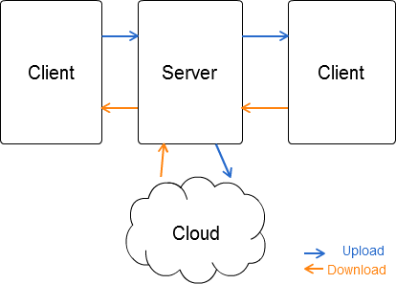
Figure 13 System Structure
As we can see in Figure 13, the blue arrow represents the uploading action while the yellow arrow represents the downloading action. The client and the server interact with each other with both the uploading and downloading action, while the server communicates with the cloud for uploading and downloading. Notice that there’s no direct communication between the cloud and the client.

4.2.2 Interaction of Components
As described in the previous section, there are mainly three major components in NetSync: The cloud, the server and the client. Assume that there are three machines: a server and two machines of a client. The diagram below demonstrates the workflow of the system when a client machine updates a file. Notice that in this figure, a more elaborated view of the processes within the 2 client machines and the server is provided.
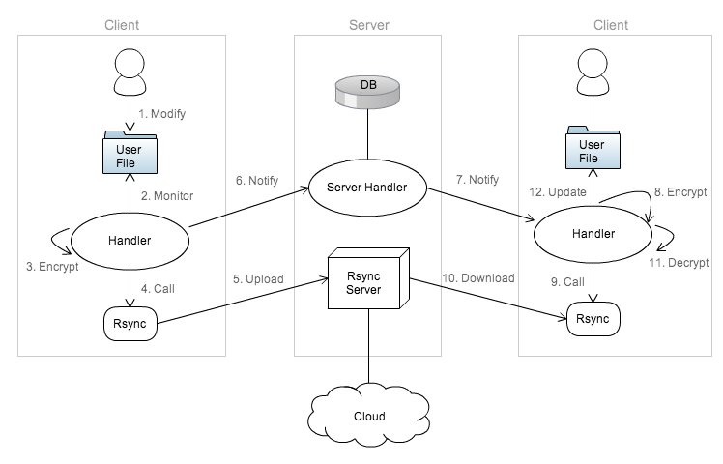
Figure 14 Interaction of System Components
Below are the procedures involved when a client updates a file at his local machine:
- Client modifies a file
- Handler which monitors the folder detects a change of the file
- Handler encrypts that modified file
- Handler calls Rsync client for the upload of the encrypted file to Rsync server
- Rsync server gets the encrypted file, compares it with the one stored on its side, i.e. the file stored in the cloud. It then obtains the diff and finally update the file
- After the file has been updated in Rsync server, handler sends notification to the server handler.
- Server handler searches for the list of user’s machines, and sends notification to them
- When handlers of other machines receive notification, they encrypts the files. This is a preparation for Rsync comparison, since the file in client side is decrypted, it needs to be encrypted so that it can be compared with the one on server side
- Handler calls Rsync client for the downloading of the file
- Rsync client gets the file, compares it with the one stored on its side. It then obtains the diff and finally updates the file
- Handler decrypts the file
- Handler updates the file

4.2.3 Details of components
4.2.3.1 Cloud
In the design phrase, cloud storage is used for storing clients’ files. Cloud storage like Amazon S3 can be used.
Amazon S3 is an online storage service. S3 provides an integrated API called the AWS Management console for “buckets” creation, and management, with which developers can easily navigate among different resources. To use the S3 service, a user account needs to be firstly created. Once a user account is created, “buckets” can be set up. Each object in the S3 service is stored within a bucket, users can set their buckets to use a specific regional server to minimise networking latency.
In the testing phrase of this project, local storage is used, i.e. the server is not connected to cloud storage.

4.2.3.2 Server
In NetSync, servers serve an important role as it provides some crucial functionalities including the storing of the clients’ information, the handling of notification delivery, and all communication to and from the cloud. In other words, they bridge the cloud and the client machines, and it is with which synchronisation is made possible.
Within the system architecture, the server can be subdivided into 3 major divisions, namely, the Rsync server, the database, and the handlers.

Rsync server
The Rsync server is the server component responsible in communicating with the cloud. Rsync server listens to the client constantly for any possible updates. When a user updates a file, Rsync client will transfer the file to Rsync server. What the Rsync server does is to use the Rsync algorithm to analyse the diff. Such analysis makes it possible for the cloud to implement incremental file synchronisation.

The Database
The database is where clients’ information is stored. There are 3 tables storing clients’ information, namely, User, Machine, and share. Under each table, different fields are stored as shown in Figure 15.
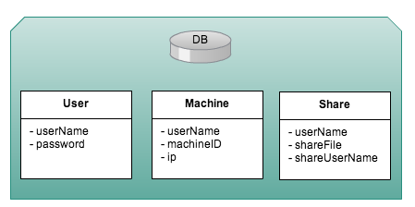
Figure 15 Tables of Database
As shown in the figure, there are two types of user information stored in the User table: the username and the password. The user name forms the identity of the user, whereas the password is used for authentication purpose and is known only by the user himself.
In the machine table, the information stored include the username, the machineld, the syncVersion, and the IP. While the user name still helps the server to identify the user’s identity, the machineld is used for the identification of a user’s machine. This is particularly useful in NetSync as the program allows multiple machines synchronisation. The IP field in the machine table contains the IP of each user’s machine, which is used by the server to help locate the different machines over a network.
In the share table, the shareFile recorded the files shared by the owner and the shared user, namely userName and shareUserName respectively. Server will make use of this information in notifying client the update of file.

The Handlers
The following is a class diagram describing the server side architecture.
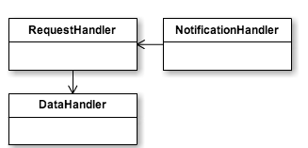
Figure 16 Server side architecture
Notification Handler – listens to, and obtains client’s request. Once such request is obtained, the notification handler will call request handler to work on it, then continue to listen and get request.
Request Handler – The request handler sits between the data handler and the notification handler. Any communication a client machine attempts to make with the database has to be directed through the request handler in the first place. In particular, the request handler can authenticate clients by getting their usernames and passwords and verifying them with the database with the data collected from Data Handler. In addition, as dynamic IPs are often assigned to individual machine as they go online in different locations, the request handler would also deal with the IP address updating in the database.
When a user updates a file, the request handler will receive a notification from the client handler about the update. Upon the receipt of such notification, the request handler will crosscheck with the database to retrieve a list of registered client machines. With this knowledge, the request handler can broadcast the notification about the update to the remaining machines.
Data Handler – This handler is responsible for the communication with the database It contains a list of functions for accessing the database, so that it can retrieve and set values in tables.

4.2.3.3 Client
When NetSync is installed on a client computer, the program stores crucial user information which is necessary for the encryption and decryption of data. The handler within the application would direct all the major communication requests made by the client to the request handler of the server. Communication is also directed by the client handler to the Rsync client so that communication can be established between the client and the cloud through Rsync server.
Within the system architecture, the client can be subdivided into 3 major departments, namely, the Rsync client, the data storage, and the handlers.
Rsync client
The Rsync client is the client component responsible in communicating with the Rsync server. Suppose there are 2 client machines, client A and client B. When client A updates a file, the Rsync client transfers the file to the Rsync server, so that the Rsync algorithm can be used to analyse the diff. Incremental file synchronisation is then possible across Client A and Client B. Once that is done, the notification handler of Client B will receive a message from Client A, informing it of the change. What the Rsync client does, is to download the file from the Rsync server, similarly, the Rsync algorithm is once again used to analyse the diff for incremental file synchronisation.
Data storage
The data storage department is where clients’ information is kept locally. Such information includes the owner’s key as well as the shared keys. Information about the association of files with the shared owners is also stored. With shared keys, encryption and synchronisation can coexist within the same program, which makes it different from other services such as Dropbox.

Handlers
Figure 17 shows a class diagram of the client side service.
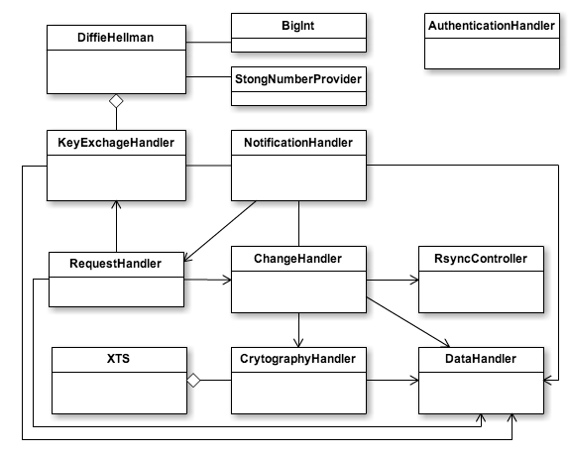
Figure 17 Class diagram of the client side service
As we can see from the figure, within a typical handler on the client side, we can further divide the components into eight sub-handlers based on their different functionalities. These include the change handler, the Rsync controller, the request handler, the notification handler, the cryptography handler, the key exchange handler, the data handler, and the authentication handler.
Change Handler – The change handler monitors file changes on a client machine. Upon file change, the handler sends a notification to the encryption handler, which will then calls the Rsync client for synchronisation. Once the uploading of encrypted file is completed, the change handler calls the notification handler to broadcast message regarding file changes.
Rsync Controller – The controller generates the Rsync argument for uploading and downloading. It also executes the uploading and downloading command.
Request Handler – The request handler is responsible for the change responses, key exchange requests and responses as well as IP requests.
Notification Handler – The notification handler is responsible for the sending and receiving of notifications regarding file changes. There are two scenarios when notifications are delivered. In the first case, a notification is received from the change handler about a file change, the notification handler will inform server handler to search for the list of the client’s registered machines and send notifications to them, asking them to download the updated file. In the second scenario, the server handler informs the notification handler about the version change, and thus the job of the notification handler in this scenario is to inform the Rsync client about the change so that synchronisation can be done accordingly.
Cryptography Handler ﹣The cryptography handler encrypts and decrypts a changed file when it’s transferred from the change handler or the Rsync Client. The encryption and decryption of files is done with the own key when the synchronisation is done for the user him/herself. When the synchronisation is done among different users, the encryption and decryption process is done with exchanged keys, using the Diffie-Hellman Key Exchange approach. A detailed discussion about this approach is provided in the Methodology section (3.2).
XTS – XTSSharp provides function for for XTS-AES encryption.
Key Exchange Handler – This is where the Diffie-Hellman Key Exchange approach is applied for the synchronisation among different users. More details in Section 3.2 when the methodology of the project is discussed.
Diffie Hellman – generates 512-bit prime and 160-bit private keys. It also calculates public keys, hashes the public keys with the verification codes using SHA-1
BigInt & StrongNumberProvider – this provides functions for Diffie Hellman to carry out the functions listed above.
Data Handler – unlike the data handler on the server side, this data handler is responsible for conversion of data types. It also gets and sets values in the text file.

Authentication Handler – The authentication handler verifies the identity of the client machines by validating the username and password of the user. The process begins with the requesting of the login name and password from a user. When the authentication handler confirms the authenticity of the client, further processes can be carried out. Note that the authentication handler sits atop each process concerning the file modifications. When a client machine is connected, a session key is established to ensure the validity of the client throughout the connection.

Work flow

4.3.1 Server side
Figure 18 shows an overview of the workflow of the server when a service starts.
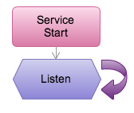
When the service on the server side starts, it will continue to listen for messages from client. The workflow after the service receiving a message from the client is illustrated in Figure 19 below.
Figure 18 The workflow of the server when a service starts

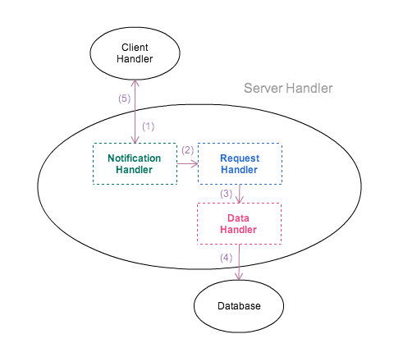
Figure 19 The workflow of the service after it has received a message from the client side
Figure 19 shows the workflow of the service after it has received a message from the client side. As shown in the figure, the notification handler constantly listens for the message from the client handler, step 1 in the figure shows the handler receiving such a request. After the request has been received, the notification handler opens a new thread, and call request handler to work on it (step 2), as this happens, the notification handler will continue to listen for further instructions from the client handler.
The kind of requests that a notification handler would receive and handle varies according to situations. They include change request, delete request, rename request, share request, IP updating and query request. When such requests involve data stored on the database, the request handler will contact data handler on the database (Step 3 & 4). After the jobs have been finished, the notification handler will notify the client handler for the request results / broadcast the message to other clients if that is necessary (Step 5).

4.3.2 Client side
Figure 20 shows an overview of the workflow of the client when a service starts.
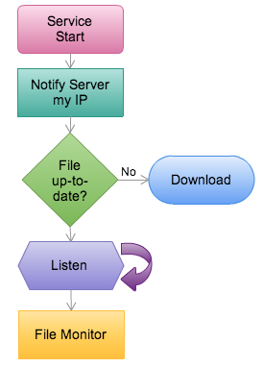
Figure 20 The workflow of the client when a service starts
When the service on the client side starts, it will notify the server its current IP address. Afterwards, the file version will be checked, if it is not up to date, it will download the file from the server and decrypt it. It will then continue to listen for requests from server / other clients. These requests include key exchange requests, Key exchange responses, change requests, as well as share requests. When requests are received, new threads will be opened for handling them. The system will then start the file monitor.

4.3.3 Version Control
The following is the workflow when a client updates a file (Figure 21). Notice how different versions of a file are kept.
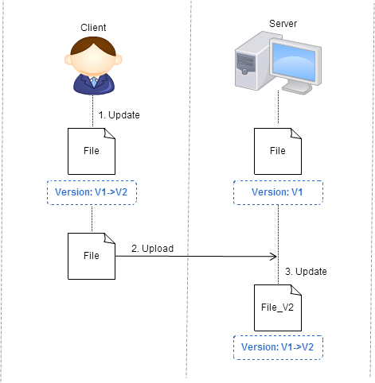
Figure 21 Workflow when a client updates a file
As shown in Figure 21, when a client updates a file, the version of the file will be changed from version 1 to version 2. This version updating is done by the change handler. The sequence below shows the workflow of this process. The numbering corresponds to the numbers shown in the figure.

- Client updates a file, version of the file is changed from 1 to 2.
- Client uploads the file.
- Server updates the file, file version change from 1 to 2

After the server has successfully updated the file from version 1 to version 2, the request handler will notify the notification handler of other clients’ machines about the file change. When the clients are online, step 3 and 4 will be carried out as shown in Figure 18, if the clients are not online when the notification is being broadcasted, steps 1 – 4 will be carried out accordingly.

5 Implementation
The system design described in the previous chapter has been implemented in three different phases – the synchronisation of files, the development of key exchange services, and the client side encryption protocols. Each of these has been implemented on both the client side and the server side. A number of handlers have also been deployed in each phase to facilitate the communication between different services. In addition, a database has also been set up on the server side for storing the client and machine lists.
In this chapter, we will first look at the environment of the system, on which the solution is built. Then the building of the three phrases will be described.

5.1 Environment
For NetSync to be implemented, a VM needs to be set up to provide a platform for the running and testing of various synchronisation processes and capabilities. Microsoft C# has also been adopted with the use of a number of Windows libraries for development of various program functions. Below is a detailed description of each of the components.
VMware
A virtual machine is a software simulation of a computer which functions like a physical counterpart. Virtual machines are self-contained and isolated from others. Figure 22 is a visual representation of a virtual architecture.
In this project, virtual machines are created using VMware to simulate system workflows. A major consideration for adopting this approach is the cost. Multiple operating systems, together with their installed applications, are able to run simultaneously on a single computer.
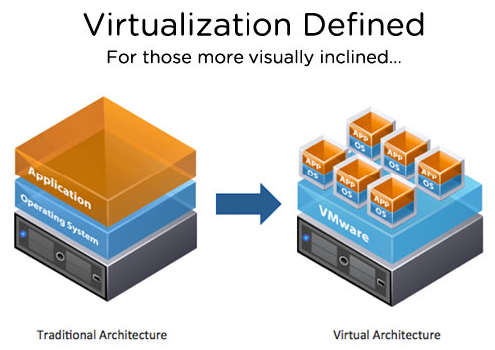
Figure 22 A visual representation of a virtual architecture (http://www.vmware.com)
Programming language - C#
C# was developed by Microsoft and is one of the object oriented programming languages designed for the Common Language Infrastructure. In this project, C# is chosen as the programming language for its better integration with the Windows working environment, as well as the provision of a large number of libraries for our use.

5.2 Synchronisation
For synchronisation to take place, any incremental file changes have to be monitored. Once a change is detected, encryption takes place (see chapter 5.4), and Rsync algorithm has to be implemented for the diff comparison and the update.
As Rsync is a program in the Unix environment, its native code in C# has been retrieved for its implementation in the Windows environment. However, due to performance issues, such implementation has been found to be impractical. To solve this, cwRsync has been adopted. A file change monitoring mechanism is also implemented so that synchronisation can be triggered.

5.2.1 Rsync using C# native code
One way to execute Rsync in the windows environment is to retrieve its native code in the C# language. In this project, the native code is retrieved from [55]. To use the native code for our synchronisation purpose, it must first be configured with a configuration file. After which, the daemon can be initiated in the virtual machine which acts as a server. The daemon will then listen to the port. The Rsync command can then be used in the local machine to perform the downloading and uploading actions.

Server Side: Configuration
The file of configuration is named rsyncd.conf. Within the file, two components, the modules and the parameters can be found. A module is identified by the name of the module in square brackets. For instance, as shown in figure 23, the two modules in the configuration file are [test] and [documents]. Within each module, different parameters are shown in the form "name = value". For example, the first parameter in the test module is path=c:\work, which shows the location at which the synchronisation takes place.

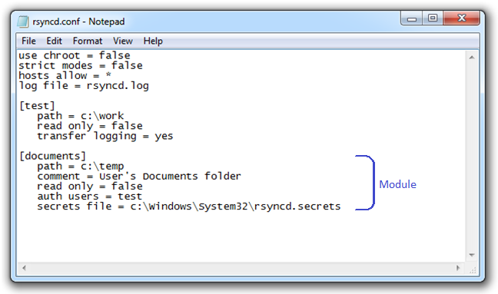
Figure 23 rsyncd.conf
NetSync incorporated the following parameters within the Rsync native code to carry out its various functions related to the synchronisation process.
log file
By default, the Rsync daemon logs diagnostic messages including when a particular network connection is established, and when the program has started listening to which port, by using syslog. Syslog is a very powerful tool which can be deployed for multiple purposes. As the configuration of syslog is too complicated for our purpose. The project sets the “log file” parameter to “rsyncd.log”, with which the Rsync daemon will log all its system messages. The log file is set with a global privilege. This saves the troubles of including the parameter on a per-module basis. The errors messages recorded by this parameter can be used for debugging purposes.
path
Within each module, it is necessary to specify a path to point to the location of the server, namely, the directory in the daemon’s file system. In Figure 20, the path specified in the documents module is c:\temp.

read only
The read only parameter is important as it helps Rsync server decide if a particular client is given the privilege to carry out uploading tasks. By default, the parameter is set as read only for all modules. As a result, its value is set to be false to allow uploading should it be permitted by the file permission settings on the daemon side.

auth users
This parameter specifies the usernames that will be allowed to connect to this module. At the current stage, the parameter is set to a value called “test”, which states that a user named “test” is allowed to connect to this module. With this parameter, the client will be asked to provide a username and password prior connection. A list of usernames and passwords are stored in the file specified by the “secrets file” parameter.

secrets file
secrets file is a parameter which specifies the file name containing the username:password pairs which are permitted to authenticate a module. This parameter is only referred when a value is specified for the "auth users" parameter. In our project, the parameter is set as rsyncd.secrets. Figure 24 shows the actual file containing the demonstrative username and password: test, test.

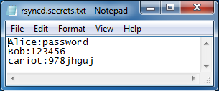
Figure 24 rsyncd.secrets – a secret file containing the username:password pairs

Server Side: Launching daemon
With the configuration file set up, the daemon can be launched on the server side. The command used for the lauching of the daemon is :
NetSync.exe --daemon -address 192.168.52.1
where
--daemon
specifies the use of daemon in the executable;

and

--address
overrides the default IP address the daemon will listen on with the specified value.

Figure 25 shows the actual input of the command in a command prompt.
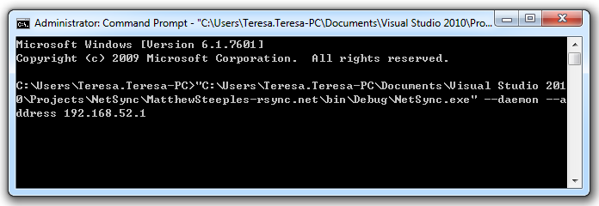
Figure 25 A screen capture of the command input for initiating the daemon

Client Side: Accessing via daemon
Once the server is initiated, the clients can access the server for uploading and downloading of files via the daemon. The below specifies the commands involved.
Pulling files from server
With this command, the contents on the server will be pulled to the specified destination:
rsync [OPTION...] rsync://[USER@]HOST[:PORT]/SRC... [DEST]

Pushing files to server
Similarly, the contents on the client will be pushed to the specified destination using this command:
rsync [OPTION...] SRC... rsync://[USER@]HOST[:PORT]/DEST

Figures 26 shows the uploading screen with the command input and the associated prompts by the system. As it can be seen from the screen capture, the following input has been entered into the system:

Netsync.exe –rv c:\\temp\ rysnc://test@192.168.52.1/documents

where the specific options represent the following:
-r, --recursive recurse into directories
-v, --verbose increase verbosity
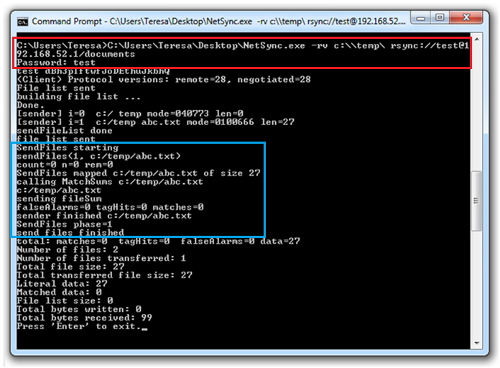
Figure 26 Uploading screen with the command input and the associated prompts by the system

After the above command is input to the system, the system will prompt the user for his/her password, as highlighted by the red rectangle in Figure 26. Once the authentication process is done, Rsync executes. As requested by the command entered by the user, the program will look for location as specified by the client for a file list. In our scenario, a file named “abc.txt” is stored at that directory. As a result, the program will push the file to the server (Figure 27). The process is highlighted in the blue box.
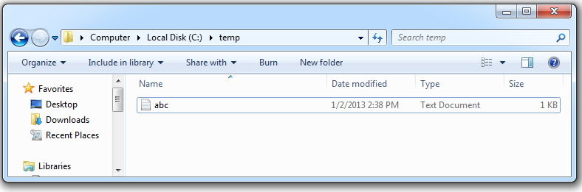
Figure 27 The file appears in the specified folder on the server
Problem
One of the major problems associated with the use of the original native code is that the code itself is incomplete. For instance, while it is possible for the client to download a file from the server, the synchronisation process fails to function if that file is later on deleted from the client system. That is, if a file is deleted from the server, the same file will not be deleted from the client side. This creates a major problem and makes the native code practically unusable for our purpose.

In light of the problem, cwRsync is adopted instead for our synchronisation needs. cwRsync is specifically written for the Windows environment.

5.2.2 Rsync using cwRsync
cwRsync is a Windows implementation of the Rsync utility [56]. Its functionalities include remote file backup and synchronisation to/from Windows systems, which makes it a perfect candidate for our NetSync implementation. There are two versions of cwRsync, namely, cwRsync client and cwRsync server. The former is implemented in NetSync to initiate Rsync transfers to the server, whereas the latter is responsible to allow users to upload and download files.
Both cwRsync client and server are installed in their relevant positions. After installation, configurations need to be done on the server side. The configuration of the software is very similar to that of Rsync, which is shown below:
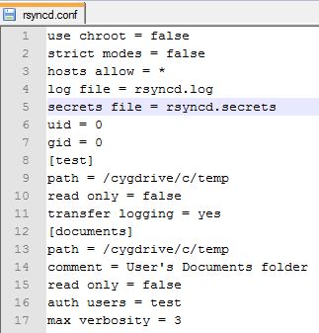
Figure 28 Configuration file for cwRsync
When server is already, the synchronisation trial begins.
In cwRsync, the command used for synchronisation is as follows:
rsync [OPTION...] SRC... rsync://[USER@]HOST[:PORT]/DEST
Rsync.exe --arv --delete /c/Users/Teresa.Teresa-PC/Desktop rsync://test@192.168.52.1/documents
Figure 29 Command entered using cwRsync
Since cwRsync is an off-the-shelf solution to our synchronisation needs, a series of tests has been carried out in order to ensure the functionality of the package. In particular, the create, change, delete, and rename commands have been tested individually. One function that is worth mentioning is the authentication system. In the test shown in Figure 30, a wrong password is input to the system upon prompt, the system has successfully blocked the access. The integrity of this system is vital for NetSync to perform its tasks securely.
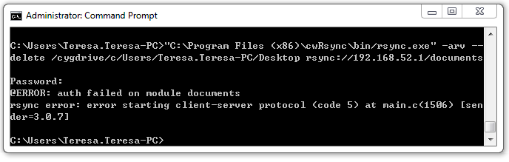
Figure 30 Authentication Test

After testing the command using cwRsync for synchronisation, the next step is to automate the process. RsyncController generates and runs the command for uploading / downloading actions. The controller also obtains the user’s password for Rsync’s authentication.

5.2.3 Monitoring file change
File monitoring is an important feature in synchronisation. With such feature, any update of a file can be detected by the program, so that a series of subsequent actions can be taken to synchronise the file. Figure 31 is a screen capture of the codes used for monitoring files stored on the client machine(s).
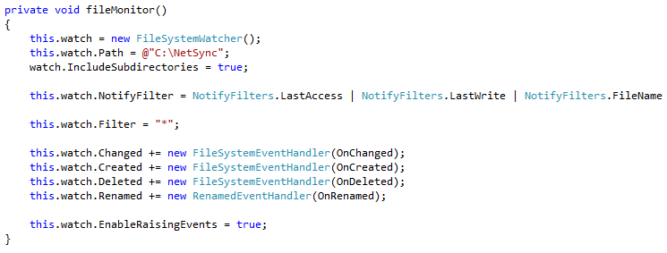
Figure 31 A screen capture of the codes used for file monitoring
FileSystemWatcher Class is used to listen to the file system change notifications and raise events when a directory, or file in a directory, changes. The path of the directory to watch is set as the temp folder on C drive. There are totally four events, including “changed”, “created”, “deleted” and “renamed” event. These events trigger a number of processes. The first one is version control. For instance, in an “onChanged” event, the version number of an edited file will be added by one integral digit. The next process is calling cryptographyHandler for encryption. When the encryption is finished, rsyncController will be called for synchronisation. Finally, notificationHandler will be summoned to send various requests, including change request, delete request, and rename request.

5.3 Key Exchange
For encrypted files to be shared, Diffie Hellman key exchange is adopted. In this section, the process of generating public and private keys is firstly discussed, followed by the key exchange process.

5.3.1 Generating public and private keys

Data Type
As discussed in the literature review chapter, Diffie Hellman problem relies on the Discrete Logarithm Problem, that is, as long as the prime p is large enough, the problem is difficult (if possible at all) to be solved. In this project, the length of prime is set to be 512 bits.

When implementing the 512-bit prime number, it is found that the length of BigInteger of C# is not long enough, which can only store 256-bit of data. As a result, C# native code of BigInt has been adopted [57] .

Relative prime
Since it takes time to generate a true 512bits prime, to make the project practical, this project makes use of the adopted BigInt class to generate a relative prime. The following describes the functions that NetSync uses for its implementation of algorithm.
GenPseudoPrime – using this function, a positive BigInteger is generated randomly, using the provided random number generator (in this case, the prime length is set at 512 bits).
IsProbablePrime – this function uses the Rabin-Miller’s test to decide if a number is a probable prime. The function will return true when the Biginteger is probably prime. When it determines that the Biginteger is definitely composite, the function will return false.

5.3.2 Key exchange process

Verification code
When key exchange needs to be performed, NetSync will generate 10 random characters as the verification code for both parties. At this stage, the delivery of the verification code is done by an automatically generated email. Figure 32 shows an example of the verification email.

Figure 32 An example of an email containing the verification code
IP request
The first step in the key exchange process is to obtain the IP address of the client who is about the receive the shared file from the server. An IP request is thus sent to the server. The server then responds by providing the IP address, and the following sequence can be initiated.

KeyExchange Handler

1. Key Exchange Request
KeyExchange handler calls Diffie Hellman for generating key exchange request. It also generates messages containing various requests, together with the user’s identify and IP address. After these, the handler calls the notification handler to inform the client of such messages.
2. Key Exchange Response
Under this function, the KeyExchange handler obtains the verification code input by the client. It then calls Diffie Hellman for generating key exchange response. After the key exchange response is generated, messages containing such response will be delivered to the sender. A shared key is then automatically set in Keyinfo.txt.

Key setting and getting
In NetSync, messages are sent in byte array. A single byte can store either an unsigned integer or signed integer. Unsigned integers are values between 0 and 255. Signed integers, on the other hand, are values between -128 and 127.

A problem experienced during the implementation process is that after writing the byte array key into the text file, the key value changes due to conversion issues associated with the integer nature. As a result, the original key is corrupted.

As a result, in order to store the key, the key is written to the text file by using BinaryWriter which inputs primitive types in binary codes to a stream.
3. Key Exchange Response Handling
When the client receives the key exchange response, Diffie Hellman will be called for handling the response. The shared key is then set in Keyinfo.txt.

Diffie Hellman
Diffie Hellman is the class NetSync adopts to carry out the following functions.
- Key Exchange Request
When a key exchange request is received, the following will be executed.
- A 512-bit prime number, p, is generated.
- A base number, g is set.
- A 160-bit private key, a, is created.
- A public key is calculated using values obtained in steps I-III: g^a mod p
- A hash of public key with the shared verification code is calculated using SHA-1

- Key Exchange Response
When a key exchange response is received, the following will be executed.
- A private key, b, is generated.
- A hash value is calculated using the received public key, together with the verification code. Verification is then taken place to see if the calculated hash value is equal to the received value.
- Using the received public key, g^a mod p, a shared key, (g^a)^b mod p is then generated.
- Using the received prime, base, and its own private key, a public key, g^b mod p is created.

3. Key Exchange Response Handling
- A hash value is calculated using the received public key, together with the verification code. Verification is then taken place to see if the calculated hash value is equal to the received value.
- Using the received public key, g^b mod p, a shared key, (g^b)^a mod p is then generated.

5.4 XTS-AES

5.4.1 Preparation
In order to perform an XTS-AES encryption, reference is sought from a C# XTS source code, xtsSharp [58]. An investigation then takes place to check whether an XTS encryption is correctly implemented.
After verifying the functionality of xtsSharp, a Dynamic-link library was then created with .dll extension. A reference named “XTSSharp” was also created (See Figure 33).
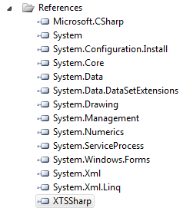
Figure 33 References of XTSSharp

5.4.2 Encryption
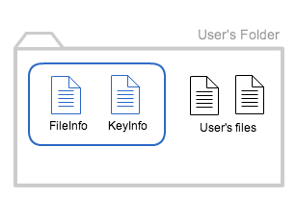
Figure 34 Housekeeping of NetSync folder

Under the NetSync folder, there is a secret folder containing two text files, namely fileInfo and KeyInfo (Figure 34). FileInfo is a document containing the file name, the version number of the file as well as the file owner information. KeyInfo, on the other hand, stores the client’s key and exchanged key. With this information, for each file to be encrypted, cryptography handler will first find out who is the owner of that file, so that it can obtain the corresponding key to execute subsequent actions. For the files stored within the secret folder, they will be encrypted with the key of client.
During the process of synchronisation, files are encrypted before synching to the server. As a result, a temporary folder will be created for storing encrypted files. A file list needs to be obtained before encryption begins. Each file is then transformed into byte array. A XTS-AES encryptor will be created to call the encrypting function of the referenced library. The encrypted byte array will then be transformed back to file. After the synchronization, the temp file will be deleted. Figure 35 shows the function of encryption.
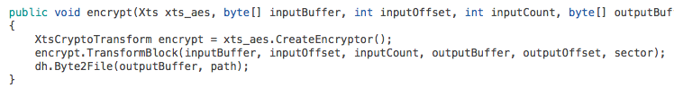
Figure 35 Encryption Function of CryptographyHandler

5.4.3 Decryption
Upon decryption, fileInfo.txt is decrypted first. This allows the handler to identify the owner of the file. With this information, decryption key can be obtained for subsequent actions. The decryption function is very similar to the encryption counterpart.

6. Results & Evaluation

6.1 Efficiency
The efficiency of NetSync has been evaluated in terms of its encryption speed. To test this, a file with a size of 1 GB is put into the NetSync folder for encryption.
File: C:\NetSync\test.txt Created
Start encryption 11:07:17
End encryption 11:08:42
Figure 36 Encryption Speed Test (NetSync)
As it can be seen from Figure 35, a file name test.txt was created. The file itself was of a size of 1GB and was stored within the NetSync folder. The encryption process started at 11:07:17 and ended at 11:08:42. 1 minute and 25 seconds was used for the entire encryption.
To compare the efficiency of NetSync with Secret Sync the same file is uploaded to the SecretSync folder within Dropbox. Both tests are carried out in the same computer setup, so there should be no difference associated with hardware issues. The table below shows the encryption time used by SecretSync to process the same file.
File: C:\NetSync\test.txt Created
Start encryption 11:30:14
End encryption 11:31:07
Figure 37 Encryption Efficiency (Secret Sync)
As shown in figure 36 and 37, the processing time needed by NetSync is slower to that of SecretSync (1 minutes and 25 seconds versus 53 seconds). The reason behind such a difference is unclear. It could probably be due to difference between the encryption algorithms. However, as NetSync provides the functionality of sharing encrypted files. Such difference is tolerable at this stage.

6.2 User Interface
In this project, a user interface is yet to be developed for file sharing and other advanced control settings (e.g. manual synchronisation, starting / pausing synchronisation, etc.). To put it into perspective, when a user needs to share a file on NetSync with another user, he/ she needs to input the file path he / she wishes to share together with the name of the recipient on a text file (with a txt extension). If key exchange needs to be carried out, one would need to input the email address and the name of the recipient so that he / she can get a notification email with the verification code inside. The recipient can then input the verification code on a text file to trigger the key exchange response.
The current implementation of NetSync is undoubtedly far from perfect. However, as the main purpose of this project is to develop a solution to make sharing and encryption co-exist in a cloud storage service, the development of a market-ready user interface is not the major consideration of this project.

6.3 File Sharing
Sharing capability is limited to the sharing of a single file at this stage. This means that a folder can yet to be shared with another user in the current version of NetSync. Nevertheless, the sharing of individual files has already proved the possibility of implementing such a system with client side encryption and key exchange. The sharing of folders could be considered as a future development direction.

6.4 Security
As client side encryption is adopted in this project, all the files have been encrypted upon reaching the server, with the keys own solely by the client. As a result, files cannot be read on the server without such keys. This is a more secured solution compared to Dropbox, where encryption takes place on the server side. As compared to other third party encryption solutions on the market, NetSync provides a highly comparable level of security as 512-bit encryption has been adopted. The use of Diffie-Hellman algorithm has also contributed to the security of the solution.
While this is not within the scope of this project, one limitation which is worth noting is that the values stores in the database on the server side is not encrypted.

6.5 Chapter Summmary
To conclude, this project aims to integrate cloud storage with client side encryption and sharing capabilities. While these have been successfully achieved, a number of shortcomings exist in the current implementation. These will be further discussed and addressed in the next chapter.

Further Development
NetSync provides the capabilities to synchronise files within a dedicated folder securely using encryption. Such synchronisation is not limited to individual users, different users can have access to encrypted shared files within the folder. As briefly mentioned in the Results and Evaluation section, the solution suffers from a lack of user interface, limitation of file sharing, as well as security issues with user database on the server side. In this chapter, further elaboration is provided for such limitations, with an attempt to provide a direction for further development. In addition to the limitations mentioned above, a number of other shortcomings are also to be discussed.

7.1 Installation
The current implementation of NetSync requires the user to install the client of cwRsync. The solution at this stage has not provided a compiled package for easy installation. The service needs to be initiated manually using commands in the command prompt. Such limitation is due to the fact that the provision of such a compiled package would require the development of a separate installer.

7.2 Authentication
As discussed in the previous chapter, the current deployment of NetSync is limited to its technical functionalities. This approach has posed limitations on the user-friendliness of the solution as a user interface is not provided.
A very important item associated with the user experience is the availability of the authentication services. Currently, there is no way for the user to register for an account to use the service. As such, no login windows have been designed and executed. With the current version of NetSync, the configurations of synchronisation as well as other configurations on the server side have been made input manually into the system. As a future direction for development, a login system needs to be implemented, such login system is crucial for the overall user experience as well as security. A remember me option or checkbox would add to that enhancement as it will allow a user to access the system without inputting their credential each time they reboot.

7.3 User interface
The lack of user interface as mentioned in Section 7.2 also affects the usability of the solution as a whole. Currently, a user interface is needed for the following:
- Opening the NetSync folder, viewing recently synced files, pausing synchronisation, quitting/ closing NetSync
- Inputting email addresses for sharing files
- Inputting verification code for key exchange
In order to create a user interface for the above functions, a Windows Forms Application can be developed. Windows Forms provide the necessary components for interface development (menus, buttons, dialog boxes, etc.). In particular, event handlers can be created for various controls.
The communication between NetSync and Windows Form Application, Windows Communication Foundation (WCF) Service is needed. WCF hosts application and accesses NetSync service. As a result, WCF can be deployed to interact with users and call upon NetSync service when necessary (likewise, NetSync can also asks the WCF service to deploy different components to obtain inputs form users).

7.3 Encryption on the fly
Encryption on the fly was a function NetSync designed to have prior its development. However, it was unrealistic to have it included as one of the features as NetSync developed due to the scale and the scope of the project. Such feature, however, would add to its usability and convenience. To implement this in the future, it is worthwhile to investigate the suitability of FreeOTFE, which is an open source on the fly disk encryption application for Windows. FreeOTFE achieve on the fly disk encryption by creating an encrypted disk. Volume. It is uncertain whether such encryption can be applied to files within a folder instead of creating an additional mounted virtual volume. Its ability to achieve this is crucial as we do not want the complexity associated with volume mounting and dismounting, which is a major downfall of third party Dropbox encryption software like TrueCrypt.

7.4 Web page & mobile version
As NetSync targets to replace Dropbox as a cloud storage solution with the ability to share client side encrypted files, it is worthwhile to investigate the possibility of developing mobile versions of the application for mobile platforms like iOS or Android. The mobile application of Dropbox is currently provided for both platforms. Being a cloud storage solution, the ability to access the service with mobile devices is definitely preferable and will make the package more complete.

8 Conclusion
Cloud storage solutions like Dropbox provide great convenience for users to have access to their files on-the-go on any devices with an internet connection. For those who have such need to store sensitive data on the cloud, security has become more increasingly a concern. Existing encryption tools in the market, like SecretSync and Truecrypt, while provide protection for the confidentiality of data, are often not well considered and cause much inconvenience to users. Sharing of encrypted files is impossible using such services. The use of a virtually mounted drive for encryption purpose with Truecrypt has also made the use of such service highly complicated.
NetSync provides a better solution for encrypted file synchronisation. It is a one-stop solution for the encryption, decryption and synchronisation of cloud data. The solution adopts Diffie-Hellman key exchange approach to share a common cryptographic key and uses XTS-AES as the encryption method. cwRsync algorithm is used for file synchronisation. The incorporation of these technologies makes NetSync a highly competitive solution on the market.
In the future, development can be geared towards the implementation of a comprehensive user interface using Windows Form Application. A login mechanism can be developed to increase the usability of the system. Encryption on the fly and web app development are two other important features to be developed and implemented.

9 Project Management

9.1 Environment

Hardware
- PC: Dell Optiplex 990

Software
- Microsoft Visual Studio 2010 Ultimate
- VM Ware

9.2 Management Methodology
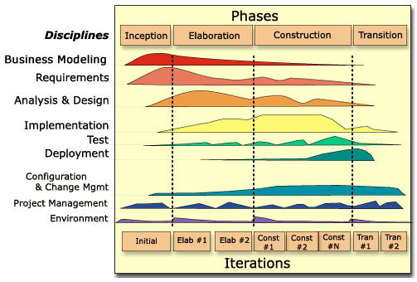
Unified Process is chosen in this project. The main feature of this approach, Iteration allows the project to be done in different phases repeatedly and incrementally. There are totally four phases divided, inception, elaboration, construction and transition.

Main objectives of phases
Inception: capturing requirement, identify key functionality
Elaboration: getting detailed requirement, designing system, implementing
Construction: implementing, testing, configuring version
Transition: validating if the function work and requirement meet, deploying

9.3 Project Timetable
 | Project Plan | Design & Study | Interim Report | Implement | Testing | FYP Report | Demo & PPT
2-8 SEP  Week 1 (A) | Initial
9-29 SEP  Week 2-4 (A) | Revised* | Initial | Initial
30 SEP - 13 OCT  Week 5-6 (A) | Revised | Revised* | Revised | Initial
14 OCT - 3 NOV  Week 7-9 (A) | Revised | Revised | Revised | Revised | Initial
4 NOV - 1 DEC  Week 10-13 (A) | Revised | Revised | Revised | Revised | Revised
2 DEC - 12 JAN  Sem Break (A) | Revised | Revised | Revised* | Revised | Revised
13 JAN - 2 FEB  Week 1-3 (B) | Revised | Revised | Final | Revised | Revised | Initial
3 FEB - 16 MAR  Week 4-8 (B) | Revised | Revised |  | Revised | Revised | Revised
17 FEB - 30 MAR  Week 9-10 (B) | Revised | Revised |  | Revised* | Revised* | Revised*
31 MAR- 20 APR  Week 11-12(B) | Final | Final |  | Final | Final | Final | Final
“Revised *” shows the expected complete period. (Non-final version)

9.4 Detailed schedule
The detailed schedule is attached in the appendix in chapter 11.

9.5 Milestones
In order to keep track the planned schedule, the following milestones are defined. Milestone is defined base on the deadline of task, and the date of milestone related to this task. For instance, testing and debugging should be done after implementation, and thus it has a later date.

- Project plan
Deadline: 29th Oct, Week 9(A)
Milestone 1: 29th Sep, Week 4(A) background, objectives, methodology, schedule & millstones
Milestone 2: 27th Oct, Week 8(A) literature review + revise all

- Study & Design
Milestone 1: 6th Oct, Week 5(A) tech. study, key exchange
Milestone 2: 20th Oct, Week 7(A) tech. study, system components, system work flow
Milestone 3: 17th Nov, Week 11(A) design diagram

- Interim Report
Deadline: 4th Feb, Week 4(B)
Milestone 1: 24th Nov, Week 12(A) methodology, revise all
Milestone 2: 12th Jan, Sem Break implementation, revise all
Milestone 3: 26th Jan, Week 2(B) revise all

- Implementation
Milestone 1: 9th Feb, Week 4(B) File sync, develop client side
Milestone 2: 9th Mar, Week 7(B) develop server side, key exchange
Milestone 3: 30th Mar, Week 10(B) encryption, other functions

- Testing & Debugging
Milestone 1: 16th Feb, Week 5(B) test if functions are ok
Milestone 2: 16th Mar, Week 8(B) test if functions are ok
Milestone 3: 6th Apr, Week 11(B) test if functions are ok

- FYP Report
Deadline: 15th Apr, Week 12(B)
Milestone 1: 6th Apr, Week 11(B) result, revise all
Milestone 2: 13th Apr, Week 12(B) evaluation, revise all

10 References
[1] Tan. (2011). Gmail, hotmail, yahoo mail storage and attachment size limit. Retrieved November 9, 2012, from http://slashtasks.com/2011/01/25/gmail-hotmail-yahoo-mail-storage-and-attachment-size-limit/

[2] News.gov.hk. (2009). Kowloon east cluster announces the loss of a USB flash drive. Retrieved November 9, 2012, from http://www.info.gov.hk/gia/general/200903/24/P200903240326.htm

[3] News.gov.hk. (2009). Kowloon east cluster (KEC) announces the loss of a USB flash drive containing patient data. Retrieved November 9, 2012, from http://www.info.gov.hk/gia/general/200904/12/P200904120196.htm

[4] Casey, M. (2012). Frequently asked questions about USB flash drives. Retrieved November 9, 2012, from http://peripherals.about.com/od/removablestorage/f/USBFAQ.htm

[5] Flatley, J.L. (2009). Kingston unveils 256GB thumb drive for well-heeled memory fiends. Retrieved November 9, 2012, from http://www.engadget.com/2009/07/20/kingston-unveils-256gb-thumb-drive-for-well-heeled-memory-fiends/

[6]. Wikipedia, The Free Encyclopedia (2012). Revision Control. Wikimedia Foundation, Inc. Retrieved November 12, 2012, Retrieved from http://en.wikipedia.org/wiki/Revision_control

[7] Mather, T. , Kumaraswamy, S. & Latif, S. (2009). Introduction: The evolution of cloud computing. In M. Loukides (Ed), Cloud security and privacy (pp.3). Sebastopol
: O’Reilly Media.

[8] Sonian. (2012). Report: Cloud storage outpacing SaaS in popularity. Retrieved November 9, 2012, from http://www.sonian.com/2012/06/report-cloud-storage-outpacing-saas-in-popularity/

[9] Lardinois, F. (2012). Report: Cloud storage services now have over 375M users, could reach 500M by year-end. Retrieved November 9, 2012, from
http://techcrunch.com/2012/10/15/report-cloud-storage-services-now-have-over-375m-users-could-reach-500m-by-year-end/

[10] Li, X. (2012). Gartner: Consumer cloud storage take-up set to soar. Retrieved November 9, 2012, from http://www.itpro.co.uk/641395/gartner-consumer-cloud-storage-take-up-set-to-soar

[11]Mather, T., Kumaraswamy, S., & Latif, S. (2009). What is cloud computing?: Cloud Computing Defined. In M. Loukides (Ed), Cloud security and privacy (pp.8). Sebastopol: O’Reilly Media.

[12] Gilson, D. (2012). How to backup files on multiple cloud storage services. Retrieved November 9, 2012, from http://reviews.cnet.co.uk/software-and-web-apps/how-to-backup-files-on-multiple-cloud-storage-services-50008379/

[13] Lloyd, C. (2011). Dropbox hits 50 million users and raises $250 million. Retrieved November 9, 2012, from http://www.techerator.com/2011/10/dropbox-hits-50-million-users-and-raises-250-million/

[14] Dropbox. (2012). Where does Dropbox store everyone's data?. Retrieved November 9, 2012, from https://www.dropbox.com/help/7/en

[15] Dropbox. (2012). Does Dropbox keep backups of my files?. Retrieved November 9, 2012, from https://www.dropbox.com/help/122/en

[16] Dropbox. (2012).How do I recover old versions of files?. Retrieved November 9, 2012, from https://www.dropbox.com/help/11/en

[17] Dropbox. (2012).How secure is Dropbox?. Retrieved November 9, 2012, from https://www.dropbox.com/help/27/en

[18] Rescorla, E. (2001). SSL and TLS: Designing and building secure systems. New Jersey: Addison-Wesley

[19] Kahate, A. (2003). Cryptography and network security. (International Edition). Singapore: Tata McGraw-Hill

[20] SecretSync [computer software] (2012). Nampa, Idaho: completelyprivatefiles.com

[21] Truecrypt [computer software] (2012). TrueCrypt Developers Association http://www.truecrypt.org/

[22] Completelyprivatefiles.com (2012) Getting started. Retrieved November 12, 2012, from http://get.com/ss/getstarted/

[23] Truecrypt (2012). Mounting TrueCrypt volumes. Retrieved November 12, 2012, fromhttp://www.truecrypt.org/docs/?s=mounting-truecrypt-volumes

[24] Mather, T., Kumaraswamy, S., & Latif, S. (2009). What is cloud computing?: Cloud Computing Defined. In M. Loukides (Ed), Cloud security and privacy (pp.11, 17-22). Sebastopol: O’Reilly Media.

[25] Rouse, M. (2012). SPI model (SaaS, PaaS, IaaS). Retrieved February 2, 2013 from
http://searchcloudcomputing.techtarget.com/definition/SPI-model

[26] Mather, T., Kumaraswamy, S., & Latif, S. (2009). What is cloud computing?: Cloud Computing Defined. In M. Loukides (Ed), Cloud security and privacy (pp.8). Sebastopol: O’Reilly Media.

[27] Daniel (2012). Top 5 Cloud Storage Services Reviewed. Retrieved February 2, 2013 from
http://www.latenightblogger.com/tech/top-5-cloud-storage-services-reviewed/

[28] Sottek, T.C. (2012). Google Drive officially launches with 5GB free storage, Google Docs integration. Retrieved February 2, 2013 from
http://www.theverge.com/2012/4/24/2971025/google-drive-official-launch-features

[29] Wikipedia, The Free Encyclopedia (2012). Dropbox_(service). Wikimedia Foundation, Inc. Retrieved February 2, 2013 from http://en.wikipedia.org/wiki/Dropbox_(service)

[30] Dropbox. (2012). Where does Dropbox store everyone's data?. Retrieved February 2, 2013 from https://www.dropbox.com/help/7/en

[31] Amazon. (2012). Amazon Simple Storage Service (Amazon S3). Retrieved February 2, 2013 from http://aws.amazon.com/s3/

[32] Dropbox. (2012). What is the Public folder for?. Retrieved February 2, 2013 from
https://www.dropbox.com/help/16/en

[33] Dropbox. (2012). Features. Retrieved February 2, 2013 from
https://www.dropbox.com/teams/features

[34] Dropbox. (2012). How do I share a file or folder with others?. Retrieved February 2, 2013 from
https://www.dropbox.com/help/274/en

[35] Dropbox. (2012). The Dropbox Blog. Retrieved February 2, 2013 from
https://blog.dropbox.com/

[36] Rundle, M. (2012). Dropbox Password Breach Leads To Mass Security Alert. Retrieved February 2, 2013 from
http://www.huffingtonpost.co.uk/2012/08/01/dropbox-password-breach-leak_n_1727338.html

[37] Greene, T. (2011). Dropbox cloud was a haven for data thieves, researchers say. Retrieved February 2, 2013 from
http://www.networkworld.com/news/2011/081711-dropbox-249830.html

[38] Dropbox. (2012). Yesterday’s Authentication Bug. Retrieved February 2, 2013 from https://blog.dropbox.com/?p=821

[39] PC Advisor staff. (2011). Five of the best encryption tools. Retrieved February 2, 2013 from http://www.pcadvisor.co.uk/features/software/3290443/five-of-the-best-encryption-tools/

[40] Viivo. (2012). About us. Retrieved February 2, 2013 from
http://viivo.com/about-us/

[41] Richard, E. S. (1997). Public key Crypt and SSL. In Internet Cryptography (pp. 200-203). United States of America: Addision-Wesley Longman

[42] Rescorla, E. (2000). SSL Overview. In SSL and TLS: Designing and Building Secure Systems (pp. 44). Addison-Wesly: New Jersey

[43] Rescorla, E. (2000). SSL Overview. In SSL and TLS: Designing and Building Secure Systems (pp. 57-61). Addison-Wesly: New Jersey

[44] Rescorla, E. (2000). SSL Overview. In SSL and TLS: Designing and Building Secure Systems (pp. 175). Addison-Wesly: New Jersey

[45] Prince, M. (2012). How to make SSL fast. Retrieved February 2, 2013 from
http://blog.cloudflare.com/how-cloudflare-is-making-ssl-fast

[46] Wikipedia, The Free Encyclopedia (2012). Disk encryption theory. Wikimedia Foundation, Inc. Retrieved February 2, 2013 from
http://en.wikipedia.org/wiki/Disk_encryption_theory

[47] Jetico (2012) BestCrypt Web Help - Encryption Mode. Retrieved February 2, 2013 from http://www.jetico.com/bcve_web_help/html/02_standards/03_mode.htm

[48] Armoush, A. (2011). XTS‐AES Mode. Retrieved February 2, 2013 from
http://elearning.najah.edu/OldData/docs/1991Ch_05_Block_Cipher_Operation_Part2.pdf

[49] IEEE. (2007). Standard for Cryptographic Protection of Data on
Block-Oriented Storage Devices. Retrieved February 2, 2013 from
http://grouper.ieee.org/groups/1619/email/pdf00086.pdf

[50] Liskov, M. , Minematsu, K. (2008). Comments on XTS-AES. Retrieved February 2, 2013 from
http://csrc.nist.gov/groups/ST/toolkit/BCM/documents/comments/XTS/XTS_comments-Liskov_Minematsu.pdf

[51] rsync. (2004). rsync features. Retrieved February 2, 2013 from
http://rsync.samba.org/features.html

[52] Davison, W (2012). rsync(1) - Linux man page. Retrieved February 2, 2013 from
http://linux.die.net/man/1/rsync

[53] Cooper, T. (2012). USB Flash Drive Security. Retrieved February 2, 2013 from
http://csrc.nist.gov/groups/SMA/fasp/documents/production_io_controls/USBDriveSecurity.pdf

[54] Jenkov, J. (2012). RSync – Overview. Retrieved February 2, 2013 from
http://tutorials.jenkov.com/rsync/overview.html

[55] Steeples, M. (2013). Rsync Homepage. Retrieved February 2, 2013 from
https://github.com/MatthewSteeples/rsync.net

[56] cwRsync (2013). Retrieved April 13, 2013 from
http://www.softpedia.com/get/Internet/Servers/Server-Tools/cwRsync.shtml

[57] Dickinson, J,C. (2008). Shared Key Generation using Diffie-Hellman. Retrieved April 13, 2013 from
http://www.codeproject.com/Articles/24632/Shared-Key-Generation-using-Diffie-Hellman

[58] Lennox, G. (2012). XTSSharp. Retrieved April 13, 2013 from https://bitbucket.org/garethl/xtssharp

11 Appendix
The following are the progress logs submitted to FYPMS.
October, 2012 | Project Plan  - Draft introduction  - Draft methodology  - Draft Hw &Sw resource requirement  - Draft project schedule  - Draft deliverable  - Set milestone  - Define work breakdown structure  Study & Design  - Study cloud storage  - Study Dropdox  - Study Google Drive, Skydrive  - Study Truecrypt  - Study GetSecretSync  - Study RSync  - Study XTS-AES  - Study Java & C#  - Study SSL  - Study Diffie-Hellmen Key Exchange  - Define system components  - Draft system design  Interim Report  - Draft Introduction  - Draft Literature review  - Draft Methodology  - Draft System Design  Implement  - Environment setup  - Server Side (Sync file by RSync)  Testing  - Test the function  //Already for submit project plan (Introduction, Literature Review, Methodology)
November, 2012 | Project Plan  - Revise milestone  - Revise work breakdown structure  - Revise project schedule  Study & Design  - Revise system design  - Study XTS-AES  - Study Google Drive, Skydrive  Interim Report  - Revise Introduction  - Revise Literature review  - Revise Methodology  - Revise System Design  Implement  - Monitor file change in folder  - Sync file by RSync  Testing  - Test the function  //Start for implementation
December, 2012 | Project Plan  - Revise milestone  - Revise work breakdown structure  - Revise project schedule  Study & Design  - Revise system design  - Study SSL  - Study Encryption  Interim Report  - Revise Literature review  Implement  - Synchronization  - Encryption  Testing  - Test the function
January, 2013 | Project Plan  - Revise milestone  - Revise work breakdown structure  - Revise project schedule  Study & Design  - Study cwRsync  Interim Report  - Revise Literature Review  - Add Literature Review (Cloud,SSL)  - Revise Methodology(XTS-AES)  - Revise System Design(Structure, work flow)  - Add System Design(Detailed components)  Implement  - setup  - Synchronization(cwRsync)  Testing  - Test the function  //ready to submit Interim Report
February, 2013 | Project Plan  - Revise milestone  - Revise work breakdown structure  - Revise project schedule  Study & Design  - Study DH code  - Study XTS-AES  Implement  - DH key exchange  Testing  - Test the function
March, 2013 | Project Plan  - Revise milestone  - Revise work breakdown structure  - Revise project schedule  Study & Design  - Draw detailed design of handler  Implement  - XTS-AES encryption  - Handlers for key exchange, encryption, notification  - Server side handler (Listener & Notifier)  FYP report  - Revise Interim Report  - Draft FYP report  Testing  - Test the function

