
Zroad – Augmented Reality Navigation
CityU CS FYP Project
Supervised by Dr. Duncan Wong
Created By Vicx Lau Wing Ying
In Feb, 2013
the world-wide geographical information has been collected, map service through the internet is now widely used. However, people who cannot find the place they want even with the map are still not the minority. Fortunately, there will be a location-based augmented reality directing application, Zroad.
Since
Zroad
, with the pronunciation “See road”, directs user to their destination with the camera in their mobile device. Even non-map readers now lose in the complicated road like “Z” shape, they can still easily get their way with directions from Zroad. All they need to do is to simply raise their mobile device with the camera, focus to the surroundings where they currently are. Zroad will give them directions with some arrows. Users will not need to worry about the map and just follow the given arrows.
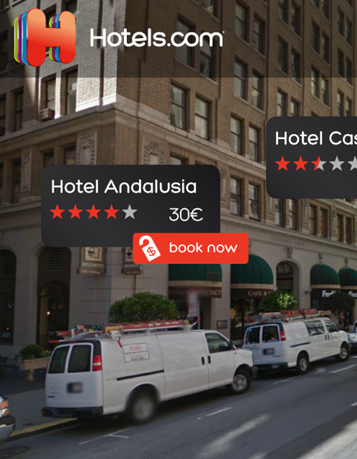
Zroad will use is Wikitude, an augmented reality SDK, which is with a cross-platform library unified all augmented reality technologies. It is available for different native OS like Android, iOS, BlackBerry 10. It also appears as a plugin of PhoneGap. For the functionalities, it provides developers to create geo-based contents with latitude, longitude, altitude. For the license, Wikitude SDK is free for educational projects with its logo in camera view.
Tech
Reference:
Figure 1 (Hotel.com, a sample app using Wikitude)

- Wikitude. (n.d.). Wikitude Showcases. Retrieved Feb 26, 2013, from http://www.wikitude.com/showcases
- Wolfgang Damm. (n.d.). Augmented Reality Using a JavaScript API. Retrieved Feb 28, 2013, from http://www.slideshare.net/wikitude/wikitude-sdk-jseverywhere-europe

Objective:
Provide a more efficient assistance for searching destination
Help the non-map reader to arrive to the destination with Zroad
Indication the surrounded building

Deliverables:
Visualize the direction by providing direction arrows or other visual aids
Show the surrounding building with “point of interest”
Provide a more efficient assistance for searching destination
- Normally input text address
- google map show destination mark in the map
- User has his current location & needa to find way by himself
  - User can have another option
  - Input text address
  - Show approximated travel time & choice
  - Once selected, show direction with arrows
    - System
    - Get input
    - Pass to google
    - Get google result
    - Display choices
    - Get user choices
    - Pass to google
    - Get path
    - Process result with wikitude
    - Show destination as point of interest & sur POI
Help the non-map reader to arrive to the destination with Zroad
Indication the surrounded building
- When open the application with camera, scan the surrounding
- The building next to the user will display as point of interest

Deliverables:
Visualize the direction by providing direction arrows or other visual aids
- Visualize the direction with visual aids showing in the camera capture
Show the surrounding building with “point of interest”
FYPMS:
Since the world-wide geographical information has been collected, map service through the internet is now widely used. However, people who cannot find the place they want even with the map are still not the minority. Fortunately, there will be a location-based augmented reality directing application, Zroad. Zroad, with the pronunciation 'See road', directs user to their destination with the camera in their mobile device. Even non-map readers now lose in the complicated road like 'Z' shape, they can still easily get their way with directions from Zroad. After inputting the destination, all they need to do is to simply raise their mobile device with the camera, focus to the surroundings where they currently are. Zroad will give them directions with some arrows. Users will not need to worry about the map and just follow the given arrows.
Obj
- Help the non-map reader to arrive to the destination with Zr...
- Help locating surrounded buildings with the map

Dev
- Visualize the direction with visual aids showing in the augmented-reality screen
- Name the surrounded buildings in the augmented-reality screen with Wikitude SDK

