BookLeaf

UI Prototype

Version <1.0>

Revision History

| **Date** | **Version** | **Description** | **Author** |
| --- | --- | --- | --- |
| 02/12/2024 | 1.0 | Init the UI Prototype | All members |
|  |  |  |  |
|  |  |  |  |
|  |  |  |  |

Table of Contents

**1. Introduction 4**

1.1. Purpose 4

1.2. Tool Used 4

**2. Key Use-Case Scenarios 4**

2.1. Login and Sign Up 4

2.2. Reading 4

2.3. View analytics at personal Profile 4

**3. Main Screen 4**

3.1. Overview 5

3.2. Features and Designs 5

**4. Screens 5**

4.1. Sign Up 5

4.2. Log In 6

4.3. Reset Password 6

4.4. Reading page 7

Overview 7

Features and Designs 7

4.5. User Profile 8

4.5.1. Libraries 8

4.5.2. Reading Time Analytics 8

4.5.3. Information 9

4.5.4. Account Management 9

Overview 9

Features and Designs 10

4.6. Admin Views 10

4.6.1. Create an admin account 10

4.6.2. See overview analytics 10

4.6.3. Navigate to a normal user profile 10

4.6.3.1. View their books, monitor their reading progress 10

4.6.3.2. Monitor their session 10

4.6.3.3. Delete a normal user’s account 10

# Introduction

## Purpose

This report presents the BookLeaf user interface (UI) prototype, designed to address modern e-reading challenges. The goal is to provide realistic, user-friendly, and community-driven digital reading experiences through an intuitive interface.

## Tool Used

Figma: for collaborative wireframe, design and feedback.

# Key Use-Case Scenarios

This section covers some important key use-case scenarios

## Login and Sign Up

**Purpose:** Provide secure user authentication and account creation.

**Overall requirements:**

* Login Screen: Users enter their credentials and click the login button to access the system. They can click the forgot password link if they need to reset their password.
* Signup Screen: New users fill out the required fields and click the signup button to create an account.

## Reading

**Purpose:** Provide a reading interface for users.

**Overall requirements:** Users can navigate through pages to read. They can also customize the reading view (e.g., font size, theme).

## View analytics at personal Profile

**Purpose:** Users can see their reading stats at their profile page.

**Overall requirements:** Users can see their reading stats and graphs and charts.

# Main Screen

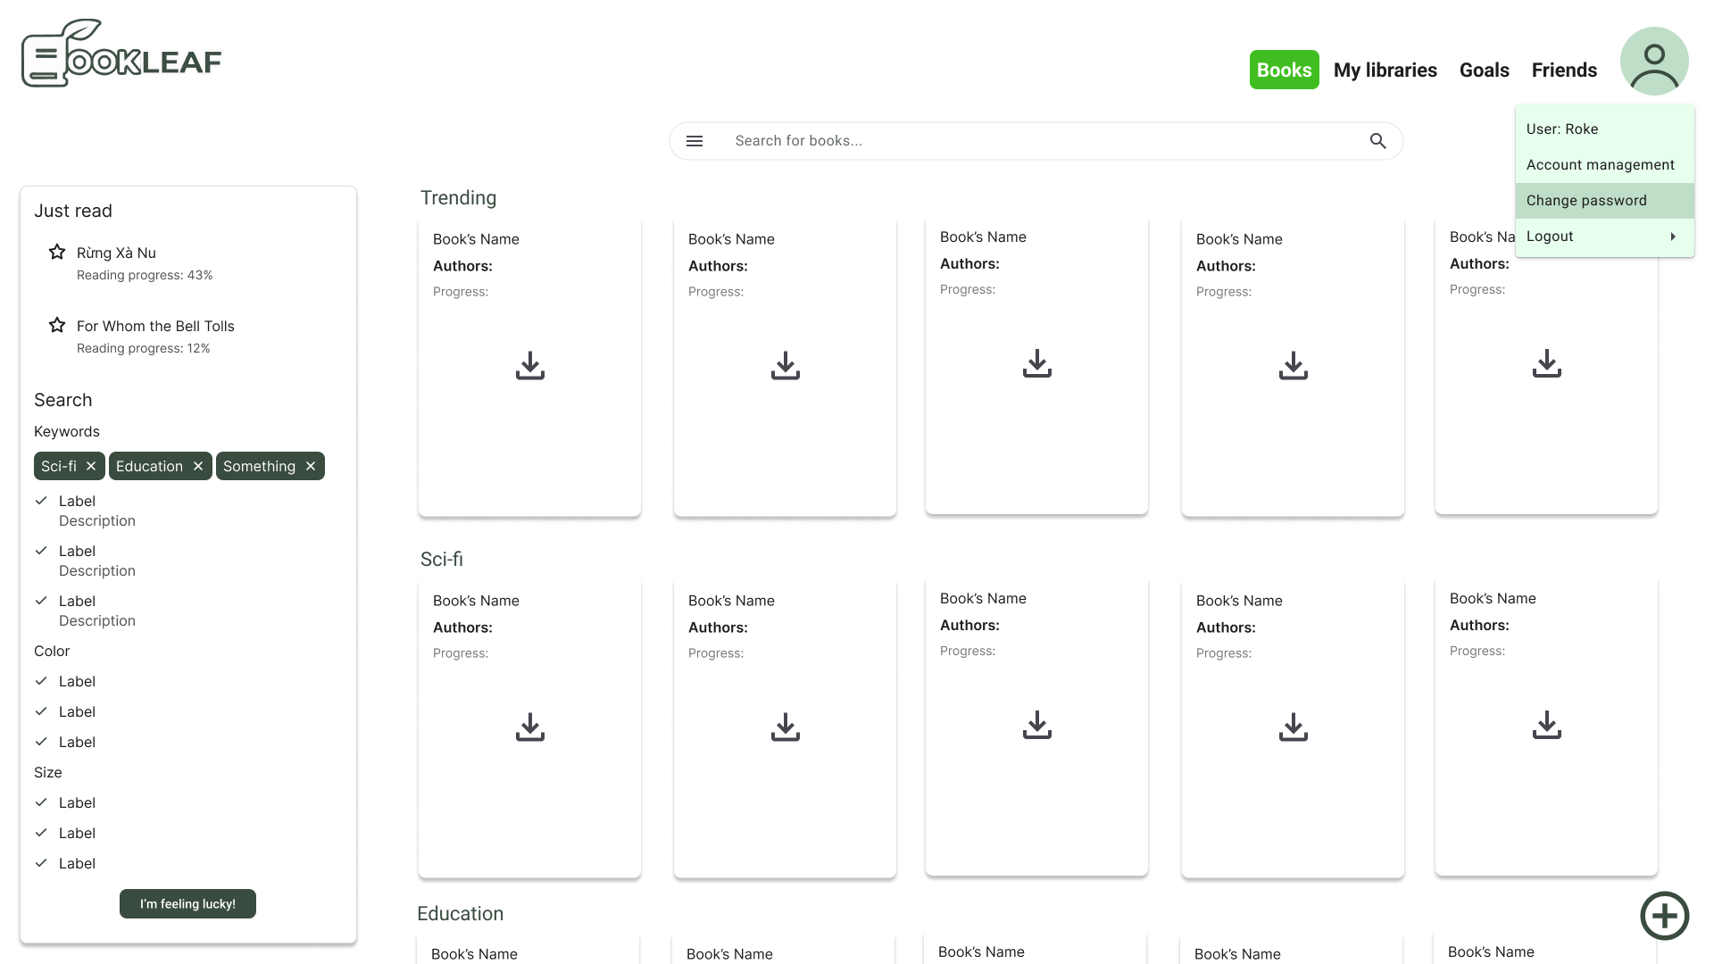

## Overview

Users can access and manage their e-book collection, search for new books, track reading progress, and navigate to other key features.

## Features and Designs

**Top Navigation Bar:**

* **Menu Options**: Provides quick access to Books, My Libraries, Goals, and Friends.
* **Profile Menu**: Clicking the user icon in the top-right corner reveals options for account management, changing passwords, and logging out.

**Search Bar:** Located at the top center, this bar allows users to search for books by title, author, or keywords.

**Left Sidebar:**

* **Recently Read Books**: Displays a list of recently accessed books with reading progress percentages.
* **Search Filters**: Users can refine search results with keyword tags (e.g., Sci-fi, Education) and filter options like color and size.
* **Category Sections** (e.g., Sci-fi, Education):

**Book Cards**: Each book card offers a quick download button, or a book cover making it easy for users to access or save books directly from the main screen.

# Screens

## Sign Up

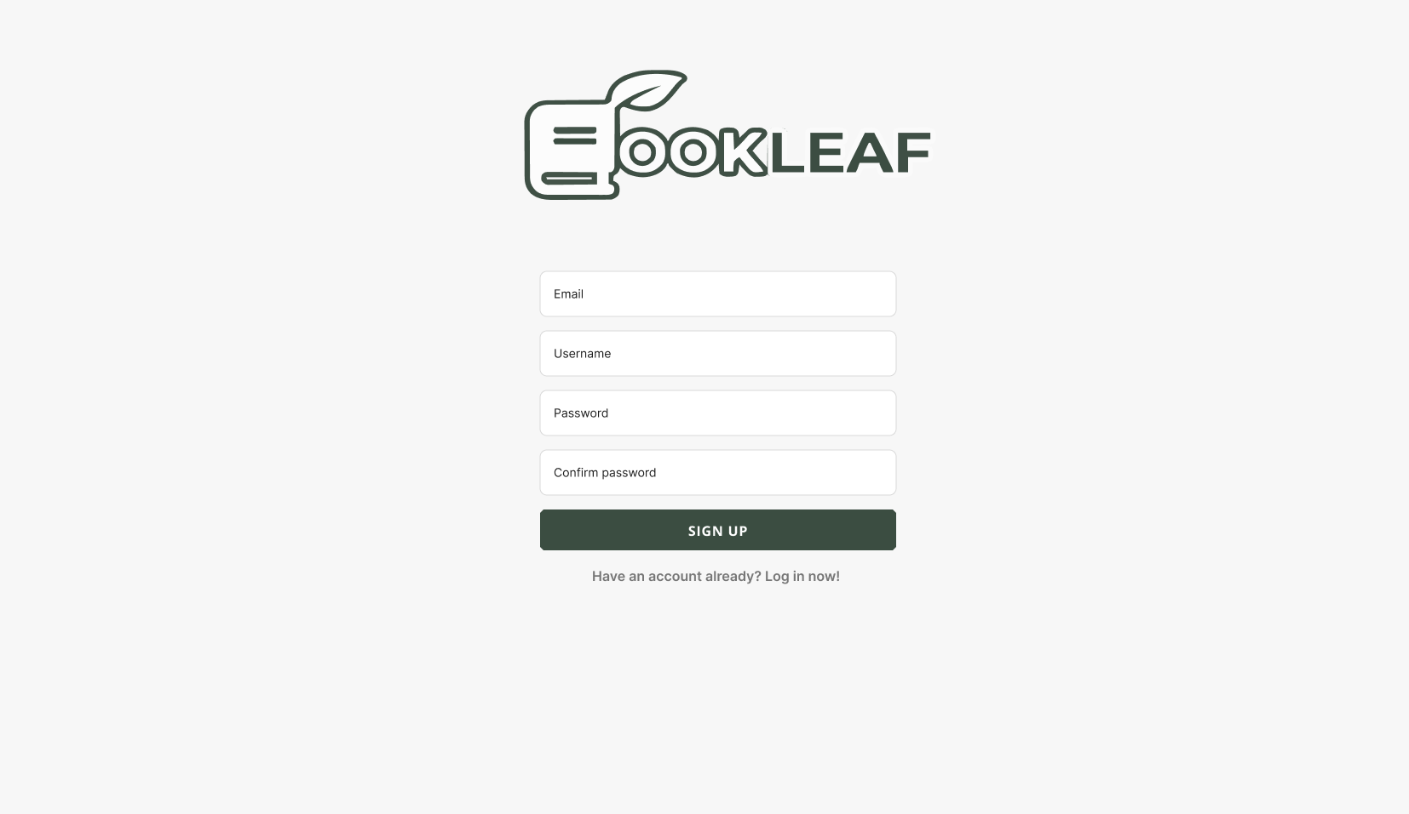

* The Sign Up screen consists of 4 inputs, which are email, username, password and password confirmation. This allows the system to verify credentials of the user in the most concise and consistent manner, with regards to least information requirement .
* If the username is selected, an error message will be displayed.
* Users could go back to the login screen by clicking the redirect statement in the bottom.
* After registering, the user will be redirected to the Login page.

## Log In

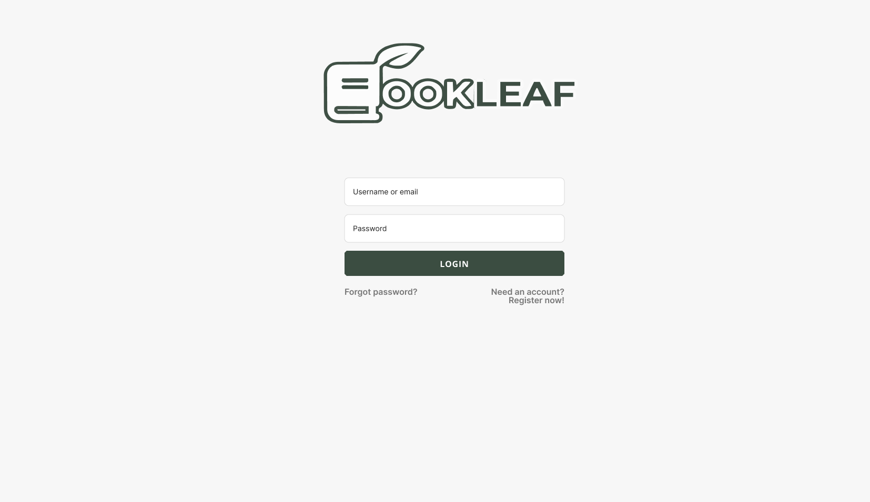

* The Login page allows the User or non-User to enter their account credentials (username and password) for logging into the Bookleaf system, if the account credentials are wrong or not in the database, the user will not be granted access to the system and an error message is displayed. Else, the user is then redirected to the main page with their data.

## Reset Password

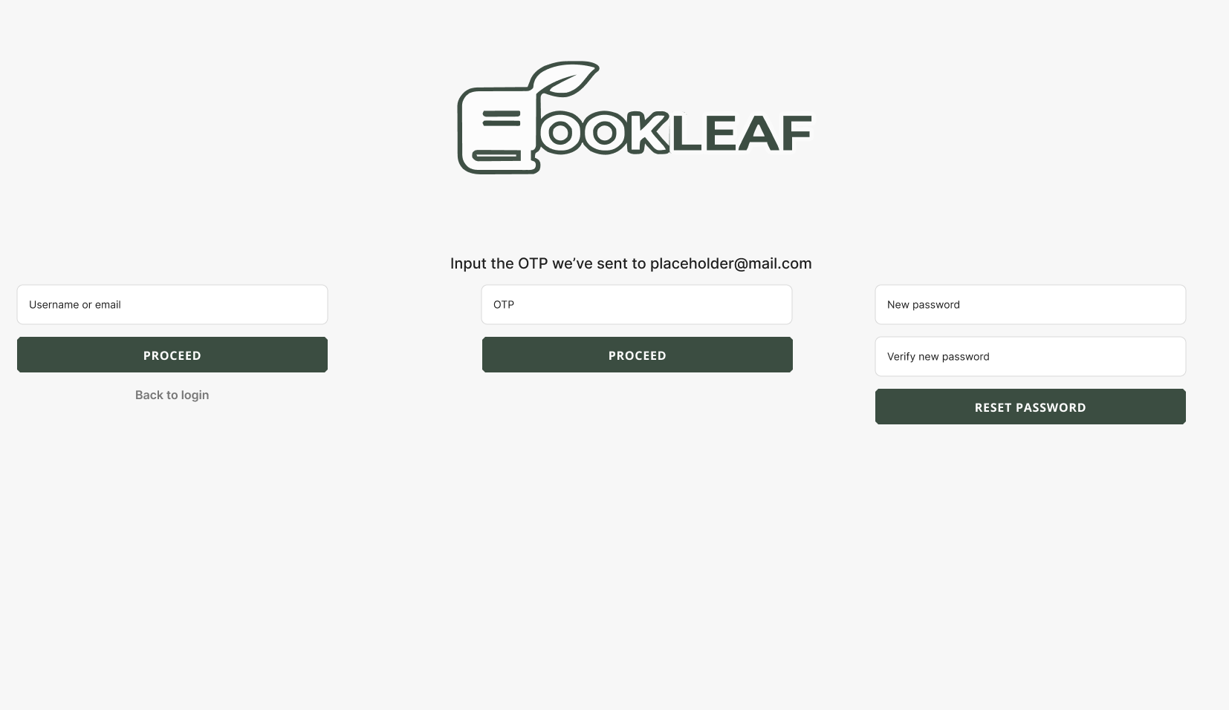

* Allows the user to change their password through the secured method of verification code (sent through email that the user registered with), upon input the username, new password and new password verification, the verification code (correct and not expired). The database will be updated with the new password for that user.

## Reading page

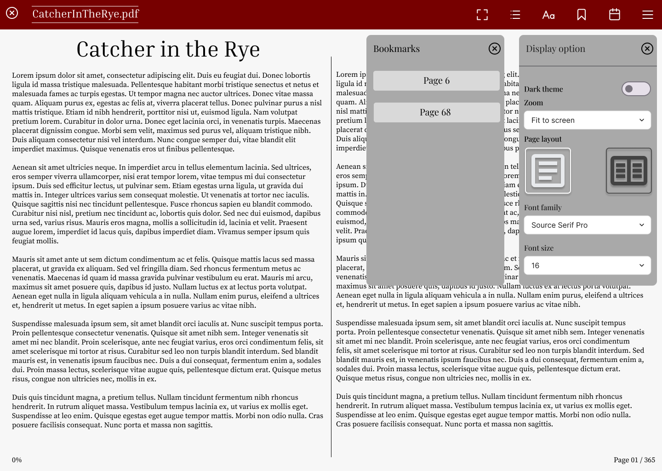

### **Overview**

Users can access a book's reading page through interacting with the card in the main page or using HTTP GET requests using the book’s ID.

### **Features and Designs**

**Hamburger menu (top right):**

* **Bookmark:** Bookmark the current page, then render a message, either success or error, in the form of toast.
* **Display option**: options to change theme, font, font size, font weight, layout option, zoom option and line height. Open a sub menu on click.
* **Annotation**: open a sub menu that stores saved annotations and their page.
* **Full-screen mode**: read the document in fullscreen for distraction-free experience.

**Chapter selection menu (side menu):** allow the user to view a list of chapters of the book, select a chapter and migrate to that chapter.

**Main reading page(center):**

* Display the content of the reading page, in two-pager layout by default separated by a divider, the user can navigate through the pages using either next and previous arrows or using left and right arrow-buttons on the keyboard.
* Also displays the current reading page and the progress user made.

## User Profile

### Libraries

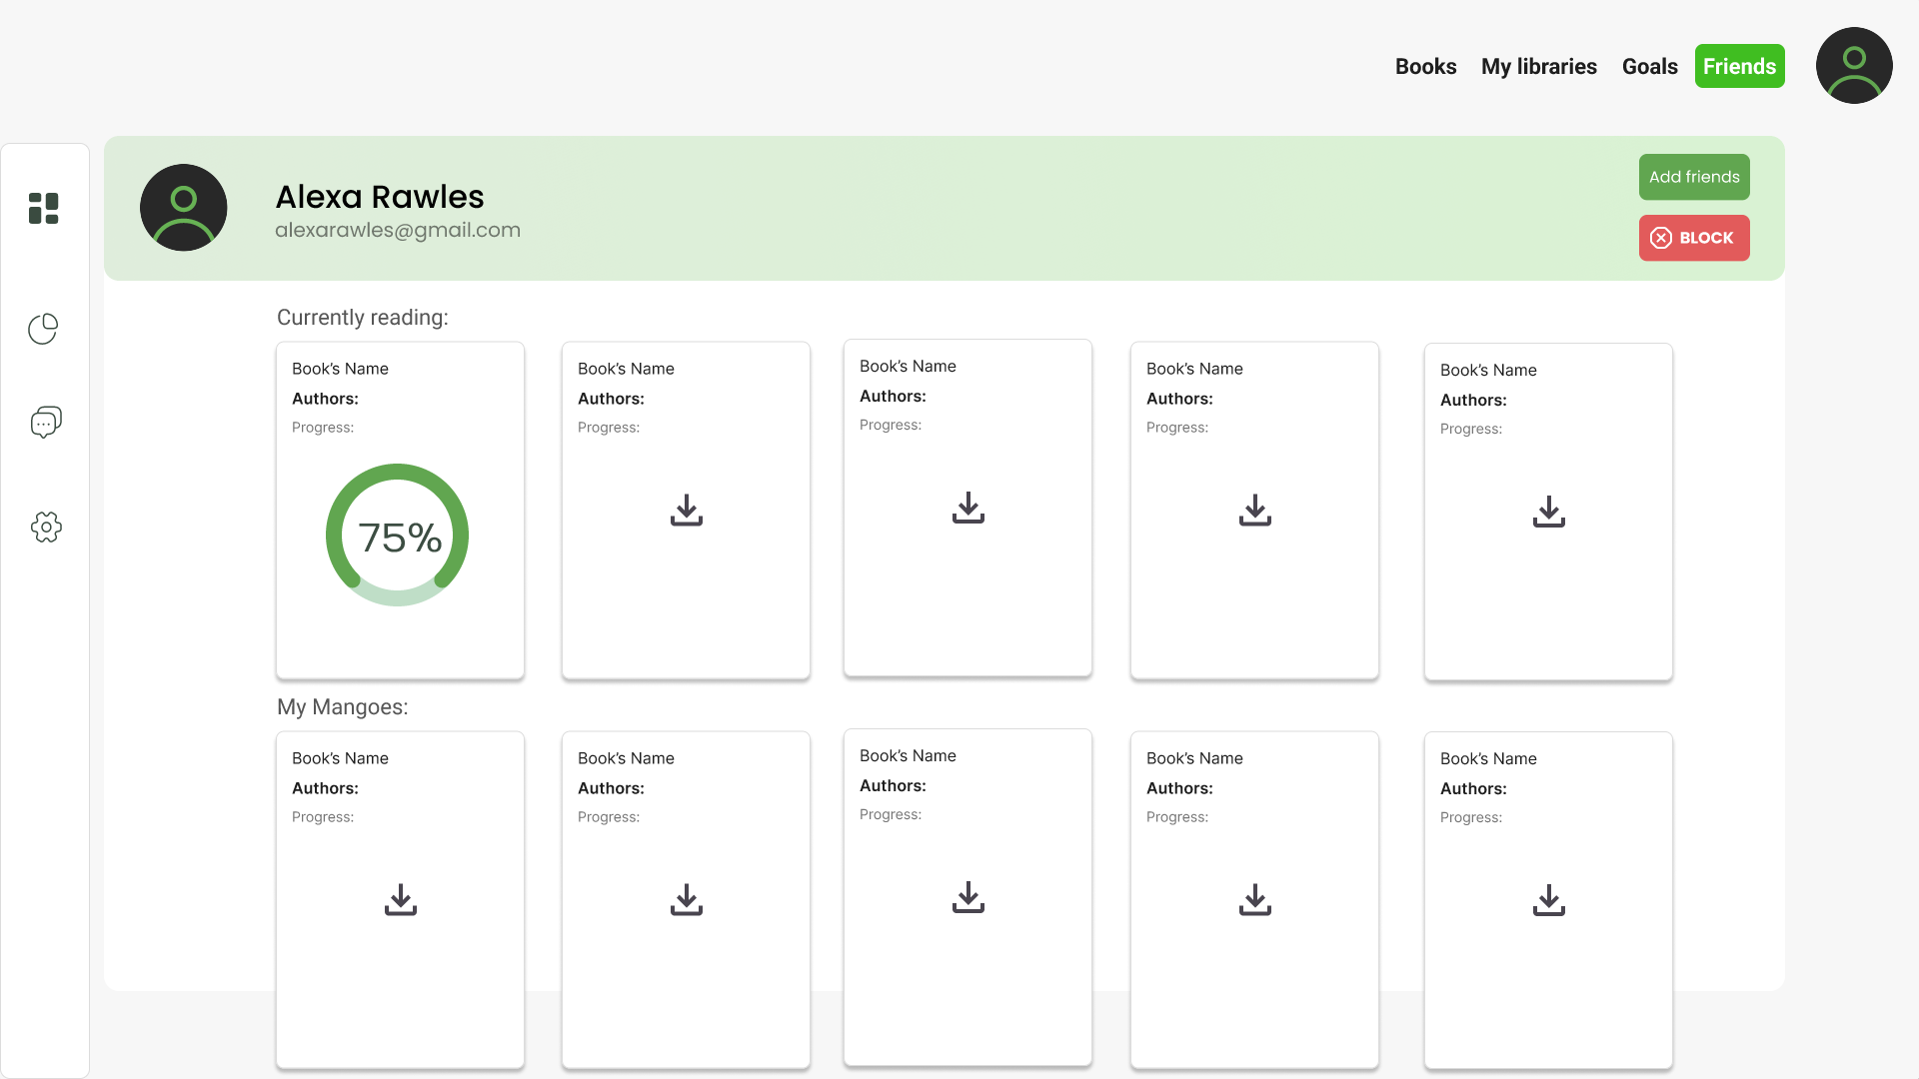

### Reading Time Analytics

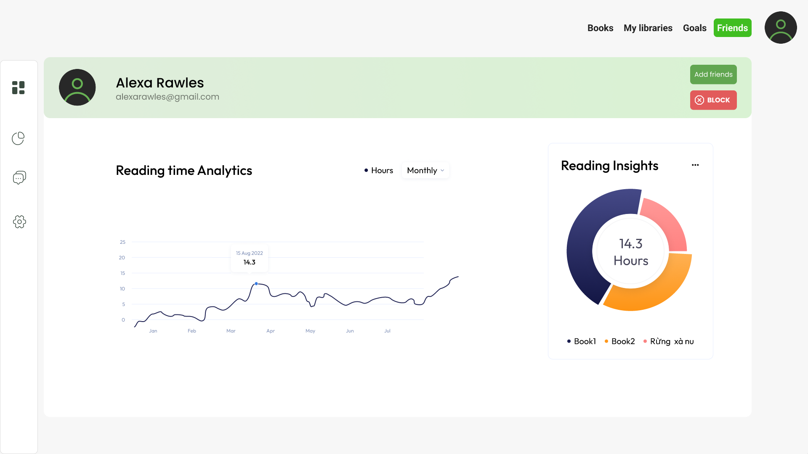

### Information

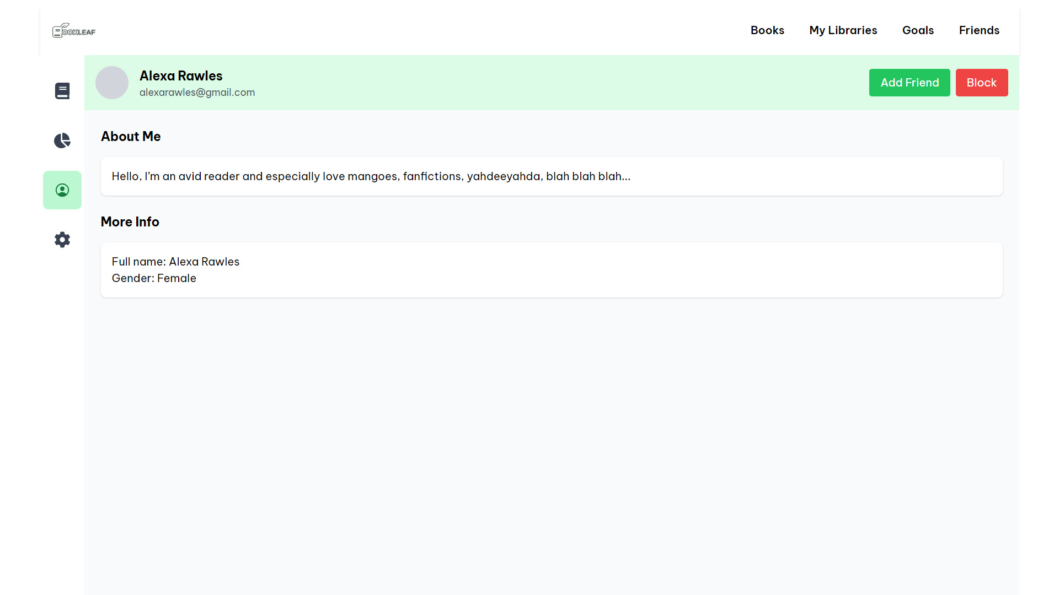

### Account Management

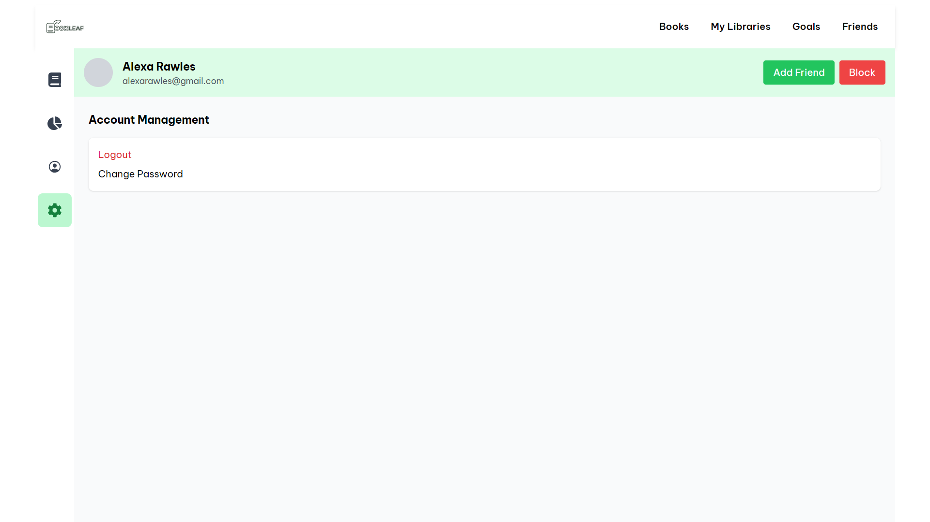

## Overview

Users can access and manage their User Profile, containing info such as: Data Analytics, User Bio, Account Management and Settings

## Features and Designs

**Top Navigation Bar:**

* **Menu Options**: Provides quick access to Books, My Libraries, Goals, and Friends.
* **Profile Menu**: Clicking the user icon in the top-right corner reveals options for account management, changing passwords, and logging out.

**Left Sidebar:** Allow user(s) to access specific information of their account. Listing from top to bottom, the information mini tabs are

* **Books view**: Displays a list of the User’s books library, may include sections such as: “Currently Reading”, custom books libraries, **other Book Cards objects, etc.**
* **Reading Time Analytics**: Users see their reading time throughout the year on analytics charts here under a pie chart (individual book reading time) and a time-series (reading time as a whole).
* **About me**: Contain more public information about the user (interests, email, etc.)
* **Account Management**: Where the user can change information about their profile (email, password, username, etc.) or logout.

## Admin Views

***[HOLD UNTIL THE PA5]***

### Create an admin account

### See overview analytics

### Navigate to a normal user profile

### View their books, monitor their reading progress

### Monitor their session

### Delete a normal user’s account