DATA DRIVEN INSIGHTS INTO ANXIETY DISORDERS

Chandni Kumari
Department of Computer Science KLE Technological University Belagavi, India 02fe22bcs026@kletech.ac.in
Wilfred Antonio Borges
Department of Computer Science
KLE Technological University
Belagavi, India
02fe22bcs177@kletech.ac.in
Prashant Uppar
Department of Computer Science
KLE Technological University
Belagavi,India
02fe22bcs069@kletech.ac.in
Yukta Sannaki
Department of Computer Science
KLE Technological University
Belagavi,India
02fe22bcs179@kletech.ac.in

Abstract—Anxiety disorders are common mental health problems that can seriously affect people's lives. Predicting these disorders early can help to provide timely support and treatment. This project explores how to use Exploratory Data Analysis (EDA) and data cleaning to make better analysis of anxiety levels. We studied different methods for handling missing data, feature scaling, and data visualization using one well-known anxiety disorder dataset. The goal is to analyse the data and understand the Trends.
Keywords: Data pre-processing, healthcare, exploratory data analysis, anxiety disorder.
- INTRODUCTION
In today’s human-powered society, disorders like anxiety, stress and depression are very commonly rolling out. It’s even conceivable to claim that they are now a constant in our lives. They make up the largest group of mental diseases and become oppressive for both society and the individual. Many of the patients who are suffering from these disorders are experiencing physical symptoms, and according to the World Health Organization (WHO), anxiety is the most common mental condition, affecting more than 300 million people globally. As claimed by the Diagnostic and Statistical Manual of Mental Diseases, disorders with excessive fear and associated behavioral problems are included in the category of anxiety disorders. Generalized anxiety disorder(GAD) involves worrying etc like these attributes are there in our dataset. They all fall under several types of anxiety disorders, and each types has its own set of symptoms. Sometimes the person can also become addicted to drugs and alcohol consumption, which leads to many risk factors and complications. The National Comorbidity Survey (NCS) and Epidemiological Catchment Area (ECA) studies in the United States, along with comparative studies in other nations, provided important data on the prevalence and burden of conditions and showed that anxiety disorders were the most common class of psychiatric disorders.
Anxiety disorder analysis is a very difficult and tough undertaking. So, it is important to take caution when diagnosing them.
EDA is the first step in working with data. It helps us to understand the structure and main features of the data by using various statistical methods and visualization techniques. EDA also helps in finding missing values and outliers—unusual data points that can affect the accuracy of our predictions if not handled properly.
Data pre-processing, on the other hand, is about cleaning and preparing the raw data so it can be used for analysis. Raw data often has noise, inconsistencies, and missing values, which can make it difficult to analyze directly. Key part of data pre-processing is handling missing values. If missing values are not addressed correctly, they can lead to errors in the analysis. Therefore, using effective methods to fill in missing data, known as imputation, is essential to maintain the dataset’s accuracy.
This project focuses on the pre-processing, especially on how to handle missing values using EDA and data pre-processing methods. It looks at different imputation strategies, such as using the mean, median, most frequent value, constant values, etc to see which ones work best in various situations. By exploring these methods, the project aims to find the best combination of data pre-processing techniques, which will improve the accuracy of disease analysis.

RELATED WORK
We have surveyed some reports of different authors. The authors named Shiekh Afaan Farooq, Ojasri Konda, Anshul Kunwar, Navmi Rajeev found accuracy like KNN-92%, RandomForest-96%,LogisticRegression-93% based on their dataset([1]).

In [2], Vidit Laijawala,Aadesh Aachaliya, Hardik jatta and Vijaya Pinjarkar, after implementing various ML algorithms, they found accuracy like Decision Tree-82.2%, Randon Forest-79.3%, Logistical Regression-81.4%, OneR-82.1%,Naive Bayes-78.7%, NNge-75.8% based on their dataset.

In [6] Guna Sekhar Sajja, he found accuracy like SVM-94%, Random forest-78%, Naïve Bayes-76% based on their dataset.

But in our project we are not implementing ML algorithms.
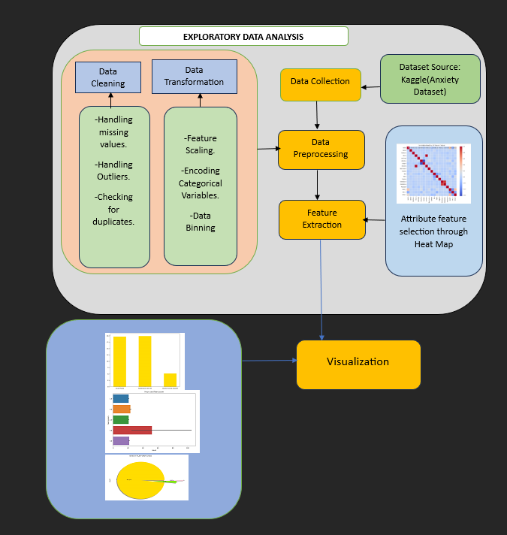

Fig.1. Data Flow of our project
In our project, first we collected anxiety dataset from Kaggle. Applying data cleaning and data pre-processing we have handled missing values,outliers, checked for duplicates. Then in Data transformation, we have done feature scaling, encoding of categorical attributes.Then through Heat Map, we have done feature selection . In Data Visualisation, we have done work on hypothesis considering Narcissism as our target variable.

III. dataset description and preprocessing
In this paper, we used the dataset provided on Kaggle. This dataset is about the anxiety due to playing game on different platforms. The dataset has 13464 data(rows) and 55 features(columns). 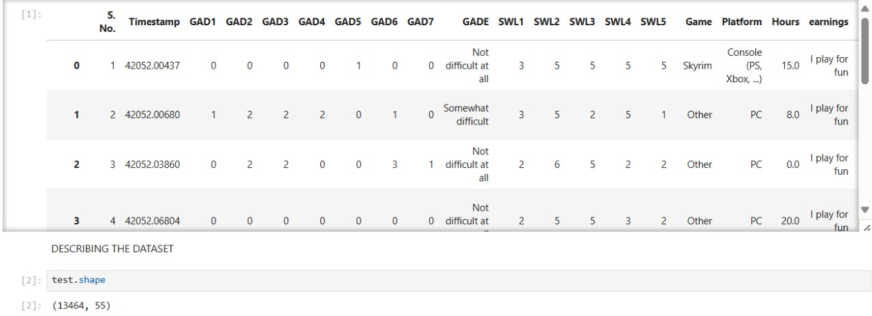
Fig.2. Dataset description

Column Name | Column Description
Timestamp | Data that indicates the date and time at which a particular event occurred. In gaming context, it includes measuring performance and providing gameplay data.
GAD(Generalized anxiety disorder) | Mental health condition characterized by persistent and excessive worry or anxiety about a wide range of everyday things.
GADE | To look at (level of difficulty).
SWL(Satisfaction with life) | This refers to an individual’s self-reported evaluation of their own wellbeing, encompassing factors such as life satisfaction, positive emotions and sense of purpose.
Game | Name of a game patient used to play that led to issues.
Platform | Refers to a digital or physical environment where individuals can engage in playing video games.
Hours | Time Duration of game played.
Earnings | refers to the income or profits generated by individual through game
Whyplay | Reason to play the game
League | Earn in-game currency and experience points by participating in game.
HighestLeague | refers to the top division or tier within a ranking system of the game.
Streams | Often refers to live broadcasts of video game play by an individual.
SPIN | Feeling mentally unclear or confused.
Narcissism | Mental health condition in which patient have an unreasonably high sense of their own importance.
Gender | Gender of the participant.
Age | Age of the participant.
Work | Employment status or occupation of the participant.
Degree | Educational degree attained by the participant.
BirthPlace | Place of birth of the participant.
Residence | Current place of residence.
Reference | Source of reference or how the participant was recruited.
Playstyle | Style or approach to gaming by the participant.
Accept | Acceptance of the gaming lifestyle or culture of the participant.
GAD_T | Total score or evaluation from the Generalized Anxiety Disorder assessment.
SWL_T | Total score or evaluation from the Satisfaction with Life scale.
SPIN_T | Total score or evaluation from the SPIN scale.
Fig.:Table1

Data Distribution
The data distribution of our dataset :
Uniform: Timestamp
Positively Skewed: ( GAD1 - GAD7 ) , ( SWL1 - SWL5 ) ,
(SPIN1- SPIN17), Narcissism, Age, GAD_T.
Normally distributed: SPIN_T

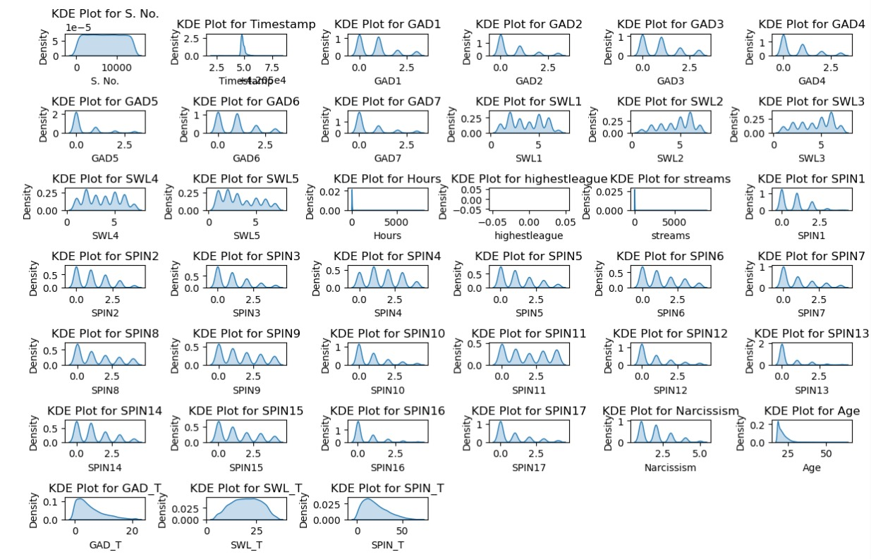
Fig.3.Distribution of the data
From the above fig.3., we understand that most of the attributes are positively skewed.

Handling Missing values

An essential step in data pre-processing is the correction of inaccurate and incorrect data within the dataset. Handling missing values appropriately is crucial and the optimal approach depends on the specific dataset and the desired outcomes. Several fundamental techniques are commonly employed to address missing values:

Identifying Missing Values: Initially, the null values in each attributes are identified. If a column contains more than 80% null values, it is typically dropped from the dataset.

Skewness Analysis: A skewness plot is generated to analyze the distribution of the data. Based on this analysis, missing values can be filled using the mean, median, or mode.

Handling Different Types of Data:
Nominal, Discrete, and Categorical Data: Missing values in these attributes are filled using the mode.

Ordinal Data: Missing values in ordinal attributes are filled using either the mean or median.

Continuous Data: For continuous attributes, the method of filling missing values depends on the skewness of the distribution. If the data is positively skewed, the mean is used. If the data is negatively skewed, the median is used.

Null Counts of each attributes:

Attributes | Null_Count
Timestamp | 0
GAD1 | 0
GAD2 | 0
GAD3 | 0
GAD4 | 0
GAD5 | 0
GAD6 | 0
GAD7 | 0
GADE | 649
SWL1 | 0
SWL2 | 0
SWL3 | 0
SWL4 | 0
SWL5 | 0
Game | 0
Platform | 0
Hours | 30
Earnings | 0
Whyplay | 0
League | 1852
Highestleague | 13464
Streams | 100
SPIN1 | 124
SPIN2 | 154
SPIN3 | 140
SPIN4 | 159
SPIN5 | 166
SPIN6 | 156
SPIN7 | 138
SPIN8 | 144
SPIN9 | 158
SPIN10 | 160
SPIN11 | 187
SPIN12 | 168
SPIN13 | 187
SPIN14 | 156
SPIN15 | 147
SPIN16 | 147
SPIN17 | 175
Narcissism | 23
Gender | 0
Age | 0
Work | 38
Degree | 1577
Birthplace | 0
Residence | 0
Reference | 15
Playstyle | 0
Accept | 414
GAD_T | 0
SWL_T | 0
SPIN_T | 650
Residence_ISO3 | 110
Birthplace_ISO3 | 121
Fig.:Table2

After filling null values:
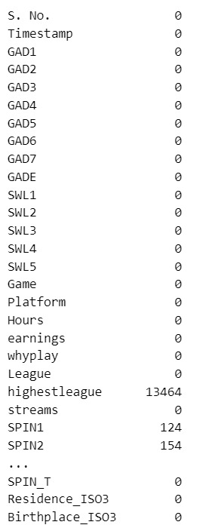
Fig.4. After filling null values

Skewness after filling null values:

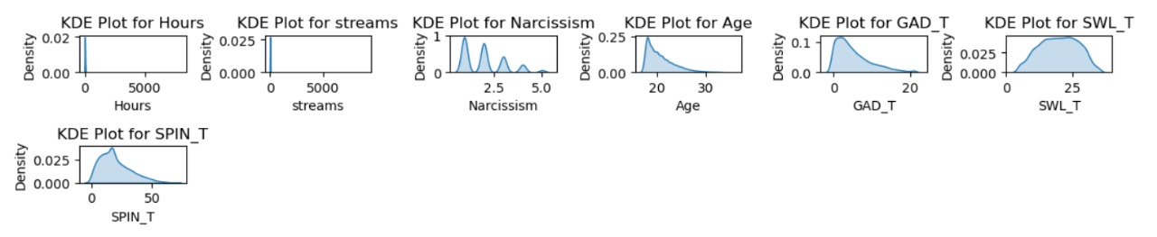
Fig.5. Skewness

Dropping Unnecessary Columns: Since the target variable is Narcissism, certain columns that are not required for analysis are dropped. These columns include:

Serial no.
Timestamp
Highest league
Residence_IS03
Birthplace_IS03
Reference
Accept

Additionally, columns associated with specific assessments are dropped because their total scores are available, making the individual item responses redundant. These columns are:
Generalized Anxiety Disorder (GAD1-GAD7)
Satisfaction with Life (SWL1-SWL5)
Social Phobia (SPIN1-SPIN17)

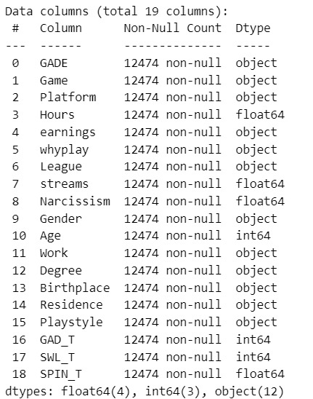
Fig.6. Total columns after dropping unnecessary columns

Handling Outliers
As outliers are less in the attributes of our dataset, we can directly delete it. As they are not influencing much to our dataset.
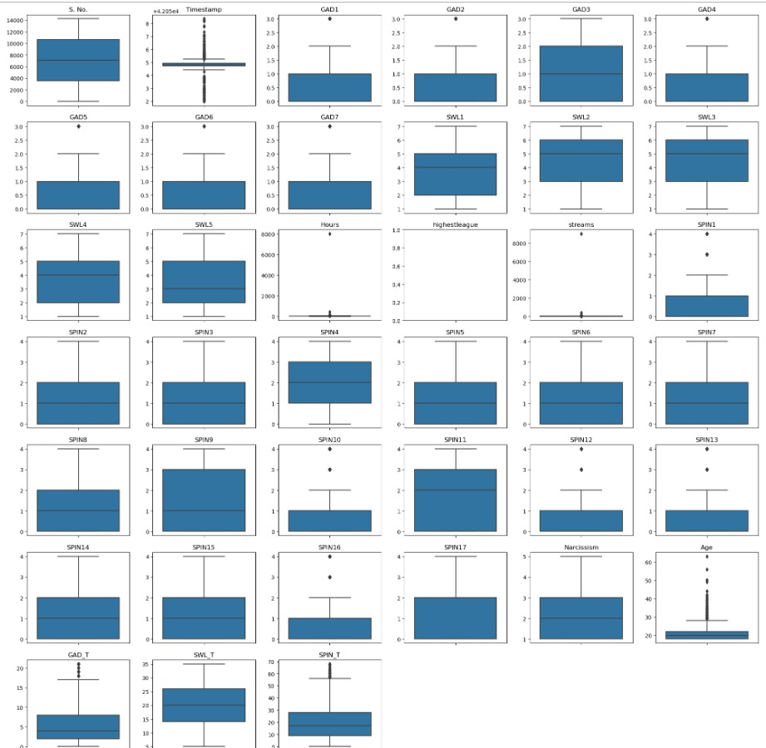
Fig.7. Box plot before removing outliers

After removing outliers, there are some attributes with outliers as shown below in fig.7. and we can’t remove or fill with null values, it will change the trend of our data. So, we are keeping these attributes as it is, if we fill it with null values, it will lead to overfitting of data.
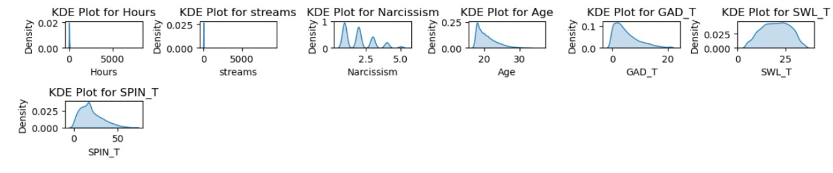
Fig.8. After removing outliers

Standardization/Normalization/String Processing
In the Categorical data attributes like whyplay, earnings, league we have lot of noise and more number of unique values so we go for binning method based on particular pattern match . Then we selected only top 3 or 5 highest frequency indices for the analysis.

After that we applied label encoding for all the attributes.

Game:
Name of game | No. assigned
Counter strike | 0
Destiny | 1
Diablo3 | 2
Guild war2 | 3
Heart stone | 4
Heroes of strom | 5
League of legends | 6
Other | 7
Skyrm | 8
Starcraft | 9
World of warcraft | 10
Fig.:Table3

Platform:
Platform Used | No.assigned
Console | 0
PC | 1
Smartphone or Tablet | 2

Fig.:Table4

Playstyle:
Playstyle | No. assigned
Multiplayer offline people in the same room | 0
Multiplayer online with online acquintances or teammates | 1
Multiplayer online with real life friends | 2
Multiplayer online with strangers | 3
singleplayer | 4
Fig.:Table5
GADE:
GeneralizedAnxiety disorder | No. assigned
Extremely difficult | 0
Not difficult at all | 1
Somewhat difficult | 2
Very difficult | 3
Fig.:Table6

Gender:

Gender | No. assigned
Female | 0
Male | 1
Other | 2
Fig.:Table7

Degree:
Player’s qualification | No. assigned
Bachelor(or equivalent) | 0
High school diploma(or equivalent) | 1
Master(or equivalent) | 2
Ph.D.,Psy.D.,MD(or equivalent) | 3
Fig.:Table8

Work:
Work | No. assigned
Employed | 0
Student at college / University | 1
Student at school | 2
Unemployed / between jobs | 3
Fig.:Table9

Earnings:
Purpose of playing | No. assigned
I earn a living by playing this game. | 0
I paly for fun | 1
I play mostly for fun but earn a little on the side tournament winnings , streamings etc. | 2
Fig.:Table10

Whyplay:
Reason for playing | No. assigned
Having fun | 1
Improving | 2
Relaxing | 3
winning | 4
All of the above | 0
Fig.:Table11

League:
Ranking | No. assigned
Bronze | 0
Challenger | 1
Diamond | 2
Gold | 3
Master | 4
Platinum | 5
Silver | 6
Unranked | 7
Unspecified | 8
Fig.:Table12

Correlation Matrix
The correlation coefficient ranges from-1 to 1.
1 represents positive correlation.
-1 represents negative correlation.
0 means no correlation.

Color represents correlation values.
Higher the color, stronger the correlation.

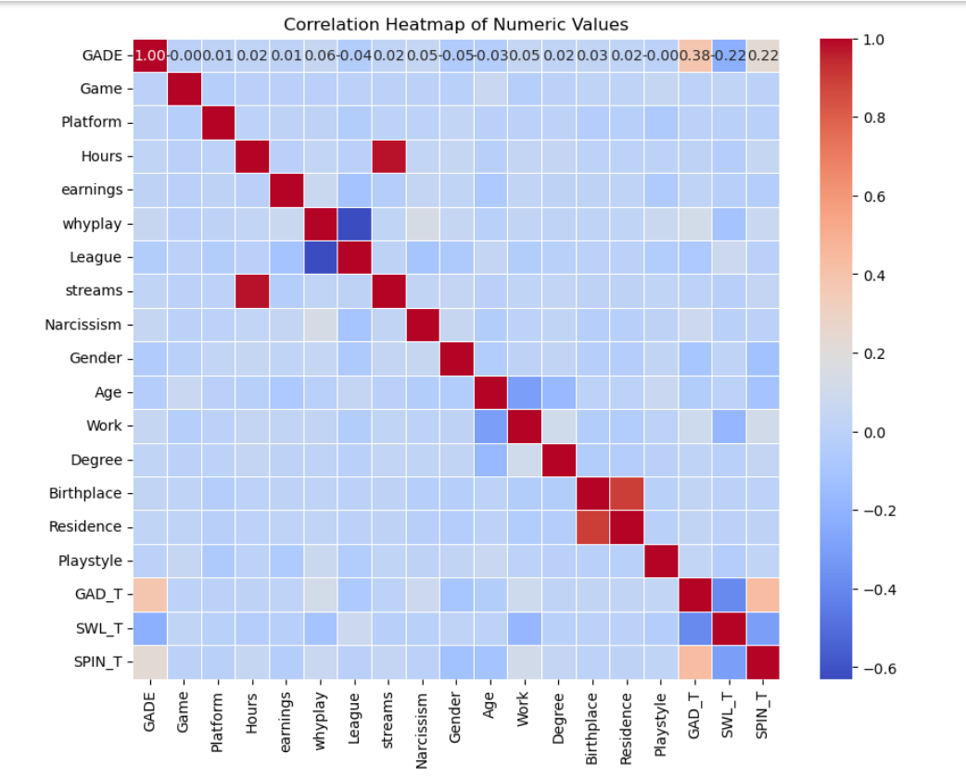
Fig.9.Heat map
From the above fig.9., we analyzed that Streams and Hours have high correlation(Positive) . And SPIN and SWL have less correlation(Negative).

IV.Exploratory data analysis

A. Univariate Analysis
Univariate analysis is all about knowing the data distribution, which value is appeared frequently etc.
For these we are using Pie chart, Count plot, histograms, box plots, violin plots.

Hpothesis1: Which platform is more used by players?

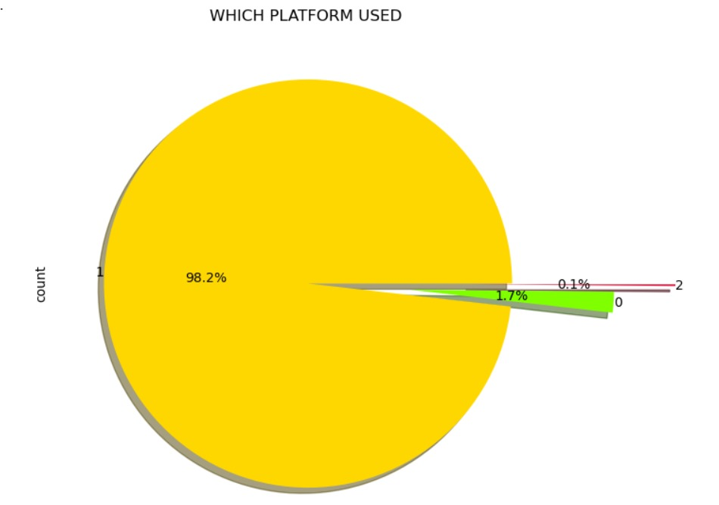
Fig.10. Pie chart of platform used
From the above fig.10., we can say that the mostly used platform is 1(i.e,PC).

Hypothesis2: Which is mostly played game?

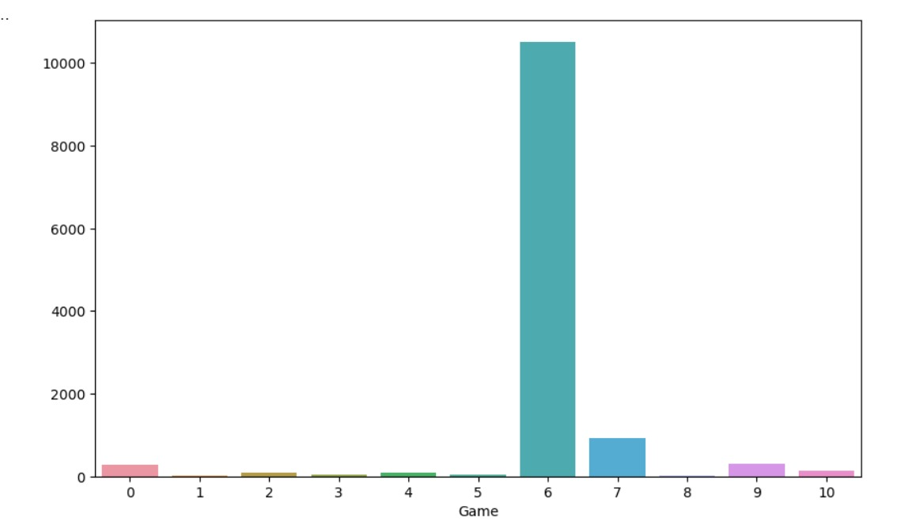
Fig.11.Barplot of mostly played game
From the above fig.11., we can say that the mostly played game is 6(i.e.League of legends).

Hypothesis3: How gender is distributed?

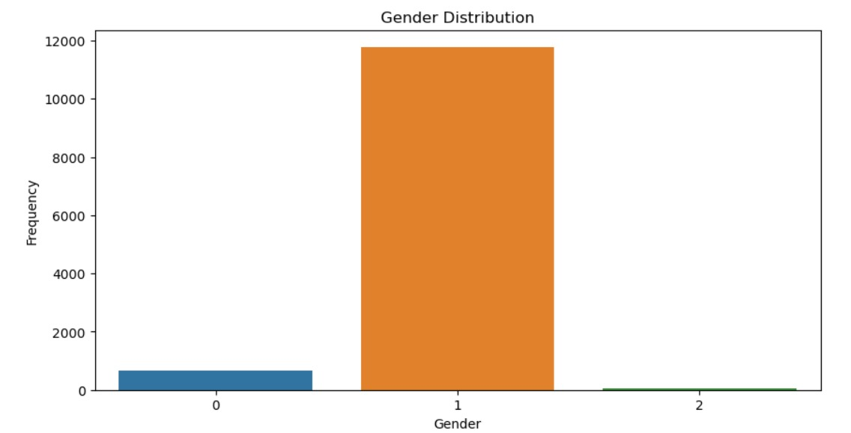
Fig.12.Count plot of gender distribution
From the above fig.12., we can say that the players who are playing game are mostly males(1).

Violin plot for the univariate analysis:
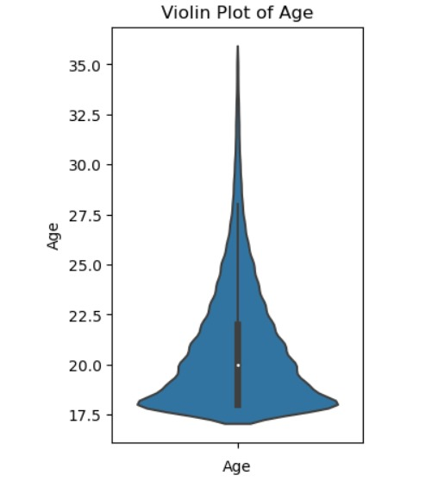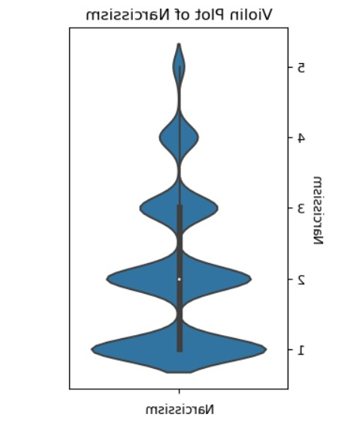
Fig.13.(a). Fig.13.(b)
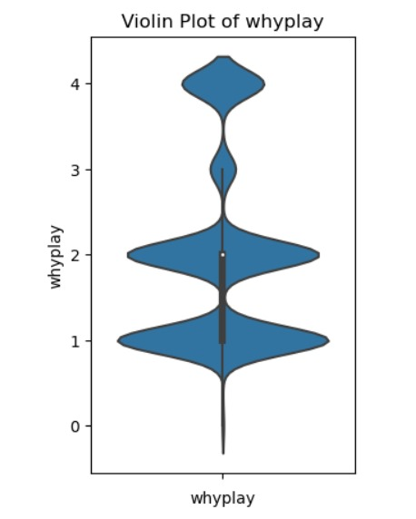
Fig.13.(c)

From the above Figures, we can infer that Students playing game are near to age 20 and Narcissism level is 1 and majority players are playing game for fun.

Bivariate Analysis
Hypothesis4: How satisfaction with life is related with social phobia?
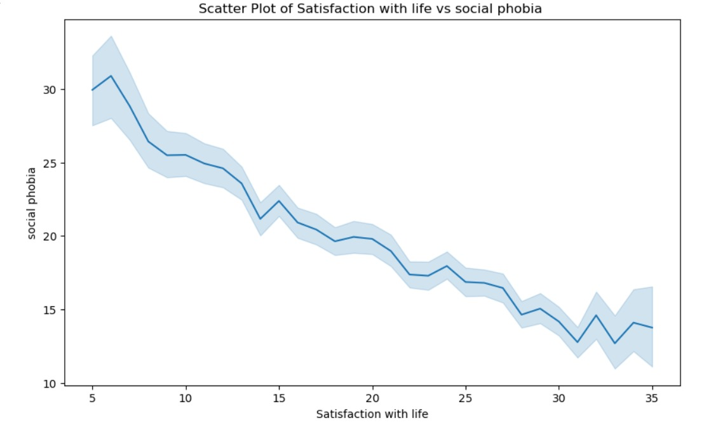

Fig.14. Lineplot
From the above fig.14., We can say that social phobia and satisfaction with life is inversely proportional to each other. As social phobia increases satisfaction with life decreases.

Hypothesis5: How Narcissism will affect the generalized anxiety disorder effect on students?

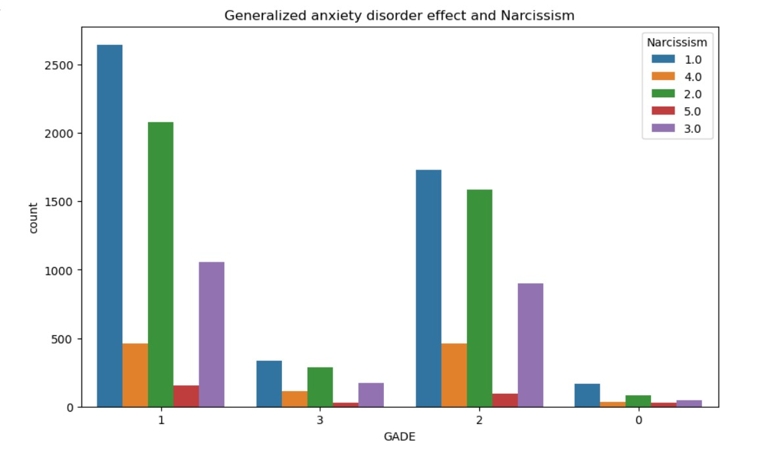
Fi.g.15.Count plot
From the above fig.15., we can say that anxiety disorder not at all difficult with Narcissism level of 1.

Hypothesis6: How Narcissism will affect the game played by students?
`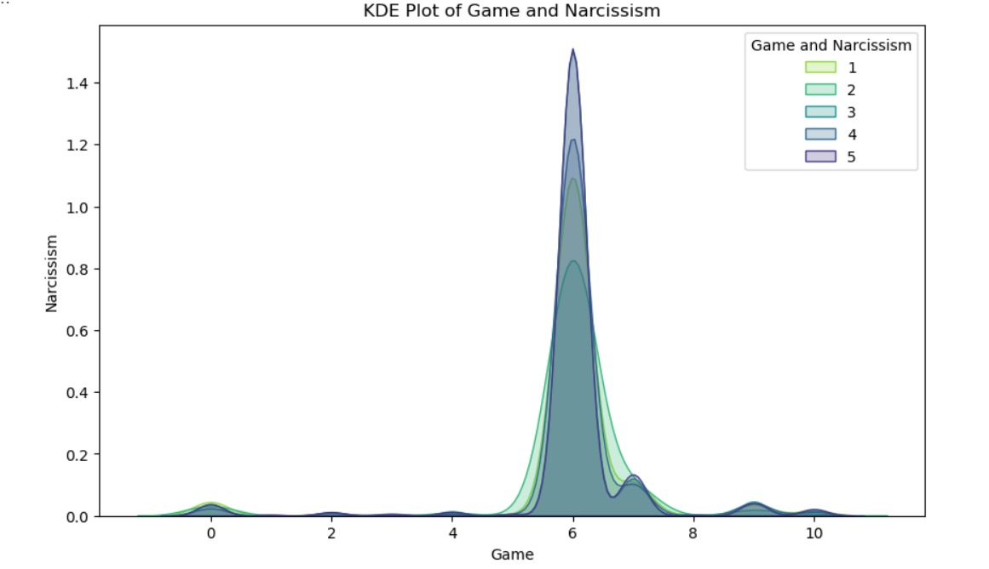
Fig.16. Kde Plot
From the above fig.16., we can say that majority of the players plays league of legends with Narcissism level of 3.

Hypothesis7: How Narcissism will affect the platform used for gaming?
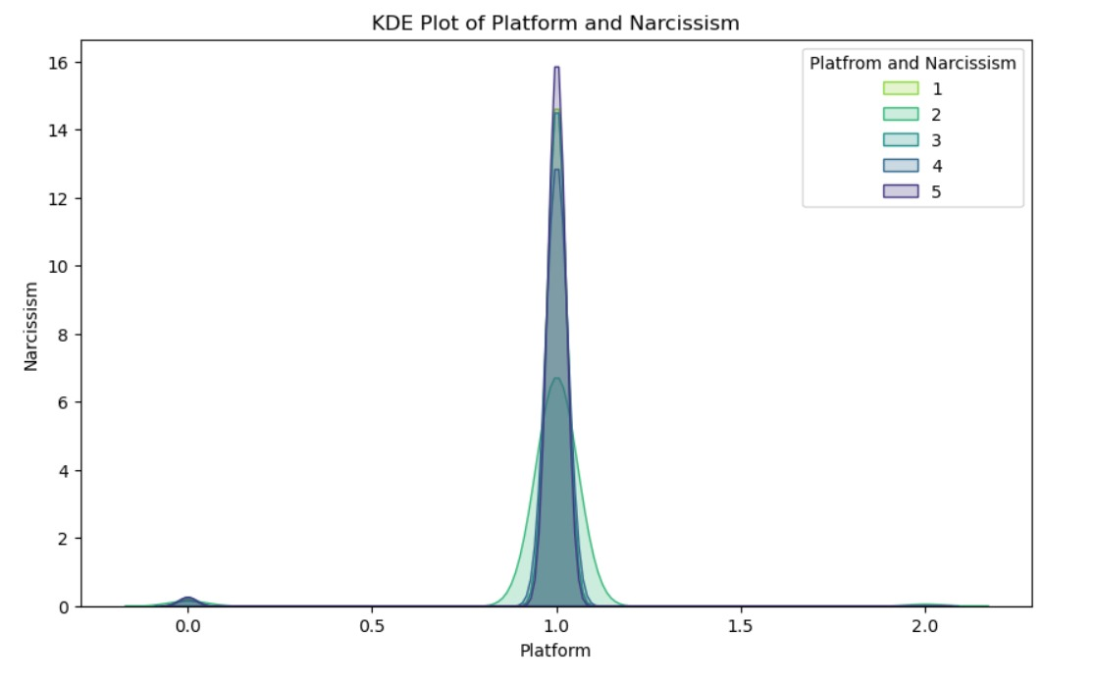
Fig.17. Kde plot
From the above fig.17., We can say that majority of the students plays on the PC(1) with Narcissism level of 2.

Hypothesis8: How Narcissism will affect the no. of hours spent playing game?
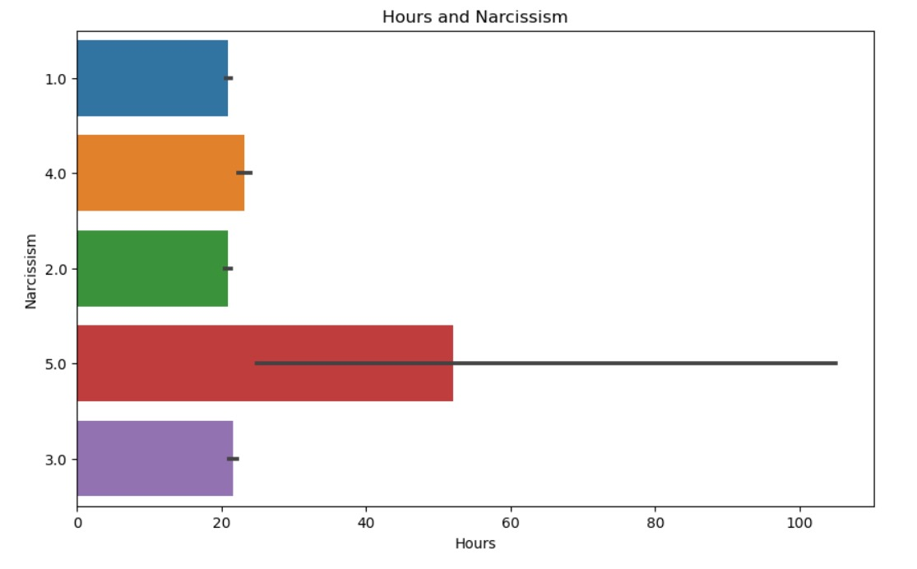
Fig.18. Barplot
From the above fig.18.,we can say that as no. of playing hours increases Narcissism level also increases.

Hypothesis9: How Narcissism will affect the whyplay of the game by students?

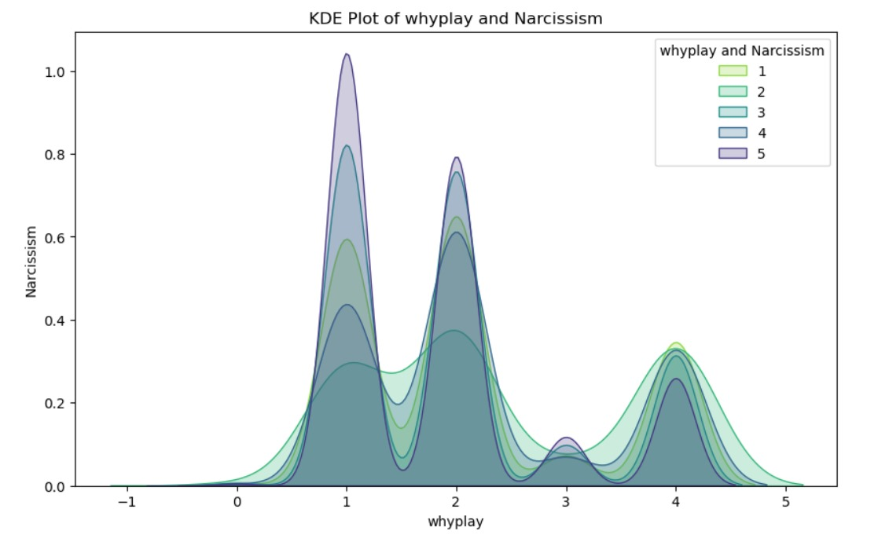
Fig.19.Kde plot
From the above fig.19., we can say that most of the students playing game for fun, improving and winning with narcissism level of 2.

Hypothesis10: How degree is related to Narcissism?

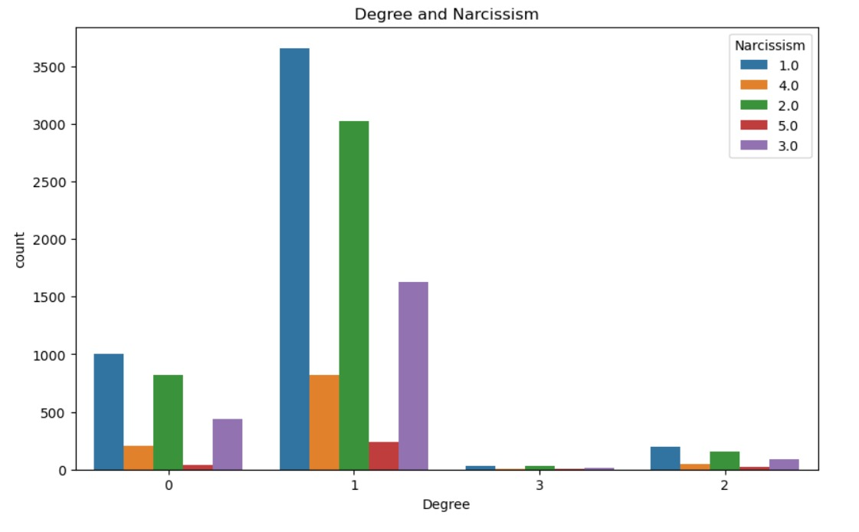
Fig.20.Count plot
From the above fig.20., We can say that majority of the players have degree high school diploma with narcissism level 1.

Hypothesis11: How Narcissism will affect the League?
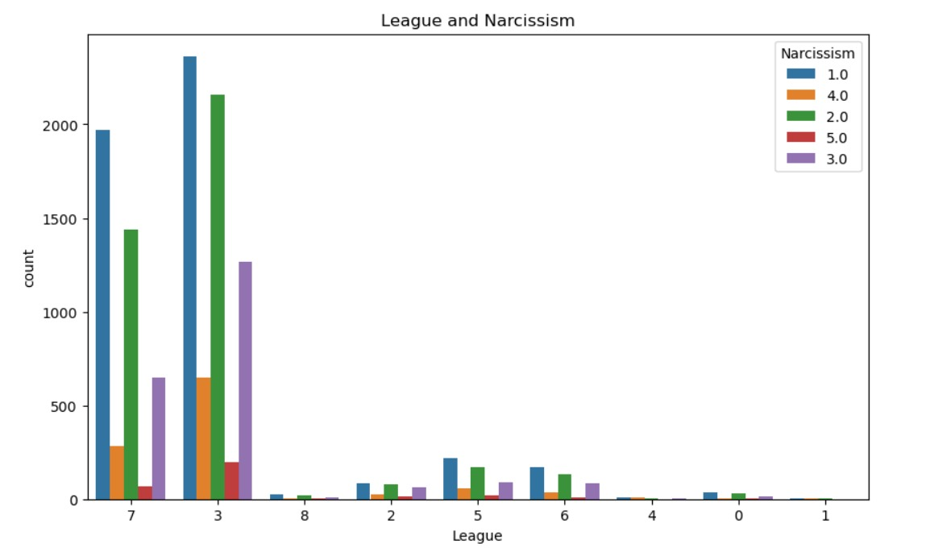
Fig.21.Count plot

From the above fig.21., we can say that most of the students got gold, platinum and some are unranked with an average narcissism level of 3.

Hypothesis12: How age is related to Narcissism?
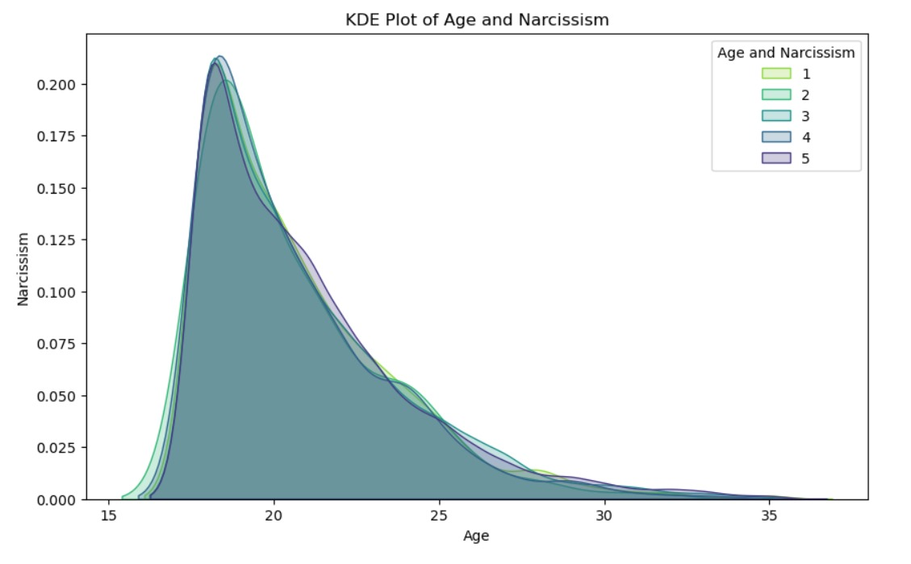
Fig.22.Kde plot
From the above fig.22., we can infer that majority of the students playing game are near to age 20 with narcissism level of 2&4.

Hypothesis13: Which is most streamed game based on hours?
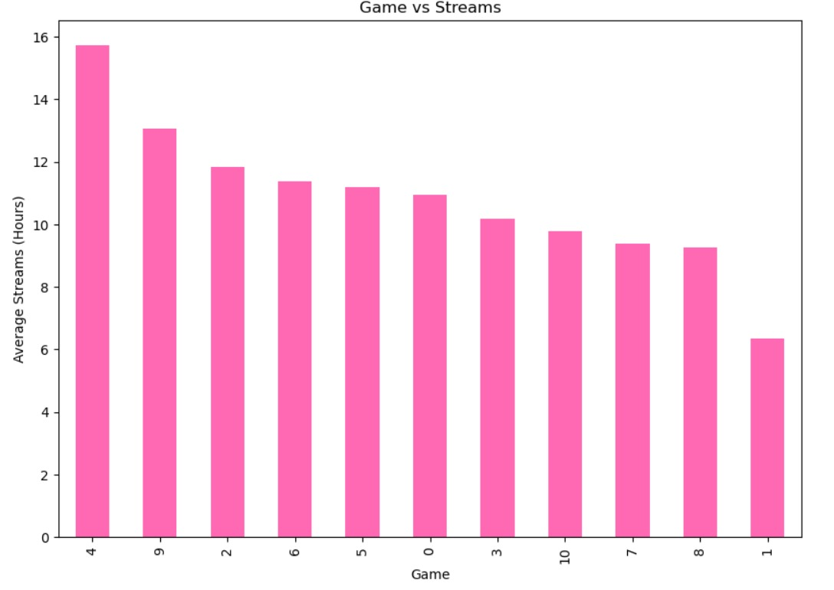
Fig.23. Bar plot

From the above fig.23., we can say that students playing heart stone spent more time in live streaming.

Hypothesis14: How generalized anxiety disorder is related to social phobia?
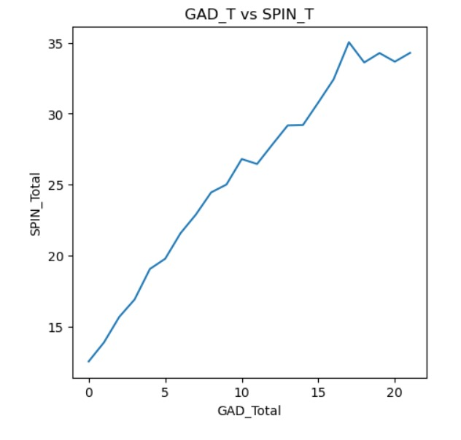
Fig.24. line plot

From the above fig,18., we can say that generalized anxiety disorder is directly proportion to each other and having high positive correlation.

Hypothesis15: How Narcissism is affected by playstyle?

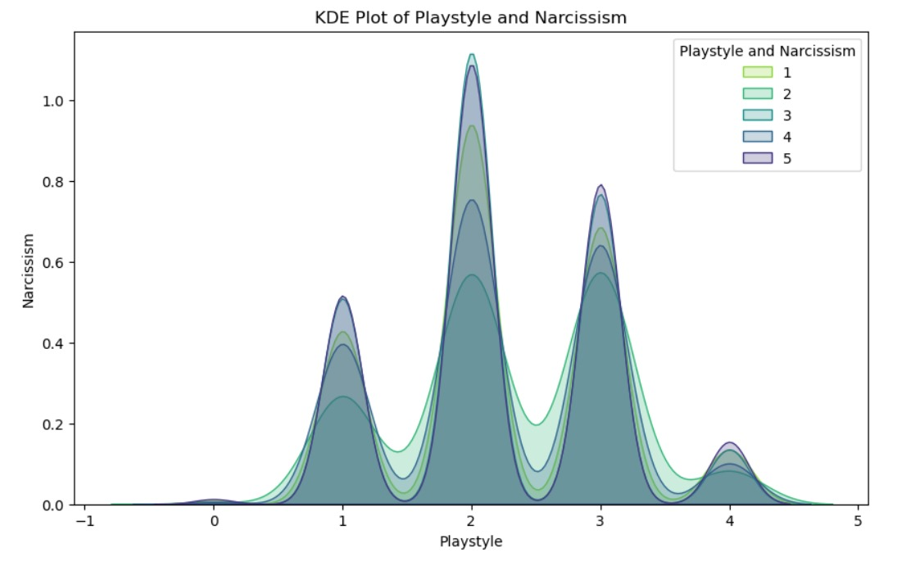
Fig.25.Kde plot

From the above fig.25., We can say that most of the players plays online with friends and strangers with narcissism level of 2.

Hypothesis16: How no. of hours related to no of hours streamed?
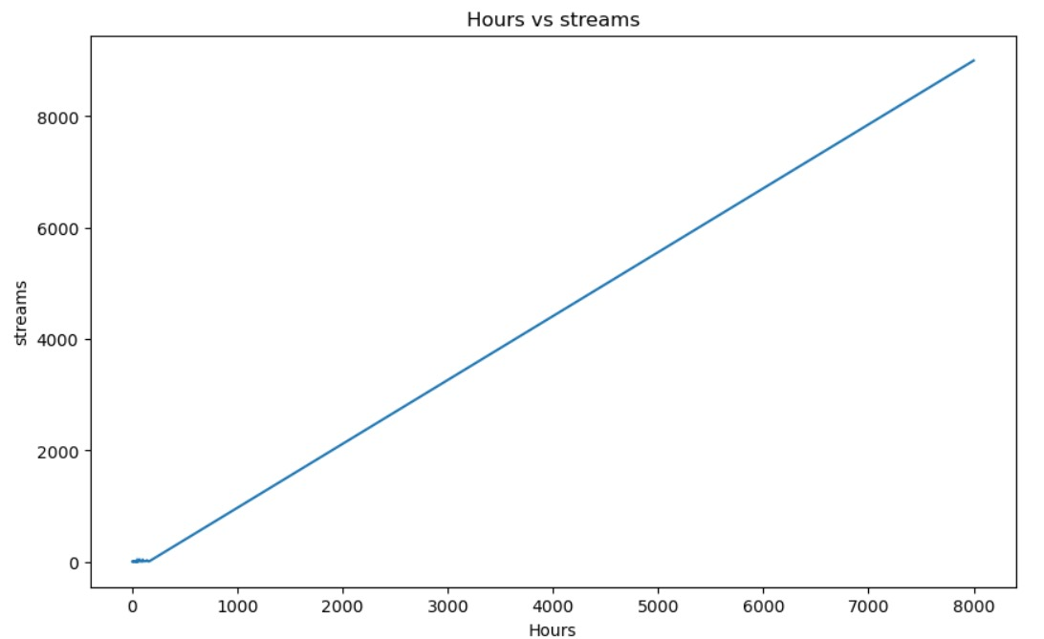
Fig.26. Line plot
From the above Fig.26., we can infer that the no. of hours is directly proportional to no. of hours streamed.

Multivariate Analysis

Hypothesis16: How social phobia(SPIN), satisfaction with life(SWL) and generalized anxiety disorder(GAD) is distributed?

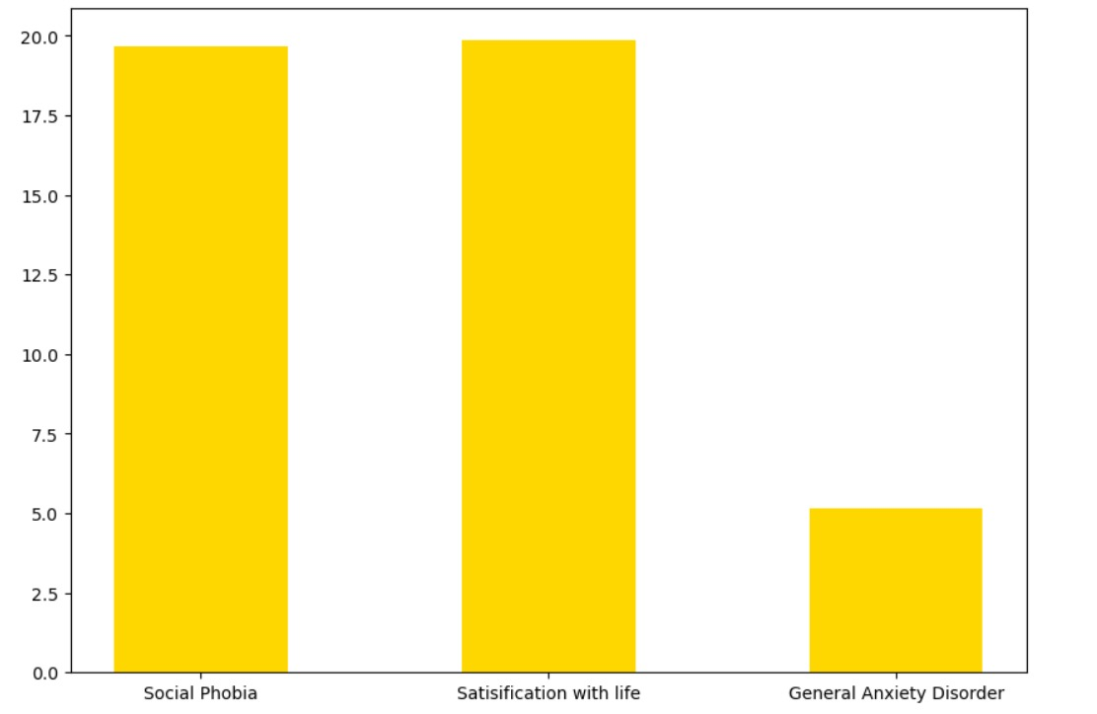
Fig.27.Bar plot
From the above fig.27., we can infer that no. of students with social phobia, satisfaction with life is same as compared with generalized anxiety disorder.

Hypothesis17: How SWL_T, SPIN_T and GAD_T will be affected by the no. of hours played?
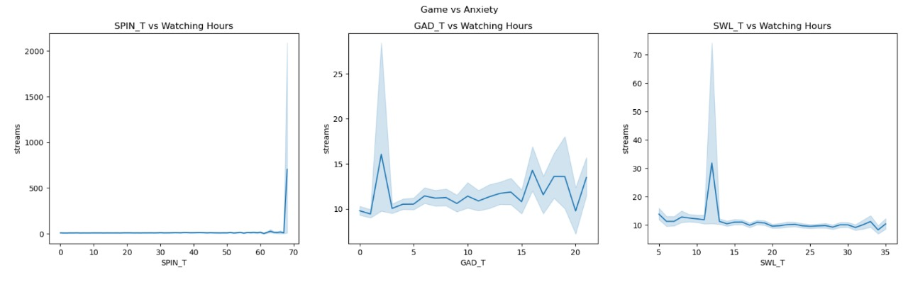
Fig.28.Lineplot

From the above fig.28., we are not getting any inferences.

V. CONCLUSION
In our project, we understood the importance of Exploratory Data Analysis (EDA) and data pre-processing for analyzing anxiety levels. By carefully handling missing values, outliers, and noise, and applying appropriate imputation and scaling techniques, the quality of the data can be significantly improved, which is crucial for accurate results.

In our project, we focused on understanding the data and forming hypotheses rather than building machine learning models. We explored different methods for dealing with missing values and outliers, and we examined how these pre-processing techniques can impact the data. We analyzed that the majority of the players suffering from anxiety are students as they are spending more time to play games on PC. Our analysis provided insights into the relationships between various features and the target variable(Narcissism), which is essential for developing robust prediction models in the future.

Future work will focus on implementing the best practices identified in this study within machine learning classifiers to validate the effectiveness of the pre-processing strategies discussed. By doing so, we aim to create more accurate and reliable models for analyzing anxiety levels, ultimately improving early diagnosis and treatment.

References
[1]Sheikh Afaan Farooq , Ojasri Konda , Anshul kunwar , Navmi_Rajeev “Anxiety prediction and analysis-A machinelearningbasedapproach”https://www.researchgate.net/publication/372269481_Anxiety_Prediction_and_Analysis-_A_Machine_Learning_Based_Approach
[2]Vidit Laijawala , Aadesh Aachaliya , Hardik Jatta , VijayaPinjarkar “Mental Health prediction using Data Mining:ASystematicReview”https://papers.ssrn.com/sol3/papers.cfm?abstract_id=3561661

[3]AnkithIndraKumar,VmanikantaSanjay“Anxiety Prediction during Stressful Scenarios using Machine Learning”https://www.researchgate.net/publication/368472289_Anxiety_Prediction_during_Stressful_Scenarios_using_Machine_Learning/download

[4]AliceV.Chavanne,MarieLaurePaillereMartinot,IMAGENconsortium“Anxiety Onset in Adolescents: a machine-learningprediction”https://www.nature.com/articles/s41380-022-01840-z

[5]WaiLimKu,HuaMin“EvaluatingMachineLearningStabilityinPredictingDepressionandAnxietyAmidstSubjectiveResponseErrors”https://www.mdpi.com/2227-9032/12/6/625

[6]GunaSekharSajja“MachineLearningBasedDetectionofDepressionandAnxiety”https://www.researchgate.net/publication/357274015_Machine_Learning_based_Detection_of_Depression_and_Anxiety

[7]AlfredoDaza,Nemias“Systematic review of machine learning techniques to predict anxiety and stress in collegestudents”https://www.sciencedirect.com/science/article/pii/S235291482300237X

