THE UNIVERSITY OF DANANG
DANANG UNIVERSITY OF SCIENCE AND TECHNOLOGY
INFORMATION TECHNOLOGY FACULTY
Tel. (84-511) 736 949, Fax. (84-511) 842 771
Website: itf.ud.edu.vn, E-mail: cntt@edu.ud.vn


SENIOR PROJECT THESIS
Information Technology

PROJECT NAME:
BUILD AN APPLICATION THAT HELPS PEOPLE
TO CALL MOTORBIKE SERVICE ON MOBILE PLATFORM

STUDENT: LE TRUNG VI
CLASS: 10T1
MENTOR: PhD. NGUYEN TAN KHOI

DANANG, May 2015

ACKNOWLEDGMENTS
At first, I want to thank all lecturer in Information Technology faculty, Danang University of Technology that trying to tech knowledge and creates favourable conditions for me to complete this graduation thesis.
I'd like to express my deeply appreciation to my supervisors, Mr. LE Hoang Hung – CEO of the Enclave and Mr. HUYNH Danh – Group Manager, for their guidance and patience during the course of our senior project at the Enclave Company.
Especially, I am truthfully thankful to Mr. NGUYEN Tan Khoi, who direct guidance and support me during the time I do my senior project.
Without the generous help of yours, our senior would not have been successful.
Once again, sincerely thank you!
Danang, May, 2015
Student

LE Trung Vi

COMMITMENTS

I assure that all bellow are true:
  - The content in this document are performed by my-self under the support from PhD. NGUYEN Tan Khoi.
  - All references, which used in this senior project thesis are quoted with author’s name, project’s name, time and location to publish clearly and faithfully.
  - All invalid copies, educated statute violation or cheating will be born the full responsibility by my-self.

Student

LE Trung Vi

MENTOR’S REVIEW

COUNCIL’S REVIEW

TABLE OF CONTENTS

LIST OF FIGURES vi
LIST OF TABLES viii
LIST OF DEFINITIONS, ACRONYMS AND ABBREVIATIONS x
INTRODUCTION 1
CHAPPTER 1. THEORIES AND TECHNOLOGIES 3
1.1. MOBILE PLATFORM 3
1.1.1. Window Phone OS 3
1.2. GLOBAL POSITIONING SYSTEM (GPS) 5
1.2.1. Global Positioning System (GPS) 5
1.3. SignalR 6
1.4. RESTful WEBSERVICE 8
1.4.1. The basic 8
1.4.2. Use HTTP methods explicitly 9
1.4.3. Be stateless 10
1.4.4. Expose directory structure-like URIs 12
1.4.5. Transfer XML, JSON, or both 12
1.5. PHP 13
1.6. MySQL 13
1.6.1. Slim PHP Framework 13
1.7. BING MAP API 14
CHAPPTER 2. SYSTEM ANALYSIS AND DESIGN 15
2.1. OVERVIEW DESIGN 15
2.2. REQUIREMENTS ANALYSIS 15
2.2.1. Project description 15
2.2.2. Feasibility study 16
2.2.3. Function specification 16
2.3. SYSTEM ANALYSIS AND DESIGN 20
2.3.1. System requirement 20
2.3.2. System actor 27
2.3.3. Use case diagram 28
2.3.4. Activity diagram 38
2.3.5. Sequence Diagram 46
2.3.6. Deployment diagram 49
2.4. DATABASE DESIGN 50
2.4.1. Table description 50
2.4.2. Database diagram 53
CHAPPTER 3. DEPLOYMENT AND RESULTS 55
3.1. DEVELOPMENT PLAN 55
3.2. DEPLOYMENT 56
3.2.1. Server system 56
3.2.2. Application on Windows Phone 8 58
3.2.3. OVERALL RESULTS 59
CONCLUSIONS 64
APPENDIX 66
LIST OF REFERENCES 67
Abstract 68

LIST OF FIGURES
Figure 1. Windows Phone 4
Figure 2. SignalR’s architecture 7
Figure 3. Stateless design 8
Figure 4. Overview Design 12
Figure 5. Use case – System use case 27
Figure 6. Use case – Customer sign in 28
Figure 7. Use case – Guest register new account 28
Figure 8. Use case – Customer call driver 28
Figure 9. Use case – Customer manage account 29
Figure 10. Use case – Customer manage itinerary 29
Figure 11. Use case - Send Feedback 29
Figure 12. Use case - Customer Report 30
Figure 13. Use case – Customer View Driver Information 30
Figure 14. Use case – Driver manage itinerary 30
Figure 15. Use case - Driver Reort 31
Figure 16. Use case - Driver manage vehicle 31
Figure 17. Use case - System use case 32
Figure 18. Use case – Staff manage itinerary 33
Figure 19. Use case - Staff manage feedback 33
Figure 20. Use case - Staff manage customer 34
Figure 21. Use case – Staff manage driver 35
Figure 22. Use case – Admin manage staff 35
Figure 23. Admin statistic 36
Figure 24. Activity diagram – Register new Account 36
Figure 25. Activity diagram – Login 37
Figure 26. Activity diagram – Update User Information 38
Figure 27. Activity diagram – Create New Itinerary 39
Figure 28. Activity diagram – Send Feedback 40
Figure 29. Activity diagram –Manage Customer 41
Figure 30. Activity diagram – Manage Staff 42
Figure 31. Activity diagram – Manage Itinerary 43
Figure 32. Send Response 44
Figure 35. Deployment diagram 45
Figure 36. Database diagram 49
Figure 37. RESTful webservice running through REST Easy 53

LIST OF TABLES
Table 1. Customer sign up, sign in, sign out 16
Table 2. Customer manage account 16
Table 3. Customer manage itinerary 17
Table 4. Customer call driver 17
Table 5. Send Feedback 17
Table 6. Driver manage vehicle 17
Table 7. Driver send feedback 17
Table 8. Driver manange itinerary 18
Table 9. Driver report 18
Table 10. Staff sign in, sign out 18
Table 11. Staff manage itinerary 18
Table 12. Staff manage user 18
Table 13. Manage driver 19
Table 14. Staff tracking itineraries 19
Table 15. Admin manage staff 19
Table 16. Admin report 19
Table 17. Customer Table 50
Table 18. Driver table 51
Table 19. Vehicle table 51
Table 20. Itinerary table 52
Table 21. Rating table 52
Table 22. Comment table 52
Table 23. Feedback table 52
Table 24. Staff table 53

LIST OF DEFINITIONS, ACRONYMS AND ABBREVIATIONS

Term | Definition
GPS | Global Positioning System
SRS | Software requirement specification
AWS | Amazon Web Services
RESTFul | Web service APIs that adhere to the REST architectural constraints
API | Application program interface - A set of routines, protocols, and tools for building software applications

INTRODUCTION

OBJECTIVE
The senior project is developed to apply all knowledge attained during study in university to build a system that help people can easily use motorbike service. The system helps people save their time, money and it also helps save the environment 'cause it reduce the consumption of fuel.

SCOPE
- Build a RESTful webservice and back-end system that help Windows Phone application and website communicate with database system.
- Build an Windows Phone app that help customer and driver to interact with system.
- Build a website that help staff manage system.

IMPLEMENTATION
Implementation step:
- Analyse requirements of the project.
- Analyse and design the system.
- Design database.
- Build RESTful webservice on Amazon cloud computing platform.
- Build mobile app on Window Phone OS.
- Build website for staff.
- Deploy the system in reality.
- Testing.
- Write document.

EXPECTED RESULTS
- Acquired knowledge about software development process.
- Acquired knowledge about RESTful webservice, mobile application development, website design and development.
- Build and deploy a system in reality.

STRUCTURE OF THESIS
- Introduction: Overview of project
- Chapter 1: Theories and Technologies
- Chapter 2: System analysis and design
- Chapter 3: Development progress, archived results
- Conclusion: Restrictions and future works

THEORIES AND TECHNOLOGIES
This chapter presents the current architecture and technologies of the project. To develop Mobile Timesheet Management application, I need to have knowledge about C#, SignalR, PHP, MySQL. About tools and environment, we need these applications installed on our machines: Visual Studio 2013, Windows Phone 8.1 SDK and MySQL.

MOBILE PLATFORM

Window Phone OS
Windows Phone 8 is the second generation of the Windows Phone mobile operating system from Microsoft. It was released on October 29, 2012, and like its predecessor, it features a flat user interface based on Metro design language. It was succeeded byWindows Phone 8.1, which was unveiled on April 2, 2014.
Windows Phone 8 replaces the Windows CE-based architecture used in Windows Phone 7 with the Windows NT kernel found inWindows 8. Current Windows Phone 7 devices cannot run or update to Windows Phone 8 and new applications compiled specifically for Windows Phone 8 are not made available for Windows Phone 7 devices. Developers can make their apps available on both Windows Phone 7 and Windows Phone 8 devices by targeting both platforms via the proper SDKs in Visual Studio.
Windows Phone 8 devices are manufactured by Nokia, HTC, Samsung and Huawei.
Windows Phone (WP) is a family of mobile operating systems developed by Microsoft for smartphones as the replacement successor to Windows Mobile and Zune. Windows Phone features a new user interface derived from Metro design language. Unlike Windows Mobile, it is primarily aimed at the consumer market rather than the enterprise market. It was first launched in October 2010 with Windows Phone 7.
Windows Phone 8.1 is the latest public release of the operating system, released to manufacturing on April 14, 2014.
The Windows Phone brand was phased out in accordance to Microsoft's new branding strategy and is due to be succeeded in 2015 with the release of Windows 10 (mobile), which is designed to provide a universal experience in conjunction with the PC version of Windows 10.
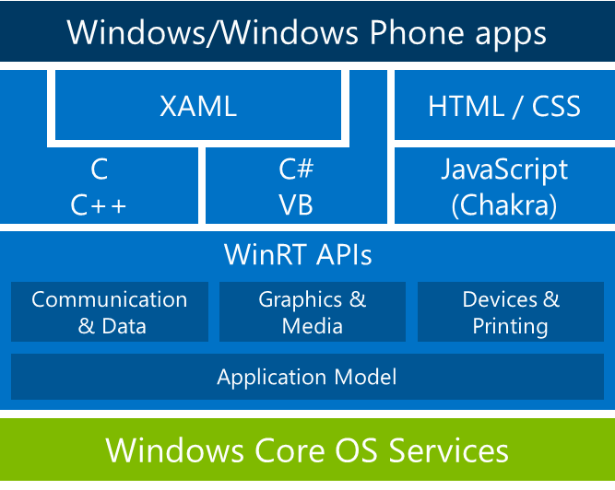
Figure 1. Windows Phone
Windows Phone 8 also allows devices with larger screens (the four confirmed sizes are "WVGA 800×480 15:9","WXGA 1280×768 15:9","720p 1280×720 16:9","1080p 1920x1080 16:9" resolutions) and multi-core processors, NFC (that can primarily be used to share content and perform payments), backwards compatibility with Windows Phone 7 apps, improved support for removable storage (that now functions more similarly to how such storage is handled on Windows and Android), a redesigned home screen incorporating resizable tiles across the entire screen, a new Wallet hub (to integrate NFC payments, coupon websites such as Groupon, and loyalty cards), and "first-class" integration of VoIP applications into the core functions of the OS. Additionally, Windows Phone 8 will include more features aimed at the enterprise market, such as device management. Additionally, Windows Phone 8 will support over-the-air updates, and all Windows Phone 8 devices will receive software support for at least 36 months after their release.
In the interest of ensuring it is released with devices designed to take advantage of its new features, Windows Phone 8 will not be made available as an update for existing Windows Phone 7 devices. Instead, Microsoft released Windows Phone 7.8 as an update for Windows Phone 7 devices, which backported several features such as the redesigned home screen.

GLOBAL POSITIONING SYSTEM (GPS)

Global Positioning System (GPS)
The Global Positioning System (GPS) is a satellite-based navigation system made up of a network of 24 satellites placed into orbit by the U.S. Department of Defense. GPS was originally intended for military applications, but in the 1980s, the government made the system available for civilian use. GPS works in any weather conditions, anywhere in the world, 24 hours a day. There are no subscription fees or setup charges to use GPS.
GPS satellites circle the earth twice a day in a very precise orbit and transmit signal information to earth. GPS receivers take this information and use triangulation to calculate the user's exact location. Essentially, the GPS receiver compares the time a signal was transmitted by a satellite with the time it was received. The time difference tells the GPS receiver how far away the satellite is. Now, with distance measurements from a few more satellites, the receiver can determine the user's position and display it on the unit's electronic map.
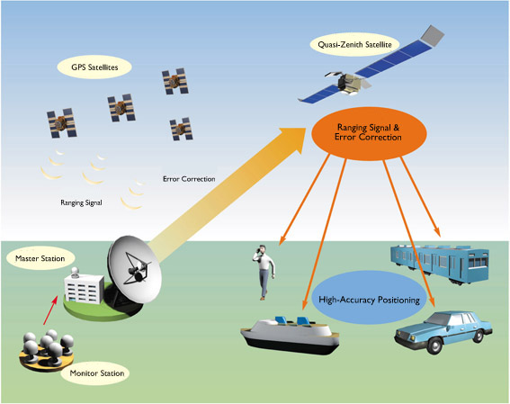
Figure 2. GPS
A GPS receiver must be locked on to the signal of at least three satellites to calculate a 2D position (latitude and longitude) and track movement. With four or more satellites in view, the receiver can determine the user's 3D position (latitude, longitude and altitude). Once the user's position has been determined, the GPS unit can calculate other information, such as speed, bearing, track, trip distance, distance to destination, sunrise and sunset time and more.
Today's GPS receivers are extremely accurate, thanks to their parallel multi-channel design. Garmin's 12 parallel channel receivers are quick to lock onto satellites when first turned on and they maintain strong locks, even in dense foliage or urban settings with tall buildings. Certain atmospheric factors and other sources of error can affect the accuracy of GPS receivers. Garmin® GPS receivers are accurate to within 15 meters on average.
Newer Garmin GPS receivers with WAAS (Wide Area Augmentation System) capability can improve accuracy to less than three meters on average. No additional equipment or fees are required to take advantage of WAAS. Users can also get better accuracy with Differential GPS (DGPS), which corrects GPS signals to within an average of three to five meters. The U.S. Coast Guard operates the most common DGPS correction service. This system consists of a network of towers that receive GPS signals and transmit a corrected signal by beacon transmitters. In order to get the corrected signal, users must have a differential beacon receiver and beacon antenna in addition to their GPS.

SignalR
ASP.NET SignalR is a library for ASP.NET developers that simplifies the process of adding real-time web functionality to applications. Real-time web functionality is the ability to have server code push content to connected clients instantly as it becomes available, rather than having the server wait for a client to request new data.
SignalR can be used to add any sort of "real-time" web functionality to your ASP.NET application. While chat is often used as an example, you can do a whole lot more. Any time a user refreshes a web page to see new data, or the page implements long polling to retrieve new data, it is a candidate for using SignalR. Examples include dashboards and monitoring applications, collaborative applications (such as simultaneous editing of documents), job progress updates, and real-time forms.
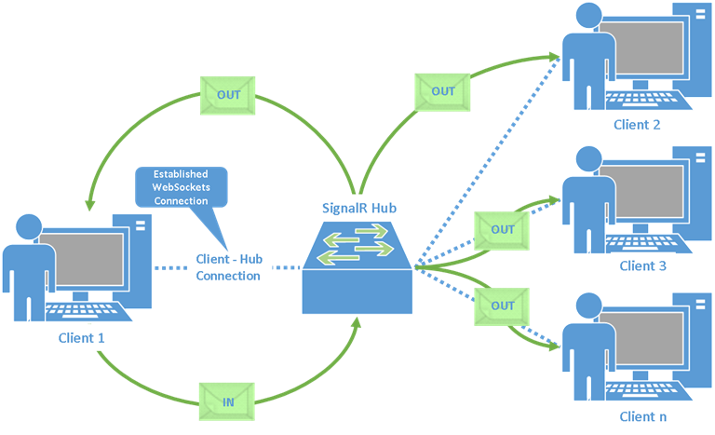
Figure 3. Signal R
SignalR also enables completely new types of web applications that require high frequency updates from the server, for example, real-time gaming. For a great example of this, see the ShootR game.
SignalR provides a simple API for creating server-to-client remote procedure calls (RPC) that call JavaScript functions in client browsers (and other client platforms) from server-side .NET code. SignalR also includes API for connection management (for instance, connect and disconnect events), and grouping connections.
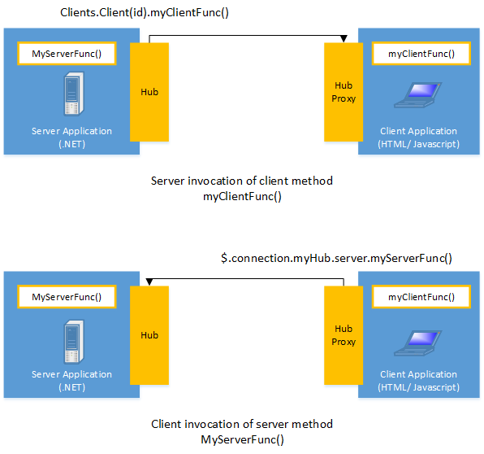
Figure 4. SignalR’s architecture

RESTful WEBSERVICE

The basic
REST defines a set of architectural principles by which you can design Web services that focus on a system's resources, including how resource states are addressed and transferred over HTTP by a wide range of clients written in different languages. If measured by the number of Web services that use it, REST has emerged in the last few years alone as a predominant Web service design model. In fact, REST has had such a large impact on the Web that it has mostly displaced SOAP- and WSDL-based interface design because it's a considerably simpler style to use.
REST didn't attract this much attention when it was first introduced in 2000 by Roy Fielding at the University of California, Irvine, in his academic dissertation, "Architectural Styles and the Design of Network-based Software Architectures," which analyzes a set of software architecture principles that use the Web as a platform for distributed computing (seeResources for a link to this dissertation). Now, years after its introduction, major frameworks for REST have started to appear and are still being developed because it's slated, for example, to become an integral part of Java™ 6 through JSR-311.
A concrete implementation of a REST Web service follows four basic design principles:
- Use HTTP methods explicitly.
- Be stateless.
- Expose directory structure-like URIs.
- Transfer XML, JavaScript Object Notation (JSON), or both.

Use HTTP methods explicitly
An unfortunate design flaw inherent in many Web APIs is in the use of HTTP methods for unintended purposes. The request URI in an HTTP GET request, for example, usually identifies one specific resource. Or the query string in a request URI includes a set of parameters that defines the search criteria used by the server to find a set of matching resources. At least this is how the HTTP/1.1 RFC describes GET. But there are many cases of unattractive Web APIs that use HTTP GET to trigger something transactional on the server—for instance, to add records to a database. In these cases the GET request URI is not used properly or at least not used RESTfully. If the Web API uses GET to invoke remote procedures.
REST asks developers to use HTTP methods explicitly and in a way that's consistent with the protocol definition. This basic REST design principle establishes a one-to-one mapping between create, read, update, and delete (CRUD) operations and HTTP methods. According to this mapping:
- To create a resource on the server, use POST.
- To retrieve a resource, use GET.
- To change the state of a resource or to update it, use PUT.
- To remove or delete a resource, use DELETE.
It's not a very attractive design because the Web method above supports a state-changing operation over HTTP GET. Put another way, the HTTP GET request above has side effects. If successfully processed, the result of the request is to add a new user—in this example, Robert—to the underlying data store. The problem here is mainly semantic. Web servers are designed to respond to HTTP GET requests by retrieving resources that match the path (or the query criteria) in the request URI and return these or a representation in a response, not to add a record to a database. From the standpoint of the intended use of the protocol method then, and from the standpoint of HTTP/1.1-compliant Web servers, using GET in this way is inconsistent.
Beyond the semantics, the other problem with GET is that to trigger the deletion, modification, or addition of a record in a database, or to change server-side state in some way, it invites Web caching tools (crawlers) and search engines to make server-side changes unintentionally simply by crawling a link. A simple way to overcome this common problem is to move the parameter names and values on the request URI into XML tags.
As a general design principle, it helps to follow REST guidelines for using HTTP methods explicitly by using nouns in URIs instead of verbs. In a RESTful Web service, the verbs—POST, GET, PUT, and DELETE—are already defined by the protocol. And ideally, to keep the interface generalized and to allow clients to be explicit about the operations they invoke, the Web service should not define more verbs or remote procedures, such as /adduser or /updateuser. This general design principle also applies to the body of an HTTP request, which is intended to be used to transfer resource state, not to carry the name of a remote method or remote procedure to be invoked.

Be stateless
REST Web services need to scale to meet increasingly high performance demands. Clusters of servers with load-balancing and failover capabilities, proxies, and gateways are typically arranged in a way that forms a service topology, which allows requests to be forwarded from one server to the other as needed to decrease the overall response time of a Web service call. Using intermediary servers to improve scale requires REST Web service clients to send complete, independent requests; that is, to send requests that include all data needed to be fulfilled so that the components in the intermediary servers may forward, route, and load-balance without any state being held locally in between requests.
A complete, independent request doesn't require the server, while processing the request, to retrieve any kind of application context or state. A REST Web service application (or client) includes within the HTTP headers and body of a request all of the parameters, context, and data needed by the server-side component to generate a response. Statelessness in this sense improves Web service performance and simplifies the design and implementation of server-side components because the absence of state on the server removes the need to synchronize session data with an external application.

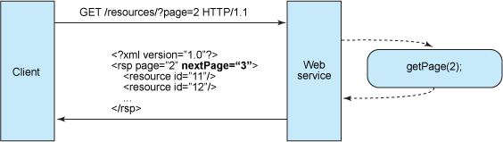
Figure 5. Stateless design
Stateful services like this get complicated. In a Java Platform, Enterprise Edition (Java EE) environment stateful services require a lot of up-front consideration to efficiently store and enable the synchronization of session data across a cluster of Java EE containers. In this type of environment, there's a problem familiar to servlet/JavaServer Pages (JSP) and Enterprise JavaBeans (EJB) developers who often struggle to find the root causes of java.io.NotSerializableException during session replication. Whether it's thrown by the servlet container duringHttpSession replication or thrown by the EJB container during stateful EJB replication, it's a problem that can cost developers days in trying to pinpoint the one object that doesn't implement Serializable in a sometimes complex graph of objects that constitute the server's state. In addition, session synchronization adds overhead, which impacts server performance.
Stateless server-side components, on the other hand, are less complicated to design, write, and distribute across load-balanced servers. A stateless service not only performs better, it shifts most of the responsibility of maintaining state to the client application. In a RESTful Web service, the server is responsible for generating responses and for providing an interface that enables the client to maintain application state on its own. For example, in the request for a multipage result set, the client should include the actual page number to retrieve instead of simply asking for next
Figure 6. Stateless Design

Expose directory structure-like URIs
From the standpoint of client applications addressing resources, the URIs determine how intuitive the REST Web service is going to be and whether the service is going to be used in ways that the designers can anticipate. A third RESTful Web service characteristic is all about the URIs.
REST Web service URIs should be intuitive to the point where they are easy to guess. Think of a URI as a kind of self-documenting interface that requires little, if any, explanation or reference for a developer to understand what it points to and to derive related resources. To this end, the structure of a URI should be straightforward, predictable, and easily understood.
One way to achieve this level of usability is to define directory structure-like URIs. This type of URI is hierarchical, rooted at a single path, and branching from it are subpaths that expose the service's main areas. According to this definition, a URI is not merely a slash-delimited string, but rather a tree with subordinate and superordinate branches connected at nodes.
REST Web service URIs should be intuitive to the point where they are easy to guess. Think of a URI as a kind of self-documenting interface that requires little, if any, explanation or reference for a developer to understand what it points to and to derive related resources. To this end, the structure of a URI should be straightforward, predictable, and easily understood.
URIs should also be static so that when the resource changes or the implementation of the service changes, the link stays the same. This allows bookmarking. It's also important that the relationship between resources that's encoded in the URIs remains independent of the way the relationships are represented where they are stored.

Transfer XML, JSON, or both
A resource representation typically reflects the current state of a resource, and its attributes, at the time a client application requests it. Resource representations in this sense are mere snapshots in time. This could be a thing as simple as a representation of a record in a database that consists of a mapping between column names and XML tags, where the element values in the XML contain the row values. Or, if the system has a data model, then according to this definition a resource representation is a snapshot of the attributes of one of the things in your system's data model. These are the things you want your REST Web service to serve up.
The last set of constraints that goes into a RESTful Web service design has to do with the format of the data that the application and service exchange in the request/response payload or in the HTTP body. This is where it really pays to keep things simple, human-readable, and connected.

PHP
PHP is a server-side scripting language designed for web development but also used as a general-purpose programming language. As of January 2013, PHP was installed on more than 240 million websites (39% of those sampled) and 2.1 million web servers. Originally created by Rasmus Lerdorf in 1994, the reference implementation of PHP (powered by the Zend Engine) is now produced by The PHP Group. While PHP originally stood for Personal Home Page, it now stands for PHP: Hypertext Preprocessor, which is a recursive backronym.

MySQL
MySQL ("My S-Q-L, officially, but also called "My Sequel") is (as of July 2013) the world's second most[a] widely used relational database management system (RDBMS)and most widely used open-source RDBMS. It is named after co-founder Michael Widenius's daughter. The SQL acronym stands for Structured Query Language.
The MySQL development project has made its source code available under the terms of the GNU General Public License, as well as under a variety of proprietary agreements. MySQL was owned and sponsored by a single for-profit firm, the Swedishcompany MySQL AB, now owned by Oracle Corporation.
MySQL is a popular choice of database for use in web applications, and is a central component of the widely used LAMP open source web application software stack (and other 'AMP' stacks). LAMP is an acronym for "Linux, Apache, MySQL,Perl/PHP/Python." Free-software-open source projects that require a full-featured database management system often use MySQL.
The MySQL development project has made its source code available under the terms of the GNU General Public License, as well as under a variety of proprietary agreements. MySQL was owned and sponsored by a single for-profit firm, the Swedish company MySQL AB, now owned by Oracle Corporation.

Slim PHP Framework
The Apache HTTP Server, colloquially called Apache, is the world's most widely used web server software. Originally based on the NCSA HTTPd server, development of Apache began in early 1995 after work on the NCSA code stalled. Apache played a key role in the initial growth of the World Wide Web, quickly overtaking NCSA HTTPd as the dominant HTTP server, and has remained the most popular HTTP server since April 1996. In 2009, it became the first web server software to serve more than 100 million websites.
Apache supports a variety of features, many implemented as compiled modules which extend the core functionality. These can range from server-side programming language support to authentication schemes. Some common language interfaces support Perl, Python, Tcl, and PHP. Popular authentication modules include mod_access, mod_auth, mod_digest, and mod_auth_digest, the successor to mod_digest. A sample of other features include Secure Sockets Layer and Transport Layer Security support (mod_ssl), a proxy module (mod_proxy), a URL rewriter (mod_rewrite), custom log files (mod_log_config), and filtering support (mod_include and mod_ext_filter).

BING MAP API
Bing Maps Platform (previously Microsoft Virtual Earth) is a geospatial mapping platform produced by Microsoft. It allows developers to create applications that layer location-relevant data on top of licensed map imagery. The imagery includes samples taken by satellite sensors, aerial cameras (including 45 degree oblique "bird's eye" aerial imagery licensed fromPictometry International), Streetside imagery, 3D city models and terrain.
Bing Maps Platform also provides a point-of-interest database including a search capability. Microsoft uses the Bing Maps Platform to power its Bing Maps product.

SYSTEM ANALYSIS AND DESIGN
This chappter describes all the functions and nonfunctional requirements of project.

OVERVIEW DESIGN

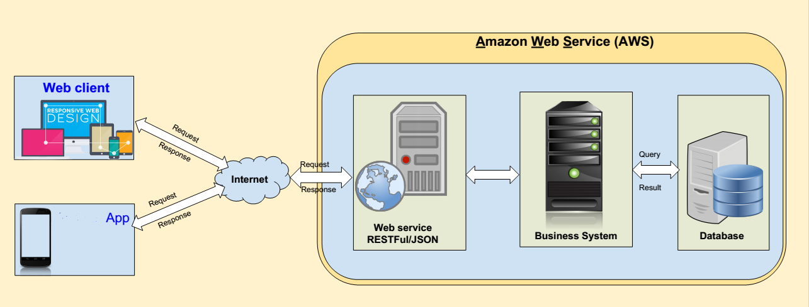
Figure 7. Overview Design

REQUIREMENTS ANALYSIS

Project description
- Customer
- For person who have no motorbike want to create new itinerary.
- For person who don’t have a motorbike want call motorbike service quickly for save time, money.
- Purpose
- Help customer create new itinerary.
- Help customer manage their account.
- Help customer manage their itineraries.
- Help customer statistic.
- Help customer send feedback to staff.
- Help driver manage itineray.
- Help driver manage vehicles.
- Help staff manage user account, verify information of user, manage itinerary, maintain system.

Feasibility study
- The system can totally deploy in reality.
- Smartphone more and more popular.
- People’s transportation needs are increasing more and more.
- Fuel prices are increasing.
- Can gain advertising to maintain the system and pay employees.

Function specification

Customer
- Sign up, sign in, sign out
Function code | Function name
1.1 | Sign up
1.2 | Sign in
1.3 | Sign out
Table 1. Customer sign up, sign in, sign out
- Manage account
Function code | Function name
2.1 | View profile
2.2 | Edit profile
2.3 | Reset password
Table 2. Customer manage account

- Manage itinerary
Function code | Function name
3.1 | View list itinerary
3.2 | Create new itinerary
3.3 | Update information of itinerary
3.4 | Delete itinerary
3.5 | Tracking
Table 3. Customer manage itinerary

- Call Driver
Function code | Function name
4.1 | Call Driver
Table 4. Customer call driver

- Send Feedback
Function code | Function name
5.1 | Send Feedback
Table 5. Send Feedback

Driver
- Manage vehicle
Function code | Function name
6.1 | Create new vehicle
6.2 | View vehicle
6.3 | Edit vehicle
6.4 | Delete vehicle
Table 6. Driver manage vehicle
- Send feedback
Function code | Function name
7.1 | Send feedback
Table 7. Driver send feedback
- Manage itineraries
Function code | Function name
8.1 | View list itinerary
8.1 | Tracking
Table 8. Driver manange itinerary
- Report
Function code | Function name
9.1 | Statistic
Table 9. Driver report

Staff
- Staff sign in, sign out
Function code | Function name
10.1 | Staff sign in
10.2 | Staff sign out
Table 10. Staff sign in, sign out
- Staff manage itinerary
Function code | Function name
11.1 | View list itinerary
11.2 | Create new itinerary
11.3 | Update information of itinerary
11.4 | Delete itinerary
Table 11. Staff manage itinerary
- Staff manage customer
Function code | Function name
12.1 | View list customer
12.2 | Create new customer
12.3 | Update customer Ìnormation
12.4 | Delete customer
Table 12. Staff manage user
- Staff manage feedback
Function code | Function name
13.1 | View list feedback
13.2 | Delete feedback
13.3 | Send Response
Table 13. Manage driver
- Staff manage driver
Function code | Function name
14.1 | View List Driver
14.2 | Create new driver
14.3 | Update driver’s information
14.4 | Delete driver
Table 14. Staff tracking itineraries

Admin
- Admin manage staff
Function code | Function name
15.1 | Create new staff
15.2 | Edit staff profile
15.3 | Delete staff
15.4 | View list staff
Table 15. Admin manage staff
- Admin report
Function code | Function name
16.1 | Statistic user
16.2 | Statistic money
Table 16. Admin report

SYSTEM ANALYSIS AND DESIGN

System requirement

Functional requirement and use case
a/ Use case of User
- User sign up, sign in, sign out
- User sign up
- Brief Description
This user-case is for the user registration. A user must register before they are able to log on the system. Registration primarily consists of entering an email address for verification and creating a password.
- Pre-Condition
User is not a member of the system
- Post-Condition
Database was updated.
- Flow of Events
- Basic flow
Step | Description
1 | User enters their email address and password in “Email” and “Password” field
2 | System validates that the email does not already exists. If it does not, a new user is created and a confirmation email is sent with a confirmation link that needs to be selected before the user is allowed to enter the system.
3 | User checks their email for the email that the system sent and gets the confirmation link. The user selects the confirmation link.
4 | System accepts the confirmation link and requests the user to log in using their email and password

- Alternative flow
Step | Description
2.1 | If user doesn't enter email, System will show an error message “Please enter email!”
2.2 | If user doesn't enter password, System will show an error message “Please enter password!”
2.3 | If email is existed, System will show an error message “This email is existed!”
2.4 | If password isn't from 6 to 12 characters, System will show an error message “Password has to be from 6 – 12 characters”

- User sign in
- Brief Description
This use case allow user to login into this application..
- Pre-Condition
The user have to register new account and activate account via email.
- Flow of Events
- Basic flow
Step | Description
1 | User type email and password in “Email” field and “Password” field
2 | User click the “Login” button
3 | Application's main screen is displayed in the screen

- Alternative flow
Step | Description
3.1 | If user doesn't enter email, system will show an error message “Please enter email!”
3.2 | If user doesn't enter password, system will show an error message “Please enter password!”
3.3 | If email isn't existed or password is wrong, system will show an error message “Wrong email or password!”

- User sign out
- Brief Description
This Use case allow user logout their account from application.
- Pre-Condition
User have login to the system.
- Post-Condition
The user’s API key was remove from Session.
- Flow of Events
- Basic flow
Step | Description
1 | User click to the “Logout” button on the right menu
2 | Screen is displayed “Do you want to logout?”
3 | User click “Yes” button
4 | System redirect to the login screen

- Alternative flow
Step | Description
3.1 | User click to the “No” button
4.1 | System redirect to the main screen

- User manage account
- View profile
- Brief Description
This use case allow user to view and manage their profile.
- Pre-Condition
The user who already logged account then click on Account Management Menu.
- Post-Condition
User profile will display in the screen.
- Flow of Events
- Basic flow
Step | Description
1 | Choose the User's Profile field.
2 | User's profile is displayed on the screen.

- Edit profile
- Brief Description
This Use-case allows user update any basic information about their profile.
- Pre-Condition
The user must log in to the system with the valid account then navigate to the menu and choose the “Account Management” feature.
- Post-Condition
The database is updated.
- Flow of Events
- Basic flow
Step | Description
1 | User navigate to the “Account Management” feature on a menu to update
2 | Click on a “Update” button
3 | Fill the Information need to update
4 | New update on a database

- Send feedback
- Brief Description
This Use case allows user or rider to send anything about application to administrator.
- Pre-Condition
User have open the function menu
- Post-Condition
Display the text field and button “Send” in order to write user’s feedback
- Flow of Events
- Basic flow
Step | Description
1 | User click to the “Feedback” Section.
2 | Screen is displayed the Feedback text field and buttons is: “Send feedback”.
3 | User write feedback in the text field.
4 | User click “Send feedback” button to send the feedback.
5 | The screen will display: “Are you sure?”
6 | Click “Yes” button to send or “No” button to cancel.

b/ Use case of Admin
- Manage Staff
- Create new Staff
- Brief Description
This Use-case allows admin create a new staff.
- Pre-Condition
The admin has accessed “Manage staff” screen.
- Post-Condition
A new staff record is saved into the database.
- Flow of Events
- Basic flow
Step | Description
1 | Admin click “Create staff” button
2 | The screen “Create staff” is displayed
3 | Staff fill in require field
4 | Staff click “Create” button
5 | New staff being created

- Alternative flow
Step | Description
5.1 | Alert “Missing require field” display
5.2 | Alert “The Personal ID” has been exist display
5.3 | Alert “The email has been exist” display

- Delete Staff
- Brief Description
This Use-case allows admin delete one, many or all of staff profile. Having two ways to do that. The first way is use can choose and delete staff when admin are using View staff function. The second way is use can delete the current receiving when use View details staff function.
- Pre-Condition
The user has accessed Manage staff main screen.
- Post-Condition
Database is updated.
- Flow of Events
- Basic flow
Step | Description
1 | User choose the staff in List Staff or Detail Staff that they want to delete
2 | Click “Delete” button
3 | System will display message: “Do you want to delete?”
4 | User click “Yes” button
5 | Update database

- Update Staff’s information
- Brief Description
This Use case allows user edit the content of staff profile. Having two ways to do it. The first way is when user use View staff function, they choose one of staff and edit it. The second way is when user use View details staff function, they can edit this staff.
- Pre-Condition
The user has accessed Manage staff main screen.
- Post-Condition
Database is updated.
- Flow of Events
- Basic flow
Step | Description
1 | User choose the staff in the staff list that they want to edit
2 | Click “Edit” button
3 | System will display screen allows user edit
4 | User edit information they want
5 | Click “Save” button

- Manage Itinerary
- View Itinerary
- Brief Description
This Use-case allows staff review an itinerary.
- Pre-Condition
The staff must log in to the system with the valid account then navigate to the menu and choose the “Itinerary Management” feature.
- Post-Condition

- Flow of Events
- Basic flow
Step | Description
1 | Staff navigate to the “View Itinerary” or “Itinerary Details” feature on a menu
2 | System display a list of all itinerary

- Udate Itinerary
- Brief Description
This Use-case allows staff update an itinerary.
- Pre-Condition
The staff must log in to the system with the valid account then navigate to the menu and choose the “Itinerary Management” feature.
- Post-Condition
Database is updated
- Flow of Events
- Basic flow
Step | Description
1 | Staff navigate to the “View Itinerary” or “Itinerary Details” feature on a menu to update
2 | New update on a database

- Delete Itinerary
- Brief Description
This Use-case allows staff delete an itinerary. Have two ways to do that, first is choose and delete itinerary when navigation to the “View Itinerary” feature. The second is delete the itinerary through the “View details Itinerary” feature..
- Pre-Condition
The user has accessed Manage staff main screen.
- Post-Condition
Database is updated
- Flow of Events
- Basic flow
Step | Description
1 | Staff select the itinerary on a “List of Itinerary” or “Details of Itinerary” to delete
2 | Click on a “Delete” button
3 | System will display message: “Do you want to delete?”
4 | User click “Yes” or “No” button
5 | Updating database

Non-functional requirement
- RESTful webservice
- Access speed have to fast.
- Make sure user informations are safe.
- Mobile app
- Simple user interface.
- Easy to install.
- Easy to use.
- Stable (Maximum crash 5 times per week).
- Website
- Simple user interface.
- Access speed have to fast.
- Stable (Online 20 hours per day, 7 days per week).
- Easy to use.

System actor
The below diagram describes all actors of the Uberriding with GPS System. An actor represents Guest Role, an actor represents a User Role, Driver and Customer Account derive from User, another actor is represents for Staff Role, Admin Account derive from Staff. Each user has his own actions when accessing into the system, based on his rights. Driver Account have right to login, create new vehicle, update vehicle, delete vehicle, view and update profile, view statistic, accept an request to join an itinerary from customer and logout.

Actor | Description
Guest | Have the rights to register new account, visit website to view information about the system
Customer | Have right to view and update their profile, create new itinerary, update itinerary, delete itinerary, tracking an itinerary, view statistic,
Driver | Have right to create new vehicle, update vehicle, delete vehicle, view and update profile, view statistic
Staff | Have right to login, manage customer. Manage driver, manage itineraries, manage feedback from user, monitor all itinerary and logout
Admin | Have right to manage Staff, view statistic.

Use case diagram

User
a/ Level 0

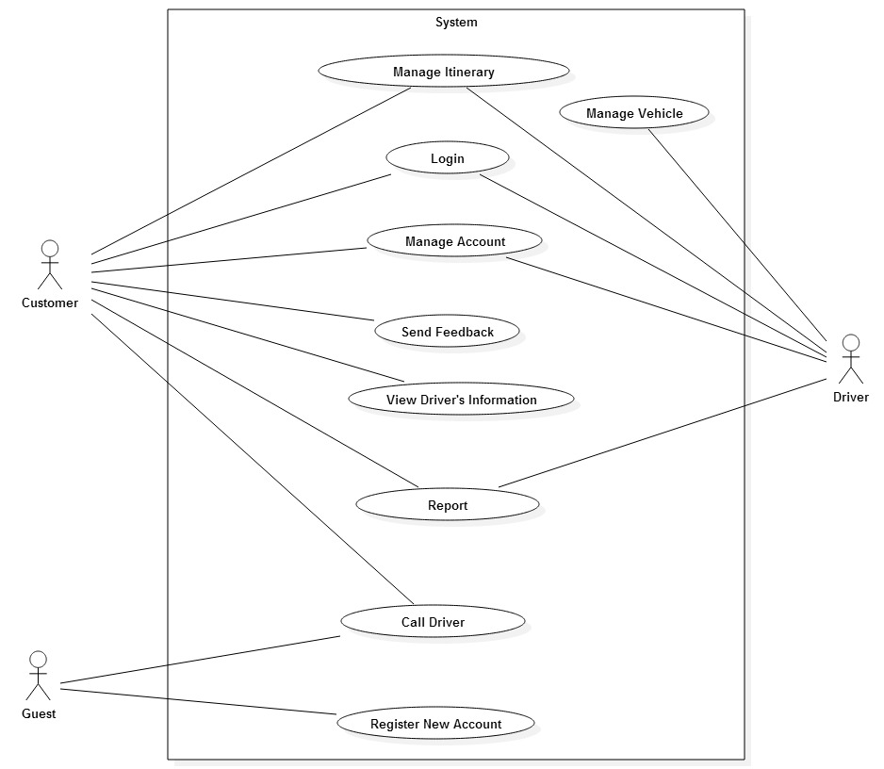
Figure 8. Use case – System use case

b/ Level 1
- Customer sign up, sign in, sign out
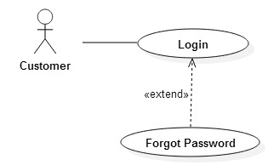
Figure 9. Use case – Customer sign in
- Customer register new account
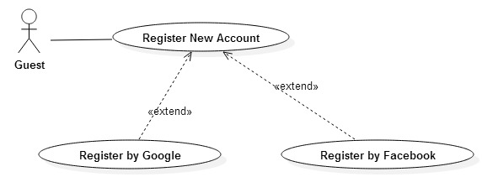
Figure 10. Use case – Guest register new account
- Customer call driver
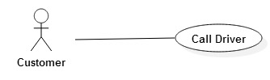
Figure 11. Use case – Customer call driver
- Customer manage account
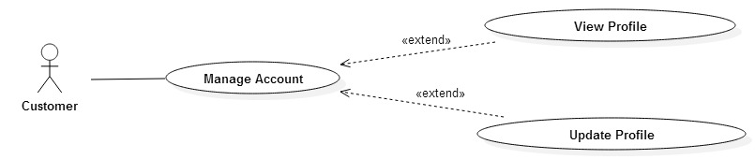
Figure 12. Use case – Customer manage account
- Customer manage itineraries
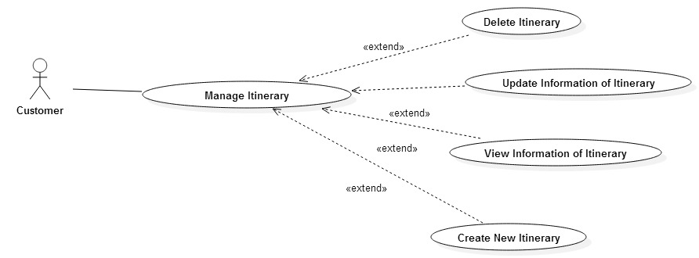
Figure 13. Use case – Customer manage itinerary
- Customer send feedback
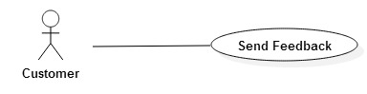
Figure 14. Use case - Send Feedback
- Customer Report
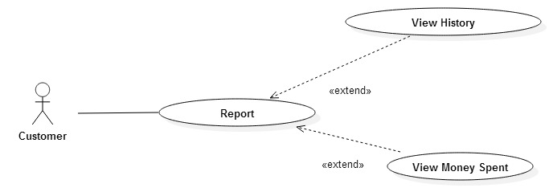
Figure 15. Use case - Customer Report
- Customer view driver’s information
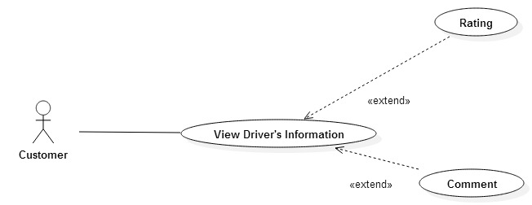
Figure 16. Use case – Customer View Driver Information
- Driver manage ititnerary
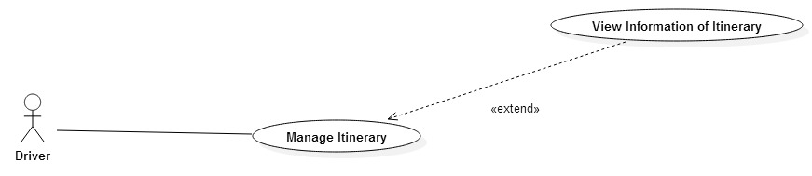
Figure 17. Use case – Driver manage itinerary

- Driver statistic
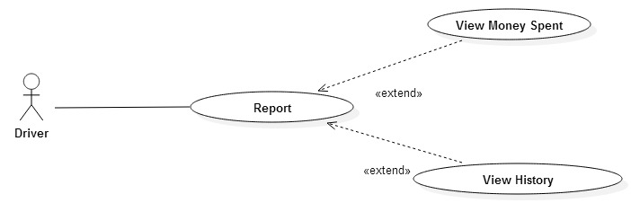
Figure 18. Use case - Driver Reort
- User statistic
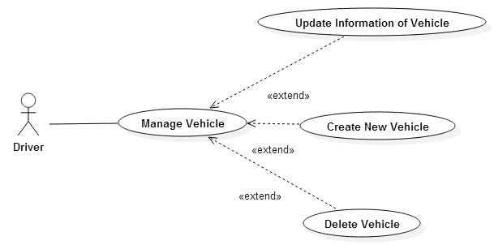
Figure 19. Use case - Driver manage vehicle

Admin
a/ Level 0

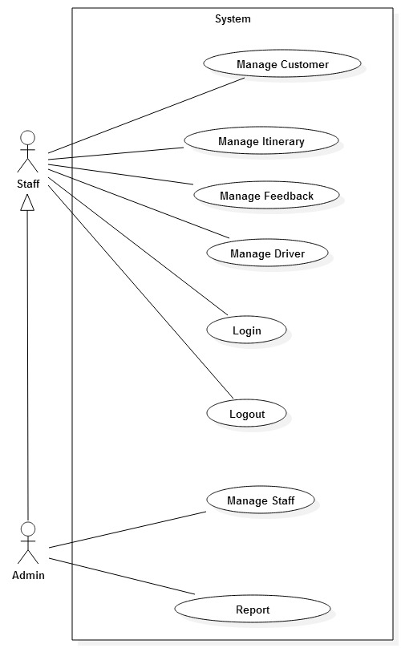
Figure 20. Use case - System use case

b/ Level 1
- Staff manage ititnerary
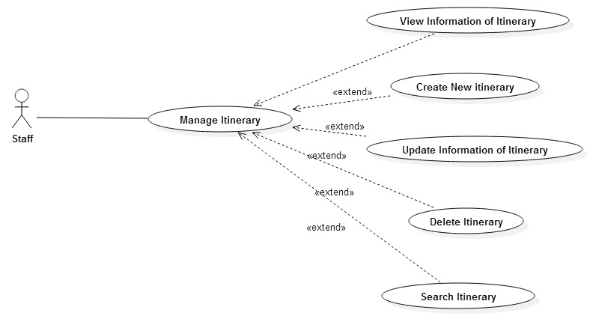
Figure 21. Use case – Staff manage itinerary

- Staff manage feedback
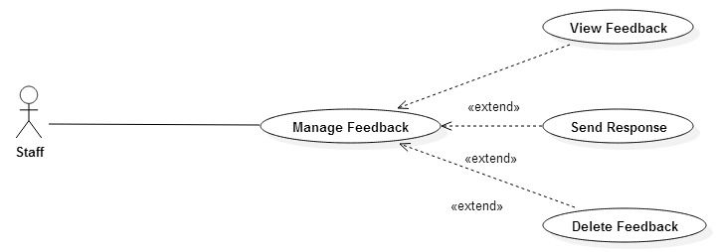
Figure 22. Use case - Staff manage feedback

- Staff manage Customer
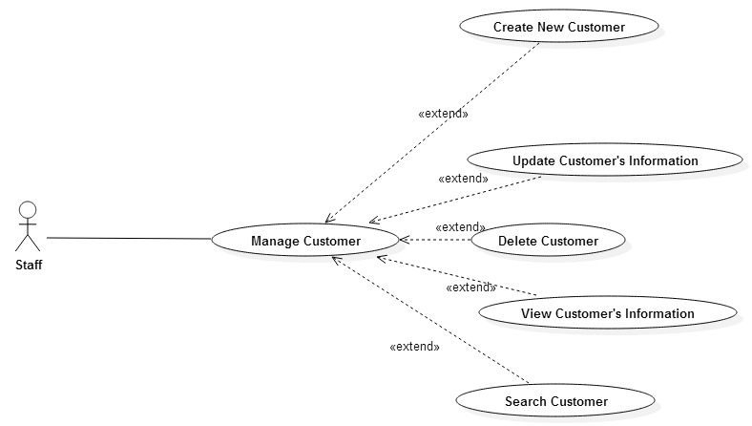
Figure 23. Use case - Staff manage customer

- Staff manage driver
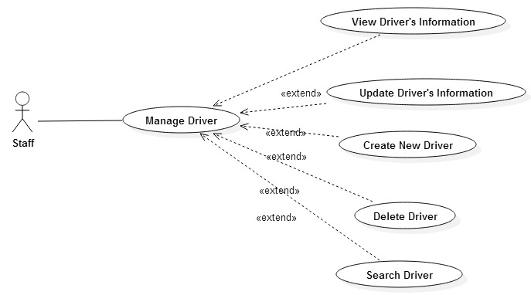
Figure 24. Use case – Staff manage driver
- Admin manage staff
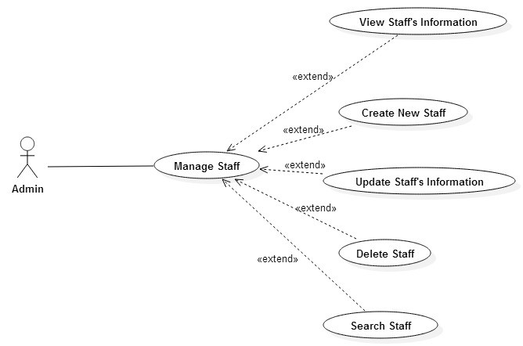
Figure 25. Use case – Admin manage staff
- Admin report
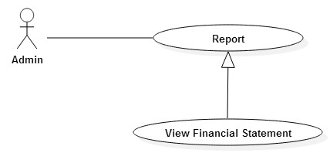
Figure 26. Admin statistic

Activity diagram

User
- Register new account
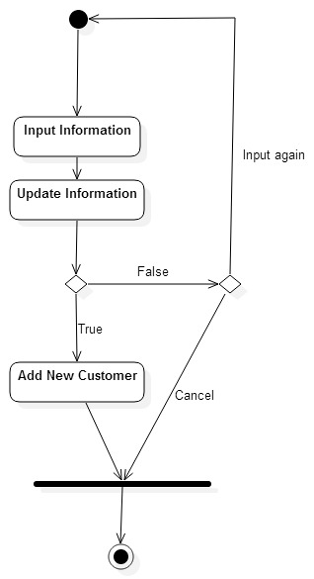
Figure 27. Activity diagram – Register new Account

- Login
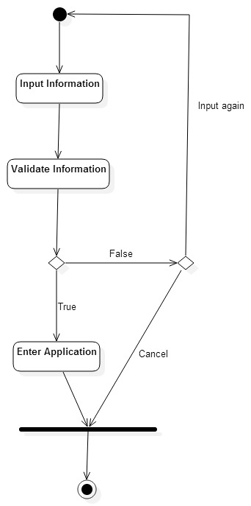
Figure 28. Activity diagram – Login

- Update User Information
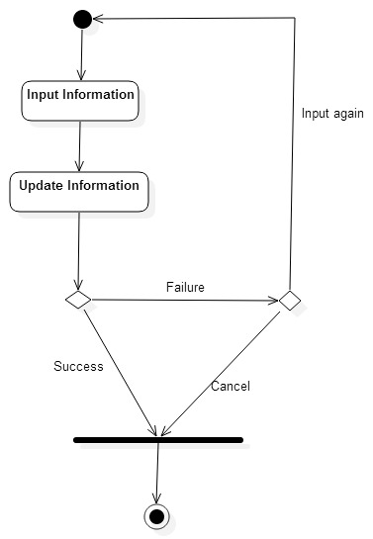
Figure 29. Activity diagram – Update User Information

- Create New Itinerary
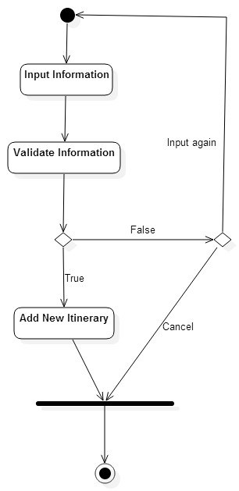
Figure 30. Activity diagram – Create New Itinerary

- Send Feedback
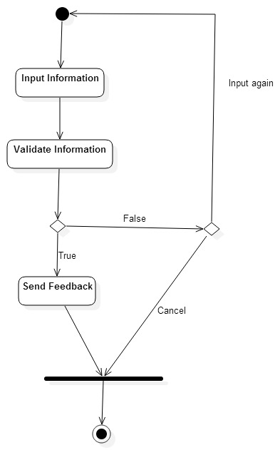
Figure 31. Activity diagram – Send Feedback

Admin
- Manage Customer
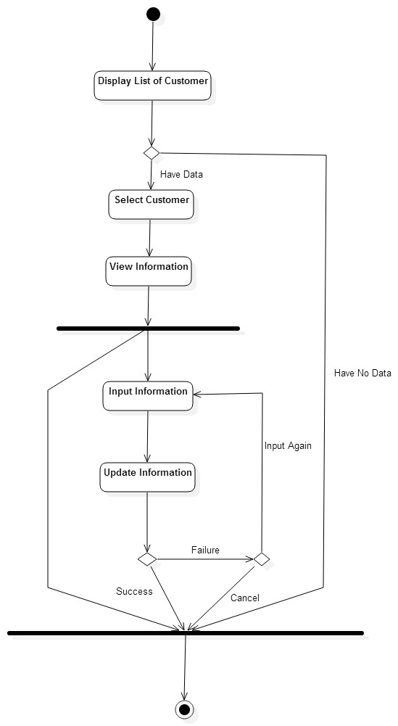
Figure 32. Activity diagram –Manage Customer

- Manage Staff
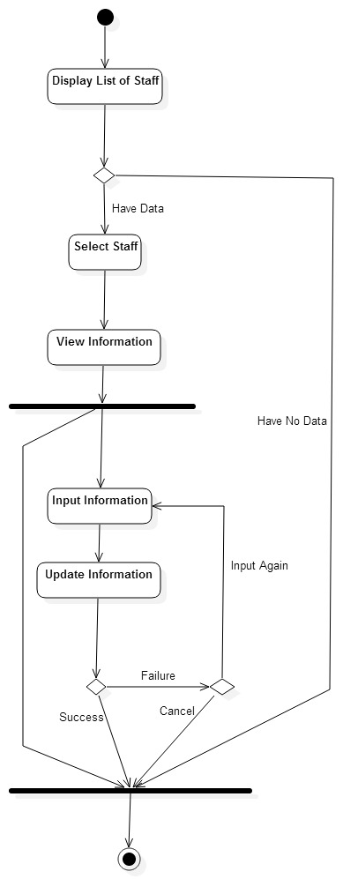
Figure 33. Activity diagram – Manage Staff

- Manage Itinerary
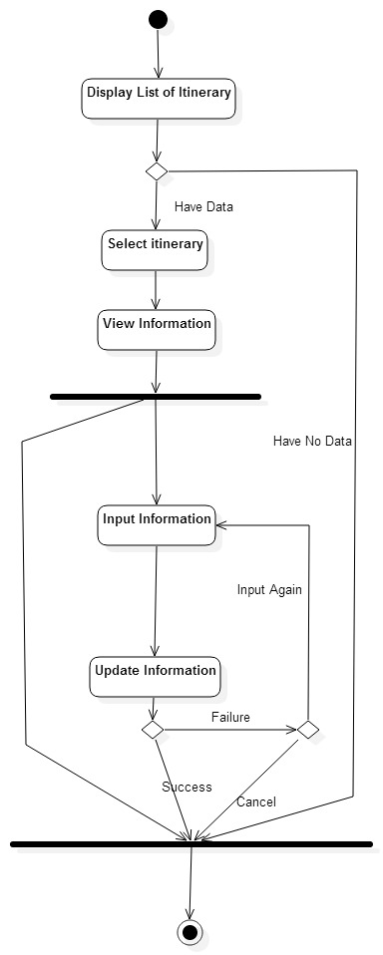
Figure 34. Activity diagram – Manage Itinerary

- Send Response
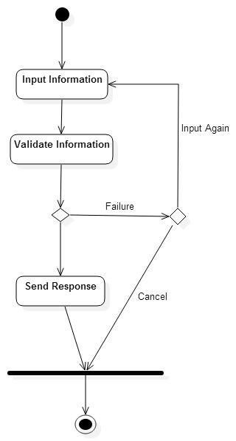
Figure 35. Activity Diagram - Send Response

Sequence Diagram

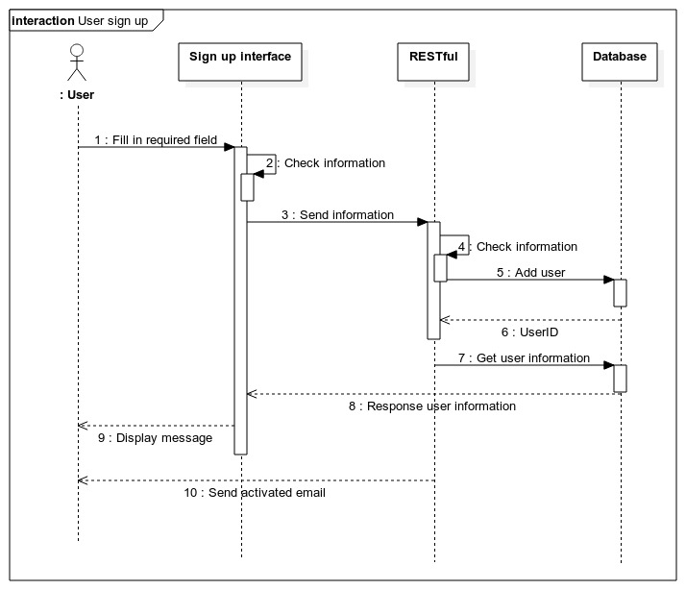
Figure 36. Sequence Diagram – User sign up

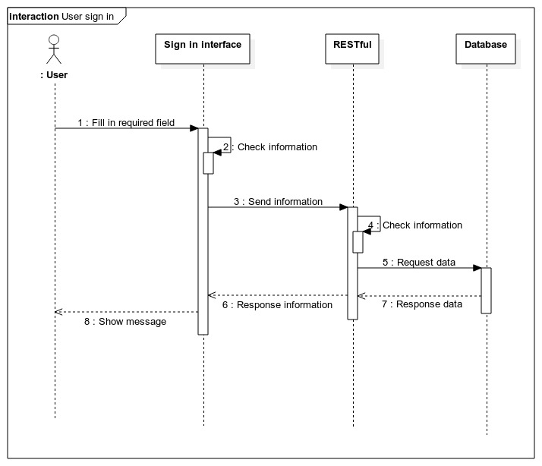
Figure 37. Sequence Diagram – User login

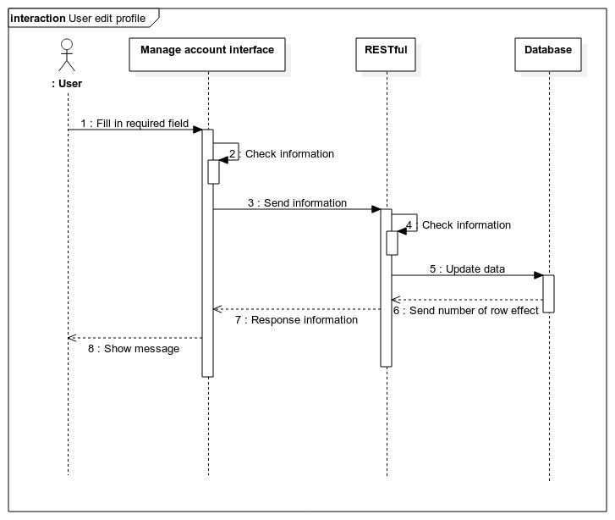
Figure 38. User edit account information

Deployment diagram
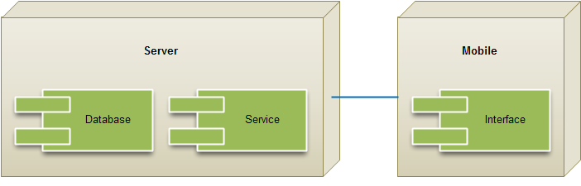
Figure 39. Deployment diagram

DATABASE DESIGN

Table description

Customer table
Contain information about user that help people to sign in to system, search itineraries, join an itinerary, edit information…
No | Field | Data Type | Description
1 | Customer_id | INT | Primary Key
2 | Email | NVARCHAR
3 | Password | NVARCHAR
4 | API_key | NVARCHAR
5 | Fullname | NVARCHAR
6 | Phone | NVARCHAR
7 | Customer_avatar | LONGTEXT
8 | PersonalID | NVARCHAR
9 | Status | INT
10 | Created_at | TIMESTAMP
Table 17. Customer Table

Driver table
Contain information about driver to make sure driver have driver license when joining the traffic, inherit from user table.
No | Field | Data Type | Description
1 | Driver_id | INT | Primary Key
2 | Email | NVARCHAR
3 | Password | NVARCHAR
4 | API_key | NVARCHAR
5 | Fullname | NVARCHAR
6 | Phone | NVARCHAR
7 | Driver_avatar | LONGTEXT
8 | PersonalID | NVARCHAR
9 | PersonalID_img | LONGTEXT
10 | Driver_lat | DOUBLE
11 | Driver_long | DOUBLE
12 | Status | INT
11 | Driver_license | NVARCHAR
12 | Driver_license_img | NVARCHAR
13 | Created_at | TIMESTAMP
Table 18. Driver table

Vehicle table
Contain information about the vehicle that driver own, to make sure it have the valid papers.
No | Field | Data Type | Description
1 | Vehicle_id | INT | Primary Key
2 | Driver_id | INT | Foreign Key
3 | Lisence_plate | NVARCHAR
4 | Lisence_plate_img | LONGTEXT
4 | Type | NVARCHAR
5 | Vehicle_img | LONGTEXT
6 | Status | INT
7 | Created_at | TIMESTAMP
Table 19. Vehicle table

Itinerary table
Contain information about the itinerary that help both driver and customer can easy look up information, also help staff manage itineraries.
No | Field | Data Type | Description
1 | Itinerary_id | INT | Primary Key
2 | Driver_id | INT | Foreign Key
3 | Customer_id | INT | Foreign Key
4 | Start_address | NVARCHAR
5 | Start_address_lat | DOUBLE
6 | Start_address_long | DOUBLE
7 | End_address | NVARCHAR
8 | End_address_lat | DOUBLE
9 | End_address_long | DOUBLE
10 | Time_start | DATETIME
11 | Description | NVARCHAR
12 | Status | INT
13 | Created_at | TIMESTAMP
Table 20. Itinerary table

Rating table
Help driver and customer rating each other.
No | Field | Data Type | Description
1 | Rating_id | INT | Primary Key
2 | Driver_id | INT | Foreign Key
3 | Customer_id | INT | Foreign Key
4 | Rating | INT
5 | Created_at | TIMESTAMP
Table 21. Rating table

Role table
Help driver and customer comment each other.
No | Field | Data Type | Description
1 | Role_id | INT | Primary Key
2 | Role_name | NVARCHAR
3 | Created_at | TIMESTAMP
Table 22. Comment table

Feedback table
Help user feedback about the system to admin.
No | Field | Data Type | Description
1 | Feedback_id | INT | Primary Key
2 | Customer_id | INT | Foreign Key
3 | Content | NVARCHAR
4 | Created_at | TIMESTAMP
Table 23. Feedback table

Staff table
Contain information that help admin manage staff.

No | Field | Data Type | Description
1 | Staff_id | INT | Primary Key
2 | Role_id | INT | Foreign Key
3 | Email | NVARCHAR
4 | Password | NVARCHAR
5 | API_key | NVARCHAR
6 | Fullname | NVARCHAR
7 | Phone | NVARCHAR
8 | Staff_avatar | LONGTEXT
9 | Hire_date | DATE
10 | Status | INT
11 | Created_at | TIMESTAMP
Table 24. Staff table

Database diagram
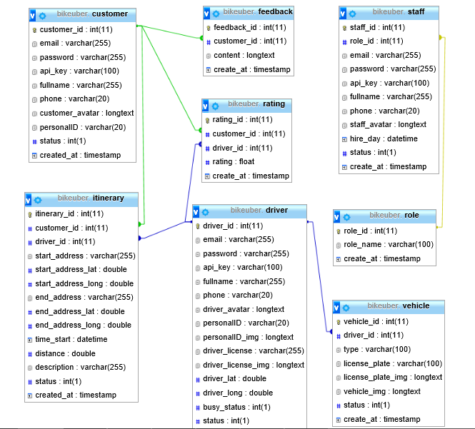
Figure 40. Database diagram

DEPLOYMENT AND RESULTS

DEPLOYMENT

Server system
Running virtual machine on EC2 Amazon webservice with:
- Operating system: Microsoft Windows Server 2012 R2 64bit
- Virtual machine: Intel Xeon Family 2.5GHz, 1 GiB memory
- XAMPP: version 5.6.8 with PHP 5.6.8
- RDBMS: MySQL 5.6.21

Database installation
Install MySQL database through 2 step:
- Step 1: Create MySQL database on server through PhpMyAdmin.
- Step 2: Import database file into MySQL on server, customize information.

RESTful Web Service installation
Install RESTful webservice through following step:
- Step 1: Connect FTP server through FileZilla. Upload RESTful packet.
- Step 2: Change configuration include: server IP address, database host, database name, database password.
- Step 3: Test connect to webservice with REST Easy add-on on firefox.
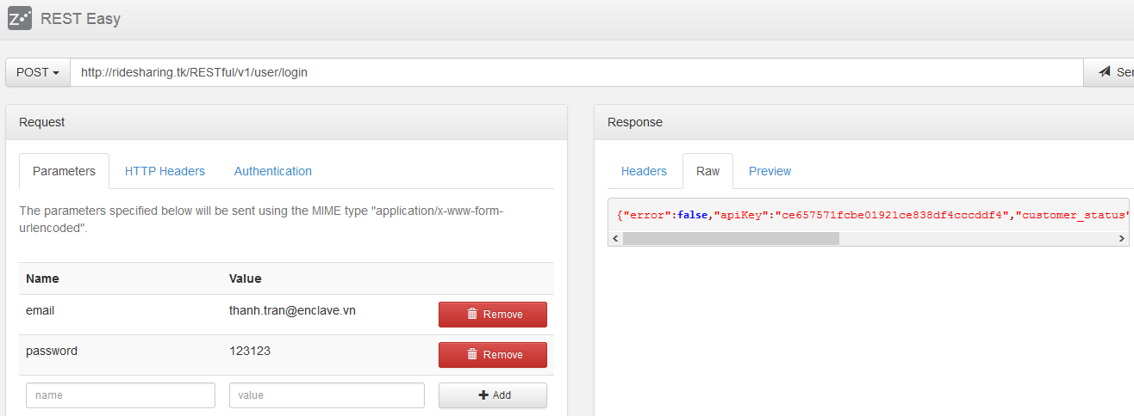
Figure 41. RESTful webservice running through REST Easy

Application on Windows Phone 8

Deployment Environment
- Language: C#
- OS: Windows Phone 8.1
- IDE: Visual Studio 2013

OVERALL RESULTS

Application on Windows Phone 8
a/ Call motorbike service
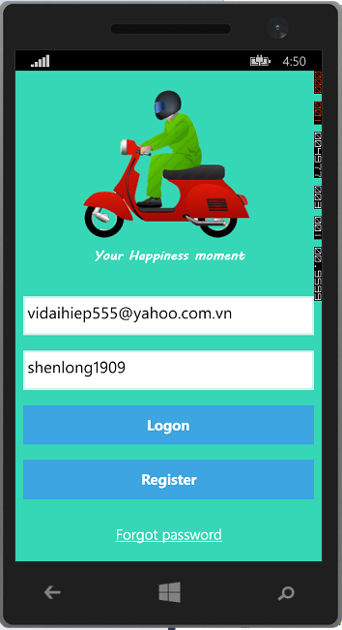
Figure 42. Login Screen

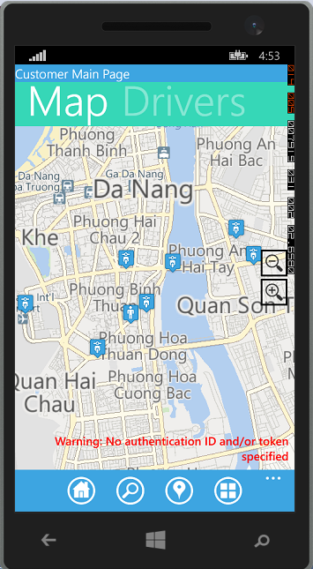
Figure 43. Search Drivers available

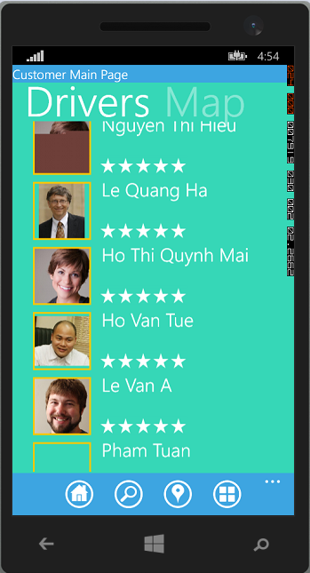
Figure 44. List Details of Drivers Available

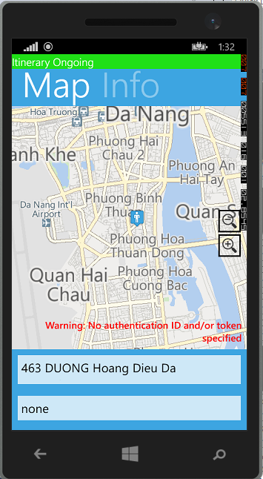
Figure 45. Ongoing Itinerary Details

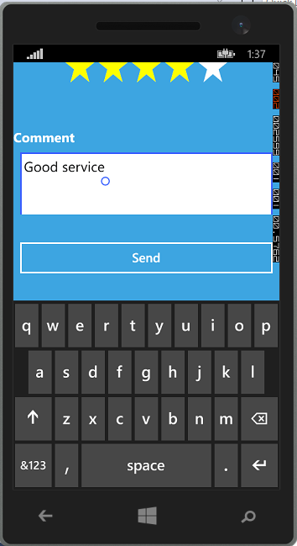
Figure 46. Rating Driver

b/ Create and manage itinerary

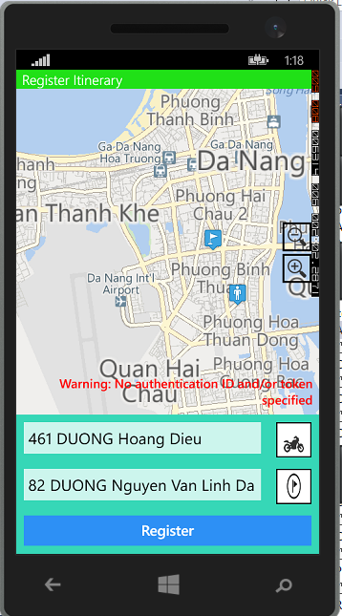
Figure 47. Create a new Itinerary

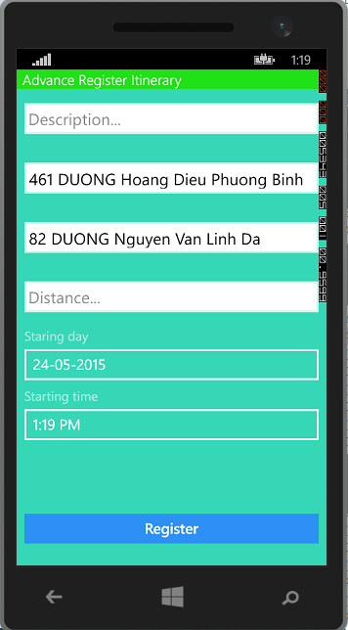
Figure 48. Create a New Itinerary

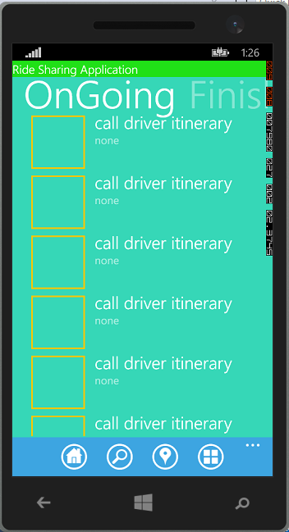
Figure 49. Itinerary Management

c/ Account Management

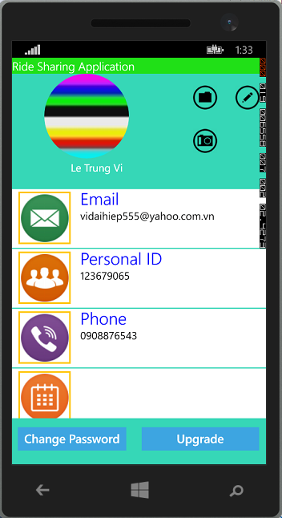
Figure 50. Account Management

d/ Report

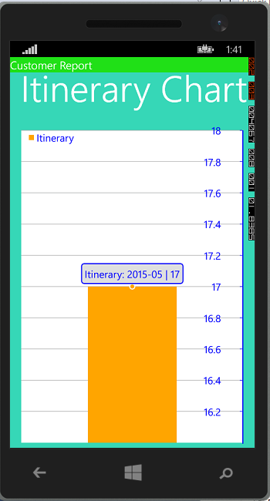
Figure 51. Report

e/ Vehicle Management

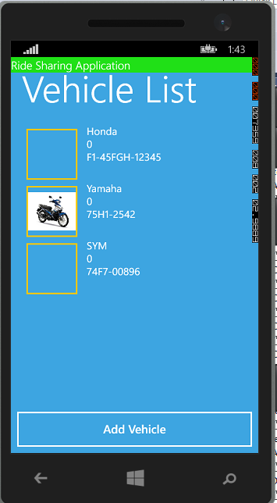
Figure 52. Vehicle Management

Web Admin

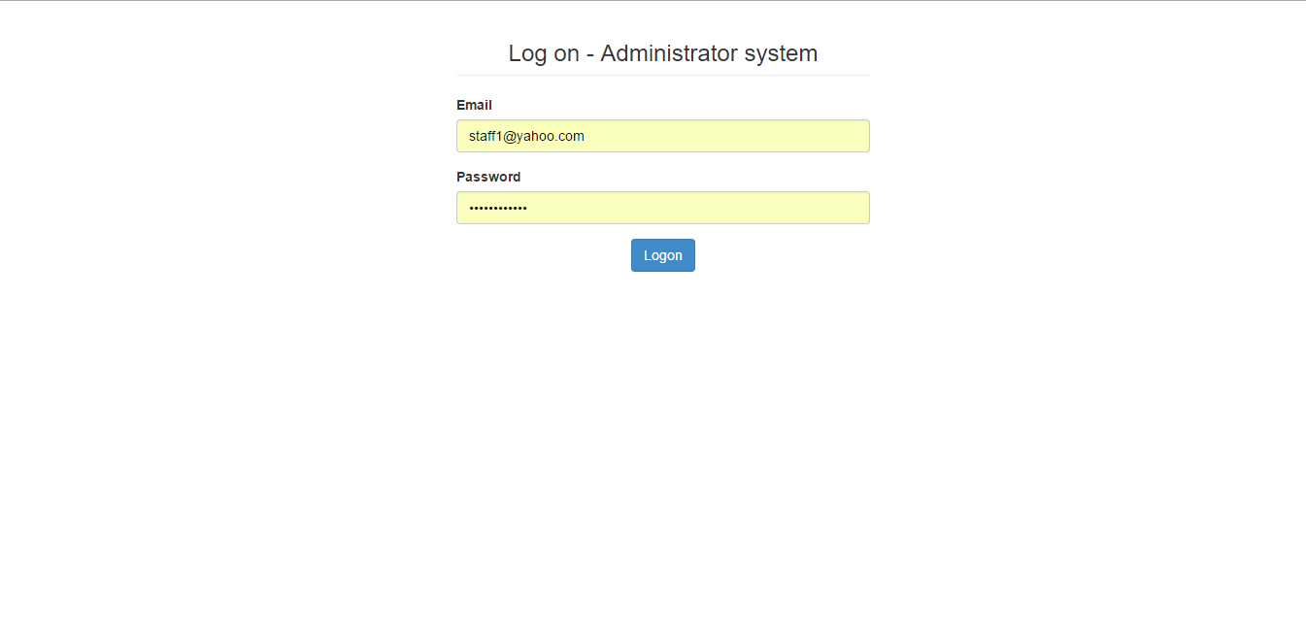
Figure 53. Login Page

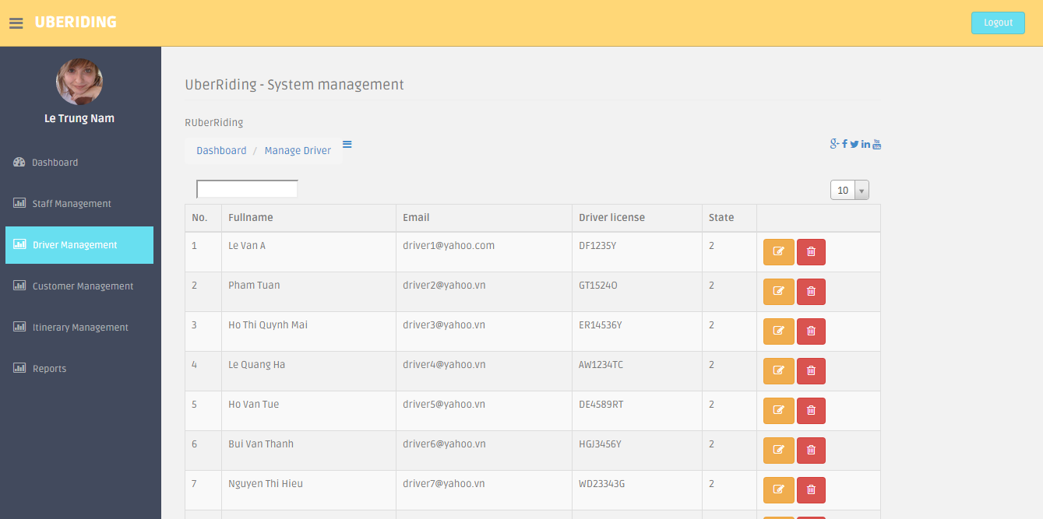
Figure 54. Admin Management Page

CONCLUSIONS

THINGS ACHIEVED
With my best efforts, the project has achieved results as expected.
Theoretically , the project has achieved:
- Get an overview theory of Webservice
- Get an overview theory of GPS
- Get an overview theory of Mobile Platform and Windows Phone 8 OS
Practically, the project has achieved:
- Build and run RESTful webservice successfully
- Research and build app on Window Phone OS successfully
- Research and build web Admin by PHP successfully
- Server system
- Design database.
- Build and run RESTful webservice successfully.
- The system worked pretty well after deploy.
- Mobile app
- Research and build app on Window Phone OS
- Deploy and run app successful on real device include: Microsoft Lumia 520, Microsoft Lumia 920, LG Optimus G, Sky 870
- The connection to server pretty well
- Website
- Research and build on PHP
Deploy and run website successful on popular web browser: Chrome, FireFox, IE
In addition, the project still has some restrictions:
- The speed of tracking is still slow
- Application is available only on Windows Phone 8
- The database is too small

DIRECTION OF FUTURE DEVELOPMENT
In future, I will try to improve the system:
- Develop an application on Android flatform
- Improve the database.
- Increase the speed of system
- Complete application on Windows Phone perfectly.

APPENDIX
Development tool
- Hardware requirements
No | Name | Description
1 | Operating system | Windows 8.1 or higher
2 | Mobile operating system | Windows Phone 8
3 | Bing Maps API | Bing Map API Code for using service

- Software requirements
No | Name | Description
1 | Microsoft Visual Studio | 2013
2 | Sublime Text | 2.2
3 | Adobe Photoshop | 7.0
4 | Microsoft Visio | 2010
5 | Windows Phone 8.1 SDK | Windows Phone 8.1 SDK
7 | Bing Maps API | -
8 | MySQL Database | 5.6.21
9 | PHP | 5.6.8

LIST OF REFERENCES

  - David Sklar and Adam Trachtenberg. PHP Cookbook
  - Matteo Pagani. Windows Phone 8 Development Succinctly
  - Alex Rodriguez. RESTful Web services: The basics.
  - Bing MAP API : https://www.microsoft.com/maps/default.aspx
  - Wiki : http://en.wikipedia.org/
  - Official U.S. Government information website about the GPS: http://www.gps.gov

Abstract

Project name: Build an application that helps people to call motorbike service on mobile platform.
Summarize the content of senior project: The purpose of this document is to give a detailed description of the requirements for the “Uber Riding with GPS” system. It will illustrate the purpose and complete declaration for the development of system. It will also explain system constraints, interface and interactions with other external application. This document is primarily intended to be proposed to a customer for its approval and a reference for developing the first version of the system for development team
Problem solving:
- Research
- Build RESTful webservice.
- Build mobile app on Window Phone OS.
- Build website for manage system.
- Deploy system in reality.

