THE UNIVERSITY OF DANANG
DANANG UNIVERSITY OF TECHNOLOGY
INFORMATION TECHNOLOGY FACULTY
Tel. (84-511) 736 949, Fax. (84-511) 842 771
Website: itf.dut.edu.vn, E-mail: cntt@dut.udn.vn

SENIOR PROJECT THESIS
INFORMATION TECHNOLOGY

PROJECT NAME:
Build an application call driver service on mobile platform

STUDENT: LE Trung Vi
INSTRUCTOR: PhD NGUYEN Tan Khoi

DA NANG, 05/2015

ACKNOWLEDGEMENTS
I am deeply indebted to PhD NGUYEN Tan Khoi- Professor of Information Technology Faculty for worthy guidance that helps me a lot in finishes the senior project.
I'd like to express my deeply appreciation to my supervisors, Mr. LE Hoang Hung – CEO of the Enclave, Mr. HUYNH Danh – Group Manager and Mr. NGUYEN Lieu – Project Manager, for their guidance and patience during the course of our senior project at the Enclave Company.
Without the generous help of yours, our senior would not have been successful.
Thanks for all again.

Danang, 05/2015
Student,

LE Trung Vi

GUARANTEE
I guarantee:
- The contents of this senior project are performed by my-self following the guidance of PhD NGUYEN Tan Khoi
- All references, which used in this senior project thesis are quoted with author’s name, project’s name, time and location to publish clearly and faithfully.
- All invalid copies, educated statute violation or cheating will be born the full responsibility by my-self.
Dannang, 05/2015
Student,

LE Trung Vi

INSTRUCTOR’S REVIEWS

TABLE OF CONTENT
INTRODUCTION 1
1. CONTEXT 1
2. ORIENTATIONS AND SCOPES 1
2.1. Orientations for developing project 1
2.2. Scopes of project 1
2.3. Theories 1
3. STRUCTURE OF THESIS 1
4. DEFINITIONS, ACRONYMS AND ABBREVIATIONS 2
Chapter 1. THEORIES AND TECHNOLOGIES 3
1. INTRODUCTION 3
2. MAIN TECHNOLOGIES IN PROJECT 3
2.1. Overview 3
2.2. Mobile Platform – Windows Phone 3
2.3. PHP Slim Framework 3
2.4. Global Poisitioning System (GPS) 3
2.5. Bing Map 4
2.6. Web Service 4
Chapter 2. REQUIREMENT SPECIFICATION 5
1. INTRODUCTION 5
1.1. Purpose 5
1.2. Scope 5
2. OVERALL DESCRIPTION 5
2.1. Actor 5
2.2. USE-CASE MODEL SURVEY 6
3. SPECIFIC REQUIREMENTS 15
3.1. USE-CASE USER APPLICATION 15
3.2. USE-CASE SYSTEM MANAGEMENT 24
Chapter 3. ANALYSIS AND DESIGN 36
1. INTRODUCTION 36
2. OVERVIEW DESIGN 36
3. DETAIL DESIGN 37
3.1. Analysis 37
3.2. Activity Diagram 37
3.3. Class Diagram 40
3.4. Sequence Diagram 40
3.5. Entity Relationship Diagram 41
Chapter 4. SYSTEM DEPLOYMENT 44
1. APLLICATION ON WINDOWS PHONE 8 45
2. WEB SERVER 49
2.1. Log-in 49
2.2. Manage User 49
2.3. Manage Itinerary 49
2.4. Tracking 50
2.5. Report 50
CONCLUSIONS 50
1. ACHIEVED RESULT 50
2. FUTURE WORK 51
REFERENCES 52

LIST OF TABLES
Table 1. UC-General-Description of actors 25
Table 2. UC-General-Description of use-case 25
Table 3. UC-Manage Timesheet-Description of use-case 26
Table 4. UC-View Timesheet-Description of use-case 26
Table 5. UC-Notification-Description of use-case 27
Table 6. đâsddfdfsdfsdf 28
Table 7. Table 1 28
Table 8. đâsddfdfsdfsdf 29
Table 9. Table 2 29
Table 10. đâsddfdfsdfsdf 30
Table 11. Table 3 30
Table 12. đâsddfdfsdfsdf 31
Table 13. đâsddfdfsdfsdf 31
Table 14. đâsddfdfsdfsdf 32
Table 15. đâsddfdfsdfsdf 32
Table 16. đâsddfdfsdfsdf 33
Table 17. đâsddfdfsdfsdf 33
Table 18. đâsddfdfsdfsdf 34
Table 19. đâsddfdfsdfsdf 35
Table 20. đâsddfdfsdfsdf 35
Table 21. đâsddfdfsdfsdf 36
Table 22. đâsddfdfsdfsdf 36
Table 23. đâsddfdfsdfsdf 37
Table 24. Table 4 37
Table 25. đâsddfdfsdfsdf 38
Table 26. Table 5 38
Table 27. đâsddfdfsdfsdf 38
Table 28. Table 6 39
Table 29. đâsddfdfsdfsdf 39
Table 30. Table 7 39
Table 31. đâsddfdfsdfsdf 40
Table 32. Table 9 40
Table 33. đâsddfdfsdfsdf 40
Table 34. Table 10 41
Table 35. đâsddfdfsdfsdf 41
Table 36. đâsddfdfsdfsdf 42
Table 37. đâsddfdfsdfsdf 42
Table 38. đâsddfdfsdfsdf 43
Table 39. đâsddfdfsdfsdf 43
Table 40. Table 11 44
Table 41. đâsddfdfsdfsdf 44
Table 42. Table 12 45
Table 43. Table 12 45
Table 44. đâsddfdfsdfsdf 46
Table 45. đâsddfdfsdfsdf 46
Table 46. đâsddfdfsdfsdf 47
Table 47. đâsddfdfsdfsdf 48
Table 48. đâsddfdfsdfsdf 48
Table 49. UC-Get review message-Flow of Events 49
Table 50. UC- Get notification-Flow of Events 49
Table 51. UC-Get notification from server-Flow of Events 49
Table 52. UC-Set up Notification System-Flow of Events 50
Table 55. User 64
Table 56. Timesheet 64
Table 57. Project 65
Table 58. Actvities 65
Table 59. Roles 65
Table 60. UserInProject 66
Table 61. UserInRoles 66
Table 62. DateStatus 66
Table 63. RegisDevice 67
Table 64. Groups 67
Table 65. CheckTimesheetLog 67

LIST OF FIGURE
Figure 1-1. PhoneGap overview 1
Figure 1-2. PhoneGap application architecture 2
Figure 1-3: PhoneGap supported platforms 4
Figure 1-4: PhoneGap application packaging and distribution 5
Figure 1-5. PhoneGap high-level application architecture 5
Figure 1-6. JQuery Mobile UI elements 7
Figure 1-7. JQuery Mobile-the same UI for smartphones and tablet 8
Figure 1-8. jQuery Mobile Browser Coverage 8
Figure 1-9. Iphone /Windows Phone/Android 9
Figure 1-10. Phone display/ Tablet/Desktop display 10
Figure 1-11. Responsive design-portrait and landscape 11
Figure 1-12. Default Theme and Custom Theme 12
Figure 1-13. JQuery Mobile page events 13
Figure 1-14. Servlet and Servlet Container 16
Figure 1-15. Multi-Thread Server 19
Figure 1-16. NodeJS server 20
Figure 2-1. General use-case diagram 23
Figure 2-2. Record time-sheet use-case diagram 24
Figure 2-3. View time-sheet use-case diagram 24
Figure 2-4. Get notifications use-case diagram 25
Figure 3-1. Overview design 31
Figure 3-2. New Timsheet activity diagram. 33
Figure 3-3. View timesheet activity diagram 34
Figure 3-4. Get new message activity diagram 35
Figure 3-5. Set up notification activity diagram 36
Figure 3-6. Get notification activity diagram 37
Figure 3-7. Overview class diagram 38
Figure 3-8. Detail class diagram 39
Figure 3-9. Timesheet management sequence diagram 40
Figure 3-10. Notification system sequence diagram 41
Figure 3-11. Entity Relationship diagram 42
Figure 3-12. Log in screen and Home screen 47
Figure 3-13. Create new timesheet screen 48
Figure 3-14. Edit Timesheet 48
Figure 3-15. Delete Timesheet 49
Figure 3-16. Get review message 49
Figure 3-17. Default set up notification system 50
Figure 3-18. Custom set up notification system 50
Figure 3-19. Get message on cell phone 51
Figure 3-20. View chart 51

CONTEXT
INTRODUCTION

The purpose of this document is to give a detailed description of the requirements for the “Uber Riding with GPS” system. It will illustrate the purpose and complete declaration for the development of system. It will also explain system constraints, interface and interactions with other external application. This document is primarily intended to be proposed to a customer for its approval and a reference for developing the first version of the system for development team.

ORIENTATIONS AND SCOPES

Orientations for developing project

Scopes of project

Theories

Technologies
- Windows Phone 8 OS
- PHP Slim Framework
- Bing Map
- Web Service
- GPS

Tool and environment implement
- Visual Studio 2013 IDE
- Sublime Text 2 IDE
- MySql

STRUCTURE OF THESIS

Introduction: Overview of project
Chapter 1: Theories and Technologies
Chapter 2: Software Requirement Specification
Chapter 3: Design
Chapter 4: System Deployment
Conclusion : Archived results, restrictions and future works.

DEFINITIONS, ACRONYMS AND ABBREVIATIONS

Term | Definition
GPS | Global Positioning System
SRS | Software requirement specification
AWS | Amazon Web Services – A cloud computing platform provided by Amazon.com
REST | Representational State Transfer – An architectural style for networked hypermedia applications
RESTFul | Web service APIs that adhere to the REST architectural constraints
API | Application program interface - A set of routines, protocols, and tools for building software applications

INTRODUCTION

THEORIES AND TECHNOLOGIES
.

MAIN TECHNOLOGIES IN PROJECT

Overview

Mobile Platform – Windows Phone

C# Language

Windows Phone 8 OS

PHP Slim Framework

PHP Language

Slim Framework Overview

Global Poisitioning System (GPS)

GPS Overview

GPS Operation

GPS Accuracy

Bing Map

Bing Map Overview

Operation of Bing Map

Bing Map API

Web Service

Web Service Overview

Architect of Webservices

Components
2.6.3.1. XML – eXtensible Markup Language
2.6.3.2. WSDL – Web Service Description Language
2.6.3.3. Universal Description, Discovery, and Integration (UDDI)
2.6.3.4. SOAP – Simple Object Access Protocol
2.6.3.5. RESTFul

Operation of Webservices

Amazone Websevices Overall

INTRODUCTION

REQUIREMENT SPECIFICATION

Purpose
The purpose of this document is to give a detailed description of the requirements for the “Ride Sharing with GPS” system. It will illustrate the purpose and complete declaration for the development of system. It will also explain system constraints, interface and interactions with other external application. This document is primarily intended to be proposed to a customer for its approval and a reference for developing the first version of the system for development team.

Scope
The “UberRiding with GPS” includes a GPS- based mobile application, a website application which help user posting, searching and join an itinerary with the other people.
By using the GPS, RESTFul web service technique, the system can help people easily find, join and tracking an itinerary.

OVERALL DESCRIPTION

Actor
The below diagram describes all actors of the Ride Sharing with GPS System. An actor represents Guest Role, an actor represents a User Role, Driver and Customer Account derive from User, another actor is represents for Staff Role, Admin Account derive from Staff. Each user has his own actions when accessing into the system, based on his rights. Driver Account have right to login, create new vehicle, update vehicle, delete vehicle, post new itinerary, update itinerary, delete itinerary, view and update profile, view statistic, accept an request to join an itinerary from customer and logout
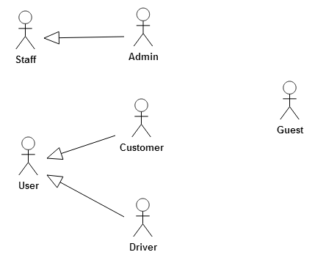
Figure 1
Actor | Description
Guest | Have the rights to register new account, visit website to view information about the system
User | Have right to login, activate their account, reset password when forgot, send feedback about the system and logout
Customer | Have right to view and update their profile, search itineraries, join and cancel an itinerary, tracking an itinerary, view schedule of itineraries, view statistic,
Driver | Have right to create new vehicle, update vehicle, delete vehicle, post new itinerary, update itinerary, delete itinerary, view and update profile, view statistic, accept and deny an request to join an itinerary from customer and tracking an itinerary
Staff | Have right to login, manage User, manage itineraries, manage feedback from user, monitor all itinerary and logout
Admin | Have right to manage Staff, view statistic.
- Table 1

USE-CASE MODEL SURVEY

Use-Case General
This use-case describes all functions of the application, this section includes: Use-Case diagram, decription of all actors, decription of all use-cases that are used to specific all requirements of this project.

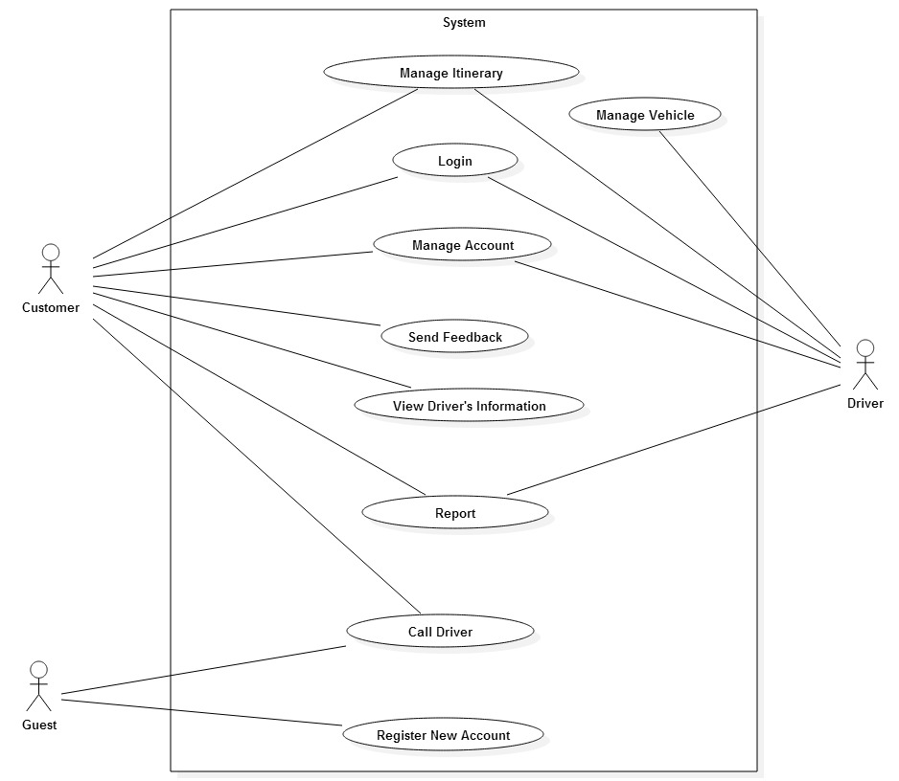

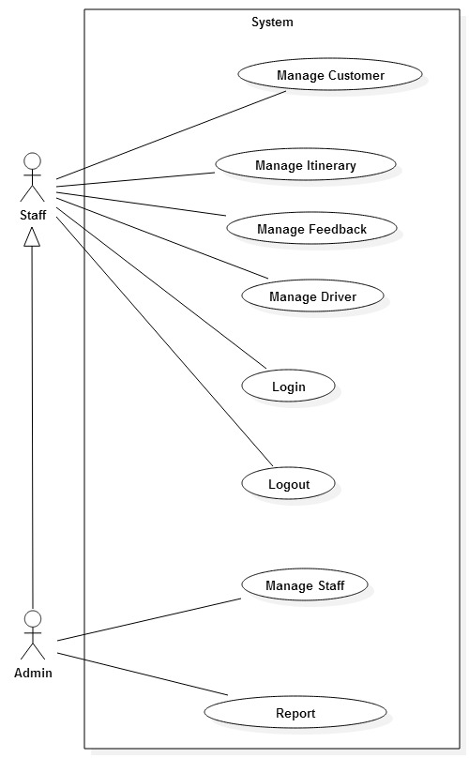

Use-Case User Application
2.2.2.1. Use-Case Login
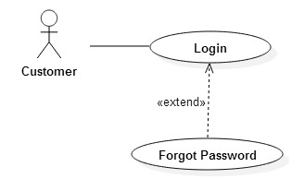

2.2.2.2. Use-Case Call Driver
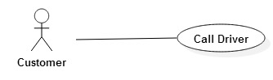
2.2.2.3. Use-Case Register New Account
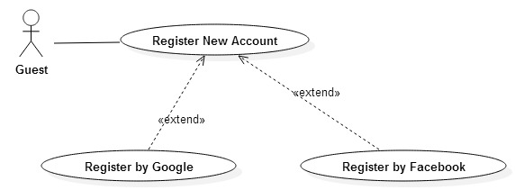
2.2.2.4. Use-Case Manage Account
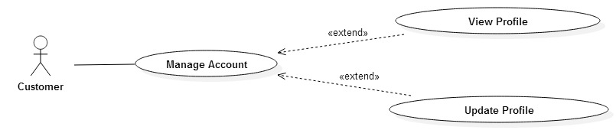

2.2.2.5. Use-Case Manage Itinerary
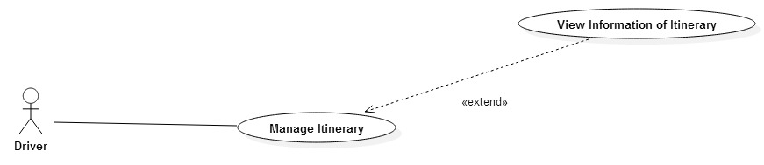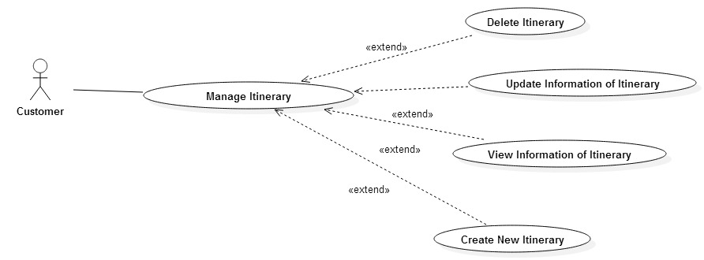

2.2.2.6. Use-Case Send Feedback
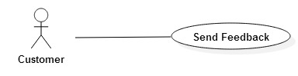

2.2.2.7. Use-Case View Driver’s Information
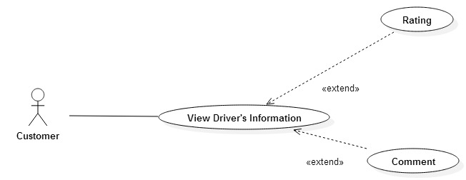

2.2.2.8. Report
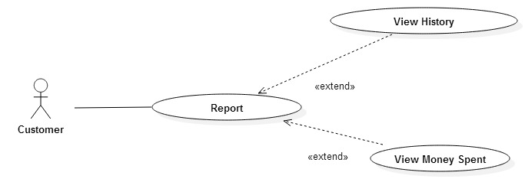

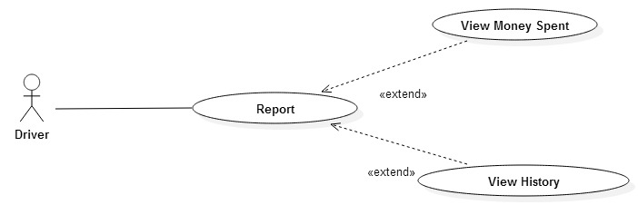

2.2.2.9. Use-Case Manage Vehicle
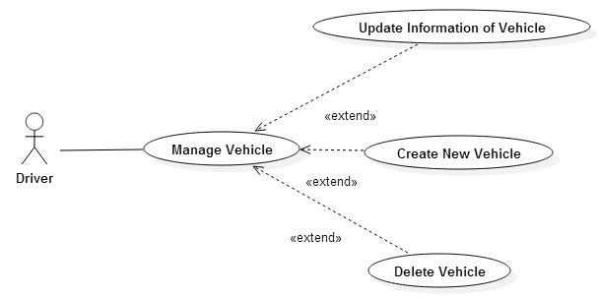

Use-Case Admin
2.2.3.1. Use-Case Manage Itinerary
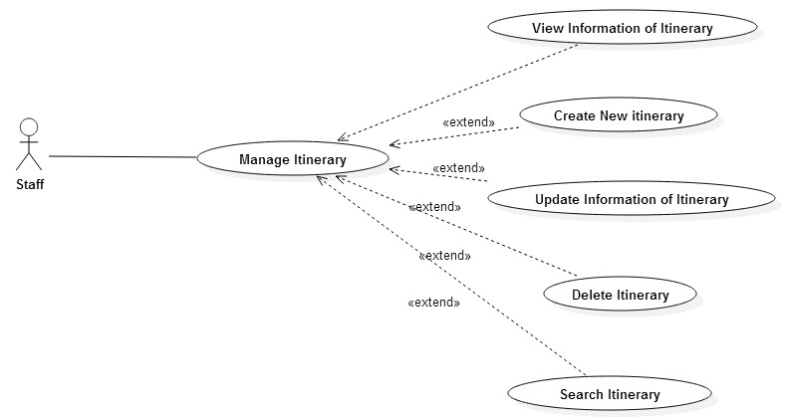

2.2.3.2. Use-Case Manage Customer

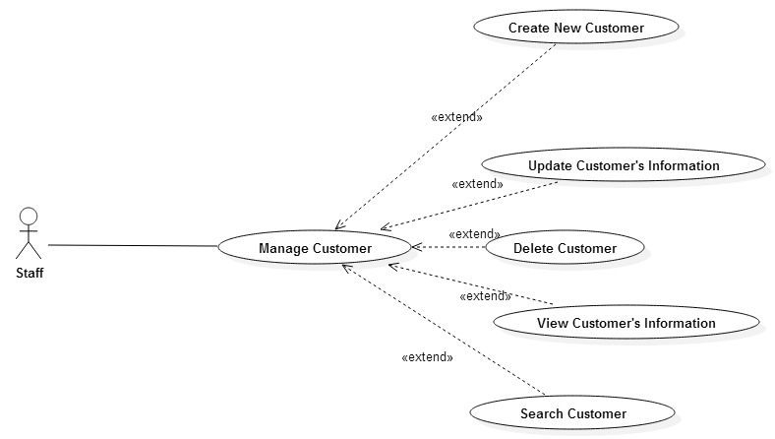

2.2.3.3. Use-Case Manage Driver
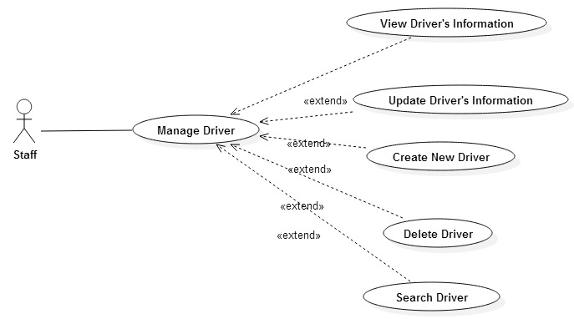

2.2.3.4. Use-Case Manage Feedback

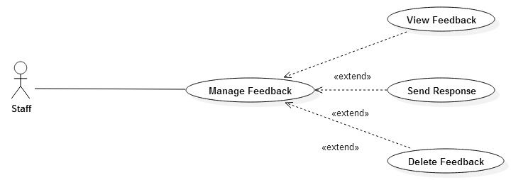

2.2.3.5. Use-Case Report
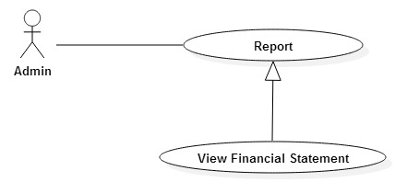
2.2.3.6. Use-Case Manage Staff
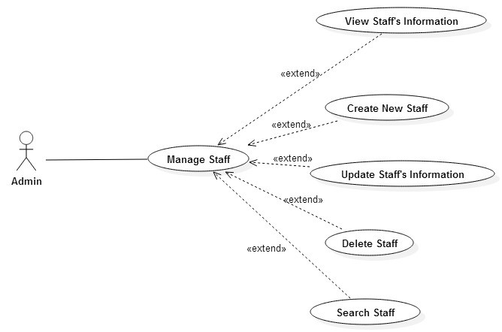

SPECIFIC REQUIREMENTS

USE-CASE USER APPLICATION

Log in
3.1.1.1. UC01-Log-in
3.1.1.1.1. Brief Description
This use case allow user to login into this application.
3.1.1.1.2. Pre-Condition
The user have to register new account and activate account via email.
3.1.1.1.3 Post-Condition
Dsdsd
3.1.1.1.4. Flow of Events
- Basic flow
Step | Description
1 | User type email and password in “Email” field and “Password” field
2 | User click the “Login” button
3 | Application's main screen is displayed in the screen
- đâsddfdfsdfsdf
- Alternative flow
Step | Description
3.1 | If user doesn't enter email, system will show an error message “Please enter email!”
3.2 | If user doesn't enter password, system will show an error message “Please enter password!”
3.3 | If email isn't existed or password is wrong, system will show an error message “Wrong email or password!”
- Table 2

Log out
3.1.2.1. UC02-Log out
3.1.2.1.1. Brief Description
This Use case allow user logout their account from application.
3.1.2.1.2. Pre-Condition
User have login to the system.
3.1.2.1.3. Post-Condition
The user’s API key was remove from Session.
3.1.2.1.4. Flow of Events
- Basic flow
Step | Description
1 | User click to the “Logout” button on the right menu
2 | Screen is displayed “Do you want to logout?”
3 | User click “Yes” button
4 | System redirect to the login screen
- đâsddfdfsdfsdf
- Alternative flow
Step | Description
3.1 | User click to the “No” button
4.1 | System redirect to the main screen
- Table 3

UC03-Register New Account
3.1.3.1. UC03-User Register New Account
3.1.3.1.1. Brief Description
This user-case is for the user registration. A user must register before they are able to log on the system. Registration primarily consists of entering an email address for verification and creating a password
3.1.3.1.2. Pre-Condition
User is not a member of the system
3.1.3.1.3. Post-Condition
Database was updated
3.1.3.1.4. Flow of Events
- Basic flow
Step | Description
1 | User enters their email address and password in “Email” and “Password” field
2 | System validates that the email does not already exists. If it does not, a new user is created and a confirmation email is sent with a confirmation link that needs to be selected before the user is allowed to enter the system.
3 | User checks their email for the email that the system sent and gets the confirmation link. The user selects the confirmation link.
4 | System accepts the confirmation link and requests the user to log in using their email and password
- đâsddfdfsdfsdf
- Alternative flow
Step | Description
2.1 | If user doesn't enter email, System will show an error message “Please enter email!”
2.2 | If user doesn't enter password, System will show an error message “Please enter password!”
2.3 | If email is existed, System will show an error message “This email is existed!”
2.4 | If password isn't from 6 to 12 characters, System will show an error message “Password has to be from 6 – 12 characters”
- Table 4

Send Feedback
3.1.4.1. UC04-Send Feedback
3.1.4.1.1. Brief Description
This Use case allows user or rider to send anything about application to administrator.
3.1.4.1.2. Pre-Condition
User have open the function menu.
3.1.4.1.3. Post-Condition
Display the text field and button “Send” in order to write user’s feedback.
3.1.4.1.4. Flow of Events
- Basic flow
Step | Description
1 | User click to the “Feedback” Section.
2 | Screen is displayed the Feedback text field and buttons is: “Send feedback”.
3 | User write feedback in the text field.
4 | User click “Send feedback” button to send the feedback.
5 | The screen will display: “Are you sure?”
6 | Click “Yes” button to send or “No” button to cancel.
- đâsddfdfsdfsdf

UC05-Manage Account
3.1.5.1. UC05-View Profile
3.1.5.1.1. Brief Description
This use case allow user to view and manage their profile.
3.1.5.1.2. Pre-Condition
The user who already logged account then click on Account Management Menu.
3.1.5.1.3. Post-Condition
User profile will display in the screen.
3.1.5.1.4. Flow of Events
- Basic flow
Step | Description
1 | Choose the User's Profile field.
2 | User's profile is displayed on the screen.
- đâsddfdfsdfsdf

3.1.5.2. UC07-Update Profile
3.1.5.2.1. Brief Description
This Use-case allows user update any basic information about their profile.
3.1.5.2.2. Pre-Condition
The user must log in to the system with the valid account then navigate to the menu and choose the “Account Management” feature.
3.1.5.2.3. Post-Condition
The database is updated.
3.1.5.2.4. Flow of Events
- Basic flow
Step | Description
1 | User navigate to the “Account Management” feature on a menu to update
2 | Click on a “Update” button
3 | Fill the Information need to update
4 | New update on a database
- đâsddfdfsdfsdf

Manage Itinerary
3.1.6.1. UC08-View Information of Itinerary
3.1.6.1.1. Brief Description
This Use case allows user view schedule.
3.1.6.1.2. Pre-Condition
The user has login to application.
3.1.6.1.3. Post-Condition
dfdfsd
3.1.6.1.4. Flow of Events
Step | Description
1 | User click on “Menu” button
2 | The screen of menu is displayed
3 | User click on “Schedule” button on menu
4 | The list of Schedule is displayed
- đâsddfdfsdfsdf

3.1.6.2. UC09-Delete Itinerary
3.1.6.2.1. Brief Description
This Use case allows user delete schedule.
3.1.6.2.2. Pre-Condition
The user has login to application.
The user has accessed “View schedule” screen
3.1.6.2.3. Post-Condition
Database is updated.
3.1.6.2.4. Flow of Events
Step | Description
1 | User click on schedule need to delete
2 | The action button for this schedule is displayed
3 | Use click “Delete” button
4 | System will display message: “Do you want to delete?”
5 | User click “Yes” button
6 | Update database

3.1.6.3. UC10-Create New Itinerary
3.1.6.3.1. Brief Description
This Use case allows user delete schedule.
3.1.6.3.2. Pre-Condition
The user has login to application.
The user has accessed “View schedule” screen
3.1.6.3.3. Post-Condition
Database is updated.
3.1.6.3.4. Flow of Events
- Basic flow
Step | Description
1 | User navigate to the “Account Management” feature on a menu to update
2 | Click on a “Update” button
3 | Fill the Information need to update
4 | New update on a database

3.1.6.4. UC11-Update Information of Itinerary
3.1.6.4.1. Brief Description
This Use case allows user delete schedule.
3.1.6.4.2. Pre-Condition
The user has login to application.
The user has accessed “View schedule” screen
3.1.6.4.3. Post-Condition
Database is updated.
3.1.6.4.4. Flow of Events
- Basic flow
Step | Description
1 | User navigate to the “Account Management” feature on a menu to update
2 | Click on a “Update” button
3 | Fill the Information need to update
4 | New update on a database
- đâsddfdfsdfsdf

View Driver’s Information
3.1.7.1. UC12-Comment
3.1.7.1.1. Brief Description
This Use case allows user comment about another user.
3.1.7.1.2. Pre-Condition
The user has login to application.
The user has accessed “Itinerary detail” screen
3.1.7.1.3. Post-Condition
A new comment is saved into the database.
3.1.7.1.4. Flow of Events
- Basic flow
Step | Description
1 | User click on the name of other user
2 | The screen of profile of another user is displayed
3 | Use click on “Comment” button
4 | User type comment content
5 | User click on “Send” button
6 | User’s comment is displayed
7 | Update database
- đâsddfdfsdfsdf

3.1.7.2. UC12-Rating
3.1.7.2.1. Brief Description
This Use case allows user rate another user.
3.1.7.2.2. Pre-Condition
The user has accessed “Itinerary detail” screen.
3.1.7.2.3. Post-Condition
A new rating is saved or update into the database.
3.1.7.2.4. Flow of Events
- Basic flow
Step | Description
1 | User click on the name of other user
2 | The screen of profile of another user is displayed
3 | Use click on “Rating” button
4 | Update database
- đâsddfdfsdfsdf

Report
3.1.8.1. UC12-View History
3.1.8.1.1. Brief Description
This Use case allows user view the list of itinerary in the past.
3.1.8.1.2. Pre-Condition
The user has login to application.
The user has open the function menu.
3.1.8.1.3. Post-Condition
A list of itinerary in the past of system are displayed.
3.1.8.1.4. Flow of Events
- Basic flow
Step | Description
1 | User click on “Analyze Statistically” section on menu.
2 | The screen of Analyze Statistically is displayed
3 | User click on “History of Itineraries” button.
4 | System will display list of itinerary in the past.
- đâsddfdfsdfsdf

3.1.8.2. UC12-View Amount of Money Spent
3.1.8.2.1. Brief Description
This Use case allows user view the amount of money has been spent.
3.1.8.2.2. Pre-Condition
The user has login to application.
The user has open the function menu.
3.1.8.2.3. Post-Condition
A total amount of money and the amount of money for each itinerary are displayed.
3.1.8.2.4. Flow of Events
- Basic flow
Step | Description
1 | User click on “Analyze Statistically” section on menu.
2 | The screen of Analyze Statistically is displayed
3 | User click on “Amount of Money Spent” button.
4 | System will display A total amount of money and the amount of money for each itinerary.
- đâsddfdfsdfsdf

USE-CASE SYSTEM MANAGEMENT

Login
3.2.1.1. UC001-Login
3.2.1.1.1. Brief Description
This use case allow staff login to system management.
3.2.1.1.2. Pre-Condition
The staff already have an account.
3.2.1.1.3. Post-Condition
The main screen is displayed, the staff’s API key was store in Session.
3.2.1.1.4. Flow of Events
- Basic flow
Step | Description
1 | Staff type email and password in “Email” field and “Password” field
2 | Staff click the “Login” button
3 | System’s main screen is displayed in the screen
- đâsddfdfsdfsdf
- Alternative flow
Step | Description
3.1 | System display “Wrong email or password” message
3.2 | System display “The email does not exist” message
- Table 5

Log out
3.2.2.1. UC002-Log out
3.2.2.1.1. Brief Description
This use case allow staff logout their account from system.
3.2.2.1.2. Pre-Condition
Staff have to login to system.
3.2.2.1.3. Post-Condition
The login screen display, the staff’s API key was remove from Session.
3.2.2.1.4. Flow of Events
- Basic flow
Step | Description
1 | Staff click the “Logout” button on the left corner or on the right menu
2 | Screen is displayed “Do you want to logout?”
3 | Staff click “Yes” button
4 | System redirect to the login screen
- đâsddfdfsdfsdf
- Alternative flow
Step | Description
3.1 | Staff click “No” button
4.1 | System redirect to main screen
- Table 6

Manage Customer
3.2.3.1. UC003-View Customer’s Information
3.2.3.1.1. Brief Description
This Use case allow staff to view list of user profile.
3.2.3.1.2. Pre-Condition
Staff have to login to system.
3.2.3.1.3. Post-Condition

3.2.3.1.4. Flow of Events
- Basic flow
Step | Description
1 | Staff click “Manage user” on the right menu.
2 | System display list of user profile.
- đâsddfdfsdfsdf
- Alternative flow
Step | Description
3.1 | Staff click “No” button
4.1 | System redirect to main screen
- Table 7

3.2.3.2. UC004-Delete Customer
3.2.3.2.1. Brief Description
This Use case allow staff delete one, many or all of user profile.
3.2.3.2.2. Pre-Condition
The staff has accessed the “Manage user” screen.
3.2.3.2.3. Post-Condition
Database is updated.
3.2.3.1.4. Flow of Events
- Basic flow
Step | Description
1 | Staff choose the user in List User they want to delete
2 | Staff click “Delete” button
3 | System display message: “Do you want to delete?”
4 | Staff click “Yes” button
5 | User was deleted from the system

- Alternative flow
Step | Description
4.1 | Staff click “No” button
5.1 | System redirect to “Manage user” screen

Table 8
3.2.3.3. UC004-Search Customer
3.2.3.3.1. Brief Description
This Use case allows staff search user by name.
3.2.3.3.2. Pre-Condition
The user has accessed “Manage user” screen.
3.2.3.3.3. Post-Condition
ssss
3.2.3.3.4. Flow of Events
- Basic flow
Step | Description
1 | Staff enter the key word into the search’s text field
2 | Staff click “Search” button
3 | System display all result on the screen

- Alternative flow
Step | Description
3.1 | System display “No result found”

3.2.3.2. UC004-Update Customer’s Information
3.2.3.2.1. Brief Description
This Use case allow staff active new user when their information is correct.
3.2.3.2.2. Pre-Condition
The staff has accessed “Manage user” screen.
3.2.3.2.3. Post-Condition
Database is updated.
3.2.3.2.4. Flow of Events
- Basic flow
Step | Description
1 | Staff choose a user in the list of user want to active
2 | Staff click “Edit” button
3 | System display “User detail” screen
4 | Staff click “Save” button
5 | System redirect to “User detail” screen

- Alternative flow
Step | Description
4.1 | Staff click “Back” button
5.1 | System redirect to “Manage user” screen

Manage Itinerary
3.2.4.1. UC004-View Itinerary
3.2.4.1.1. Brief Description
This Use-case allows staff review an itinerary.
3.2.4.1.2. Pre-Condition
The staff must log in to the system with the valid account then navigate to the menu and choose the “Itinerary Management” feature.
3.2.4.1.3. Post-Condition

3.2.4.1.4. Flow of Events
- Basic flow
Step | Description
1 | Staff navigate to the “View Itinerary” or “Itinerary Details” feature on a menu
2 | System display a list of all itinerary

3.2.4.2. UC004-Update Itinerary
3.2.4.2.1. Brief Description
This Use-case allows staff update an itinerary.
3.2.4.2.2. Pre-Condition
The staff must log in to the system with the valid account then navigate to the menu and choose the “Itinerary Management” feature.
3.2.4.2.3. Post-Condition
Database is updated
3.2.4.2.4. Flow of Events
- Basic flow
Step | Description
1 | Staff navigate to the “View Itinerary” or “Itinerary Details” feature on a menu to update
2 | New update on a database

3.2.4.3. UC004-Delete Itinerary
3.2.4.3.1. Brief Description
This Use-case allows staff delete an itinerary. Have two ways to do that, first is choose and delete itinerary when navigation to the “View Itinerary” feature. The second is delete the itinerary through the “View details Itinerary” feature..
3.2.4.3.2. Pre-Condition
The user has accessed Manage staff main screen.
3.2.4.3.3. Post-Condition
Database is updated
3.2.4.3.4. Flow of Events
- Basic flow
Step | Description
1 | Staff select the itinerary on a “List of Itinerary” or “Details of Itinerary” to delete
2 | Click on a “Delete” button
3 | System will display message: “Do you want to delete?”
4 | User click “Yes” or “No” button
5 | Updating database

3.2.4.4. UC004-Search Itinerary
3.2.4.4.1. Brief Description
This Use-case allows staff search itineraries by the day or the position
3.2.4.4.2. Pre-Condition
The user has accessed “Itinerary Management” main screen.
3.2.4.4.3. Post-Condition

3.2.4.4.4. Flow of Events
- Basic flow
Step | Description
1 | User choose the type of key word that they want to search for
2 | User enter the key word into the text field
3 | Click on a “Search” button
4 | System will display all result on the screen

Manage Staff
3.2.5.1. UC004-Create New Staff
3.2.5.1.1. Brief Description
This Use-case allows admin create a new staff.
3.2.5.1.2. Pre-Condition
The admin has accessed “Manage staff” screen.
3.2.5.1.3. Post-Condition
A new staff record is saved into the database.
3.2.5.1.4. Flow of Events
- Basic flow
Step | Description
1 | Admin click “Create staff” button
2 | The screen “Create staff” is displayed
3 | Staff fill in require field
4 | Staff click “Create” button
5 | New staff being created

- Alternative flow
Step | Description
5.1 | Alert “Missing require field” display
5.2 | Alert “The Personal ID” has been exist display
5.3 | Alert “The email has been exist” display

3.2.5.2. UC004-Delete Staff
3.2.5.1.1. Brief Description
This Use-case allows admin delete one, many or all of staff profile. Having two ways to do that. The first way is use can choose and delete staff when admin are using View staff function. The second way is use can delete the current receiving when use View details staff function.
3.2.5.1.2. Pre-Condition
The user has accessed Manage staff main screen.
3.2.5.1.3. Post-Condition
Database is updated.
3.2.5.1.4. Flow of Events
- Basic flow
Step | Description
1 | User choose the staff in List Staff or Detail Staff that they want to delete
2 | Click “Delete” button
3 | System will display message: “Do you want to delete?”
4 | User click “Yes” button
5 | Update database

3.2.5.3. UC004-Search for Staff
3.2.5.3.1. Brief Description
This Use case allows user search staff by Name or by Personal ID.
3.2.5.3.2. Pre-Condition
The user has accessed manage staff main screen.
3.2.5.3.3. Post-Condition
Display all of result about staff with key word was entered.
3.2.5.3.4. Flow of Events
- Basic flow
Step | Description
1 | User choose the type of key word that they want to search for.
2 | User enter the key word into the text field
3 | User click “Search” button
4 | System will display all result on the screen

3.2.5.3. UC004-Update Staff’s Information
3.2.5.3.1. Brief Description
This Use case allows user edit the content of staff profile. Having two ways to do it. The first way is when user use View staff function, they choose one of staff and edit it. The second way is when user use View details staff function, they can edit this staff.
3.2.5.3.2. Pre-Condition
The user has accessed Manage staff main screen.
3.2.5.3.3. Post-Condition
Database is updated.
3.2.5.3.4. Flow of Events
- Basic flow
Step | Description
1 | User choose the staff in the staff list that they want to edit
2 | Click “Edit” button
3 | System will display screen allows user edit
4 | User edit information they want
5 | Click “Save” button

Manage Feedback
3.2.6.1. UC004-View Feedback
3.2.6.1.1. Brief Description
This Use-case allows staff review all feedback from user
3.2.6.1.2. Pre-Condition
The staff must log in to the system with the valid account then navigate to the menu and choose the “Feedback Management” feature.
3.2.6.1.3. Post-Condition

3.2.6.1.4. Flow of Events
- Basic flow
Step | Description
1 | Staff navigate to the “View Feedback” feature on a menu
2 | System display a list of feedback

3.2.6.2. UC004-Send Response
3.2.6.2.1. Brief Description
This Use-case allows staff send response to user through their feedback
3.2.6.2.2. Pre-Condition
The staff must log in to the system with the valid account then navigate to the menu and choose the “Feedback Management” feature.
3.2.6.2.3. Post-Condition

3.2.6.2.4. Flow of Events
- Basic flow
Step | Description
1 | Staff navigate to the “List of Feedback” feature
2 | Staff choose the feedback
3 | Type the response into the text field
4 | Click the “Send” button
5 | New response is updated into Database

3.2.6.3. UC004-Delete Feedback
3.2.6.3.1. Brief Description
This Use-case allows staff delete a feedback.
3.2.6.3.2. Pre-Condition
The staff has accessed Manage Feedback main screen.
3.2.6.3.3. Post-Condition
Database is updated.
3.2.6.3.4. Flow of Events
- Basic flow
Step | Description
1 | Staff select the feedback on a “List of Feedback” to delete
2 | Click on a “Delete” button
3 | System will display message: “Do you want to delete?”
4 | Click on a “Yes” or “No” button
5 | Updating database

Report
3.2.7.1. UC004-View History of Itinerary
3.2.7.1.1. Brief Description
This Use-case allows user view the list of itinerary in the past.
3.2.7.1.2. Pre-Condition
The user must log in to the system with their valid account and navigate to the menu and choose the Analyze Statistically feature.
3.2.7.1.3. Post-Condition

3.2.7.1.4. Flow of Events
- Basic flow
Step | Description
1 | User click on “Analyze Statistically” feature on menu
2 | Display the Analyze Statistically screen
3 | User click on “History of Itineraries” button
4 | System will display all the list of itineraries

3.2.7.1. UC004-View Amount of Money Spent
3.2.7.1.1. Brief Description
This Use-case allows user review the history of the payment.
3.2.7.1.2. Pre-Condition
The user must log in to the system with their valid account then navigate to the menu and choose the “History of Payment” feature.
3.2.7.1.3. Post-Condition

3.2.7.1.4. Flow of Events
- Basic flow
Step | Description
1 | User click on “Analyze Statistically” feature on menu
2 | Display the Analyze Statistically screen
3 | User click on “History of Payment” button
4 | System will display a history of payment

INTRODUCTION

ANALYSIS AND DESIGN
This chapter presents the current design and implementation of the project. It includes data model analyze and design, some detailed design such as: activity diagram, class diagram, sequence diagram.

OVERVIEW DESIGN

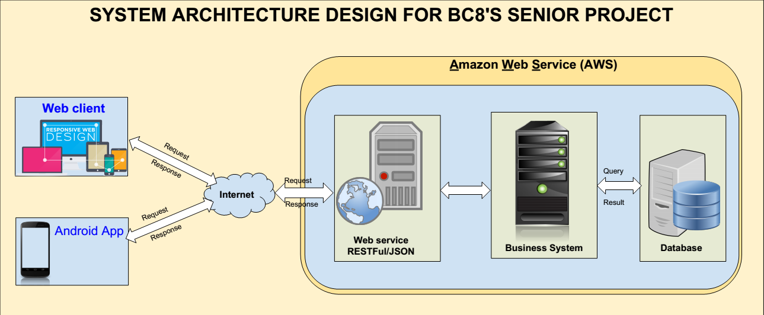
Figure 3-2. Overview design

DETAIL DESIGN

Analysis

Activity Diagram

User Application Activity Diagram
3.2.1.1. Register

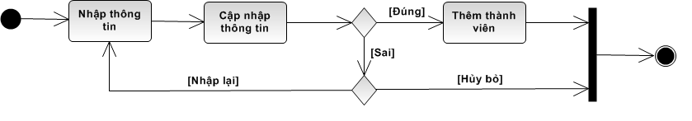
3.2.1.2. Log-in
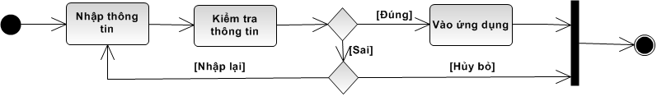
3.2.1.3. Manage Account
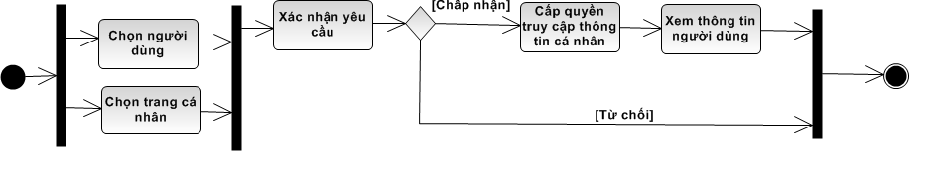
3.2.1.4. Update Customer’s Information
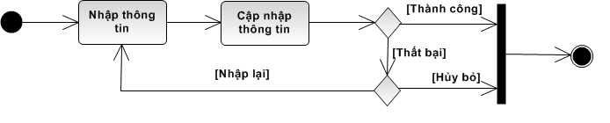

3.2.1.5. Create New Itinerary
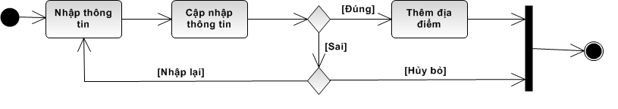

3.2.1.6. Update Information of Itinerary
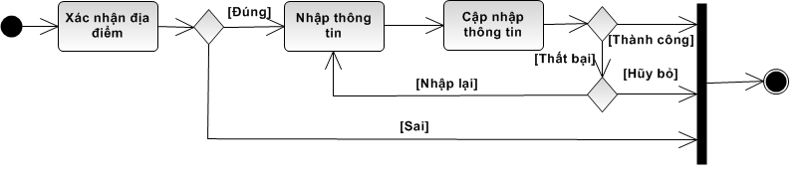
3.2.1.7. Send Feedback
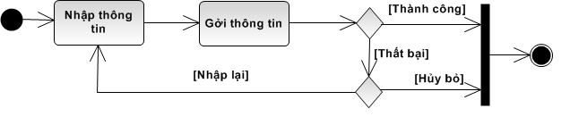

Admin Activity Diagram

3.2.2.1. Search for Information

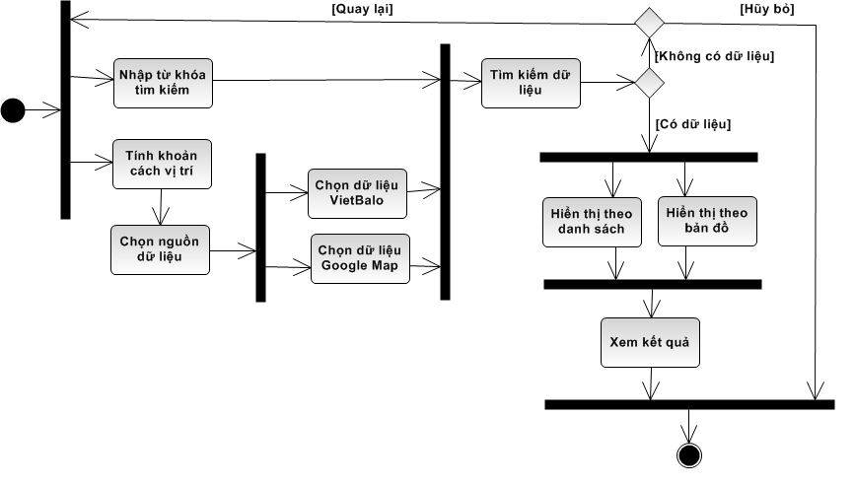
3.2.2.2. Response Feedback
3.2.2.3. Manage Feedback
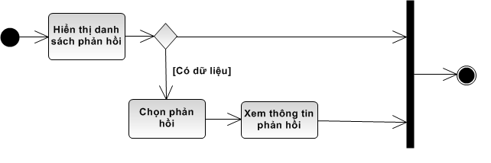

3.2.2.4. Manage User
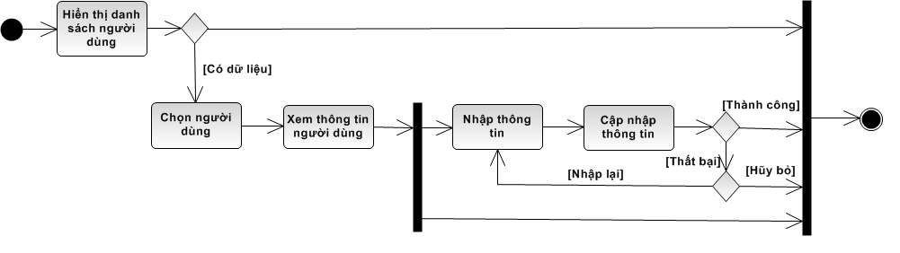

Class Diagram

Overview Diagram

Detailed diagram

Sequence Diagram

Timesheet Management module

Notification system module

Entity Relationship Diagram

Diagram

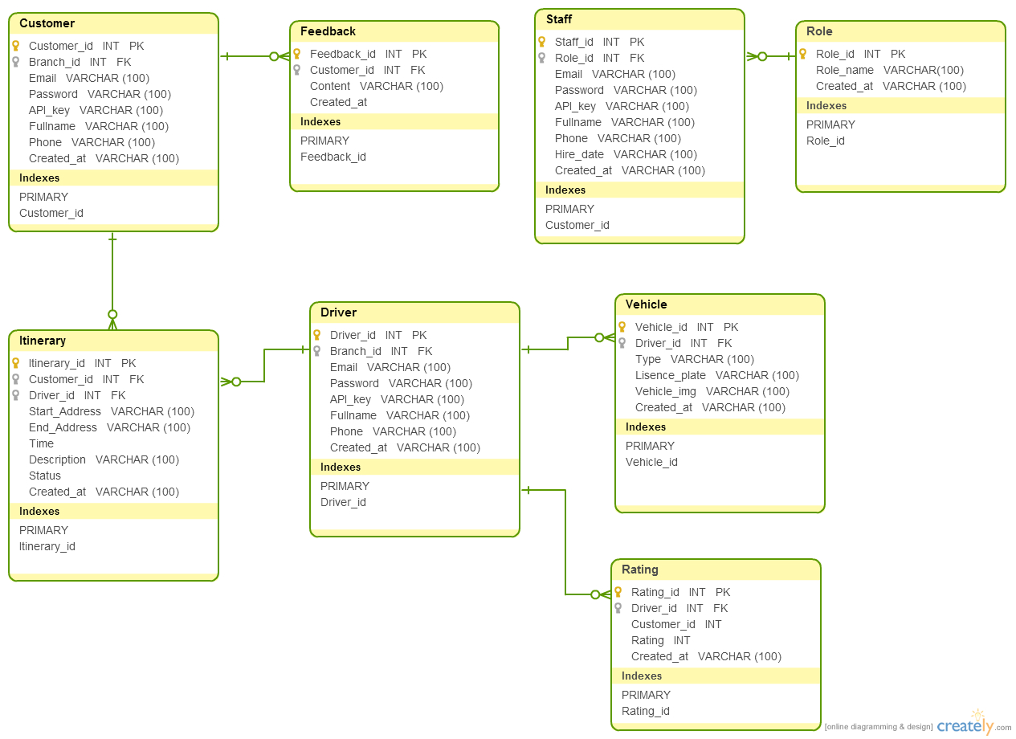
Figure 3-3. Entity Relationship diagram

Table description
3.5.2.1. Table Customer
No | Field | Data Type | Description
1 | Customer_id | INT | Primary Key
2 | Email | NVARCHAR
3 | Password | NVARCHAR
4 | API_key | NVARCHAR
5 | Fullname | NVARCHAR
6 | Phone | NVARCHAR
7 | Created_at | DATETIME
- Table 9

3.5.2.2. Table Driver

No | Field | Data Type | Description
1 | Driver_id | INT | Primary Key
2 | Email | NVARCHAR
3 | Password | NVARCHAR
4 | API_key | NVARCHAR
5 | Fullname | NVARCHAR
6 | Phone | NVARCHAR
7 | Created_at | DATETIME

3.5.2.3. Table Itinerary

No | Field | Data Type | Description
1 | Itinerary_id | INT | Primary Key
2 | Driver_id | INT
3 | Customer_id | INT
4 | Start_address | NVARCHAR
5 | End_address | NVARCHAR
6 | Time | DATETIME
7 | Description | NVARCHAR
8 | Status | INT
0 | Created_at | DATETIME

3.5.2.4. Table Vehicle

No | Field | Data Type | Description
1 | Vehicle_id | INT | Primary Key
2 | Driver_id | INT
3 | Lisence_plate | NVARCHAR
4 | Type | NVARCHAR
5 | Vehicle_img | NVARCHAR
6 | Created_at | DATETIME

3.5.2.5. Table Feedback

No | Field | Data Type | Description
1 | Feedback_id | INT | Primary Key
2 | Customer_id | INT
3 | Content | NVARCHAR
4 | Created_at | DATETIME

3.2.5.6. Table Rating

No | Field | Data Type | Description
1 | Rating_id | INT | Primary Key
2 | Driver_id | INT
3 | Customer_id | INT
4 | Rating | INT
5 | Created_at | DATETIME

3.2.5.7. Table Staff

No | Field | Data Type | Description
1 | Staff_id | INT | Primary Key
2 | Role_id | INT
3 | Email | NVARCHAR
4 | Password | NVARCHAR
5 | API_key | NVARCHAR
6 | Fullname | NVARCHAR
7 | Phone | NVARCHAR
8 | Hire_date | DATE
9 | Created_at | DATETIME

3.2.5.8. Table Role

No | Field | Data Type | Description
1 | Role_id | INT | Primary Key
2 | Staff_id | INT
3 | Role_name | NVARCHAR
4 | Created_at | DATETIME

APLLICATION ON WINDOWS PHONE 8

SYSTEM DEPLOYMENT

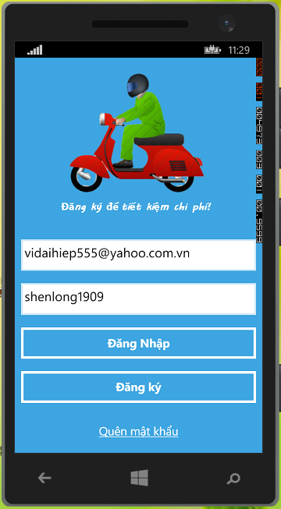

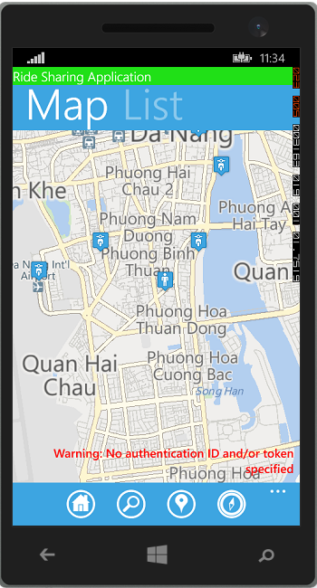

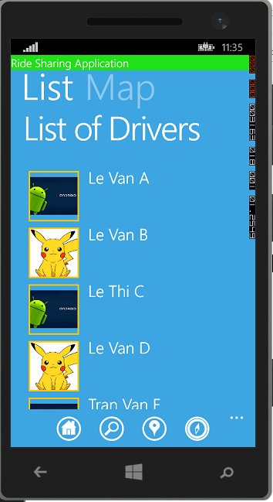

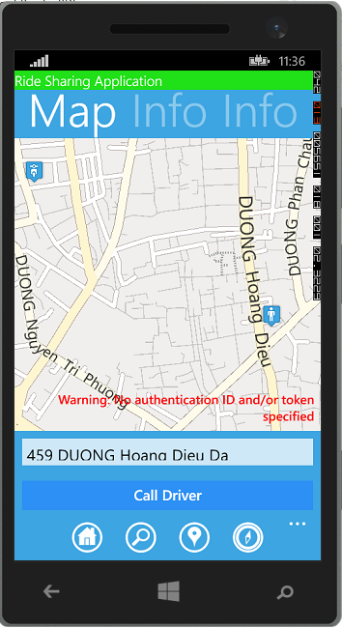

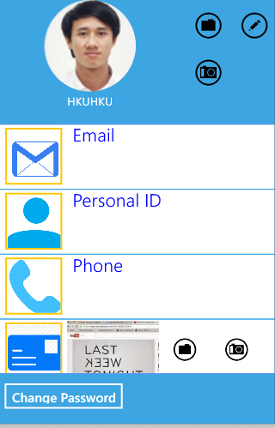

WEB SERVER

Log-in
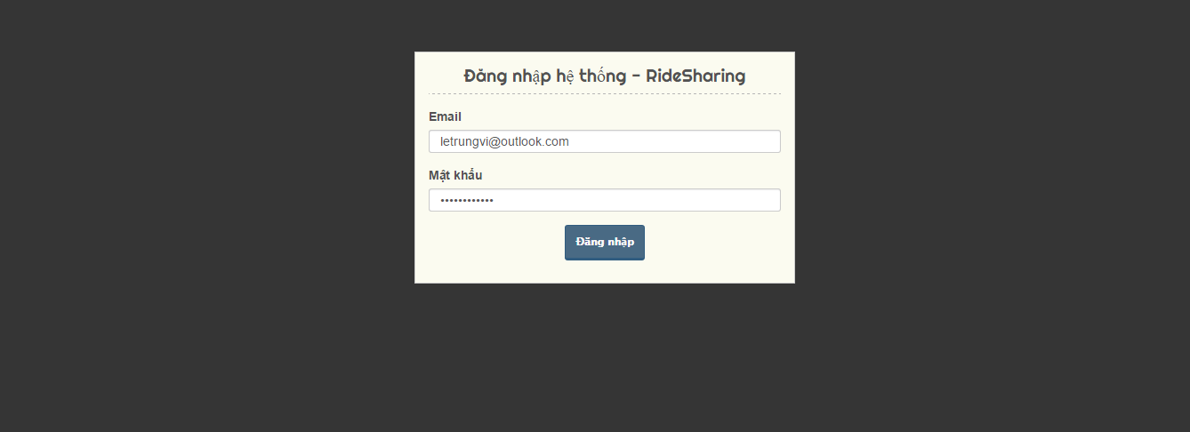

Manage User
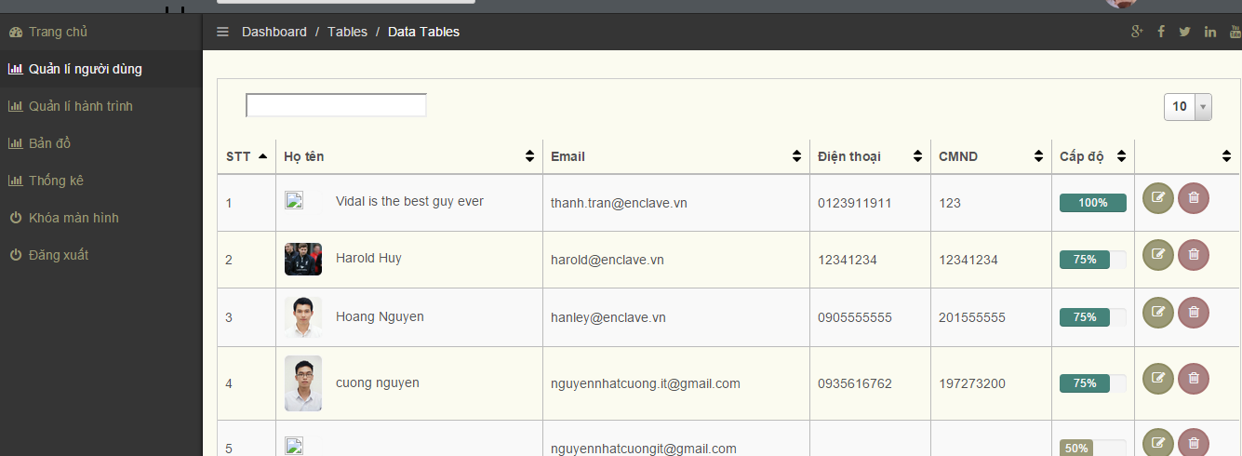

Manage Itinerary
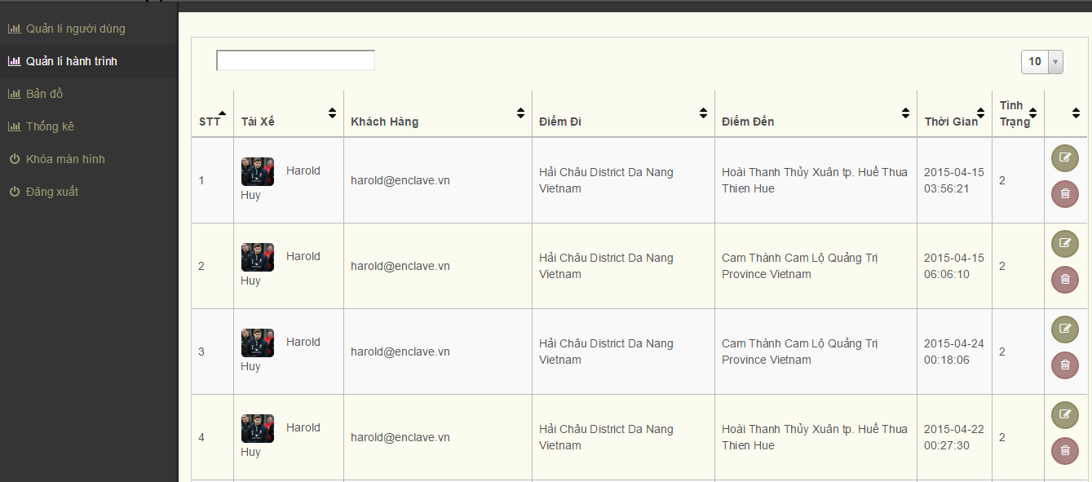

Tracking
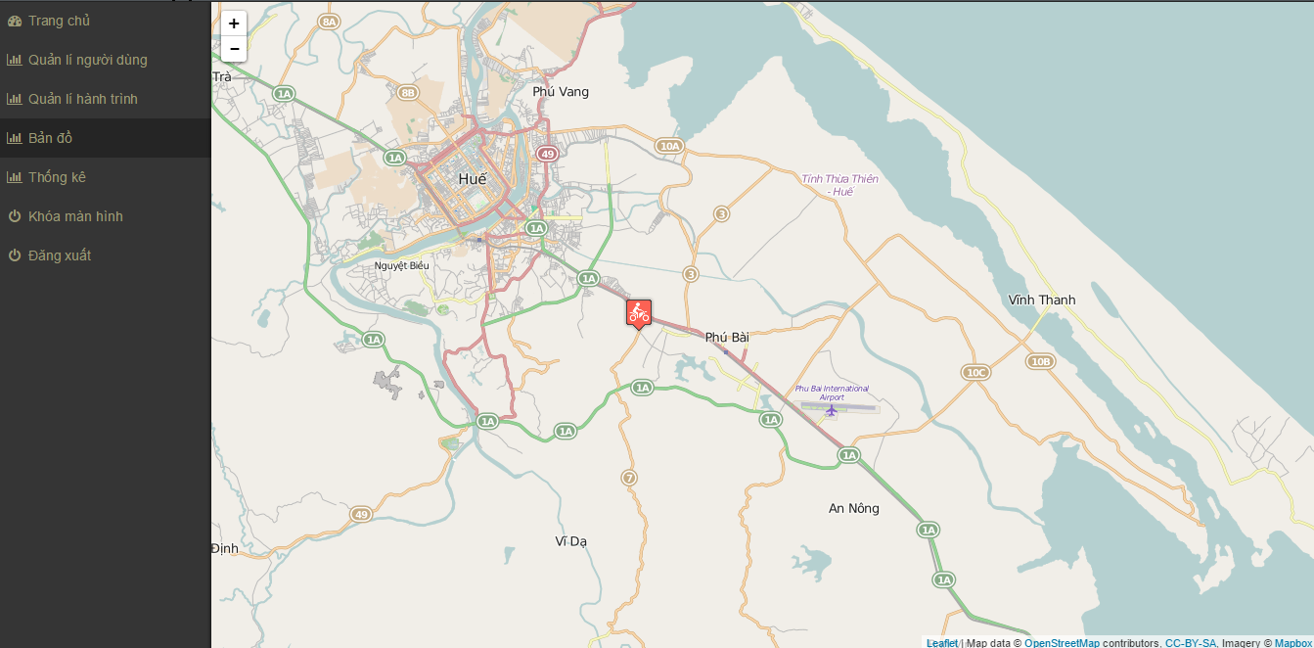

Report
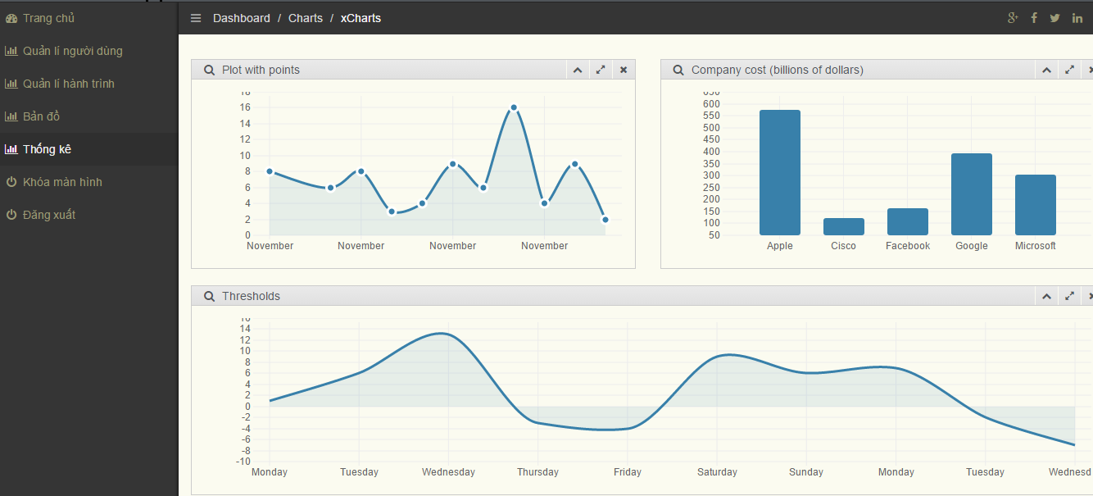

With my best efforts, my project has achieved results as expected. In addition, it still has some restrictions. In future, I will expand this project much more so it can work with web form to help managers manage timesheet of his employees.
CONCLUSIONS

ACHIEVED RESULT

FUTURE WORK

REFERENCES
- Website:
- Website:
- Website:
- Website:

