**Lovaverkefni í GSÖ1TÖ05AU**

**Hluti B:**

**Eftirfarandi fyrirspurnir:**

**a)** SELECT diskur.nafn as Diskur, lag.nafn FROM lag JOIN diskur WHERE diskur.nafn = "Far Wes" and diskur.id = lag.diskur;

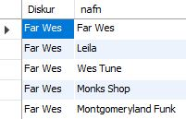,

**b)** SELECT flytjandi.nafn as Flytjandi, lag.nafn FROM lag JOIN flytjandi WHERE flytjandi.nafn = "Andy Mckee" and flytjandi.id = lag.flytjandi;

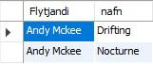,

**c)** SELECT lag.nafn as Lag, tegund.nafn as Tegund FROM lag JOIN tegund WHERE tegund.nafn = "Rock" and tegund.id = lag.tegund;

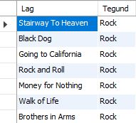,

**d)** SELECT nafn as Lag, sec_to_time(lengd) as Duration FROM lag WHERE sec_to_time(lengd) > sec_to_time(300) ORDER BY lengd DESC;

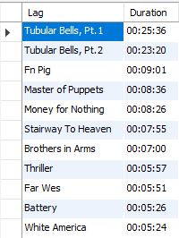,

**e)** SELECT nafn, utgafudagur FROM diskur WHERE utgafudagur > 2010;

,

**f)** SELECT utgefandi.nafn as Útgefandi , flytjandi.nafn as flytjandi, diskur.utgafudagur, diskur.nafn as Diskur

FROM utgefandi

JOIN diskur ON diskur.utgefandi = utgefandi.id

JOIN flytjandi ON flytjandi.id = diskur.flytjandi

ORDER BY IF(utgefandi.nafn RLIKE '^[a-z]', 1, 2), utgefandi.nafn LIMIT 2;

,

**g)** SELECT flytjandi.nafn as Flytjandi, lag.nafn, sec_to_time(lag.lengd) as duration, utgefandi.nafn as 'Útgefandi', diskur.nafn as Diskur

FROM diskur

JOIN flytjandi ON diskur.flytjandi = flytjandi.id

JOIN utgefandi ON utgefandi.id = diskur.utgefandi

JOIN lag ON diskur.id = lag.diskur

ORDER BY lag.lengd DESC LIMIT 5;

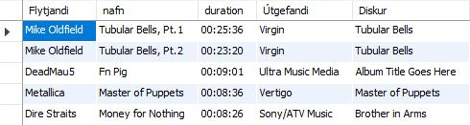,

**h)** SELECT tegund.nafn as tegund, count(diskur.tegund_disks) as 'fjöldi_diska'

from diskur

JOIN tegund ON tegund.id = diskur.tegund_disks

GROUP BY tegund

ORDER BY count(diskur.tegund_disks) DESC LIMIT 2;

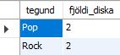,

**i)** SELECT utgefandi.nafn as 'Útgefandi', count(diskur.utgefandi) as fjöldi_diska

FROM diskur

JOIN utgefandi ON utgefandi.id = diskur.utgefandi

GROUP BY utgefandi

ORDER BY count(diskur.utgefandi) ASC LIMIT 5;

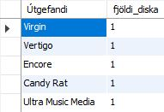,

**j)** SELECT DISTINCT diskur.nafn as diskur, tegund.nafn as tegund, diskur.utgafudagur as útgáfudagur ,utgefandi.nafn as útgefandi

FROM diskur

JOIN utgefandi ON utgefandi.id = diskur.utgefandi

JOIN tegund ON diskur.tegund_disks = tegund.id WHERE diskur.utgafudagur BETWEEN 1998 AND 2017

GROUP BY utgefandi.nafn;

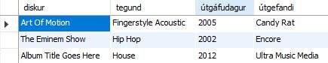,

**k.1)** SELECT count(nafn) as fjöldi_staf_sembyrja_bokstaf_a FROM lag WHERE nafn LIKE 'A%';

,

**k.2)** SELECT count(nafn) as fjöldi_staf_semhafa_bokstaf_s FROM lag WHERE nafn LIKE '%s%';

,

**l)** SELECT nafn, TIMESTAMPDIFF(YEAR, faedingardagur, NOW()) AS age FROM flytjandi;

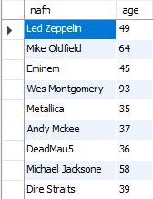,

**m)** SELECT round(avg(sec_to_time(lag.lengd))) as Meðallengd_allra_laga FROM lag;



**n)** SELECT flytjandi.nafn as flytjandi, COUNT(lag.id) as Fjoldi_laga

FROM lag

JOIN flytjandi ON flytjandi.id = lag.flytjandi

GROUP BY flytjandi

HAVING COUNT(DISTINCT lag.id) > 4;

,

**o)** SELECT flytjandi.nafn, flytjandi.faedingardagur as 'Fæðingardagur', lag.nafn as lag

from flytjandi

JOIN lag ON lag.flytjandi = flytjandi.id

where flytjandi.faedingardagur = (

select min(flytjandi.faedingardagur) from flytjandi

);

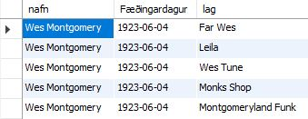,

**-- Bætið við 7 fyrirspurnum \***

**1)** SELECT nafn, tilnefningar FROM diskur WHERE tilnefningar IS NULL;

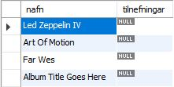,

**2)** SELECT nafn, uppruni FROM flytjandi WHERE uppruni LIKE '%England%';

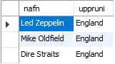,

**3)** SELECT nafn, vefsida FROM flytjandi WHERE vefsida LIKE '%.org';

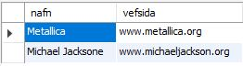,

**4)** SELECT nafn, uppruni FROM flytjandi WHERE uppruni LIKE '%United States%';

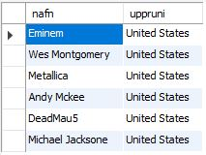,

**5)** SELECT nafn, vefsida FROM flytjandi WHERE vefsida LIKE '%.com';

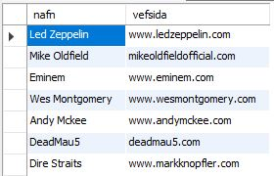,

**6)** SELECT nafn, count(tilnefningar) as Is_Tilnefningar FROM diskur GROUP BY nafn;

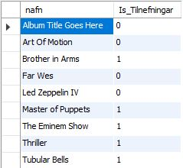,

**7)** SELECT nafn, REPLACE (uppruni, 'England', 'Iceland') as Uppruni FROM flytjandi;

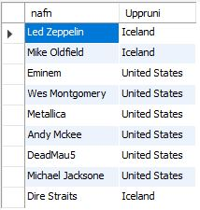;

Höfundar eru: Sigurður Róbert Rúnarsson og Viðar Erik Viðarsson.