LAB Manual

|  |
| --- |
| **Name of Student: Vidhi Binwal PRN: 22070122249** |
| **Semester: IV Year AY 23-24** |
| **Subject Title: Operating Systems Lab** |
| **EXPERIMENT No: 9 Assignment No : 10** |
| **TITLE: Page Replacement Algorithm** **DoP : 23-4-24** |

***Aim:*** Implement C program demonstrate **Page Replacement Algorithm (LRU)**

***Learning Outcomes:*** *1. To understand the* **Page Replacement algorithm**

*2. To Demonstrate the working of* **Page Replacement**Shortest algorithm

***Hardware/Software*:**



***Theory:***

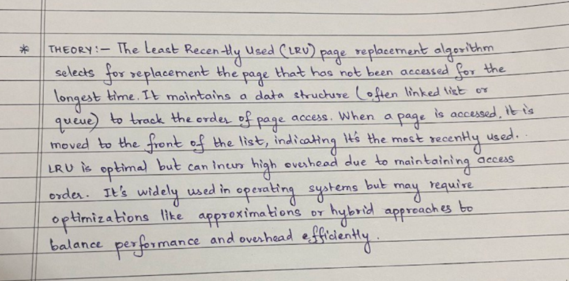

***Algorithm:***

#### Data Structures:

- Maintain a data structure to track the recent usage of pages. A doubly linked list is commonly used for this purpose.

#### Initialization:

1. Initialize an empty doubly linked list to track the pages in memory.

2. Initialize a hash table to map page numbers to their corresponding nodes in the linked list.

#### Accessing a Page:

1. When a page is accessed:

- If the page is already in memory:

- Move the corresponding node to the end of the linked list (indicating it's the most recently used).

- If the page is not in memory (page fault):

- If the memory is not full:

- Create a new node for the page and append it to the end of the linked list.

- Add an entry to the hash table mapping the page number to the new node.

- If the memory is full:

- Remove the node at the front of the linked list (indicating it's the least recently used).

- Remove the corresponding entry from the hash table.

- Create a new node for the new page and append it to the end of the linked list.

- Add an entry to the hash table mapping the page number to the new node.

***Program:***

#include <stdio.h>

#include <stdlib.h>

#define MEMORY_SIZE 3

// Node structure for the doubly linked list

typedef struct Node {

    int page_number;

    struct Node* prev;

    struct Node* next;

} Node;

// Function to create a new node

Node* createNode(int page_number) {

    Node* newNode = (Node*)malloc(sizeof(Node));

    if (newNode == NULL) {

        printf("Memory allocation failed\n");

        exit(EXIT_FAILURE);

    }

    newNode->page_number = page_number;

    newNode->prev = NULL;

    newNode->next = NULL;

    return newNode;

}

// Function to move a node to the end of the list

void moveToEnd(Node** head_ref, Node* node) {

    if (*head_ref == NULL || node == NULL)

        return;

    if (*head_ref == node)

        *head_ref = node->next;

    if (node->next != NULL)

        node->next->prev = node->prev;

    if (node->prev != NULL)

        node->prev->next = node->next;

    while ((*head_ref)->next != NULL)

        *head_ref = (*head_ref)->next;

    (*head_ref)->next = node;

    node->prev = *head_ref;

    node->next = NULL;

}

// Function to handle page replacement using LRU algorithm

void lruPageReplacement(int page_reference_array[], int size) {

    Node* memory[MEMORY_SIZE]; // Memory frames

    Node* page_list = NULL; // Doubly linked list to track page usage

    int page_faults = 0;

    // Initialize memory frames to NULL

    for (int i = 0; i < MEMORY_SIZE; i++)

        memory[i] = NULL;

    // Iterate through page reference array

    for (int i = 0; i < size; i++) {

        int page_number = page_reference_array[i];

        int found = 0;

        // Check if page is already in memory

        for (int j = 0; j < MEMORY_SIZE; j++) {

            if (memory[j] != NULL && memory[j]->page_number == page_number) {

                found = 1;

                moveToEnd(&page_list, memory[j]);

                break;

            }

        }

        // Page fault

        if (!found) {

            page_faults++;

            // If memory is full, remove the least recently used page

            if (page_list != NULL && page_list->prev != NULL) {

                Node* temp = page_list->prev;

                page_list->prev = temp->prev;

                if (temp->prev != NULL)

                    temp->prev->next = page_list;

                free(temp);

            }

            // Create a new node for the new page

            Node* newNode = createNode(page_number);

            if (page_list == NULL)

                page_list = newNode;

            else {

                page_list->next = newNode;

                newNode->prev = page_list;

                page_list = newNode;

            }

            // Add the new page to memory

            memory[MEMORY_SIZE - 1] = newNode;

        }

    }

    printf("Total Page Faults: %d\n", page_faults);

}

int main() {

    // Example page reference array

    int page_reference_array[] = {1, 3, 0, 3, 5, 6, 3};

    int size = sizeof(page_reference_array) / sizeof(page_reference_array[0]);

    lruPageReplacement(page_reference_array, size);

    return 0;

}

***Output:***

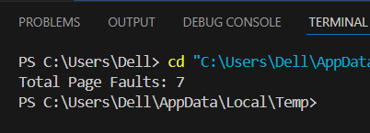

***Conclusion:***

