Practical Number 5 b

Aim: To implement RSA algorithm for providing authentication.
Theory: Source authentication is a security service that is provided by public key cryptography; the sender signs the message with his/her private key and the receiver decrypts the message with sender’s public key. Encryption of message with sender’s private key results in a “Digital signature” and this process is also known as signing the message. The process of decrypting the signature with sender’s public key is also known as verification of the signature.
It is customary to sign the digest of the message instead of signing the message itself. This results in two advantages:
- The size of digest is smaller than the message and hence size of signature also is smaller.
- Use of hash function for creating digest additionally provides integrity service apart from providing source authentication.
RSA Digital Signature Algorithm:
The sender creates a signature out of the message using his private component as
S = M^{d} mod n.
The receiver verifies the signature by applying the public component of the sender on the signature and creates a copy of the message M’= S^{e} mod n.
If M’ = M, receiver accepts the message.
M’ ≡ M(mod n)
➔ S^{e} ≡ M (mod n)
- M^{e x d} ≡ M (mod n)

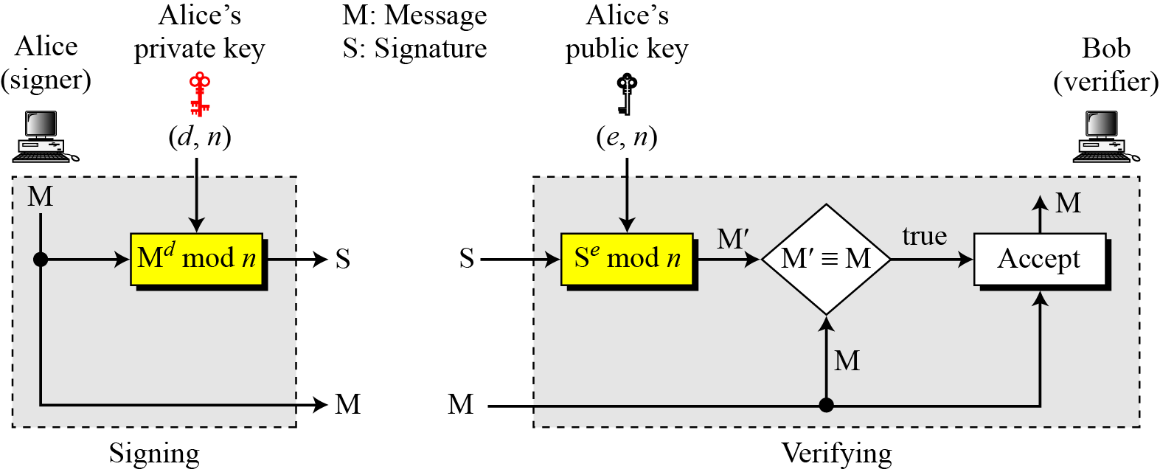

Attacks on RSA Signed Digests:
When the digest is signed instead of the message itself, the susceptibility of the RSA digital signature scheme depends on the strength of the hash algorithm.

Key-Only Attack: There are three cases of this attack
- The attacker intercepts the pair (S, M) and tries to find another message M’ that creates the same digest, h(M) = h(M’). If the hash algorithm is second preimage resistant, this attack is very difficult.
- The attacker finds two messages M and M’ such that h(M) = h(M’). The attacker lures the sender to sign h(M) to find S. Now the attacker has a pair (M’, S) which passes the verifying test, but is actually a forgery. If the hash function is collision resistant, this attack is difficult.
- The attacker may randomly finds message digest D, which may match with a random signature S. He then finds a message such that D=h(M). If the hash function is preimage resistant, this attack is difficult to launch.
Known-Message Attack: Assume that the attacker has two message-signature pairs (M₁, S₁) and (M₂, S₂) which have been created using the same private key. The attacker calculates S ≅ S₁ * S₂. If he can find a message M such that h(M) ≅ h(M₁) * h(M₂), he has forged a new message. However, finding M given h(M) is very difficult if the hash function is preimage resistant.
Chosen-Message Attack: Attacker can ask the sender to sign two legitimate messages M₁ and M₂ and then creates a new signature S ≅ S₁ * S₂. Since the attacker can calculate h(M) ≅ h(M₁) * h(M₂) if he can find a message M given h(M), the new message is a forgery. However, finding M given h(M) is very difficult if the hash function is preimage resistant.

Conclusion: The concepts of RSA cryptosystem for providing source authentication has been understood and successfully implemented.

