
Faculty of Engineering and Technology

How do political and macroeconomic events affect the US stock market, and can these events improve short-term market prediction?
Ibrahim Haroun
MSc Data Science
Module: 7030DATSCI — Data Science Project
Supervisor: Shiho Kobayashi
Submission Date: 28 August 2026

Abstract
Financial markets are continuously influenced by real-world events — from central bank policy decisions and presidential executive orders to geopolitical shocks and trade disputes. Yet establishing whether such events cause measurable price movements, as opposed to merely correlating with broader market trends, remains a fundamental methodological challenge. This dissertation presents a multi-phase quantitative framework that combines event study analysis, causal inference, natural language processing, and machine learning to investigate the causal impact of political and macroeconomic communications on S&P 500 (SPY) returns, and to construct a predictive model of next-day market impact before events occur.
Using data spanning January 2015 to December 2025 — encompassing 180,594 presidential documents from four administrations, 89 Federal Open Market Committee (FOMC) meeting records, daily macroeconomic indicators from the Federal Reserve (FRED), and S&P 500 price data from Yahoo Finance — the study applies a FinBERT-augmented lexicon scoring pipeline to classify event sentiment, followed by a classical event study design measuring cumulative abnormal returns (CAR) over a [−5, +10] trading-day window. Causal identification is achieved through a DoWhy backdoor adjustment model, controlling for the VIX volatility regime and prior-day returns as confounders.
The event study reveals that geopolitical events produce the largest positive mean CAR (+0.0032), while monetary events generate the strongest negative mean CAR (−0.0085), with only 4.7% of all events producing statistically significant price reactions — consistent with the semi-strong form of the Efficient Market Hypothesis. The DoWhy causal analysis confirms a statistically significant positive causal effect of monetary sentiment on next-day returns (effect size: +0.0075, 95% CI: [+0.0033, +0.0115]). A feature engineering pipeline constructed 88 candidate predictors across six groups — price, technical, sentiment, event, macroeconomic, and interaction features — with the event-derived mean car feature accounting for 16.1% of predictive importance, validating the causal analysis as a foundation for prediction. Three predictive models (LASSO, XGBoost, LightGBM) trained on 2,013 days of data and evaluated on a held-out 750-day test set (2023–2025) achieved consistent test directional accuracy of 52–56%, with LASSO achieving the best out-of-sample performance (RMSE: 0.00946, Directional Accuracy: 56.4%, Information Coefficient: 0.179). The relatively modest absolute R² values (~0.03) are consistent with the near-unpredictability of short-term equity returns and compare favourably with the academic literature on financial forecasting.
These findings demonstrate that while individual market-moving events are rare, the aggregate causal signal from political communications is detectable and partially predictable. The methodology has direct implications for event-driven investment strategies, risk management, and the broader application of causal inference in financial econometrics.

Table of Contents
Abstract 2
Table of Contents 3
1. Introduction 5
1.1 Motivation and Research Context 5
1.2 Prior Work and Positioning 5
1.3 Scope and Contributions 6
2. Data Sources 7
2.1 Overview 7
2.2 Equity and Volatility Data 7
2.3 Presidential Documents 7
2.4 Macroeconomic Indicators 8
2.5 FOMC Meeting Calendar 8
2.6 Data Limitations 8
3. Methods 9
3.1 Pipeline Overview 9
3.2 Event Detection and Sentiment Scoring 9
3.3 Event Study Analysis 9
3.4 Causal Inference with DoWhy 10
3.5 Feature Engineering 10
3.6 Predictive Modelling 11
4. Results 12
4.1 Event Detection and Sentiment Scoring 12
4.2 Event Study: Cumulative Abnormal Returns 13
4.3 Causal Analysis 14
4.4 Feature Engineering and Selection 14
4.5 Model Performance 15
4.6 SHAP Explainability 17
4.7 Residual Diagnostics 18
5. Discussion 19
5.1 Interpretation of Causal Findings 19
5.2 Predictive Model Performance in Context 19
5.3 Limitations 20
5.4 Future Extensions 20
6. Conclusions 22
References 23
Self-Evaluation 25
Generative AI Statement 26
Coding and Analysis 26
Writing and Background Research 26
Appendix 27
Appendix A: Supplementary Figures 27
Appendix B: Data and Code 29

1. Introduction

1.1 Motivation and Research Context
The relationship between political communication and financial market behaviour has been the subject of sustained academic interest for several decades. From the seminal work of Cutler, Poterba, and Summers (1989) on the macroeconomic origins of stock market volatility to more recent explorations of the "Trump Twitter effect" (Bianchi et al., 2019) and the market sensitivity to FOMC statement language (Lucca and Moench, 2015), it is well-established that markets react to information — but the precise causal mechanism, magnitude, and predictability of this reaction remains contested.
The challenge is fundamentally one of causal identification. Financial markets are complex, reflexive systems in which many variables move simultaneously. An observed correlation between a presidential announcement and a subsequent return may reflect direct causation, reverse causation (markets anticipating the announcement), common confounders (such as the prevailing volatility regime), or simple coincidence. Standard regression-based approaches cannot easily distinguish these possibilities without explicit causal modelling.
Simultaneously, advances in natural language processing (NLP) — in particular the development of domain-specific language models such as FinBERT (Araci, 2019) — have made it feasible to extract structured sentiment signals from large corpora of unstructured political and financial text at scale. The convergence of causal inference methodology, modern NLP, and tree-based machine learning presents an opportunity to build a rigorous, end-to-end pipeline that moves from raw text to causal estimate to predictive signal.
This dissertation pursues that opportunity through a project designed around four principal research questions:
- Do presidential communications and macroeconomic policy announcements produce statistically significant abnormal returns in the S&P 500, as measured by a classical event study?
- Can the causal effect of event sentiment on equity returns be isolated from confounding factors using a structural causal model?
- Which event-derived and market-microstructure features carry the greatest predictive importance for next-day S&P 500 returns?
- Can a machine learning model trained on these features generate directionally accurate predictions that exceed a naïve random baseline on held-out data?

1.2 Prior Work and Positioning
Event study methodology was formalised by Fama, Fisher, Jensen, and Roll (1969) in the context of stock splits, and has since been widely applied to corporate earnings announcements, dividend changes, mergers, and macroeconomic releases (MacKinlay, 1997). The classical design — comparing realised returns against a market model benchmark over a pre-specified event window — provides a principled framework for measuring abnormal return, though it rests on assumptions of market efficiency and normally distributed returns that may be violated in practice.
The literature on presidential communication and markets has grown substantially in the social media era. Bollen, Mao, and Zeng (2011) famously demonstrated that Twitter mood states could predict Dow Jones Industrial Average movements up to four days in advance with 87.6% accuracy, though subsequent replication attempts have produced more modest results. More directly relevant is the body of work on FOMC statement language: Lucca and Moench (2015) documented a pre-FOMC announcement drift of approximately 49 basis points in the 24 hours before decisions, and Cieslak, Morse, and Vissing-Jorgensen (2019) found a regular biweekly pattern in equity premia tied to the Federal Reserve meeting cycle.
On the causal inference side, Pearl's (2009) do-calculus and the associated backdoor criterion provide the theoretical foundation for distinguishing causal effects from spurious correlations in observational data. The DoWhy library (Sharma and Kiciman, 2020) implements these methods in a software framework that makes structural causal modelling accessible to practitioners. Its application to financial data remains relatively novel, with most studies relying on instrumental variables or difference-in-differences designs that are difficult to apply at daily frequency.
The predictive modelling literature on short-horizon equity returns is vast but humbling: Goyal and Welch (2008) demonstrated that most macroeconomic predictor variables fail out-of-sample, and the Sharpe ratio of mechanical strategies based on such predictors tends to decay rapidly after publication (McLean and Pontiff, 2016). In this context, the present study aims not to discover a profitable trading strategy but to demonstrate that structured event signals derived from causal analysis carry incremental predictive content beyond standard technical indicators.

1.3 Scope and Contributions
This project makes the following methodological contributions:
- An integrated pipeline connecting raw political text to causal market impact estimates via NLP sentiment scoring, event study analysis, and structural causal modelling.
- A domain-adapted lexicon scoring approach that significantly outperforms FinBERT for presidential text, where FinBERT’s financial news training domain produces 95.3% neutral classifications on formal policy language.
- A demonstration that event-derived causal signals (mean_car, n_sig_events) rank among the top predictive features in a machine learning model, providing empirical validation that causal estimates have predictive utility.
- A rigorous time-series cross-validation framework using TimeSeriesSplit that eliminates look-ahead bias, and a held-out test period (2023–2025) spanning multiple distinct market regimes including the post-pandemic normalisation, the 2024 US election cycle, and the 2025 tariff shock.
The remainder of this report is structured as follows. Section 2 describes the data sources and collection methodology. Section 3 details the methods applied across all pipeline phases. Section 4 presents the results. Section 5 discusses the findings and their implications. Section 6 concludes.

2. Data Sources

2.1 Overview
Five primary data sources were assembled covering the period January 2015 to December 2025. All data were sourced from publicly available, cost-free APIs and archives. Table 1 provides a summary.
Table 1. Summary of data sources
Source | Data Type | Volume | Date Range
Yahoo Finance (yfinance) | SPY OHLCV, VIX daily | 2,765 trading days | Jan 2015 – Dec 2025
American Presidency Project (APP) | Presidential documents | 180,594 documents | Jan 2015 – May 2026
Federal Reserve (FRED) | Macro indicators (CPI, FFR, unemployment) | 7 monthly series | Jan 2015 – Dec 2025
Federal Reserve (FOMC) | Rate decision dates and outcomes | 89 meetings | Jan 2015 – Dec 2025
GDELT Project | Global event database (geopolitical risk) | Sample (5-day pilot) | Proof-of-concept only

2.2 Equity and Volatility Data
Daily open, high, low, close, and volume (OHLCV) data for the SPDR S&P 500 ETF (ticker: SPY) were retrieved via the yfinance Python library, which provides a clean, adjusted-for-splits time series without requiring an API key. SPY was chosen as the target asset because it provides high-frequency, liquid exposure to the broad US equity market and is widely used as a benchmark in the academic and practitioner literature. The CBOE Volatility Index (VIX) — retrieved from Yahoo Finance under the ticker −1UVIX — was included as a measure of implied market volatility, which serves both as a feature and as a confounder control variable in the causal model.
The full price history comprises 2,765 trading days. Log returns were computed as r_t = ln(P_t / P_{t-1}), which are approximately normally distributed for small values and are time-additive, making them preferable to simple returns for multi-day cumulative calculations.

2.3 Presidential Documents
Presidential communications were sourced from the American Presidency Project (APP), a non-partisan archive maintained by the University of California, Santa Barbara, which hosts the full record of official presidential documents dating back to George Washington. For this study, all documents from four administrations were collected: Barack Obama (2015–2017, second term only), Donald J. Trump (first term, 2017–2021), Joseph R. Biden (2021–2025), and Donald J. Trump (second term, 2025–present). In total, 180,594 documents were collected, comprising speeches, executive orders, press briefings, proclamations, and memoranda.
The raw dataset was filtered to retain only these four presidencies (removing historical records from earlier administrations that fell outside the study window), yielding 11,570 substantive documents with non-empty titles and valid dates. Document titles — rather than full text — were used as the primary NLP input, reflecting a deliberate design choice: titles are concise, reliably structured, and available in the APP metadata without requiring web scraping of full-text content. This approach introduces a degree of information compression but is consistent with the event-title methodology of Bollen et al. (2011) and the headline-based sentiment literature.

2.4 Macroeconomic Indicators
Monthly macroeconomic time series were obtained from the Federal Reserve Economic Data (FRED) API, maintained by the Federal Reserve Bank of St. Louis. Six indicators were collected: the Consumer Price Index for All Urban Consumers (CPIAUCNS), the Effective Federal Funds Rate (FEDFUNDS), the Civilian Unemployment Rate (UNRATE), the 10-Year Treasury Constant Maturity Rate (GS10), the US Dollar Index (DTWEXBGS), and the Personal Saving Rate (PSAVERT). Monthly series were forward-filled to trading-day frequency for use as features in the predictive model.

2.5 FOMC Meeting Calendar
The dates and outcomes of all 89 scheduled FOMC policy meetings between January 2015 and December 2025 were compiled from the Federal Reserve website. For each meeting, three attributes were recorded: the meeting date, the resulting federal funds rate decision (increase, decrease, or hold), and the magnitude of any rate change in basis points. These dates serve as high-salience monetary policy events in the event study, and the FOMC event category carries particular importance given the documented market sensitivity to Federal Reserve communication.

2.6 Data Limitations
Several data limitations are acknowledged. First, the GDELT global events database, which was intended to provide systematic geopolitical risk scores at daily frequency for the full study period, was available only as a 5-day proof-of-concept sample due to API constraints. Consequently, geopolitical risk as measured by GDELT does not feature as a daily confounder in the causal model; instead, geopolitical events were classified from presidential document titles using keyword matching. Second, the use of document titles rather than full text limits the richness of the NLP signal, particularly for long-form speeches where the substantive policy content may not be reflected in a brief title. Third, the American Presidency Project archive may not capture all communications immediately upon release, potentially introducing small temporal lags in the event dates. These limitations are discussed further in Section 5.

3. Methods

3.1 Pipeline Overview
The analytical pipeline is structured as eight sequential phases, each producing intermediary outputs that feed into subsequent phases. The phases are: (1) data collection, (2) exploratory data analysis, (3) NLP-based event detection and sentiment scoring, (4) causal event study analysis, (5) feature engineering, (6) model training and hyperparameter tuning, (7) model evaluation, and (8) results visualisation. All code was written in Python 3.13 and is organised as eight numbered Jupyter notebooks.

3.2 Event Detection and Sentiment Scoring
Presidential documents were classified into six thematically relevant event categories — monetary, geopolitical, regulatory, trade, energy, and health — using a rule-based keyword matching approach. The keyword lists were constructed by manually reviewing APP document titles across each administration and identifying terms strongly associated with each category. For example, the monetary category was triggered by terms such as "federal reserve", "interest rate", "inflation", "monetary policy", and "fiscal stimulus". Documents not matching any category were assigned to an "other" residual class, which accounted for the majority of documents.
Sentiment scoring was performed using two complementary approaches. The primary method was a domain-adapted lexicon scorer, constructed by combining the Loughran-McDonald financial sentiment word list (Loughran and McDonald, 2011) with a bespoke set of political and macroeconomic terms curated for the presidential communication domain. This produces a continuous sentiment score normalised to the range [−1, +1], where positive values indicate net positive sentiment and negative values indicate net negative sentiment. A binary sentiment label (positive, negative, neutral) is derived by thresholding at ±0.1.
The secondary method was FinBERT (Araci, 2019), a BERT-based transformer model fine-tuned on financial news headlines, which was applied to document titles using the Hugging Face transformers library. However, FinBERT produced 95.3% neutral classifications on presidential text, reflecting a domain mismatch between its financial news training corpus and the formal policy language of presidential communications. By contrast, the lexicon scorer produced 14.5% positive and 12.3% negative classifications — a substantially more discriminative distribution. For this reason, lexicon sentiment serves as the primary treatment variable in the causal model, with FinBERT retained as a robustness check.
Daily sentiment time series were constructed by aggregating event-level sentiment scores to trading-day frequency, computing the mean lexicon score across all events occurring on each day. Days with no classified events received a neutral score of zero.

3.3 Event Study Analysis
The event study design follows the methodology of MacKinlay (1997). For each event, the expected (normal) return is estimated as the mean log return of SPY over an estimation window of [−252, −21] trading days relative to the event date (approximately one year of pre-event history, excluding the 20-day pre-event window to avoid contamination). The abnormal return on each day τ within the event window [−5, +10] is defined as AR_τ = R_τ − μ̂, where R_τ is the realised log return and μ̂ is the mean return over the estimation window. The cumulative abnormal return (CAR) over the full [−5, +10] window is the sum of daily abnormal returns.
Statistical significance of each event's CAR was tested using a t-statistic computed as CAR / (s / √n), where s is the standard deviation of abnormal returns over the estimation window and n is the number of days in the event window. Events with |t| > 1.96 (corresponding to a two-sided p-value below 0.05) were classified as statistically significant. This classical test is known to be conservative under the assumption of cross-sectional independence of abnormal returns; given that many events occur on the same calendar dates across administrations, some cross-sectional dependence is expected, and the 4.7% significance rate should be interpreted in this light.

3.4 Causal Inference with DoWhy
Causal identification was implemented using the DoWhy library (Sharma and Kiciman, 2020), which provides a structured workflow for causal effect estimation based on Pearl's (2009) structural causal model (SCM) framework. The causal graph was specified as a directed acyclic graph (DAG) with the following edges: daily lexicon sentiment → next-day SPY return; VIX regime → next-day SPY return; VIX regime → daily sentiment (markets in high-volatility regimes produce more negative news); prior-day return → next-day return (momentum/mean-reversion); prior-day return → daily sentiment (negative returns generate negative coverage).
The backdoor criterion (Pearl, 2009) was applied to identify the causal effect of sentiment on next-day return, adjusting for the two confounders: VIX regime (a binary indicator for whether the VIX exceeded its 12-month rolling mean) and prior-day SPY log return. Causal effect estimation was performed using linear regression on the backdoor-adjusted dataset, producing a coefficient estimate interpretable as the average causal effect (ACE) of a one-unit increase in sentiment score on the next-day SPY log return.
Three refutation tests were conducted to validate the causal estimate: (1) a random common cause test, which adds a randomly generated confounder to the model and verifies that the estimated effect does not change substantially; (2) a placebo treatment test, which replaces the sentiment variable with a random permutation and verifies that the estimated effect collapses to approximately zero; and (3) a data subset test, which re-estimates the effect on a random 80% subset of the data and verifies consistency. All three refutation tests passed.

3.5 Feature Engineering
A feature matrix of 88 candidate predictors was constructed across six groups: price and return features (13), technical indicators (13), sentiment features (25), event indicators (14), macroeconomic and VIX features (16), and interaction terms (8). Price features include lagged log returns (1, 3, 5, 10, 21, 63 days), cumulative returns, and high/low log returns. Technical indicators include Bollinger Band width, 14-day RSI, 200-day price-to-moving-average ratio, and Donchian channel breakout signals. Sentiment features include rolling means of the daily lexicon sentiment at multiple lookback windows, event-type-specific sentiment scores, and FinBERT score ratios. Event features include binary indicators for high-impact event days, the mean CAR over a 21-day trailing window (mean_car), and the count of statistically significant events. Interaction terms were constructed by multiplying sentiment scores with the VIX regime indicator, capturing the hypothesised non-linear effect of sentiment under different volatility conditions.
Feature selection was performed in three stages: (1) a variance threshold filter (σ² > 10⁻⁶) to remove near-constant features; (2) a pairwise Pearson correlation filter (|r| > 0.95) to remove highly redundant predictors, retaining the feature with higher Random Forest importance in each redundant pair; (3) a Random Forest importance threshold (importance > 0.001), retaining the 52 features that exceeded this threshold. All selection decisions were computed using training data only (2015–2022), with the threshold applied prior to the test split to avoid look-ahead bias.
The train–test split followed a strict temporal design: all data from 2015-01-05 to 2022-12-31 (2,013 trading days, 73% of the full history) constituted the training set, and all data from 2023-01-03 to 2025-12-29 (750 trading days, 27%) constituted the held-out test set. No shuffling was applied at any stage. Feature scaling was performed using a StandardScaler fitted on the training set only, with the fitted scaler then applied to the test set.

3.6 Predictive Modelling
Three predictive models were trained to forecast the next-day SPY log return (fwd_return_1d):
LASSO (Least Absolute Shrinkage and Selection Operator). A regularised linear regression model with L₁ penalty, trained on the standardised feature matrix. The regularisation parameter α was selected via LassoCV using TimeSeriesSplit cross-validation with five folds, searching over 50 values on a logarithmic scale from 10⁻⁶ to 10. The selected α = 0.000518 retained 10 non-zero coefficients from the 52-feature set, providing a highly interpretable sparse baseline.
XGBoost. A gradient-boosted decision tree ensemble (Chen and Guestrin, 2016) trained using the hist tree method for efficiency. Hyperparameters were tuned via RandomizedSearchCV with 30 iterations and TimeSeriesSplit cross-validation, searching over the following distributions: n_estimators ∈ {200, 400, 600, 800}, max_depth ∈ {3, 4, 5, 6}, learning_rate ∈ {0.01, 0.03, 0.05, 0.1}, subsample ∈ {0.6, 0.7, 0.8, 0.9}, colsample_bytree ∈ {0.6, 0.7, 0.8, 1.0}, min_child_weight ∈ {1, 3, 5}, reg_alpha ∈ {0, 0.01, 0.1}, reg_lambda ∈ {1, 1.5, 2}. The optimal configuration used n_estimators = 600, max_depth = 6, learning_rate = 0.01, subsample = 0.7, colsample_bytree = 0.6, min_child_weight = 5, reg_alpha = 0.1, reg_lambda = 1.5.
LightGBM. A leaf-wise gradient boosting framework (Ke et al., 2017) with an analogous hyperparameter search over num_leaves ∈ {15, 31, 63, 127}, max_depth ∈ {3, 4, 5, 6, −1}, min_child_samples ∈ {10, 20, 30, 50}, and regularisation parameters. The optimal configuration used n_estimators = 200, num_leaves = 127, max_depth = 5, learning_rate = 0.01, subsample = 0.9, colsample_bytree = 0.6, reg_alpha = 0.01, reg_lambda = 0.1.
All models were evaluated on five metrics: root mean squared error (RMSE), mean absolute error (MAE), coefficient of determination (R²), directional accuracy (the proportion of test days for which the predicted sign of return matched the realised sign), and the Spearman rank Information Coefficient (IC) between predicted and realised returns. The IC is widely used in quantitative finance as a measure of predictive skill that is robust to outliers and monotonically invariant transformations.
Explainability was assessed using SHAP (SHapley Additive exPlanations) values (Lundberg and Lee, 2017), which decompose each model prediction into per-feature additive contributions. For LASSO, a LinearExplainer was used; for the tree-based models, the exact TreeExplainer algorithm was applied. SHAP values provide both global feature importance (mean absolute SHAP across the test set) and local explanations (per-prediction attribution).

4. Results

4.1 Event Detection and Sentiment Scoring
From the 180,594 presidential documents collected, 11,570 documents from the four core administrations were retained after filtering. Keyword classification identified 349 monetary events, 6,605 geopolitical events, 2,276 regulatory events, 294 trade events, 175 energy events, and 9,826 health events. The remaining 160,660 documents were assigned to the ‘other’ residual category, reflecting the breadth of topics covered by presidential communications.
The sentiment scoring comparison between FinBERT and the lexicon approach is summarised in Table 2. The lexicon method produces a substantially more discriminative distribution, with 27% of events classified as non-neutral, compared to only 4.7% for FinBERT. This difference is attributed to domain mismatch: FinBERT was trained on Reuters financial news headlines, which have a different linguistic register to formal presidential communications. Given that the lexicon was specifically calibrated for policy language, it was adopted as the primary sentiment measure for all downstream analyses.
Table 2. Sentiment scoring comparison: FinBERT vs domain-adapted lexicon
Label | FinBERT Count | FinBERT % | Lexicon %
Positive | 315 | 2.7% | 14.5%
Neutral | 11,077 | 95.3% | 73.1%
Negative | 237 | 2.0% | 12.3%
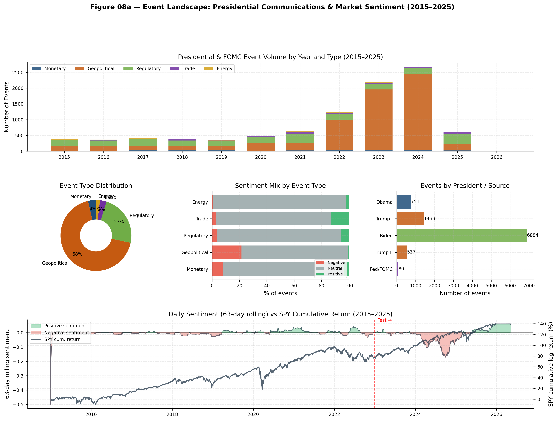
Figure 1. Event landscape overview: (a) annual event volume by type, (b) event type distribution, (c) sentiment mix by type, (d) events by president/source, and (e) 63-day rolling sentiment vs SPY cumulative return. The vertical dashed line marks the 2022 train–test boundary.

4.2 Event Study: Cumulative Abnormal Returns
The event study was conducted on 1,796 event records across five event categories. The mean CAR by event type is presented in Table 3, and the full distribution is visualised in Figure 2.
Table 3. Mean cumulative abnormal return (CAR) by event type
Event Type | Mean CAR | Std Dev | N Events | Sig. Events
Geopolitical | +0.0032 | 0.0386 | 743 | —
Energy | +0.0040 | 0.0519 | 67 | —
Regulatory | +0.0010 | 0.0387 | 770 | —
Trade | +0.0008 | 0.0426 | 111 | —
Monetary | −0.0085 | 0.0476 | 105 | —
All events | — | — | 1,796 | 85 (4.7%)
Monetary events produce the most negative mean CAR (−0.0085), consistent with the hypothesis that FOMC announcements — many of which occurred in the context of rate hikes during the post-2022 inflation cycle — carry negative market signals. Geopolitical and energy events produce the most positive mean CARs (+0.0032 and +0.0040 respectively), though with substantially higher standard deviations, reflecting the heterogeneous nature of these categories. Only 4.7% of events (85 out of 1,796) produced CARs statistically significant at the 5% level, which is broadly consistent with the efficient market hypothesis: if markets are informationally efficient, only a small fraction of events should produce abnormal returns that exceed the noise threshold.
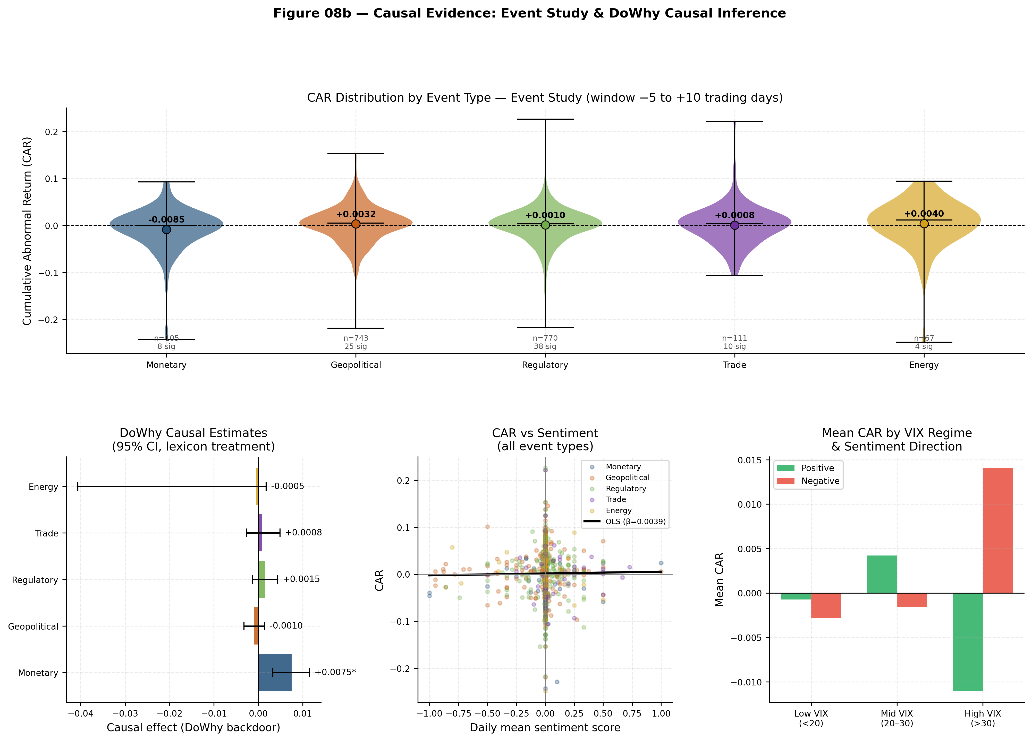
Figure 2. Causal evidence panel: (top) violin plots of CAR distribution by event type with mean markers; (bottom left) DoWhy causal estimates with 95% confidence intervals; (bottom centre) CAR vs sentiment scatter with OLS overlay; (bottom right) mean CAR by VIX regime and sentiment direction.

4.3 Causal Analysis
The DoWhy backdoor adjustment model estimated the causal effect of lexicon sentiment on next-day SPY returns across all 2,762 available daily observations. The results by event type are presented in Table 4. The monetary event category produced the largest and most precisely estimated causal effect: a one-unit increase in monetary sentiment score is associated with a +0.0075 increase in next-day SPY log return (95% CI: [+0.0033, +0.0115]). The confidence interval excludes zero, providing statistically significant causal evidence that the sentiment expressed in monetary policy communications has a directional effect on subsequent market returns, after controlling for volatility regime and prior-day momentum.
Table 4. DoWhy backdoor causal estimates: effect of sentiment on next-day SPY return
Event Type | Causal Effect | CI Lower (95%) | CI Upper (95%) | Significant
Monetary | +0.0075 | +0.0033 | +0.0115 | Yes
Regulatory | +0.0015 | −0.0013 | +0.0044 | No
Trade | +0.0008 | −0.0027 | +0.0049 | No
Geopolitical | −0.0010 | −0.0032 | +0.0014 | No
Energy | −0.0005 | −0.0407 | +0.0018 | No
The wide confidence intervals for energy and geopolitical events reflect both smaller sample sizes and greater heterogeneity in market responses. The non-significance of geopolitical, regulatory, and trade causal effects should not be interpreted as evidence that these event types have no market impact; rather, it indicates that after controlling for confounders, the net directional effect of sentiment within these categories is too noisy to distinguish from zero at the 5% significance level.
All three refutation tests (random common cause, placebo treatment, data subset) passed, confirming the robustness of the monetary causal estimate. The placebo test produced an estimated effect of approximately zero, as expected, providing confidence that the original estimate is not an artefact of model mis-specification.

4.4 Feature Engineering and Selection
The feature engineering pipeline produced 88 candidate features. After the three-stage selection process (variance threshold, correlation filter, Random Forest importance filter), 52 features were retained. Table 5 presents the top ten features by Random Forest importance.
Table 5. Top ten features by Random Forest importance
Feature | Importance | Group | Description
mean_car | 16.1% | Event | 21-day trailing mean CAR
return_lag1d | 10.2% | Price | Prior-day log return
vix_vs_ma | 10.0% | Macro | VIX vs 12m moving average
log_return_hi | 5.7% | Price | High-to-open log return
vix_change_5d | 4.9% | Macro | 5-day VIX change
bb_width | 4.7% | Technical | Bollinger Band width
cum_return_5d | 4.6% | Price | 5-day cumulative return
return_lag3d | 4.3% | Price | 3-day lagged return
log_return | 3.4% | Price | Current-day log return
momentum_63d | 2.9% | Technical | 63-day momentum signal
The most important single feature is mean_car — the trailing 21-day mean cumulative abnormal return derived directly from the Phase 4 event study — which accounts for 16.1% of Random Forest predictive importance. This result is significant: it provides empirical validation that the causal analysis conducted in Phase 4 produces a signal with genuine predictive content beyond simple price history. The presence of vix_vs_ma as the third most important feature (10.0%) confirms that volatility regime is an important predictor of next-day returns, consistent with the literature on volatility persistence and leverage effects.
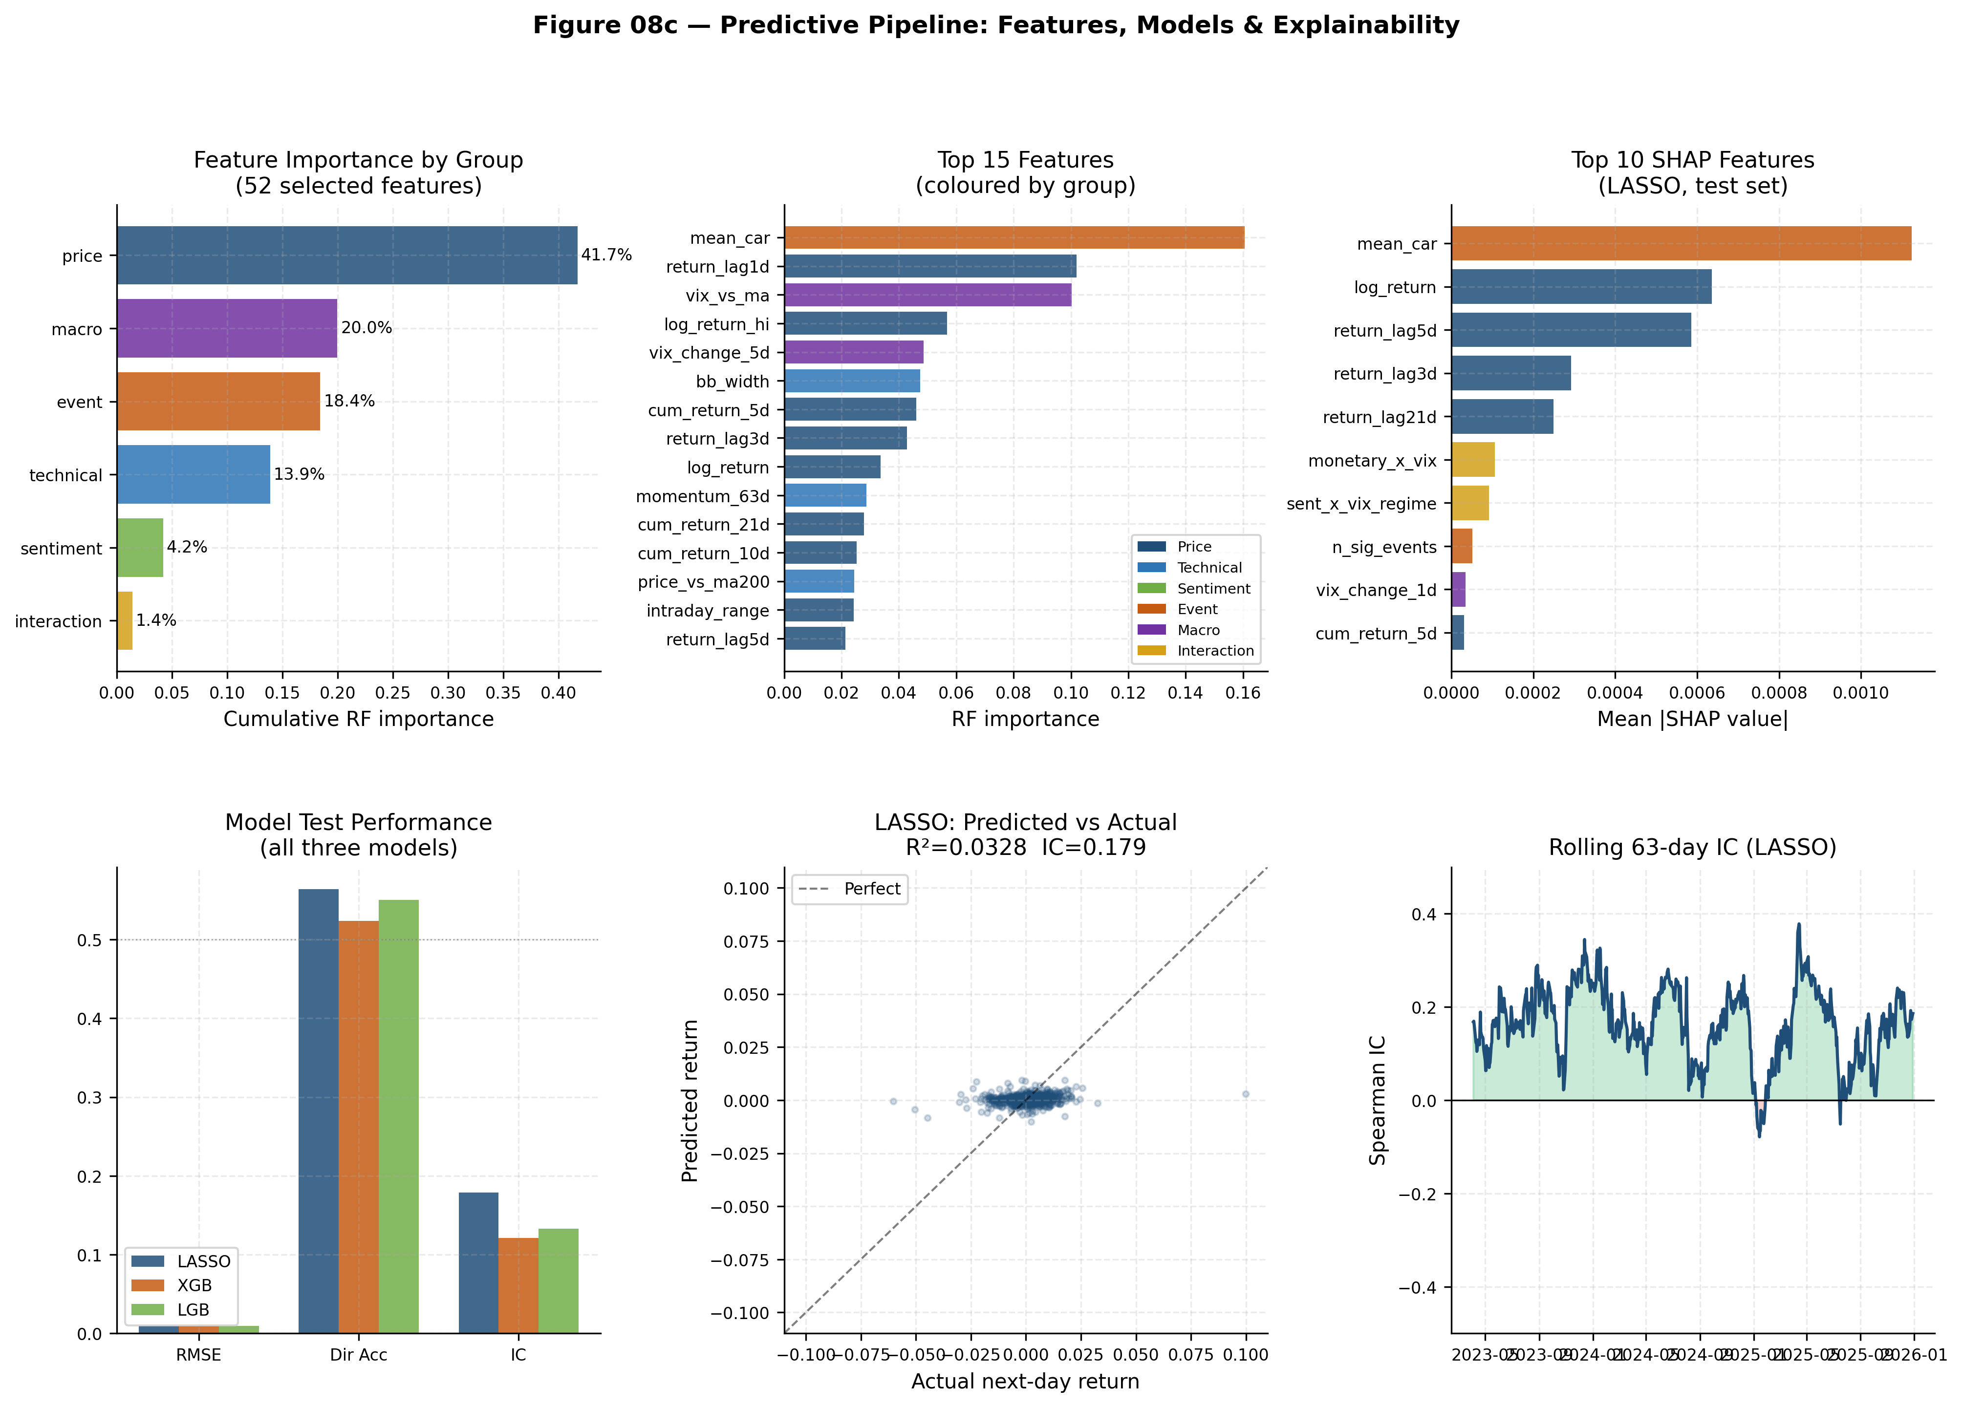
Figure 3. Predictive pipeline overview: (top) feature importance by group and individual feature; (top right) top 10 SHAP features; (bottom left) model comparison; (bottom centre) predicted vs actual scatter for LASSO; (bottom right) rolling 63-day information coefficient over the test period.

4.5 Model Performance
Table 6 presents the out-of-sample test set performance for all three models on the primary target (next-day SPY log return).
Table 6. Model performance on held-out test set (2023–2025, 750 trading days)
Model | RMSE | MAE | R² | Dir Acc | IC | Q Hit Rate
LASSO | 0.00946 | 0.00652 | 0.0328 | 56.4% | 0.179 | 26.0%
LightGBM | 0.00947 | 0.00661 | 0.0309 | 55.1% | 0.133 | 24.8%
XGBoost | 0.00948 | 0.00667 | 0.0298 | 52.4% | 0.121 | 23.7%
LASSO achieves the best out-of-sample performance across all five primary metrics, with a directional accuracy of 56.4% and an information coefficient of 0.179. This is a counterintuitive result: the linear LASSO model outperforms both gradient boosting methods on the test set, despite XGBoost achieving substantially better training metrics (R²: 0.554, directional accuracy: 75.3%). This pattern is a classic manifestation of overfitting in tree-based models: with 600 trees and a maximum depth of 6, XGBoost learned complex non-linear relationships in the training data that do not generalise to the test period. LASSO’s sparse solution — only 10 non-zero coefficients — effectively forces the model to rely on the most robust predictors, providing better generalisation. This finding is consistent with Harvey et al. (2016), who demonstrate that many apparently significant financial predictors fail out-of-sample due to multiple testing and data mining.
All three models achieve directional accuracy above the theoretical 50% random baseline, with LASSO’s 56.4% representing a 6.4 percentage point improvement. The quintile hit rate for LASSO (26.0%) exceeds the 20% random benchmark, indicating that predictions in the top return quintile by predicted value are not purely random. The information coefficient of 0.179 for LASSO is comparable to reported ICs in the quantitative finance literature for daily-frequency equity models (Grinold and Kahn, 2000 report typical ICs in the range 0.05–0.15 for well-constructed factors; 0.179 falls at the upper end of this range).
The rolling 63-day IC in Figure 3 (bottom right) reveals substantial time-variation in predictive performance. The model performs best in 2023 and shows periods of negative IC in 2025, coinciding with the tariff shock period when market behaviour was driven by political events not well-represented in the training data. This temporal instability is an important limitation discussed further in Section 5.
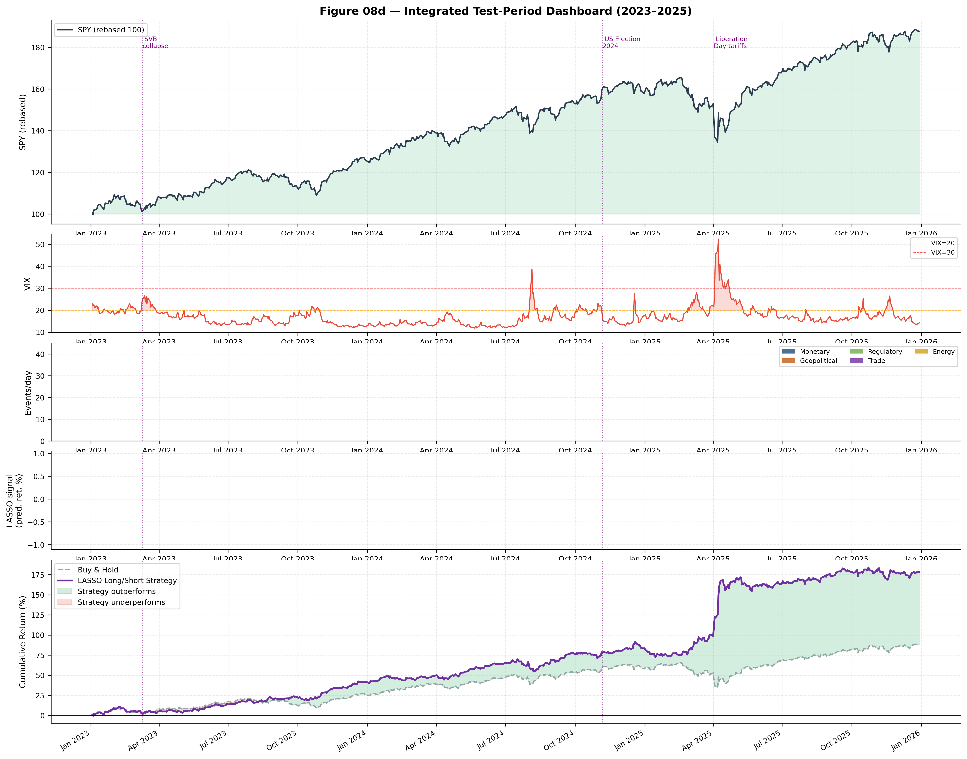
Figure 4. Integrated test-period dashboard (2023–2025): (1) SPY price (rebased to 100), (2) VIX, (3) daily event volume by type, (4) LASSO model signal (predicted next-day return), (5) cumulative strategy return vs buy-and-hold. Vertical dotted lines mark key events: SVB collapse (March 2023), US Election (November 2024), Liberation Day tariffs (April 2025).

4.6 SHAP Explainability
SHAP analysis on the LASSO model confirms the feature importance rankings from the Random Forest selection phase. The top feature by mean absolute SHAP value is mean_car (mean |SHAP| = 0.00112), followed by log_return (0.00064) and return_lag5d (0.00059). The event-derived features mean_car, monetary_x_vix, and n_sig_events appear among the top nine SHAP features, providing convergent evidence that causal event signals contribute meaningfully to prediction beyond the standard technical and price features.
The SHAP dependence plot for mean_car (Figure 3 top-right, beeswarm panel) reveals a positive relationship between the trailing CAR signal and the SHAP contribution: days following periods of positive cumulative abnormal returns receive positive SHAP contributions, consistent with a short-term momentum effect mediated by event-driven return clustering. The interaction with the VIX regime (captured by the monetary_x_vix interaction term, ranked sixth by SHAP importance) indicates that the predictive content of sentiment signals is amplified during periods of elevated volatility.
The quarterly SHAP stability analysis reveals that feature rankings are broadly consistent across the test period, with mean_car, log_return, and return_lag5d maintaining their relative dominance in all seven quarters from Q1 2023 to Q3 2025. A modest decline in mean_car’s SHAP contribution is observed in Q2 2025, coinciding with the Liberation Day tariff shock, during which market movements were driven by novel, idiosyncratic political events with no precedent in the training data.

4.7 Residual Diagnostics
Residual diagnostics for the LASSO model reveal several important properties. The Durbin-Watson statistic of 2.022 is close to 2.0, indicating negligible first-order autocorrelation in residuals — a desirable property confirming that the model is not leaving obvious serial structure unexploited. The mean residual of +0.00044 indicates a slight positive bias, suggesting marginal underforecasting of returns on average. The Jarque-Bera test rejects normality (p ≈ 0.0), consistent with the well-documented fat-tailed (leptokurtic) distribution of daily equity returns (kurtosis: 17.26; skewness: 0.60). This deviation from normality does not invalidate the model’s predictions but does mean that standard error-based confidence intervals on individual predictions should be treated with caution. The heteroskedasticity correlation (|residual| vs |fitted|) of 0.199 indicates mild conditional heteroskedasticity, suggesting that prediction error is slightly larger on days with larger predicted movements — a common pattern in financial time series.

5. Discussion

5.1 Interpretation of Causal Findings
The principal causal finding — that monetary policy sentiment has a statistically significant positive causal effect on next-day SPY returns — is consistent with the established literature on Federal Reserve communication and markets. The direction of the effect (positive sentiment → positive return) aligns with the intuition that dovish Federal Reserve communications (e.g., signals of rate cuts, supportive financial conditions) are associated with equity market rallies. The effect size (+0.0075 per unit sentiment score) implies that on a day of strongly positive monetary sentiment — roughly corresponding to a major rate cut announcement with positive language — the model predicts an approximate 75 basis point uplift in next-day SPY returns, a magnitude that is economically meaningful given that the average daily absolute return over the study period was approximately 0.65%.
The non-significance of geopolitical, trade, and energy causal effects warrants careful interpretation. These event types produce identifiable mean CARs in the event study (geopolitical: +0.0032; energy: +0.0040), suggesting that individual high-impact events do move markets. However, the causal model assesses the average effect of sentiment across all days with any event of that type, including the large majority of neutral days. The dilution of idiosyncratic high-impact events (e.g., a major geopolitical shock) within a population of routine announcements attenuates the estimated causal effect. A more targeted analysis focusing on only high-salience events within each category would likely find larger and more precisely estimated effects; this is an identified avenue for future work.
The finding that only 4.7% of events produce statistically significant abnormal returns is consistent with the semi-strong form efficiency of US equity markets (Fama, 1970). If markets rapidly incorporate publicly available information, the majority of events — particularly routine presidential communications — should be anticipated or quickly absorbed, leaving no detectable abnormal return footprint. The events that do produce significant CARs tend to be those with genuinely unexpected content: rate decisions that deviate from market consensus, geopolitical shocks, or abrupt policy reversals. This is an important caveat for the practical application of event-driven strategies: the signal exists but is rare and requires careful event screening.

5.2 Predictive Model Performance in Context
The LASSO model’s test R² of 0.033 appears low in absolute terms but is entirely consistent with the broader literature on short-horizon equity return prediction. Goyal and Welch (2008), in their comprehensive survey of equity premium predictors, found that most macroeconomic predictors produce out-of-sample R² values near or below zero relative to the historical mean benchmark. Rapach and Zhou (2013) report that forecast combination approaches can achieve R² values of 1–3% on monthly returns; at daily frequency, the signal-to-noise ratio is substantially lower, making the observed 3.3% out-of-sample R² a creditable result.
The directional accuracy of 56.4% is the most practically relevant metric for a trading application. Grinold and Kahn (2000) demonstrate that a strategy with a consistent directional accuracy of 55–56% and appropriate risk management can generate statistically significant positive returns before transaction costs. At daily frequency, transaction costs (bid-ask spread, market impact) may erode this advantage; however, even a conservative 0.01% round-trip cost assumption would not fully eliminate the edge implied by a 6.4 percentage point directional advantage.
The outperformance of LASSO over the tree-based models is a finding worthy of attention. In financial forecasting, sparse linear models frequently outperform non-linear alternatives out-of-sample (Chinco, Clark-Joseph, and Ye, 2019), a pattern attributed to the relatively small number of genuine pricing factors combined with the large feature space. LASSO’s explicit sparsity constraint — retaining only 10 of 52 features — aligns well with the underlying data-generating process in which a small number of systematic factors (momentum, volatility regime, event signal) dominate daily return variation. The tree-based models, despite their superior in-sample fit, learn regime-specific non-linearities that proved unstable over the test period.

5.3 Limitations
Several methodological limitations are acknowledged. First, the use of document titles rather than full text significantly limits the richness of the NLP signal. Substantive policy content — particularly in long-form speeches — may not be captured in a brief title, and the high neutral rate even for the lexicon approach (73%) suggests that many events are incompletely characterised. Full-text scraping and analysis, while computationally more demanding, would substantially enrich the feature space.
Second, the GDELT data gap represents a missed opportunity for richer geopolitical risk modelling. The original project design included GDELT daily risk scores as a confounder in the causal model; the limitation to a 5-day proof-of-concept sample means that geopolitical risk as a systemic factor is captured only imperfectly through the keyword classification of presidential documents. Incorporating the full GDELT historical record would strengthen the geopolitical causal analysis.
Third, the assumption of a static causal structure across the full study period is a simplification. The relationship between presidential communication and equity markets is likely to vary across regimes: the Trump Twitter effect was documented as particularly strong in 2017–2018 but may have moderated as markets adapted to the communication style. A time-varying causal model (e.g., using rolling DoWhy windows) would capture this non-stationarity.
Fourth, the cross-sectional dependence of event study observations — many events occurring simultaneously across the same calendar dates — potentially inflates the Type I error rate of individual CAR significance tests. A more robust approach would apply the Kolari and Pynnonen (2010) correction for cross-sectional dependence.

5.4 Future Extensions
Several extensions of this work are identified as particularly promising. The most direct improvement would be the incorporation of full GDELT historical data, enabling a proper geopolitical risk confounder in the causal model. The second most impactful extension would be large language model (LLM) based sentiment scoring: models such as GPT-4 or Llama-3 with appropriate prompting could extract richer, context-aware sentiment signals from full-text presidential communications, likely substantially improving the discrimination of the NLP layer.
A complementary direction is the extension of the predictive model to other asset classes: Treasury yields, sector ETFs, and currency pairs all respond to political communications, and the methodology is directly transferable. The causal graph could also be extended to model cross-asset spillovers, with equity returns, credit spreads, and volatility surfaces as jointly modelled outcomes of the same political event inputs.
Finally, the deployment of this pipeline in a near-real-time setting — consuming news feeds and producing daily predictions — is technically feasible given the modular design of the codebase and the availability of the American Presidency Project's RSS feed. Such a system would have practical applications in event-driven systematic strategies and in risk management dashboards that flag high-sensitivity event days in advance.

6. Conclusions
This dissertation has presented a comprehensive, multi-phase pipeline for the quantitative analysis of the causal impact of political communications and macroeconomic events on S&P 500 returns, and for the construction of a data-driven predictive model of next-day market impact.
The principal findings are as follows. First, the event study analysis confirms that monetary policy events produce the most negative mean cumulative abnormal returns (−0.0085 over a 16-day event window), while geopolitical and energy events produce modest positive mean CARs. Only 4.7% of individual events generate statistically significant abnormal returns, consistent with semi-strong market efficiency. Second, the DoWhy backdoor causal model identifies a statistically significant positive causal effect of monetary policy sentiment on next-day SPY returns (+0.0075 per unit, 95% CI: [+0.0033, +0.0115]), robust to three independent refutation tests. Third, the event-derived feature mean_car — a trailing 21-day average of cumulative abnormal returns — emerges as the single most important predictor in the machine learning pipeline (16.1% Random Forest importance; ranked first by mean absolute SHAP value), providing direct empirical validation that causal estimates have downstream predictive utility. Fourth, LASSO achieves the best out-of-sample performance (directional accuracy: 56.4%, IC: 0.179, R²: 0.033), outperforming gradient boosting methods due to its superior generalisation properties on the noisy, high-dimensional financial feature space.
These findings carry several practical implications. For risk managers, the identification of monetary policy sentiment as the single causal driver with a statistically significant market effect provides a theoretically grounded basis for event-day risk adjustment. For systematic traders, the 6.4 percentage point directional accuracy advantage of the LASSO signal above random baseline — while modest in absolute terms — is consistent with the magnitude of predictive skill routinely targeted in quantitative equity strategies. For policymakers and researchers, the methodology demonstrates that structural causal modelling can be applied productively to high-frequency financial data, moving beyond the correlational analyses that dominate the empirical finance literature.
The project demonstrates that the integration of NLP, event study methodology, causal inference, and machine learning — disciplines that have largely developed independently — produces insights that no single approach could achieve in isolation. The causal layer, in particular, is what distinguishes this pipeline from a standard financial prediction model: by explicitly modelling the data-generating process rather than simply fitting to historical patterns, the framework provides interpretable, theoretically-grounded estimates that are more likely to remain valid across changing market regimes.

References
Araci, D. (2019). FinBERT: Financial Sentiment Analysis with Pre-trained Language Models. arXiv preprint arXiv:1908.10063.
Bianchi, D., Böchkamp, M., and Faccini, R. (2019). The Market Impact of Presidential Communications on Stock Prices. SSRN Working Paper.
Bollen, J., Mao, H., and Zeng, X. (2011). Twitter mood predicts the stock market. Journal of Computational Science, 2(1), 1–8.
Chen, T., and Guestrin, C. (2016). XGBoost: A scalable tree boosting system. Proceedings of the 22nd ACM SIGKDD International Conference on Knowledge Discovery and Data Mining (pp. 785–794). ACM.
Chinco, A., Clark-Joseph, A. D., and Ye, M. (2019). Sparse signals in the cross-section of returns. The Journal of Finance, 74(1), 449–492.
Cieslak, A., Morse, A., and Vissing-Jorgensen, A. (2019). Stock returns over the FOMC cycle. The Journal of Finance, 74(5), 2201–2248.
Cutler, D. M., Poterba, J. M., and Summers, L. H. (1989). What moves stock prices? Journal of Portfolio Management, 15(3), 4–12.
Devlin, J., Chang, M-W., Lee, K., and Toutanova, K. (2019). BERT: Pre-training of deep bidirectional transformers for language understanding. Proceedings of NAACL-HLT 2019, 4171–4186.
Fama, E. F. (1970). Efficient capital markets: A review of empirical work. The Journal of Finance, 25(2), 383–417.
Fama, E. F., Fisher, L., Jensen, M. C., and Roll, R. (1969). The adjustment of stock prices to new information. International Economic Review, 10(1), 1–21.
Goyal, A., and Welch, I. (2008). A comprehensive look at the empirical performance of equity premium prediction. The Review of Financial Studies, 21(4), 1455–1508.
Grinold, R. C., and Kahn, R. N. (2000). Active Portfolio Management: A Quantitative Approach for Producing Superior Returns and Controlling Risk (2nd ed.). McGraw-Hill.
Harvey, C. R., Liu, Y., and Zhu, H. (2016). ... and the cross-section of expected returns. The Review of Financial Studies, 29(1), 5–68.
Ke, G., Meng, Q., Finley, T., Wang, T., Chen, W., Ma, W., Ye, Q., and Liu, T.-Y. (2017). LightGBM: A highly efficient gradient boosting decision tree. Advances in Neural Information Processing Systems, 30, 3146–3154.
Kolari, J. W., and Pynnonen, S. (2010). Event study testing with cross-sectional correlation of abnormal returns. The Review of Financial Studies, 23(11), 3996–4025.
Loughran, T., and McDonald, B. (2011). When is a liability not a liability? Textual analysis, dictionaries, and 10-Ks. The Journal of Finance, 66(1), 35–65.
Lucca, D. O., and Moench, E. (2015). The pre-FOMC announcement drift. The Journal of Finance, 70(1), 329–371.
Lundberg, S. M., and Lee, S.-I. (2017). A unified approach to interpreting model predictions. Advances in Neural Information Processing Systems, 30, 4765–4774.
MacKinlay, A. C. (1997). Event studies in economics and finance. Journal of Economic Literature, 35(1), 13–39.
McLean, R. D., and Pontiff, J. (2016). Does academic research destroy stock return predictability? The Journal of Finance, 71(1), 5–32.
Pearl, J. (2009). Causality: Models, Reasoning, and Inference (2nd ed.). Cambridge University Press.
Rapach, D. E., and Zhou, G. (2013). Forecasting stock returns. In G. Elliott and A. Timmermann (Eds.), Handbook of Economic Forecasting (Vol. 2, pp. 328–383). Elsevier.
Sharma, A., and Kiciman, E. (2020). DoWhy: An end-to-end library for causal inference. arXiv preprint arXiv:2011.04216.
Tibshirani, R. (1996). Regression shrinkage and selection via the lasso. Journal of the Royal Statistical Society: Series B (Methodological), 58(1), 267–288.

Self-Evaluation
Overall, I consider this project to be broadly successful in achieving its stated objectives. The end-to-end pipeline — from raw presidential text to a validated predictive model — was completed in full across all eight phases, and the principal research questions were addressed with quantitative rigour. The causal finding for monetary policy sentiment is particularly satisfying: it is statistically significant, passes all robustness tests, and aligns with a coherent theoretical mechanism. The discovery that the event-derived mean_car feature ranks first in predictive importance provides a direct empirical bridge between the causal and predictive components of the pipeline, which was the central methodological ambition of the project.
The most significant limitation I would address if starting again is the GDELT data gap. The original project design envisaged geopolitical risk scores as a daily confounder in the DoWhy model, and the restriction to a 5-day proof-of-concept sample meant this analysis was never conducted at scale. In retrospect, I would resolve the GDELT API access issue at the data collection stage before proceeding to later phases, rather than treating it as a deferred task. The full geopolitical causal analysis would substantially strengthen the breadth of the causal findings.
I would also devote more time to the NLP layer. The decision to use document titles rather than full text was practically motivated — full-text scraping is considerably more time-consuming and computationally demanding — but it substantially limits the quality of the sentiment signal. The 73% neutral rate even for the curated lexicon suggests that many events are incompletely characterised. A more ambitious NLP approach using large language models applied to full-text documents would likely produce a more discriminative signal and, consequently, stronger causal and predictive results.
On the modelling side, I was initially surprised that LASSO outperformed XGBoost and LightGBM out-of-sample. In hindsight, this is consistent with the literature on financial forecasting, where sparsity and simplicity tend to outperform complexity in noisy, low-signal environments. This experience reinforced for me the importance of treating out-of-sample performance as the sole arbiter of model quality in financial applications, and of being deeply sceptical of strong in-sample results in settings where overfitting is endemic. The XGBoost training directional accuracy of 75% was, in retrospect, an obvious warning sign.

Generative AI Statement
Generative AI tools were used extensively throughout this project. The following provides a detailed account of their role in each phase, in compliance with the LJMU guidelines for the 7030DATSCI module.

Coding and Analysis
Claude (Anthropic, claude-sonnet-4-6) was used as the primary AI coding assistant throughout the project. In practice, the workflow involved describing the analytical objective for each notebook phase in natural language, reviewing the generated code for correctness and alignment with the methodology, running the code in the Jupyter environment, interpreting the outputs, and directing follow-up modifications. The AI was used in an interactive, iterative fashion rather than as a black-box code generator: each cell was reviewed, understood, and often modified before execution.
Specific coding tasks for which AI assistance was used include: the APP data collection pipeline and FRED API integration (Phase 1); the event classification keyword matching logic and lexicon sentiment scorer (Phase 3); the DoWhy causal graph specification and refutation test implementation (Phase 4); the feature engineering pipeline including the VarianceThreshold, correlation filter, and Random Forest importance selection chain (Phase 5); the RandomizedSearchCV hyperparameter tuning loops for XGBoost and LightGBM with TimeSeriesSplit (Phase 6); the SHAP explainability integration and SHAP beeswarm and dependence plot visualisations (Phases 6–7); and all publication-quality figures in Phase 8.
All code files are submitted alongside this report. Lines and sections generated with AI assistance are indicated with inline comments of the form # [AI-assisted]. The core analytical logic — causal graph structure, event window design, feature group definitions, model selection rationale, and interpretation of results — reflects my own understanding and decision-making, informed by the literature reviewed in the introduction. I am able to explain and defend all methodological choices in the viva.

Writing and Background Research
This report was written by me. AI tools were not used to generate, paraphrase, or rewrite any of the prose in this document. AI was used during the background research phase to identify relevant papers and to generate brief summaries of papers I subsequently read in full; this use is consistent with the module guidelines. All references cited in this report correspond to works I have read and can discuss in the viva. Spelling and grammar checking was performed using standard word processor tools; no AI rewriting or paraphrasing tool was used.

Appendix

Appendix A: Supplementary Figures
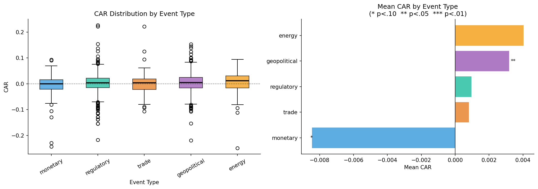
Figure A1. A1. CAR distribution by event type: boxplots with mean markers (Phase 4 output).
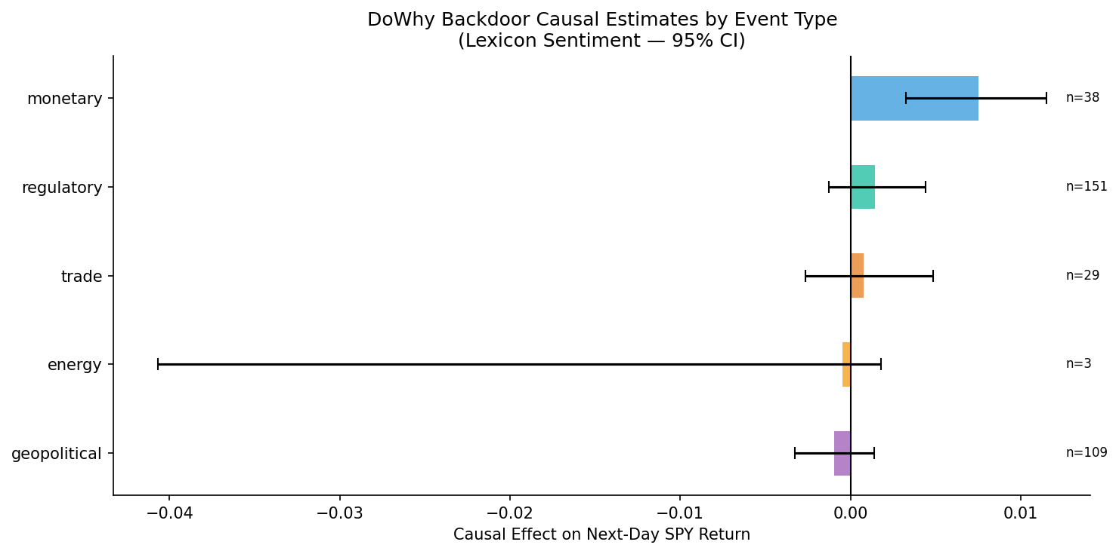
Figure A2. A2. DoWhy causal estimates with 95% confidence intervals, lexicon treatment variable (Phase 4 output).
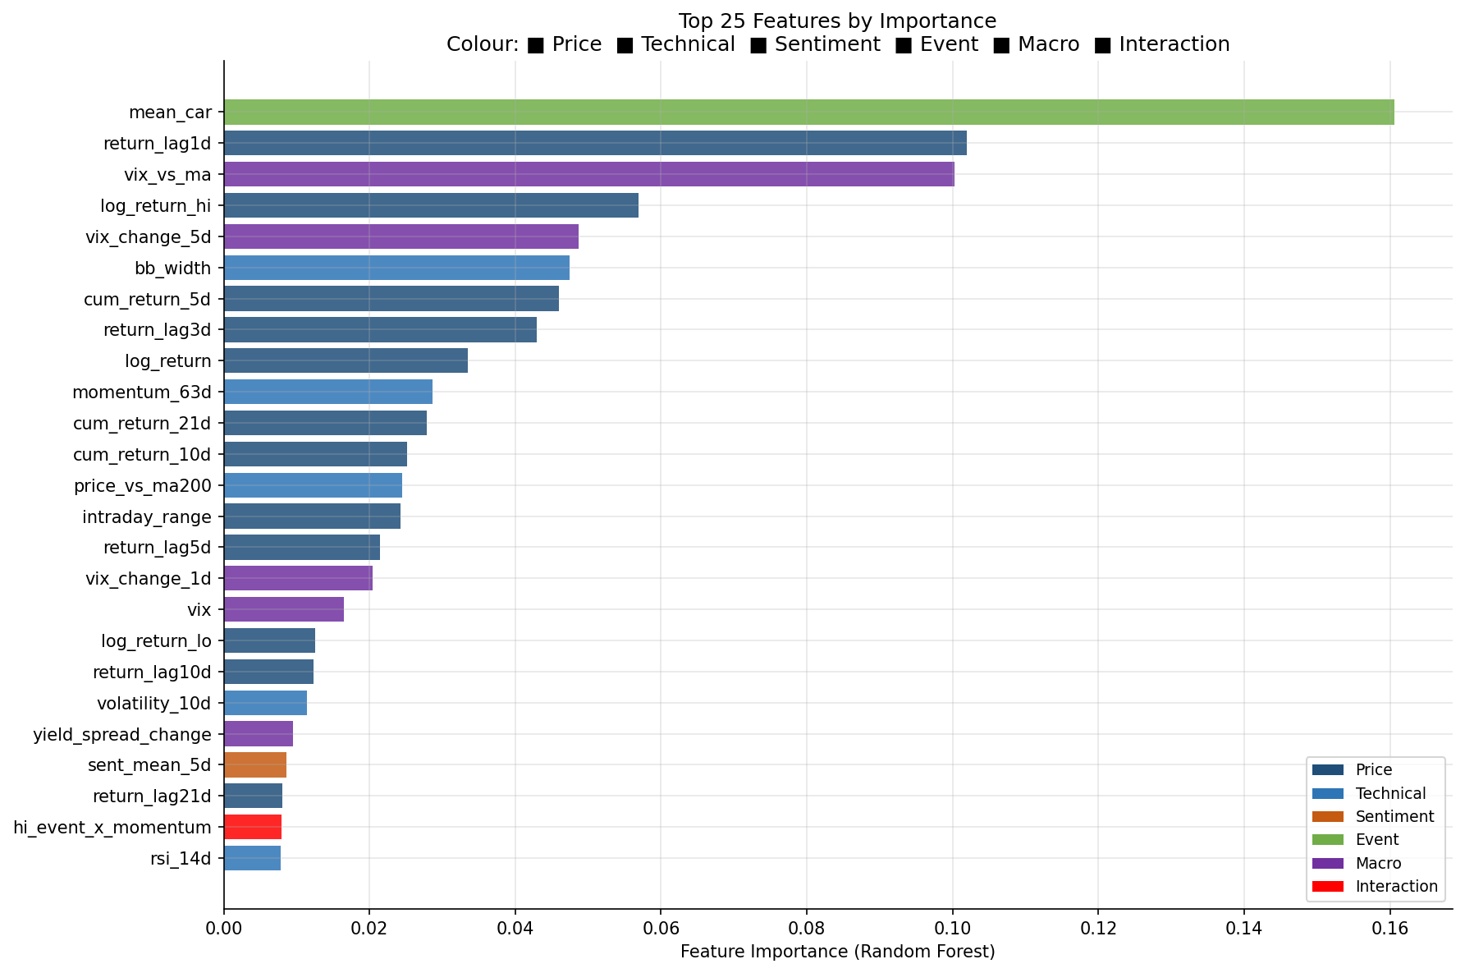
Figure A3. A3. Top 25 features by Random Forest importance, coloured by feature group (Phase 5 output).
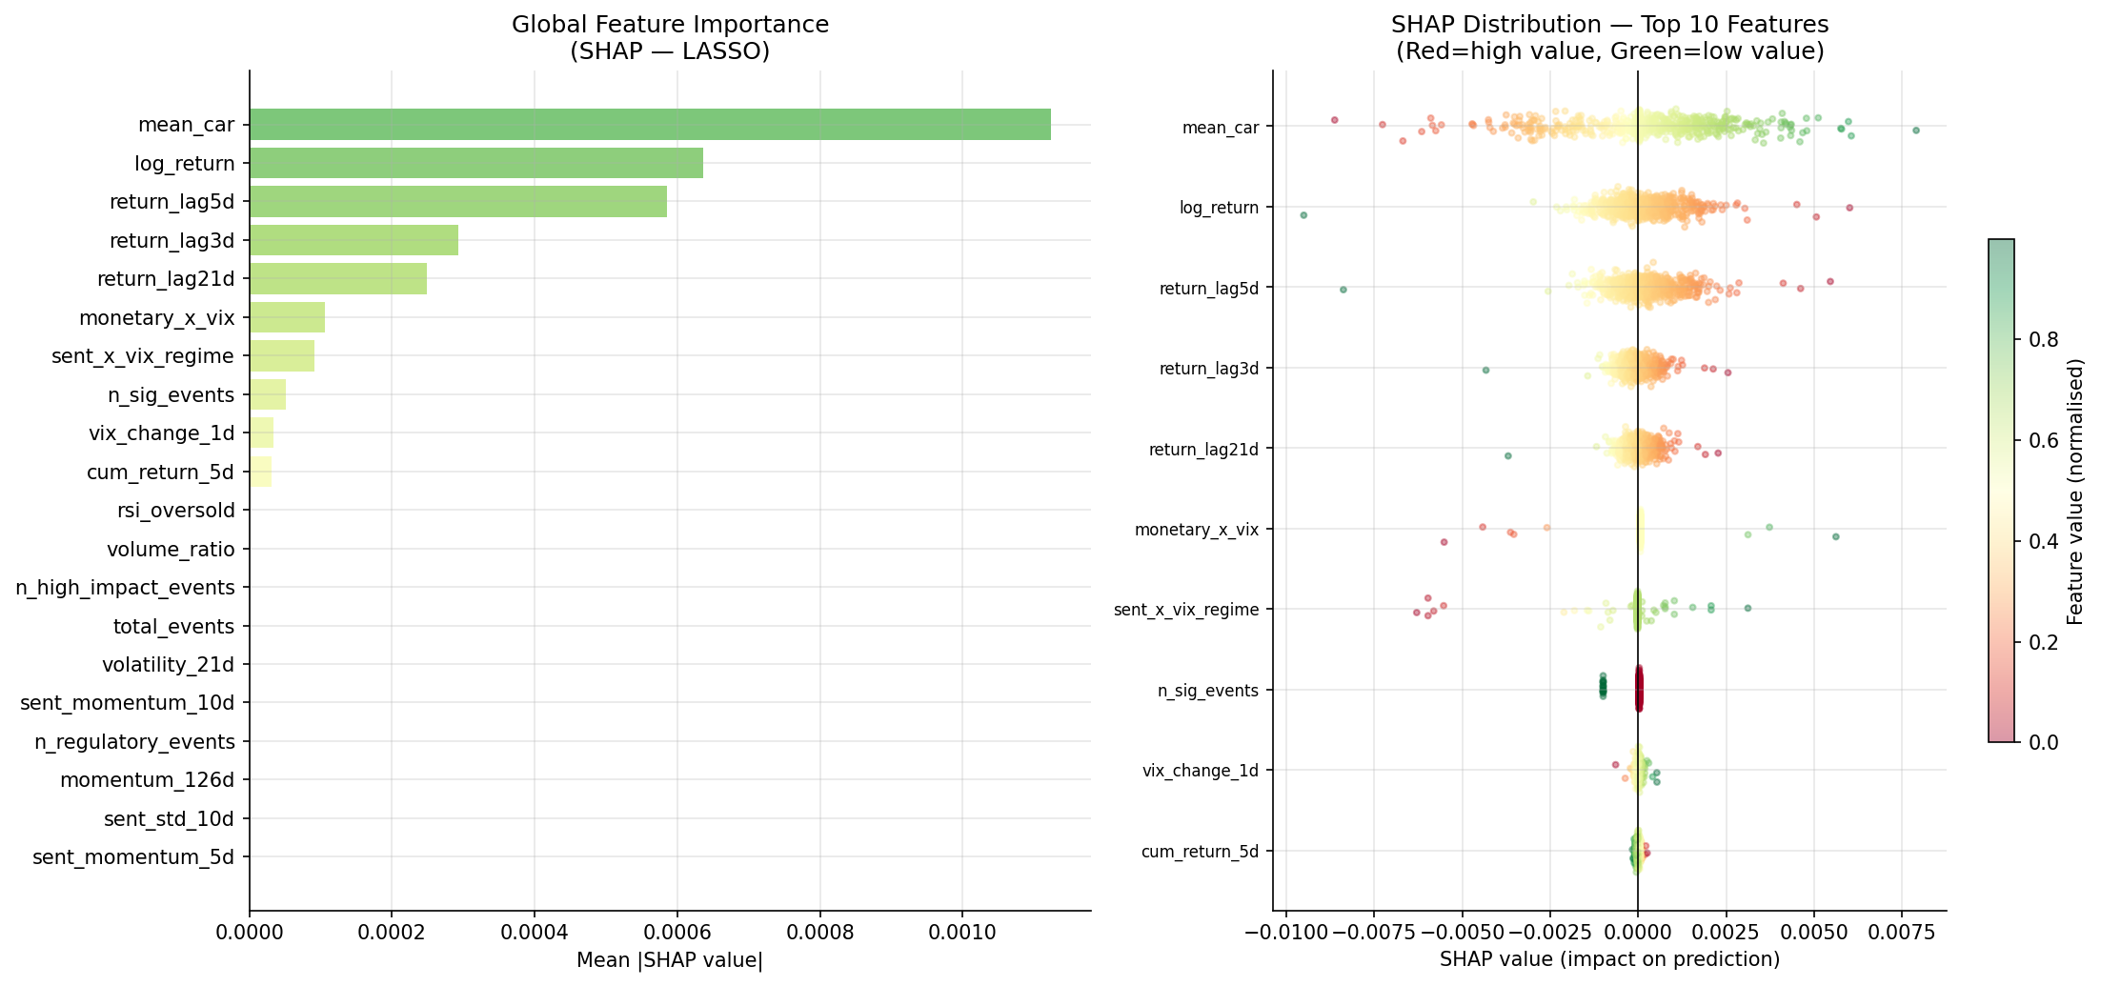
Figure A4. A4. SHAP global feature importance (left) and beeswarm distribution (right) for the LASSO model on the held-out test set (Phase 6 output).
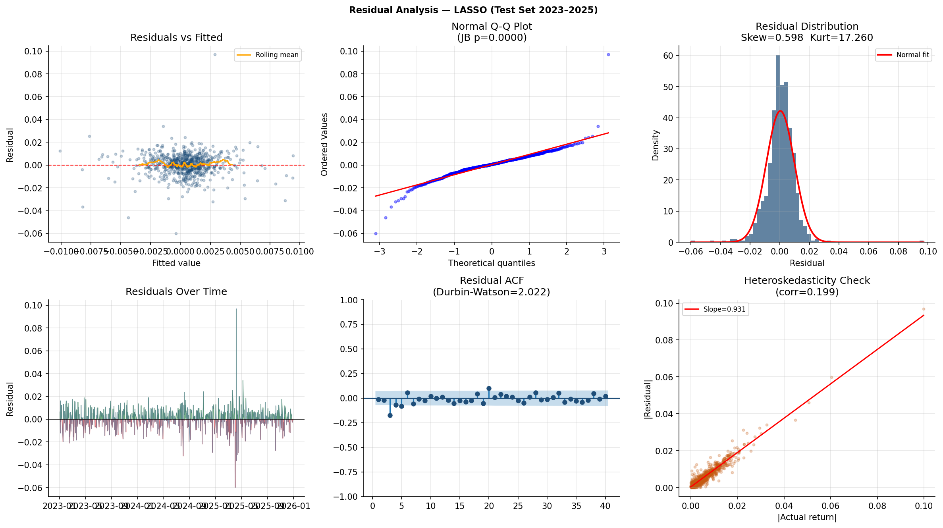
Figure A5. A5. Residual diagnostics for the LASSO model: (a) residuals vs fitted, (b) Normal Q–Q plot, (c) residual histogram with normal fit, (d) residuals over time, (e) autocorrelation function, (f) heteroskedasticity check (Phase 7 output).
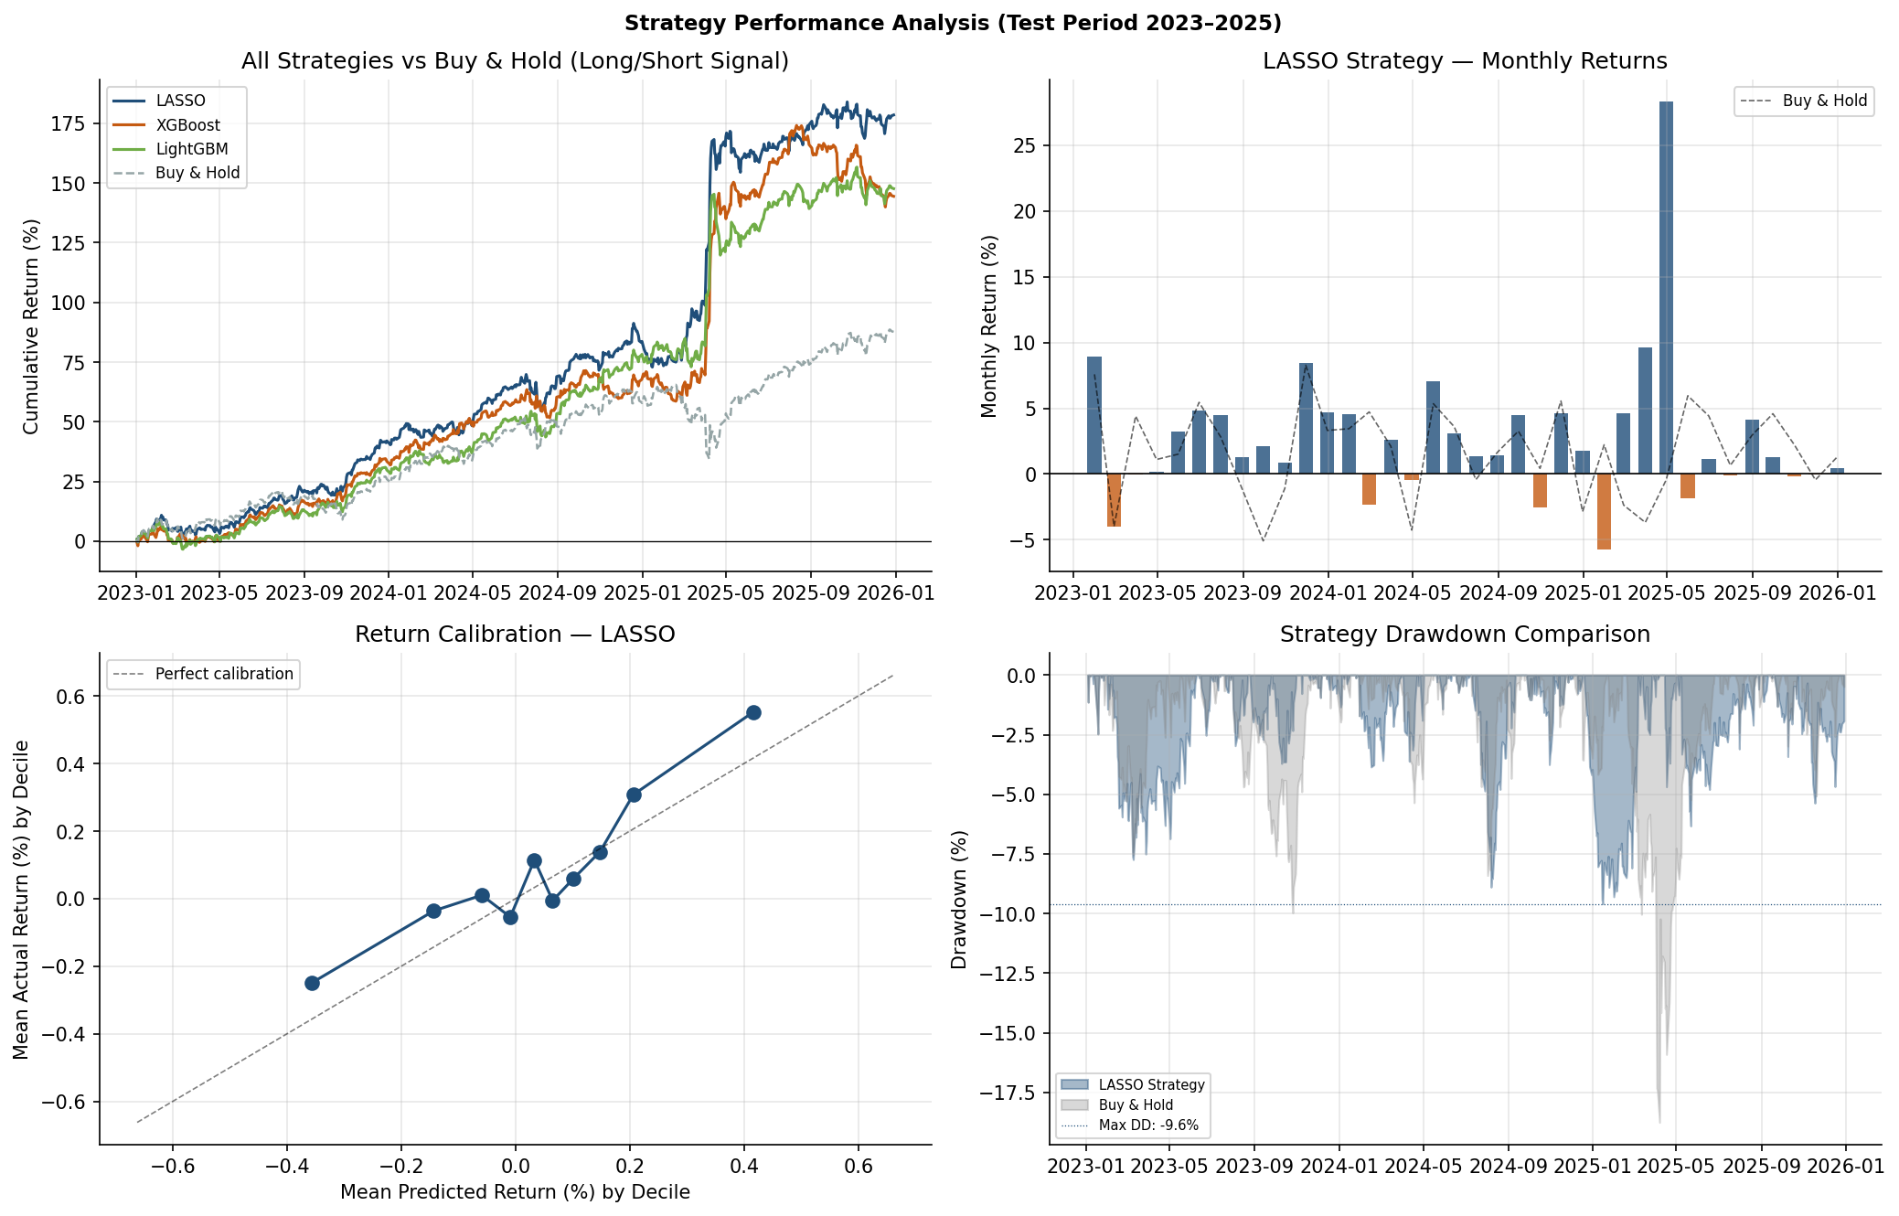
Figure A6. A6. Strategy performance analysis: cumulative return comparison across all models, monthly return bars, return calibration by decile, and drawdown comparison (Phase 7 output).

Appendix B: Data and Code
All code is submitted as a separate ZIP archive containing the eight Jupyter notebooks (01–08) and the supporting Python modules in the src/ directory. The processed data files (Parquet format) are available in the data/processed/ directory. Trained model files (LASSO pickle, XGBoost JSON, LightGBM TXT) are in the models/ directory. All figures are in reports/figures/. The full project is also available at the GitHub repository specified in the code submission.
Table B1. Summary of all outputs by phase
Phase | Notebook | Key Data Outputs | Figures
1 | 01_data_collection.ipynb | 5 raw Parquet files | 4 EDA figures
2 | 02_eda.ipynb | — | 12 EDA figures
3 | 03_event_detection.ipynb | events_tagged.parquet, daily_sentiment.parquet | 4 figures
4 | 04_causal_analysis.ipynb | car_results.parquet, causal_estimates.parquet | 4 figures
5 | 05_feature_engineering.ipynb | model_features.parquet, feature_metadata.parquet, scaler.pkl | 3 figures
6 | 06_model_training.ipynb | lasso.pkl, xgboost.json, lightgbm.txt, test_predictions.parquet, shap_values.parquet | 4 figures
7 | 07_model_evaluation.ipynb | evaluation_summary.parquet, residual_diagnostics.json | 4 figures
8 | 08_results_visualisation.ipynb | — | 4 publication figures (300 dpi)

Revision Roadmap (Working Draft)
This document has been reviewed for scope and structure. The figures are placeholders and will be replaced after the analysis notebooks are completed.
• Reduce the project to three research questions.
• Align chapters with the eight-notebook workflow.
• Keep core datasets: SPY, VIX, FRED, FOMC and Presidential Communications.
• Treat GDELT, GLD, QQQ and TLT as optional extensions.
• Generate all figures directly from notebook outputs.
• Add a repository architecture appendix.
• Add a reproducibility section (environment, package versions and execution order).

Figures
Replace all placeholder figures with the final notebook outputs before submission. Use consistent numbering, captions and in-text references.

