UHF PDA

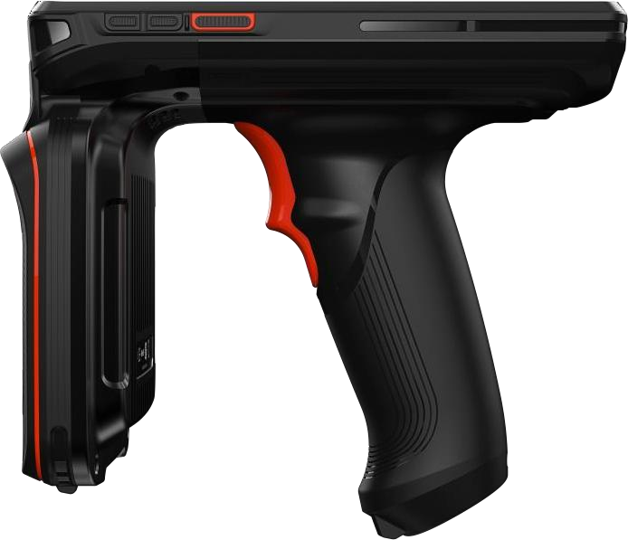

Model：CF-H906
Size：143.3mmx169mm×90.5mm
Weight：678G

1. Specifications
Performance | Model | CF-H906
Performance | O.S. | Android 9.0
Performance | Processor | Octa-core 1.4GHz
Performance | Memory | RAM： 2GB ROM： 16GB  RAM： 4GB ROM： 64GB (optional)
Performance | Extended memory | Micro-SD card, up to 128 GB
Basic specifica tions | Dimensions | 143.3mm X 169mmX90.5mm
Basic specifica tions | Weight | 678g
Basic specifica tions | Display | 5.7 inch HD display, 720X1440 resolution.
Basic specifica tions | Touch Screen | Ultra-sensitive capacitive touch panel ,works with gloves and wet fingers ;Corning Gorilla Glass 3; 5 fingers Multi-touch
Basic specifica tions | Main battery | Capacity： 3.85V 9000mAh
Basic specifica tions | Charging time | <7 hours
Basic specifica tions | Audio | Speakers、Dual Microphones、Earphone、Receiver
Basic specifica tions | Buttons | Volume+/-x Power, Scan buttonX2, Programable button, Pistol Grip trigger button
Basic specifica tions | Camera | Front 5M Pixels, Rear 13MP auto-focus color rear camera with flash
Basic specifica tions | Sensors | Light + Accelerator+ Proximity + Geomagnetic + Gyro (optional)
Basic specifica tions | Scanning | 1D/2D barcode reader  Can read all international standardslD/2D barcode；  Can read barcode displayed on screens and colored barcode；
Basic specifica tions | Slots | MicroSD/TFxl, Nano-SIMx2
Wireless commu nication | WAN | Dual-SIM, Dual-Standby
Wireless commu nication | WAN | 4G,3G,2G
Wireless commu nication | Bluetooth | BT4.2+BR/EDR+BLE
Wireless commu nication | Wi-Fi | 2-4G/5G, IEEE 802.11a/b/g/n/ac/d/e/h/i/k/r/v/w  Roaming： 802.Hr/OKC/ PMKID caching
Wireless commu nication | Positioning | GPS, A-GPS, BEIDOU, GLONASS、Galileo
Environ  merit | Temperature | -20°C 〜+60°C
Environ  merit | Storage | -40°C 〜+70°C
Environ  merit | Humidity | 5%RH〜95%RH (No condensation)
Environ  merit | Drop test | 1.2 meters
Environ  merit | Tumbling | 400 3.2ft./1.0m tumbles  Exceeds MIL-STD810G
Environ  merit | Seal | IP65

2. Data Capture Specifications
- Camera
Camera
Rear Camera | 1300W
Front Camera | 500W
Focus method | Auto focus, touch selection, face detection
flash | 700mA, support flashlight function
Video | 1080p front and rear camera video recording
- Scanner
Module | 2D Barcode
Scan Angels Tilt | 360°
Scan Angels Pitch | ±45°
Scan Angels Skew | ±60°
Laser type | Class Ⅱ
Barcodes support | UPC/EAN, UPC/EAN with supplementals, Code128, GS1-128, Code 39, Trioptic, Code 32, Code 93, Code11, Matrix 2 of 5, Interleaved 2 of 5, IATA 2 of 5, Industrial 2 of 5,Codabar, Codablock F,MSI,Telepen,Code11, GS1 DataBar variants,PDF417, MicroPDF417, Composite Code,Data Matrix, Maxicode, QR Code, MicroQR, Aztec
- RFID(UHF)
RFID | UHF
Frequency | 865-868MHz,902-928MHz
Protocol | ISO 18000-6C(EPC Global Class 1 Gen 2)  ISO 18000-6B
Reading Distance | up to 20 meters(relative to tags)
Antenna gain | Gain 4.5dBi

3. Wireless communication
1) GPS Positioning
Positioning | Specification
Support | GPS、A-GPSx BEIDOUx GLONASS、Galileo
Frequency | GPS(L1 1.575GHz C/A code), BEIDOU (Bl 1.561GHz),GLONASS(L1 1.602GHz), Galileo (El 1.589 GHz/E2 1.561 GHz)
Cold start | Less than 40s
Channels | Max31channels
Sensitivity | -130dB
Precision | 5-10 Meters (open space)
2) WIFI
WIFI | Specification
Protocol | IEEE 802.11a/b/g/n/ac/d/e/h/i/k/r/v/w (2.4G/5G Wi-Fi)
Frequency | 2.4G/5G
Working Channels | 2.4G： CH1-CH13 (Depends on Country/Region)  5G：  36/38/40/42/44/46/48/52/56/60/64/100/104/108/112/116/120/124/128/132/1  36/140/149/153/157/161/165 (Depends on Country/Region)
Security | EAP-TLS, EAP-TTLS, PEAP-MSCHAPv2, PEAP-TLS, PEAP-GTC, PWD, SIM,  AKA, WEP , WPA/WPA2-PSK, WAPI certificate, WAPI-PSK
Roaming | Support PMKID caching, 802.Hr, OKC

3) WAN
WAN | Specification
Mode | Dual-SIM, Dual-Standby
Global Version | 4G(TD-LTE)  4G(FDD-LTE) | TD-LTE:B34/B38/B39/B40/B41  FDD-LTE(B1/B2/B3/B4/B5/B7/B8/B12/B13/B17/  B19/B20/B25/B26/B28A/B28B/B66
Global Version | 3G(WCDMA)  3G(CDMA2000)  3G(TD-SCDMA) | WCDMA: B1/B2/B4/B5/B8  TD-SCDMA(B34/B39)  CDMA2000 lx EV-DO Rev-A BC0 (800MHz)
Global Version | 2G | CDMAlx  GSM/EDGE/GPRS(850/900/1800/1900)

4) Bluetooth
Bluetooth | Specification
Support | BT4.2+BR/EDR+BLE
Distance connect | >10 m

4. Optional Accessorie
Accessories | Specification
Accessories | Dock charger (supports 1 device + 1 battery charging), five-row charger, tempered film

