Project - Low Level Design
On
Multimodal Manufacturing Creator

Course Name: Generative Artificial Intelligence

Institution Name: Medicaps University – Datagami Skill Based Course
Student Name(s) & Enrolment Number(s):
Sr no | Student Name | Enrolment Number
1. | SRASHTI SEN | EN22CS301983
2. | SOUMYA SHRIVASTAVA | EN22CS301978
3. | TANISHKA RAGHUWANSHI | EN22CS3011019
4. | TARUN PATIDAR | EN22CS3011034
5. | VIDHI PRAJAPATI | EN22CS3011076

Group Name: Group 12
Project Number: 12
Industry Mentor Name: Mr. Yash
University Mentor Name: Prof. Vineeta Rathore
Academic Year: 2026

Table of Contents
- Introduction.
  - Scope of the document.
  - Intended Audience
  - System overview.
- System Design.
  - Application Design
  - Process Flow.
  - Information Flow.
  - Components Design
  - Key Design Considerations
  - API Catalogue.
- References

1. Introduction
The rapid advancement of Generative Artificial Intelligence (GenAI) has enabled systems that can generate multiple forms of content from a single input. In the manufacturing domain, visualization of product concepts plays a crucial role in design, prototyping, and presentation.
This project implements a Multimodal GenAI application that integrates Large Language Models (LLMs) with Image Generation Models through APIs to transform textual prompts into detailed textual explanations and visual representations of manufacturing concepts.
The system allows users to enter a prompt describing a manufacturing idea or product prototype. The application then generates:
- A descriptive narrative explaining the concept.
- A high-quality image visualization representing the product prototype.
This integration demonstrates the synergy between text-to-text and text-to-image models, enabling users to create multi-dimensional content suitable for educational demonstrations, research presentations, and product conceptualization.

1.1 Scope of the Document
This document provides the Low Level Design (LLD) of the Multimodal GenAI Application. It describes:
- Detailed system architecture
- Internal components and modules
- Data flow within the system
- Process workflow
- API integrations
- Design considerations
The document serves as a technical guide for developers, researchers, and system designers who need to understand the implementation and functionality of the system.

1.2 Intended Audience
This document is intended for the following stakeholders:
- Software Developers – For implementing and maintaining the application
- System Architects – For understanding the system structure and design decisions
- Project Evaluators / Faculty Members – For reviewing the project implementation
- Researchers and Students – For learning how multimodal AI systems are designed

1.3 System Overview
The Multimodal GenAI Manufacturing Visualization System is designed to convert user-provided textual prompts into both descriptive text and product visualization images.
The system integrates the following technologies:
- Large Language Model (LLM) for generating explanations and concept descriptions
- Image Generation Model for producing product prototype visuals
- Backend Server for handling API communication and logic
- Frontend Interface for user interaction
The workflow of the system includes:
- User enters a manufacturing concept prompt.
- The prompt is processed by the backend system.
- The prompt is sent to an LLM API to generate descriptive content.
- The same prompt is sent to an Image Generation API to generate a visual representation.
- The system combines both outputs and displays them to the user.
This allows users to visualize product concepts quickly without manual design tools.

2. System Design

2.1 Application Design
The system follows a three-tier architecture consisting of:

1. Presentation Layer (Frontend)
Responsible for user interaction.
Functions:
- Accepts user prompts
- Displays generated text and images
- Provides a user-friendly interface
Technologies that can be used:
- Streamlit
- React
- HTML/CSS/JavaScript

2. Application Layer (Backend)
Handles system logic and communication with AI models.
Functions:
- Prompt processing
- API request handling
- Response formatting
- Error handling
Technologies:
- Python
- Flask / FastAPI

3. AI Model Layer
This layer integrates external AI services.
Includes:
- Text Generation Model (LLM)
- Image Generation Model
These models generate the outputs based on user prompts.

2.2 Process Flow
The operational workflow of the system is as follows:
- User enters a manufacturing concept prompt.
- The frontend sends the prompt to the backend server.
- The backend processes the request.
- The prompt is sent to the LLM API for narrative generation.
- The prompt is also sent to the Image Generation API.
- Both responses are received by the backend.
- The backend combines and formats the outputs.
- The results are displayed on the user interface.

2.3 Information Flow
The system follows a structured information flow:
User Prompt
↓
Frontend Interface
↓
Backend Processing Server
↓
LLM API (Text Generation)
↓
Image Generation API
↓
Backend Response Handling
↓
Frontend Display
↓
User Output
This ensures efficient communication between system modules.

2.4 Components Design
The system consists of the following components:
1. User Interface Module
Handles user input and displays generated results.
Features:
- Prompt input field
- Output display section
- Image visualization panel

2. Prompt Processing Module
Responsible for preparing prompts for AI models.
Functions:
- Prompt validation
- Input formatting
- Prompt optimization

3. Text Generation Module
Uses an LLM API to generate textual explanations of manufacturing concepts.
Output includes:
- Product description
- Functional explanation
- Use cases

4. Image Generation Module
Uses an image generation API to generate product concept images.
Output includes:
- Prototype visualization
- Concept illustrations

5. Response Integration Module
Combines text and image outputs before displaying them to the user.
Functions:
- Formatting output
- Error handling
- Response synchronization

2.5 Key Design Considerations
Several factors were considered while designing the system:
Scalability
The system should handle multiple user requests and support future integration of additional AI models.
Performance
Efficient API calls and response handling ensure faster output generation.
Usability
The interface should be simple and easy for users without technical knowledge.
Reliability
Proper error handling ensures the system functions even when APIs fail or network issues occur.
Security
API keys and credentials must be securely stored to prevent unauthorized access.

2.6 API Catalogue
The application integrates external APIs for AI processing.
1. Text Generation API (LLM)
Purpose:
Generate descriptive explanations for manufacturing concepts.
Input:
User prompt
Output:
Detailed textual narrative
Example Use Case:
Explaining the design and functionality of a smart manufacturing robot.

2. Image Generation API
Purpose:
Generate visual representations of product prototypes.
Input:
Text prompt describing the product concept
Output:
Generated image visualization
Example Use Case:
Generating a conceptual design of an automated assembly machine.

3. Backend Service API
Purpose:
Manage communication between frontend and AI services.
Functions:
- Receive user input
- Send requests to AI APIs
- Return generated outputs

4.Architecture Diagram
Use Case Diagram
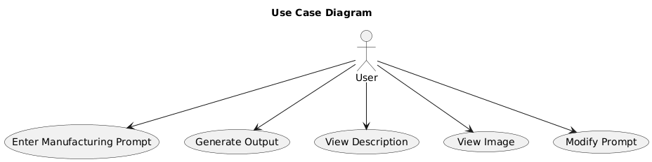
Activity Diagram
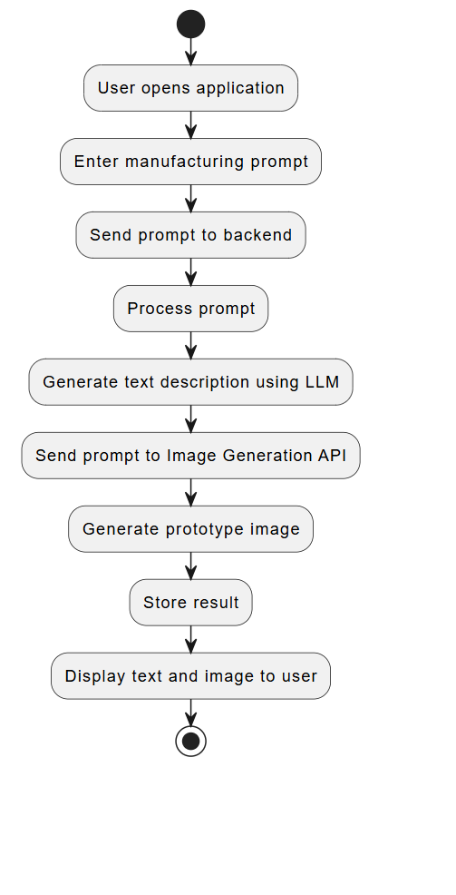

5. References
- Goodfellow, I., Bengio, Y., & Courville, A. – Deep Learning
- OpenAI Documentation – Generative AI APIs
- Hugging Face Transformers Documentation
- Research papers on Multimodal Artificial Intelligence
- Generative AI Applications in Manufacturing – IEEE Publications

