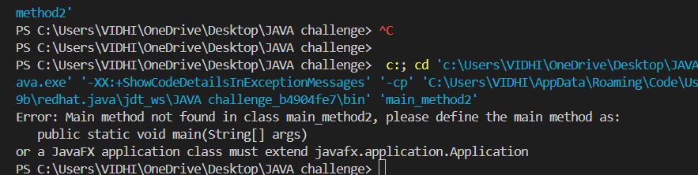

ENHANCEMENT IN JAVA 1.7 VERSION OF MORE MEANINGFUL ERROR

PREVIOUS ERROR—NO SUCH METHOD error :MAIN

* From 1.7 version main method is mandatory for starting to execute the program even though class contains static block but no main method it wont be executed

