You have started selling. Now what?

Do people know what, when, where, how, and why you’re selling your product/ service? Why should they care? It’s important to craft appealing messages to each of your target audiences. Let’s find out how.

You have **3 hours** to complete this assignment.

Once done, submit this assignment as PDF on LearnWise.

**Instructions:**

**Part 1 – Key Idea**

1. **Reflect:**

What is your key message? Articulating your key message and repeating it consistently across platforms is crucial for it to register in people’s minds.

1. **We promote physical and mental health through yoga and meditation.**

Who are you targeting? Go back to your User Personas and identify which audience you will reach through specific platforms, and tailor the messages accordingly.

1. **We are targetting college students of IIIT-NR who are fitness enthusiasts.**
2. **Do**
3. **Digital Ad –**For adaptation across various social media platforms including WhatsApp

Attention Attention Attention‼

We are here to remove your tension.

Want to work on your posture and flexibility? Are you fed up of your sedentary life and disturbed biological clock⏰!? Do you feel dull and drowsy all day long?

Here's an opportunity for you, which will leave you refreshed 😌.

We present to you a six day long YOGA AND MEDITATION SESSION🧘‍♀ ,starting from tomorrow, followed by a personality development session(optional).

Starting date:Aug 22.

Time:6:30-7:30 am.

Venue: We'll be using different venues so you'll be notified on daily basis.

Charges: Rs.150 per head

Contact:

Vidhi(6267157411),

Priya(8889104395),

Navya (7860056761).

Kindly revert by tonight.

1. **Poster –** For use in print material and collaterals around the campus

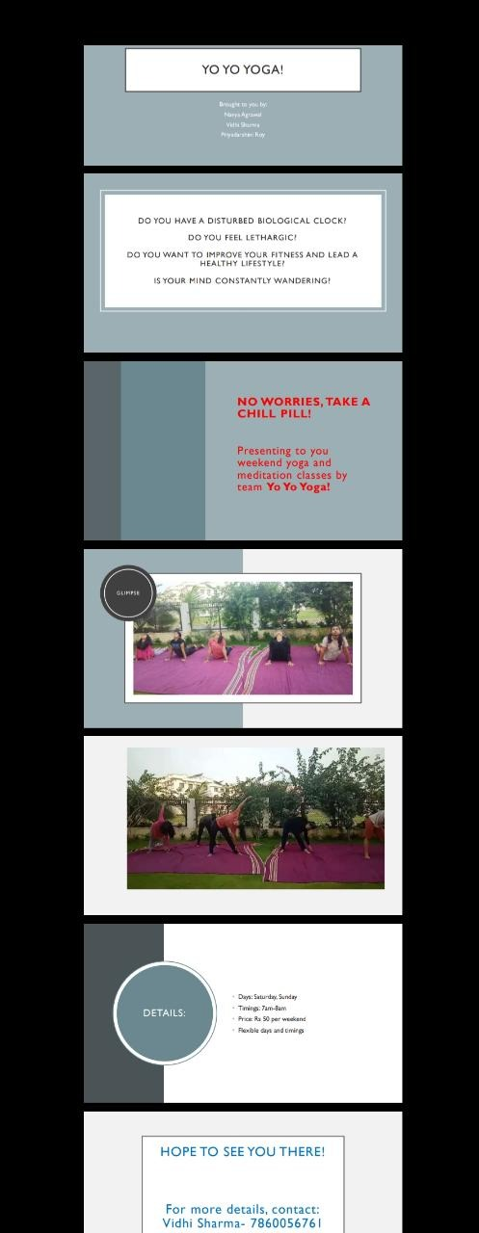

1. **Film** – A short 60 second video/teaser to build excitement

https://drive.google.com/folderview?id=17Npo2eZ15lNofd32_6ycMegRZHUg2WP_

**Part 2 – Anatomy of a Good Ad**

|  |  |
| --- | --- |
| **WHAT IS YOUR BIG IDEA?**  **Reducing stress levels among today’s youth both physically and mentally.** | **THE HOOK**  Early Bird Offer: Rs 50 per weekend for the first 5 customers!  **Free One Week Trial for limited customers.** |
| **WHAT MAKES YOU DIFFERENT?**  Our flexibility in terms of timings and venues. Adopting traditional yoga and mindfulness meditation instead of gymming which is a fad in today’s youth. | **HEADLINE**  **Making India Fit. Changing Lifestyles.** |
| **WHAT IS THE RTB (REASON TO BELIEVE)?**  **We don’t believe what we hear but what we see. We show what we promise. We conducted demo sessions where we showed what we we had in store for our customers.** | **BODY COPY**  **Customer gets an economical and feasible means to get fit. This is a practical solution towards fullfilling the dream of a healthy lifestyle.** |
| **CALL TO ACTION**  **We ask interested customers to register for our classes by directly contacting us (call or whatsapp)** |

**Part 3: Tell Your Story**

Create a 30-45 second video/short film to make your idea come alive, and demonstrate the usage and benefits to your users. First, write a script. Then, create rough sketches scene-wise for this storyboard. The last step is to do a low-budget shoot. Go

|  |  |  |  |
| --- | --- | --- | --- |
| **Motive:**   * Promoting health * Creating mental awarness * Reducing stress |  | **EUREKA!!**We found a way….  YOGA AND MEDITATION CLASSES | **Key features**:   * Weekend classes * Economical * Expertised trainers * Feasible timings |
| **Still Confused???**  Attend our live demo sessions to get a clarity. | **VENUES:**   * **Open Gym** * **Common Room** * **Balcony** * **Campus** | **PLANNED WEEKLY ACTIVITIES:**   * **Yoga** * **Meditation** * **Running** * **Aerobics** * **Zumba** | Contact us on call or dm (whatsapp)  Navya- 7860056761  SPECIAL OFFERS FOR FIRST CUSTOMERS |