Sales Data Analysis Using SQL

1. Introduction
This project analyzes sales data using SQL queries to identify sales trends, customer behavior, payment preferences, and product performance.

2. Objective
- Analyze product sales.
- Find top customers.
- Analyze payment methods.
- Study order status distribution.
- Evaluate referral source performance.

3. Tools Used
- MySQL Workbench
- SQL
- Dataset for Data Analytics

4. Dataset Description
The dataset contains 1200 sales records with fields such as:
- OrderID
- Date
- CustomerID
- Product
- Quantity
- UnitPrice
- PaymentMethod
- OrderStatus
- ReferralSource
- TotalPrice

5. SQL Queries and Outputs

Query 1: Product-wise Total Sales
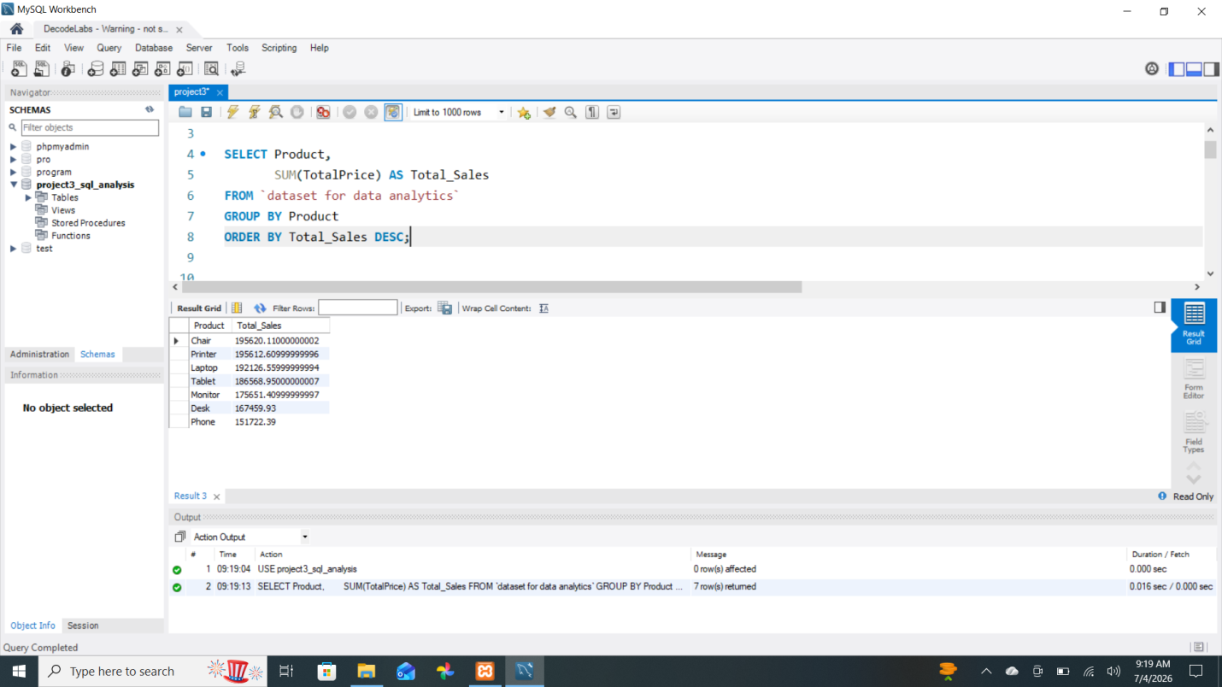

Query 2: Order Status Analysis
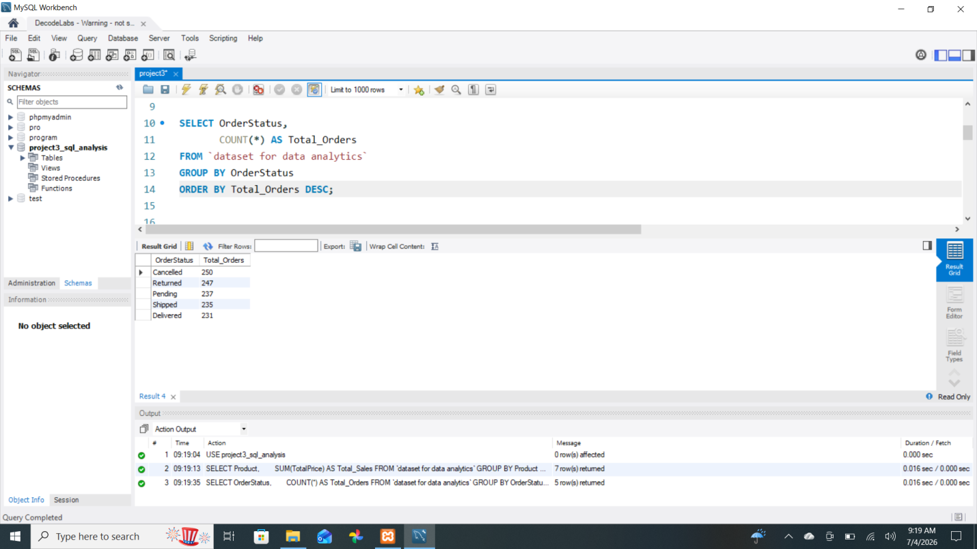

Query 3: Payment Method Analysis
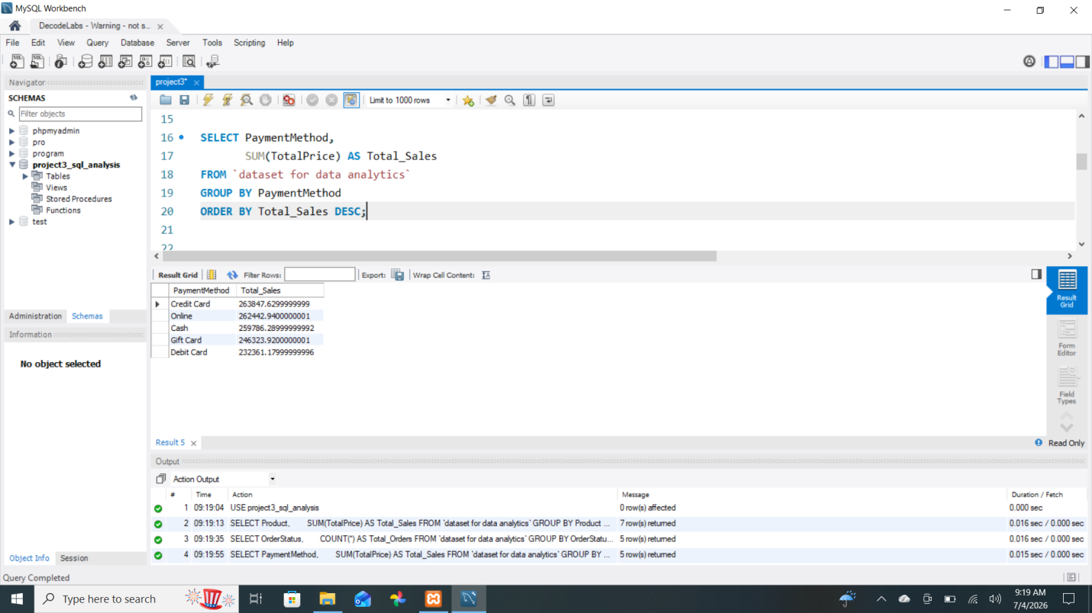

Query 4: Top 5 Customers by Spending
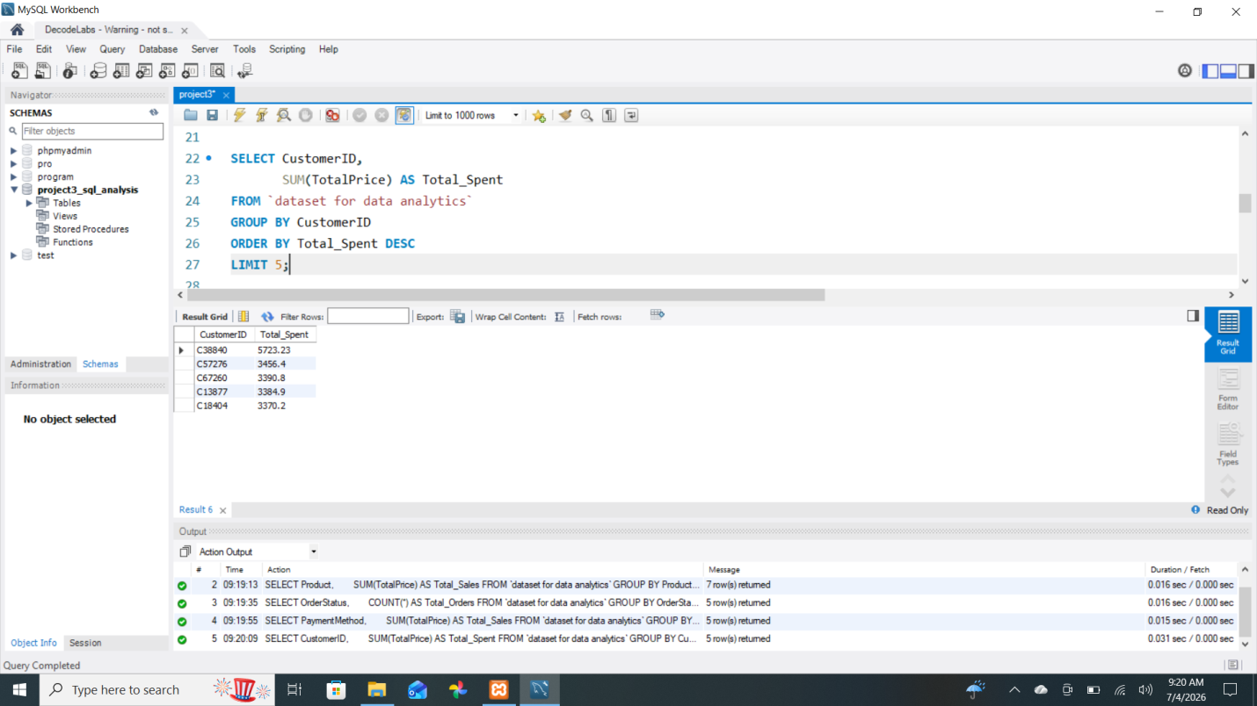

Query 5: Dataset Preview

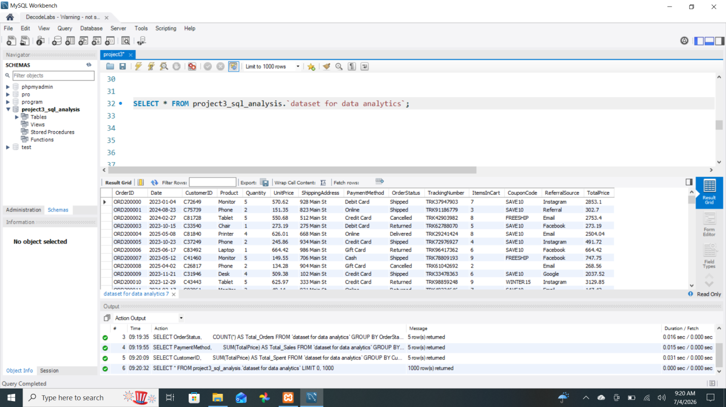

Query 6: First 10 Records

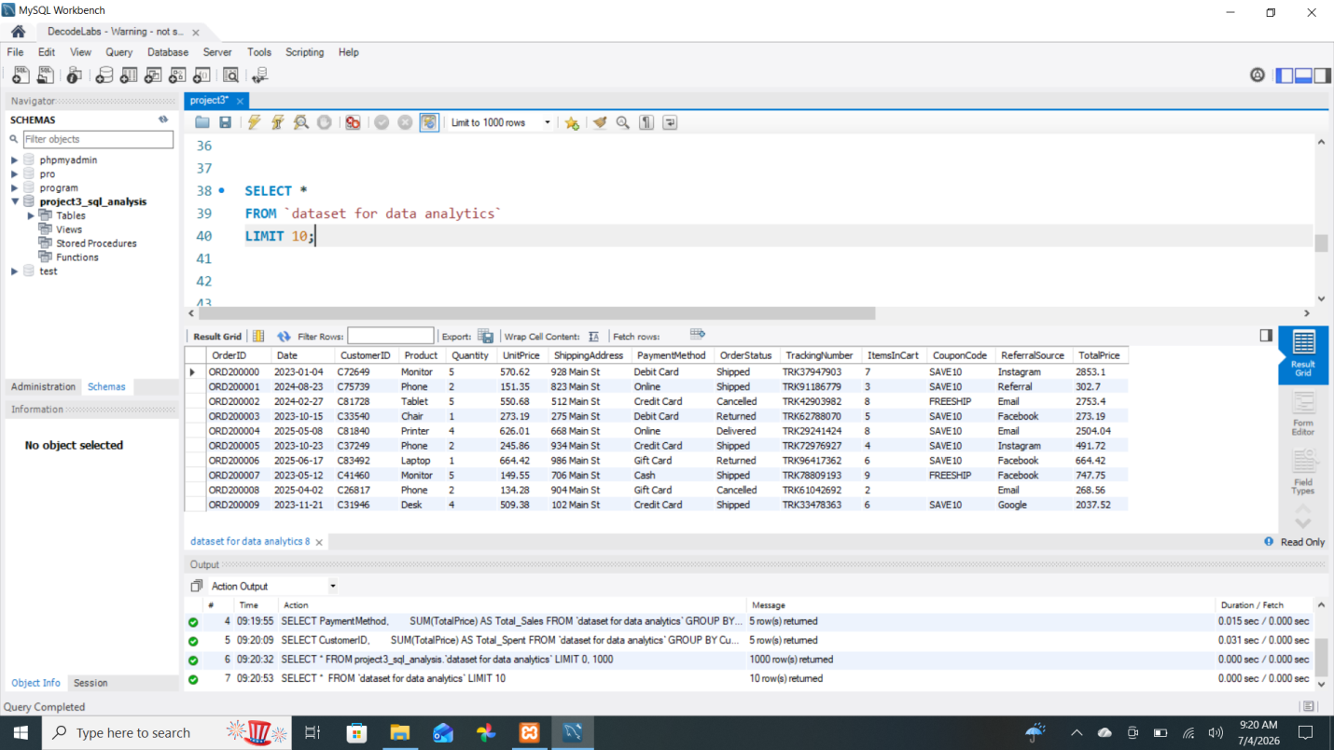

Query 7: Total Records Count

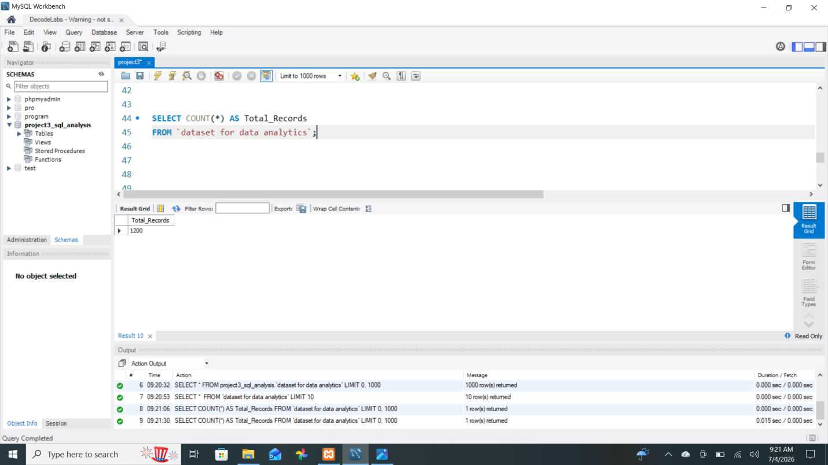

Query 8: Referral Source Analysis
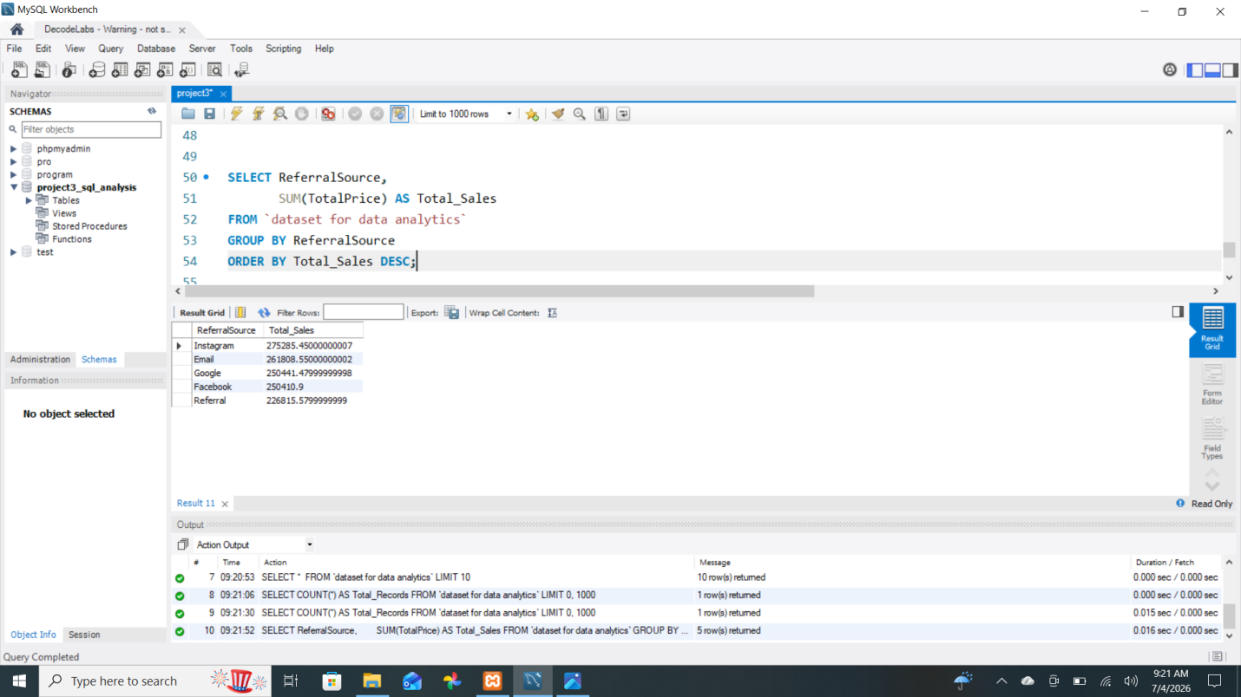

Query 9: Average Product Price Analysis

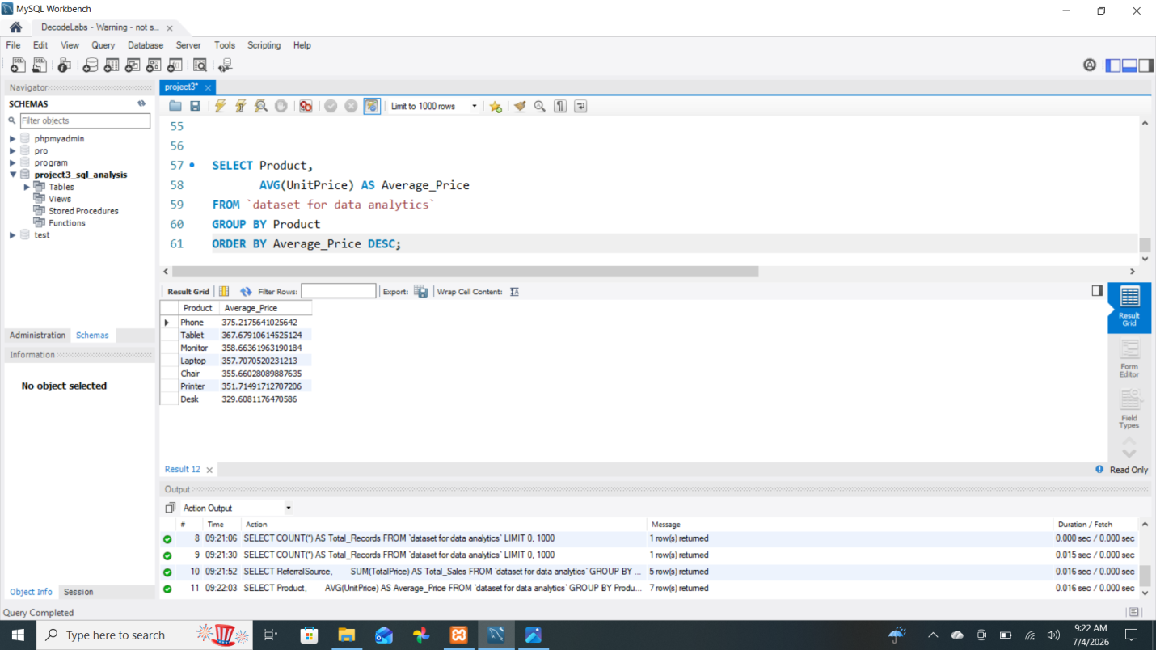

Query 10: Product-wise Quantity Sold Analysis

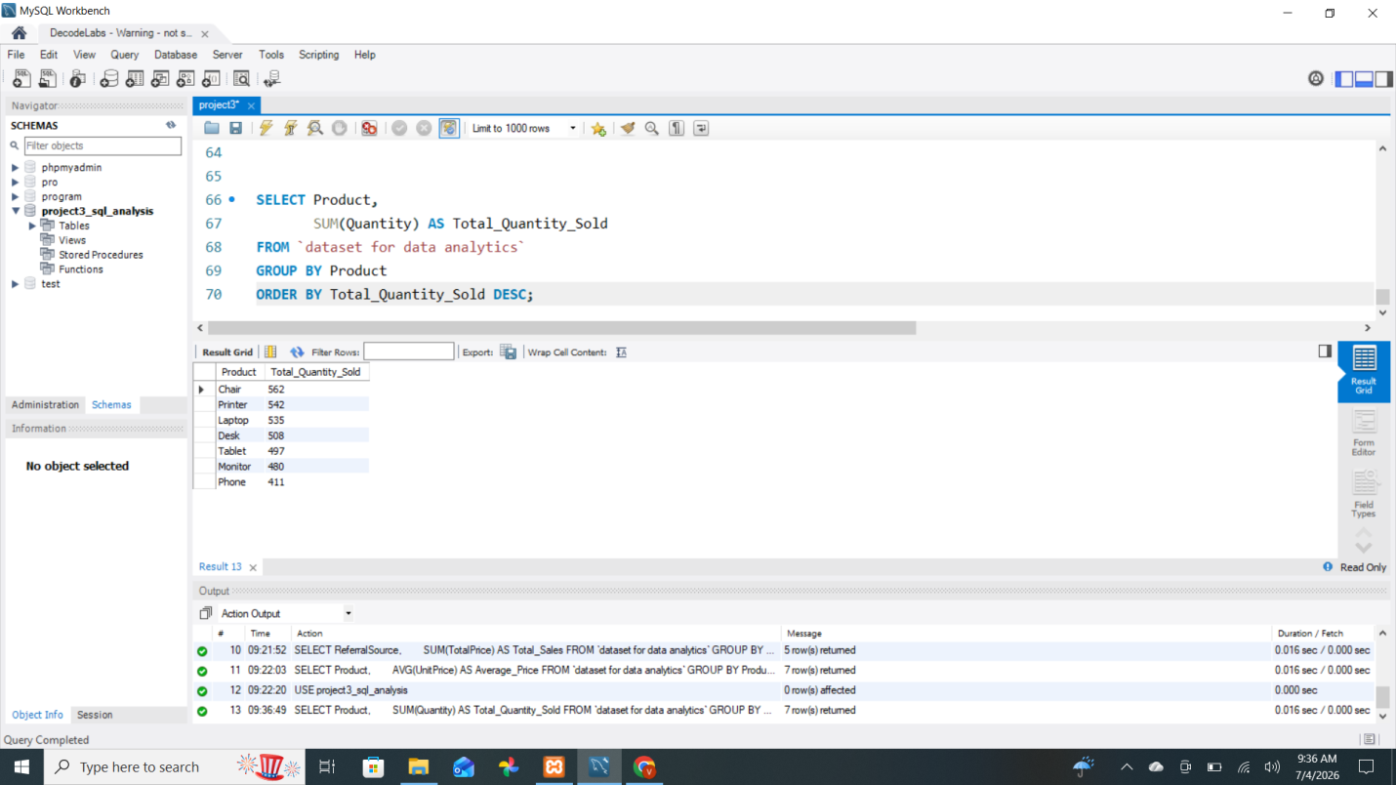

6. Key Findings
- Chair generated the highest total sales.
- Credit Card was the highest revenue-generating payment method.
- Customer C38840 spent the most.
- Instagram generated the highest referral sales.
- The dataset contains 1200 records.

7. Conclusion
This project demonstrated how SQL can be used for data analysis by applying aggregation, grouping, sorting, and filtering techniques to extract meaningful business insights from sales data.

8. GitHub Link

