
Nagar Yuwak Shikshan Sanstha’s

Yeshwantrao Chavan College of
Engineering
(Empowered Autonomous Institution under
R.T.M Nagpur University)

Hingna Road, Wanadongri, Nagpur - 441 110 NAAC A++ Grade
Ph.: 07104-237919, 234623, 329249, 329250 Fax: 07104-232376, Website: www.ycce.edu
Department of Artificial Intelligence & Data Science

Vision of the Department
To be a preferred hub for nurturing computer engineering aspirants through innovative, ethical, value-based technical education, impactful research, and industry collaboration, to become successful professionals contributing for the betterment of society.

Mission of the Department
To nurture computer engineering professionals by offering: Dynamic learning environment that encourages problem-solving using emerging technology, · National Education Policy aligned evidence-based technical education, fostering innovation, research, and industry–institute collaboration, Holistic, ethical and sustainable development for lifelong success.

Session 2025-2026(EVEN)
Vision: Dream of where you want. | Mission: Means to achieve Vision

Program Educational Objectives of the program (PEO): (broad statements that describe the professional and career accomplishments)
PEO1 | Preparation | P: Preparation | Pep-CL abbreviation
 |  |  | pronounce as
PEO2 | Core Competence | E: Environment | Pep-si-lL easy to
 |  | (Learning Environment) | recall
PEO3 | Breadth | P: Professionalism
PEO4 | Professionalism | C: Core Competence
PEO5 | Learning | L: Breadth (Learning
 | Environment | in diverse areas)

Program Outcomes (PO): (statements that describe what a student should be able to do and know by the end of a program)

Keywords of POs:
Engineering knowledge, Problem analysis, Design/development of solutions, Conduct Investigations of Complex Problems, Engineering Tool Usage, The Engineer and The World, Ethics, Individual and Collaborative Team work, Communication, Project Management and Finance, Life-Long Learning

PSO Keywords: Cutting edge technologies, Research
“I am an engineer, and I know how to apply engineering knowledge to investigate, analyse and design solutions to complex problems using tools for entire world following all ethics in a collaborative way with proper management skills throughout my life.” to contribute to the development of cutting-edge technologies and Research.

Integrity: I will adhere to the Laboratory Code of Conduct and ethics in its entirety.

Name and Signature of Student and Date



28-03-26
(Signature and Date in Handwritten)

Nagar Yuwak Shikshan Sanstha’s

Yeshwantrao Chavan College of
Engineering
(Empowered Autonomous Institution under
R.T.M Nagpur University)

Hingna Road, Wanadongri, Nagpur - 441 110 NAAC A++ Grade
Ph.: 07104-237919, 234623, 329249, 329250 Fax: 07104-232376, Website: www.ycce.edu
Department of Artificial Intelligence & Data Science

Vision of the Department
To be a preferred hub for nurturing computer engineering aspirants through innovative, ethical, value-based technical education, impactful research, and industry collaboration, to become successful professionals contributing for the betterment of society.

Mission of the Department
To nurture computer engineering professionals by offering: Dynamic learning environment that encourages problem-solving using emerging technology, · National Education Policy aligned evidence-based technical education, fostering innovation, research, and industry–institute collaboration, Holistic, ethical and sustainable development for lifelong success.

Session | 2024-25 (EVEN) | Course Name | Java Full Stack Development Lab
Semester | 4 | Course Code | 23ADS1407
Roll No | 129 | Name of Student | Vidhi Chavhan

Practical Number | 09
Course Outcome  Aim | Students will understand array manipulation, searching and sorting algorithms, loop structures, comparison logic, and basic algorithm efficiency concepts through practical implementation in Java.  To establish database connectivity in Java using JDBC and perform basic operations on aMySQL database.

Problem Definition  Theory  (100 words) | To establish database connectivity in Java using JDBC and perform basic operations on aMySQL database.  JDBC (Java Database Connectivity) serves as the standard industrial abstraction layer that enables Java applications to communicate with relational databases like MySQL. At its core, JDBC follows a "driver-based" architecture where the DriverManager class acts as a central registry to manage different database drivers. When a connection is requested using a specific URL—such as jdbc:mysql://localhost:3306/db_name—the DriverManager selects the appropriate MySQL Connector/J driver to translate generic Java method calls into the specific network protocol understood by the MySQL server. This design ensures "write once, run anywhere" portability, meaning the application's logic remains largely the same even if the underlying database engine is swapped.  Once a session is established through a Connection object, the application performs operations using Statement or PreparedStatement objects. For "Read" operations, the database returns a ResultSet, which is a logical table that the developer can iterate through to retrieve data row by row. For "Create, Update, or Delete" operations, the system returns an integer representing the number of rows affected. Modern Java development emphasizes the use of PreparedStatements to pre-compile SQL queries, which not only improves performance through execution plan caching but also provides a vital security barrier against SQL Injection by treating user input as data rather than executable code.
Procedure and Execution  (100 Words) | To perform any operation, the program must strictly follow these five stages:  - Driver Registration: The application first identifies the necessary driver (e.g., com.mysql.cj.jdbc.Driver). This "registers" the MySQL-specific communication logic with Java's global DriverManager.  - Connection Establishment: A connection object is created using a JDBC URL, which acts like an address. It contains the protocol (jdbc), the  sub-protocol (mysql), the host/IP (localhost), the port (3306), and the specific database name.  - Statement Creation: The logic separates the connection from the action. You create a Statement (for static SQL) or a PreparedStatement (for dynamic

SQL with parameters). The PreparedStatement is logically superior because it pre-compiles the SQL on the server, enhancing speed and preventing SQL injection.
- Execution and Processing: * For Data Querying (Read): Use executeQuery(). The logic returns a ResultSet object, which is a virtual table that the application iterates through to extract data.
  - For Data Manipulation (Create, Update, Delete): Use executeUpdate(). The logic returns an integer representing how many rows were modified.
- Resource Cleanup: This is the most critical logical step. Database connections are "expensive" in terms of memory. The procedure dictates that the ResultSet, Statement, and Connection must be closed in reverse order of their opening to prevent memory leaks and "hanging" connections.


Nagar Yuwak Shikshan Sanstha’s

Yeshwantrao Chavan College of
Engineering
(Empowered Autonomous Institution under
R.T.M Nagpur University)

Hingna Road, Wanadongri, Nagpur - 441 110 NAAC A++ Grade
Ph.: 07104-237919, 234623, 329249, 329250 Fax: 07104-232376, Website: www.ycce.edu
Department of Artificial Intelligence & Data Science

Vision of the Department
To be a preferred hub for nurturing computer engineering aspirants through innovative, ethical, value-based technical education, impactful research, and industry collaboration, to become successful professionals contributing for the betterment of society.

Mission of the Department
To nurture computer engineering professionals by offering: Dynamic learning environment that encourages problem-solving using emerging technology, · National Education Policy aligned evidence-based technical education, fostering innovation, research, and industry–institute collaboration, Holistic, ethical and sustainable development for lifelong success.

Code:
import java.sql.Connection; import java.sql.DriverManager; import java.sql.ResultSet; import java.sql.Statement; public class Main {
public static void main(String[] args) {
String url ="jdbc:mysql://localhost:3306/mydatabase"; String user = "root";
String password = "root"; // Change if different try {
Connection con = DriverManager.getConnection(url,
user,
password); System.out.println("Connected to Database
Successfully");
Statement stmt = con.createStatement();
ResultSet rs = stmt.executeQuery("SELECT * FROM student");
while (rs.next()) { System.out.println(
"ID: " + rs.getInt("id") +
" Name: " + rs.getString("name")
);
}
con.close();
} catch (Exception e) { e.printStackTrace();
}
}
}

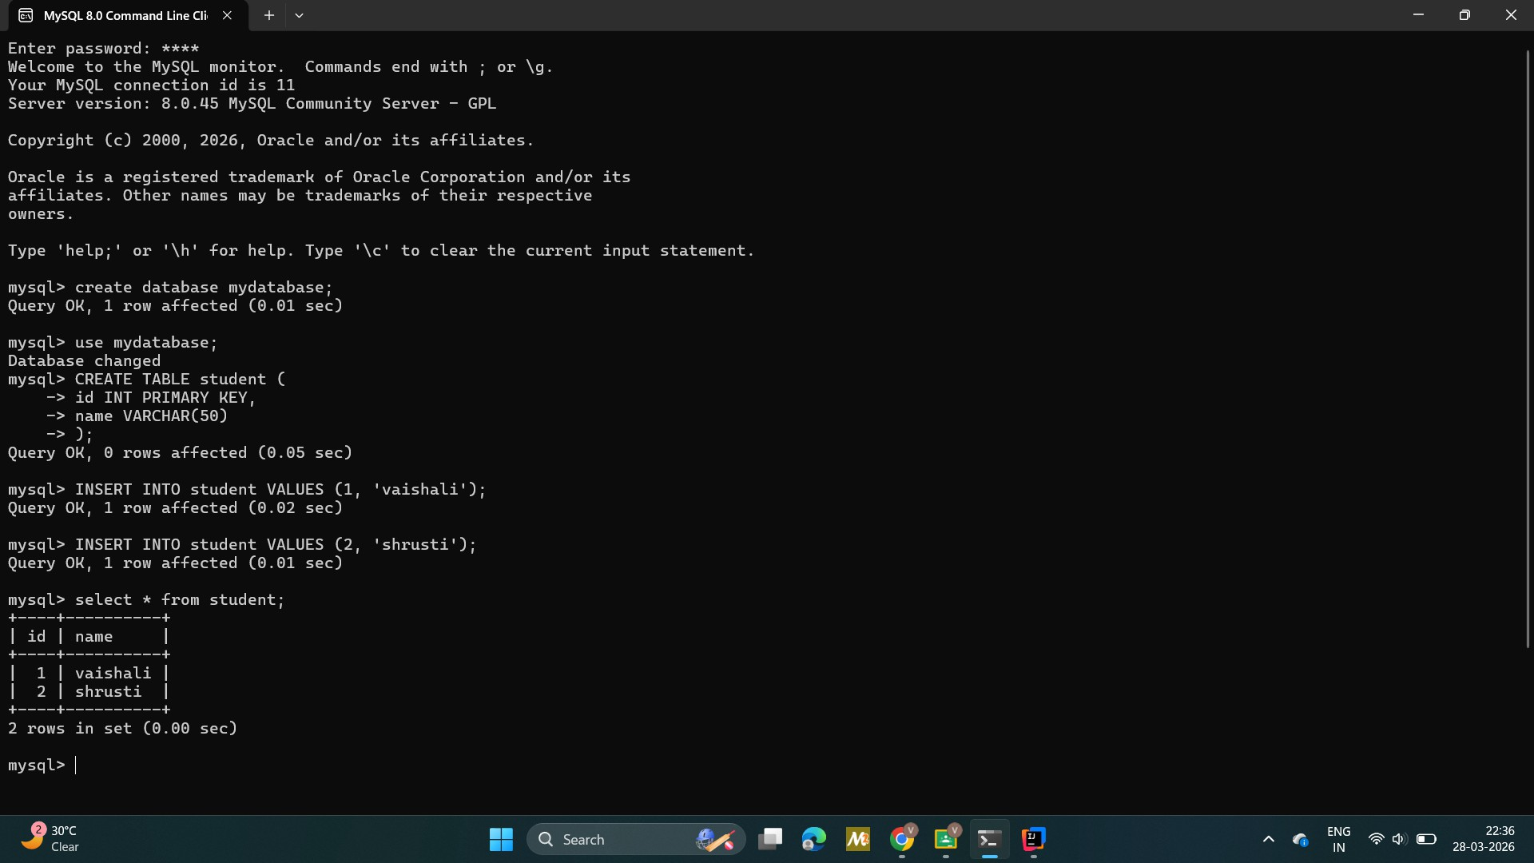


Nagar Yuwak Shikshan Sanstha’s


Yeshwantrao Chavan College of Engineering
(Empowered Autonomous Institution under R.T.M Nagpur University)

Hingna Road, Wanadongri, Nagpur - 441 110 NAAC A++ Grade
Ph.: 07104-237919, 234623, 329249, 329250 Fax: 07104-232376, Website: www.ycce.edu
Department of Artificial Intelligence & Data Science

Vision of the Department
To be a preferred hub for nurturing computer engineering aspirants through innovative, ethical, value-based technical education, impactful research, and industry collaboration, to become successful professionals contributing for the betterment of society.

Mission of the Department
To nurture computer engineering professionals by offering: Dynamic learning environment that encourages problem-solving using emerging technology, · National Education Policy aligned evidence-based technical education, fostering innovation, research, and industry–institute collaboration, Holistic, ethical and sustainable development for lifelong success.

Output:

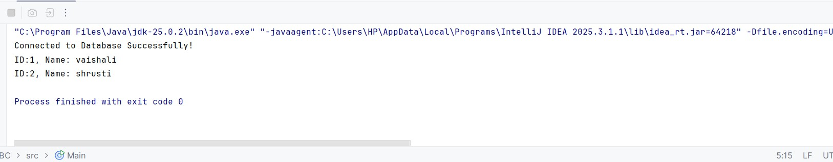

Output Analysis  Link of student Github profile where lab assignment has been uploaded  Conclusion | In JDBC represents the final phase of the database interaction, where the Java application interprets the data or feedback returned by the MySQL server. This analysis is logically split into two categories based on the type of SQL command executed: Query Results and Update Counts.  http://github.com/vidhichavhan18-cell/Java -installation  Establishing database connectivity in Java via JDBC is a structured process that transforms a static Java application into a dynamic, data-driven system. By leveraging the JDBC API as a universal middleman, developers can execute complex SQL operations on a MySQL database without needing to manage low-level network protocols.  The strength of this approach lies in its logical separation of concerns: the connection handles the session, the statement handles the command logic, and the result set handles the data output. Adhering to the established procedure—particularly the use of PreparedStatements for security and Try-With-Resources for efficient memory management—is essential for building robust and scalable applications. Ultimately, mastering this connectivity allows for the seamless integration of persistent storage, ensuring that application data remains secure, organized, and easily accessible

Plag Report (Similarity index  < 12%) | 
Date | 04/04/2026

Nagar Yuwak Shikshan Sanstha’s
Yeshwantrao Chavan College of
Engineering
(Empowered Autonomous Institution under
R.T.M Nagpur University)

Hingna Road, Wanadongri, Nagpur - 441 110 NAAC A++ Grade
Ph.: 07104-237919, 234623, 329249, 329250 Fax: 07104-232376, Website: www.ycce.edu
Department of Artificial Intelligence & Data Science

Vision of the Department
To be a preferred hub for nurturing computer engineering aspirants through innovative, ethical, value-based technical education, impactful research, and industry collaboration, to become successful professionals contributing for the betterment of society.

Mission of the Department
To nurture computer engineering professionals by offering: Dynamic learning environment that encourages problem-solving using emerging technology, · National Education Policy aligned evidence-based technical education, fostering innovation, research, and industry–institute collaboration, Holistic, ethical and sustainable development for lifelong success.

Observation copy screenshot

