Session 2025-2026(EVEN)

Vision: Dream of where you want. | Mission: Means to achieve Vision

Program Educational Objectives of the program (PEO): (broad statements that describe the professional and career accomplishments)
PEO1 | Preparation | P: Preparation | Pep-CL abbreviation  pronounce as Pep-si-lL easy to recall
PEO2 | Core Competence | E: Environment (Learning Environment)
PEO3 | Breadth | P: Professionalism
PEO4 | Professionalism | C: Core Competence
PEO5 | Learning Environment | L: Breadth (Learning in diverse areas)

Program Outcomes (PO): (statements that describe what a student should be able to do and know by the end of a program)
Keywords of POs:
Engineering knowledge, Problem analysis, Design/development of solutions, Conduct Investigations of Complex Problems, Engineering Tool Usage, The Engineer and The World, Ethics, Individual and Collaborative Team work, Communication, Project Management and Finance, Life-Long Learning

PSO Keywords: Cutting edge technologies, Research

“I am an engineer, and I know how to apply engineering knowledge to investigate, analyse and design solutions to complex problems using tools for entire world following all ethics in a collaborative way with proper management skills throughout my life.” to contribute to the development of cutting-edge technologies and Research.

Integrity: I will adhere to the Laboratory Code of Conduct and ethics in its entirety.

Name and Signature of Student and Date
(Signature and Date in Handwritten)

Session | 2024-25 (EVEN) |  | Course Name | Java Full Stack Development Lab
Semester | 4 |  | Course Code | 23ADS1407
Roll No | 129 |  | Name of Student | Vidhi Chavhan
Practical Number |  | Practical 8
Course Outcome
Aim |  | WAP to demonstrate concept of file handling
Problem Definition |  | Develop a program to demonstrate the concept of file handling by creating a file, writing data into it, and reading the stored data. The program should use appropriate file handling classes and methods to perform operations like file creation, writing, and reading. It should also handle possible errors such as file not found or input/output exceptions, ensuring smooth execution and proper management of data stored in files.
Theory  (100 words) |  | - File handling is used to store and retrieve data permanently from files.  - It allows programs to read, write, and update data in files.  - Java provides classes like File, FileWriter, FileReader, BufferedReader, and BufferedWriter.  - A file can be created using the File class.  - Data is written using FileWriter or BufferedWriter.  - Data is read using FileReader or BufferedReader.  - Exception handling is important to manage I/O errors.  - File handling supports efficient data storage and management.  - It is useful for saving user data and program results permanently.
Procedure and Execution  (100 Words) |  | - Procedure:  - Import required classes (java.io.*).  - Create a class and main method.  - Create a file using File or FileWriter.  - Write data into the file using FileWriter or BufferedWriter.  - Close the file after writing.  - Open the file using FileReader or BufferedReader.  - Read and display the file content.  - Close the file after reading.  - Add try-catch blocks to handle exceptions.  - Execution:  - Compile the program using javac command.  - Run the program using java command.  - Check the file created in the directory.  - Verify written and displayed content.
Code:
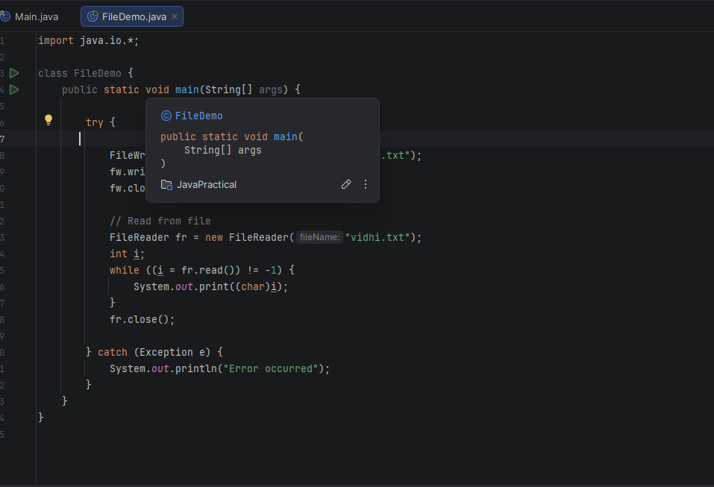

Output:
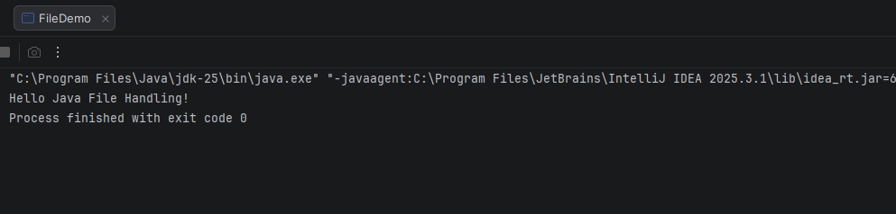

Output Analysis |  | - When the program runs successfully, a new file is created in the specified directory.  - The data provided in the program is written correctly into the file.  - Upon reading, the same content is displayed on the console.  - If the file already exists, data may be overwritten or appended based on the mode used.  - If an error occurs (like file not found or access denied), it is handled using exception handling.  - The program does not crash and shows proper error messages.  - This demonstrates that file handling enables safe storage and retrieval of data.
Link of student Github profile where lab assignment has been uploaded |  | https://github.com/vidhichavhan18-cell/Java-Installation
Conclusion |  | File handling allows efficient storage and retrieval of data in a program.  It ensures data can be saved permanently and accessed when needed.  Thus, it improves data management and reliability in applications.
Plag Report (Similarity index < 12%) |  | 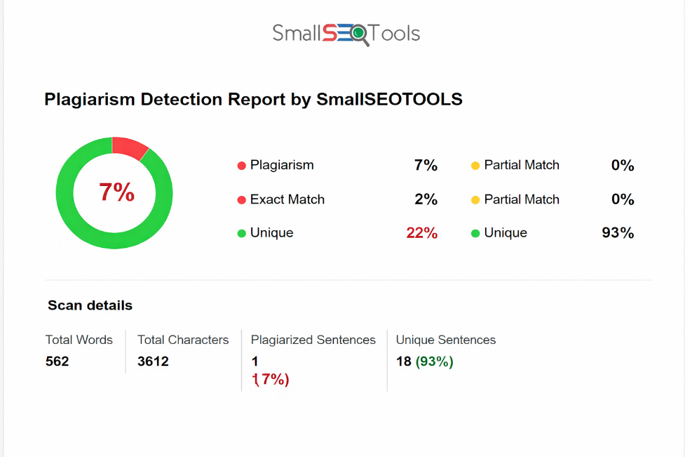
Date |  | 24.03.2026

Observation copy screenshot

