Personalized Python Tutor Using Student Knowledge Modelling
Jenil Kalsariya Priyanshu Panchasara | Iska Puneeth Abhishek | Vidhi Jain
2026701029 2026701004  1. Domain and Target User  Domain:  Education and Learning  Target User: | 2026701051 | 2026701024
Novice programmers learning introductory programming, particularly students with heterogeneous levels of prerequisite knowledge and programming experience. The scope is intentionally limited to introductory Python rather than attempting to teach the entire language.

2. Problem statement
Novice programmers differ widely in prior knowledge and in the misconceptions they hold. Human tutoring adapts to these differences, but it does not scale to large classes or self-learners. Current LLMs coding assistants operate primarily as direct solution engines rather than effective pedagogical tutors. Furthermore, existing LLM tutoring tools lack persistent cognitive state tracking, failing to maintain an evolving profile of student mastery across learning sessions. As a result, they often re-explain mastered concepts, miss recurring misconceptions, and frequently just give away the solution. Therefore, there is a critical need for an orchestrated multi-agent tutoring framework that enforces Socratic guidance, maintains a persistent student knowledge state. This project builds and evaluates a multi-agent tutor in which diagnosis, tutoring, and assessment share an explicit student knowledge base. That knowledge base is updated from execution-grounded evidence rather than the LLM's impression of the student.

3. Research Questions
RQ1: Does an orchestrated multi-agent tutoring framework with explicit role separation (Diagnosis, Tutoring, Assessment) and a persistent Student Knowledge Base (SKB) improve student concept retention and reduce direct solution leakage compared to a single-agent tutoring baseline under the same token budget?
RQ2: Does grounding knowledge-base updates in assessment results (test outcomes, error types) produce more accurate student models than LLM-judged updates
- Why this problem matters?
Learning programming requires active problem-solving, step-by-step cognitive scaffolding, and rapid, verifiably accurate feedback. When AI tutors leak complete assessment solutions, they break the active learning loop and encourage shallow memorization, which makes pedagogical control a real concern. Solving this problem enables scalable, high-quality CS education without requiring 1-on-1 human teaching assistant availability. Students are already using LLMs for help, so the open question is how they get help, not whether they get help.
- What is missing in existing approaches?
- Static Learning Trajectories (Lack of Adaptiveness):
Current LLM tutoring platforms offer static, uniform instruction paths. They lack a closed-loop feedback mechanism connecting diagnostic assessment results to curriculum execution, treating beginners and experienced learners with the same linear explanations and problem sets regardless of individual diagnostic outcomes.
- Absence of Persistent Cognitive State Tracking & Dynamic Knowledge Tracing:
Existing LLM-based tutors operate in a stateless or window-constrained conversational mode, failing to maintain an evolving representation of student skill mastery across sessions. Without a persistent Student Knowledge Base (SKB) or dynamic knowledge tracing mechanism, current models fail to track concept proficiencies, recurring anti-patterns, or learning style preferences over time.
- Immediate Solution Dumping ("Illusion of Competence"):
Generic LLMs act as answer engines rather than tutors, frequently releasing complete, runnable code solutions when students face errors, thereby bypassing active problem-solving. Also, combining diagnosis, pedagogical strategy, and assessment evaluation in a single prompt dilutes model instructions and leads to unreliable behavior.

6. Capabilities used and why they are needed
- Fine-tuning: A lightweight LoRA-based model may optionally be used for domain-specific tasks such as student error classification if required during development.
- RAG: RAG will retrieve relevant course material and the student's existing knowledge state to support personalized course planning, including selecting concepts and increasing or decreasing question difficulty.
- Reasoning: The system will reason over the student's current performance, prerequisites, and knowledge gaps to determine the appropriate learning strategy and next activity.
- Agentic Abilities: The Orchestrator manages the overall workflow. It coordinates the Diagnosis, Tutor, Assessment, Error Analysis, and SKB Update agents to plan learning, practice, and knowledge updates.
- Tool Calling (Optional): Tool use is optional in the initial prototype. A sandboxed Python compiler/interpreter may be introduced later to execute and verify student code if the project scope permits. The project brief allows capabilities to be used in varying amounts depending on the problem.
7. Proposed idea and architecture

Architectural Overview
Our project is designed as a closed-loop, multi-agent intelligent tutoring framework that decouples pedagogical responsibilities into specialized functional agents governed by a Central Orchestrator. Rather than using a single monolithic LLM prompt, the system maintains a persistent, evolving Student Knowledge Base (SKB) that tracks individual topic mastery levels (strengths and weaknesses), learning preferences, and recurring anti-patterns across learning sessions.

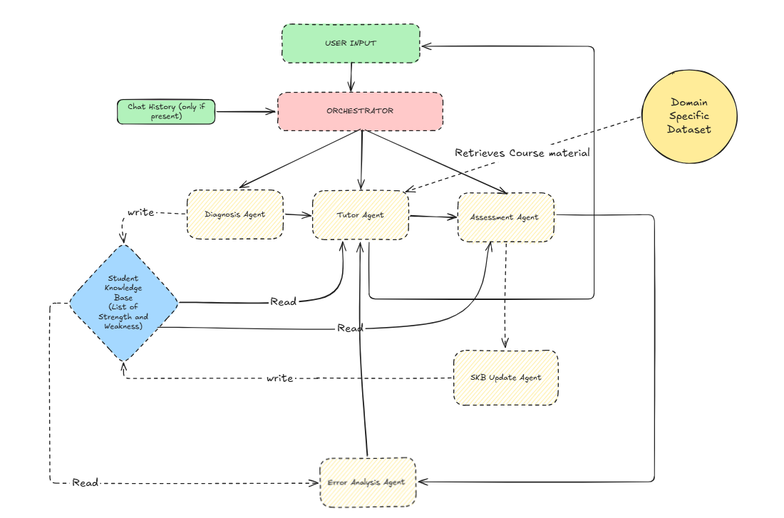
Fig. 1 Architectural Design
- User Input Ingestion & Central Orchestrator Routing:
▫ Incoming learner queries and contextual Chat History(if present) are processed by the Central Orchestrator, which acts as a deterministic state controller for system-wide decision flow.
▫ The Orchestrator inspects current context to route control dynamically to the appropriate functional agent (Diagnosis, Tutor, or Assessment), enforcing state transitions based on pedagogical objectives rather than unstructured chat flow.

- Diagnosis Agent:
▫ Before instruction begins, the Diagnosis Agent administers targeted diagnostic problems to evaluate prior programming knowledge and identify current conceptual standing.
▫ Student responses are evaluated to construct an initial diagnostic profile, categorizing errors into conceptual, procedural, syntactical etc.

- Student Knowledge Base (SKB) Initialization:
▫ Diagnostic outcomes populate the Student Knowledge Base (SKB)—a persistent JSON/vector representation that maps the student's mastery across core Python topics.
▫ The SKB maintains an active list of the student's explicit strengths and weaknesses, serving as the single source of truth for downstream personalization.

- Tutor Agent (Personalized Instruction & RAG Grounding):
▫ This agent provides personalized instruction. It uses the SKB to find weak spots, retrieves Python course materials via RAG, and uses real-time feedback from the Error Analysis Agent to immediately address the student's mistakes.
▫ Personalization Mechanism: The Tutor Agent adapts its instructional style to the student's profile, concentrating pedagogical effort on identified weak areas (e.g., spending additional cycles on while loop conditions if Loops scored low).

- Assessment Agent (Adaptive Testing):
▫ Generates targeted practice problems based on the student's SKB profile. It sends the final outcomes to the SKB Update Agent and the raw answers to the Error Analysis Agent to figure out exactly what went wrong.

- SKB Update Agent & Closed-Loop Learning Cycle:
▫ Updates the student's strengths, weaknesses, and error history in the SKB based on recent assessments. This creates two feedback loops: a quick loop for immediate tutoring help, and a main loop that tells the Orchestrator what to teach next.

7. Error Analysis Agent:
▫ Reads the raw assessment answers and checks the SKB to understand why the student failed. It identifies specific logic or syntax errors and sends this breakdown to the Tutor Agent for quick correction

8. Expected novelty
The main novelty of the project is that the system will adapt the learning path using a persistent model of the student's knowledge, rather than responding only to the student's current question. The Student Knowledge Base will track the student's strengths, weaknesses, misconceptions, and progress over time. The Orchestrator will use this information to decide what the student should learn next, the appropriate difficulty level, and the amount of guidance required.
The system will continuously adapt as the student's knowledge changes. Each assessment will update the Student Knowledge Base, allowing the Orchestrator to refine subsequent learning activities and provide targeted support where needed. Students with knowledge gaps can receive additional practice and remediation, while students demonstrating stronger mastery can progress to more challenging concepts. The project will evaluate whether this approach improves independent problem-solving and learning outcomes compared with standard LLM and RAG-based tutors.

9. Dataset or evaluation environment
The system will use a domain-specific Python learning corpus containing introductory concepts, prerequisite relationships, explanations, examples, and questions at different difficulty levels. A pretrained LLM will handle diagnosis, course planning, tutoring, and decision-making, while the corpus will provide the domain knowledge used to structure and retrieve learning material. The question bank will be organized by concept and difficulty to support controlled evaluation.
The evaluation will compare two settings using the same LLM, Python knowledge base, question bank, student profiles, and interaction budget. In the adaptive setting, the Student Knowledge Base will be updated after each interaction and used to select the next concept, difficulty, and level of guidance. In the non-adaptive baseline, the system will provide a predefined sequence of questions without considering the student's previous performance. Both settings will use pre-tests, post-tests, and unseen transfer problems, with performance compared using learning gain, final accuracy, and independent transfer accuracy.

10. Baselines
- Single-Agent Monolithic LLM: A general-purpose chat model (e.g., Llama-3-8B / GPT-4o-mini) prompted to act as a Python tutor without role separation, persistent state, or tool access.
- Standard RAG Chatbot: A single-agent RAG system retrieving Python documentation, but completely lacking a Student Knowledge Base.
- Ablations of our system: The same multi-agent setup, but without the SKB or Error Analysis loops. The Tutor and Assessment agents will not have access to past student data or real-time error breakdowns.

11. Metrics
The primary evaluation will measure learning improvement and independent problem-solving. We will use normalized learning gain, post-test accuracy, and transfer accuracy on unseen Python problems to determine whether the adaptive system improves student learning. We will also measure concept mastery improvement for topics identified as weaknesses. To evaluate personalization, we will measure whether the system selects an appropriate concept and difficulty level based on the student's current knowledge state.
Capability-specific metrics will include diagnosis accuracy for identifying student errors, retrieval relevance for assessing whether the tutor retrieves appropriate course material, and decision accuracy for evaluating whether the system selects an appropriate next learning activity. The system will also measure direct-answer leakage to determine how often the tutor gives complete solutions instead of appropriate guidance. If the Python sandbox is implemented, we will additionally measure the success rate of tool calls and whether any unsafe actions are attempted.

12. Compute plan ( GPU Hours , API Budget )
The initial implementation will prioritize free and open-source pretrained models that can potentially be run locally on CPU. We will first evaluate suitable small models based on response quality, inference latency, and usability for tutoring and decision-making. If CPU inference proves too slow for interactive use, GPU resources will be considered for running the selected model and for any optional LoRA finetuning experiments. Therefore, the exact GPU requirement will be finalized after the initial model and latency evaluation.
The project will minimize API usage by relying primarily on locally hosted models. If an API-based model is required for comparison or evaluation, usage will be limited to a small controlled test set and kept within a small predefined budget, which will be finalized based on the selected model and number of evaluation runs.

13. Expected risks and fallback plan
A key risk is that the selected open-source model may provide insufficient reasoning quality or have high latency when run locally on CPU. We will first compare a small set of models for response quality, latency, and usability, and use a lightweight model or GPU-based inference if CPU performance is inadequate. Another risk is inaccurate estimation of the student's knowledge or misconceptions. The initial system will therefore use a simple and interpretable Student Knowledge Base, with rule-based updates where necessary, rather than relying entirely on unconstrained LLM decisions.
The scope may also become difficult to manage if all planned capabilities are implemented simultaneously.
In such a case, the core system will prioritize the Orchestrator, Student Knowledge Base, Diagnosis, Tutor, and Assessment components, while optional features such as fine-tuning and Python tool execution can be deferred. If sufficient real student data is unavailable, evaluation will fall back to controlled Python question sets and scripted student profiles with predefined knowledge levels and error patterns. This ensures that the core adaptive-learning hypothesis can still be tested within the available time and compute.

