Introduction
RESTful web services are services built using the RESTful architectural style. Building web services using the RESTful approach is emerging as a popular alternative to using SOAP-based technologies for deploying services on the internet, due to its lightweight nature and the ability to transmit data directly over HTTP.
The IDE supports rapid development of RESTful web services using JSR 311 - Java API for RESTful Web Services (JAX-RS) and Jersey, the reference implementation for JAX-RS.
For detailed information, refer to the following:
- JSR 311: JAX-RS: The Java API for RESTful Web Services
- Jersey, the open source JAX-RS (JSR 311) Reference Implementation for building RESTful Web services
In addition to building RESTful web services, the IDE also supports testing, building client applications that access RESTful web services, and generating code for invoking web services (both RESTful and SOAP-based.)
Here is the list of RESTful features provided by the IDE:
- Rapid creation of RESTful web services from JPA entity classes and patterns.
- Rapid code generation for invoking web services such as Google Map, Yahoo News Search, and StrikeIron web services by drag-and-dropping components from the Web Services manager in the Services window.
- Generation of RESTful Java Clients for services registered in the Web Services manager.
- Test client generation for testing RESTful web services.
- Logical view for easy navigation of RESTful web service implementation classes in your project.
- Fully integrated Spring framework, providing Spring transaction handling.
In this tutorial, you will be shown how the IDE supports you in generating, implementing, and testing RESTful web services.

RESTful Web Services, Persistence, and Entity Classes
RESTful web services in Java rely on the Java Persistence API to communicate with a database. Specifically, RESTful web services rely on entity classes and a persistence unit, as defined in the Persistence API. Entity classes are Java classes that map to objects in a relational database. According to The Java EE5 Tutorial, "An entity is a lightweight persistence domain object. Typically an entity represents a table in a relational database, and each entity instance corresponds to a row in that table." A persistence unit consists of the set of entity classes, the data source, the persistence provider, and the persistence unit's own name, as defined in a persistence.xml file.
You can use NetBeans IDE either to create entity classes and RESTful web services in the same process, or you can use the IDE to create RESTful web services from existing entity classes. In this tutorial, you use the RESTful Services from Database wizard to generate entity classes and RESTful web services in the same process. The wizard automatically generates the persistence unit.

Using a MySQL Database Server
If you use the MySQL database server instead of JavaDB (Derby), you need to register the database server with the IDE and add the sample database to the server.
To use a MySQL database server with this tutorial:
- Register your MySQL server in the IDE, if the server is not registered. To register a MySQL server, go to the IDE's Services window, right-click the Databases node, and select Register MySQL server.
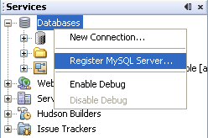
- A dialog opens in which you type the configuration details of your MySQL server, including administrator user name and password. See "Configuring MySQL Server Properties" in Connecting to a MySQL Database.
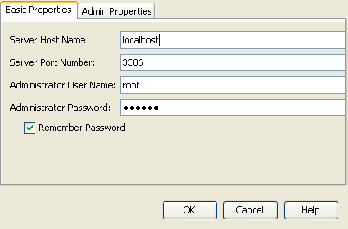
- Start the MySQL server and connect to it. See "Starting the MySQL Server" in Connecting to a MySQL Database.
- Right-click the MySQL server node and select Create Database. The Create MySQL Database dialog opens.
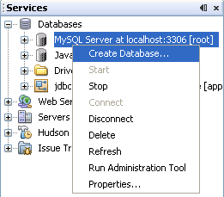
- Type sample as the new database name. Grant full access to your root user, or a user of your choice.
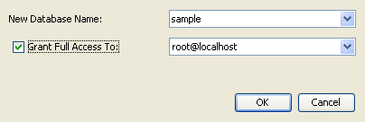
- Click OK. A dialog opens informing you that sample is the name of a sample database, and asking you if you want to create the tables, objects, and data for this database.
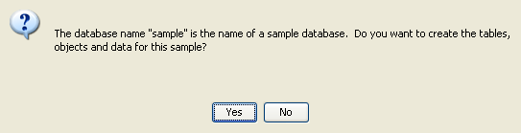
- Click Yes. The IDE creates and populates the database, and adds a connection to the database.
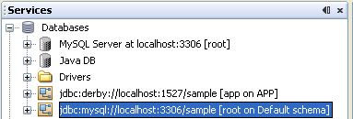

Creating RESTful Web Services from a Database
The goal of this exercise is to create a project and generate entity classes and RESTful web services from a database.
This section uses the JavaDB (Derby) database and the jdbc/sample data source. JavaDB is included with the SDK. The jdbc/sample data source is generated by NetBeans IDE automatically when you install the IDE together with GlassFish.

Creating the Project
To create RESTful web services, you need a Java Web application project.
To create the project:
- Choose File > New Project (Ctrl-Shift-N on Linux and Windows, ⌘-Shift-N on MacOS). Under Categories, select Java Web. Under Projects, select Web Application. Click Next. The New Web Application wizard opens.
Alternatively, you can create a Maven Web Application. Choose File > New Project (Ctrl-Shift-N on Linux and Windows, ⌘-Shift-N on MacOS). Under Categories, select Maven. Under Projects, select Maven Web Application and click Next.
- Under Project Name, enter CustomerDB. Click Next.
- Select either EE 6 or EE 5. Under Server, select the server you want to use, but note that EE 6 projects require GlassFish server 3 or later. Click through the remaining options and click Finish.
Important for Maven Projects: You cannot set the server when you create a Maven web application. However, you have to set the server before you can create a persistence unit. Therefore, after you create the Maven web application, open the project's Properties and set the server in the Run properties. To open the project's Properties, right-click on the Project node and select Properties from the context menu.

Generating Entity Classes and RESTful Services
When you have a Java web application, add entity classes and RESTful web services to the project.
To generate entity classes and RESTful web services:
- Right-click the CustomerDB node and choose New > Other > Web Services > RESTful Web Services from Database. The New RESTful Web Service wizard opens, on the Database Tables panel.
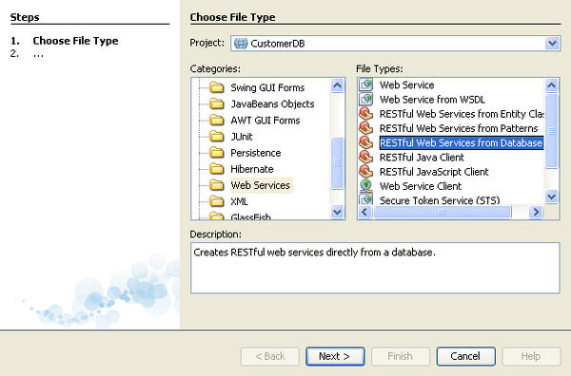
- In the Database Tables panel, if you are using the GlassFish server, select the jdbc/sample data source from the Data Source drop-down field.
If you are using Tomcat, select jdbc:derby://localhost:1527/sample. If the Derby database server does not start automatically, you need to start it from the Databases tab in the Services window.
Note for MySQL users: You have to create a new data source. Select New Data Source, give it an arbitrary descriptive name, and select the jdbc:mysql://localhost:3306/sample database connection. You created this connection when you created the sample database on MySQL.
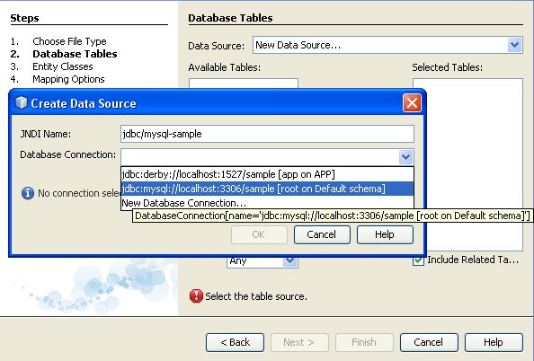
- Under Available Tables, select CUSTOMER and then click Add. The DISCOUNT_CODE table, which has a relationship with the CUSTOMER table, is also automatically added to the Selected Tables list. If you are using a MySQL database, the MICRO_MARKET table is also added. You now see the following (Derby version):
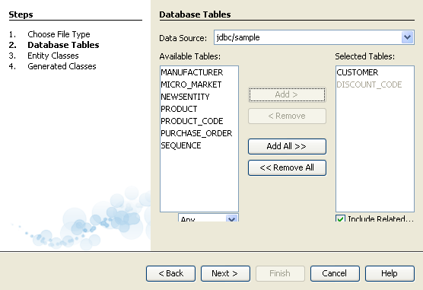
- Click Next. The Entity Classes page opens. Under Package, type entities. You now see the following (Derby version).
Note: The RESTful Web Services from Database wizard automatically generates JAXB annotations. If you generate entity classes for an EE6 application with the Entity Classes from Database wizard, and you might later want to create RESTful web services from those entity classes, make sure the Generate JAXB Annotations box is checked. You can also add JAXB annotations by hand to entity classes before running the RESTful Web Services from Entity Classes wizard. For more information, see NetBeans to Generate Simpler RESTful Web Services.
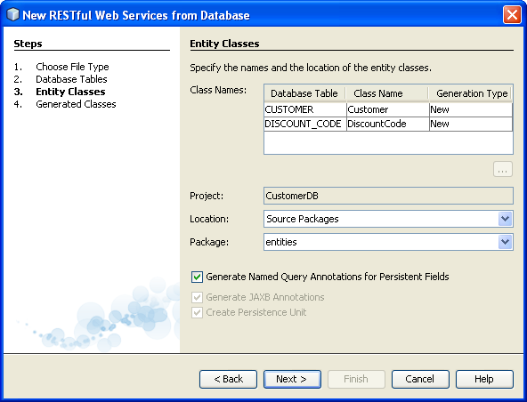
- Click Next. The Generated Classes panel opens. In this panel you can set the location of the RESTful web service classes that the IDE generates for your project. The Generated Classes panel differs between EE5 and EE6 RESTful web services, because EE5 projects include JPA controller classes but EE6 web services generate service classes as stateless session beans, instead.
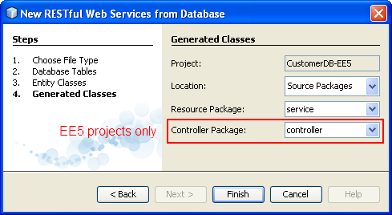

- Accept the default packages and locations and click Finish. The IDE generates entity classes. Then a dialog opens, asking how you want to register RESTful resources. For EE5 projects, you have the (default) choice of using a Jersey RESTful servlet adaptor in the web.xml deployment descriptor, or of hand coding your own solution. For EE6 projects, you have the additional choice (default) of using a subclass of javax.ws.rs.core.Application.
Spring framework applications: Register the RESTful resources in the web.xml deployment descriptor. Do NOT use javax.ws.rs.core.Application.
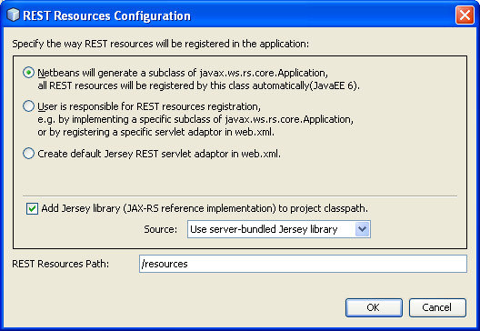
The IDE now generates the RESTful web services. When the IDE is finished, look in the Projects window. The generated entity classes are in the entities package. Services are in the service package. For an EE5 project, there are JPA controller classes in the controller package and a web.xml deployment descriptor under Configuration Files.
Caution: The IDE might prompt you to Resolve Reference Problems for the project. In this case, right-click the CustomerDB project node and select Resolve Reference Problems. This issue can happen when the service is the first Jersey application to run on a WebLogic installation. In this case, the IDE solves the reference problem by copying the Jersey libraries to the server.
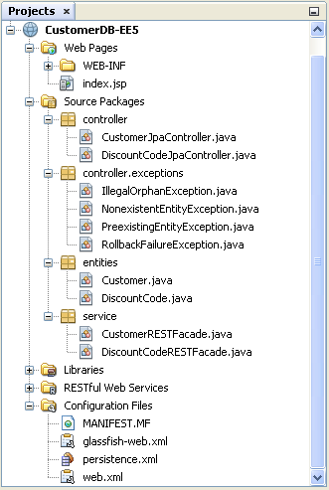
EE6 RESTful web services from a database instantiate EntityManager in each service class. This removes the need for JPA controller classes and generates simpler code.
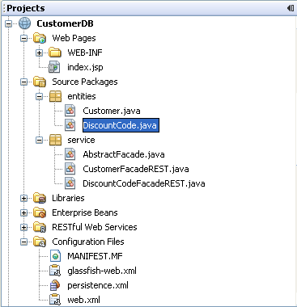

Testing the RESTful Web Services
The goal of this exercise is to try out your application.
- Right-click the project node and choose Test RESTful Web Services. A dialog opens asking if you want to generate the test client inside the service project or in another Java web project. This option lets you work around security restrictions in some browsers. You can use any Web project, as long as it is configured to deploy in the same server domain as the CustomerDB project.
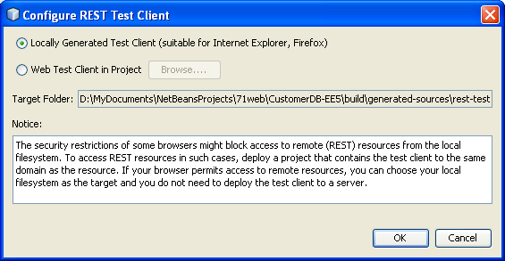
- Select where to generate the test client and click OK. The server starts and the application is deployed. When deployment is complete, the browser displays your application, with a link for each of the web services.
If the output window shows an error message that one or more classes fails to exist and the project does not build, add the Jersey libraries to the compile-time libraries. Right-click the project node and select Properties. In the Properties tree menu, select Libraries. Click Add Library and browse for the Jersey libraries.
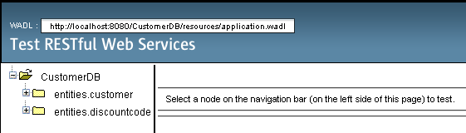
On the left-hand side is the set of root resources. Here they are named entities.customer and entities.discountCodes.
- Click the entities.customer node. In the "Choose method to test" field, select either GET (application/json) or GET (application/xml). Click Test. The test client sends a request and displays the result in the Test Output section. The test client dispays the Raw View by default. The following image shows the response to an application/xml request.
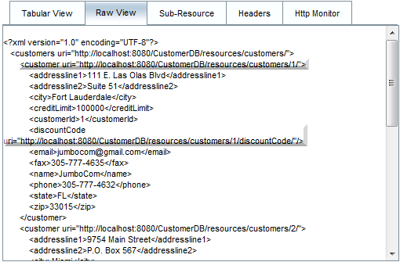
There are 5 tabs in the Test Output section.
- The Tabular View is a flattened view that displays all the URIs in the resulting document. Currently this view only displays a warning that Container-Containee relationships are not allowed.
- The Raw View displays the actual data returned. Depending on which mime type you selected (application/xml or application/json), the data displayed will be in either XML or JSON format, respectively.
- The Sub Resource tab shows the URLs of the root resource and sub resources. When the RESTful web service is based on database entity classes, the root resource represents the database table, and the sub resources represent the columns.
- The Headers tab displays the HTTP header information.
- The HTTP Monitor tab displays the actual HTTP requests and responses sent and received.
Exit the browser and return to the IDE.

