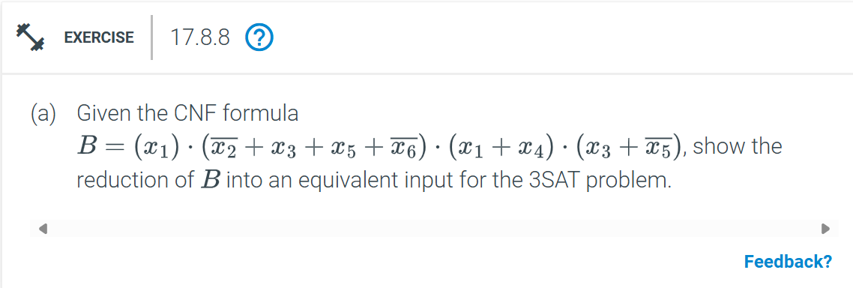

Identify Clauses Break down the given CNF formula into individual clauses
- x1
- not x2 + x3 + x5 + not x6
- x1 + x4
- x3 + not x5
Convert Each Clause to 3-Literal Form
- For the clause x1 we need to add two dummy variables to make it a 3-literal clause Let's introduce dummy variables y1 and y2: x1 + y1 + y2
- For the clause not x2 + x3 + x5 + not x6 we need to split it into two 3-literal clauses
Let's introduce a dummy variable y3: not x2 + x3 + y3 * not y3 + x5 + not x6

- For the clause x1 + x4 we need to add one dummy variable to make it a 3-literal clause
Let's introduce a dummy variable y4: x1 + x4 + y4

- For the clause x3 + not x5 we need to add one dummy variable to make it a 3-literal clause
Let's introduce a dummy variable y5: x3 + not x5 + y5

Combine the Converted Clauses The final 3SAT formula is
(x1 + y1 + y2 )(not x2 + x3 + y3 )( not y3 + x5 + not x6 )( x1 + x4 + y4 )( x3 + not x5 + y5)
This is the equivalent input for the 3SAT problem
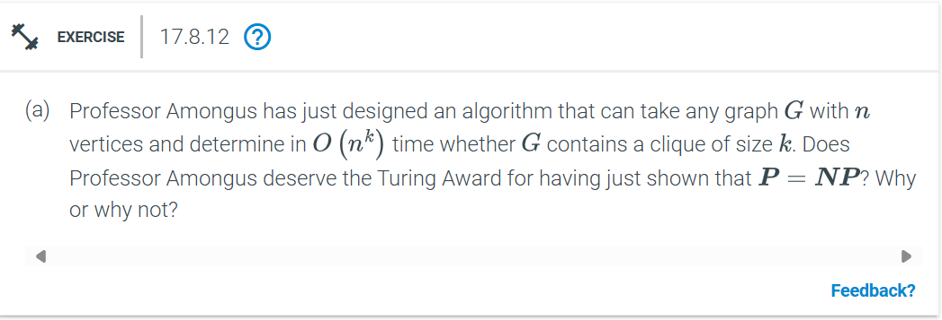
No, Professor Amongus does not deserve the Turing Award.
The algorithm runs in O(n^k), which is exponential in k, and k can vary depending on the input.
This is not a polynomial-time solution for k as part of the input, so it does not prove P = NP .
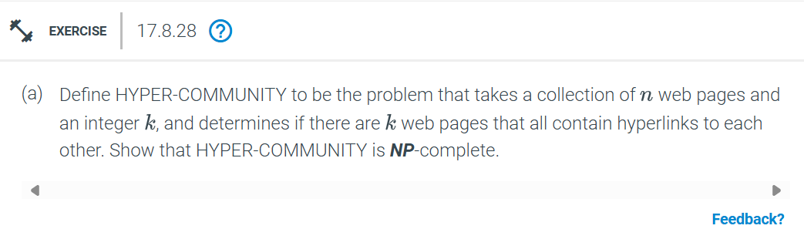
A solution to HYPER-COMMUNITY can be verified in polynomial time:
- A certificate for the problem is a subset of k web pages.
- We verify that each of the k web pages contains hyperlinks to all the other k-1 pages.
- Checking all pairs of hyperlinks takes O(k^2) time, which is polynomial for fixed k.
Thus, HYPER-COMMUNITY is in NP.
HYPER-COMMUNITY is NP-hard
- We reduce from the CLIQUE problem, which is known to be NP-complete:
-CLIQUE Problem: Given a graph G = (V, E) and an integer k, determine if there is a subset of k vertices such that every pair of vertices in the subset has an edge connecting them.
Reduction:
1. For a given instance of the CLIQUE problem (graph G), construct a collection of n = |V| web pages, one for each vertex in V.
2. Add hyperlinks between web pages to represent edges in G. Specifically, for every edge (u, v) in E, make the web page for u contain a hyperlink to the web page for v and vice versa.
3. Set k as the desired size of the hyper-community.
4. The web pages form a hyper-community of size k if and only if the graph G contains a clique of size k.
- The reduction runs in polynomial time because constructing the web pages and adding hyperlinks takes O(|E|), which is polynomial in |V|.
Since HYPER-COMMUNITY is in NP and NP-hard, it is NP-complete.
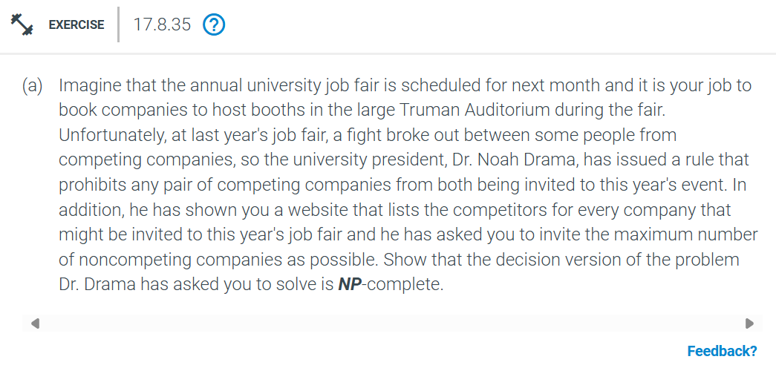
The problem is to determine if it is possible to invite at least k noncompeting companies such that no two invited companies are competitors.
A solution can be verified in polynomial time by checking if the set of k companies contains no pairs that compete.
Reduction from the Independent Set problem:
1. Represent companies as vertices in a graph and competition between companies as edges.
2. Finding k noncompeting companies is equivalent to finding an independent set of size k in the graph.
3. Independent Set is NP-complete, and this reduction can be done in polynomial time.
The decision version of this problem is NP-complete.
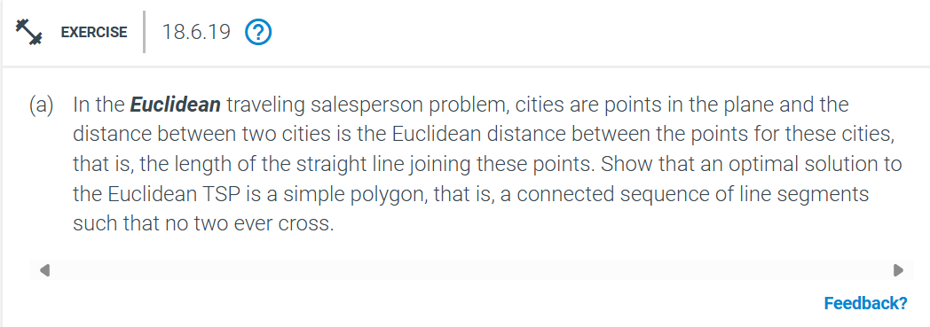
In the Euclidean TSP, the goal is to find the shortest possible closed tour (cycle) that visits every city (point) exactly once.
The optimal solution forms a simple polygon, meaning the path does not cross itself.
Suppose the optimal tour T crosses itself. Let the crossing occur at segments AB and CD, where A, B, C, D are points in the plane.
By the triangle inequality:
- Replacing AB and CD with AC and BD, or AD and BC, reduces the total length of the tour or leaves it unchanged.
Since replacing the crossing segments with non-crossing segments results in a shorter or equal-length tour, the original tour T cannot be optimal if it crosses itself.
Thus, any optimal solution to the Euclidean TSP must be a simple polygon, as removing crossings always leads to a tour of equal or shorter length.
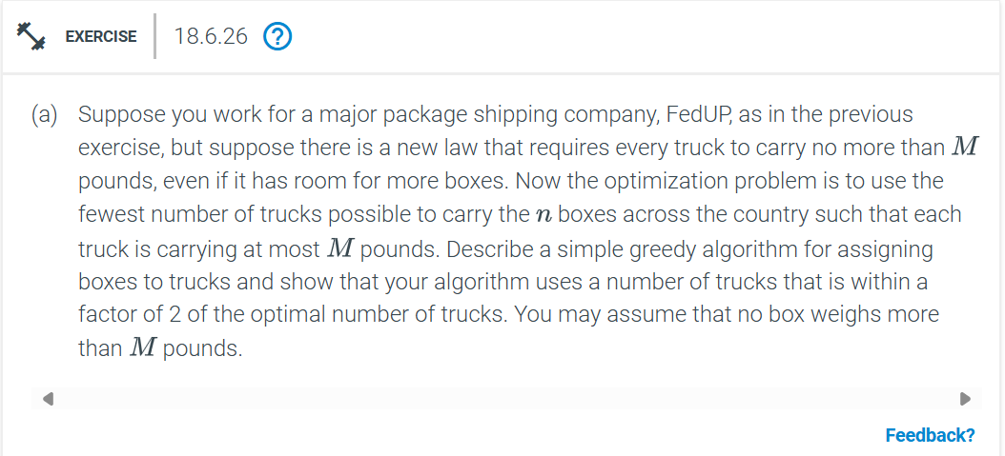
Greedy Algorithm
1 Sort the boxes by weight in non-increasing order
2 Initialize an empty list of trucks
3 For each box in the sorted list do
a Try to place the box in an existing truck that has enough capacity remaining
b If no such truck exists start a new truck and place the box in it
Approximation Factor
1 Let OPT be the optimal number of trucks
2 Each truck in the greedy algorithm carries at least half of its capacity except possibly the last truck
3 Therefore the greedy algorithm uses at most \( 2 \times \text{OPT} \) trucks

