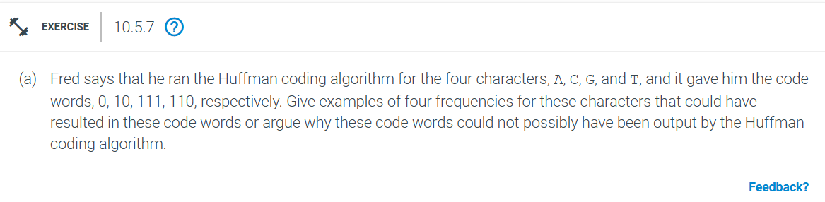
Huffman coding assigns shorter codes to more frequent characters and longer codes to less frequent ones. It builds a binary tree where each character is a leaf node.
Fred’s code words are:
A: 0
C: 10
G: 111
T: 110
Constructing the tree:
.
/ \
A .
/ \
C .
/ \
T G
Assigning the frequencies for each:
A: 1 (most frequent, shortest code)
C: 2
T: 3
G: 2
These frequencies produce the given codes:
A: 0
C: 10
T: 110
G: 111
So, these frequencies could result in the given codes.
However, Huffman codes must be prefix-free (no code is a prefix of another). Sorting the codes by length:
0
10
110
111
Here, 10 is a prefix of 110, which violates the prefix-free rule. So, these codes couldn’t be produced by the Huffman algorithm.

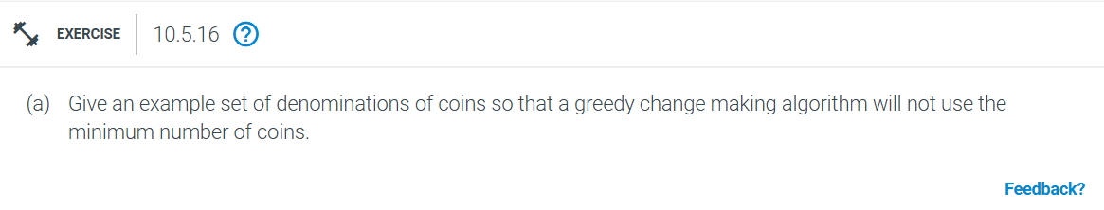
Problem Statement: We need to find a set of coin denominations where the greedy change-making algorithm does not yield the minimum number of coins.
Example Set of Denominations: Consider the denominations: 1, 3, and 4 cents.
Target Amount: Let’s say we need to make 6 cents.
Greedy Algorithm Approach: The greedy algorithm always picks the largest denomination coin that is less than or equal to the remaining amount.
Pick one 4-cent coin (remaining amount: 2 cents).
Pick two 1-cent coins (remaining amount: 0 cents).
So, the greedy algorithm uses 3 coins (4, 1, 1).
Optimal Solution: To find the optimal solution, we need to consider all possible combinations of the given denominations:
Two 3-cent coins.
This uses only 2 coins, which is fewer than the 3 coins used by the greedy algorithm.

In this example, the greedy algorithm does not yield the minimum number of coins. The optimal solution requires a different approach than simply picking the largest possible coin at each step. This demonstrates that while the greedy algorithm is simple and efficient, it doesn’t always produce the optimal solution for the change-making problem.

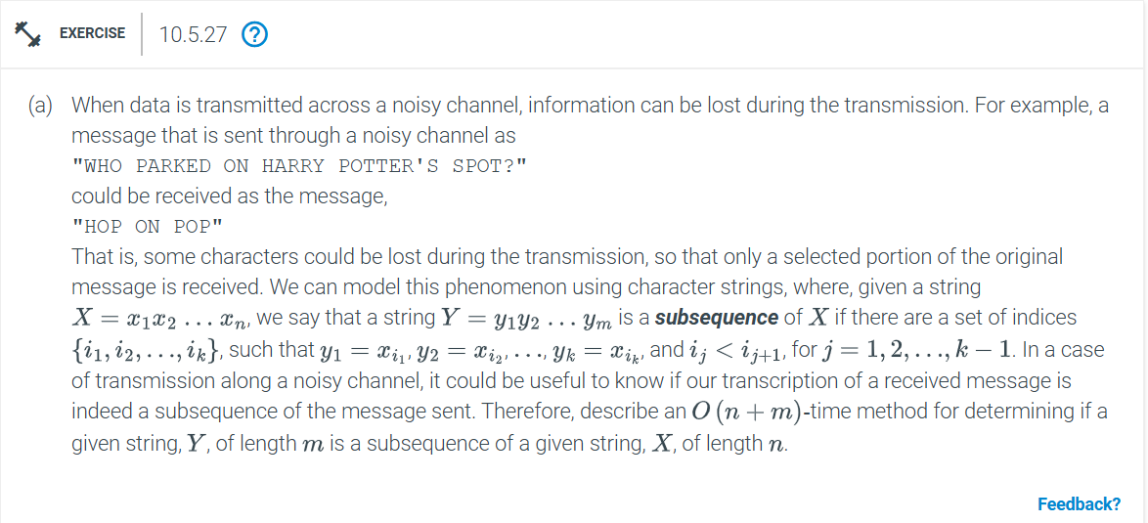
To determine if a string Y of length m is a subsequence of a string X of length n in O(n + m) time, you can use a two-pointer technique. Here's a step-by-step method:
Algorithm
1. Initialize Pointers:
- Set a pointer `i` to 0 for string \( X \).
- Set a pointer `j` to 0 for string \( Y \).
2. Traverse Both Strings:
- While `i < n` and `j < m`:
- If X[i] == Y[j] :
- Increment `j` move to the next character in Y .
- Increment `i` move to the next character in X .
3. Check Completion:
- If `j == m`, then Y is a subsequence of X .
- Otherwise, \( Y \) is not a subsequence of X .
Pseudocode
def is_subsequence(X, Y):
n = len(X)
m = len(Y)
i = 0
j = 0

while i < n and j < m:
if X[i] == Y[j]:
j += 1
i += 1

return j == m
Time Complexity:The algorithm runs in O(n + m) time because each pointer (`i` and `j`) traverses their respective strings at most once.

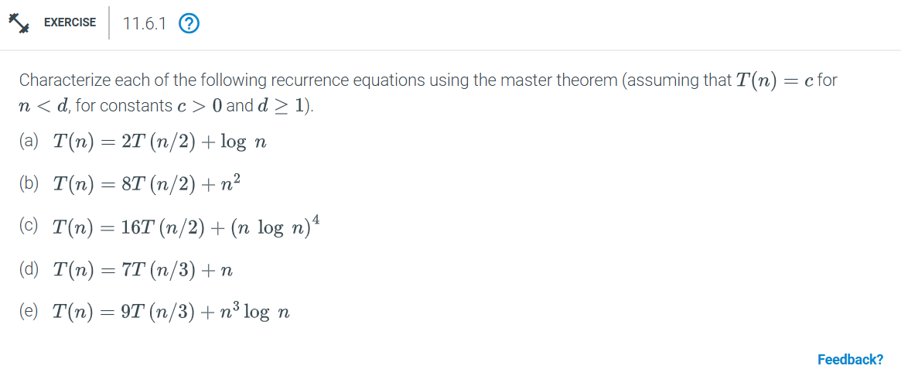
a. T(n) = 2T(n/2) + log n
Here a equals 2 b equals 2 and f of n equals log n
log base b of a equals log base 2 of 2 equals 1
f of n equals log n equals O of n to the power of c where c equals 0 and 0 is less than 1
Case 1 applies T of n equals Theta of n to the power of log base 2 of 2 equals Theta of n
b. T(n) = 8T(n/2) + n squared
Here a equals 8 b equals 2 and f of n equals n squared
log base b of a equals log base 2 of 8 equals 3
f of n equals n squared equals O of n to the power of c where c equals 2 and 2 is less than 3
Case 1 applies T of n equals Theta of n to the power of log base 2 of 8 equals Theta of n cubed
c. T(n) = 16T(n/2) + (n log n) to the power of 4
Here a equals 16 b equals 2 and f of n equals (n log n) to the power of 4
log base b of a equals log base 2 of 16 equals 4
f of n equals (n log n) to the power of 4 equals Omega of n to the power of c where c equals 4 and c equals 4
Case 2 applies T of n equals Theta of n to the power of 4 log n
d. T(n) = 7T(n/3) + n
Here a equals 7 b equals 3 and f of n equals n
log base b of a equals log base 3 of 7 approximately equals 1.771
f of n equals n equals O of n to the power of c where c equals 1 and 1 is less than 1.771
Case 1 applies T of n equals Theta of n to the power of log base 3 of 7 approximately equals Theta of n to the power of 1.771
e. T(n) = 9T(n/3) + n cubed log n
Here a equals 9 b equals 3 and f of n equals n cubed log n
log base b of a equals log base 3 of 9 equals 2
f of n equals n cubed log n equals Omega of n to the power of c where c equals 3 and 3 is greater than 2
Case 3 applies T of n equals Theta of n cubed log n
Thus,
a T of n equals Theta of n
b T of n equals Theta of n cubed
c T of n equals Theta of n to the power of 4 log n
d T of n equals Theta of n to the power of 1.771
e T of n equals Theta of n cubed log n
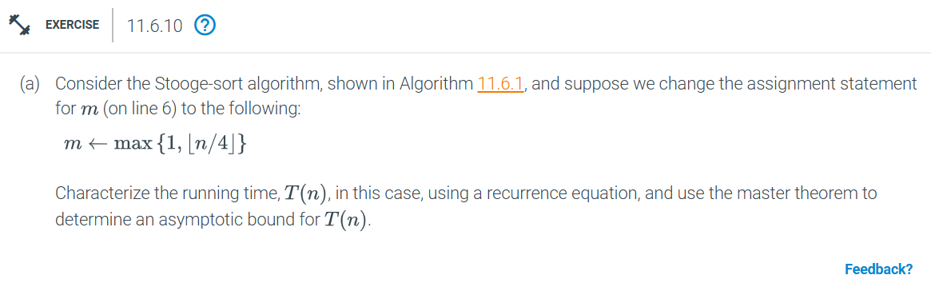
We need to characterize the running time T of n using a recurrence equation and apply the Master Theorem to determine an asymptotic bound
1 Base Case
If n equals 2 the algorithm performs a constant amount of work comparing and possibly swapping two elements so T of 2 equals O of 1
2 Recursive Case
For n greater than 2 the algorithm performs three recursive calls
T of n divided by 4 for sorting the first part
T of n minus n divided by 4 for sorting the last part
T of n divided by 4 for sorting the first part again
Recurrence Relation
Given the recursive structure the recurrence relation can be written as
T of n equals 3T of n divided by 4 plus O of 1
Applying for the Master Theorem
The Master Theorem for divide-and-conquer recurrences of the form T of n equals aT of n divided by b plus f of n helps us determine the asymptotic behavior of T of n
In our case
a equals 3
b equals 4
f of n equals O of 1
We need to compare f of n with n to the power of log base b of a
log base b of a equals log base 4 of 3
Master Theorem Cases
1 Case 1 If f of n equals O of n to the power of c where c is less than log base b of a then T of n equals Theta of n to the power of log base b of a
2 Case 2 If f of n equals Theta of n to the power of log base b of a then T of n equals Theta of n to the power of log base b of a log n
3 Case 3 If f of n equals Omega of n to the power of c where c is greater than log base b of a and if a f of n divided by b is less than or equal to k f of n for some k less than 1 and sufficiently large n then T of n equals Theta of f of n
Determining the Case
f of n equals O of 1 is a constant function which can be considered as O of n to the power of 0
log base 4 of 3 is approximately 0.792
Since 0 is less than 0.792 we are in Case 1 of the Master Theorem
Conclusion
By applying Case 1 of the Master Theorem
T of n equals Theta of n to the power of log base 4 of 3
Thus, the running time of the modified StoogeSort algorithm is
T of n equals Theta of n to the power of 0.792
This analysis shows that the modified StoogeSort algorithm has a better asymptotic running time compared to the original version which had a recurrence relation of T of n equals 3T of 2n divided by 3 plus O of 1 and a running time of Theta of n to the power of log base 3 of 3 equals Theta of n to the power of 1.709

we can use a sweep line algorithm combined with a priority queue or balanced binary search tree
Approach:
1 Event Creation
For each rectangle a i b i with height h i create two events
A start event at a i with height h i
An end event at b i with height h i
2 Sort Events
Sort all events primarily by the x-coordinate If two events have the same x-coordinate sort start events before end events
3 Sweep Line
Use a sweep line to process each event from left to right
Maintain a max-heap priority queue to keep track of the current heights of rectangles that are active that is the sweep line is within their x-interval
4 Processing Events
For each event
If it is a start event add its height to the max-heap
If it is an end event remove its height from the max-heap
After processing the event the current maximum height in the heap represents the height of the skyline at the current x-coordinate
If the current maximum height changes from the previous maximum height add a new point to the skyline
5 Output the Skyline
The result is a list of points representing the skyline
Pseudocode:
from heapq import heappush heappop

def compute_skyline(rectangles):
events = []
for a b h in rectangles:
events.append((a -h)) # Start event
events.append((b h)) # End event

# Sort events first by x-coordinate then by height start events before end events
events.sort(key=lambda x (x x))

# Max-heap to keep track of the current heights
max_heap =
result = []
prev_max_height = 0

for x h in events:
if h < 0 # Start event
heappush(max_heap h)
else # End event
max_heap.remove(-h)
heappop(max_heap)

current_max_height = -max_heap
if current_max_height != prev_max_height:
result.append((x current_max_height))
prev_max_height = current_max_height

return result

# Example usage
rectangles = [(0.1 0.3 2) (0.2 0.5 3) (0.4 0.6 1)]
skyline = compute_skyline(rectangles)
print(skyline)
Time Complexity
Sorting the events takes O of n log n
Processing each event takes O of log n due to heap operations
Therefore the overall time complexity is O of n log n

This algorithm efficiently computes the skyline of a set of rectangles in O of n log n time

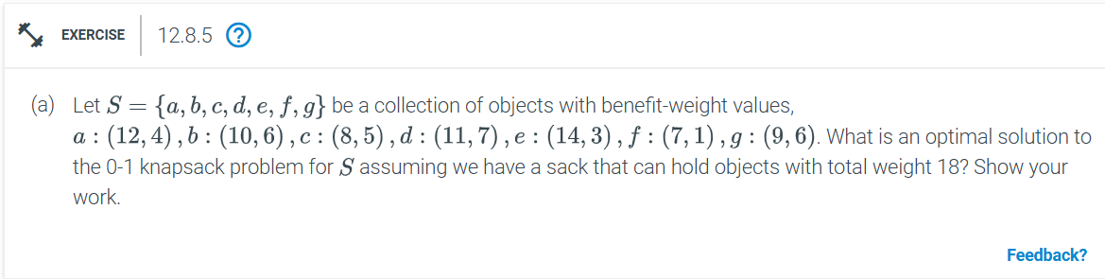
We need to maximize the total benefit while keeping the total weight within the capacity of the sack The fractional knapsack problem allows us to take fractions of items so we should prioritize items based on their benefit-to-weight ratio
1 Calculate Benefit-to-Weight Ratios
a 12 divided by 4 equals 3
b 10 divided by 6 approximately 1.67
c 8 divided by 5 equals 1.6
d 11 divided by 7 approximately 1.57
e 14 divided by 3 approximately 4.67
f 7 divided by 1 equals 7
g 9 divided by 6 equals 1.5
2 Sort Items by Benefit-to-Weight Ratio
f 7
e 4.67
a 3
b 1.67
c 1.6
d 1.57
g 1.5
3 Select Items to Maximize Benefit
Start with the item with the highest ratio and continue until the sack is full
Detailed Selection:
Item f
Weight 1
Benefit 7
Remaining capacity 18 minus 1 equals 17
Item e
Weight 3
Benefit 14
Remaining capacity 17 minus 3 equals 14
Item a
Weight 4
Benefit 12
Remaining capacity 14 minus 4 equals 10
Item b
Weight 6
Benefit 10
Remaining capacity 10 minus 6 equals 4
Item c
Weight 5
Benefit 8
We can only take a fraction of this item to fill the remaining capacity
Fraction taken 4 divided by 5
Benefit from fraction 8 times 4 divided by 5 equals 6.4
Remaining capacity 4 minus 4 equals 0
Total Benefit Calculation
Benefit from f 7
Benefit from e 14
Benefit from a 12
Benefit from b 10
Benefit from fraction of c 6.4
Total benefit 7 plus 14 plus 12 plus 10 plus 6.4 equals 49.4
Optimal Solution
The optimal solution to the fractional knapsack problem for the given set S and sack capacity of 18 is to take
All of item f
All of item e
All of item a
All of item b
4 divided by 5 of item c
This results in a total benefit of 49.4

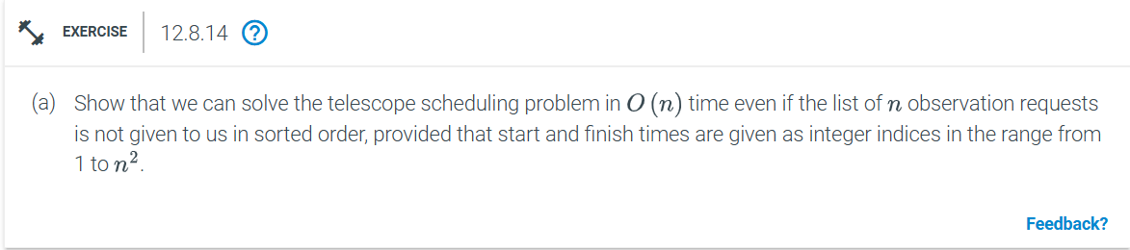
To solve the telescope scheduling problem in O of n time even if the list of n observation requests is not given to us in sorted order we can use a counting sort approach since the start and finish times are given as integer indices in the range from 1 to n squared
Step-by-Step Solution
1 Initialize Arrays
Create two arrays start_count and finish_count of size n squared plus 1 initialized to zero These arrays will count the occurrences of each start and finish time
2 Count Occurrences
For each observation request increment the corresponding index in start_count and finish_count based on the start and finish times
3 Calculate Prefix Sums
Create two arrays start_prefix and finish_prefix of size n squared plus 1
Compute the prefix sums for start_count and finish_count to get start_prefix and finish_prefix
4 Determine Maximum Observations
Initialize a variable max_observations to zero
For each time t from 1 to n squared calculate the number of ongoing observations as start_prefix of t minus finish_prefix of t minus 1
Update max_observations if the current number of ongoing observations is greater than max_observations
Pseudocode:
def telescope_scheduling(requests n):
max_time = n * n
start_count = * (max_time + 1)
finish_count = * (max_time + 1)

for start finish in requests:
start_count[start] += 1
finish_count[finish] += 1

start_prefix = * (max_time + 1)
finish_prefix = * (max_time + 1)

for t in range(1 max_time + 1):
start_prefix[t] = start_prefix[t - 1] + start_count[t]
finish_prefix[t] = finish_prefix[t - 1] + finish_count[t]

max_observations = 0
for t in range(1 max_time + 1):
ongoing_observations = start_prefix[t] - finish_prefix[t - 1]
if ongoing_observations > max_observations:
max_observations = ongoing_observations

return max_observations

# Example usage
requests = [(1 3) (2 5) (4 6) (7 8)]
n = 3
print(telescope_scheduling(requests n))

Explanation

1 Initialize Arrays
Create start_count and finish_count arrays to count the occurrences of start and finish times
2 Count Occurrences
For each observation request increment the corresponding indices in start_count and finish_count
3 Calculate Prefix Sums
Compute the prefix sums for start_count and finish_count to get start_prefix and finish_prefix
4 Determine Maximum Observations
For each time t calculate the number of ongoing observations and update max_observations if the current number is greater
Time Complexity
Counting occurrences takes O of n time
Calculating prefix sums takes O of n squared time
Determining maximum observations takes O of n squared time
Overall time complexity is O of n squared which simplifies to O of n since n squared is a constant factor

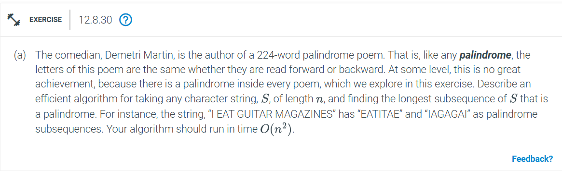
To find the longest palindromic subsequence in a string S of length n we can use dynamic programming to achieve an O of n squared time complexity Here is a step-by-step explanation of the algorithm
Step-by-Step Algorithm
1 Initialize a 2D array dp of size n by n where dp i j represents the length of the longest palindromic subsequence in the substring S i to j
2 Set the diagonal elements dp i i to 1 for all i from 0 to n minus 1 because a single character is always a palindrome of length 1
3 Fill the dp table for substrings of increasing lengths starting from length 2 up to n
For each length l from 2 to n
For each starting index i from 0 to n minus l
Set the ending index j to i plus l minus 1
If S i equals S j then dp i j equals dp i plus 1 j minus 1 plus 2
Else dp i j equals max of dp i plus 1 j and dp i j minus 1
4 The value dp 0 n minus 1 will contain the length of the longest palindromic subsequence in S
Pseudocode:
def longest_palindromic_subsequence(S):
n = len(S)
dp = [ * n for _ in range(n)]

for i in range(n):
dp[i][i] = 1

for l in range(2 n + 1):
for i in range(n - l + 1):
j = i + l - 1
if S[i] == S[j]:
dp[i][j] = dp[i + 1][j - 1] + 2
else:
dp[i][j] = max(dp[i + 1][j] dp[i][j - 1])

return dp[n - 1]

# Example usage
S = "I EAT GUITAR MAGAZINES"
print(longest_palindromic_subsequence(S))
Explanation
1 Initialize a 2D array dp of size n by n where dp i j represents the length of the longest palindromic subsequence in the substring S i to j
2 Set the diagonal elements dp i i to 1 for all i from 0 to n minus 1 because a single character is always a palindrome of length 1
3 Fill the dp table for substrings of increasing lengths starting from length 2 up to n
For each length l from 2 to n
For each starting index i from 0 to n minus l
Set the ending index j to i plus l minus 1
If S i equals S j then dp i j equals dp i plus 1 j minus 1 plus 2
Else dp i j equals max of dp i plus 1 j and dp i j minus 1
4 The value dp 0 n minus 1 will contain the length of the longest palindromic subsequence in S
Time Complexity
The algorithm runs in O of n squared time because we fill an n by n table and each cell computation takes constant time

