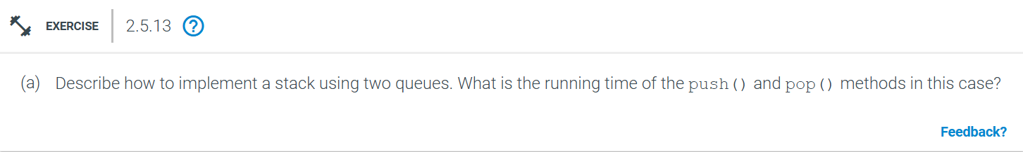
The pseudo code will be:
class StackUsingTwoQueues:
def __init__(self):
self.queue1 = []
self.queue2 = []

def push(self, x):
# Push element to queue1
self.queue1.append(x)

def pop(self):
# Transfer all elements except the last to queue2
while len(self.queue1) > 1:
self.queue2.append(self.queue1.pop(0))
# The last element is the one to pop (LIFO behavior)
popped_element = self.queue1.pop(0)
# Swap queue1 and queue2
self.queue1, self.queue2 = self.queue2, self.queue1

return popped_element

Here the push() operation would have O(1) as enqueueing in the queue is constant time and the pop() operation would have O(n) as dequeuing and enqueuing elements between 2 queues take linear time as of the number of elements (let’s say n) in the stack
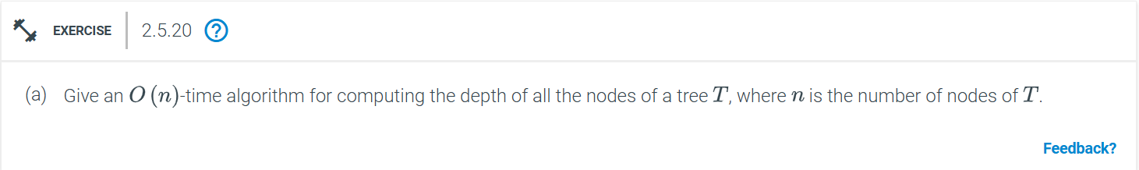
To compute the depth of nodes, BFS (breadth first search) or DFS (Depth first search) both approach of traversal can be used, but since, the number of edges on the path from the root to that node BFS would be more suitable.
The pseudo code would be
from collections import deque
# tree nodes are the Node class- assumption
class Node:
def __init__(self, value):
self.value = value
self.children = []

def compute_depths_bfs(root):
# Dictionary to store depths of each node
node_depth = {}

# Initialize queue with root node and its depth
queue = deque([(root, 0)]) # (node, depth)

# BFS traversal
while queue:
current_node, depth = queue.popleft()

# Store the depth of the current node
node_depth[current_node] = depth

# Enqueue all children of the current node with their depth
for child in current_node.children:
queue.append((child, depth + 1))

return node_depth

The time complexity is O(n) as one node is visited and for each node, the children is processed in constant state and the space complexity is O(n) as the space is needed for the queue.
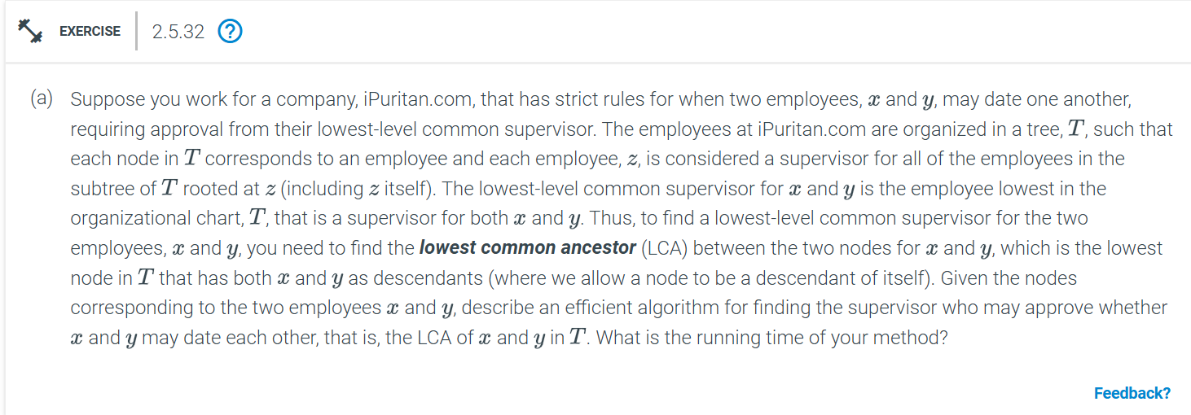
To solve this problem, we can use a Depth-First Search (DFS) and backtracking approach in a rooted tree, which allows us to compute the LCA efficiently.
We can solve the LCA problem using DFS with backtracking as follows:
- Base Case: If the current node is either x or y, return this node since it's part of the answer.
- Recursive Case: Recursively explore each child of the current node. Keep track of how many of the recursive calls return x or y.
  - If two children return x and y, then the current node is the LCA.
  - If only one child returns x or y, propagate that value upward in the recursive call.
Pseudocode is as follows:
class TreeNode:
def __init__(self, value):
self.value = value
self.children = []

# Function to find LCA
def find_lca(root, x, y):
# Base case: if root is None or root is one of x or y
if root is None:
return None
if root == x or root == y:
return root

# Keep track of how many children have x or y
found = 0
lca_node = None

# Recursively search for x and y in all children
for child in root.children:
child_lca = find_lca(child, x, y)
if child_lca is not None:
found += 1
lca_node = child_lca

# If two children return non-null results, root is the LCA
if found == 2:
return root

# Otherwise, return the non-null child result (if any)
return lca_node
The running time of this algorithm is O(n), where 𝑛 is the number of nodes in the tree. It is because, we perform DFS traversal of entire tree and each node is visited once is it’s children is processed once at constant time.

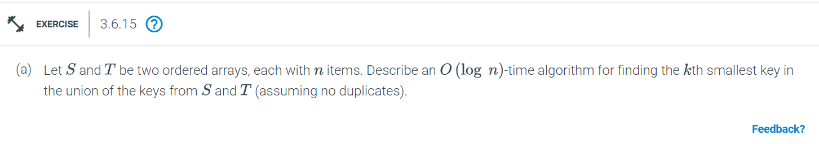
We can use a binary search based approach on both arrays simultaneously and at each step, we will divide the arrays and check if we can determine the kth smallest element by comparing the midpoints of the current search ranges in the two arrays.
The pseudocode is like:
def find_kth_smallest(S, T, k):
n = len(S)

# Ensure S is the smaller array to reduce the binary search space
if len(S) > len(T):
return find_kth_smallest(T, S, k)

# Binary search range for the partition in S
low, high = 0, min(k, len(S))

while low <= high:
i = (low + high) // 2 # partition in S
j = k - i # partition in T

# Handle edge cases when i or j is 0 or exceeds array bounds
S_left = S[i - 1] if i > 0 else float('-inf')
S_right = S[i] if i < len(S) else float('inf')
T_left = T[j - 1] if j > 0 else float('-inf')
T_right = T[j] if j < len(T) else float('inf')

# Check if we found the correct partition
if S_left <= T_right and T_left <= S_right:
# The kth smallest element is the maximum of the left sides
return max(S_left, T_left)

# If S_left is greater than T_right, move the partition in S to the left
elif S_left > T_right:
high = i - 1

# If T_left is greater than S_right, move the partition in S to the right
else:
low = i + 1

raise ValueError("No valid kth element found")

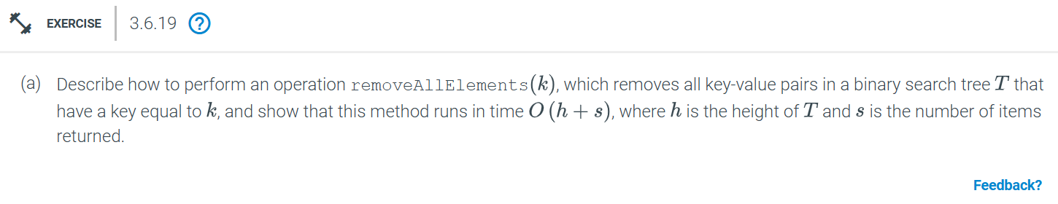
On a binary search tree (T), we want to remove all nodes with a key equal to 𝑘. Since the BST property states that nodes with the same key will be adjacent in the in-order traversal, we can efficiently find and remove these nodes in one traversal.
The pseudocode would be:
class TreeNode:
def __init__(self, key, value):
self.key = key
self.value = value
self.left = None
self.right = None

def removeAllElements(root, k):
# Helper function to delete a single node from the tree
def deleteNode(node):
# Case 1: No children (leaf node)
if node.left is None and node.right is None:
return None

# Case 2: One child (either left or right)
if node.left is None:
return node.right
if node.right is None:
return node.left

# Case 3: Two children (find in-order successor)
# Replace node with minimum node in the right subtree
successor = getMin(node.right)
node.key, node.value = successor.key, successor.value
node.right = removeNode(node.right, successor.key)
return node

# Helper function to find the minimum node in a subtree
def getMin(node):
while node.left is not None:
node = node.left
return node

# Recursive function to remove all nodes with key k
def removeNode(node, k):
if node is None:
return None

# Traverse the tree to find nodes with key k
if k < node.key:
node.left = removeNode(node.left, k)
elif k > node.key:
node.right = removeNode(node.right, k)
else:
# Found a node with key k, delete it
return deleteNode(node)

return node

# Count the number of nodes removed
def countNodes(node, k):
if node is None:
return 0

count = 0
if node.key == k:
count += 1

# Continue searching in left and right subtrees
count += countNodes(node.left, k)
count += countNodes(node.right, k)

return count

# Main execution
# Count the nodes to be deleted
s = countNodes(root, k)
# Remove all nodes with key k
root = removeNode(root, k)

return root, s

Searching for the first occurrence of k and traversing through the tree to find all such nodes takes O(h) time, where h is the height of the tree and in case of deletion, the time complexity is proportional to the height of the tree ℎ, since we need to adjust pointers and potentially restructure the tree. If 𝑠 is the number of nodes with key 𝑘 then removing all such nodes will take 𝑂(𝑠⋅ℎ) time in the worst case.
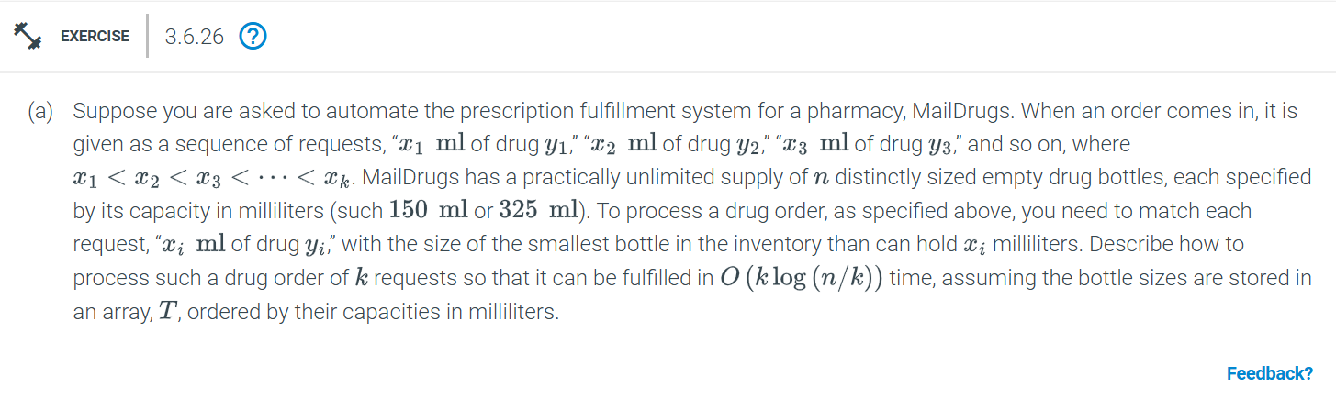
The algorithm for matching the drug request would be like:
- We use binary search to find the smallest bottle in T for each drug request.
- After finding the appropriate bottle for the current request, we narrow the search range for the next request by only searching the part of T that starts after the previously found bottle. This is because the requests are sorted in increasing order, and we are looking for bottles that are increasingly larger.
- This approach reduces the search space for each subsequent request, and the overall time complexity becomes O(k log(n/k)).
The pseudocode of the following algorithm would be like:
def process_drug_order(T, requests):
# T is the sorted array of bottle capacities
# requests is the list of tuples (xi, yi) where xi is the required milliliters, and yi is the drug
n = len(T) # number of bottles
k = len(requests) # number of drug requests

# This list will store the results, i.e., which bottle size was assigned to each drug request
results = []

# Initialize the search range to be the entire array
left = 0
right = n - 1

# Process each request
for xi, yi in requests:
# Perform binary search to find the smallest bottle that can hold at least xi ml
best_bottle_index = -1

while left <= right:
mid = (left + right) // 2
if T[mid] >= xi:
best_bottle_index = mid # Potential candidate found, continue searching to the left
right = mid - 1
else:
left = mid + 1

# After binary search, best_bottle_index will have the smallest bottle >= xi ml
if best_bottle_index != -1:
results.append((xi, yi, T[best_bottle_index])) # Store the bottle size for this request
# For the next request, start searching from the bottle after the current match
left = best_bottle_index + 1
else:
# Handle case where no suitable bottle is found (this shouldn't happen with "practically unlimited" assumption)
results.append((xi, yi, None))

return results

The time complexity would be
For each of the k requests, we perform a binary search over a smaller range of the array T. The first request has a search space of size n, the second request has a search space of size n−1, and so on.
- The total work done in the binary searches is approximately: logn+log(n−1)+log(n−2)+⋯+log(n−k)=O(klog(n/k)
This is because, on average, the search space reduces as we process each request.
Thus, the overall time complexity of processing all k requests is O(klog(n/k)).
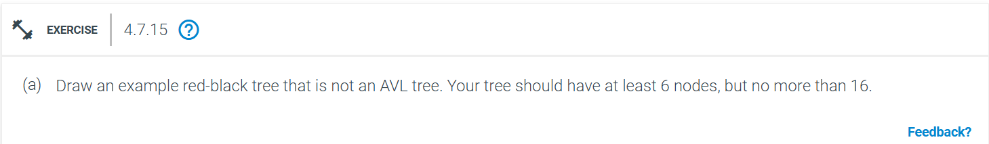
Tree Structure:
Root: 10 (Black)
Left child of 10: 5 (Red)
Left child of 5: 2 (Black)
Right child of 10: 20 (Black)
Left child of 20: 15 (Red)
Left child of 15: 12 (Black)
Right child of 20: 25 (Black)
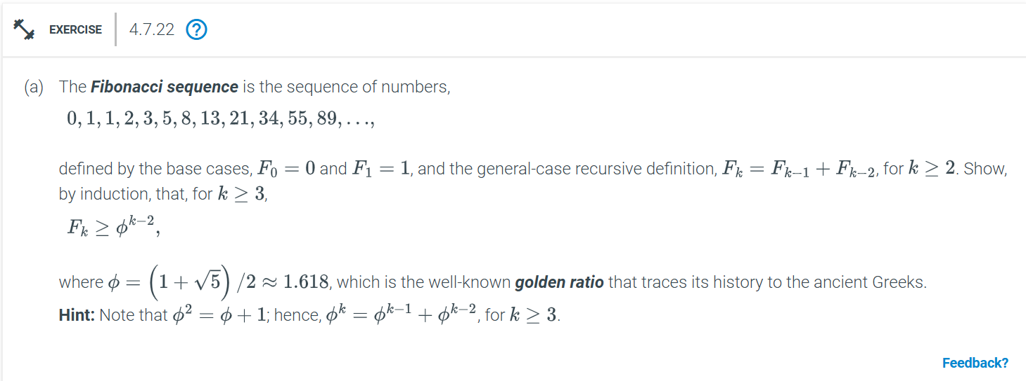
We can use mathematical induction:
Step 1: Base Case
We need to check the statement for k = 4 .
F4​>(4−2)⋅ϕ=2⋅ϕ=2⋅1.618=3.236
Step 2: Inductive Hypothesis
Fn​>(n−2)⋅ϕ
We need to prove that the inequality also holds for k=n+1
Step 3: Inductive Step
We need to prove:
Fn+1​>(n−1)⋅ϕ
By the Fibonacci recurrence relation:
Fn+1=Fn+Fn−1
From the inductive hypothesis:
Fn>(n−2)⋅ϕ
Fn−1​>(n−3)⋅ϕ
Thus:
Fn+1=Fn+Fn−1>(n−2)⋅ϕ+(n−3)⋅ϕ
Simplifying the right-hand side:
Fn+1​>ϕ⋅((n−2)+(n−3))=ϕ⋅(2n−5)
We want to show that:
ϕ⋅(2n−5)>(n−1)⋅ϕ
This inequality holds for sufficiently large n, as the Fibonacci sequence grows exponentially, whereas the linear term (n−2)⋅ϕ grows much slower.

To improve the runtime of the first-fit heuristic from O(mn) to O(mlogn), optimisation is needed on how we search for the first USB drive that can fit each image. We can use a balanced binary search tree (BST) (e.g., a self-balancing AVL tree or a Red-Black tree) to store the remaining capacities of the USB drives. We use a balanced binary search tree to store the remaining capacities of the USB drives. Because these trees allow efficient search, insertion, and deletion in O(logn) time.
Pseudocode:
def first_fit(images, usb_capacity):
# usb_capacity is the capacity of a single USB drive, say 1GB = 1000 MB
# images is a list of image sizes

# Step 1: Initialize a balanced BST with initial capacity of all USB drives
capacities = BST() # A balanced binary search tree
capacities.insert(usb_capacity) # First drive is available

# Step 2: Process each image
for img_size in images:
# Step 3: Find the smallest capacity that can fit the image
# Find the first USB drive that can fit the image
drive_capacity = capacities.find_ge(img_size) # O(log n)

if drive_capacity is not None:
# Remove the old capacity of the drive from the tree
capacities.delete(drive_capacity)

# Calculate the new remaining capacity after adding the image
new_capacity = drive_capacity - img_size

# If the new capacity is greater than zero, reinsert it back into the tree
if new_capacity > 0:
capacities.insert(new_capacity) # O(log n)
else:
# If no suitable drive is found, use a new USB drive
new_capacity = usb_capacity - img_size
if new_capacity > 0:
capacities.insert(new_capacity) # O(log n)

# Return the total number of USB drives used (number of insertions)
return capacities.total_drives_used()

The total time complexity would be: O(mlogn) considering the initialization by inserting the initial drive capacity and then processing each “m” images by searching for the smallest drive with enough capacity takes O(logn)and inserting or updating the remaining capacity also takes O(logn).

