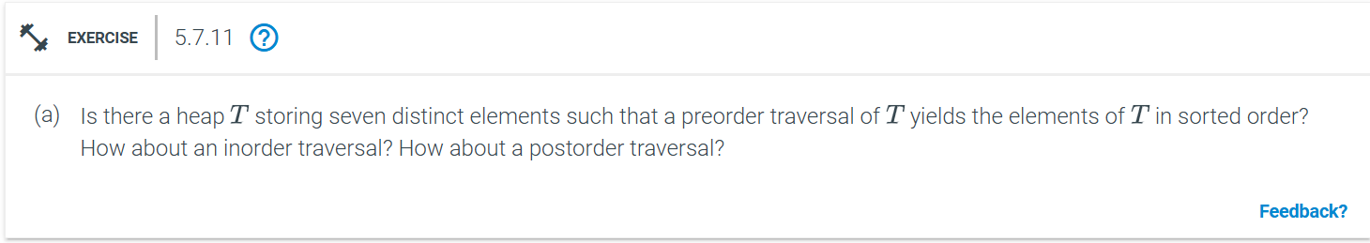
Preorder Traversal:
In a min-heap, the root is always the smallest element, and in a max-heap, the root is always the largest element. In preorder traversal, we visit the root first, then the left subtree, and then the right subtree.
Sorted order using preorder transversal:
Min-Heap: Preorder traversal would visit the root first, which is the smallest element. However, the next element in the preorder traversal would be from the left subtree, but it could be greater than other elements in the heap that are not yet visited. This would violate the sorted order. Hence, A preorder traversal of a heap cannot yield elements in sorted order for a min-heap.
Max-Heap: In a max-heap, the root is the largest element. A preorder traversal would start with the largest element, which contradicts the requirement for sorted order. A preorder traversal of a max-heap also cannot yield elements in sorted order.
Thus, preorder traversal of a heap will not give elements in sorted order.
Inorder Traversal:
In an inorder traversal, we visit the left subtree first, then the root, and finally the right subtree.
Sorted order using inorder transversal:
Min-Heap and Max-Heap: In a heap (whether min or max), there is no guarantee that the elements in the left subtree are smaller than the root, as the heap property only guarantees that the root is smaller (in a min-heap) or larger (in a max-heap) than its immediate children. Therefore, an inorder traversal does not follow the natural ordering of elements. Therefore, an inorder traversal of a heap will not yield elements in sorted order.
Postorder Traversal:
In a postorder traversal, we visit the left subtree first, then the right subtree, and then the root.
Sorted order using postorder transversal:
Min-Heap and Max-Heap: In a min-heap, the root (which is the smallest element) would be visited last, which contradicts the sorted order. In a max heap, the root (which is the largest element) would also be visited last, but the previous elements will not be in ascending order.
Thus, no traversal (preorder, inorder, or postorder) of a heap will yield the elements in sorted order.

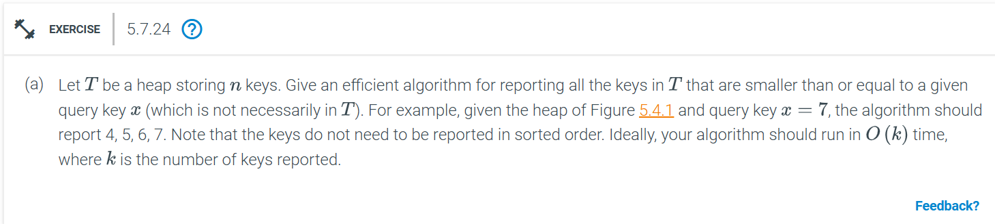
Using min-heap we can solve this problem efficiently. In a min-heap, every parent node is smaller than or equal to its children, which allows us to prune unnecessary subtrees when searching for keys smaller than or equal to a given query key
We can implement a depth-first search (DFS) starting from the root. At each node, we check if the current key is less than or equal to x :
If the key is less than or equal to x , we include it in our result and continue to check its children.
If the key is greater than x , we stop the search on that branch because, in a min-heap, all its children will be greater than the current key.
def find_keys_less_than_or_equal_to_x(heap, x):
result = []
def dfs(node):
if node is None:
return
if node.key <= x:
result.append(node.key) # Add the current key to the result list
dfs(node.left) # Recursively search the left subtree
dfs(node.right) # Recursively search the right subtree

dfs(heap.root) # Start DFS from the root
return result
We repeat this process for each node we visit.
Time Complexity:
Best Case: If x is smaller than most of the keys, we will explore only a small part of the tree. The time complexity is proportional to the number of reported keys k , which gives us O(k) time.
Worst Case: In the worst case, we may need to explore the entire tree, which will take O(n), where n is the total number of nodes in the heap. However, we expect the performance to be closer to O(k) when x is smaller than a significant number of nodes, as we can prune large subtrees.
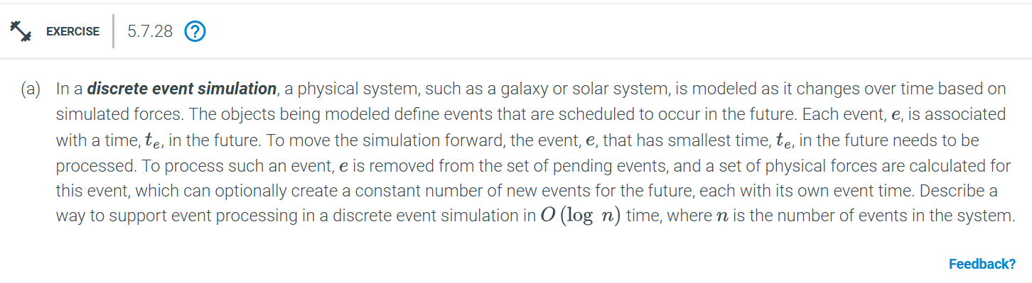
we can use a priority queue (implemented as a min-heap) to store the events. This data structure allows for fast insertion of new events and fast retrieval of the event with the smallest time, t_{e} , both in O(log n) time, where n is the number of events.
class Event:
def __init__(self, time, data):
self.time = time # the time at which the event occurs
self.data = data # any additional data for the event

def process_event(event):
# Perform calculations and processing for this event
# Optionally generate new events based on the current event
new_events = [] # list of new events generated
return new_events

def discrete_event_simulation():
# Initialize the min-heap (priority queue)
event_queue = MinHeap() # use a min-heap for events

while not event_queue.is_empty():
# Extract the event with the smallest time
current_event = event_queue.extract_min() # O(log n)

# Process the event
new_events = process_event(current_event)

# Insert new events (if any) into the min-heap
for event in new_events:
event_queue.insert(event) # O(log n) per insert
Time Complexity:
Inserting an Event: O(log n) per insertion.
Extracting the Minimum Event: O(log n).
Total Time per Event: Since we extract an event and potentially insert a constant number of new events, the overall time complexity per event is O(log n) .

Thus, by using a min-heap to store the pending events, we can ensure that each event is processed in O(log n) time, where n is the number of events currently in the system.
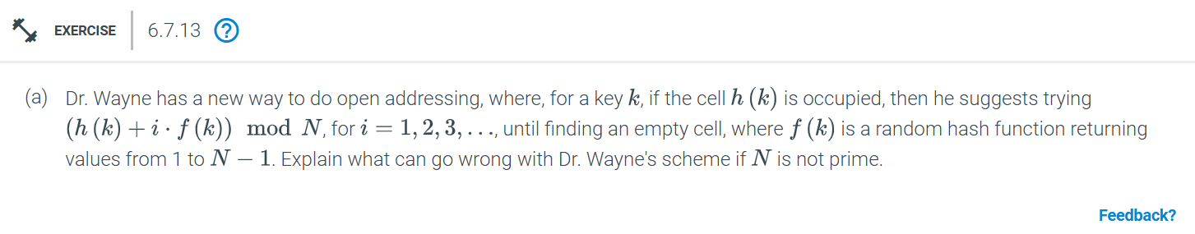
Dr. Wayne’s scheme for open addressing involves using a probing sequence of the form:

h(k) + i . f(k)) mod N
where:
h(k) is a hash function that computes the initial position in the table.
f(k) is a random function that generates a value between 1 and N - 1, determining the step size for probing.
i is the iteration count for probing, starting from 1.
The potential problem with this scheme arises when N, the size of the hash table, is not prime, because
If N is not prime, then the probing sequence might fail to explore all possible slots in the table. In other words, the set of indices generated by the probing sequence might get stuck in a cycle, and certain table cells will never be checked.
Thus, when N is not prime, Dr. Wayne’s scheme can lead to incomplete coverage of the hash table because the probe sequence might revisit the same subset of slots without ever checking all the cells. This happens because f(k) and N may share a common divisor, leading to a smaller cycle in the modulo arithmetic. Hence, it’s important that N be prime to ensure full exploration of the hash table during open addressing.
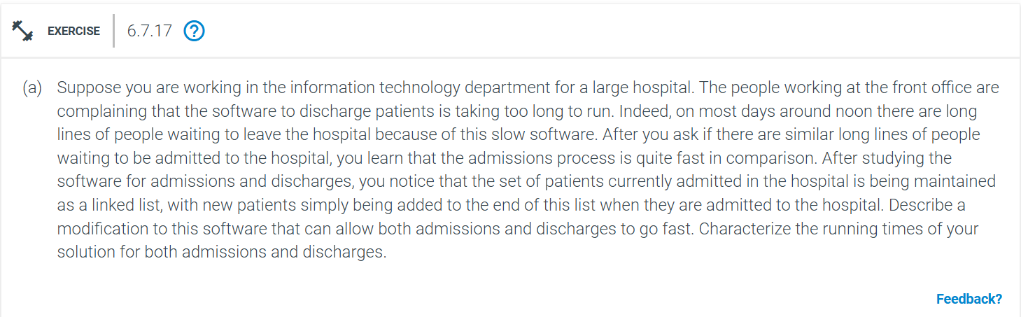
To speed up both admissions and discharges in the hospital software, the key issue is the data structure used to maintain the set of currently admitted patients. Currently, a linked list is used, which allows efficient admissions (adding patients to the end of the list) but results in slow discharges (finding and removing a specific patient from the list), particularly when there are many patients.
Issue with current linked list approach:
Admission: Adding a patient to the end of the list is O(1) because you can maintain a pointer to the last node.
Discharge: Discharging a patient requires searching through the entire linked list to find the patient, which is O(n), where n is the number of patients in the hospital. This is inefficient, especially during peak times.

Instead of linked list we can use Hash map or hash table. This will allow us to efficiently handle both admissions and discharges, as hash tables support constant time operations for insertions, deletions, and lookups (on average).
Key Operations in the Hash Table:
1. Admission: When a new patient is admitted, add the patient's information (e.g., patient ID, name, etc.) as an entry in the hash table. The patient ID (or a unique identifier) can serve as the key, and the patient’s record can be the value.
Time Complexity for Admission: O(1) on average. Inserting into a hash table is typically an O(1) operation, provided the hash table is well-sized and there are few collisions.
2. Discharge: To discharge a patient, simply use their ID to lookup the patient in the hash table, then remove the corresponding entry.
Time Complexity for Discharge: O(1) on average. Both the lookup and deletion in a hash table are O(1) operations.

Uses of hash table:
Admission remains fast, as adding a patient to the hash table is just an insertion operation, which is O(1).
Discharge becomes much faster, because finding and removing a patient from the hash table is also O(1) on average, rather than the O(n) required to search through a linked list.
The hash table provides direct access to patient records, avoiding the need to traverse the list when discharging patients.
Furthermore, If patient order needs to be preserved (e.g., for reporting or other use cases), you can pair the hash table with a doubly linked list:
The hash table can store pointers to nodes in the doubly linked list, allowing fast lookups, admissions, and discharges.
The doubly linked list maintains the order of patient admissions, while the hash table allows fast discharges.
Time Complexity:
Admission:(O(1) on average, for insertion into the hash table.
Discharge: O(1) on average, for lookup and removal from the hash table.
By switching to a hash table, both admission and discharge processes will run in constant time on average, drastically improving the performance of the hospital software. This change should eliminate the long waiting lines during patient discharge.
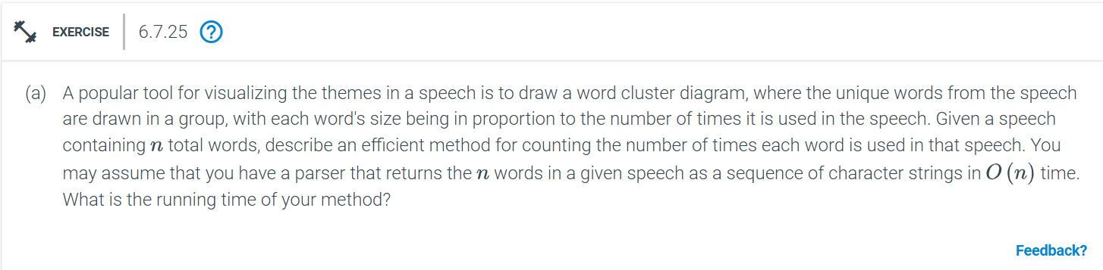
To efficiently count the number of times each unique word appears in a speech containing n total words, you can use a hash table (or hash map) data structure. Here's a step-by-step method to achieve this:
Pseudocode:
def count_words(speech):
word_counts = {} # Create an empty hash table

for word in speech: # Assume 'speech' is a list of words returned by the parser
if word in word_counts:
word_counts[word] += 1 # Increment count if word is already in the table
else:
word_counts[word] = 1 # Add word to table with count 1 if not already there

return word_counts
Running Time Analysis:
Parsing the speech: The parser returns n words in O(n) time.
Inserting words into the hash table: Each word is inserted or updated in the hash table. Insertion and lookup in a hash table (with good hashing and few collisions) take O(1) on average and processing all n words will therefore take O(n) time in total.
The overall running time of this method is:
O(n) + O(n.1) = O(n)
Thus, the entire process of counting the occurrences of words in a speech takes O(n) time, which is optimal given that we need to examine every word in the speech at least once.

